Annex (iv) – SSSI Assessment Form
SSSI Assessment for permit/licence and deployment applications | 
To be completed by Permitting Officers for any applications for a permission which Natural Resources Wales has considered under S28I duty to notify SNCB and take their advice into account. This applies to all proposed permissions within a SSSI, and to operations outside the SSSI boundary which are likely to damage its special features.
NRW as a Section 28G authority has, when exercising its functions, a general duty to take reasonable steps, consistent with the proper exercise of its functions, to further the conservation and enhancement of the flora, fauna or geological or physiological features by reason of which the site is of special interest’

Part 1 – SSSI Assessment
Part 2 – Formal notification to SNCB (to be completed if part 1 assessment concludes likely damage, not likely to damage because of conditions or you cannot conclude no likely damage)
Part 3 – Decision
Pink text – drafting notes, to be deleted before completion/consultation.
Blue text – examples, to be replaced with permission-specific information and text turned to black.

Part 1 – SSSI Assessment

- Permitting officer/team | Bryan Burn  Waste Permitting
- Permit application reference and site name | PAN-027648  Plas Bach, Cerrigceinwen, Bodorgan.LL62 5NS
- a. SSSI name(s)  b. location  c. NRW Operational Area/Environment Team | a. Llyn Llywenan  b. Angelsey  c. NW Industry and Waste regulation team
- Brief description of proposal | Land spreading deployment under standard rules permit SR 2010 No4 Mobile plant for land spreading.  Farm Location: SH 40350 72400  Fields: only field Bodnolwyn B is in range  SJC1 - SH 40195 72209  SJC2 - SH 40401 72446  SJC3 - SH 40558 72232  SJC4 - SH 40807 71974  SJC5 - SH 40812 72206  SJC6 - SH 40211 72075  Bodnolwyn A - SH 35449 82903  Bodnolwyn B - SH 35585 82700  Storage: none in range  The activity is not wholly or partly within the SSSI.  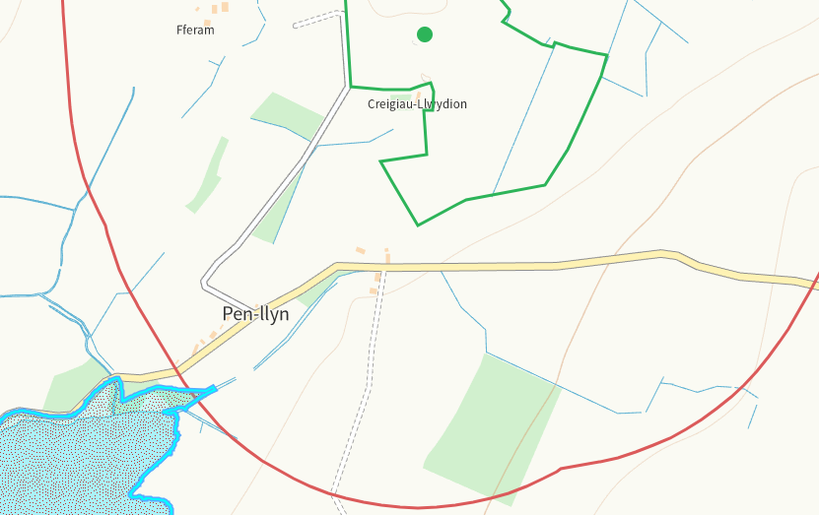  The proposed landspreading activity is to spread 10x 190902 waste streams on the fields with only 4x potentially being spread on field Bodnolwyn B. This field is in grass rotation with the upper application rate being 250t/ha.  Spreading will only take place subject to ground conditions  and following the Code of Good Agricultural Practice (Defra,  2011), Water Resources (Control of Agricultural Pollution)  Wales Regulations 2021, and the permit holder’s  Environmental Management System (EMS).  Targeted periods of spreading on grass fields include early  spring 2025 (late February – May), after cutting of silage,  and prior to grazing through summer (August).  Liquid sludges will be surface spread by tractor and tanker  using a low-trajectory splash plate.  No more than 50t/ha of waste will be spread on a field in any  3-week period in accordance with CoGAP, and no more than  250t/ha will be spread within any 12-month period.  The slope of field Bodnolwyn B is 0-7 degrees.  Documents relating to the deployment, PAN-027648, can be found at DMS.
- What aspects of the proposed permission are likely to damage the SSSI features of special interest?

The following activities are likely to cause damage:

7 Dumping, spreading or discharging of any waste materials.

The following SSSI(s) features and potential impacts have been considered to assess the likelihood of damage:

• A shallow lowland lake with moderate nutrient levels and a rich assemblage of
aquatic plants and animals, including extensive reedswamp.
• Uncommon aquatic plants such as eight-stamened water-wort, spring quillwort
and needle spike rush

As well as the features listed above, Llyn Llywenan has other species and habitats that are
key components of the special interest. These include an assemblage of wintering birds, a black headed gull colony, breeding wildfowl including gadwall, and willow scrub.

- Summary of any informal advice received from internal experts (if required and including pre-app advice) | none
- Recommendation | The proposed permission is not likely to damage any of the flora, fauna or geological or physiological features which are of special interest.  - The sludges are of low dry matter and will infiltrate readily into the soil surface following application minimising potential impact.  - The land is flat with only a gentle slope (0-7degrees).  - All application machinery is calibrated and regularly checked to ensure the stated application rates are maintained.  - 10m buffer zone adjacent to surface water features, including dry ditches.  - Spreading operations and spreading will cease if conditions are deemed unsuitable.  - No spread buffers are in place at the boundary of the feilds and for all watercourses, springs, wells and issues within range of all fields in the deployment.  - The land spreading activity will comply with the Code of Good Agricultural Practice guidelines (COGAP).
- Signature and date assessment made | Bryan Burn 20/01/2025
- Officers name and job title | Bryan Burn,  Waste Permitting Officer


Permitting
Formal Notification under Section 28I of the Wildlife and Countryside Act 1981

Part 2 Formal notification under S28I – To be completed for all permit applications assessed as: not likely to damage because of conditions, likely to damage SSSI and those where we are unable to conclude no likely damage.

- Date Notice of intention to permit activity likely to damage SSSI sent to NRW (SCNB)  If you assess activity as being likely to damage even if you think this can be mitigated by conditioning you need to formally notify SNCB send them a copy of this notice with part 1 of this form. Environment teams have 28 days to respond.  Environment teams please complete question 11 and 12 using the information in questions 1-9 | Insert date  We have assessed that [permit ref/name of site] is likely to damage [insert name of SSSI] and request your formal advice. We have assessed that this damage could be mitigated by including conditions[remove if not applicable].  Or  We are unable to conclude that [permit ref/name of site] is not likely to damage [insert name of SSSI] and request your formal advice.  Information on the permit application can be found in Part 1 of this form and [include link to DMS documents if required]
- Advice received from NRW (SNCB)

Environment Teams and Marine Area Management and Advice Teams are expected to log and issue formal statutory advice through our CAMS system. The advice letter generated can simply by attached/appended here. ET/MAAMT can just refer to that here or write a summary of advice here too.

To be completed by environment officers.
Within 28 days of receiving notice from a permitting/licensing regime, you should advise whether the operation:
• Should be allowed to proceed.
• Should be allowed to proceed with certain conditions.
• Should not proceed.

Please ensure all advice provided is evidenced and comprehensive. Advice provided may be scrutinised as part of a formal appeal.

- Name and job title of conservation/marine officer (sign and date)
Part 3 – To record NRW decision following SNCB Advice
- DECISION  Provide reasoning for your decision and how you have considered advice from NRW(SNCB) in the box opposite and delete text in blue that is not relevant. This might be the same as the info and decision in part 1 of the form  Large amounts of supporting information can be appended to this form. | The proposed permission is not likely to damage any of the flora, fauna or geological or physiological features which are of special interest  The permission is not likely to damage any of the flora, fauna or geological or physiological features which are of special interest because of conditions  The permission is likely to damage
- Natural Resources Wales (Section 28G Authority) (permitting service) is minded to  Delete as appropriate  If this decision is not in line with advice received from NRW(SNCB) please outline your reasoning (please note that you should try to resolve any differences in opinion) | Issue the permission  Issue the permission with conditions to ensure no damage to SSSI  Refuse the permission due to likely damage to SSSI
- Is decision in line with advice from SNCB  If your decision is not in line with the recommendations from SNCB you must formally notify them using the appropriate online form or letter.  Record the date the notice/letter was sent opposite and save a link. The permitted operation cannot commence for 21 days following service of this notice. | Yes/No  If No record date notice was sent to SNCB
- Signature and date assessment completed
- Officers name and job title



