TASK / JOB | Washing Down Post Dredging Campaign – Workboats (Valid for Sealion and Seahorse)
ASSESSED BY | Bruce Bradley | REFERENCE NUMBER | UKD/BIO/003
DATE OF ASSESSMENT | 24th January 2025 | REVIEW DUE DATE | 23rd January 2026

Indicate Areas of Ship “at risk” of Carrying INNS due to Dredging or Marine Works
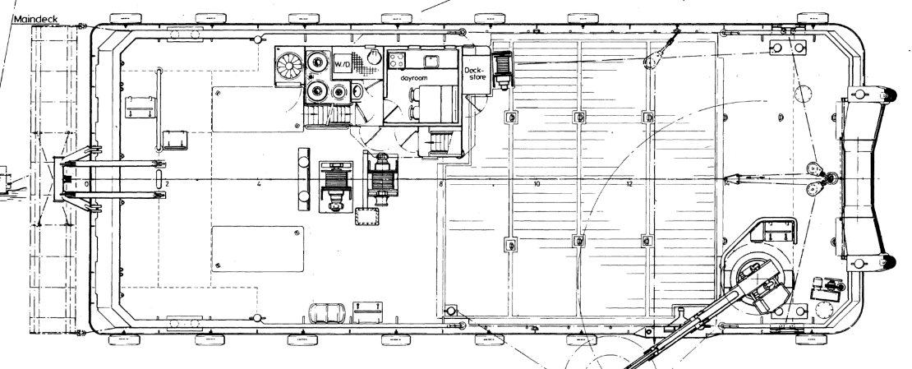
Plough

Job Step | Risks Identified | Method Statement
On completion of bed levelling | N/A | - Recover plough and secure if necessary.  - Inspect any dredge mud if accessible for flora and fauna, photograph and forward to Bio-Security Manager for identification and recording.
Prior to departure if dredge area | Transfer of INNS outside of dredge area. | - Using either hoses or prop wash, wash down the plough.  - Inspect and repeat as required.  - Inspect deck areas around plough and wash down if required.  - Record in diary

