CRoW Appendix 4 (140_10_SD02)  CRoW Act 2000: Natural Resources Wales application for permission - Formal Notice |  | 
Natural Resources Wales Formal Notice.
Requirements of Section 28I of the Wildlife & Countryside Act 1981 as amended by the Countryside and Rights of Way Act (CRoW) 2000.
Duty in relation to granting any consent, licence or permit for activities likely to damage Sites of Special Scientific Interest (SSSI).
Guide to filling in this form for Natural Resources Wales staff:
To be completed by Permitting Officers for any applications for a permission which the Natural Resources Wales has considered under S28G duties to protect and enhance SSSIs. This applies to all proposed permissions within a SSSI, and to operations outside the SSSI boundary which are likely to damage its special features.
Refer to OI 140_10 ‘Applying the Countryside and Rights of Way (CRoW) Act 2000 to applications for permits with potential for impact on Sites of Special Scientific Interest (SSSI)’, including the flowchart in Appendix 2.
Pink italic text – drafting notes, to be deleted before completion/consultation.
Blue text – examples, to be replaced with permission-specific information.
Ensure you have completed all sections.
- Natural Resources Wales area/region/NPS hub: | Installations/MCP/RSR national permitting function,  North-East Environment Team
- Name of SSSI: | Based on standard (AQTAG 14) screening distance for MCPs 10-20 MW_{th} with non-sulphurous fuels, SSSIs within 2.5 km of the source require assessment and are as follows:  - Glaslyn (31 WEK)  - Morfa Harlech (31 WNT)  - Ysbyty Bron y Garth (31 WTN)  Note that Llanfrothen SSSI and Coed Tremadog SSSI are outside of screening distance, each at > 2.6 km from the source. As impact is shown to be highly localised and is fully assessed, possibility of damage to these more distant SSSIs can be ruled out. The applicant has provided further information on more distant SACs up to 10km distance, but this information is unnecessary – there is no likelihood of damage at greater distance.
- Type of permission: | EPR industry Environmental Permit – MCPD-SG (Medium combustion plant generator 15.66 MW_{th} maximum)  Application by Hochtief Construction Ltd for a National Grid NSIP infrastructure project (grid improvements for stability and decarbonisation of electricity supply) – long term temporary generators fired on HVO (biodiesel) for tunnel boring machine for electricity lines under the Dwyryd Estuary near Minffordd.
- Date for Natural Resources Wales permit determination: | ASAP
- Predicted 28 day date for response from NRW conservation/ecology (under S28 I(4)): | Request by 17/01/25 by exception
- Natural Resources Wales reference no: | PAN-027839
- National grid reference: | Hotchief UK Construction Ltd – Site Office, Minffordd, LL48 6HP  (NGR 259327, 338720) – see below for map sketch
- Description of proposal: | Permitting of 15.66 MW_{th} HVO (biodiesel fuel oil) generators (6 x 2.61 MW_{th}, each comprising of 2 engines @1.305MW_{th}) needed to power a tunnel boring machine for the construction of a power cable tunnel (3.4 Km long) under the Dwyryd Estuary near Minffordd.  The tunnel is for National Electricity Grid network improvement which is part of the UK Government “accelerated strategic transmission investment”. This work is a Nationally Significant Infrastructure Project (NSIP) which is essential to the transition to a decarbonised UK electricity supply. The long term impact of the work is therefore to reduce airborne emissions (NOX and SO2) from power generation, and any short term localised impacts should therefore be seen in the context of net air quality improvement enabled by the project.  Tunnel boring is needed for the new cabling in the Pentir to Trawsfynyndd project, while minimising environmental and visual impact. Standalone generators are needed to power the tunnel boring machinery as the local grid supply is insufficient. Grid power and a battery storage system are used to minimise engine requirement (total capacity and operating time).  The consenting is temporary – application states 14 months, but NRW will consent emissions for 2 years to allow for any delays, after which the engines will no longer be able to operate under the proposed permit. Owing to the proximity of protected SSSI’s sensitive to air pollutants and emissions of NO_{X} from the engines, App 4 is required
- Is the proposed activity within (wholly or partially) the SSSI boundary? | NO but the activity (generators) are <100m from nearest SSSI so any impact from emissions to air needs full consideration. However direct effects e.g. physical damage can be disregarded and are not subject to MCPD/SG controls.  layout information:  Emissions via 2 shared stacks – NGRs 259301,338733 and 259283,338724  Black circle = generator site location (representing both NGRs as so close) , blue = SACs, red = SSSI’s, purple = red+ blue = SAC+ SSSI boundary.  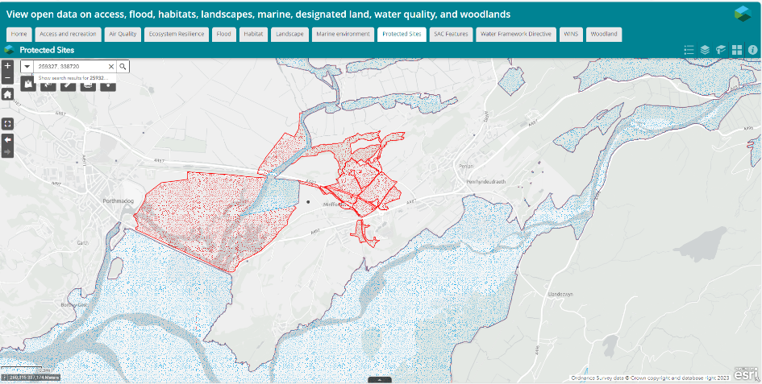
- Has there been any pre-application discussion or correspondence with NRW conservation/ecology | Some preliminary conversations 12/2024. Teams Call to resolve outstanding issues 07/01/25 when suitable N-deposition critical load was established (5 kgN/Ha/yr is precautionary, relaxing the APIS most restrictive requirement of 2 kgN/ha/yr)  Note that an HRA has also been prepared for the partially overlapping European site designations Meirionnydd Oakwoods and Bat Sites & Lleyn Peninsula and the Sarnau – draft decision is “no likely significant effect”, which is informative to the parallel SSSI assessment on this form and the two can usefully be read in conjunction.
- What aspect(s) of the proposed permission may damage the features which are of special interest for the SSSI?
The following ‘Operations Requiring Consent’ (or other activities associated with the permission) that may cause damage) are relevant to the proposed permission.
(for Glaslyn) 7. Dumping, spreading, discharging or storage of any materials… – i.e. specifically discharging of emissions from the generator chimney stacks, and subsequent spreading/dispersion into the environment, including the atmosphere (air) over the SSSI’s, and following this, deposition (nutrient nitrogen, acid) onto the SSSI, as calculated/described in air impact screening/modelling and considered against relevant critical levels/loads assigned for the SSSIs and their features.
The other SSSIs have similar ORC’s, described slightly differently for each, but the need for assessment and possible impact mechanisms are the same.

No other impacts (e.g. noise or physical damage) are relevant to MCP/SG consenting.

The following characteristics of the industrial source have been considered to assess the likelihood of damage:
The applicant has undertaken screening assessment of air emission impacts (SCAIL tool) to assess whether there is likely effect of NOX, SO2, or via deposition from NOX of nutrient nitrogen and acid deposition. This goes beyond normal assessment requirements for Gas Oil (etc) powered MCP/SGs where only NOX and N-related deposition impact is assessed.

Impacts are considered insignificant (no likelihood of damage) if the process contribution (PC) from the source is less than 1% of the long term [annual] critical level/load (i.e. a pollution source so small as to be indistinguishable at receptors) or if the critical level/load is unlikely to be exceeded, when background pollution level is taken into account. For short term standards (e.g. daily / 24 hour averages) a PC of 10% is considered insignificant. These are a standard screening insignificance threshold for air pollutants. If pollutants do not screen out via the SCAIL assessment, further analysis may be undertaken using detailed dispersion modelling or detailed receptor information to assess impact.

The following SSSI features and mechanisms of impact have been considered to assess the likelihood of damage:

Glaslyn SSSI (31 WEK) (<100m from generators at closest point, stated in application approx. 77m)
The most sensitive features to key pollutants are summarised below, detail from APIS at end of this assessment
Pollutant | Limiting critical level/load for SSSI impact | Most sensitive feature | Max Process contribution (%) | App4 conclusion
NOX | 30 ug/m3 [annual] | All flora – standard limit | 0.3% (screening)  ≤0.7% (detailed modelling) | Insignificant – not likely to damage
NOX | 75 ug/m3 [daily] | All flora – standard limit | 4.9% | Insignificant – not likely to damage
SO2 | 10 ug/m3 [annual] | Oligotrophic low altitude rivers, semi-natural woodland, salt-marsh, marshy grassland, swamp – as further detailed at end of this assessment | <0.1% (screening)  <0.1% (detailed modelling) | Insignificant – not likely to damage
N dep | (A) 2-10 kg N/ha/yr [annual] | 2-10: Oligotrophic low altitude rivers, Luronium natans. | 1% (not screening insignificant at this N sensitivity) | Insignificant. The highest N-sensitivity of 2kgN/ha/yr is not applicable as described below following discussion with Environment Team as these features are absent from the maximum impact area of the generators. Impact is <1% at greater distance where more sensitive features are present
N dep | 5-15 kg N/ha/yr [annual] | 5-15: Semi-natural woodland (Semi-natural woodland (Betula pubescens-Molinia caerulea woodland: Juncus effusus subcommunity) and (Salix cinerea-Galium palustre woodland)  and 10+ for other listed features (including salt marsh)– as detailed at end of this assessment, or not sensitive at all. | 0.4%, insignificant | Insignificant – not likely to damage any features present in the area of maximum impact, as depicted below
Acid dep | 0.285 kg eq/ha/yr [annual]  (MinCLminN 0.285, MinClmaxN 1.205) | Unmanaged broadleafed/coniferous woodland (7 types as listed at end of assessment), no other features are assigned specific acid sensitivity | SCAIL – insignificant – PC <0.03% (of 0.285, not 1.395 stated by operator) | Insignificant – not likely to damage

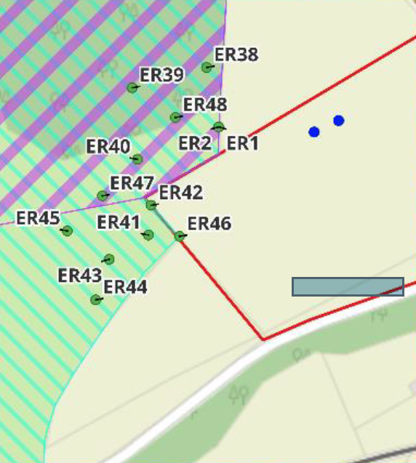
Assuming Clo of 2 kgN/ha/yr:
ER1&2 – PC 0.5% - insignificant
ER38 – 0.8% - insignificant
ER39 – 2.4% - highest impact point – further assessment needed
ER40 – 1% - insignificant
ER41 – 1.1% - further assessment needed
ER42 - 1.1% - further assessment needed
ER43 – 1.3% - further assessment needed
ER44 – 1.1% - further assessment needed
ER45 – 1.5% - further assessment needed
ER46 – 0.8% - insignificant
ER47 – 1.4% - further assessment needed
ER48 – 1.5% - further assessment needed
All are ≤0.4% insignificant with Clo of 5kgN/ha/yr or above
Evidently from this distribution, PC will be <1% insignificant against Clo of 2kgN/ha/yr at greater distances, and aside from highly localised area around ER points depicted in the plan.

As indicated, the area of theoretical significance is in any case very small, and non the woodland / flood plain adjacent to site – will certainly be insignificant <1% by river channel.

All pollutants other than N-deposition are immediately considered insignificant from SCAIL screening results. For N-deposition, further information was sought from environment team on 07/01/25 as impacts could not immediately be ruled insignificant against a N-deposition critical load of 2kgN/ha/yr. Environment team confirmed that the level of 2 (for oligotrophic waters and Luronium Natans) was not relevant to the area of highest impact, depicted above as the features are not present there.

Occurrence of Luronium Natans is shown on the map below, and is seen to be a large distance from the application area – likelihood of damage is not credible:
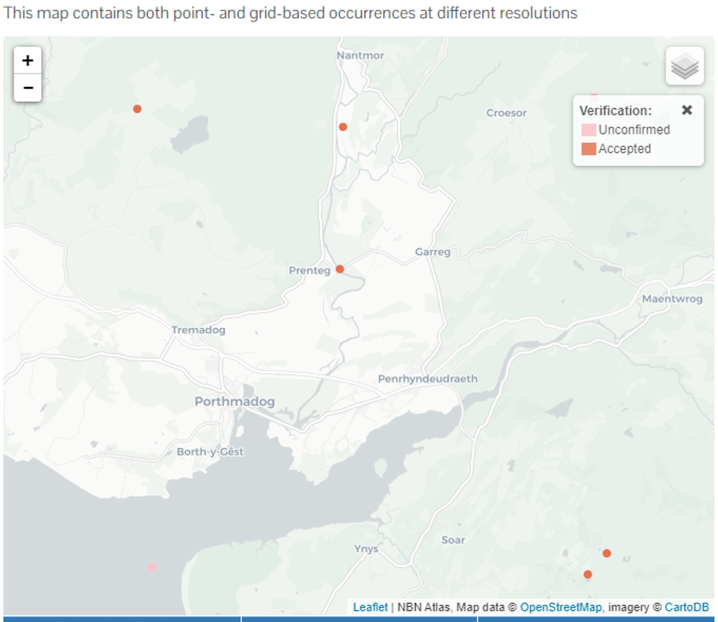

The watercourse feature of the SSSI is at least 450m from the emission point. Impact will be insignificant (<1%) of a Clo of 2 kgN/ha/yr by this point. In any case, it is highly unlikely that a level of 2 is appropriate to this downstream part of the water body – there is no credible likelihood of damage.
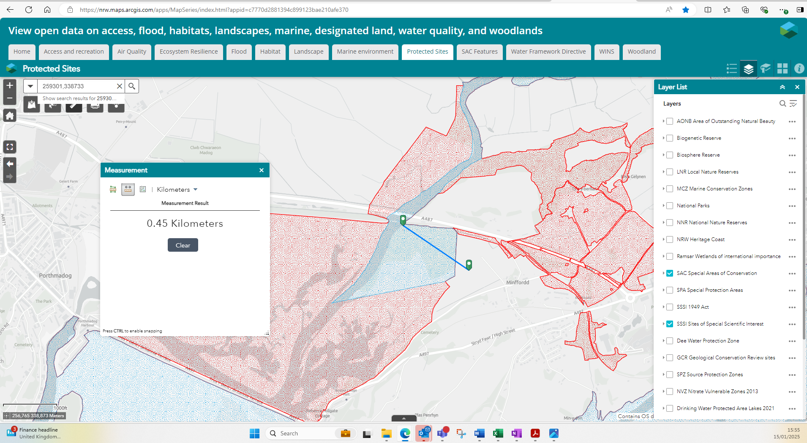
Conclusion for Glaslyn – for the reasons above, not likely to damage

Morfa Harlech (31 WNT) (approx. 1.2km from emission point)
The most sensitive features to key pollutants are summarised below, detail from APIS at end of this assessment
Pollutant | Limiting critical level/load for SSSI impact | Most sensitive feature | Max Process contribution (%) | App4 conclusion
NOX | 30 ug/m3 [annual] | All flora – standard limit | SCAIL 0.66%  Modelled ≤ 0.7% | Insignificant – not likely to damage
NOX | 75 ug/m3 [daily] | All flora – standard limit | <4.9% | Insignificant (<10% for short term) – not likely to damage
SO2 | 10 ug/m3 [annual] | Sand dune and salt marsh features (numerous) as listed at end of this assessment) | SCAIL 0.0%  Modelled <0.1% | Insignificant – not likely to damage
N dep | 5 kg N/ha/yr [annual] | 8 specific sand dune features comprising “coastal dune grasslands” as listed at end of this assessment, Petalophyllum ralfsii | SCAIL 0.4%  Modelled 0.1% | Insignificant – not likely to damage
Acid dep | 0.142 kg eq/ha/yr [annual]  (MinCLminN 0.142, MinClmaxN 1.09) | Coniferous plantation – unmanaged woodland | SCAIL: <0.1% using sensitivity NRW obtained from APIS | Insignificant – not likely to damage.

Conclusion for Morfa Harlech: All process contributions are insignificant at the receptor (<1% annual average, <10% daily average critical level/load) – there is no credible likelihood of damage using precautionary receptor sensitivities.

Ysbyty Bron y Garth (31 WTN) (approximately 180m from the generators at nearest point)
The most sensitive features to key pollutants are summarised below, detail from APIS at end of this assessment
Pollutant | Limiting critical level/load for SSSI impact | Most sensitive feature | Max Process contribution (%) | App4 conclusion
NOX | 30 ug/m3 [annual] | All flora – standard limit | 1.1% | Insignificant based on PEC – see below
NOX | 75 ug/m3 [daily] | All flora – standard limit | ≤4.9% | Insignificant (<10% for short term) – not likely to damage
SO2 | 20 ug/m3 [annual] | All flora – standard limit (no specific feature sensitivities on APIS) | 0.0% | Insignificant – not likely to damage
N dep | No sensitivity identified | None identified (see APIS below) | NA – not sensitive | Insignificant – not likely to damage
Acid dep | No sensitivity identified | None identified (see APIS below) | NA – not sensitive | Insignificant – not likely to damage.

Conclusion for Ysbyty Bron y Garth: Not likely to damage. All process contributions are insignificant at the receptor other than annual average nox (<1% annual average, <10% daily average critical level/load). For annual average NOX, the process contribution cannot be considered insignificant, but the predicted environmental concentration (PEC) is 19% of the environmental standard, which is therefore not likely to be breached – there is no credible likelihood of damage. There is no site-specific or feature-specific sensitivity of the site to SO2, N-deposition or acid deposition. This is because the only protected feature of the site is lesser horseshoe bat, which is not highly sensitive directly to aerial pollutants. While excessive pollution could damage the species broad habitat, no specific limits have been set, and the level and extent of pollution (SOX, N-dep, Acid-dep) is not likely to damage this wider habitat, which is not specifically N-sensitive or acid sensitive.

- Decision
i) The proposed permission is not likely to damage any of the flora, fauna or geological or physiological features which are of special interest.

As detailed above, where site / feature relevant critical loads / levels are identified, the poroposed MCP/SG is either insignificant impact (<1% process contribution of long term limit, or <10% of short term limit), or for NOX at Ysbyty Bron y Garth the environmental standard is unlikely to be breached. This conclusion is drawn following expert input from habitats colleagues, who have confirmed that in the area of greatest impact from the MCP-SG a N deposition sensitivity of 2kg/ha/yr is not required, and a more general limit of 5kgN/ha/yr is sufficiently precautionary for the features present.

Natural Resources Wales is minded to: Issue the permission

- Name and job title of Natural Resources Wales officer: | Dr David Poole, Industrial Decarbonisation Senior Specialist Advisor, on behalf of NRW permitting service
- Date form sent to NRW conservation/ecology | NA – assessment placed on file as per our guidance as there is robust point-by-point evidence “unlikely to damage” after conversation with Environment Team
For Natural Resources Wales use only, once NRW conservation/ecology response received
- NRW conservation/ecology comment on assessment: | Please delete as appropriate:  i) NRW conservation/ecology advise the operation can go ahead  ii) NRW conservation/ecology advise the operation can go ahead with conditions  iii) NRW conservation/ecology advise against permitting the operation  Please ensure that the NRW conservation/ecology response is attached to this Formal Notice.
- Name and job title of NRW conservation/ecology officer:
- Date of receipt of NRW conservation/ecology response:

Appendix: Further information

Glaslyn:

N-deposition, NOX and SO2 sensitivity:
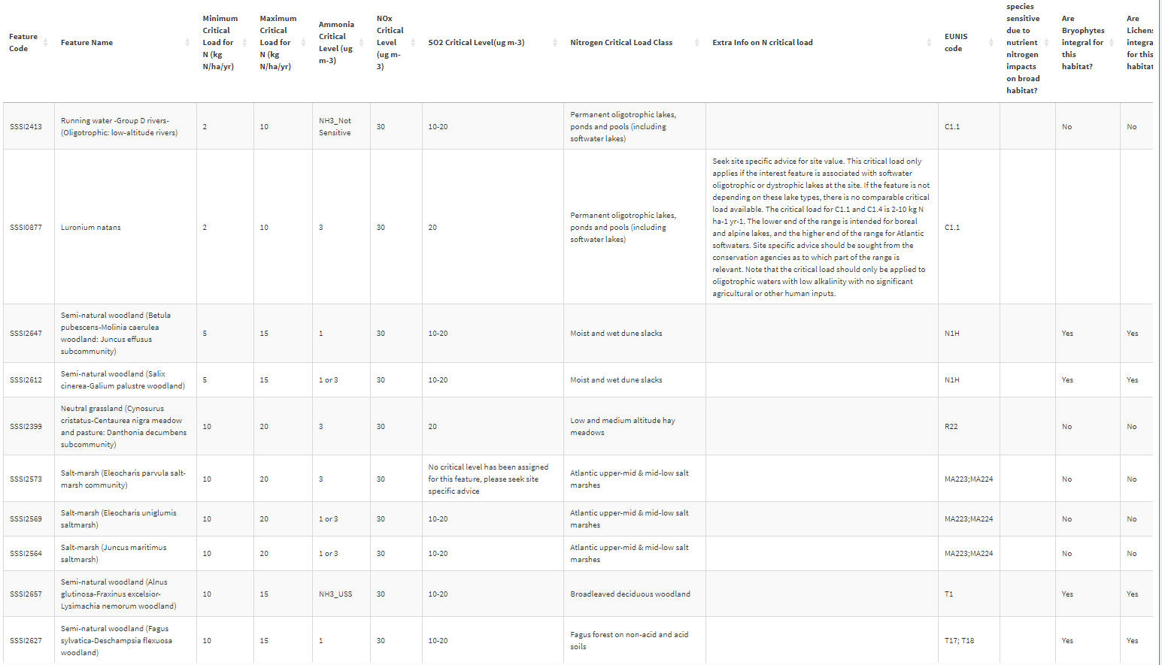

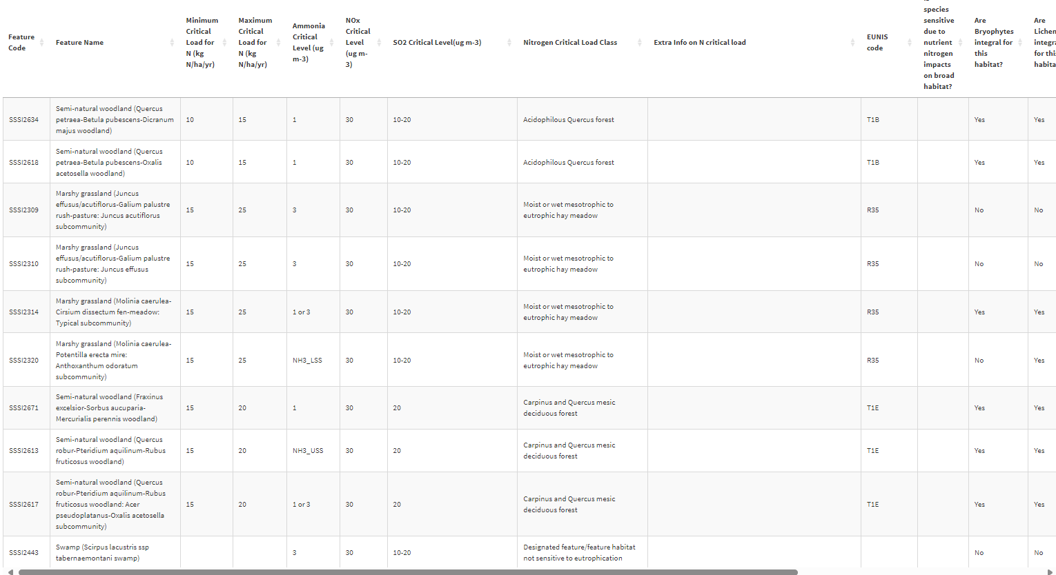

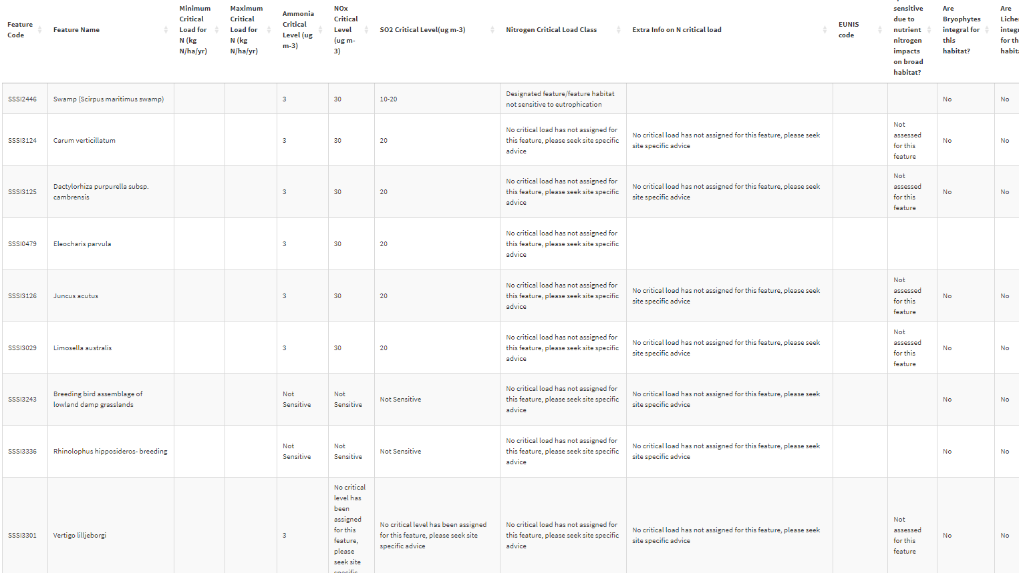

Acid sensitivity:
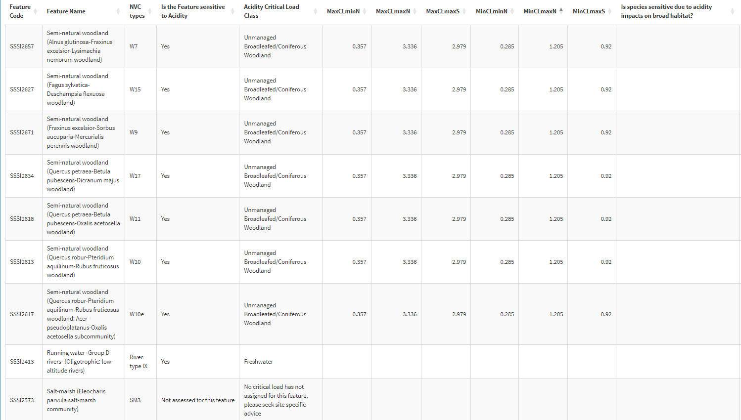

Morfa Harlech:

N-deposition, NOX, SO2 sensitivity:

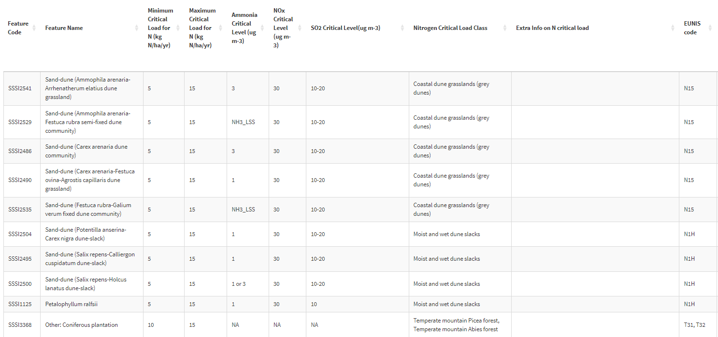

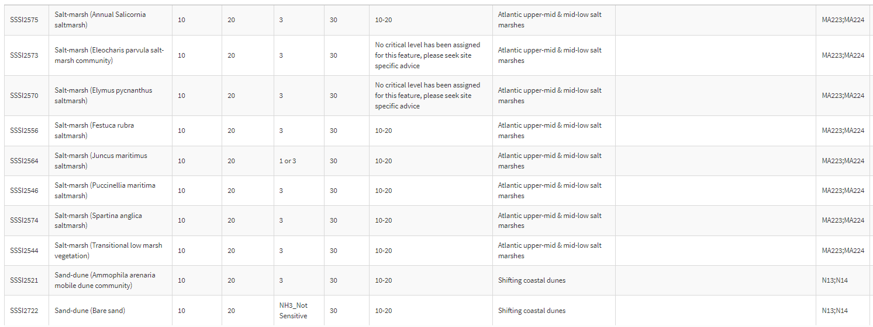

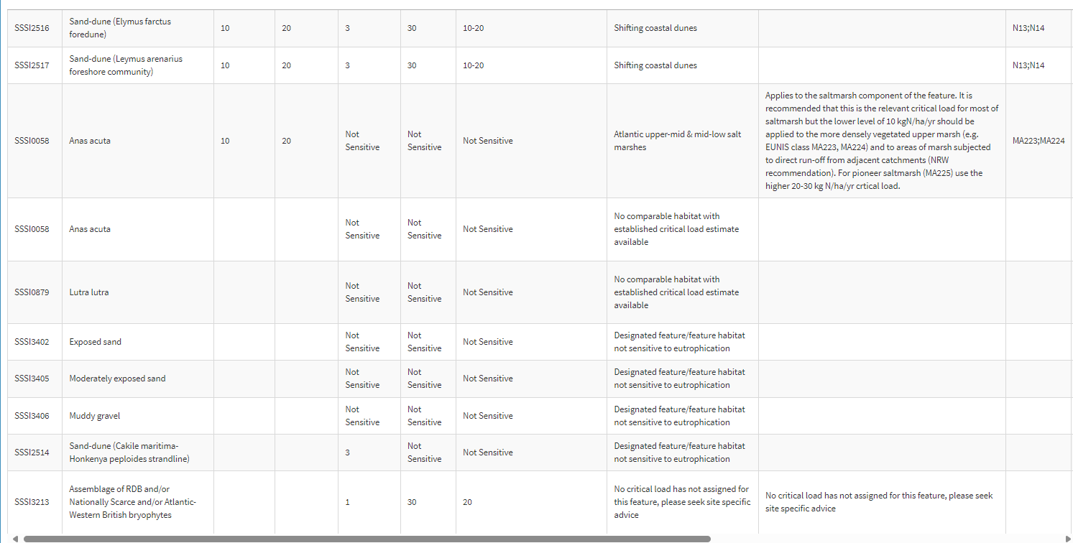

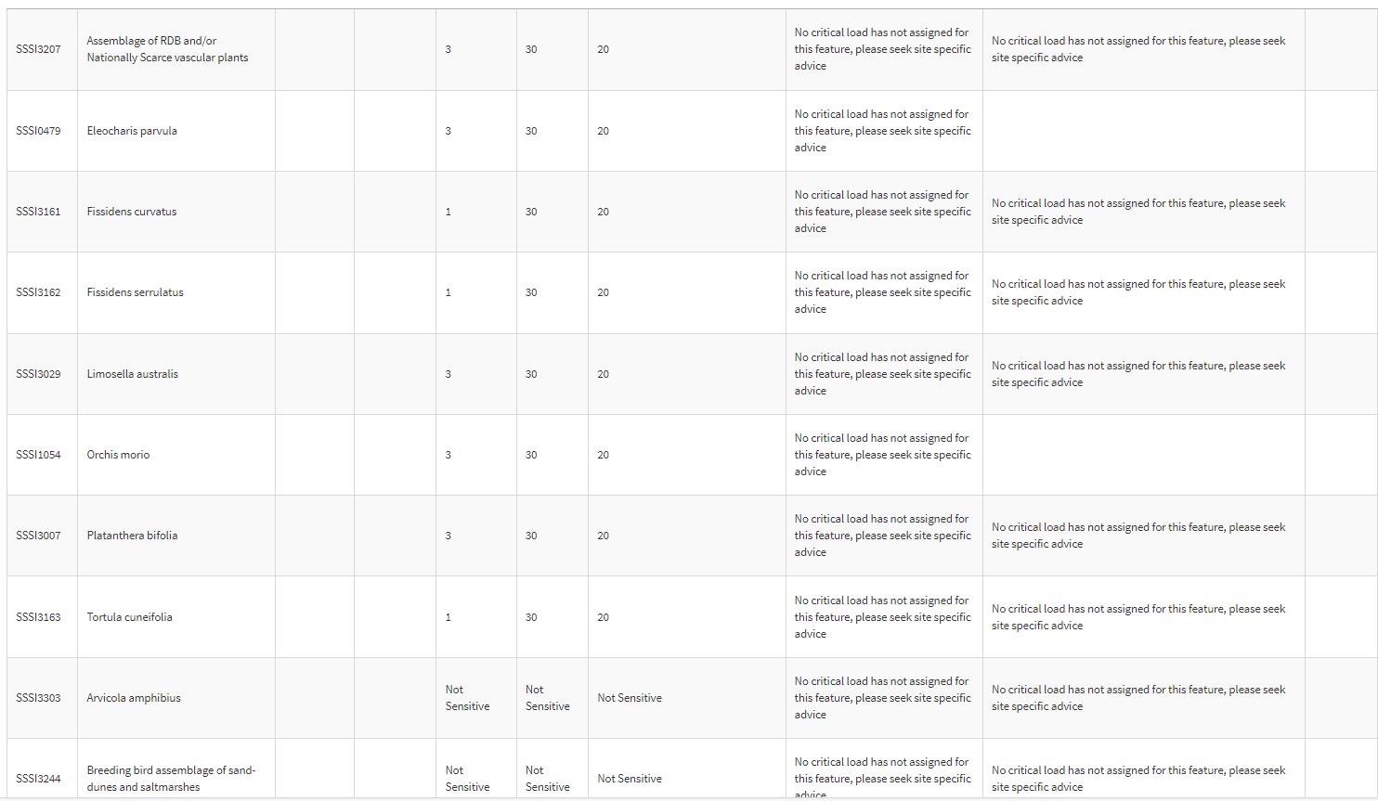

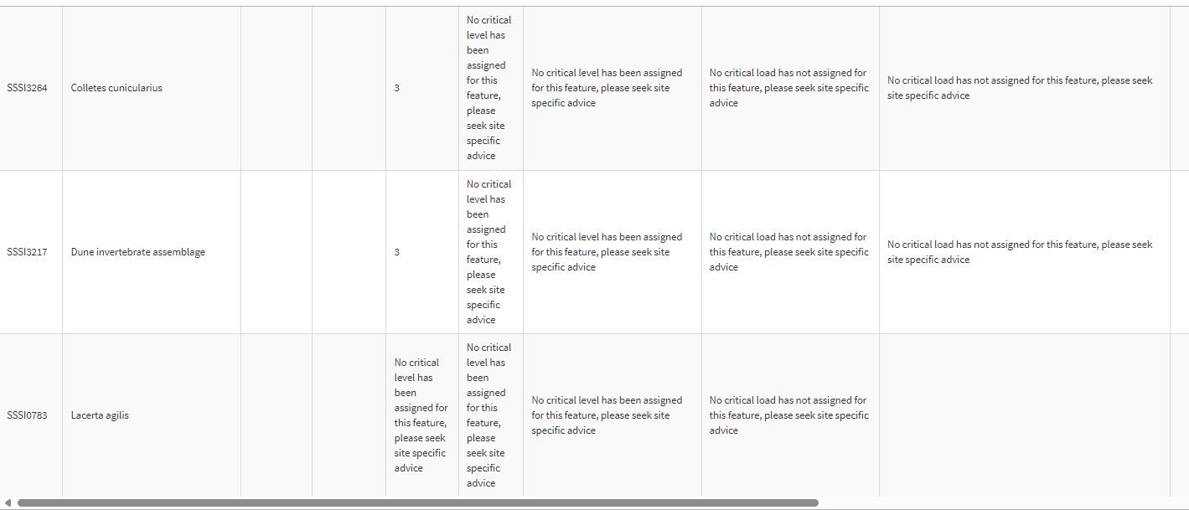

Acid sensitivity:

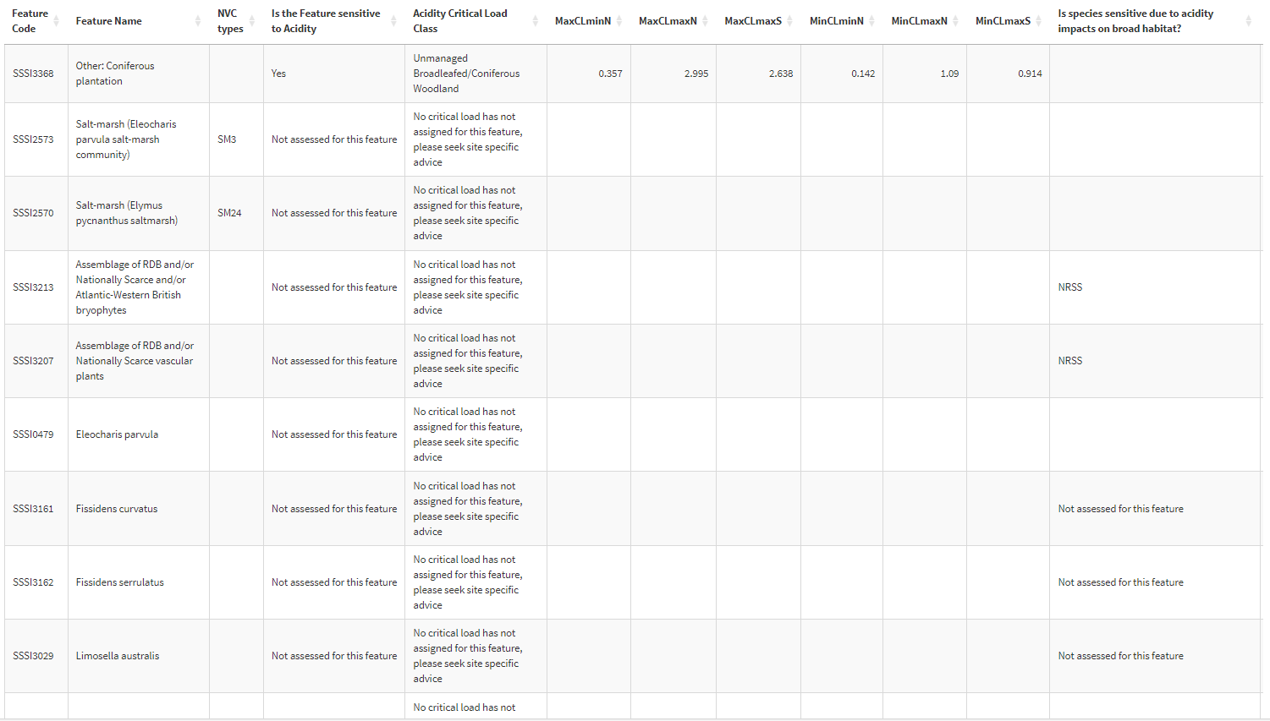

Ysbyty Bron y Garth :


