OGN 200 Form 1A

Record of a Habitats Regulations Assessment
Plan or project name, brief description or application reference number | Environmentanl Permitting Regulations PAN-027839 (Medium Combustion Plant and specified generator)  Consenting of 15.66 MW_{th} HVO (fuel oil) generators (6 x 2.61 MW_{th}) needed to power a tunnel boring machine for the construction of a power cable tunnel (3.4 Km long) under the Dwyryd Estuary near Minffordd.

HRA iteration/version | 1 – Following call with Local Protected Sites Advisor and Protected Sites Air Quality Advisor

1. Plan or Project Details
Information about the plan or project
1 | Date application received | 20/12/24  Noting applicant has been in discussion with NRW since Summer 2024 and consenting is urgent – needed by end of January 2025. Delay will affect delivery of a £300M NSIP, and cost project >£75k/day.
2 | Applicant details | Hochtief (UK) Construction Ltd on behalf of National Grid  Registered office Whitehill House, Windmill Hill Business Park, Whitehill Way, Swindon, SN4 6PE.
3 | NRW team responsible for carrying out, or requiring to be carried out, the plan or project, and name of lead officer | N/A
4 | Activity/ies proposed | The tunnel is for National Electricity Grid network improvement which is part of the UK Government “accelerated strategic transmission investment”. This work is a Nationally Significant Infrastructure Project (NSIP) which is essential to the transition to a decarbonised UK electricity supply. The long term impact of the work is therefore to reduce airborne emissions (NOX and SO2) from power generation, and any short term localised impacts should therefore be seen in the context of net air quality improvement enabled by the project.  Tunnel boring is needed for the new cabling in the Pentir to Trawsfynyndd project, while minimising environmental and visual impact. Standalone generators are needed to power the tunnel boring machinery as the local grid supply is insufficient. Grid power and a battery storage system are used to minimise engine requirement (total capacity and operating time).  The consenting is temporary – application states 14 months, but NRW will consent emissions for 2 years to allow for any delays, after which the engines will no longer be able to operate under the proposed permit. Owing to the proximity of protected (SAC) sites and emissions of NO_{X} from the engines, HRA is needed.
5 | Relevant legislation or statutory basis | Conservation of Habitats and Species Regulations 2017  Environmental Permitting (England and Wales) Regulations 2016 – specifically including Schedule 25A (MCP) and 25B (Specified Generators) – requiring NRW permit
6 | Location | Hochtief UK Construction Ltd – Site Office, Minffordd, LL48 6HP (NGR 259327, 338720):  Emissions via 2 shared stacks – NGRs 259301,338733 and 259283,338724  Black circle = generator site location (both represented by same dot as so close), blue = SACs, red = SSSI’s, purple = red+ blue = SAC+ SSSI boundary.  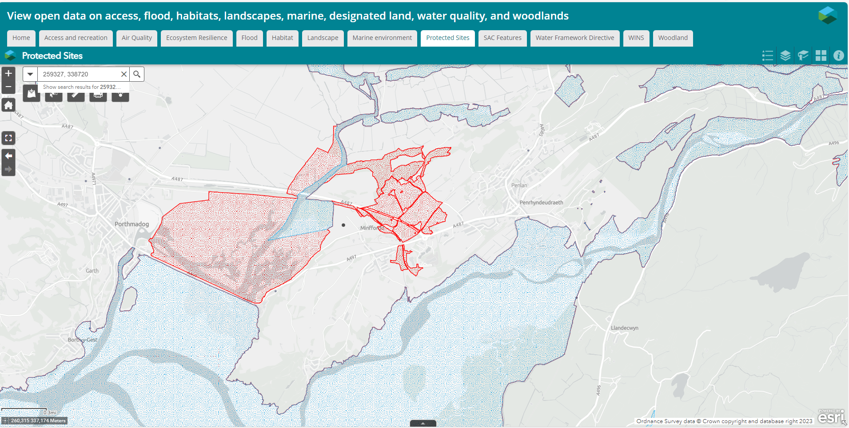
7 | Plan or project documents, including any application documents | NRW Internal: PAN-027839 (AQA and ecological supplement are relevant)  Public register: Public register - Customer Portal – PAN 027839
8 | Environmental Statement | N/A
9 | Pre-application correspondence | Teams call with Arfon Hughes, Katrina Jenkinson, Environment Team NW, Heather Galliford Protected sites and air quality, David Poole, Jeremy Walters and Anna Griffiths, Reg industry permitting etc.
10 | NRW team responsible for preparing this HRA report, and lead officer | David Poole, Industrial Decarbonisation and Standards Reg Approaches, on behalf of Installations & RSR EPR Permitting Team
11 | Team or person responsible for approving the plan or project (competent authority role) | Application sits in the North West Environment Team area. After discussion with them, it has been concluded that there is “no likely significant effect” as documented and therefore formal Competent Authority approval (HRA) is not required.

2. Determining the need for a Habitats Regulations Assessment
2.1 Is there any possibility that the plan or project could negatively affect any European sites? | Yes – emissions of air pollutants (NO_{X,} SO₂) from the engines could affect European Sites within screening distances (2.5km for <20 MW engines running on diesel/gas oil/HVO). Impact directly as NOX, and via Nitrogen deposition and Acid deposition should be considered against relevant critical levels/loads. Under EPR legislation no other impacts (e.g. noise) are relevant to HRA for MCP/SG consent.
2.2 Is the whole of the plan or project directly and only connected with or necessary to the management of one or more European sites, for the purposes of conserving the habitats or species for which the European site(s) is/are designated? | No
2.3 Is there a possibility that the plan or project could affect any other feature of the European site(s) concerned, or of another European site, in a way that would undermine that feature’s conservation objectives? | N/A as 2.2 answered “no”

3. Considering the likelihood of a significant effect (LSE)

3.1 Renewal of a project authorisation on the same or more restrictive terms as an extant authorisation
Is this a renewal of an extant authorisation which complies with NRW approved criteria for ruling out significant effects of renewals (see Part 2 of OGN200) without conducting a project-specific LSE test? | No

3.2 Likelihood of significant effects (LSE) test

3.2.1 Which European sites might be affected by the plan or project?
(a) | Based on the plan or project specification or information provided in the application, it is considered that these European sites have features which could be negatively affected by the plan or project | According to standard (AQTAG 14) Table 1 and SCAIL guidance, screening distances for combustion plant <20 MW_{th}, any European sites within 2.5 km of the proposed emission point should be screened for likely significant effect. The outer blue circle shows sites within 2.5km (manual, to nearest 25m):  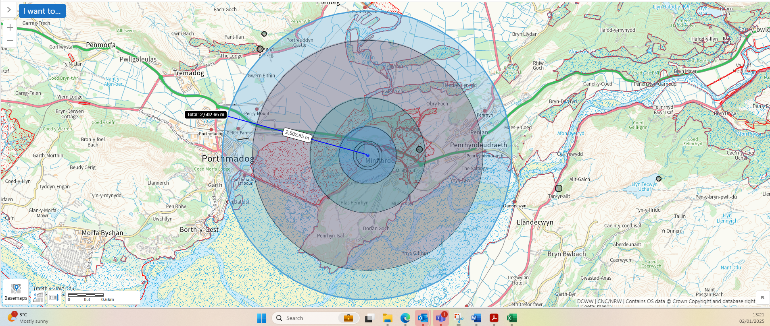  The identified European sites within 2.5 km are:  Coedydd Derw a Safleoedd Ystlumod Meirion / Meirionnydd Oakwoods and Bat Sites (UK0014789) <100m from engines to SAC  Pen Llyn a'r Sarnau / Lleyn Peninsula and the Sarnau (UK0013117) ~1km from engines to SAC
(b) | The potential for the plan or project to negatively affect these European sites was also initially considered, but can be ruled out without further consideration | More distant European Sites, eg:  - Morfa Harlech a Morfa Dyffryn (UK0030049) – beyond AQTAG screening distance at ~ 3.8 km  - Northern Cardigan Bay / Gogledd Bae Ceredigion – beyond AQTAG screening distance at ~ 6 km  - Rhinog (UK 0012945) – beyond AQTAG screening distance at ~6.8km  It is clear from the application information that maximum impact is within a few hundred metres of the emissions source and decreasing with dispersion distance, so consideration of more distant sites can be ruled out with high confidence.

3.2.2 Screening for likelihood of significant effect (LSE)
TABLE 3.2.2 Screening assessment
Overview – Both European Sites and Features within screening distance: The only relevant impact (“source”) from MCP/SGs are emissions to air of pollutants. The proposed genearators are outside of the European site (~100m distance at closest point), so direct effects e.g. physical damage can be disregarded.

The applicant has undertaken screening assessment of air emission impacts (SCAIL tool) to assess whether there is likely significant effect of NOX, SO2, or via deposition from NOX of nutrient nitrogen, and from NOX and SO2 of acid deposition. After clarification from protected sites advisors, all pollutants screen out via the screening assessment against most precautionary critical levels/loads for the whole SAC, indicating no likely significant effect as detailed below. Impacts are considered insignificant (no LSE) if the process contribution (PC) from the source is less than 1% of the most precautionary long-term [annual] critical level/load applicable to the site (i.e. a pollution source so small as to be indistinguishable at receptors) or if the critical level/load is unlikely to be exceeded, when background pollution level is taken into account. SCAIL does not calculate short term critical load (NOX 24-h average) – it is expected that this impact is insignificant if annual NOX is achieved. This is a standard screening insignificance threshold and approach for air pollutants.

It is noted that the applicant has also undertaken detailed dispersion modelling to assess the impact of air pollutants on receptors. Results from this modelling can make the impact assessment seem more complicated than it need be for HRA purposes. The further detail is not necessary to the HRA because, as detailed below, screening assessment robustly demonstrates “no LSE” from the proposed MCP-SG against appropriate critical levels/loads.
European site name: Meirionnydd Oakwoods and Bat Sites (UK0014789) <100m from MCP-SG to SAC
Overall conclusion for Meirionnydd SAC – “IN COMB”:
All annual average air pollutants screen out at less than 1% process contribution against the relevant critical level/load for the most sensitive and potentially relevant designated feature of the protected site to that pollutant, as summarised in the table below. Pollution is insignificant, therefore there is no likely significant effect and the HRA screening alone for Meirionnydd Oakwoods and Bat Sites is concluded. This is as expected for well controlled diesel engine MCPs, with low NOX and low SO2. However, there is potential for cumulative effect with other plans and projects, so in combination assessment is completed below.

Pollutant | Limiting critical level/load | Most sensitive feature | Max Process contribution (%) | LSE conclusion
NOX | 30 ug/m3 | All plant features as per APIS table below | 0.5% | Insignificant – no LSE
SOX | 10 ug/m3 | Bog woodland, heath & others as listed in APIS table below | <0.1% | Insignificant – no LSE
N dep | 5 kg N/ha/yr | Bog woodland, dry & wet heaths as listed in APIS table below | 0.8% | Insignificant – no LSE
Acid dep | 0.745 kg eq/ha/yr | Old sessile oak woods as shown in APIS table below | 0.01% | Insignificant – no LSE

For information, the 24-hour average NOX [not normally included in SCAIL for ecosystems as explained above] is calculated by the applicant to be a maximum at any ecological receptor of 12.7 ug/m3, or 4.9% of the critical level of 75% ug/m3. For short term impacts, <10% is considered insignificant, so this provides further evidence that the impact is insignificant.

Detail
The table below, from APIS, indicates the designated features of the Meirionnydd SAC, and the associated site- and feature- relevant critical levels and loads (other than acid, see separate table further down):

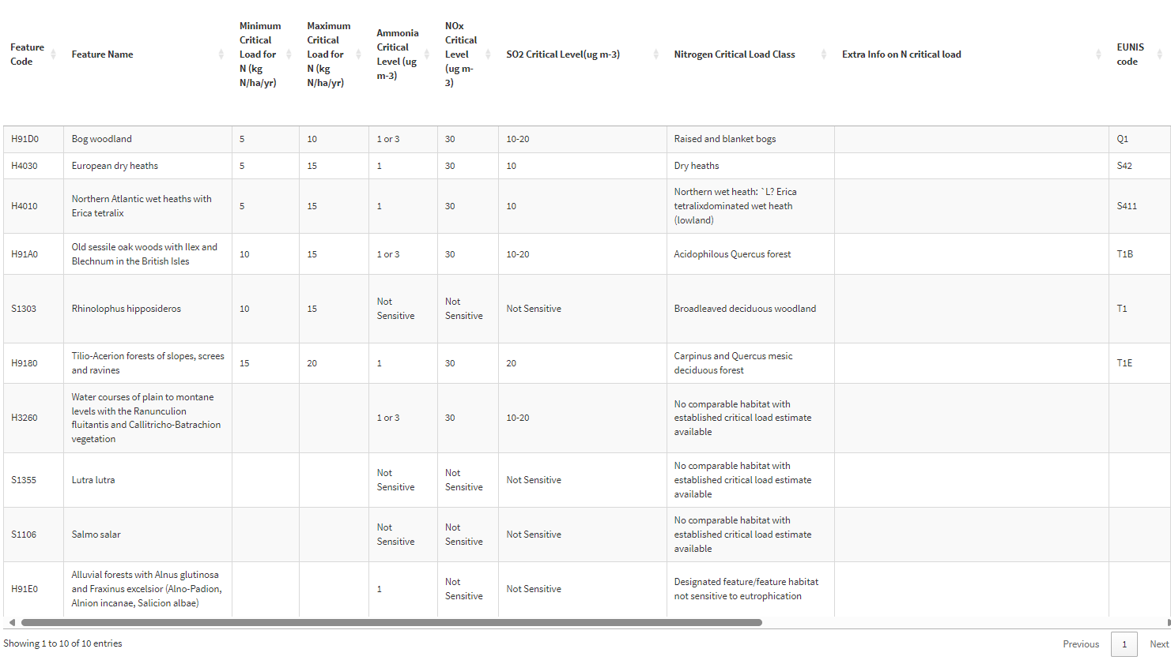

NOX: As shown, all designated habitat features are sensitive sensitive to airborne NOX with an annual critical level of 30 ug/m3. Species features are not directly sensitive to the pollutant. The SCAIL assessment of MCP impacts provided by the applicant indicates that the annual maximum NOX PC from the proposed MCP-SG is 0.14 ug/m3, or 0.5% of the critical level, less than the 1% significance threshold routinely applied to air emissions assessment. The NOX pollution is therefore insignificant at the SAC, and there is no likely significant effect The detailed modelling (informative only for HRA) further supports this conclusion.

SO₂: As shown, the most sensitive designated features of the SAC to SO2 are Bog woodland, European dry heaths, Northan Atlantic wet heaths with Erica tetralix, Old sessile oak woods with Ilex and Blechnum in the British Isles, and Water courses of plain to montane levels with the Ranunculion fluitantis and Callitricho-Batrachion vegetation, with a minimum SO2 critical level of 10 ug/m3. Other features are either not sensitive, or have a sensitivity of 20ug/m3 (Tilio-Acerion forests of slopes, screes and ravines). The SCAIL assessment of MCP impacts provided by the applicant indicates that the annual SO2 from the proposed MCP-SG is 0.0 mg/m3 (to 2 significant figures), or <0.1% of the critical level, below than the 1% significance threshold routinely applied to air emissions assessment. For other features listed above, with a lesser SO2 sensitivity, it therefore follows that the impact of the MCP-SG is <1% and is therefore insignificant. The overall SO2 pollution is therefore insignificant at the SAC, and there is no likely significant effect The detailed modelling (informative only for HRA) further supports this conclusion.

N-Deposition: As shown, the most sensitive designated features of the SAC to N deposition are Bog woodland, European dry heaths, and Northan Atlantic wet heaths with Erica tetralix, with a minimum N critical load of 5 kgN/ha/yr. The SCAIL assessment of MCP impacts provided by the applicant indicates that the annual maximum N-deposition from the proposed MCP-SG is 0.0404 kgN/ha/yr, or 0.8% of the critical load, less than the 1% significance threshold routinely applied to air emissions assessment. For other features listed above, with a lesser N-deposition sensitivity, it therefore follows that the impact of the MCP-SG is <1% and is therefore insignificant. The overall N deposition pollution is therefore insignificant at the SAC, and there is no likely significant effect The detailed modelling (informative only for HRA) further supports this conclusion when a N-deposition critical load of 5 kgN/ha/yr is used.

Acid Deposition: The table below, from APIS, indicates the designated features of the Meirionnydd SAC that are sensitive to acid deposition, and the associated feature relevant critical loads:

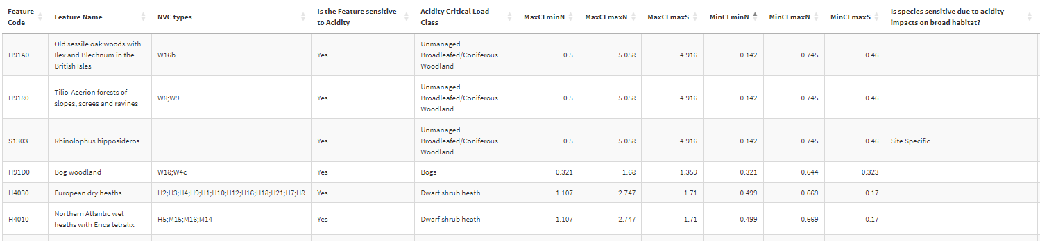

As shown, old sessile oak woods with Ilex and Blechnum in the British Isles are the most sensitive to acid deposition. The applicant’s SCAIL screening calculates a process contribution of acid of 0.0001 kg/ha/yr, or <0.1% of the critical level, less than the 1% significance threshold routinely applied to air emissions assessment. For other features listed above, with a lesser acid-deposition sensitivity, it therefore follows that the impact of the MCP-SG is <1% and is therefore insignificant. The overall acid deposition pollution is therefore insignificant at the SAC, and there is no likely significant effect. Noting that NRW have updated the assessment to the most acid sensitive feature, as the applicant information / SCAIL used a less sensitive critical load.

The APIS screen shot below confirms that the PC for acid deposition is insignificant, using the values from SCAIL, the old sessile oak acid sensitivities, for the grid square closest to the proposed MCP-SG.

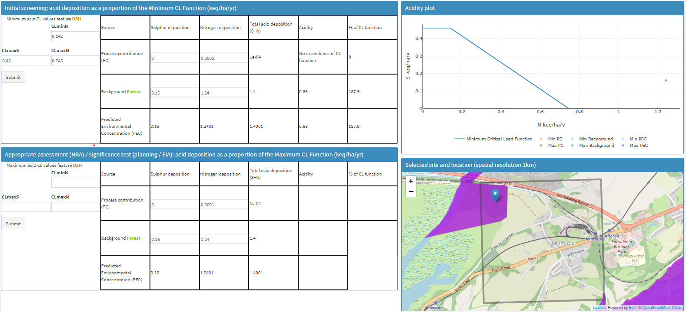

European site name: Pen Llyn a'r Sarnau / Lleyn Peninsula and the Sarnau (UK0013117) ~1km from MCP-SG to SAC

Overall conclusion for Llyn Peninsula SAC – “IN COMB”:
All air pollutants “screen out” at less than 1% process contribution against the relevant critical level/load for the most sensitive designated feature of the protected site to that pollutant, as summarised in the table below. Pollution is insignificant, therefore there is no likely significant effect and the HRA screening alone for Llyn peninsula SAC is concluded. However, there is potential for cumulative effect with other plans and projects, so in combination assessment is completed below.

Pollutant | Limiting critical level/load | Most sensitive feature | Max Process contribution (%) | LSE conclusion
NOX | 30 ug/m3 | Lagoons, estuaries, salt meadows, spartina swards, and others as listed in APIS table reproduced below | 0.5% | Insignificant – no LSE
SOX | 10 ug/m3 | Lagoons, estuaries, salt meadows, spartina swards and others as listed in APIS table below | <0.1% | Insignificant – no LSE
N dep | 10 kg N/ha/yr | Lagoons, estuaries, salt meadows, spartina swards as detailed below | 0.2% | Insignificant – no LSE
Acid dep | NOT Specified so NRW screened assuming  0.2 kg eq/ha/yr | Alosa alosa, Alosa fallax, Lampetra fluviatilis, Lutra lutra, Petromyzon marinus – via potential impact on species’ broad habitat – as detailed in table below. | <0.1% of precautionary screening value | Insignificant – no LSE
For information, the 24-hour average NOX [not normally included in SCAIL for ecosystems] is calculated by the applicant to be a maximum at any ecological receptor of 12.7 ug/m3, or 4.9% of a critical level of 75% ug/m3. For short term impacts, <10% is considered insignificant, so this is insignificant.

Detail:
The table below (2 parts), from APIS, indicates the designated features of the Llyn SAC, and the associated site- and feature- relevant critical levels and loads (other than acid, see further down):

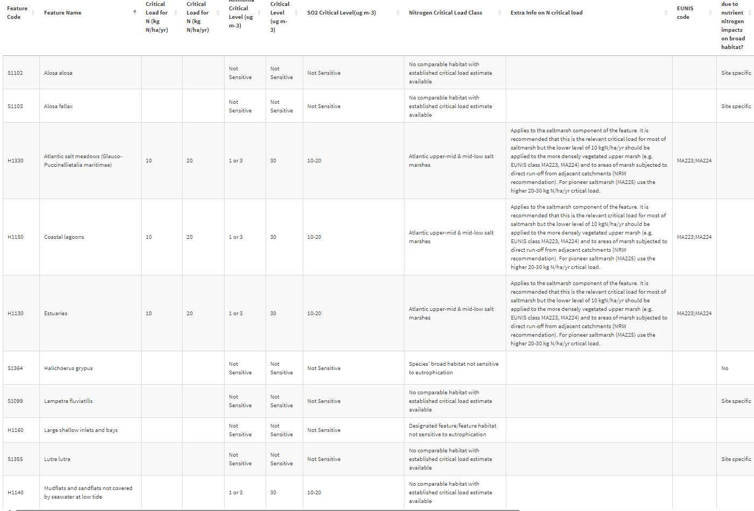
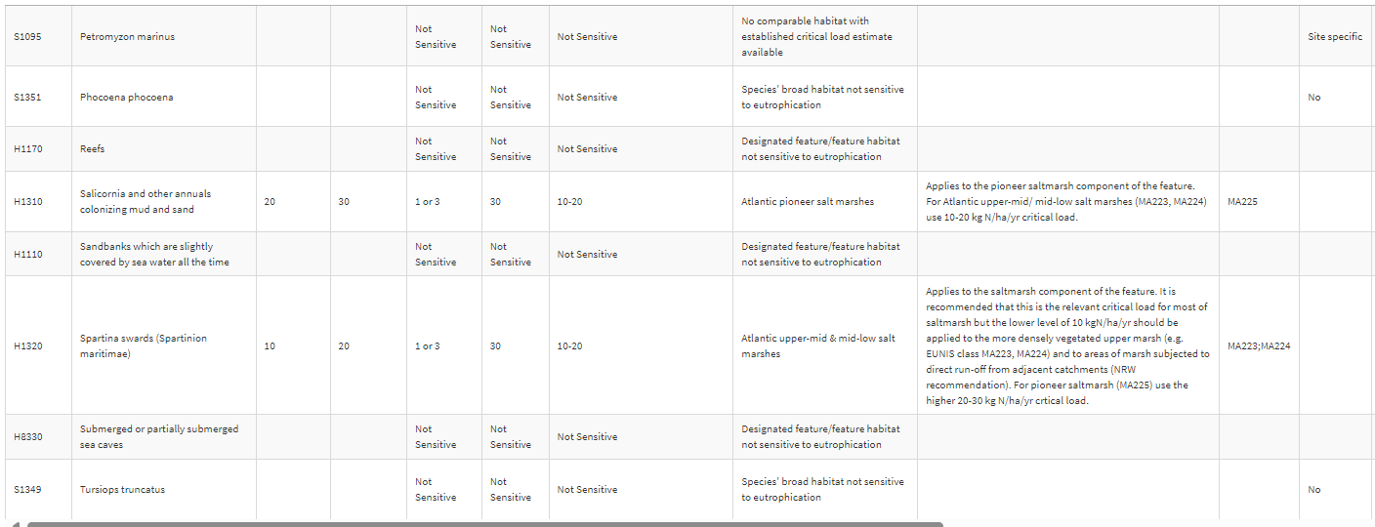

NOX: As shown, a number of designated habitat features (flora) are sensitive sensitive to airborne NOX with an annual critical level of 30 ug/m3. Fauna features are not directly sensitive to the pollutant. The SCAIL assessment of MCP impacts provided by the applicant indicates that the annual maximum NOX PC from the proposed MCP-SG is 0.2 ug/m3, or 0.5% of the critical level, less than the 1% significance threshold routinely applied to air emissions assessment. The NOX pollution is therefore insignificant at the SAC, and there is no likely significant effect The detailed modelling (informative only for HRA) further supports this conclusion.

SO₂: As shown, the most sensitive designated features of the SAC to SO2 are lagoons, estuaries, salt meadows, mud flats, spartina swards, and salicornia, with a minimum SO2 critical level of 10 ug/m3. Other features are not sensitive. The SCAIL assessment of MCP impacts provided by the applicant indicates that the annual SO2 from the proposed MCP-SG is 0.0 mg/m3 (to 2 significant figures), or <0.1% of the critical level, below than the 1% significance threshold routinely applied to air emissions assessmentThe overall SO2 pollution is therefore insignificant at the SAC, and there is no likely significant effect The detailed modelling (informative only for HRA) further supports this conclusion.

N-Deposition: As shown, the most sensitive designated features of the SAC to N deposition are Lagoons, estuaries, salt meadows, spartina swards, with a minimum N critical load of 10 kgN/ha/yr. Salicornia are N-sensitive with a critical load of 20 kgN/ha/yr. The SCAIL assessment of MCP impacts provided by the applicant indicates that the annual maximum N-deposition from the proposed MCP-SG is 0.0224 kgN/ha/yr, or 0.2% of the critical load, less than the 1% significance threshold routinely applied to air emissions assessment. For salicornia, with a lesser N-deposition sensitivity, it therefore follows that the impact of the MCP-SG is <1% (at 0.1%) and is therefore insignificant. The overall N deposition pollution is therefore insignificant at the SAC, and there is no likely significant effect The detailed modelling (informative only for HRA) further supports this conclusion when a N-deposition critical load of 10 kgN/ha/yr is used.

Acid Deposition: The table below, from APIS, indicates the designated features of the Llyn SAC that are potentially sensitive to acid deposition, and the associated feature relevant critical loads:

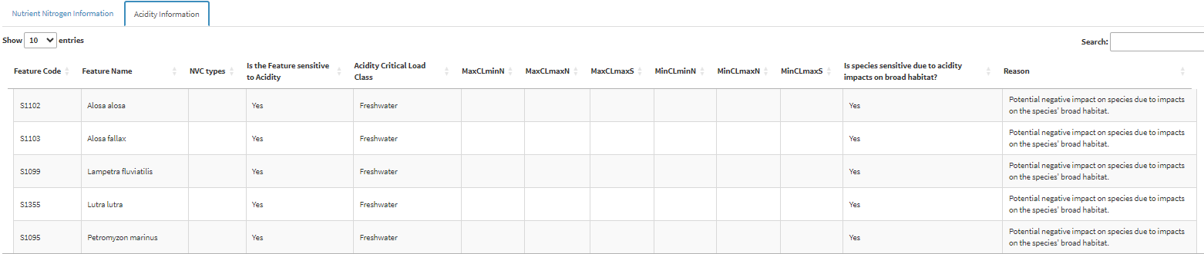

Normally, acid critical loads are applied to habitat areas (ground) or to plants. It is unusual for animal species to be flagged as acid sensitive, and no critical load is shown, simply a note of potential acid influence. The operator has concluded that there is no acid deposition impact on the Llyn SAC.

In the absence of an acid critical load, NRW permitting has arbitrarily assigned a trial acid sensitivity of 0.2 kgeq/ha/hr, chosen simply because it represents a highly acid sensitive environment. The applicant’s SCAIL screening calculates a process contribution of acid on the Llyn SAC (dominated by N) of 0.0001 kg/ha/yr, or <0.1% of the screening critical level, less than the 1% significance threshold routinely applied to air emissions assessment. An illustrative calculation clearly demonstrates that the acid deposition is insignificant, even using an arbitary high acid sensitivity for screening purposes. The overall acid deposition pollution is therefore insignificant at the SAC, and there is no likely significant effect.

TABLE 3.2.3 Screening decision of the plan or project ‘alone’
(c) If there are no features in Table 3.2.2 that are ‘SCREEN IN’ and any features that are ‘IN COMB’ | The plan or project is not likely to have a significant effect on any European sites when considered alone, but the possibility of significant effects in combination with other plans and projects needs to be considered.

5. In combination assessment
Table 5.1 Identification and assessment of in combination effects
European site name: Coedydd Derw a Safleoedd Ystlumod Meirion / Meirionnydd Oakwoods and Bat Sites (UK0014789) <100m from MCP-SG to SAC

Potential in combination effects to be considered:

Cumulative effect of air emissions of this proposal with any other new permission plan or project sources of the same pollutants (NOX, SO2, Acid deposition or N deposition) within the time frame of the operation and at a level likely to cause significance in the same maximum impact areas as the proposed MCP-SG.

Other potential impacts of the tunnel boring construction project are beyond the scope of MCP-SG consenting HRA, but it has been confirmed that the applicant is in contact with NRW separately in relation to managing these broader potential impacts.

In combination assessment:

No credible cumulative impact – there are no other air emissions source consents on the permitting queue, nor known or anticipated for the same area/region in the coming months. Given this MCP-SG emissions are only to be authorised for 2 years, the potential for any in-combination air emission sources to be consented and have cumulative impacts during the impact period are sufficiently low as to be disregarded. The level of “other” development in the area affecting air quality is expected to be relatively low, and the impact area of the MCP-SG is limited.

Can significant or adverse in combination effects be ruled out for all features? Yes

European site name: Pen Llyn a'r Sarnau / Lleyn Peninsula and the Sarnau (UK0013117) ~1km from MCP-SG to SAC

Potential in combination effects to be considered:

Cumulative effect of air emissions of this proposal with any other new permission plan or project sources of the same pollutants (NOX, SO2, Acid deposition or N deposition) within the time frame of the operation and at a level likely to cause significance in the same maximum impact areas as the proposed MCP-SG.

Other potential impacts of the tunnel boring construction project are beyond the scope of MCP-SG consenting HRA, but it has been confirmed that the applicant is in contact with NRW separately in relation to managing these broader potential impacts.
In combination assessment:

No credible cumulative impact – there are no other air emissions source consents on the permitting queue, nor known or anticipated for the same area/region in the coming months. Given this MCP-SG emissions are only to be authorised for 2 years, the potential for any in-combination air emission sources to be consented and have cumulative impacts during the impact period are sufficiently low as to be disregarded. The level of “other” development in the area affecting air quality is expected to be relatively low, and the impact area of the MCP-SG is limited.

Can significant or adverse in combination effects be ruled out for all features? Yes

Table 5.2 In combination assessment: results
(a) If the answer for all features considered in Table 5.1 is ‘YES’ | The plan or project, when considered in combination with other plans and projects, is either not likely to have a significant effect on, or will not adversely affect the integrity of, any European site.

6. Conclusion
The plan or project has been screened for likelihood of significant effects and is considered not likely to have a significant effect on any European sites. (As documented in section 3.2 of this form, and section 5 if applicable) | X
Signed: David Poole

Name: David Poole
Position: Senior Specialist Advisor, Industrial Decarbonisation & Standards (on behalf of installations permitting team)

Date: 28/01/25 following ANCB comments (no objections/corrections) on 16/01/25)
Was this HRA conclusion an escalated decision? YES or NO | No

7. Consultation with the ANCB and how sections 2, 3, 4 and 5 of this HRA report (as applicable) take into account that advice.
Relevant section of the HRA report | Correspondence and/or meetings with the ANCB | Description of how the comments from the ANCB have been taken into account
All | Meeting 07/01/25 | HRA “no LSE” final drafting in accordance with meeting comments

9. Appendix: supporting information

Screen shot 1: SCAIL screening results as submitted by applicant (with minor adjustments by NRW to reflect actual APIS N and acid sensitivity as noted above).


