Record of a Habitats Regulations Assessment of a project
March 2016

OGN 200 Form 1
Document owner: Protected Sites Team, KSP

Version History:
Document Version | Date Published | Summary of Changes
1.0 | March 2016 | Document created
Review Date: February 2017

Record of a Habitats Regulations Assessment of a project

Contents

Section

1. Project details

- External applications to NRW

- Internal NRW projects

2. Determining whether HRA is required

3. Test of likely significant effect

- Screening of renewals

- Identifying likely significant effects

4. Appropriate assessment

- In the absence of additional conditions or restrictions

- Taking into account additional conditions or restrictions

5. In combination assessment

6. Conclusion

7. Record of consultation with protected sites advisors

8. Conservation Technical Specialist’s comments (to be completed only where HRA sign off and protected sites advice are done by the same team)

1. Project Details

1(a): Project details where an external party has applied to NRW for any form of authorisation
Application reference number (if applicable) | CML2491
Date application received | 04/12/2024
Applicant details | MPH Construction Limited
Activity proposed | Penmaenmawr sea defence wall is located in Penmaenmawr, Conwy and runs along the coastline in a NE/SW orientation protecting the existing railway. An area of the wall, approximately 20m long x 0.50m x 0.70m has been undermined and needs remedial measures to be carried out to ensure long term stability of the existing structure. The wall is subject to tidal action, which is assumed to be the cause for the undermining observed.  To mitigate the undermining wave action sheet piles will be installed in front of the existing wall. Capping of the sheet pile wall is to be undertaken in accordance with NR Standards Details. To limit deflections anchors are to be installed through the sheets and existing sea wall into the retained ground. The existing voids within the wall are to be infilled with grout once the sheet piles are installed.  The following is to be undertaken using long reach machinery from the top of the retaining wall:  1. Carry out dilapidation survey of the existing sea wall.  2. Installation of sheets to designed toe level.  3. Installation of ground anchors as per specification.  4. Construction and installation of waling beam.  5. Pump grout into voids within existing sea wall  6. Pour marine grade concrete behind the sheet piles.  7. Rock armour will be placed in front of the piles to provide extra protection
Relevant legislation | Marine and Coastal Access Act 2009
Location | 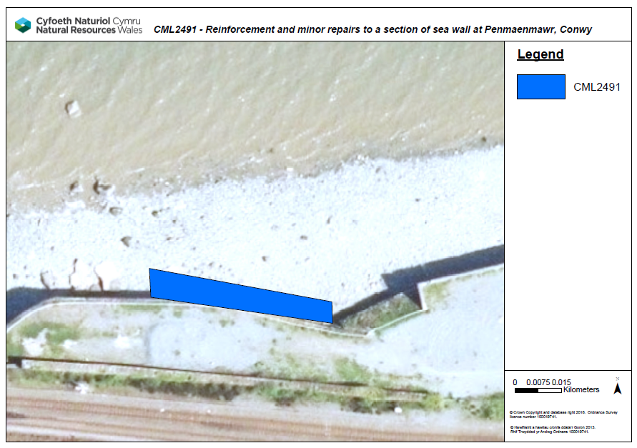  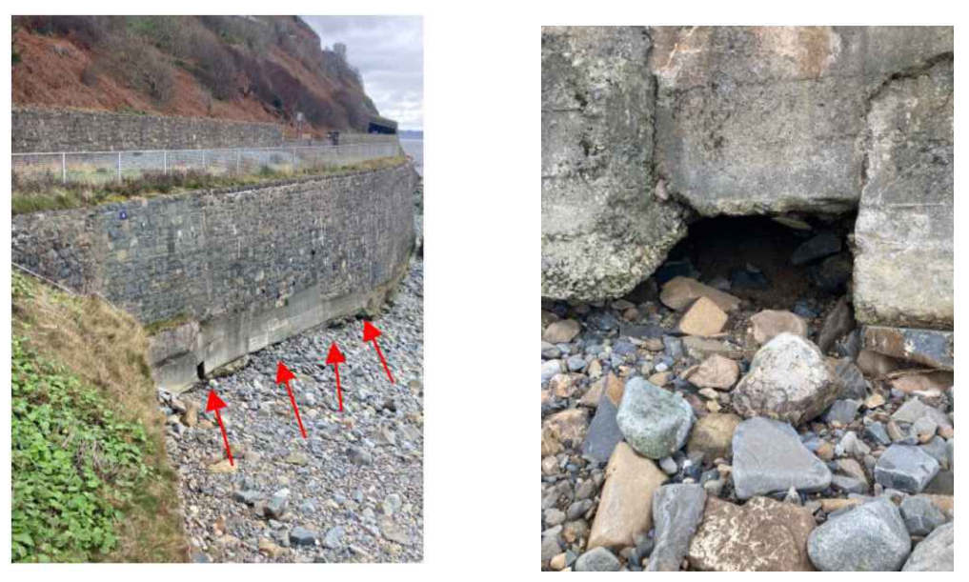  Proposed licence area:  53.267500 , -3.9432769  53.267455 , -3.9432749  53.267410 , -3.9427480  53.267446 , -3.9427496
Application documents | CML2491 - 1067A_WAL_MPH - marine-works-licence-application-form  CML2491 - 1067A - Application Continuation Sheet  CML2491 - 1067A - Location Plan  CML2491 - 1067A - Site Plan  CML2491 - 24088W-002-P01 - Technical Drawing  CML2491 - 24088W-003-P01 - Technical Drawing  CML2491 - 16064-WFD-01  CML2491 - 1067A_WAL_MPH - WNMP Signposting Document_Completed  CML2491 - Coastal Asset Condition Survey Report_compressed  CML2491 - 1067A_WAL_MPH - OS Map  CML2491 - 24088W-RAR-001 P01 - Designers Risk Assessment  CML2491 - 24088W-FOA-001 A01_AIP  CML2491 - 24088W-001-P01 General Notes
Environmental Statement | N/A
Pre-application correspondence | N/A
NRW team responsible for drafting this HRA report, and name of lead officer | Stephen Treby - Marine Licensing Team
2. Determining the need for a Habitats Regulations Assessment

2.1 Is the whole of the project directly connected with or necessary to the management of one or more Natura 2000 sites, for the purposes of conserving the habitats or species for which the Natura 2000 site(s) is/are designated? | NO
2.2 Is there a possibility that the project could affect a different Natura 2000 site to the one(s) the project is intended to conserve? | YES
2.3 Is it necessary to carry out an HRA? | YES

3. Considering the likelihood of a significant effect (LSE)

3.1 Renewal of a permission on the same or more restrictive terms as the extant permission

Is this project a renewal of a current permission which complies with NRW approved criteria for ruling out significant effects of renewals (see section 6.2A of OGN 200) without conducting a project-specific LSE test? | NO

3.2 Likelihood of significant effects (LSE) test

3.2.1 Which Natura 2000 sites might be affected by the proposal? | Based on the project specification or information provided in the application, it is considered that the following Natura 2000 sites have features which could be affected by the project:  Menai Strait and Conwy Bay SAC  Liverpool Bay SPA
3.2.2 Screening assessment

There is no impact pathway from the proposal to the designated feature
There is an impact pathway in principle, but significant effects from the proposal when considered alone can be ruled out
There is an impact pathway and significant effects cannot be ruled out
 | Assessment of likelihood of significant effect
 | I  Relevant conservation objectives | II  Potential impact pathway
Menai Strait and Conwy Bay SAC

Mudflats and sandflats not covered by seawater at low tide | RANGE  The overall distribution and extent of the habitat features within the site, and each of their main  component parts is stable or increasing.  For the intertidal mudflats and sandflats feature these include;  • Muddy gravel communities  • Dwarf eelgrass, Zostera noltei beds  • Sediment communities at Traeth Lafan  For the reef feature these include;  • Reef communities in high energy wave-sheltered, tide-swept conditions  • Under-boulder, overhang and crevice communities  • Limestone reef communities  • Clay outcrop reef communities  For the large shallow bay feature these include;  • Organically enriched muddy sediment areas  STRUCTURE AND FUNCTION  The physical biological and chemical structure and functions necessary for the long-term maintenance  and quality of the habitat are not degraded. Important elements include;  - geology,  - sedimentology,  - geomorphology,  - hydrography and meteorology,  - water and sediment chemistry,  - biological interactions.  This includes a need for nutrient levels in the water column and sediments to be:  • at or below existing statutory guideline concentrations  • within ranges that are not potentially detrimental to the long term maintenance of the features  species populations, their abundance and range.  Contaminant levels in the water column and sediments derived from human activity to be:  • at or below existing statutory guideline concentrations  • below levels that would potentially result in increase in contaminant concentrations within  sediments or biota  • below levels potentially detrimental to the long-term maintenance of the features species  populations, their abundance or range.  Restoration and recovery  This includes the need for restoration of some reef features such as underboulder, overhang and  crevice communities, and of some mudflat and sandflat features such as the muddy gravel habitats  and sheltered muddy habitats. All of these habitats are also part of the large inlets and bays feature.  TYPICAL SPECIES  The presence, abundance, condition and diversity of typical species is such that habitat quality is not  degraded. Important elements include:  - species richness:  - population structure and dynamics,  - physiological heath,  - reproductive capacity  - recruitment,  - mobility  - range  As part of this objective it should be noted that:  • populations of typical species subject to existing commercial fisheries need to be at an  abundance equal to or greater than that required to achieve maximum sustainable yield and  secure in the long term  • the management and control of activities or operations likely to adversely affect the habitat  feature, is appropriate for maintaining it in favourable condition and is secure in the long  term.  A glossary of terms is included at Appendix 1. | The works area is outside of the SAC. There is no direct overlap with this feature and any impacts are unlikely to extend beyond the immediate location of the works.  Standard licence conditions include pollution prevention measures.  No impacts are therefore predicted to this feature.
Reefs |  | The works area is outside of the SAC. There is no direct overlap with this feature and any impacts are unlikely to extend beyond the immediate location of the works.  Standard licence conditions include pollution prevention measures.  No impacts are therefore predicted to this feature.
Sandbanks which are slightly covered by seawater all the time |  | The works area is outside of the SAC. There is no direct overlap with this feature and any impacts are unlikely to extend beyond the immediate location of the works.  Standard licence conditions include pollution prevention measures.  No impacts are therefore predicted to this feature.
Large shallow inlets and bays |  | The works area is outside of the SAC. There is no direct overlap with this feature and any impacts are unlikely to extend beyond the immediate location of the works.  Standard licence conditions include pollution prevention measures.  No impacts are therefore predicted to this feature.
Submerged or partially submerged sea caves |  | The works area is outside of the SAC. There is no direct overlap with this feature and any impacts are unlikely to extend beyond the immediate location of the works.  Standard licence conditions include pollution prevention measures.  No impacts are therefore predicted to this feature.

 | Assessment of likelihood of significant effect
 | I  Relevant conservation objectives | II  Potential impact pathway | III  Avoidance measure  In light of the ruling of the CJEU in case C-323/17 ‘People over Wind’, avoidance measures should not be considered at this stage of HRA, so this column is left blank.
Liverpool Bay SPA
Red-Throated Diver | The conservation objective for Liverpool Bay / Bae Lerpwl SPA Interest feature: Internationally important non-breeding population of red-throated diver (Gavia stellata)  Subject to natural change, maintain or restore the red-throated diver population and its supporting habitats in favourable condition.  The interest feature red-throated diver will be considered to be in favourable condition only when each of the following three conditions are met:  (i) The red-throated diver population shows only non-significant fluctuation around the  mean population at the time of classification of the SPA, with due consideration to the  potential for natural change.  (ii) Red-throated diver distribution and ability to use the site does not significantly change  (subject to natural fluctuations and variation).  (iii) The extent and distribution of the supporting habitat available to the red throated diver  population within the site, including its structure, function and supporting processes, is  maintained. | The works area is outside of the SPA. There is no direct overlap with this feature and any impacts are unlikely to extend beyond the immediate location of the works.  Standard licence conditions include pollution prevention measures.  No impacts are therefore predicted to this feature.
Common Scoter | The conservation objective for Liverpool Bay / Bae Lerpwl SPA Interest feature: Internationally important non-breeding population of common scoter (Melanitta nigra).  Subject to natural change, maintain or restore the common scoter population and its supporting habitats in favourable condition.  The interest feature common scoter will be considered to be in favourable condition only when each of the following three conditions is met:  (i) The common scoter population shows only non-significant fluctuation around the mean population at the time of classification of the SPA, with due consideration to the potential for natural change.  (ii) Common scoter distribution and ability to use the site does not significantly change (subject to natural fluctuations and variation)  (iii) The extent and distribution of the supporting habitat available to the common scoter population within the site, including its structure, function and supporting processes, is maintained | The works area is outside of the SPA. There is no direct overlap with this feature and any impacts are unlikely to extend beyond the immediate location of the works.  Standard licence conditions include pollution prevention measures.  No impacts are therefore predicted to this feature.
Little Gull (Hydrocoloeus minutus) (over winter) | The conservation objective for Liverpool Bay / Bae Lerpwl SPA Interest feature: Internationally important non-breeding population of Little Gull (Hydrocoloeus minutus).  Subject to natural change, maintain or restore the little gull population and its supporting habitats in favourable condition.  The interest feature little gull will be considered to be in favourable condition only when each of the following three conditions is met:  (i) The little gull population shows only non-significant fluctuation around the mean population at the time of classification of the SPA, with due consideration to the potential for natural change.  (ii). Little gull distribution and ability to use the site does not significantly change (subject to natural fluctuations and variation).  (iii) The extent and distribution of the supporting habitat available to the little gull population within the site, including its structure, function and supporting processes, is maintained. | The works area is outside of the SPA. There is no direct overlap with this feature and any impacts are unlikely to extend beyond the immediate location of the works.  Standard licence conditions include pollution prevention measures.  No impacts are therefore predicted to this feature.
Little Tern (Sternula albifrons) (breeding) | The conservation objective for Liverpool Bay / Bae Lerpwl SPA Interest feature: Internationally important non-breeding population of little tern (Sternula albifrons).  Subject to natural change, maintain or restore the little tern population and its supporting habitats in favourable condition.  The interest feature little tern will be considered to be in favourable condition only when each of the following three conditions is met:  (i) The little tern population shows only non-significant fluctuation around the mean population at the time of classification of the SPA, with due consideration to the potential for natural change.  (ii) Little tern distribution and ability to use the site does not significantly change (subject to natural fluctuations and variation)  (iii) The extent and distribution of the supporting habitat available to the little tern population within the site, including its structure, function and supporting processes, is maintained | The works area is outside of the SPA. There is no direct overlap with this feature and any impacts are unlikely to extend beyond the immediate location of the works.  Standard licence conditions include pollution prevention measures.  No impacts are therefore predicted to this feature.
Common Tern (Sterna hirundo) (breeding) | The conservation objective for Liverpool Bay / Bae Lerpwl SPA Interest feature: Internationally important non-breeding population of Common Tern (Sterna hirundo).  Subject to natural change, maintain or restore the common tern population and its supporting habitats in favourable condition.  The interest feature common tern will be considered to be in favourable condition only when each of the following three conditions is met:  (i) The common tern population shows only non-significantfluctuation around the mean population at the time of classification of the SPA, with due consideration to the potential for natural change.  (ii) Common tern distribution and ability to use the site does not significantly change (subject to natural fluctuations and variation).  (iii) The extent and distribution of the supporting habitat available to the common tern population within the site, including its structure, function and supporting processes, is maintained. | The works area is outside of the SPA. There is no direct overlap with this feature and any impacts are unlikely to extend beyond the immediate location of the works.  Standard licence conditions include pollution prevention measures.  No impacts are therefore predicted to this feature.
Assemblage of over 20,000 waterbirds | The conservation objective for Liverpool Bay / Bae Lerpwl SPA Interest feature: Non-breeding assemblage of over 20,000 waterbirds  Subject to natural change, maintain or restore the waterbird assemblage and its supporting habitats in favourable condition  The interest feature waterbird assemblage will be considered to be in favourable condition only when each of the following three conditions is met:  (i) The waterbird assemblage population shows only non-significant fluctuation around the mean population at the time of classification of the SPA, with due consideration to the potential for natural change  (ii) The waterbird assemblage population and ability to use the site does not significantly change (subject to natural fluctuations and variation)  (iii) The extent and distribution of the supporting habitat available to the waterbird assemblage population within the site, including its structure, function and supporting processes, is maintained.  Explanatory information for the waterbird objectives  In the period  2004/05 – 2010/11 a five year peak mean of 69,687 individual waterbirds was estimated (Lawson and others, 2016). The most recent four-year peak mean population estimate for  the waterbird assemblage in Liverpool Bay / Bae Lerpwl SPA is 157,952 individuals based  on recent digital aerial surveys (HiDef, in prep.). | The works area is outside of the SPA. There is no direct overlap with this feature and any impacts are unlikely to extend beyond the immediate location of the works.  Standard licence conditions include pollution prevention measures.  No impacts are therefore predicted to this feature.

Traeth Lafan SPA

Oystercatcher (Haematopus ostralegus) | The vision for this feature is for it to be in a favourable conservation status, where all of the  following conditions are satisfied:  1. The 5 year mean peak of the number of wintering oystercatchers is at least 4,000.  2. The abundance and distribution of cockles of 15mm or larger and other suitable food are  maintained at levels sufficient to support the population with a 5 year mean peak of 4,000  individuals.  3. Oystercatchers are not disturbed in ways that prevent them spending enough time feeding for  survival.  4. Roost sites, including high tide roost sites, remain suitable for oystercatchers to roost  undisturbed.  5. The management and control of activities or operations likely to adversely affect the  oystercatchers, is appropriate for maintaining the feature in favourable condition and is secure  in the long term. | The works area is outside of the SPA. There is no direct overlap with this feature and any impacts are unlikely to extend beyond the immediate location of the works.  Standard licence conditions include pollution prevention measures.  No impacts are therefore predicted to this feature.

3.2.3 Screening decision of the project ‘alone’

(a) If ALL rows in column II of Table 3.2.2 are GREEN | The project is not likely to have a significant effect on any Natura 2000 site, because there is no impact pathway from the project to any Natura 2000 features, and no further consideration under the Habitats Directive/Regulations is required in order to determine the application.
(b) If there are NO rows coloured RED in column II of Table 3.2.2, and there are ANY rows which are BLUE | The project is not likely to have a significant effect on any Natura 2000 sites when considered alone, but the possibility of significant effects in combination with other plans and projects needs to be considered.
(c) If ANY rows in Column II of Table 3.2.2 are RED | The project is likely to have a significant effect on one or more Natura 2000 sites and therefore an appropriate assessment is required.

6. Conclusion

HRA is not required because the whole of the project is directly connected with or necessary to the management of one or more Natura 2000/Ramsar sites, for the purposes of conserving the habitats or species for which the site(s) is/are designated, and the project is not likely to have a significant effect on any other Natura 2000/Ramsar sites.
(As documented in section 2.1 and 2.2 of this form)

HRA is not required because there is no conceivable impact pathway to any Natura 2000/Ramsar site
(As documented in section 2.3 of this form)

This project is a renewal of a current permission which complies with NRW agreed criteria for ruling out significant effects of a renewal without conducting a project-specific LSE test. Therefore it is considered not likely to have a significant effect on any Natura 2000/Ramsar sites, either alone or in-combination with other plans and projects.
(As documented in section 3.1 of this form)

The project has been screened for likelihood of significant effects and, taking account of the advice received from protected sites advisors, is considered not likely to have a significant effect on any Natura 2000/Ramsar site  (As documented in section 3.2 of this form, or section 5 if applicable) | X
In light of the conclusions of an appropriate assessment, and taking account of the advice received from protected sites advisors, it has been established that the project will not adversely affect the integrity of any Natura 2000/Ramsar site, taking into account any conditions or restrictions as applicable, either alone or in-combination with other plans and projects.
(As documented in section 4 of this form, and section 5 if applicable)

In light of the conclusions of the appropriate assessment, it has not been ascertained that the project will not adversely affect the integrity of any Natura 2000/Ramsar site, as documented in section 4 of this form, and section 5 is applicable.

Approval for the project cannot be given unless either:
- the project specification, and/or the terms under which it might be approved, are modified so as to remove the risk of adverse effects, and a revised HRA report is prepared, or
- the project satisfies the requirements of Article 6(4) of the Habitats Directive, an Article 6(4) Statement of Case is prepared (OGN 200 Form 3) and submitted for consideration by the appropriate authority, normally Welsh Ministers

Signed: S. Treby

Name: Stephen Treby

Position: Marine Licensing Officer

Date: 23 January 2025

7. Consultation with protected sites advisor(s) and how sections 2, 3, 4 and 5 of this HRA report (as applicable) take into account that advice.

Relevant section of the HRA report | Date(s) of correspondence* and any meeting(s) with protected sites advisor(s) | Description of how the comments from protected sites advisors have been taken into account
2 & 3 | 04 March 2025 | NRW (A) were consulted and agreed with the conclusion of no LSE. For completeness they advised including Traeth Lafan SPA in to the assessment. Accordingly, Traeth Lafan SPA was added to the assessment.

8. Conservation Technical Specialist’s comments



