Annex (iv) – SSSI Assessment Form
SSSI Assessment for permit/licence and deployment applications | 
To be completed by Permitting Officers for any applications for a permission which Natural Resources Wales has considered under S28I duty to notify SNCB and take their advice into account. This applies to all proposed permissions within a SSSI, and to operations outside the SSSI boundary which are likely to damage its special features.
NRW as a Section 28G authority has, when exercising its functions, a general duty to take reasonable steps, consistent with the proper exercise of its functions, to further the conservation and enhancement of the flora, fauna or geological or physiological features by reason of which the site is of special interest’

Part 1 – SSSI Assessment
Part 2 – Formal notification to SNCB (to be completed if part 1 assessment concludes likely damage, not likely to damage because of conditions or you cannot conclude no likely damage)
Part 3 – Decision
Pink text – drafting notes, to be deleted before completion/consultation.
Blue text – examples, to be replaced with permission-specific information and text turned to black.

Part 1 – SSSI Assessment

- Permitting officer/team | Megan Tucker, Waste permitting team
- Permit application reference and site name | PAN-027503
- a. SSSI name(s)  b. location  c. NRW Operational Area/Environment Team | a. Caeau Blaenau-mawr  b. SN 59589 12239  c. Carmarthenshire
- Brief description of proposal | A bespoke land spreading application for 3 waste stream, waste code, 19 13 06 at Twynwaun Farm. Wastes are to be spread on a mixture of fields planted for Grass. The application rates range from 33 and 81 tonnes per ha, with a total tonnage to spread 1840 tonnes.  The waste will be spread over 26.74 hectares of land within the listed fields. The sludge cakes will be stored in two stockpiles prior to spreading by a conventional rear discharge spreader.  The fields will be spread in March -August. No more than 50t/ha of liquid sludge will be spread on a field in any 3-week period in accordance with CoGAP, and no more than 250t/ha will be spread within any 12-month period. Wastes will be applied when ground and weather conditions are suitable, following CoGAP to avoid soil damage including wheel ruts, compaction, structural damage, erosion and run-off.  The SSSI sits 425m from the border of field 23.  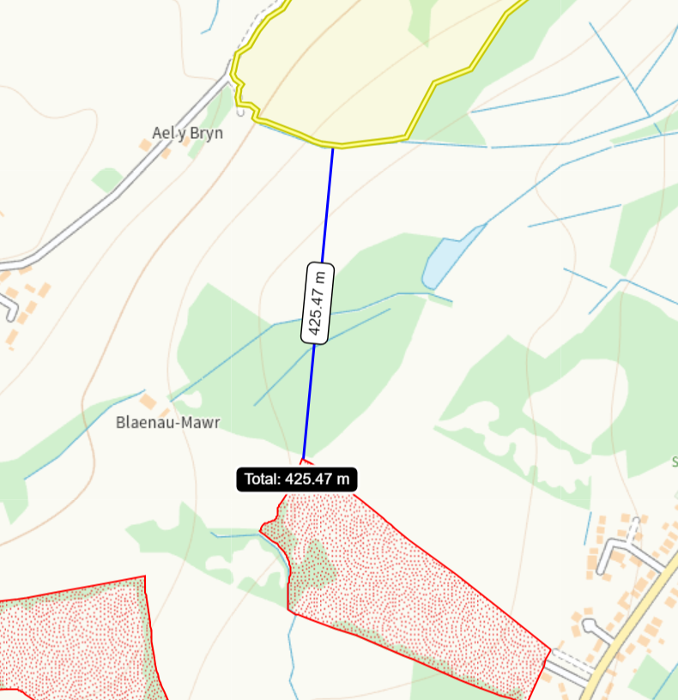
- What aspects of the proposed permission are likely to damage the SSSI features of special interest?

The following activities are likely to cause damage:

- Application of manure, slurry, silage liquor, fertilisers and lime.
- Cultivation, including ploughing, rotovating, harrowing and re-seeding.
- Dumping, spreading, discharging or storage of any materials
- Storage of materials.
- Use of vehicles

The following SSSI(s) features and potential impacts have been considered to assess the likelihood of damage:

- Marshy Grassland

Due to the distance between the spreading area and the SSSI boundary there is no potential impact pathway for the proposed actions to have an impact on the SSSI or their features.

- Summary of any informal advice received from internal experts (if required and including pre-app advice) | N/A
- Recommendation | The proposed permission is not likely to damage any of the flora, fauna or geological or physiological features which are of special interest
- Signature and date assessment made | M tucker
- Officers name and job title | Megan Tucker  Waste permitting officer


Permitting
Formal Notification under Section 28I of the Wildlife and Countryside Act 1981

Part 2 Formal notification under S28I – To be completed for all permit applications assessed as: not likely to damage because of conditions, likely to damage SSSI and those where we are unable to conclude no likely damage.

- Date Notice of intention to permit activity likely to damage SSSI sent to NRW (SCNB)  If you assess activity as being likely to damage even if you think this can be mitigated by conditioning you need to formally notify SNCB send them a copy of this notice with part 1 of this form. Environment teams have 28 days to respond.  Environment teams please complete question 11 and 12 using the information in questions 1-9 | Insert date  We have assessed that [permit ref/name of site] is likely to damage [insert name of SSSI] and request your formal advice. We have assessed that this damage could be mitigated by including conditions[remove if not applicable].  Or  We are unable to conclude that [permit ref/name of site] is not likely to damage [insert name of SSSI] and request your formal advice.  Information on the permit application can be found in Part 1 of this form and [include link to DMS documents if required]
- Advice received from NRW (SNCB)

Environment Teams and Marine Area Management and Advice Teams are expected to log and issue formal statutory advice through our CAMS system. The advice letter generated can simply by attached/appended here. ET/MAAMT can just refer to that here or write a summary of advice here too.

To be completed by environment officers.
Within 28 days of receiving notice from a permitting/licensing regime, you should advise whether the operation:
• Should be allowed to proceed.
• Should be allowed to proceed with certain conditions.
• Should not proceed.

Please ensure all advice provided is evidenced and comprehensive. Advice provided may be scrutinised as part of a formal appeal.

- Name and job title of conservation/marine officer (sign and date)
Part 3 – To record NRW decision following SNCB Advice
- DECISION  Provide reasoning for your decision and how you have considered advice from NRW(SNCB) in the box opposite and delete text in blue that is not relevant. This might be the same as the info and decision in part 1 of the form  Large amounts of supporting information can be appended to this form. | The proposed permission is not likely to damage any of the flora, fauna or geological or physiological features which are of special interest  The permission is not likely to damage any of the flora, fauna or geological or physiological features which are of special interest because of conditions  The permission is likely to damage
- Natural Resources Wales (Section 28G Authority) (permitting service) is minded to  Delete as appropriate  If this decision is not in line with advice received from NRW(SNCB) please outline your reasoning (please note that you should try to resolve any differences in opinion) | Issue the permission  Issue the permission with conditions to ensure no damage to SSSI  Refuse the permission due to likely damage to SSSI
- Is decision in line with advice from SNCB  If your decision is not in line with the recommendations from SNCB you must formally notify them using the appropriate online form or letter.  Record the date the notice/letter was sent opposite and save a link. The permitted operation cannot commence for 21 days following service of this notice. | Yes/No  If No record date notice was sent to SNCB
- Signature and date assessment completed
- Officers name and job title

