CRoW Appendix 4 (140_10_SD02)  CRoW Act 2000: Natural Resources Wales application for permission - Formal Notice |  | 
Natural Resources Wales Formal Notice.
Requirements of Section 28I of the Wildlife & Countryside Act 1981 as amended by the Countryside and Rights of Way Act (CRoW) 2000.
Duty in relation to granting any consent, licence or permit for activities likely to damage Sites of Special Scientific Interest (SSSI).
Guide to filling in this form for Natural Resources Wales staff:
To be completed by Permitting Officers for any applications for a permission which the Natural Resources Wales has considered under S28G duties to protect and enhance SSSIs. This applies to all proposed permissions within a SSSI, and to operations outside the SSSI boundary which are likely to damage its special features.
Refer to OI 140_10 ‘Applying the Countryside and Rights of Way (CRoW) Act 2000 to applications for permits with potential for impact on Sites of Special Scientific Interest (SSSI)’, including the flowchart in Appendix 2.
Pink italic text – drafting notes, to be deleted before completion/consultation.
Blue text – examples, to be replaced with permission-specific information.
Ensure you have completed all sections.
- Natural Resources Wales area/region/NPS hub: | Monmouthshire – Environment team
- Name of SSSI: | - Brockwells Meadows (approximately 3.2 km away from the installation)  - Coombe Valley Woods (approximately 0.15 km away from the installation)  - Dinham Meadows (approximately 0.62 km away from the installation)  - Llwyn y Celyn Wetland (approximately 2.4 km away from the installation)  - Mwyngloddfa Mynydd-Bach (approximately 2.6 km away from the installation)  - Nedern Brook Wetlands, Caldicot (approximately 3.26 km away from the installation)  - Penhow Woodlands (approximately 4.35 km away from the installation)  - Plantation Farm and the Gethley (approximately 4.16 km away from the installation)  - Rectory Meadow – Rogiet (approximately 4.65 km away from the installation)  - Wye Valley Lesser Horseshoe Bat Site (approximately 3.85 km away from the installation)
- Type of permission: | Environmental Permit Application – Substantial Variation
- Date for Natural Resources Wales permit determination: | 10/09/2021
- Predicted 28 day date for response from NRW conservation/ecology (under S28 I(4)): | 28 days:
- Natural Resources Wales reference no: | EPR-AP3232AD-V003
- National grid reference: | NGR: ST 46410 93180  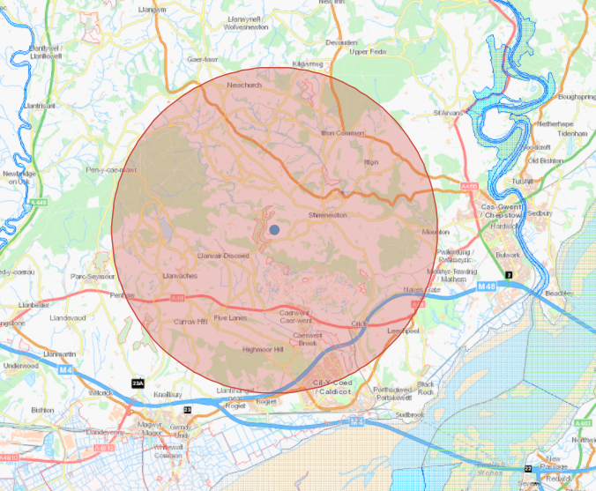
- Description of proposal: | The proposal is for the construction of an additional two poultry houses with the expansion of the installation boundary to increase the number of birds by 80,000. A total of 300,000 birds are to be housed on site at Coombe Farm Poultry Unit.  Biomass heating has not installed at the installation and the operator is using air heat source pumps with underfloor heating and LPG back up heating systems.  The operator is proposing to fit heat exchangers to both existing poultry houses and the two new houses to mitigate the increased emissions from the additional bird numbers.  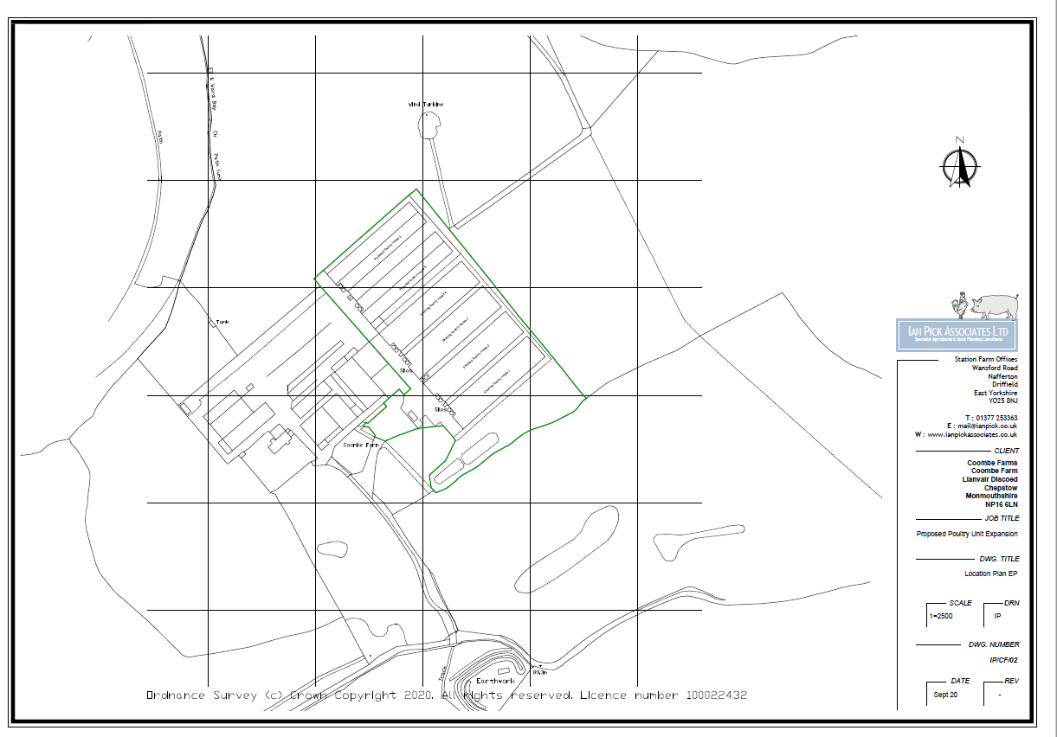
- Is the proposed activity within (wholly or partially) the SSSI boundary? | NO
- Has there been any pre-application discussion or correspondence with NRW conservation/ecology | NO
- What aspect(s) of the proposed permission may damage the features which are of special interest for the SSSI?
The following ‘Operations Requiring Consent’ (or other activities associated with the permission) that may cause damage) are relevant to the proposed permission.
- Emissions from the housing of poultry.

The following SSSI features and mechanisms of impact have been considered to assess the likelihood of damage:
- Potential for increased Ammonia concentration and potential increased Nitrogen deposition.

This form has been completed using the following documents for reference:
- Site of Special Scientific Interest: Management Statement Monmouthshire Brockwell Meadows
- Coombe Valley Woods Site of Special Scientific Interest
- Dinham Meadows Site of Special Scientific Interest
- Llwyn y Celyn Wetland Site of Special Scientific Interest
- Site of Special Scientific Interest: Management Statement Monmouthshire Mwyngloddfa Mynydd-Bach
- Neddern Brook Wetlands, Caldicot Site of Special Scientific Interest
- Penhow Woodlands Site of Special Scientific Interest
- Site of Special Scientific Interest: Management Statement Monmouthshire Plantation Farm and the Gethley
- Rectory Meadow – Rogiet Site of Special Scientific Interest
- Wye Valley Lesser Horseshoe Bats Site of Special Scientific Interest

SSSI Features
- SSSI Brockwell Meadows
- Unimproved and semi improved calcareous grassland
- Hornet Robber Fly
- Bracken/scrub and hedgerows

- SSSI Coombe Valley Woods
- Semi-natural broadleaved woodland
- The dormouse

- SSSI Dinham Meadows
- Unimproved neutral grassland, associated with unimproved limestone grassland
- Grizzled skipper butterfly

- SSSI Llwyn y Celyn Wetland
- Marshy grassland

- SSSI Mwyngloddfa Mynydd-Bach
- Lesser horseshoe bat winter hibernation roost

- SSSI Neddern Brook Wetlands, Caldicot
- Important wet grassland, which supports wintering bird species

- SSSI Penhow Woodlands
- Semi-natural broadleaved woodland

- SSSI Plantation Farm and the Gethley
- Unimproved neutral grassland and associated vegetation

- SSSI Rectory Meadow – Rogiet
- Calcareous grassland supporting the regionally rare plant species; Meadow Clary

- SSSI Wye Valley Lesser Horseshoe Bats
- 4 Lesser horseshoe bat summer roosts

- Decision

The applicant has submitted computer modelling to assess the impact of ammonia emissions from the existing and proposed free range egg-laying chicken houses at Coombe Farm, Monmouthshire. The proposed houses have been assessed and quantified based upon the Environmental Agency’s standards for ammonia emission factors. Ammonia emission from ranging areas have been assessed and quantified based upon a range of sources. The ammonia emission rates have then been used as inputs to an atmospheric dispersion and deposition model which calculates ammonia exposure levels and nitrogen and acid deposition rates in the surrounding area.

Comparison against critical loads:
The applicant has presented a detailed assessment of ammonia concentration and nitrogen deposition as part of the application. The process contribution from the installation has been calculated and compared against the minimum and maximum critical loads for each habitat type found within the SSSI. The results for the SSSI are as follows:

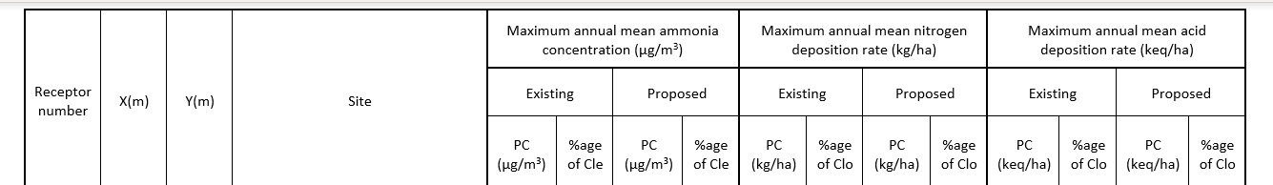
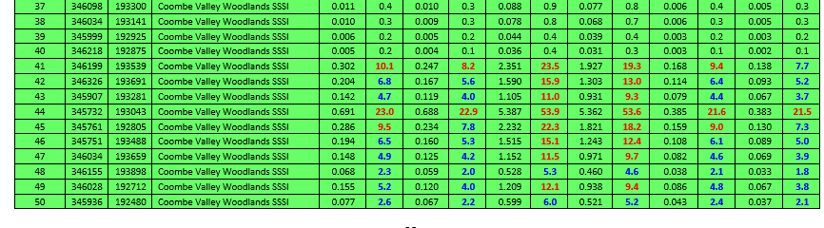
SSSI Coombe Valley Woodlands

Ammonia concentration:
- The maximum annual ammonia process concentration (PC) in the proposed modelling is 0.688 µg/m3 representing 22% of the critical level therefore does not screen out.

Nitrogen concentration:
- The maximum annual nitrogen process contribution (PC) under the proposed modelling is 5.362 Kg/ha representing 53.6% of the critical load therefore does not screen out.

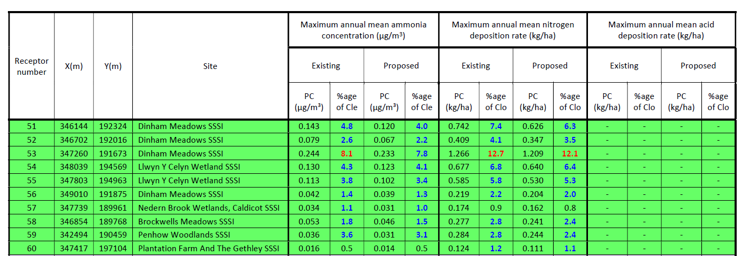

SSSI Dinham Meadows

Ammonia concentration:
- The maximum annual ammonia process concentration (PC) in the proposed modelling is 0.233 µg/m3 representing 7.8% of the critical level therefore does not screen out.

Nitrogen concentration:
- The maximum annual nitrogen process contribution (PC) under the proposed modelling is 1.209 Kg/ha representing 12.1% of the critical load therefore does not screen out.

SSSI Llwyn Y Celyn Wetland

Ammonia concentration:
- The maximum annual ammonia process concentration (PC) in the proposed modelling is 0.123 µg/m3 representing 4.1% of the critical level therefore does not screen out.

Nitrogen concentration:
- The maximum annual nitrogen process contribution (PC) under the proposed modelling is 0.640 Kg/ha representing 6.4% of the critical load therefore does screen out.

SSSI Nedern Brook Wetlands, Caldicot

Ammonia concentration:
- The maximum annual ammonia process concentration (PC) in the proposed modelling is 0.031 µg/m3 representing 1% of the critical level therefore does screen out.

Nitrogen concentration:
- The maximum annual nitrogen process contribution (PC) under the proposed modelling is 0.162 Kg/ha representing 0.8% of the critical load therefore does screen out.

SSSI Brookwells Meadows

Ammonia concentration:
- The maximum annual ammonia process concentration (PC) in the proposed modelling is 0.046 µg/m3 representing 1.5% of the critical level therefore does not screen out.

Nitrogen concentration:
- The maximum annual nitrogen process contribution (PC) under the proposed modelling is 0.241 Kg/ha representing 2.4% of the critical load therefore does not screen out.

SSSI Penhow Woodlands

Ammonia concentration:
- The maximum annual ammonia process concentration (PC) in the proposed modelling is 0.031 µg/m3 representing 3.1% of the critical level therefore does not screen out.

Nitrogen concentration:
- The maximum annual nitrogen process contribution (PC) under the proposed modelling is 0.244 Kg/ha representing 2.4% of the critical load therefore does not screen out.

SSSI Plantation Farm and the Gethley

Ammonia concentration:
- The maximum annual ammonia process concentration (PC) in the proposed modelling is 0.014 µg/m3 representing 0.5% of the critical level therefore does screen out.

Nitrogen concentration:
- The maximum annual nitrogen process contribution (PC) under the proposed modelling is 0.111 Kg/ha representing 1.1% of the critical load therefore does not screen out.

Conclusion
- The applicant has modelled the proposal based on the assumption of heat exchangers have been installed to the existing and new proposed houses which would lead to a reduction in ammonia emissions of at least 35% compared to without heat exchangers. Under this scenario all emissions are reduced at all modelled discrete receptors and therefore results in an improvement to nitrogen deposition.

Natural Resources Wales is minded to:
Issue the permission

- Name and job title of Natural Resources Wales officer: | Lewis Downey - Permitting Officer, Installations & RSR
- Date form sent to NRW conservation/ecology | 21/07/2021
For Natural Resources Wales use only, once NRW conservation/ecology response received
- NRW conservation/ecology comment on assessment: | We agree with the findings of this report that the levels will actually be lower given the installation of new infastructure.
- Name and job title of NRW conservation/ecology officer: | Liz Lawrie-Meddins  Senior Officer (Conservation)
- Date of receipt of NRW conservation/ecology response: | 26/7/2021

