PAN-026792 MyMap Report
Application map
Condition 2.4 of Standard rules SR2009No6 - inert and excavation waste transfer station with treatment

2.4.1 The activities shall not extend beyond the site, being the land shown edged in green on the site plan attached to the permit.
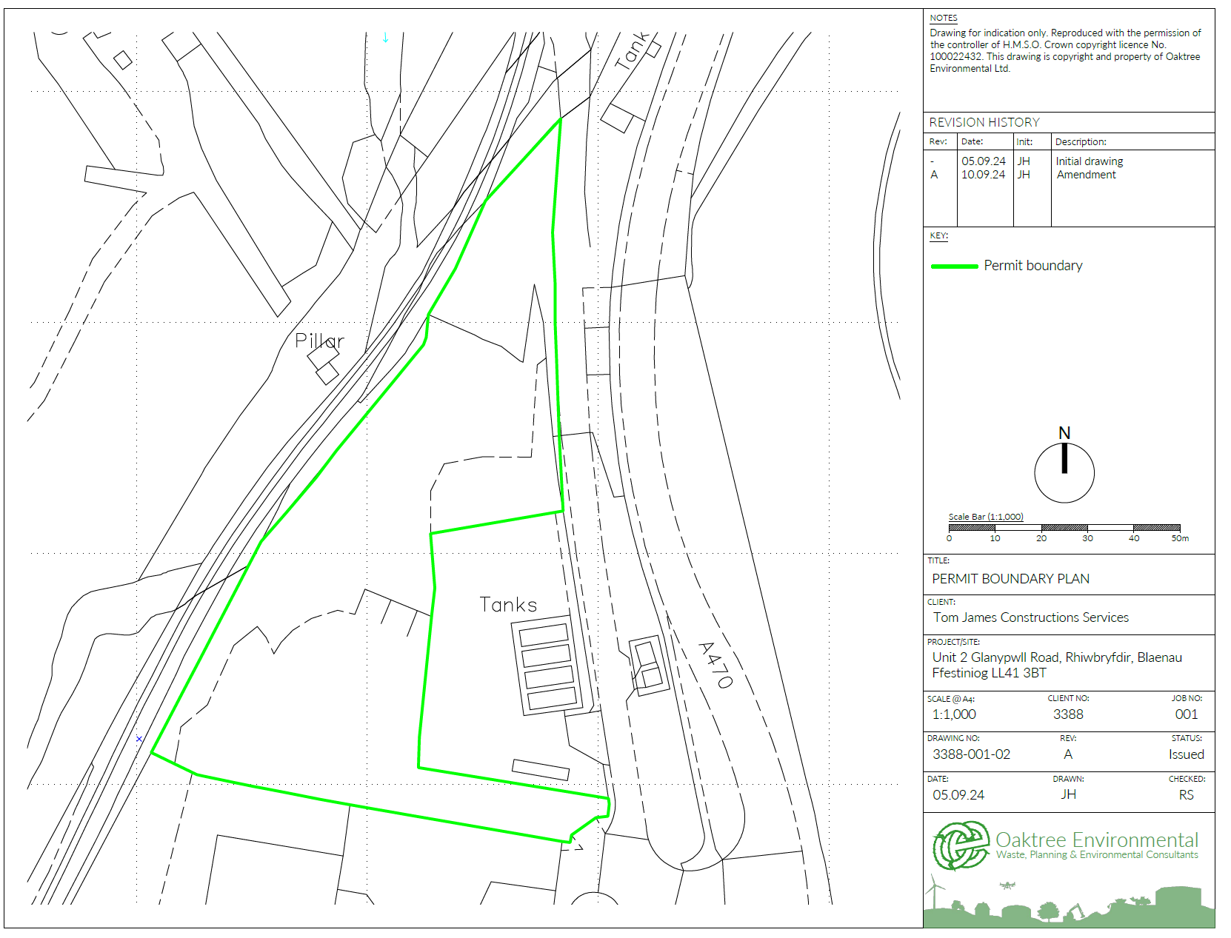
2.4.2 The activities shall not be carried out within:
(a) 500 metres of a European Site or a SSSI;

None
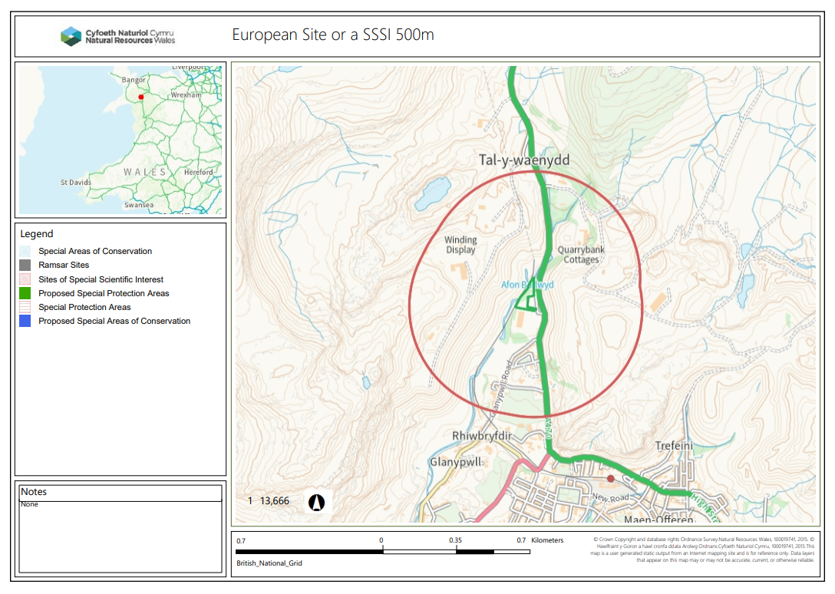
(b) 50m of any well spring or borehole used for the supply of water for human consumption. This must include private water supplies

None
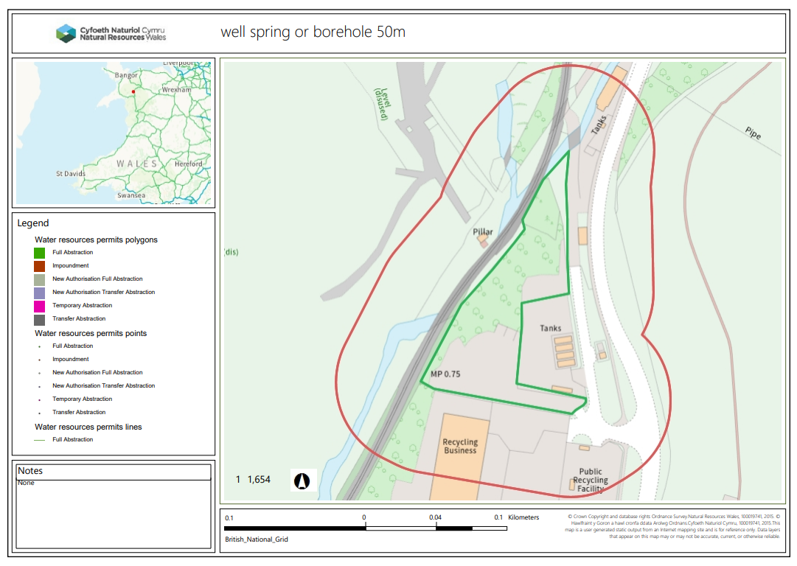

(c) 250 metres of the presence of Great Crested Newts, where it is linked to the breeding ponds of the newts by good habitat.

None
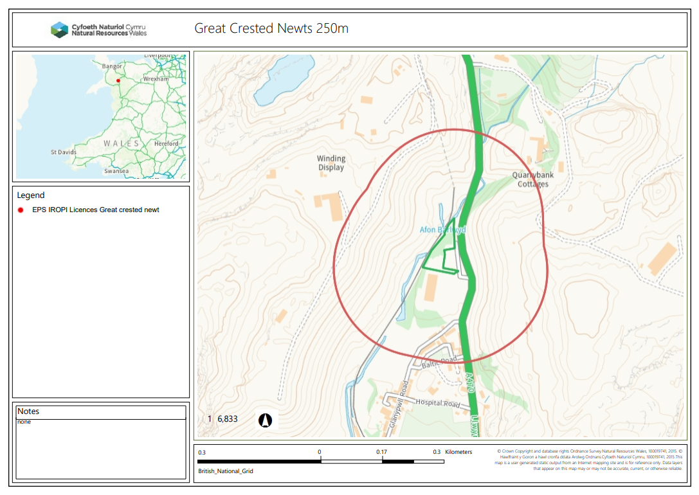

(d) a specified AQMA.
None
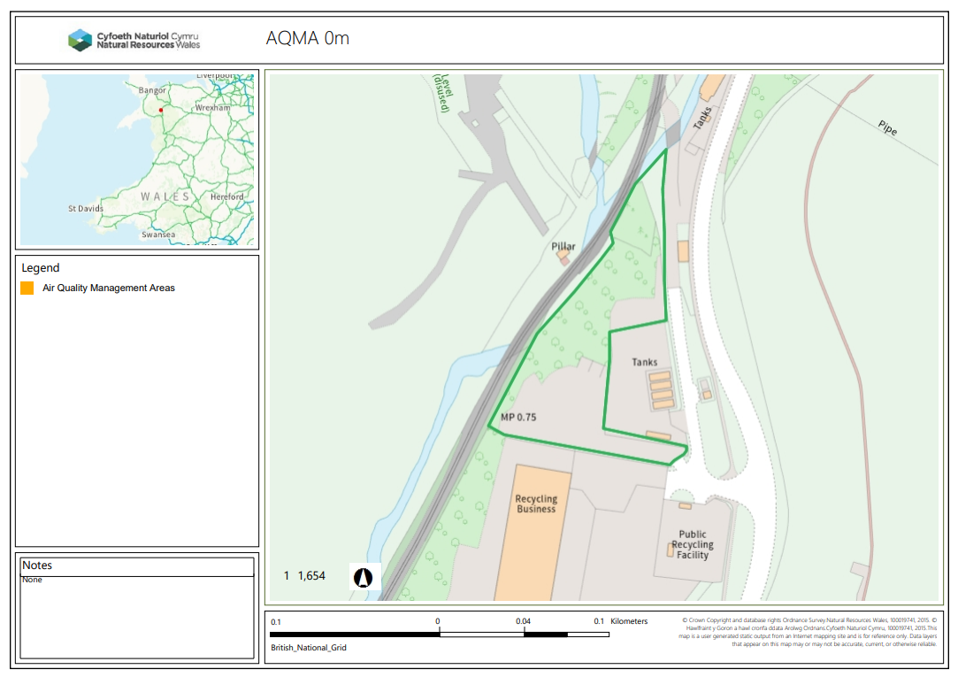
END

