Grab sampling Band 1 Licence Application Method Statement
Title: NRW Environmental Grab Sampling at Milford Haven Inner and Outer, Fishguard Bay and Caernarfon Bay
Prepared by: Matthew Green Senior Specialist, Marine Environmental Assessment Officer; Marine Monitoring Team (Natural Resources Wales) 0300 0354105 | 07768142891 | matthew.green@cyfoethnaturiolcymru.gov.uk
Activity Summary: 0.1m2 Environmental Grab Sampling from a vessel

Contents
Application 3
Method Statement 3
Overview: 3
Sampling Platform Vessel: 3
Contractor Details: 3
Route and access 4
Sampling procedure 4
Monitoring Drivers 4
Impact 4
Duration and timing 4
Retained/deposited material 4
Consultation 4
Target Grab Sampling Locations 4
Contracted Vessel 9
Sensitive Habitat 9
Samples close to Sensitive Habitat 11
Mearl Bed 11
Seagrass 12
Annex I habitats (not targeted) & SSSI 12
Samples within current known extent of a sensitive habitat: 12
Samples taken in recently expanded extent of a sensitive habitat: 12
Sensitive and Annex I Habitats and NRW Grab Sample Monitoring Conclusion 13

Application
NRW are applying for a Band 1 licence to undertake 0.1m2 grab sampling around Milford Haven inner and Outer WFD waterbodies (within Pembrokeshire Marine SAC), Fishguard Bay (Large Shallow Inlet and Bay Feature outside Special Area of Conservation) and within Caernarfon Bay (Large Shallow Inlet and Bay Feature outside Special Area of Conservation). This is undertaken for WER (previously named WFD) assessment of benthic invertebrates (also relevant to SAC condition) and for regulation 9a reporting. NRW have applied for a larger scale band 2 licence (RML2503) covering this and other sampling across Wales 2025-2027. The activities applied for in this licence are the same as those described in the documents sent in relation to application RML2503. It is not clear whether application RML2503 will be in place for surveys planned at the beginning of March, 2025. Following discussions we have decided to apply for a smaller band 2 licence which is quicker to process for our planned monitoring in March/April, 2025.

Method Statement

Overview:
Natural Resources Wales and the Environment Agency intend to conduct sampling (with Briggs Marine Contractors) in 3 areas between March and April, 2025. Please see maps and indicative target positions below (Figure 1, Figure 2, Figure 3 & Figure 4) and positions xlsx spreadsheet attached. We have a sampling accuracy of around 25m. The survey will involve small scale underwater sediment grab sampling for invertebrates, with associated particle size/chemistry sampling for standard WER (previously WFD) and Habitats Directive reporting purposes (Regulation 9a). We sample a small depth of sediment (up to 14 litres will be scooped in the most extreme cases) using a grab sampler with an area of 0.1m2. Sampling target locations are indicative and may change slightly on the day (for example if there is an obstruction or sampling fails due to change of substrate).

At one of the Milford Haven WFD (WER) sampling stations (either Milford_Haven_CSEMP one of the Milford Inner Sites prefixed with MHT not MHT_21), we aim to test a double grab sampler (van veen grab with 2 x 0.1m grab samplers) which we plan to use in June (in Conwy Bay). We plan to take (and quickly re-deposit) up to 20 successful samples (10 successful deployment) in addition to our standard monitoring to test the equipment in March/April. We have include 20 successful samples for flexibility but it is hoped we will take less than this. We will not do this at site MHT_21 which is close to a seagrass bed.

Sampling Platform Vessel:
The sampling platform will either be the Severn Guardian (918778) or the Mersey Guardian (918768) operated by Briggs Marine and Environmental Services Ltd with the Environment Agency. A grab with a sampling area of 0.1 m², will be deployed from the stern gantry of the vessel to recover sediment from each target location. The vessels are bespoke coastal survey vessels frequently used for this type of work and will be appropriately signed and lighted in accordance with collision regulation rules. Skippers and crew are experienced at undertaking these types of surveys.

The guardian vessels are equipped with Trimble® HYDROpro™ software for real-time navigation and survey data acquisition (Figure 1). The primary survey GPS feeding into Trimble Hydropro software is a SIMRAD MX512 DGPS. In the wheelhouse, a Furuno SC-30 DGPS is used for vessel navigation and acts as a backup in case the primary fails. Vessel direction of travel is provided by the Koden KGC300 sat compass and also feeds into Hydropro. Samples are generally collected within 25 m from the target coordinate unless obstructed by fishing gear or other hazard, as guided by the software. The Skipper has a Hydropro repeater screen in the wheelhouse for positioning the vessel within the sampling target. The wheelhouse is also equipped with an electronic plotter with up-to-date UKHO charts showing locations of cables, pipelines and structures. NRW vessels are equipped with updated charts with the latest navigational information. All activities are risk assessed and only carried out when safe to do so from a manual handling and navigation perspective.

Skippers are briefed by the Scientist In Charge before the vessel leaves port to ensure everyone on board is familiar with the survey plan. When within range of coastal stations the survey vessel can be tracked in real-time via MarineTraffic e.g. https://www.marinetraffic.com/en/ais/details/ships/shipid:198782/mmsi:235091052/imo:0/vessel:SEVERN_GUARDIAN and contact with other vessel traffic will be maintained via marine VHF. Vessel activities will be inline with maritime legislation and notification of activities will be made via notice to mariners where required.

Contractor Details:
Contractor Company or Trading Name | Address
Environment Agency | Environment Agency,  FAO Samantha Camp  Manley House  Kestrel Way  Exeter  EX2 7LQ
Briggs Marine Contractors Limited | Briggs Marine Contractors (contracted by the EA)  Seaforth House,  Seaforth Place,  Burntisland,  Fife,  KY3 9A
Natural Resources Wales | Natural Resources Wales, Cathays Park  Cardiff, CF10 3NQ

Route and access
The vessels route will depend on the most efficient route to the sampling sites usually from local ports.

Sampling procedure
In general, a grab sampler is deployed until it makes contact with the sea bed, then a small amount of sediment is scooped up and hauled back onboard either sediment is subsampled for sediment analysis (and the remaining sediment washed back) or the entire grab is collected and then sieved using a hose on board using either a 0.5mm or 1mm mesh sieve, small amounts of sediment residue will be washed off board back into the sea on passage between sampling locations. There may be instances where sampling fails due to mechanism being triggered before fully being in contact with the seabed, where a stone or shell becomes trapped in the mechanism, in this instance a small amount of sediment may be hauled up and quickly discarded (failed/discarded samples are not included in the figures provided). There may be instances where a sample is taken in order to sub-sample it for sediment and this sample needs to match that of one taken for biota, where it doesn’t match it will be discarded and sampling will be repeated until a reasonable match is obtained. Discarded samples are not included in the numbers within this document or supporting information.

Monitoring Drivers
The key monitoring requirements for the work planned in March and April are for WER assessment (benthic invertebrates), CSEMP monitoring and Habitats Directive Regulation 9a reporting. However, under the principle of “gather once, use many times”, the data obtained will be used for several purposes including: MPA (primarily Habitats Regulations SAC) Condition assessment, assessment of condition of large shallow inlets and bays outside of SAC’s to inform Reg 9A reporting (Habitats Regulations), Water Environment Regulations Waterbody status assessment and investigation (where required), Clean Seas Environmental Monitoring Programme (CSEMP). All sampling is for environmental monitoring purposes.

Impact
Sampling is undertaken in order to support nature conservation and water quality and environmental monitoring. Sampling is minimised to a level where it is just sufficient to meet statistical and methodological requirements for its associated drivers. Biosecurity procedures are in place to minimise the risk of spreading invasive non-native species. Sampling is done at a scale which will not impact the environment in any significant way. A HRA assessment (see attached) was undertaken for application RML2503 which included sampling in this application. It was concluded that no HRA assessment was required (see attached correspondence and HRA document).

Duration and timing
Sampling is planned to take several days in March and April, 2025. Weather/logistics may impact our ability to undertake surveys and may delay work to later months in 2025. More detail can be provided if relevant.

Retained/deposited material
Each grab sample has an approximate maximum area of 0.1m2 and the approximate maximum volume of 14 litres. This maximum is rarely reached (volume attained depends on the sediment type and sea conditions) and sediment volume is usually significantly lower than this.

A small volume of sediment will be removed at each sampling station, this will either be sub-sampled with the remaining sediment returned to sea or sieved (typically with a 0.5 and/or+1mm sieve) and retained with finer material which passes through the sieve to be returned to sea or the sample will be rejected (due to the sample being too small, sampling mechanism failure or if the sample is not similar enough to the biota sample [sediment sample data support biota data]).

All deposited materials represent residues from samples just obtained from the seabed. No artificial material will be deposited that was not already in the environment. Small amounts of sieve residue will be washed off board (samples processed onboard to remove sediment below 0.5 or 1mm depending on survey). Where samples are sub-sampled for chemical or particle size analysis the remaining sample will be re-deposited. There may be instances where sampling fails due to jaws being triggered before fully being in contact with the seabed, where a stone or shell becomes trapped in the jaws, in this instance a small amount of sediment may be hauled up and quickly discarded (discarded samples are not included in the figures provided). In some cases sediment will be discarded where there is an inadequate visual substrate match between biota grab samples and separate sediment particle size analysis samples.

Consultation
In relation to the RML2503, NRW has consulted with all Heneb Archaeological Organisations, the Royal Commission, The MCA and Trinity House (please see attached). Where appropriate, a Notice to Mariners will be sent prior to sampling.

Target Grab Sampling Locations
Positions, number and max volume of successful samples are provided in attached spreadsheet. Maps summarise target locations at each of the areas to be surveyed (Figure 1, Figure 2, Figure 3 & Figure 4).
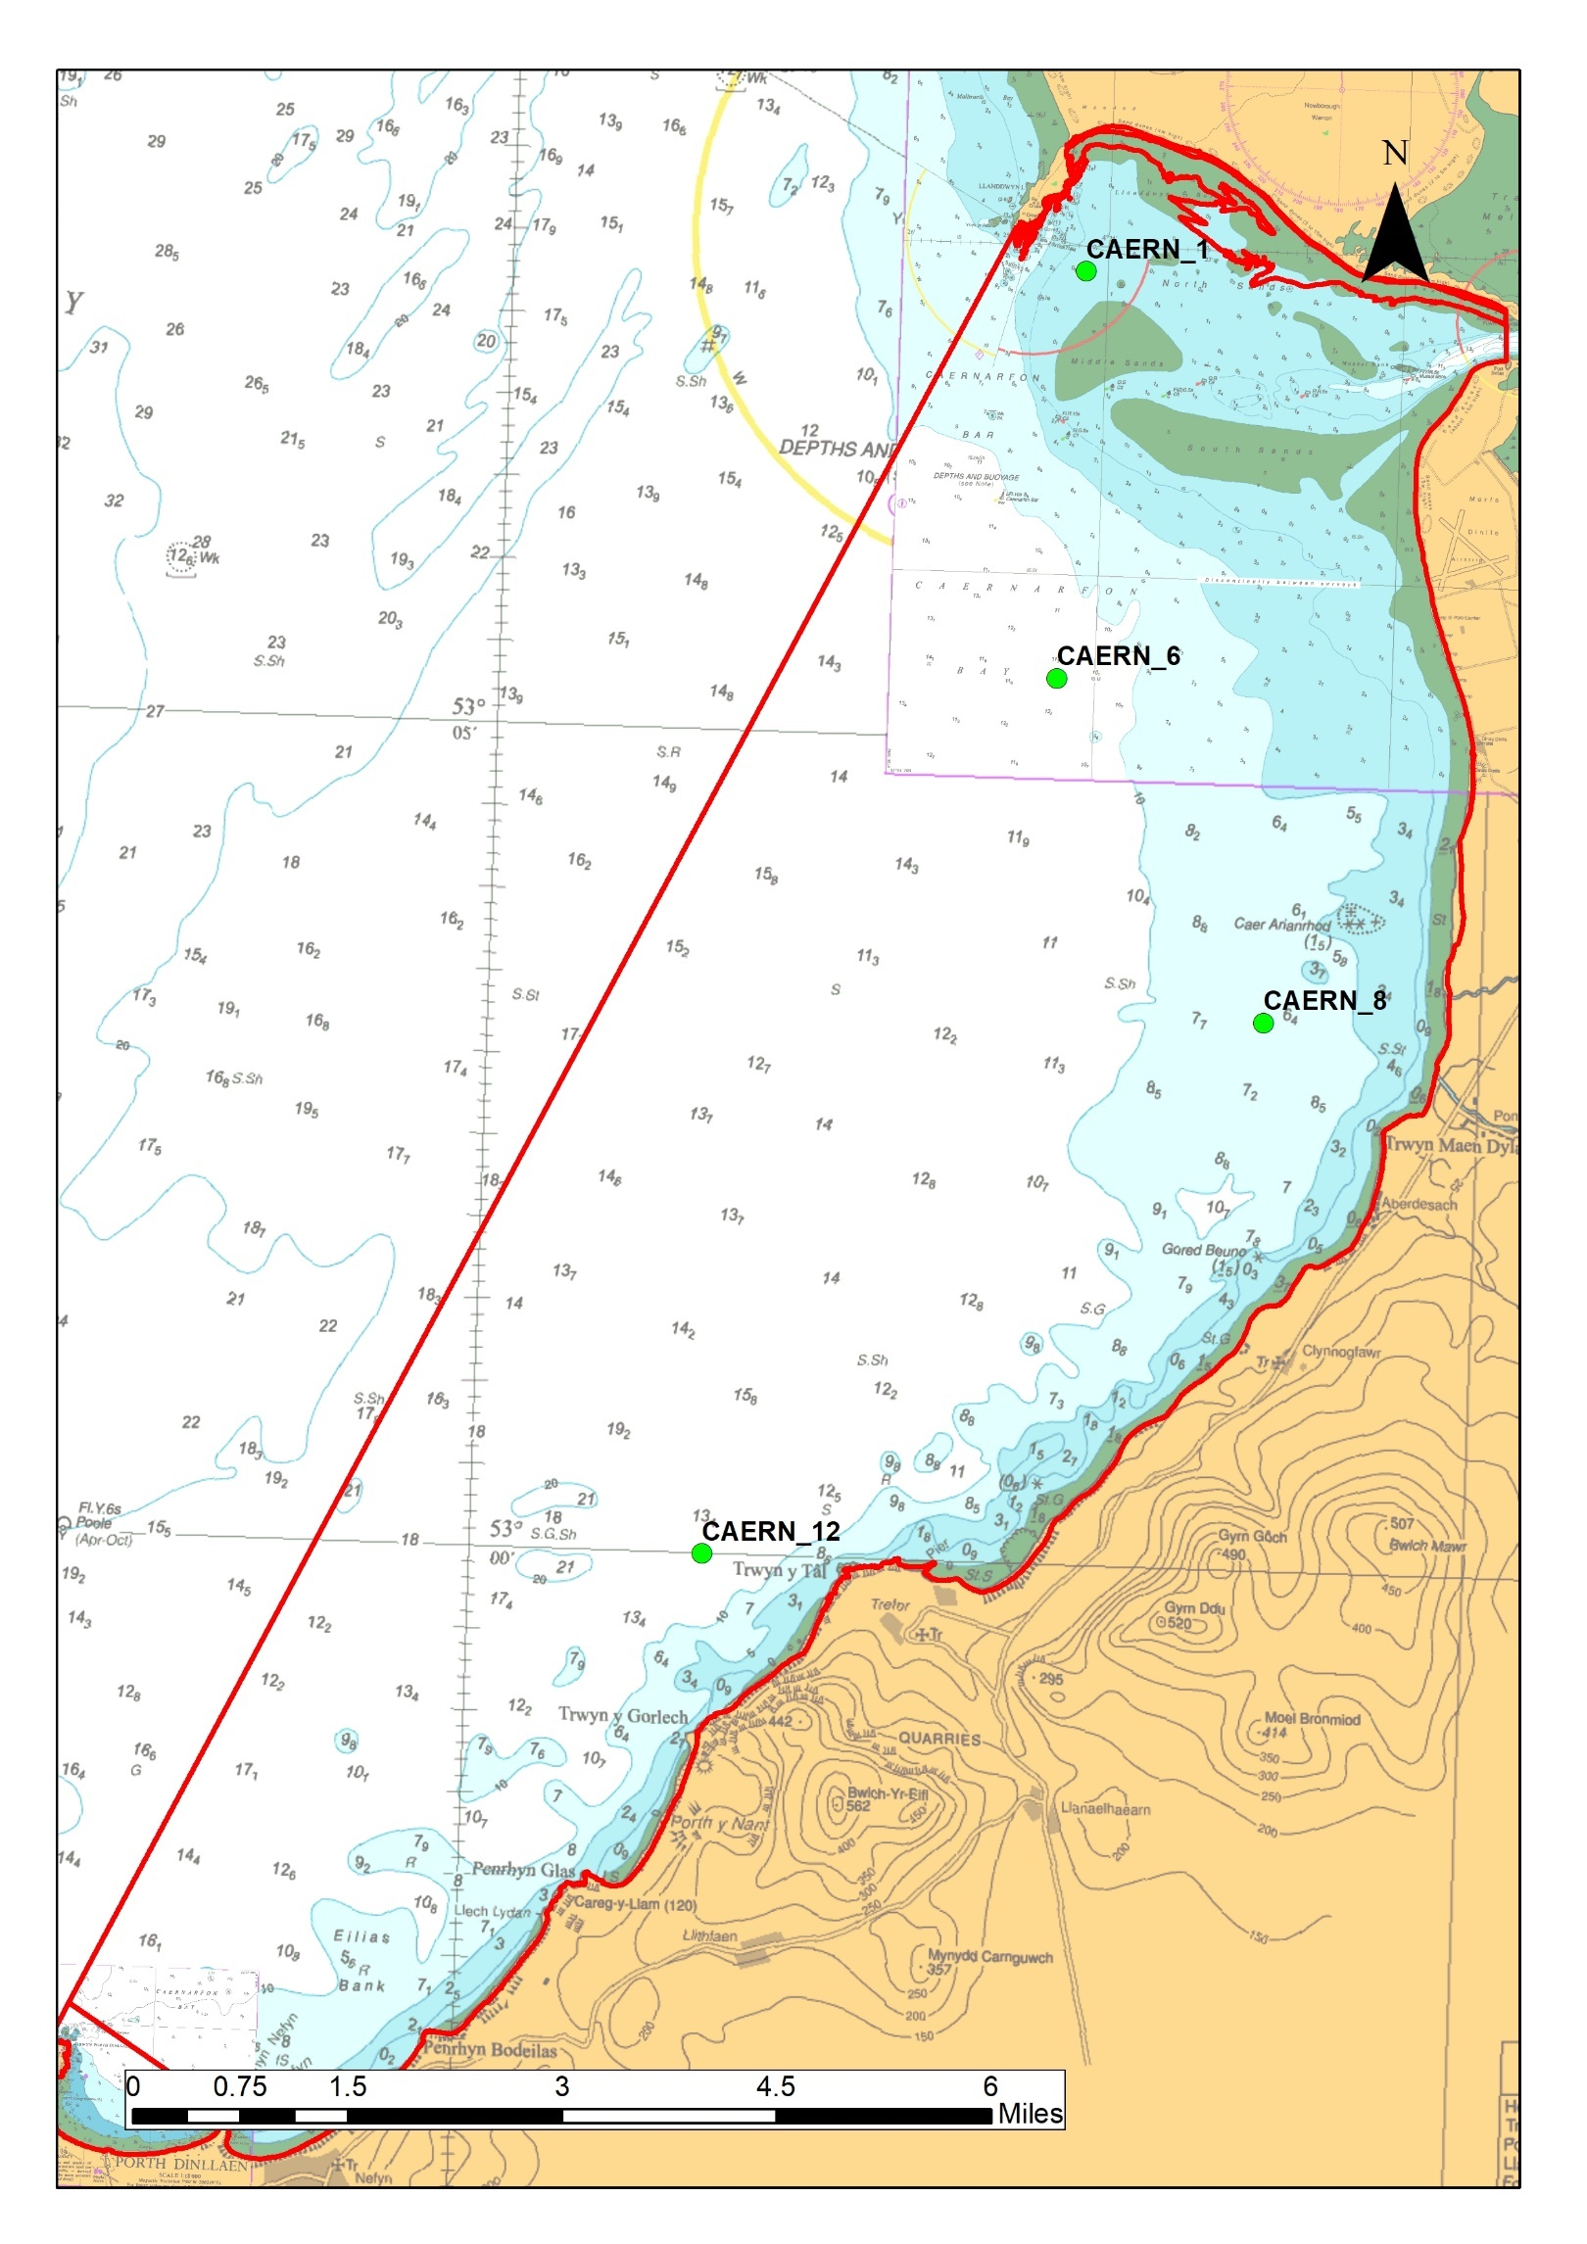
Figure 1 A chart of Caernarfon Bay Large Shallow Inlet and Bay Feature (outside of Special Area of Conservation) with surveillance sampling locations indicted by green symbols
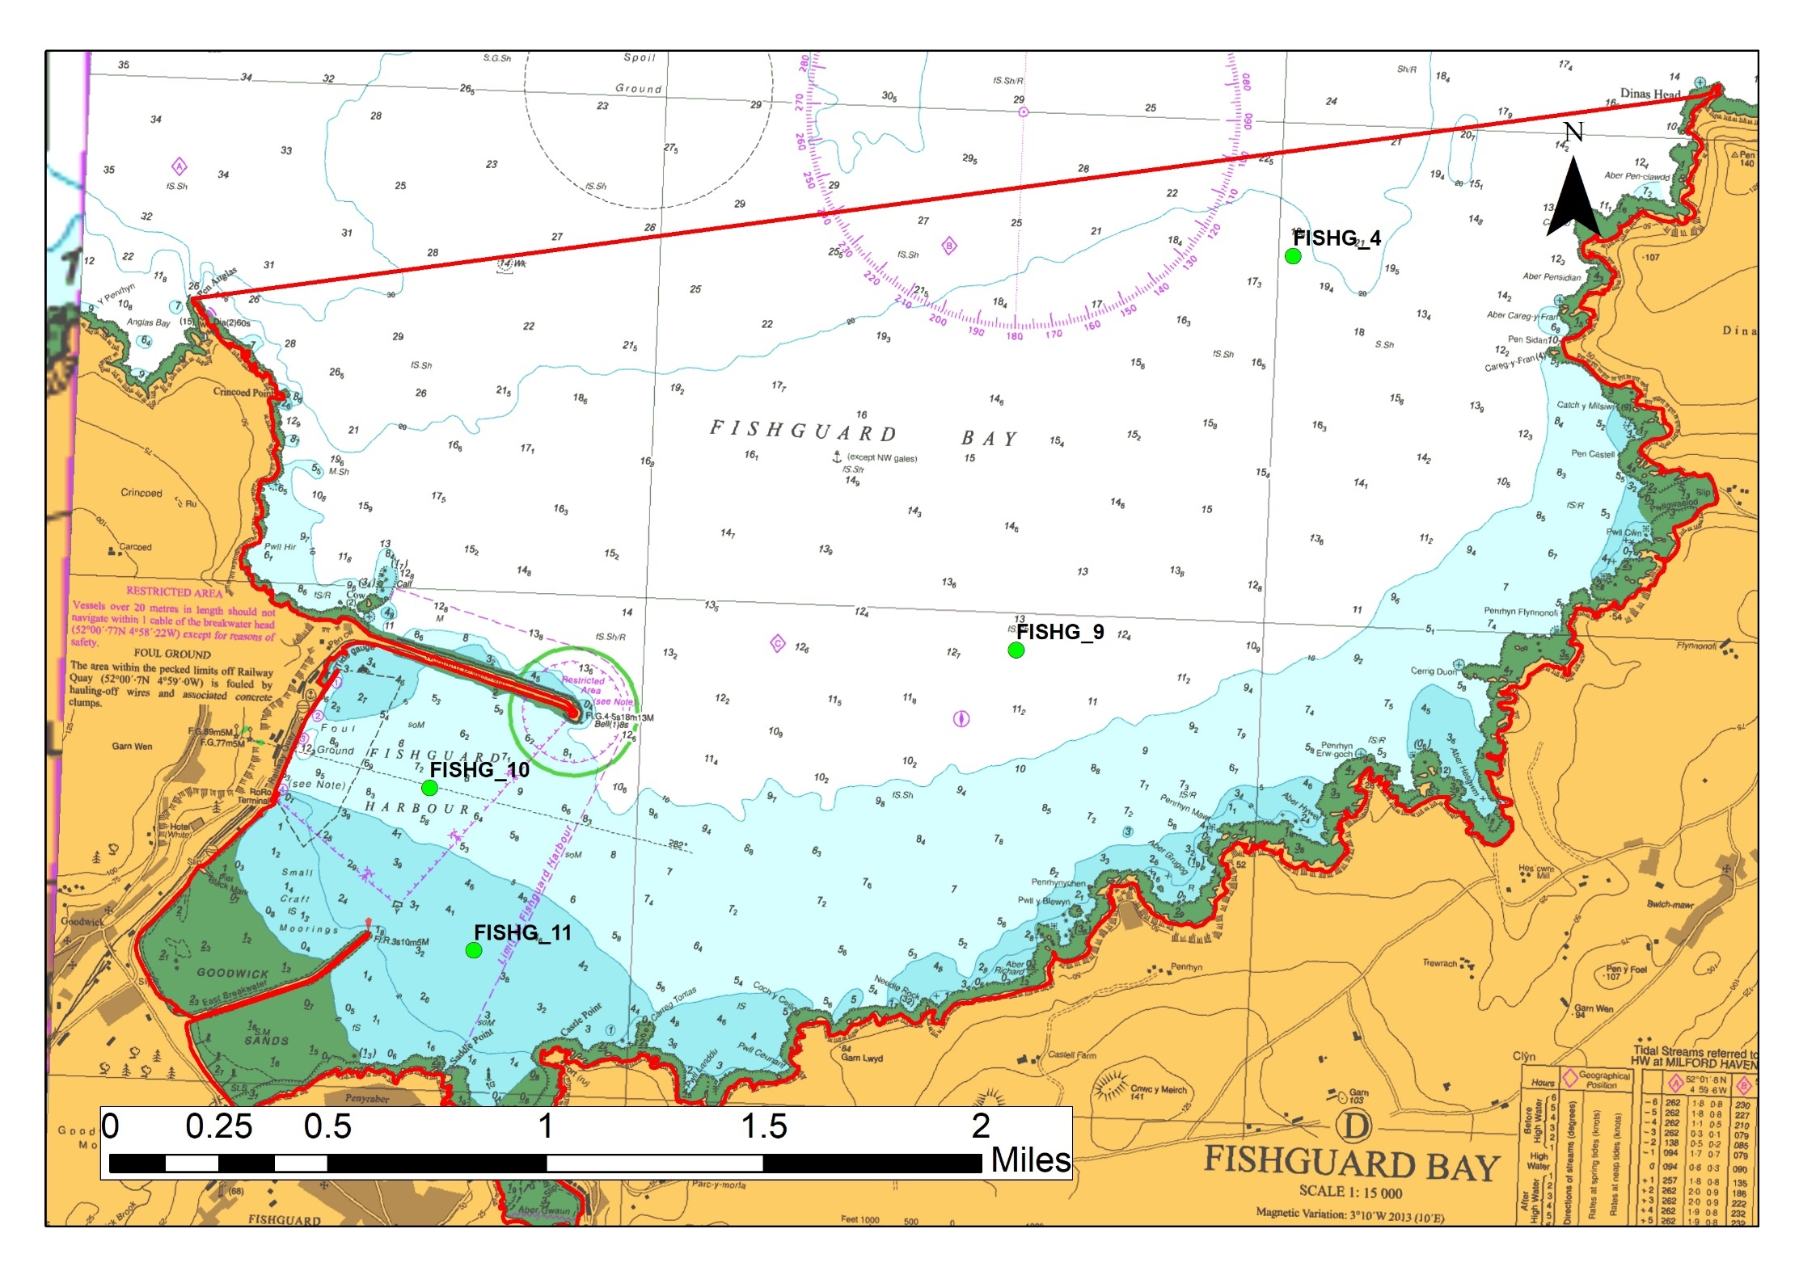
Figure 2 A chart of Fishguard Bay Large Shallow Inlet and Bay Feature (outside of Special Area of Conservation) with surveillance sampling locations indicted by green symbols
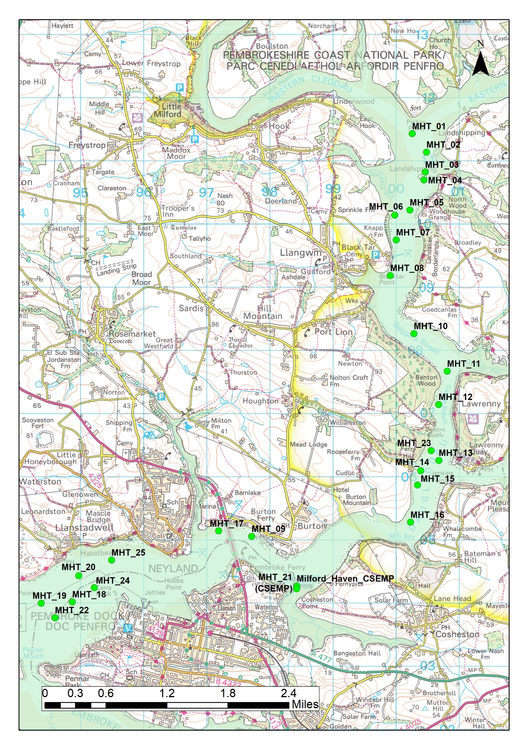
Figure 3 A chart of Milford Haven Inner Waterbody (light green filled polygon) with sampling locations indicted by green symbols
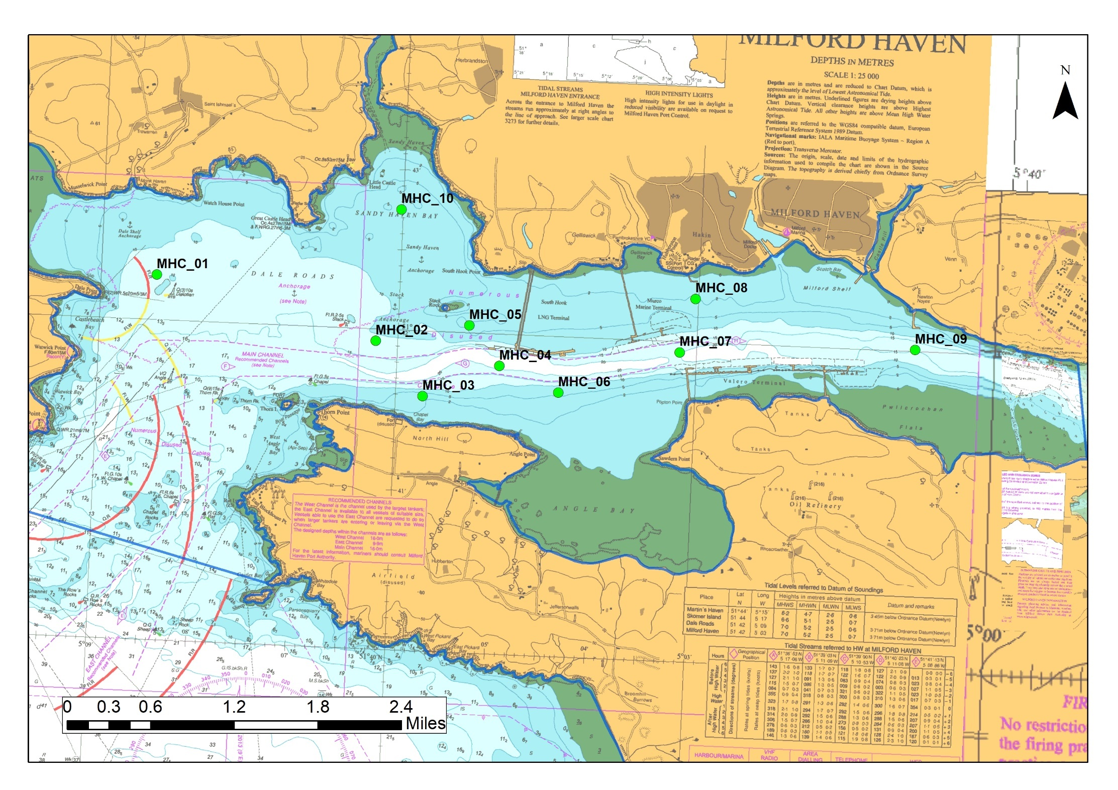
Figure 4 A chart of Milford Haven Outer Waterbody (encircled in a blue line) with sampling locations indicted by green symbols

Contracted Vessel
The contracted vessel is likely to be the Severn Guardian, however it may also be the Mersey Guardian, these are both high specification dedicated survey vessels which have been used for many years to undertake grab sampling work. NRW contracts the Environment Agency an Briggs Marine to do this work.

Sensitive Habitat
Band 1 activities require a method statement to outline interactions with sensitive habitats. It is required that the method statement must describe the works to be undertaken. Information on relevant sensitive habitat is provided below to assist the application assessment process.
The interaction between planned sampling and known sensitive habitat (using GIS layers presented in Table 1 and Table 2) has been assessed. GIS layers used were checked with appropriate specialists from Marine and Freshwater Ecosystems/Evidence Analysis Group to ensure that most up to date sensitive habitat maps were used (see emails embedded below).
Planned sampling locations were buffered using a 50m radius which was then saved as a Polygon in ArcGIS. The intersect tool was then used to highlight where planned sampling was within 50m of a mapped sensitive area. Egg wrack (Ascophyllum nodosum) on variable salinity rock and Tide swept egg wrack (Ascophyllum nodosum) communities were not assessed as these habitats would not be suitable for grab sampling and samples would not be planned in areas containing these habitats.
Table 1 A list of sensitive habitats and the related GIS layer, Accessed December 2024
Sensitive Habitat | GIS layer
- Egg wrack (Ascophyllum nodosum) on variable salinity rock | Not assessed
- Tide swept egg wrack (Ascophyllum nodosum) communities | Not assessed
- Maerl beds | Geodatabase: nmq501.9da46ec3d278.database.windows.net  - NRWGDBVECTOR.GISDATA.NERC_OSPAR_TOTALMAERL_WGS84_POLYGON
- Horse mussel (Modiolus modiolus) beds | Geodatabase: nmq501.9da46ec3d278.database.windows.net  - NRWGDBVECTOR.GISDATA.HORSE_MUSSEL_REEF_POLY_2020  - NRWGDBVECTOR.GISDATA.HORSE_MUSSEL_REEF_2020
- Oyster (Ostrea edulis) beds | Y:\Marine\Marine_Subtidal\Marine_Habitats_Species\BAP_habitats\BAP_Habitat_updates_2022.gdb  - NRW_Oyster_beds_point_v2_20220728  Areas currently being trailed for restoration have been assessed visually with Ben Wray (Oyster Restoration Project lead)
- Seagrass beds | Y:\Marine\Marine_Subtidal\Marine_Habitats_Species\BAP_habitats\BAP_Habitat_updates_2022.gdb  - NRW_Segrass_polygon_v6_20220728  Y:\Marine\Marine_Subtidal\Marine_Habitats_Species\BAP_habitats\Seagrass_updates_2024.gdb  - NRW_seagrass_Point_v10_20240626
- Sea-pen and other burrowing megafauna communities | Geodatabase: nmq501.9da46ec3d278.database.windows.net  - NRWGDBVECTOR.GISDATA.SEAPENS_2020
- Peat and clay exposures | Geodatabase: nmq501.9da46ec3d278.database.windows.net  - NRWGDBVECTOR.GISDATA.NERC_OSPAR_PEAT_CLAY_EXP_POLYGON_V2  - NRWGDBVECTOR.GISDATA.NERC_OSPAR_PEAT_CLAY_EXP_POINT_V2  - NRWGDBVECTOR.GISDATA.NERC_OSPAR_PEAT_CLAY_EXPOSURES_WGS84_POINT
- Sabellaria reefs | Y:\Marine\Marine_Subtidal\Marine_Habitats_Species\BAP_habitats\BAP_updates_2019.gdb  - NRW_Sabellaria_spinulosa_reef_point_v5_20230912  - NRW_honeycomb_worm_point_v6_20230112  Y:\Marine\Marine_Subtidal\Marine_Habitats_Species\BAP_habitats\SMMNR_biogenic_reef_polygon.gdb  - SMMNR_biogenic_reef_2019  Y:\Marine\Marine_Subtidal\Marine_Habitats_Species\BAP_habitats\Sabellaria_mapping_2024.gdb  - Sabellaria_alveolata_mapping_2024_polygon2  - Rowland_west_shore_sabellaria_polygons_2024  Y:\Marine\Marine_Subtidal\Marine_Habitats_Species\BAP_habitats\BAP_NERC_OSPAR_Habitats_BNG.gdb  - NRW_honeycomb_worm_polygon_v5_20200122

Table 2 A list of Annex I habitats assessed
Annex I Habitat | GIS Layer
- Reefs | Y:\Marine\Marine_Subtidal\Marine_Habitats_Species\Reg9a 2024\Updated layers_2024.gdb  - Reg9a_Subtidal_Reef_Points_2024  - Reg9a_Intertidal_Reefs_2024  - Reg9a_Inshore_Subtidal_reefs_2024_UTM30N  - Reg9a_Inshore_MDAC_2024
- Large Shallow Inlets and Bays | Y:\Marine\Marine_Subtidal\Marine_Habitats_Species\Reg9a 2024\Updated layers_2024.gdb  - Reg9a_LSIB_2024
- Atlantic salt meadows (Glauco-Puccinellietalia maritimae) and Salicornia and other annuals colonising mud and sand | Saltmarsh Layer which combines both Atlantic salt meadows and Salicornia:  Y:\Marine\Marine Intertidal & Coastal Ecosystems\Steve Jones\Saltmarsh\Saltmarsh_Extent_(Biological).shp
- Sandbanks | Y:\Marine\Marine_Subtidal\Marine_Habitats_Species\Reg9a 2024\Updated layers_2024.gdb  - Reg9a_sandbanks_2024
- Mud and Sand Flats | Y:\Marine\Marine_Subtidal\Marine_Habitats_Species\Reg9a 2024\Updated layers_2024.gdb  - Reg9a_MudflatsSandflats_2024

Samples close to Sensitive Habitat
All sampling is undertaken to support condition assessment/water quality assessment to support beneficial environmental management. There were 2 samples assessed to be close to or within sensitive habitat. Details provided below.

Mearl Bed
One planned sampling location (MHC_05) is within mapped maerl bed. It is likely that some fragments of maerl are also picked up in sampling stations local to this maerl bed as the maerl fragments moves with sediment movement (for example live maerl has been noted at station MHC_06 in the past) (Figure 5).
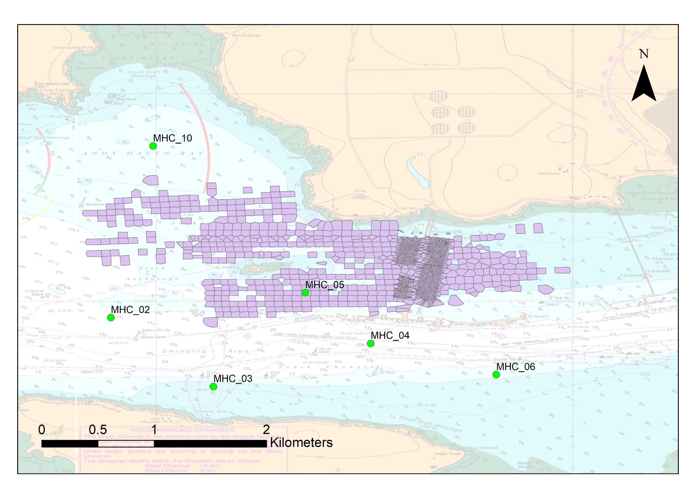
Figure 5 Known extent of Mearl bed within Milford Haven with planned sampling indicated.

Seagrass
No sampling locations overlaid seagrass. One target sampling station MHT_21(CSEMP) is close but not overlying a mapped seagrass bed (Zostera noltii) (Figure 6)
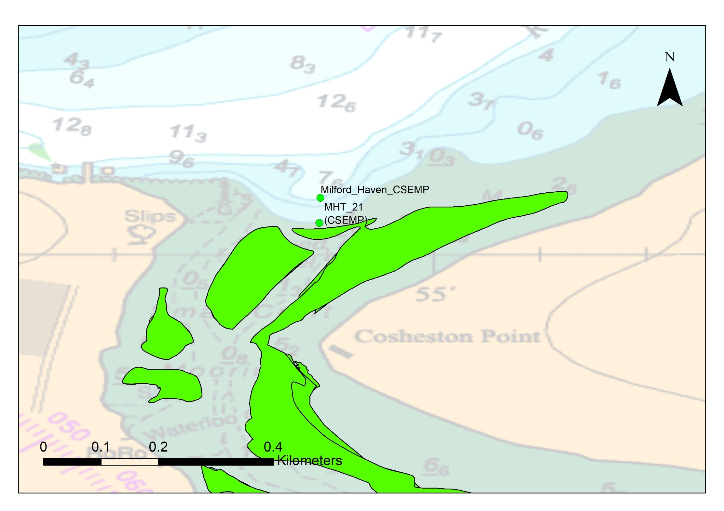
Figure 6 Known extent of Seagrass within Milford Haven with planned sampling indicated.

Annex I habitats (not targeted) & SSSI
Sampling is planned within Milford Haven Waterway (which is within the Pembrokeshire Marine SAC) which includes a designated Annex I Estuary and Large Shallow Inlet and Bay. All samples within Milford Haven are taken in the designated Estuary and Large Shallow Inlet and Bay some samples were within or close to the Milford Haven Waterway SSSI (Milford_Haven_CSEMP, MHT_06, MHT_08, MHT_17, MHT_21 (CSEMP) & MHT_23). This data contributes to condition assessments of both features as well as WER assessment. A GIS proximity check revealed that a small number of sampling stations were close to or within modelled Annex I reef (subtidal and intertidal) habitat. These locations have been successfully sampled in the past which suggest that at least the local habitat is suitable for grab sampling. A closer assessment of samples within 50m of reef show that samples were mostly close to but not overlying definite reef. Stoney mixed substrate can be classified as reef and in some cases is part of the habitats we are trying to sample. In general, the aim of grab sampling is to target sediment when planning surveys, as such we aim to avoid reef.

Samples within current known extent of a sensitive habitat:
Sampling within these areas is needed to ascertain SAC habitat condition. All information gained from sampling is used to understand, maintain or enhance sensitive protected habitats. Data gained from sampling aids assessment of health and condition of beds and is used to inform site management and report on feature condition.

Samples taken in recently expanded extent of a sensitive habitat:
Much of NRW sampling forms part of long-term monitoring of fixed locations to assess trends in community change. Having to relocate due to a community change (e.g. through expansion of Zostera beds or colonisation by Sabellaria spp.) would confound the sampling design and our ability to draw reliable conclusions from the already established monitoring programme. Where we encounter the habitat outside known established areas the number of samples of the habitat present gives an indication of both extent and certainty of presence (i.e. confidence), this information will be used to assess condition and for future casework advice (this is then used to protect sensitive habitats). For example, we may want to continue sampling an area where we find sensitive habitats in order to assess the habitat extent and then report the area covered so we can use this in casework advice.

Sensitive and Annex I Habitats and NRW Grab Sample Monitoring Conclusion
Overall, relatively few sampling positions are close or within to sensitive habitats or annex I habitat feature which is not targeted as part of the monitoring programme. Where sampling picks up sensitive habitat it is important to make a note of this to improve our knowledge of such habitats (e.g. species/biodiversity associated with sensitive habitats). We have received confirmation from the Marine Area Advice Team that sampling of sensitive habitats is required (see correspondence attached).

