Annex (iv) – SSSI Assessment Form
SSSI Assessment for permit/licence and deployment applications | 
To be completed by Permitting Officers for any applications for a permission which Natural Resources Wales has considered under S28I duty to notify SNCB and take their advice into account. This applies to all proposed permissions within a SSSI, and to operations outside the SSSI boundary which are likely to damage its special features.
NRW as a Section 28G authority has, when exercising its functions, a general duty to take reasonable steps, consistent with the proper exercise of its functions, to further the conservation and enhancement of the flora, fauna or geological or physiological features by reason of which the site is of special interest’

Part 1 – SSSI Assessment
Part 2 – Formal notification to SNCB (to be completed if part 1 assessment concludes likely damage, not likely to damage because of conditions or you cannot conclude no likely damage)
Part 3 – Decision
Pink text – drafting notes, to be deleted before completion/consultation.
Blue text – examples, to be replaced with permission-specific information and text turned to black.

Part 1 – SSSI Assessment

- Permitting officer/team | Louise Bailey  Waste Permitting Officer
- Permit application reference and site name | PAN-026615  Blancomet Recycling UK Limited  Blancomet- Cardiff, Unit 18C, Freemans Parc, Penarth Road, Cardiff, CF11 8EQ
- a. SSSI name(s)  b. location  c. NRW Operational Area/Environment Team | a. Cwm Cydfin, Leckwith SSSI  b. Approx. 530m to the SW of the site  c. South Wales Central Waste Regulation/ Vale of Glamorgan & Cardiff Environment team
- Brief description of proposal | Application for metal recycling site accepting 4,150 tonnes of hazardous and non-hazardous metal waste a year.  All waste must be stored and treated within a building on an impermeable surface with sealed drainage.  Quantined waste may be sotred externally within a fully lockable and sealed skip.  The maximum amount of hazardous waste that can be sotred on site at any one time is 50 tonnes  The only permitted treatment of the proposed wastes are manual sorting and/or separation; and bulking up for onwards transfer.  The site consists of an industrial unit within a larger industrial estate which is surrounded by additional industrial and commercial properties with open woodland (including Cwm Cydfin, Leckwith SSSI) to the west, and residential houses beyond to the north, east and west.  An EMS, Risk Assessment and Fire prevention and mitigation plan have been supplied with the application, and include how waste will managed.  SSSI location map, site layout map and sensitive receptor map can be found at the end of this document.
- What aspects of the proposed permission are likely to damage the SSSI features of special interest?

The following activities are likely to cause damage:
- None

The following SSSI(s) features and potential impacts have been considered to assess the likelihood of damage:

Features of interest: Semi-natural broadleaved woodland
Mechanisms/pathways of impact:
- Grazing- not relevant to proposed activity
- Traditional Woodland Management- not relevant to proposed activity
- Invasive non-native trees (sycamore) - not relevant to proposed activity
- Removal of dead and decaying wood- not relevant to proposed activity

- Summary of any informal advice received from internal experts (if required and including pre-app advice) | n/a
- Recommendation | The proposed permission is not likely to damage any of the flora, fauna or geological or physiological features which are of special interest.
- Signature and date assessment made | Louise Bailey  11/02/25
- Officers name and job title | Louise Bailey  Waste Permitting Officer
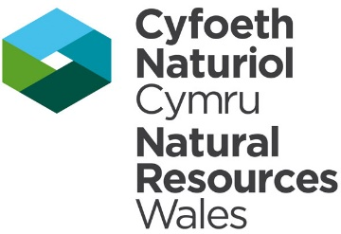

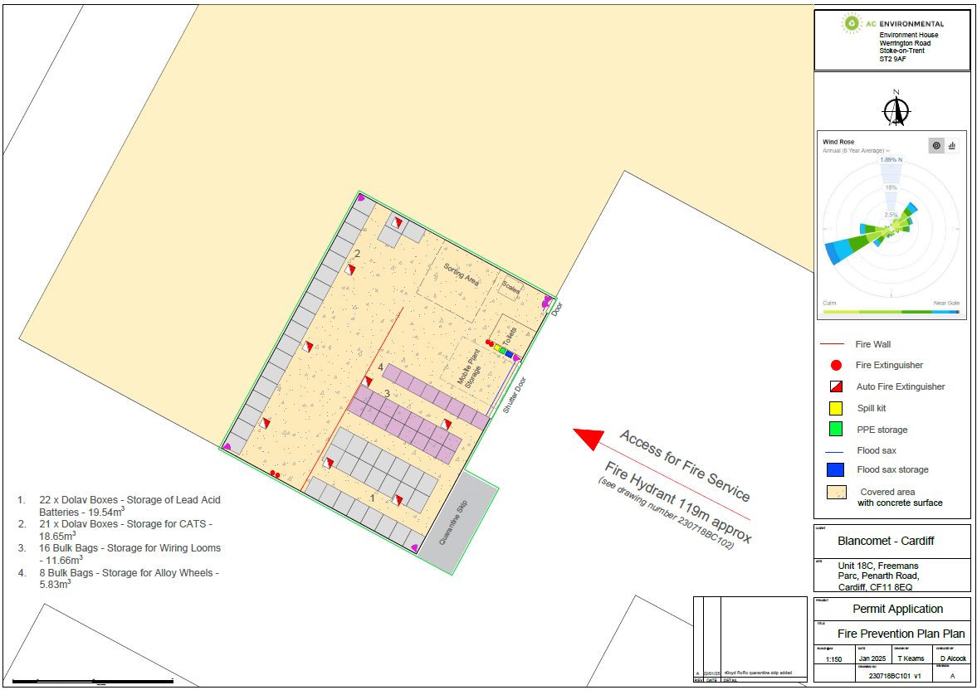

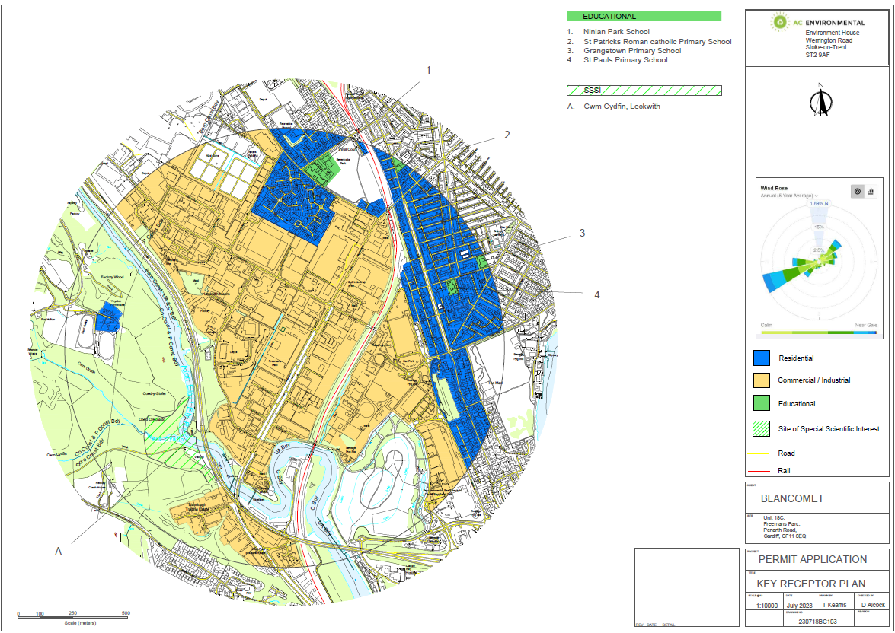

Sites of Special Scientific Interest (SSSI) within 2km of site
- Cwm Cydfin, Leckwith SSSI- approx 530m



