

Company Director and/or Company Secretary  Fenestration Recycling Company Limited  1 Bowden Way  Failand  Bristol  England  BS8 3XA | Ein cyf/Our ref: HP3938RN  Eich cyf/Your ref:  Dyddiad/Date: 1 May 2019
Dear Sir/Madam

Fenestration Recycling Company Limited - Regulation 36 Notice

Further to a site visit conducted on 5 February 2019 and the withdrawal of the Regulation 36 Notice dated 6 April 2018, please find enclosed a Regulation 36 Notice. The Notice requires you to take the steps outlined in Schedule 1.

If you have any questions, then please do not hesitate to contact me via the details below.

Regards

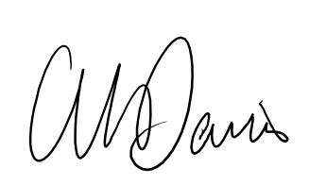

Gareth M Davies

Senior Environment Officer
Tel: 03000 653226
Gareth.davies@cyfoethnaturiolcymru.gov.uk

