

Company Director and/or Company Secretary  Fenestration Recycling Company Limited  1 Bowden Way  Failand  Bristol  England  BS8 3XA | Ein cyf/Our ref: HP3938RN  Eich cyf/Your ref:  Dyddiad/Date: 1 May 2019
Dear Sir/Madam

Regulation 36 Notice Withdrawal

Further to a site visit conducted on 5 February 2018, the Regulation 36 Notice dated 6 April 2018, shall be considered withdrawn from the date of this letter.

A further Regulation 36 Notice has been sent to Fenestration Recycling Company Limited requiring steps to be carried out as outlined in Schedule 1 of the Notice.

If you have any questions, then please do not hesitate to contact me via the details below.

Regards

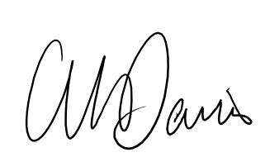

Gareth M Davies

Senior Environment Officer
Tel: 03000 653226
Gareth.davies@cyfoethnaturiolcymru.gov.uk

