Permit
The Environmental Permitting (England & Wales) Regulations 2016

Tom James Construction Services Ltd

Tom James Construction Services Ltd
Unit 2 Glanypwll Road
Rhiwbryfdir
Blaenau Ffestiniog
Gwynedd
Wales
LL41 3BT

Permit number
EPR/DB3491ZP

Permit
The Environmental Permitting (England and Wales) Regulations 2016

Permit number

EPR/DB3491ZP

The Natural Resources Body for Wales (“Natural Resources Wales”) authorises, under regulation 13 of the Environmental Permitting (England and Wales) Regulations 2016

Tom James Construction Services Ltd (“the operator”),

whose registered office is

Unit 2 Glanypwll Road

Rhiwbryfdir

Blaenau Ffestiniog

Gwynedd

Wales

LL41 3BT

company registration number 09939299

to operate waste operations at

Tom James Construction Services Ltd

Unit 2 Glanypwll Road

Rhiwbryfdir

Blaenau Ffestiniog

Gwynedd

Wales

LL41 3BT

to the extent authorised by and subject to the conditions of this permit.

Under regulation 27(2) of the Regulations, standard rules SR2009 No6 are conditions of this permit.
Name | Date
Huw Davies | 11/02/2025

Authorised on behalf of Natural Resources Wales

Schedule 1 - Site plan

This is the plan referred to in the standard rules SR2009 No6

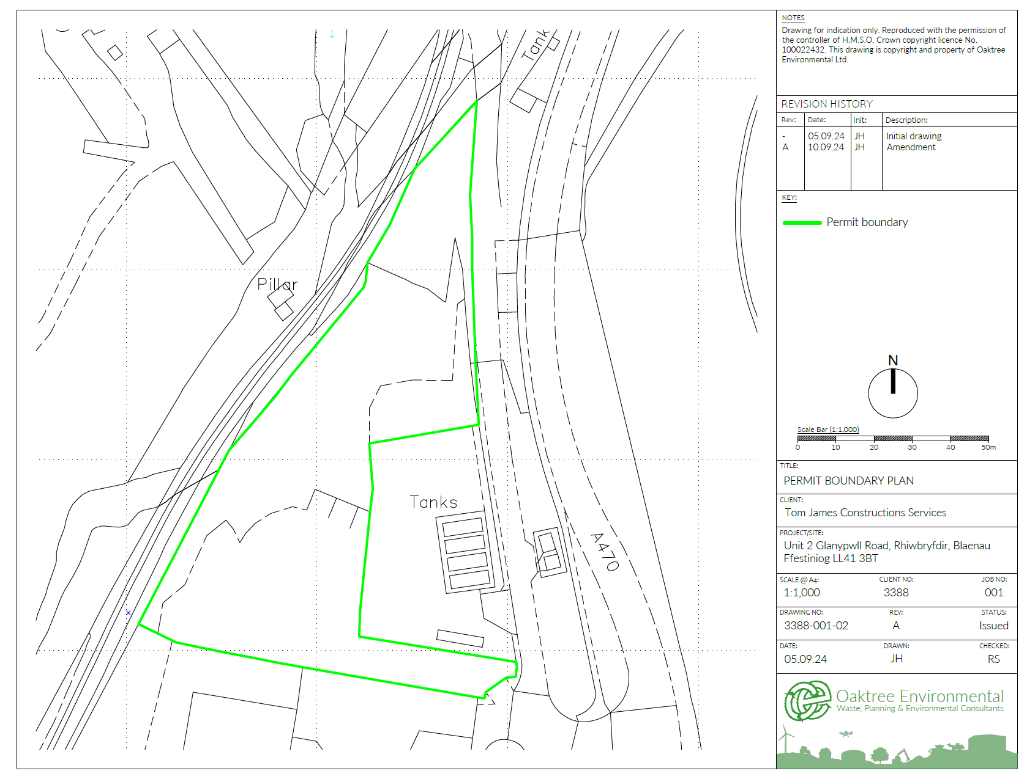

END OF PERMIT

