Annex (iv) – SSSI Assessment Form
SSSI Assessment for permit/licence and deployment applications | 
To be completed by Permitting Officers for any applications for a permission which Natural Resources Wales has considered under S28I duty to notify SNCB and take their advice into account. This applies to all proposed permissions within a SSSI, and to operations outside the SSSI boundary which are likely to damage its special features.
NRW as a Section 28G authority has, when exercising its functions, a general duty to take reasonable steps, consistent with the proper exercise of its functions, to further the conservation and enhancement of the flora, fauna or geological or physiological features by reason of which the site is of special interest’

Part 1 – SSSI Assessment
Part 2 – Formal notification to SNCB (to be completed if part 1 assessment concludes likely damage, not likely to damage because of conditions or you cannot conclude no likely damage)
Part 3 – Decision
Pink text – drafting notes, to be deleted before completion/consultation.
Blue text – examples, to be replaced with permission-specific information and text turned to black.

Part 1 – SSSI Assessment

- Permitting officer/team | Owen Clee  Waste Permitting
- Permit application reference and site name | PAN-027872
- a. SSSI name(s)  b. location  c. NRW Operational Area/Environment Team | a. Mynydd Parys SSSI  b. Parys Mountain Anglesey  c. Mon ac Arfon, North West Wales
- Brief description of proposal | A land spreading application to spread 4 dairy waste streams (EWC 02 05 01 & 02 04 02) at Trysglwyn Farm, Rhosybol, LL68 9RF. Wastes are to be spread on 10 fields which contain grass. The application rate of the wastes ranges from 250-100 tonnes per ha, with a total tonnage to spread a maximum of 12,500 tonnes.  The waste will be spread over 50 ha hectares of land within the listed fields at Trysglwyn Farm. The waste spread under this deployment are composed of non-stackable liquid wastes. No storage of waste is proposed under this deployment.  The wastes may be mixed. If this is the case the application rates will be adjusted to ensure crop requirement/ nutrient replacement is not exceeded, no more than 250 kg total N /ha and no more than 250t/ha  of organic matter is applied within any 12-month period.  The non-stackable liquids will be spread via trailing shoe applicator. The elements are fitted with a self-sharpening share which parts the plant leaves allowing sludge to be delivered to the soil surface via a rubber injection cone, which is positioned directly behind the share. The trailing shoe applies sludge at the soil surface minimising sward contamination and root disturbance.  Targeted periods for spreading on grass fields will be split into 4 applications: February 2025, April 2025, June 2025 and August 2025.  The land spreading activity will comply with the Code of Good Agricultural Practice guidelines (COGAP).  Documents related to this deployment can be found on the DMS.  Farm location: SH 43784 89579  Fields:  1 SH 43995 89717  2 SH 44282 89634  3 SH 44422 89724  4 SH 44517 89635  5 SH 44640 89727  7 SH 44716 89859  8 SH 44846 90008  9 SH 45059 90039  12 SH 45347 90163  13 SH 45278 90009  Storage: No storage  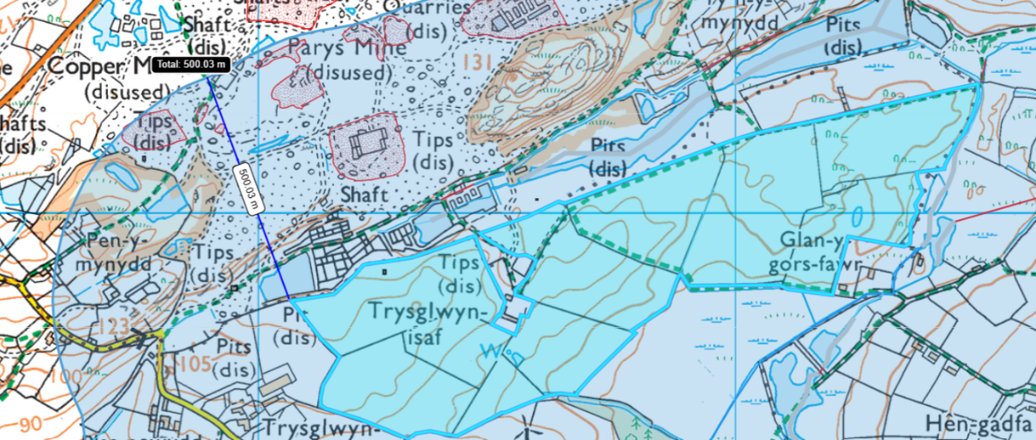  The landspreading fields are within 500 meters of the Mynydd Parys SSSI the closest field is located 174 meters from the SSSI.
- What aspects of the proposed permission are likely to damage the SSSI features of special interest?

The following activities are likely to cause damage:

- Application of manure, fertilisers and lime.

- Dumping, spreading or discharging of any materials.

The following SSSI(s) features and potential impacts have been considered to assess the likelihood of damage:

- Mineral bearing spoil-tips, mineral veins and rock exposures

- Assemblage of metallophyte lichens

Assessment of Impact pathways: None identified due to the SSSI located upslope from the spreading fields and approximately 174 meters from SSSI (closest field 1). As the waste is non stackable dust is also not considered to be an impact pathway.

- Summary of any informal advice received from internal experts (if required and including pre-app advice) | n/a
- Recommendation | The proposed permission is not likely to damage any of the flora, fauna or geological or physiological features which are of special interest.  Due to the following reasons:  - No Impact pathway identified due to SSSI located upslope from the spreading fields and approximately 174 meters from the closest field (field 1).  - 50 meter no spread buffer zone in place in field 1 (closest field to SSSI).  - The sludges are of low dry matter and will infiltrate readily into the soil surface following application minimising potential impact.  - Highly sloping land has been removed from the deployment.  - All application machinery is calibrated and regularly checked to ensure the stated application rates are maintained.  - Potential run-off is prevented by the low application rates (<50t/ha).
- Signature and date assessment made | OWEN CLEE 12/02/2024
- Officers name and job title | Owen Clee  Waste Permitting Officer


Permitting
Formal Notification under Section 28I of the Wildlife and Countryside Act 1981

Part 2 Formal notification under S28I – To be completed for all permit applications assessed as: not likely to damage because of conditions, likely to damage SSSI and those where we are unable to conclude no likely damage.

- Date Notice of intention to permit activity likely to damage SSSI sent to NRW (SCNB)  If you assess activity as being likely to damage even if you think this can be mitigated by conditioning you need to formally notify SNCB send them a copy of this notice with part 1 of this form. Environment teams have 28 days to respond.  Environment teams please complete question 11 and 12 using the information in questions 1-9 | Insert date  We have assessed that [permit ref/name of site] is likely to damage [insert name of SSSI] and request your formal advice. We have assessed that this damage could be mitigated by including conditions[remove if not applicable].  Or  We are unable to conclude that [permit ref/name of site] is not likely to damage [insert name of SSSI] and request your formal advice.  Information on the permit application can be found in Part 1 of this form and [include link to DMS documents if required]
- Advice received from NRW (SNCB)

Environment Teams and Marine Area Management and Advice Teams are expected to log and issue formal statutory advice through our CAMS system. The advice letter generated can simply by attached/appended here. ET/MAAMT can just refer to that here or write a summary of advice here too.

To be completed by environment officers.
Within 28 days of receiving notice from a permitting/licensing regime, you should advise whether the operation:
• Should be allowed to proceed.
• Should be allowed to proceed with certain conditions.
• Should not proceed.

Please ensure all advice provided is evidenced and comprehensive. Advice provided may be scrutinised as part of a formal appeal.

- Name and job title of conservation/marine officer (sign and date)
Part 3 – To record NRW decision following SNCB Advice
- DECISION  Provide reasoning for your decision and how you have considered advice from NRW(SNCB) in the box opposite and delete text in blue that is not relevant. This might be the same as the info and decision in part 1 of the form  Large amounts of supporting information can be appended to this form. | The proposed permission is not likely to damage any of the flora, fauna or geological or physiological features which are of special interest  The permission is not likely to damage any of the flora, fauna or geological or physiological features which are of special interest because of conditions  The permission is likely to damage
- Natural Resources Wales (Section 28G Authority) (permitting service) is minded to  Delete as appropriate  If this decision is not in line with advice received from NRW(SNCB) please outline your reasoning (please note that you should try to resolve any differences in opinion) | Issue the permission  Issue the permission with conditions to ensure no damage to SSSI  Refuse the permission due to likely damage to SSSI
- Is decision in line with advice from SNCB  If your decision is not in line with the recommendations from SNCB you must formally notify them using the appropriate online form or letter.  Record the date the notice/letter was sent opposite and save a link. The permitted operation cannot commence for 21 days following service of this notice. | Yes/No  If No record date notice was sent to SNCB
- Signature and date assessment completed
- Officers name and job title

