Supporting Information for Marine Licence Application

NRW Grab Sampling Survey programme 2025-2027

Prepared by: Matthew Green
Senior Specialist, Marine Environmental Assessment Officer; Marine Monitoring Team (Natural Resources Wales)
0300 0354105 | 07768142891 | matthew.green@cyfoethnaturiolcymru.gov.uk

Contents
Introduction 4
Planned Monitoring Survey Summary 5
MPA monitoring (mainly The Conservation of Habitats and Species Regulations 2017 Surveys) 6
Annex I Large Shallow Inlet and Bay monitoring outside of SACs (to inform regulation 9a) 7
Milford Haven Waterway Environmental Surveillance Group Sampling 10
Sediment and Invertebrates assessment: 10
Water Environment Regulations Surveillance Grab Sample Surveys 13
EA England Water Environment Regulations Surveillance Grab Sample Surveys 14
Skomer Marine Conservation Zone Monitoring 14
Clean Seas Environment Monitoring Programme (CSEMP) 16
Water Environment Regulations Operational Grab Sample Surveys 17
Water Environment Regulations Failure Investigation Survey 22
Ad Hoc sampling (unplanned) 23
Ad hoc MPA surveys 23
Water Environment Regulations Investigation Monitoring 23
Welsh Territorial Waters 25
Summary of sampling: 26
Samples within designated areas 27
Habitats Regulation Assessment (HRA) 28
Designated N2K Sites 28
WER Assessment 29
50 Samples Per Hectare Test 29
4m³ of sediment volume test 29
Worst Case Scenario 30
Scenario 1 Milford Haven Inner: 30
Scenario 2; Conwy Bay: 31
Scenario 3; Three Rivers: 31
High Status Hydro-morphology WFD Water Bodies 31
Conclusion: 31
Sensitive Habitats: 32
Seagrass: 34
Seapens Burrowing Megafauna 40
Maerl Bed 42
Unplanned Sampling: 42
Annex I Designated habitats: 42
Reefs 43
Subtidal Sandbanks 43
Large shallow inlets and bays 43
Estuaries 44
Mudflats and sandflats not covered by seawater at low tide 44
Atlantic salt meadows (Glauco-Puccinellietalia maritimae) and Salicornia and other annuals colonising mud and sand 44
Sensitive and Annex I Habitats and NRW Grab Sample Monitoring Conclusion 44
Samples within current known extent of a sensitive habitat: 44
Samples taken in recently expanded extent of a sensitive habitat: 44
Annex I habitats (not targeted) 45

Introduction
Marine licence RML2208 expires in Dec , 2024. RML2208 authorised NRW’s ongoing programme of benthic sampling and therefore this application is being made for the next 3 years of the survey programme (2025-2027). The activities undertaken under this licence are likely to be very similar, to those authorised under RML2208. Due to possible changing monitoring priorities and available budget there may be some changes to NRW’s current planned sediment sampling programme (Figure 1). Therefore, we have had to build in flexibility with this licence application and the total number of grab samples taken is expected to be significantly lower than the maximum total number provided in this document (8,825 grab samples). Numbers quoted in this document include only successful samples (not failed samples; for example, where the grab does not close properly, a sediment sample is not deemed large enough to accept or where a sediment sample does not match the biota sample and required to be returned – this has not been considered in this licence).

The proposed marine benthic grab sampling will take place at various marine sediment habitats, bays, coasts, and estuaries around Wales. The application covers multiple surveys between 2025-2027, mainly to be undertaken to meet monitoring needs. All sampling will improve knowledge and be used to assess marine ecological health to better understand, manage and/or conserve marine habitats in Wales.

The surveys can be grouped into the following categories:
- Marine Protected Area monitoring (mainly Habitats Directive but also includes SSSI [currently planned standard monitoring and ad hoc/incident response])
- Annex 1 Large Shallow Inlet and Bay monitoring outside of SACs (Regulation 9a)
- Water Environment Regulations (surveillance, operational and investigation monitoring)
- NRW and Milford Haven Waterway Environmental Surveillance Group collaborative sampling
- Skomer Marine Conservation Zone monitoring
- Clean Seas Environmental Monitoring Programme (CSEMP)
- Other Ad hoc sampling within welsh waters not covered above
Each grab sample has an approximate maximum area of 0.1m² and the approximate maximum volume of ~14 litres (although rarely would reach 14 litres). The volume attained depends on the sediment type and sampling conditions (e.g. sea state).

The Marine Licensing Team were contacted regarding advertising requirements as this application does not meet the requirements for a Band 1 licence (which is generally restricted to a smaller area). In the past, the Marine Licensing team confirmed advertisement of a public notice would not be required (query reference Q18176) on a related matter.

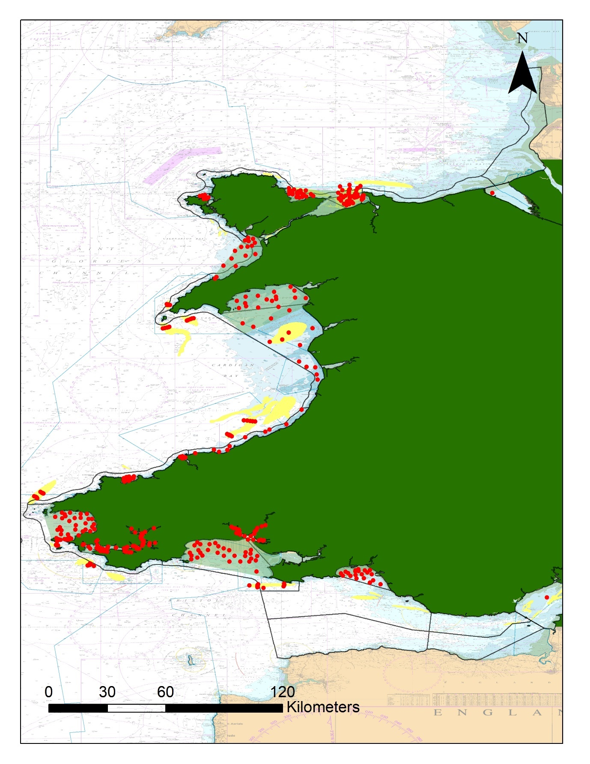
Figure 1 A map of currently planned samples around Wales. Red Dots = planned grab sample target positions. Dark lines = WER waterbody boundaries. Light green areas = Lare Shallow inlet and Bay. Light yellow areas = sandbanks. SACs = blue lines. Other features are too small to visualise in an all Wales map.

Planned Monitoring Survey Summary
In this section the purpose and nature of the survey work is summarised. However, samples primarily taken for one purpose are often used to inform/report for numerous directives and NRW ensures that surveys are undertaken in a way which enables as much use of the data as possible to add value to our time at sea and laboratory analysis time and power to our assessments. The sample numbers are provided in summary tables below (Table 1, Table 2 & Table 3). There may be some double counting, for example Conwy bay SAC monitoring includes almost all samples taken for Conway Bay WER sampling (a similar situation is apparent in Carmarthen Bay).

MPA monitoring (mainly The Conservation of Habitats and Species Regulations 2017 Surveys)
Surveys are planned to be undertaken in Special Areas of Conservation (SAC) primarily in order to assess the condition of designated Annex I habitats (Large Shallow Inlets and bays, Sandbanks and Estuaries, intertidal mud and sandflats) (see Figure 1 and attached electronic annex for indicative planned sample numbers and positions). Planned numbers of samples are summarised in Table 1 and currently planned positions are presented in an electronic appendix and Figure 1. Positions and timings are indicative and may change if priorities/conditions change but will remain within the SAC area within 2025-2027 timeframe. A small number of samples lie outside of the SAC boundary where the feature (e.g. sandbank) intersects with the SAC boundary or historic sample sites lie just outside the SAC boundary (this includes Bias Bank, Pembrokeshire Marine SAC Survey [15 samples] and in Conwy Bay [6 samples], Menai Strait and Conwy Bay SAC Survey – see electronic appendix), sampling associated with these sites will occur outside the SAC boundary. The Conservation of Habitats and Species Regulations 2017 surveys are currently planned at the following Special Areas of Conservation:
- Pen Lleyn a’r Sarnau SAC
- Carmarthen Bay and Estuaries SAC
- Pembrokeshire Marine SAC
- Menai Strait and Conwy Bay SAC
- Cardigan Bay SAC
Table 1 A summary of the number of grab samples currently planned in various SACs to primarily contribute to condition assessment. This is not the total number of samples to be taken within various SACs, this is presented further down in this document.
SAC Feature Survey | 2025 | 2026 | 2027
Cardigan Bay / Bae Ceredigion
Cardigan_Bay_Sand_Bank | 0 | 30 | 0
Carmarthen Bay and Estuaries / Bae Caerfyrddin ac Aberoedd
Carmarthen_Bay | 40 | 92 | 40
Helwick | 36 | 0 | 0
Three_Rivers_Inlets | 154 | 0 | 0
Dee Estuary / Aber Dyfrdwy (Wales)
The_Dee_CSEMP | 20 | 20 | 20
Pembrokeshire Marine / Sir Benfro Forol
Bais_Bank_South | 15 | 0 | 0
Knoll_Sand_bank | 18 | 0 | 0
Milford_Haven_CSEMP | 20 | 20 | 20
Milford_Haven_Inlets | 141 | 0 | 0
St_Brides_Bay | 40 | 90 | 40
Turbot_Bank | 18 | 0 | 0
Pen Llyn a'r Sarnau / Lleyn Peninsula and the Sarnau
Bastram_Shoal | 0 | 0 | 15
Devil's_ridge | 0 | 0 | 15
Tremadog_Bay | 50 | 50 | 84
Tripods | 0 | 0 | 15
Y Fenai a Bae Conwy / Menai Strait and Conwy Bay
Conwy_Bay | 196 | 20 | 20
Conwy_Bay_Sand_Bank | 18 | 0 | 0
Red_Wharf_Bay | 52 | 20 | 20
Red_Wharf_Bay_Sand_bank | 15 | 0 | 0
Outside SACs
Bais_Bank_North | 15 | 0 | 0
Conwy_Bay | 18 | 0 | 0
* 15 grab samples planned at Bais Bank sandbank are slightly outside the SAC boundary but were planned in order to adequately represent the sandbank & 18 samples taken in Conwy Bay were slightly outside the SAC boundary to adequately represent the bay (and includes WER planned investigation) and continue long term monitoring at these locations.

Annex I Large Shallow Inlet and Bay monitoring outside of SACs (to inform regulation 9a)
Surveys are planned to be undertaken at Large Shallow Inlets and Bays outside of the SAC network. This allows comparison with protected sites and appraisal of this habitat for The Conservation of Habitats and Species Regulations 2017, Regulation 9a reporting (and will contribute to WER reporting). The number of samples to be taken are summarised in Table 2 and in Figure 2, Figure 3 & Figure 4. These surveys are planned at the following Large Shallow Inlets and Bays:
- Caernarfon Bay (Figure 2)
- Swansea Bay (Figure 3)
- Fishguard Bay (Figure 4)
Positions and timings are indicative and may change if priorities/conditions change but will remain within the areas defined within 2025-2027 timeframe. At Swansea bay, a number of samples are outside the Large Shallow Inlets and Bay Feature, this is so that the data can also be used for WER assessment for the Swansea Bay Waterbody; therefore sampling will be undertaken within the area encompassed by the Large Shallow Inlet and Bay and the Swansea Bay WER waterbody 2025-2027 (Figure 4).

Table 2 A summary of the number of samples planned to be taken at Large Shallow Inlet and Bays outside of SACs in Wales
Annex I Bay | 2025 | 2026 | 2027
Caernarfon Bay | 40 | 64 | 40
Fishguard Bay | 40 | 58 | 40
Swansea Bay (+ Swansea Bay Waterbody) | 40 | 72 | 40

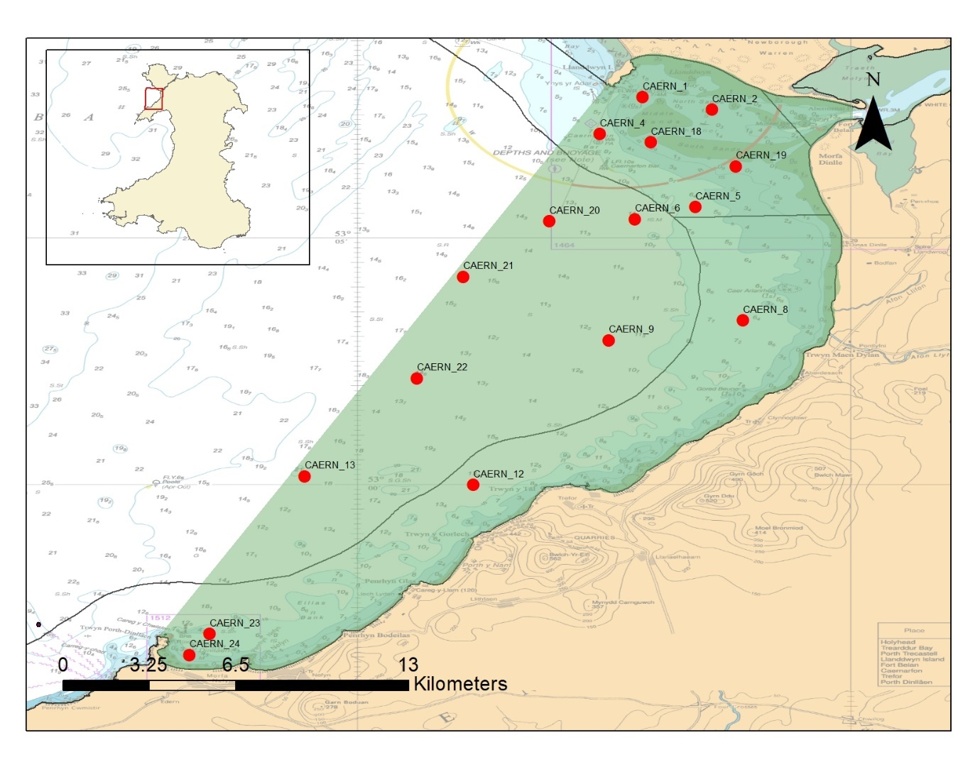
Figure 2 Caernarfon Bay Large Shallow Inlet and Bay Feature with indicative currently planned sample positions. Black lines indicate WER waterbody boundary. Light green polygon = Large Shallow Inlet and Bay Feature extent.
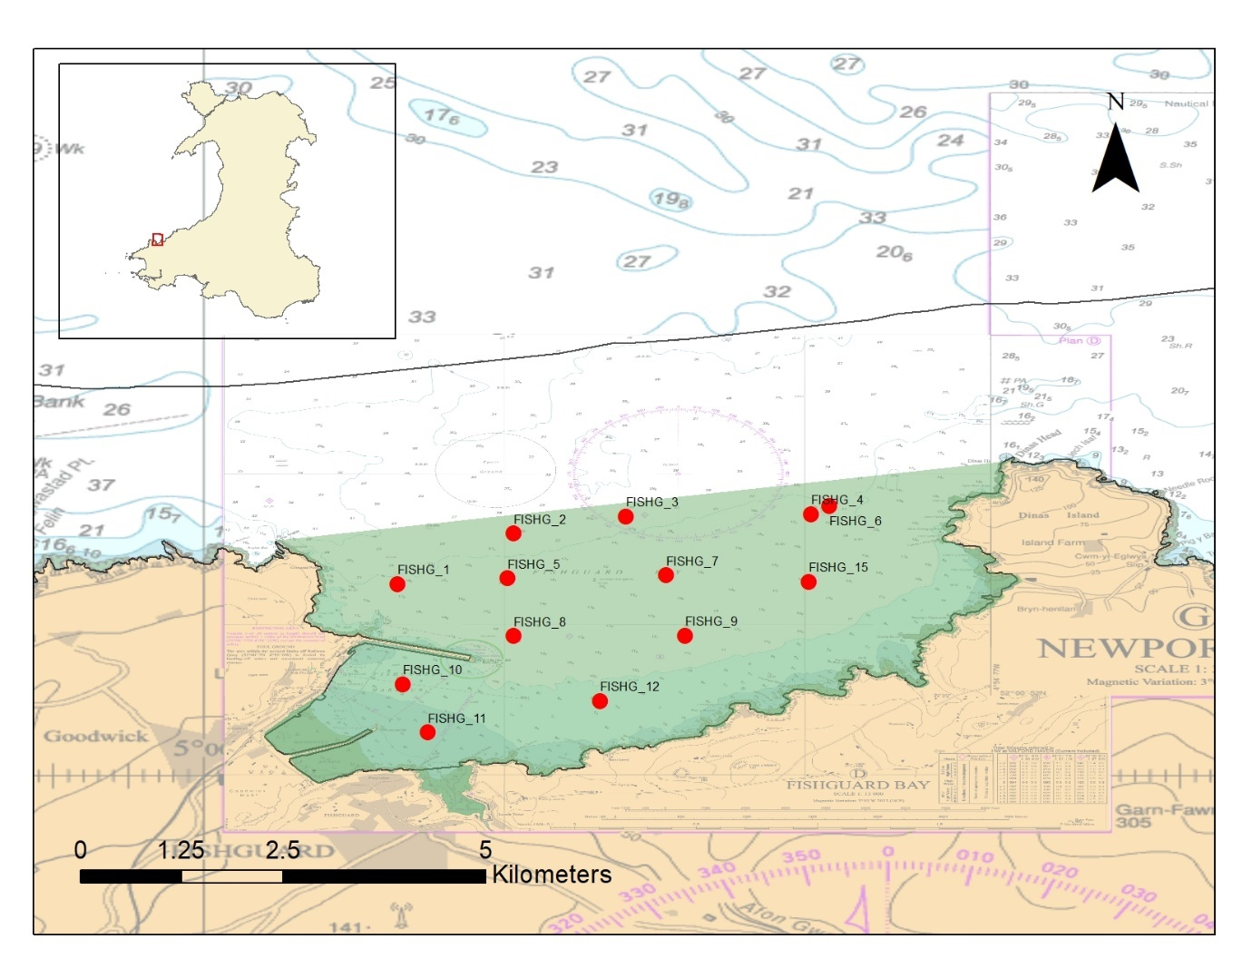
Figure 3 Fishguard Bay Large Shallow Inlet and Bay Feature with indicative currently planned sample positions. Black lines indicate WER waterbody boundary. Light green polygon = Large Shallow Inlet and Bay Feature extent.
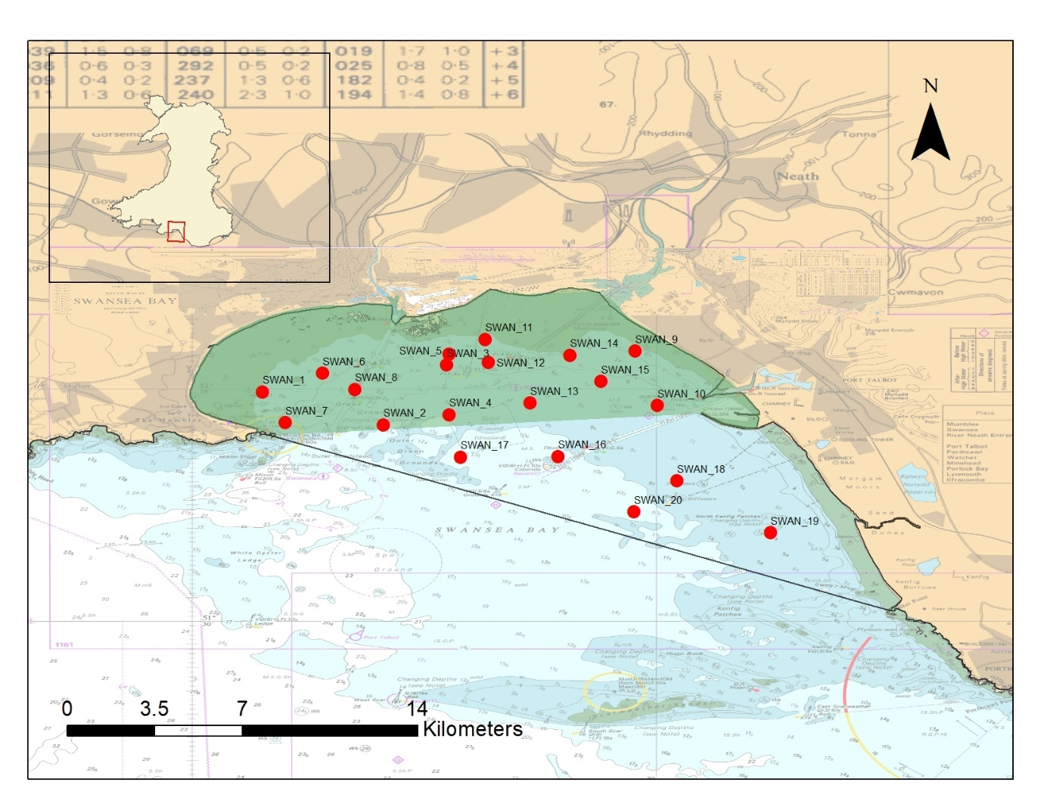
Figure 4 Swansea Bay Large Shallow Inlet and Bay Feature with indicative currently planned sample positions. Black lines indicate WER waterbody boundary. Light green polygon = Large Shallow Inlet and Bay Feature extent.

Milford Haven Waterway Environmental Surveillance Group Sampling
NRW funds and has a collaborative relationship with the Milford Haven Waterway Environmental Surveillance Group (MHWESG). The MHWESG is a group of organisations (including NRW) who aim to provide high quality environmental data to enable members of the group and other authorities and industry working in and adjacent to Milford Haven Waterway to contribute to the maintenance and enhancement of the rich and diverse marine environment in the waterway.

The Milford Haven Waterway is an important component of the Pembrokeshire Marine SAC and the data gathered is used by NRW to assess the condition of the relevant SAC features and to inform NRW’s management advice for this industrialised part of the SAC.

Every three years the group sample around Milford Haven for sediment chemistry, sediment dwelling invertebrates and sediment, the indicative positions of samples are presented in Figure 5 and in the electronic appendix.

Sediment and Invertebrates assessment:
8 stations are planned to be grab sampled to monitor biological invertebrates, 5 replicate biota grab samples are taken at all 8 stations. Each grab sample is sub-sampled for PSA analysis (or separate grabs are taken where sediment is too coarse/samples are small to sub-sample). At 12 stations (4 of the stations being sampled for biota) sediment sampling is planned for chemical analysis. Therefore there are 1-15 grabs taken at 16 stations, with a likely maximum total of 79 grab samples planned for 2027. Total numbers are based on likely scenario based on the most recent sampling. The anticipated scheduling/timing may change (Figure 5).

As with surveys detailed above the positions and timings presented are indicative and will depend on priorities and conditions but the MHWESG sampling will occur within the Milford Haven Waterway.
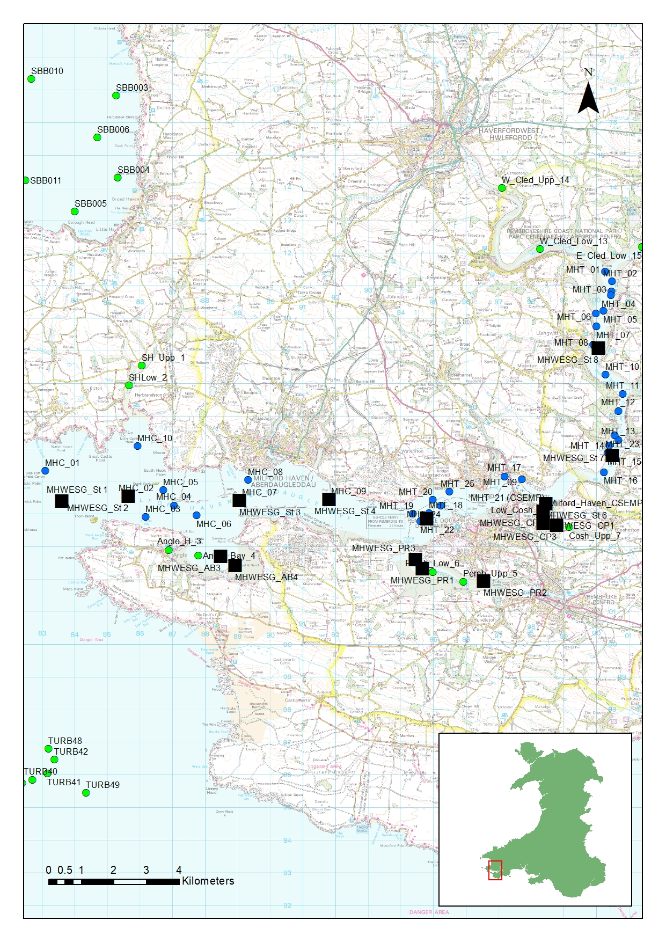
Figure 5 A chart showing indicative sample positions of the sampling to be undertaken by Milford Haven Waterway Environmental Surveillance Group in collaboration with NRW (black squares indicate approximate position of planned sample locations). Other planned samples indicated by green/blue dots.

Water Environment Regulations Surveillance Grab Sample Surveys
WER surveillance monitoring is undertaken at representative waterbodies across Wales. Grab sampling is required to assess the benthic invertebrate element of the Water Environment Regulations Assessment in subtidal environments, this will contribute to status assessments along with other ecological and physical elements. Where sampling lies within a Marine Protected Area and is relevant to one of it’s designated features, the data is used to assess feature condition and to inform NRW’s management advice for that site. WER surveys are planned at the following waterbodies (charts can be provided if required). Planned number of samples are summarised in Table 3. The planned target positions and timings presented in Figure 1 and the electronic appendix are indicative and may change with changing priorities and conditions on the day but the samples will be taken within stated WER waterbodies (below) in the 2025-2027 period:

- ‘Holyhead Bay’
- ‘CONWY’ Estuary
- ‘Conwy Bay’ (joint The Conservation of Habitats and Species Regulations 2017 survey)
- ‘TEIFI ESTUARY’
- ‘Carmarthen Bay’ (joint The Conservation of Habitats and Species Regulations 2017 survey)
- ‘Cardigan Bay North’
- ‘Cardigan Bay Central’
- ‘Milford Haven Inner’
- ‘Milford Haven Outer’
- ‘Severn Lower’ (EA)

Table 3 A summary of number of samples planned primarily for WER assessments 2025-2027
Sampling Groups | 2025 | 2026 | 2027
Coastal
Cardigan_Bay_Central_Waterbody | 0 | 0 | 20
Cardigan_Bay_North_Waterbody | 0 | 0 | 20
Carmarthen_Bay (joint Habs) | 0 | 92 | 0
Conwy_Bay (joint habs/investigation survey) | 178 | 0 | 0
Holyhead_Bay_WER_waterbody | 20 | 0 | 0
Milford_Haven_Outer_Waterbody | 20 | 0 | 20
Outside Waterbody
Conwy_Bay | 24 | 0 | 0
Transitional
Conwy__Estuary | 10 | 0 | 0
Milford_Haven_Inner_Waterbody | 50 | 0 | 50
Teifi_Waterbody | 0 | 24 | 0
Grand Total | 302 | 116 | 110
Severn_lower | 100

EA England Water Environment Regulations Surveillance Grab Sample Surveys
The Environment Agency plan to undertake some sampling within the Severn Lower waterbody. To ensure surveys are representative they will likely be required to sample within Welsh waters. The Severn may require 100 samples within this waterbody on the welsh side but is likely to be less than this.
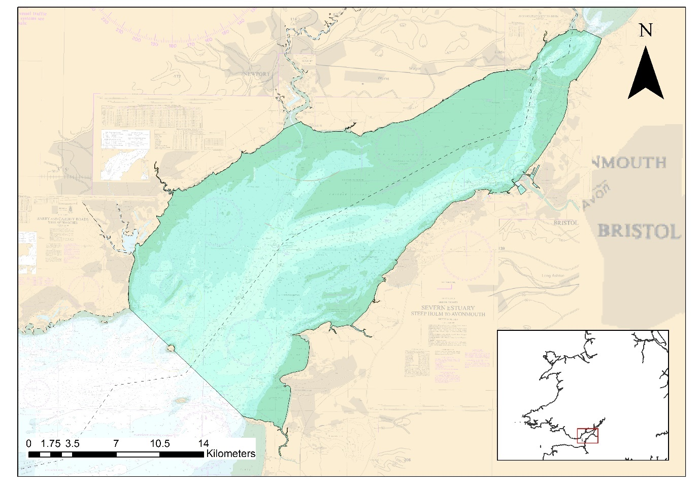
Figure 6 Chart showing the Severn Lower WER waterbody with Welsh/English boundary (dashed line)

Skomer Marine Conservation Zone Monitoring
Sediment infauna and epifaunal communities are recognised as management features of the Skomer Marine Conservation Zone. The sediments studied at Skomer also include several of the priority sediment habitats identified in Section 7 of the Environment (Wales) Act 2016. Surveys are required every 4 years to assess the condition of local habitats. All sampling lies within the Pembrokeshire Marine SAC and the data is used for SAC feature condition assessments and to inform SAC management. 3 samples are planned to be collected at 12 locations (36 samples in total). See Figure 5 and electronic appendix for a summary of sampling locations. This survey runs every 4 years so no sampling is currently planned for 2025-2027 but we wanted to include these positions in this licence application incase priorities change or there is an environmental issue which then requires samples are taken. The planned target positions and timings presented are indicative and may change with changing priorities and conditions on the day, but sampling will remain within the MCZ boundary (currently planned in 2028) (Figure 5).
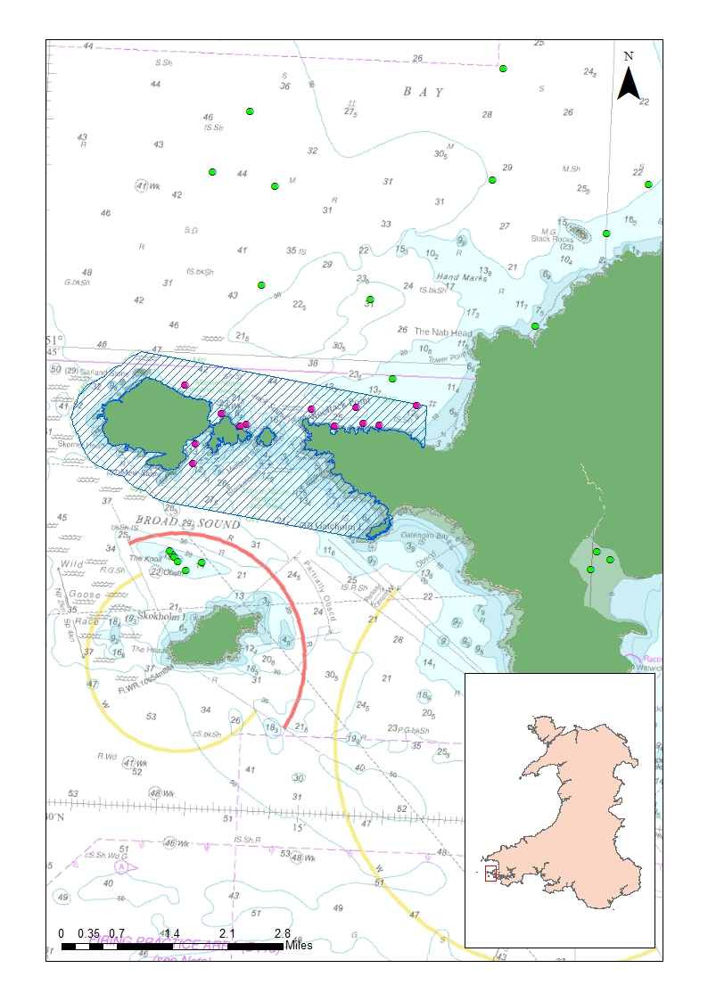
Figure 7 Skomer Marine Conservation Zone with indicative currently planned sample positions (purple/green dots).

Clean Seas Environment Monitoring Programme (CSEMP)
The CSEMP programme provides a coordinated approach to environmental monitoring in the UK's coastal and estuarine areas. Contaminants are measured in waters, sediments, and biota to assess their distribution and fate in the environment. Biological effects are also measured to determine the response of organisms to contaminants. The programme fulfils the UK's commitment to European directives including its mandatory monitoring requirements under the Oslo and Paris Convention (OSPAR) Joint Assessment Monitoring Programme (JAMP). There are two sites in Wales (In the Dee, The Severn and Milford Haven) which are monitored using grab sampling. This is an important long-term monitoring programme which informs various statutory assessments (Figure 1) including N2K condition assessments and management advice. Up to 20 samples are taken at each CSEMP station annually for biota, sediment, and chemistry (Metals and Organic compounds), usually 15 samples are taken. Positions are provided in the appended table of positions.

Water Environment Regulations Operational Grab Sample Surveys
Operational WER monitoring will be undertaken for invertebrate communities where the waterbody is thought to be at risk. Monitoring may also be undertaken in any WER TraC waterbody currently unmonitored for benthic invertebrates, so we have at one benthic classification for all waterbodies. Between 2025 and 2027 these waterbodies may be monitored once on an operational basis (with up to 100 grab samples taken in each waterbody over the 3-year licence period), this will depend on budget, prioritisation, logistical planning, and available resources. Where sampling lies within an N2K site and is relevant to one of its designated features, the data will be used to assess feature condition and to inform NRW’s management advice for that site. A preliminary assessment of all the waterbodies thought to be currently ‘at risk’ or unmonitored and suitable for grab sampling was undertaken (Table 4). Waterbodies at risk are most likely to be monitored (although not currently planned). These are presented in Figure 8 -Figure 11.

Table 4 A summary of WER waterbodies ‘at risk’ or unmonitored which may be operationally monitored for invertebrates 2025-2027. Waterbody type, Transitional = T, Coastal = C. The reason for monitoring is provided.
Waterbody Name | Waterbody Type | Reason for survey
Anglesey North | C | Unmonitored
Bristol Channel Inner North | C | At risk
Bristol Channel Outer North | C | At risk
Caernarfon Bay North | C | At risk
Caernarfon Bay South | C | Unmonitored
Cardigan Bay South | C | Unmonitored
Cefni | T | At risk
Cymran Bay | C | Unmonitored
Grasholm Island and the Smalls | C | Unmonitored
Menai Strait | C | Unmonitored
North Wales | C | Unmonitored
Pembrokeshire South | C | Unmonitored
The Skerries | C | Unmonitored

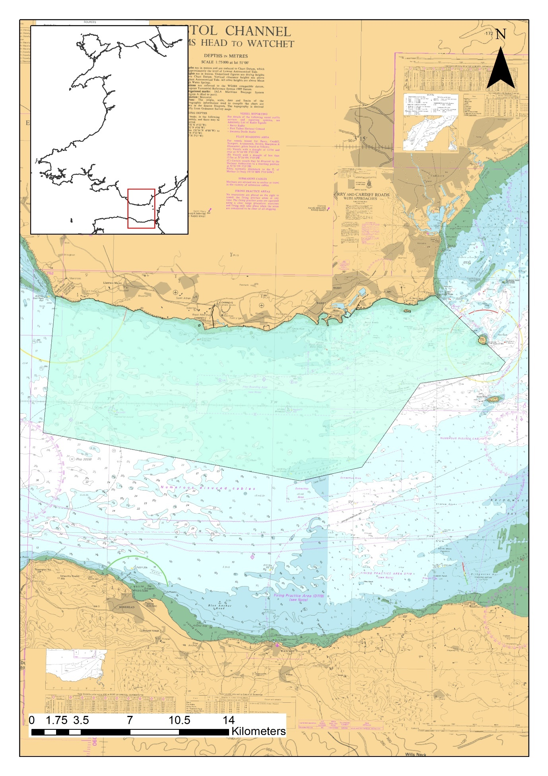
Figure 8 The Bristol Channel Inner North Waterbody (light blue transparent polygon).
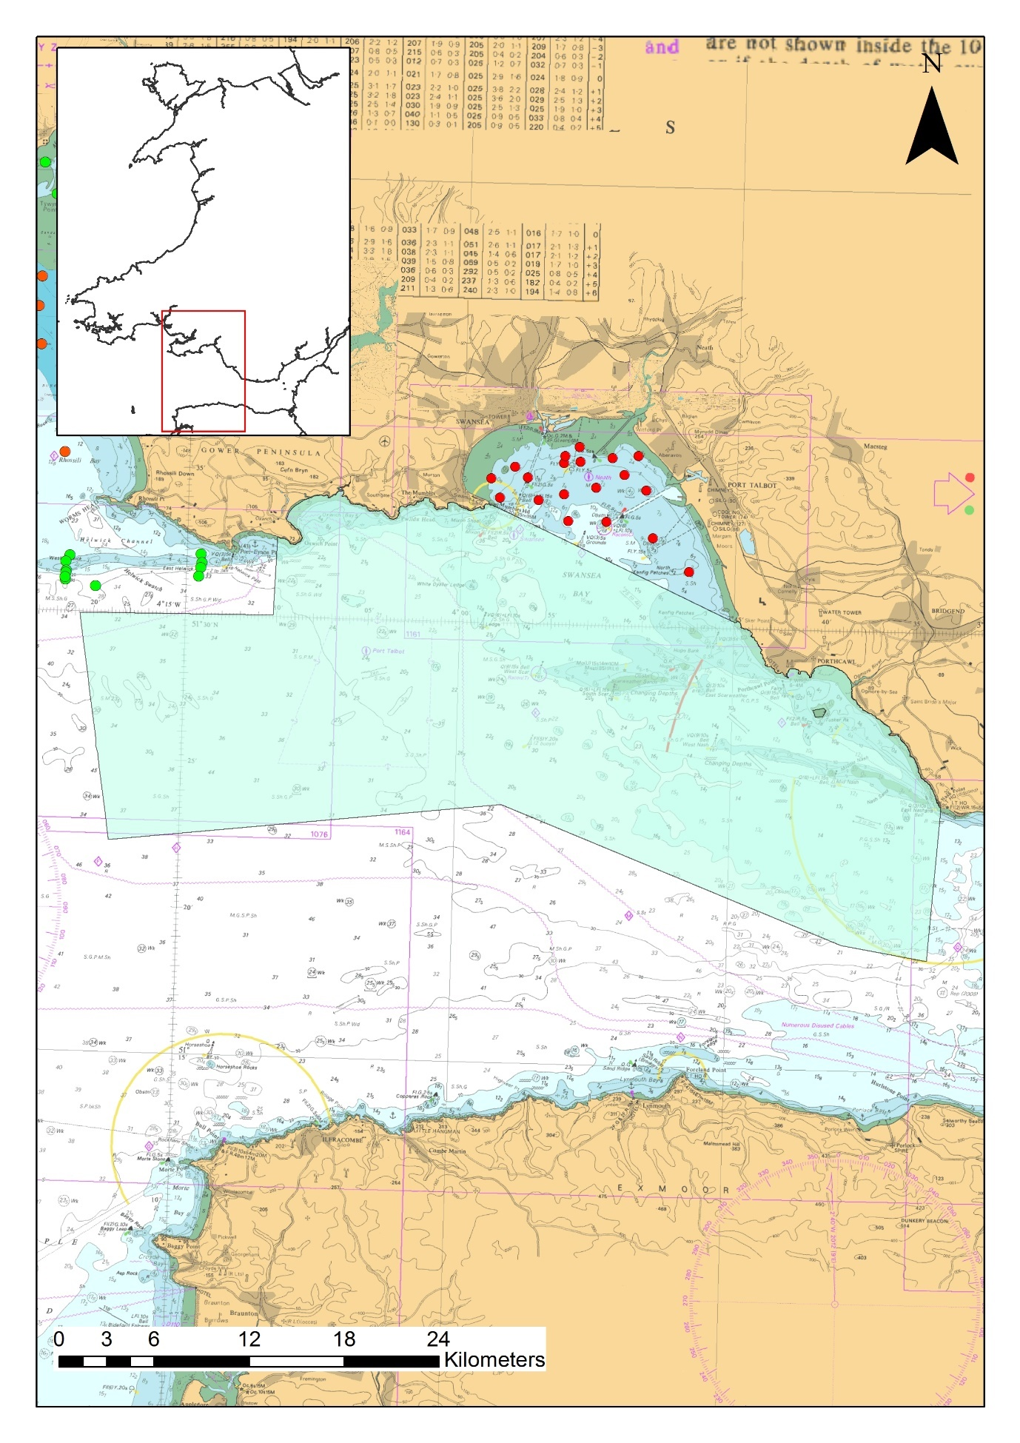
Figure 9 The Bristol Channel Outer North Waterbody (light blue transparent polygon). Red/green dots = currently planned sample stations.
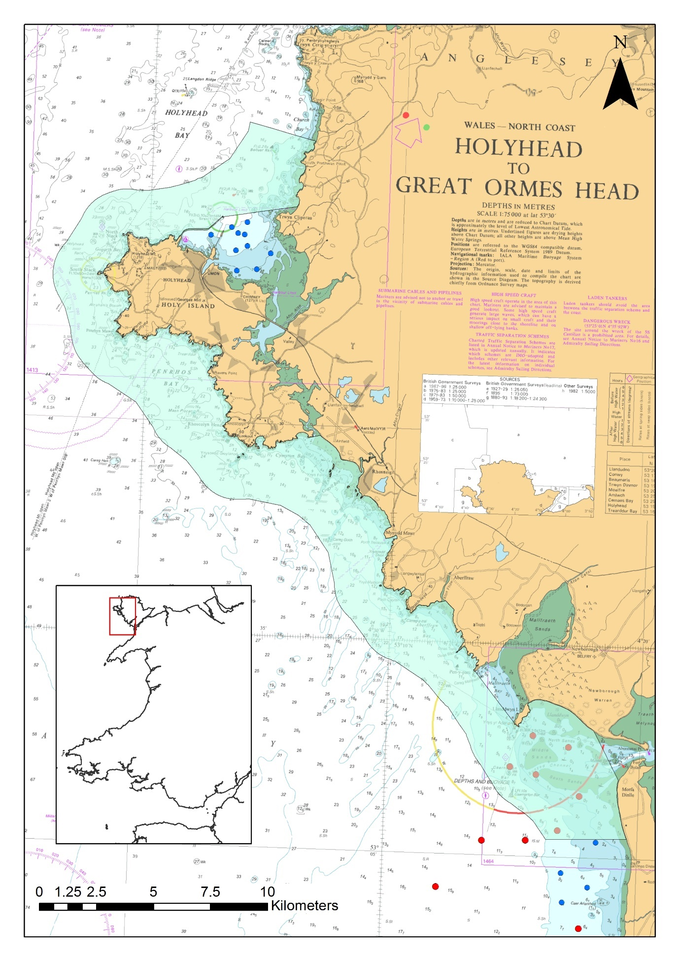
Figure 10 The Caernarfon Bay North Waterbody (light blue transparent polygon). Red/blue dots = currently planned samples.

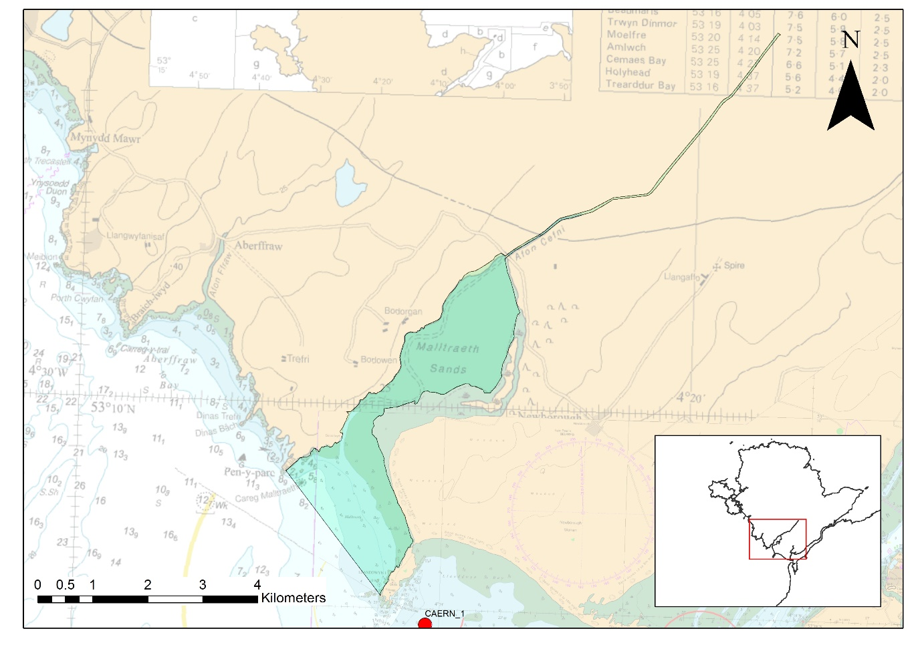
Figure 11. The Cefni Waterbody (light blue transparent polygon).

Water Environment Regulations Failure Investigation Survey

Conwy Bay has failed to meet Good ecological status in Cycle 2 (2015), Cycle 3 (2021) and in Cycle 3 interim (2024) Infaunal Quality Index (IQI) classifications. An investigation into the failures have indicated several Reasons for Not Achieving Good status (RNAGs). These are associated with metal contamination from historic metal mines and nutrient enrichment from sewage and agricultural sources. As part of the investigation, a grab survey of Conwy Bay has been planned to collect sediment chemistry samples in conjunction with the regular broad scale monitoring. The survey will collect sediment samples to test for metal contamination, nutrient enrichment, pharmaceuticals and hydrocarbons. The survey aims to utilise a double 0.1m2 Grab to sample biota and chemistry simultaneously. Two additional stations near to sewage discharge points have also been added to the survey plan to provide a chemical profile associated with point sources of sewage in the bay. This survey will aim to link the potential RNAGs to the IQI failure within the Bay. The numbers for this investigation work are included in the Conwy Bay survey work. The numbers of samples will be per grab (i.e. each dual sample will count as 2 single grabs in the figures presented in this document and in appended tables).`

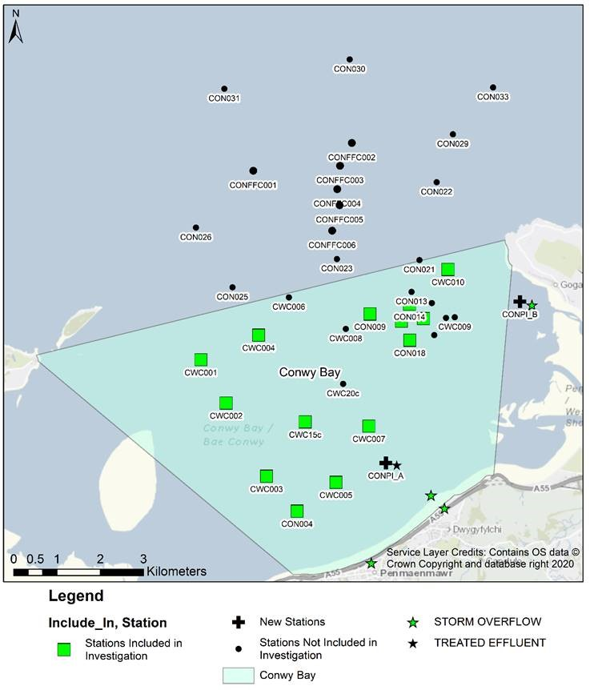
Figure 12 The planned survey for Conwy Bay in 2025 including both broad scale sampling and additional investigatory sediment chemistry sampling.

Ad Hoc sampling (unplanned)

Ad hoc MPA surveys
There may be a requirement for unplanned surveys to be undertaken in response to an incident or if monitoring priorities change. Where the MPA is an N2K site, this sampling will be directly necessary to the management of that site. Ad Hoc surveys could be carried out within all SACs outlined below – a maximum of 200 additional samples per SAC per year (in addition to those planned outlined above). It is extremely unlikely that all these ad hoc samples will be taken.
- Pen Lleyn a’r Sarnau SAC
- Carmarthen Bay and Estuaries SAC
- Pembrokeshire Marine SAC
- Menai Strait and Conwy Bay SAC
- Cardigan Bay SAC
- Severn Estuary (Wales) SAC
- The Dee Estuary (Wales) SAC
Figure 13 A list of Special Areas of Conservation with associated ‘ad hoc’ samples
Special Area of Conservation | 2025 | 2026 | 2027
Cardigan Bay / Bae Ceredigion | 200 | 200 | 200
Carmarthen Bay and Estuaries / Bae Caerfyrddin ac Aberoedd | 200 | 200 | 200
Dee Estuary / Aber Dyfrdwy (Wales) | 200 | 200 | 200
Pembrokeshire Marine / Sir Benfro Forol | 200 | 200 | 200
Pen Llyn a'r Sarnau / Lleyn Peninsula and the Sarnau | 200 | 200 | 200
Severn Estuary (Wales) SAC | 200 | 200 | 200
Y Fenai a Bae Conwy / Menai Strait and Conwy Bay | 200 | 200 | 200

Water Environment Regulations Investigation Monitoring
Ad Hoc samples (positions not yet planned) for investigation of WER failures / pollution (and other) incidents may be required and will be included in this Marine Licence application. A maximum of 200 samples per waterbody (coastal or transitional – see Figure 14), with a maximum of 400 samples per annum is expected to be sufficient to include in this licence (in addition to planned sampling outlined above). It is very unlikely that all these potential samples would be taken. Where sampling lies within an N2K site and is relevant to one of it’s designated features, the data will be used to assess feature condition and to inform the management for that site.
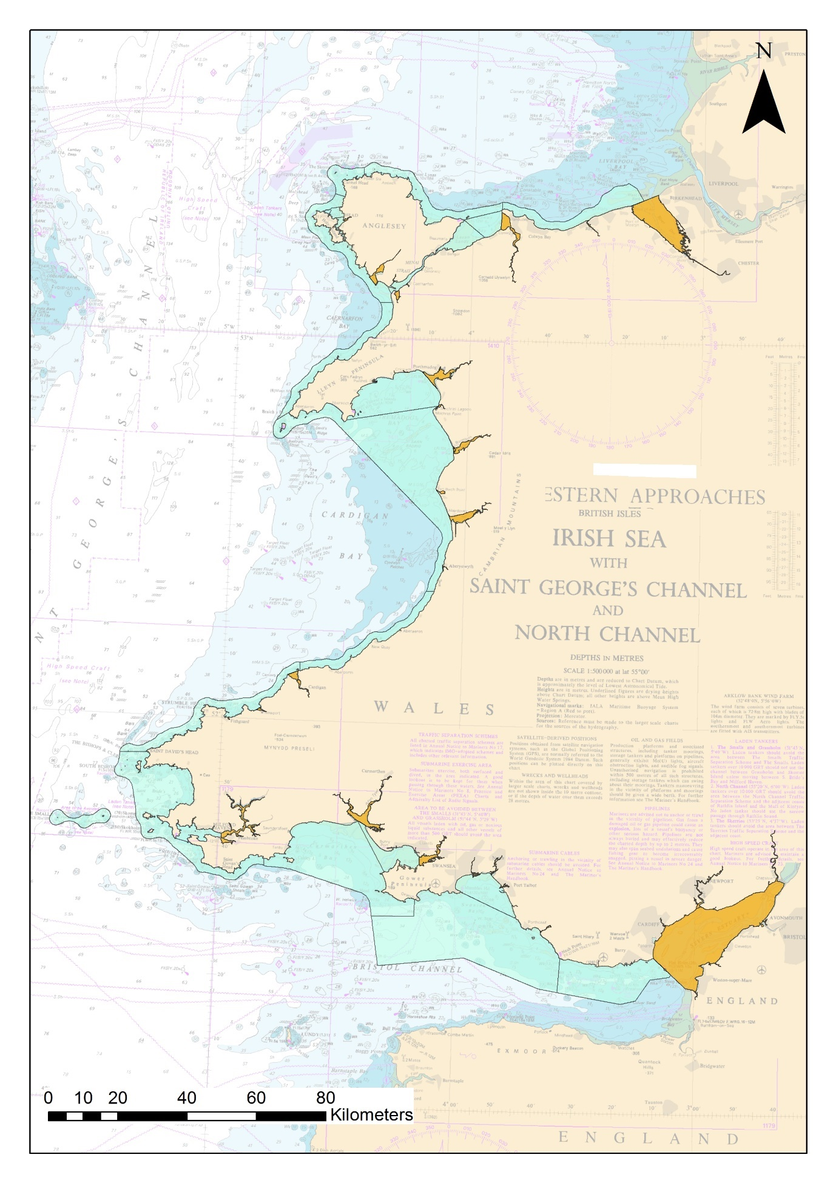
Figure 14 Welsh Coastal and Transitional WER waterbodies (light blue = coastal & orange = transitional).

Welsh Territorial Waters
NRW will also include 200 additional samples per annum which can be taken anywhere within Welsh Territorial Waters (up to 12nm) to cover sampling not covered by other ad hoc samples. This will cover NRW for grab sampling requirements for pollution incidents, changing monitoring priorities and additional sampling not covered by other ad hoc sampling. Where sampling lies within an N2K site and is relevant to one of it’s designated features, the data will be used to assess feature condition and to inform NRW’s management advice for that site.
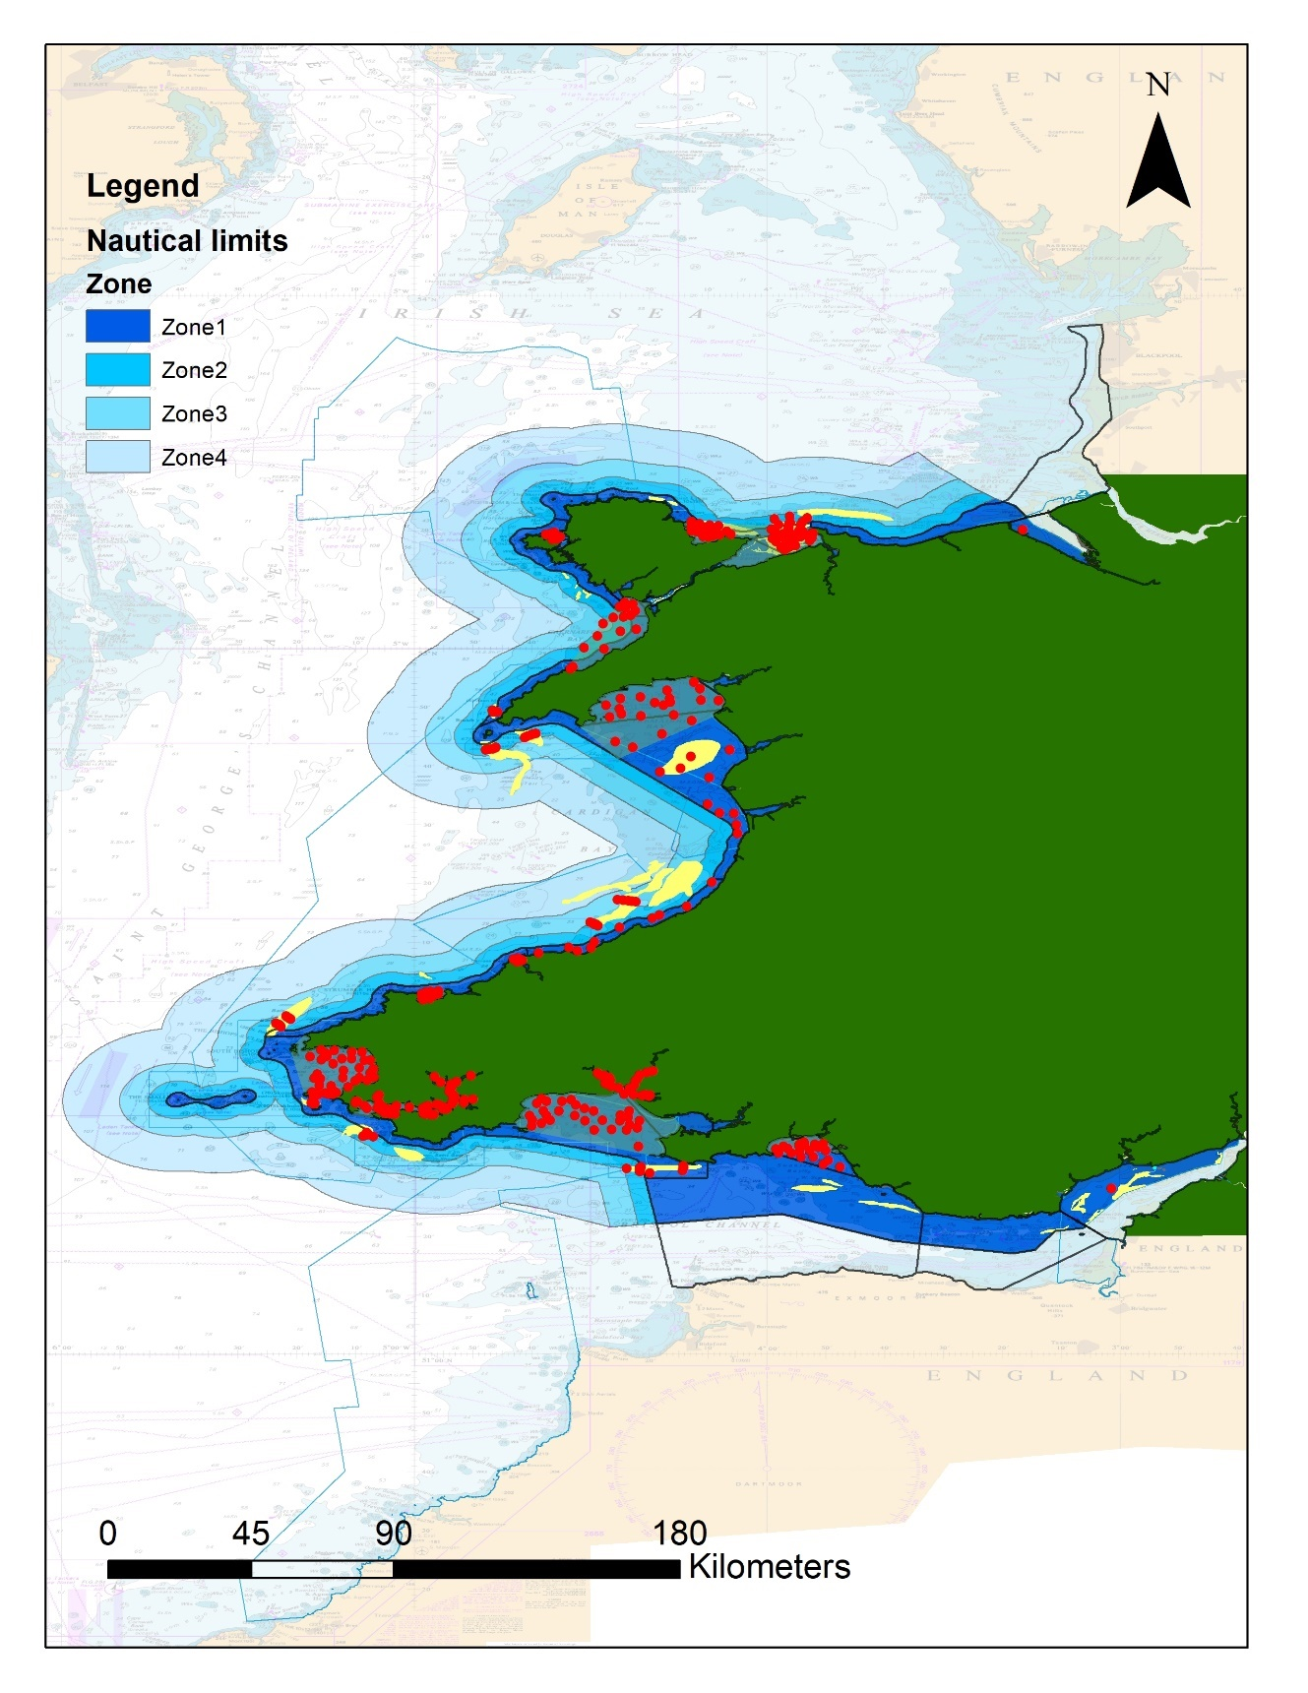
Figure 15 Welsh Territorial Limits. (Please ignore plotted sampling locations) Zone 4 = 6nm - 12nm, Zone 3 = 3nm - 6nm, Zone 2 = 1nm - 3nm and Zone 1 = MHW -1nm

Summary of sampling:
Overall, a maximum of 8,825 samples are included in this application. It is extremely unlikely that anywhere near the maximum number of adhoc samples will be taken but this licence application aims to cover all eventualities and cover sampling requirements for any incident responses or changing monitoring requirements.

Table 5 A summary of the number of grab samples included in this licence application, numbers are provided by year to indicate the most likely situation but timing is indicative only.
Planned/unplanned | Sampling Group | 2025 | 2026 | 2027
Planned sampling | Regulation 9a | 120 | 194 | 120
Planned sampling | Habs | 443 | 190 | 330
Planned sampling | Habs/WER (collaborative) | 242 | 112 | 60
Planned sampling | MCZ | 0 | 0 | 36
Planned sampling | MHWESG | 0 | 0 | 79
Planned sampling | WER | 100 | 24 | 110
Planned sampling | EA Severn Estuary (WER) | 100
Planned sampling | CSEMP | 55 | 55 | 55
Total Planned | 2,425
WER operational (uncertain) | Bristol Channel Inner North | 100
WER operational (uncertain) | Bristol Channel Outer North | 100
WER operational (uncertain) | Caernarfon Bay North | 100
WER operational (uncertain) | Cefni | 100
Total Possible Operational | 400
Unplanned | Cardigan Bay / Bae Ceredigion | 200 | 200 | 200
Unplanned | Carmarthen Bay and Estuaries / Bae Caerfyrddin ac Aberoedd | 200 | 200 | 200
Unplanned | Dee Estuary / Aber Dyfrdwy (Wales) | 200 | 200 | 200
Unplanned | Pembrokeshire Marine / Sir Benfro Forol | 200 | 200 | 200
Unplanned | Pen Llyn a'r Sarnau / Lleyn Peninsula and the Sarnau | 200 | 200 | 200
Unplanned | Severn Estuary (Wales) SAC | 200 | 200 | 200
Unplanned | Y Fenai a Bae Conwy / Menai Strait and Conwy Bay | 200 | 200 | 200
Unplanned | Welsh territorial Wates | 200 | 200 | 200
Unplanned | WER waterbodies | 400 | 400 | 400
Total Unplanned | 6,000
Total Possible | 8,825

Samples within designated areas
Information below can be used to inform Habitat Regulations assessment and Water Environment Regulations assessments which may be required for this licence. Some of the various surveys described above overlap spatially and samples are planned to be used for multiple drivers to maintain high efficiency. Rather than give numbers of samples per survey we provide below the numbers of planned samples with indicative sample points divided up by SAC and by WER waterbodies (which themselves overlap). This information should provide a good indication of the scale of the activity for HRA /WER Assessment purposes. However actual numbers of samples and timing may change with changes in monitoring priorities (as described above). Sample numbers for incident response (WER waterbodies), operational WER monitoring (other than Caernarfon Bay South which is uncertain) and welsh territorial waters sampling have not been included in this table.

Table 6 Number of grab samples currently planned in Welsh MPAs (MPA boundaries accessed in 2021)
Marine Protected Area | 2025 | 2026 | 2027
Sites of Scientific Interest
Aber Taf / Taf Estuary | 56 | - | -
Aber Taf / Taf Estuary & Whitehill Down (between 2 SSSIs) | 14 | - | -
Afon Tywi | 49 | - | -
Arfordir Pen-bre / Pembrey Coast | 35 | - | -
De Porth Sain Ffraid / St Bride's Bay South | - | - | 6
Dee Estuary / Aber Afon Dyfrdwy | 20 | 20 | 20
Milford Haven Waterway | 30 | 20 | 179
Skomer Island and Middleholm | - | - | 6
RAMSAR
The Dee (Wales) | 20 | 20 | 20
SPA
Anglesey Terns / Morwenoliaid Ynys Môn | 20 | - | -
Bae Caerfyrddin / Carmarthen Bay | 40 | 90 | 40
Glannau Aberdaron ac Ynys Enlli / Aberdaron Coast and Bardsey Island | - | - | 45
Liverpool Bay / Bae Lerpwl (Wales) | 291 | 40 | 40
Northern Cardigan Bay / Gogledd Bae Ceredigion | 30 | 30 | 68
Skomer, Skokholm and the Seas off Pembrokeshire | 24 | 10 | 36
The Dee Estuary (Wales) | 20 | 20 | 20
Harbour Porpoise SAC
Bristol Channel Approaches / Dynesfeydd Môr Hafren | 43 | 92 | 40
North Anglesey Marine / Gogledd Môn Forol | 20 | - | -
West Wales Marine / Gorllewin Cymru Forol | 148 | 202 | 212
Marine SAC (not Harbour Porpoise SAC)
Cardigan Bay / Bae Ceredigion | - | 54 | 16
Cardigan Bay / Bae Ceredigion Ad Hoc | 200 | 200 | 200
Carmarthen Bay and Estuaries / Bae Caerfyrddin ac Aberoedd | 230 | 92 | 40
Carmarthen Bay and Estuaries / Bae Caerfyrddin ac Aberoedd Ad Hoc | 200 | 200 | 200
Dee Estuary / Aber Dyfrdwy (Wales) | 20 | 20 | 20
Dee Estuary / Aber Dyfrdwy (Wales) Ad Hoc | 200 | 200 | 200
Pembrokeshire Marine / Sir Benfro Forol | 181 | 110 | 386
Pembrokeshire Marine / Sir Benfro Forol Ad Hoc | 200 | 200 | 200
Pen Llyn a'r Sarnau / Lleyn Peninsula and the Sarnau | 50 | 52 | 149
Pen Llyn a'r Sarnau / Lleyn Peninsula and the Sarnau Ad Hoc | 200 | 200 | 200
Severn Estuary/ Môr Hafren SAC ad hoc | 15 | 15 | 15
Severn Estuary/ Môr Hafren SAC ad hoc | 200 | 200 | 200
Y Fenai a Bae Conwy / Menai Strait and Conwy Bay | 291 | 40 | 40
Y Fenai a Bae Conwy / Menai Strait and Conwy Bay Ad hoc | 200 | 200 | 200

The planned samples numbers are indicative based on current monitoring plans (barring operational difficulties). The other sample numbers (labelled ‘ad hoc’) are maximums, and it is extremely unlikely that all will be taken but are included to allow flexibility to respond to events over the 3 years. Timing (year) of surveys may be subject to change. Ad hoc (unplanned) samples and samples for Severn Lower (EA) are not included under Special Areas of Conservation, Harbour Porpoise Special Areas of Conservation, Sites of Scientific Interest, RAMSARs or Special Protection Areas in Table 6.

Habitats Regulation Assessment (HRA)

Designated N2K Sites
Sampling may be undertaken in the following Special Areas of Conservation:

- Y Fenai a Bae Conwy / Menai Strait and Conwy Bay
- Severn Estuary (Wales)
- Dee Estuary / Aber Dyfrdwy (Wales)
- Cardigan Bay / Bae Ceredigion
- Pembrokeshire Marine / Sir Benfro Forol
- Carmarthen Bay and Estuaries / Bae Caerfyrddin ac Aberoedd
- North Anglesey Marine / Gogledd Môn Forol
- West Wales Marine / Gorllewin Cymru Forol
- Bristol Channel Approaches / Dynesfeydd Môr Hafren
- Pen Llyn a'r Sarnau / Lleyn Peninsula and the Sarnau
Sampling may be undertaken in the following Special Protection Areas:

- Bae Caerfyrddin / Carmarthen Bay
- Burry Inlet
- Severn Estuary (Wales)
- The Dee Estuary (England)
- The Dee Estuary (Wales)
- Traeth Lafan / Lavan Sands, Conway Bay
- Ynys Seiriol / Puffin Island
- Grassholm
- Liverpool Bay / Bae Lerpwl (England)
- Liverpool Bay / Bae Lerpwl (Wales)
- Severn Estuary (England)
- Glannau Aberdaron ac Ynys Enlli / Aberdaron Coast and Bardsey Island
- Northern Cardigan Bay / Gogledd Bae Ceredigion
- Skomer, Skokholm and the Seas off Pembrokeshire
- Anglesey Terns / Morwenoliaid Ynys Môn
- Dyfi Estuary / Aber Dyfi
Sampling may be undertaken in the following RAMSAR sites:

- Burry Inlet
- Cors Fochno and Dyfi
- Severn Estuary (Wales)
- The Dee Estuary (England)
- The Dee Estuary (Wales)

WER Assessment

50 Samples Per Hectare Test
A GIS analysis has shown that with the current sampling plan the number of grab samples will not exceed 50 per hectare. A 100m buffer was applied to each sample (this was a precautionary radius to allow for sampling positional error as approximately 56.5m circular buffer is required to generate 1 hectare of area), the number of times these buffered areas overlapped was highlighted using a spatial join function in ArcGIS. These sample target locations and plan were investigated in more detail.

Overall, there were no areas where sampling would meet or exceed 50 grabs per hectare per year. The densest annual sampling planned occurs around the Milford Haven CSEMP site where it is planned that up to 28 samples will be taken in 2027 (as part of Milford Haven Waterway Environmental Surveillance Group sampling, Water Environment Regulations and CSEMP sampling is planned close together).

4m³ of sediment volume test
The surveys described above overlap with many WER waterbodies (Table 7). It is noted a Band 1 licence requires that benthic grab surveys with a total volume of less than 4 cubic metres (with a density of no more than 50 samples in any one hectare) can be screened out from further assessment. This application (though it encompasses a total maximum possible volume of more than 4 cubic metres) is made up of multiple discrete surveys carried out over a 3-year period across wales to support conservation and environmental monitoring.

With current planned sampling the annual volume of sediment to be removed is very unlikely to be over the 4 cubic metres per waterbody. It is extremely unlikely that the density of the surveys will be anywhere close to 50 samples per hectare (indicative sample locations illustrate this – and Ad Hoc surveys would be extremely unlikely to reach this density).

Table 7 summarises the number of samples planned to be taken over time by water body with associated estimated maximum volume (L).

Table 7 Maximum number of possible samples within various WER waterbodies with associated volume. Volumes calculated based on an approximate max volume of 14.2L for Day and Van Veen Grabs and 12L for mini Hammon grabs
Number of samples |  |  |  | Max Volume
 | 2025 | 2026 | 2027 | 2025 | 2026 | 2027
 | Number of samples |  |  | Max possible volume (L)
Unplanned
Ad Hoc SAC sampling¹ | 200 | 200 | 200 | 2840 | 2840 | 2840
All WER waterbodies² | 200 | 200 | 200 | 2840 | 2840 | 2840
Planned (including MCZ, WER, SAC and MHWESG sampling)
Coastal
Anglesey North | 89 | 20 | 20 | 1263.8 | 284 | 284
Burry Inlet Outer | 7 | - | - | 99.4 | - | -
Caernarfon Bay North | 10 | 20 | 10 | 142 | 284 | 142
Caernarfon Bay South | 20 | 24 | 32 | 284 | 340.8 | 454.4
Cardigan Bay Central | - | - | 20 | - | - | 284
Cardigan Bay North | 10 | 10 | 36 | 142 | 142 | 511.2
Cardigan Bay South | 40 | 58 | 40 | 568 | 823.6 | 568
Carmarthen Bay | 55 | 92 | 40 | 781 | 1306.4 | 568
Conway Bay | 6 | - | - | 85.2 | - | -
Conwy Bay | 154 | 20 | 20 | 2186.8 | 284 | 284
Holyhead Bay | 20 | - | - | 284 | - | -
Milford Haven Outer | 20 | - | 121 | 284 | - | 1718.2
Pembrokeshire South | 58 | 90 | 76 | 823.6 | 1278 | 1079.2
Swansea Bay | 40 | 72 | 40 | 568 | 1022.4 | 568
Tremadog Bay | 40 | 40 | 68 | 568 | 568 | 965.6
Transitional
CONWY | 16 | - | - | 227.2 | - | -
DEE (N. WALES) | 20 | 20 | 20 | 284 | 284 | 284
MILFORD HAVEN INNER | 70 | 20 | 189 | 994 | 284 | 2683.8
Severn Lower | 15 | 15 | 15 | 213 | 213 | 213
TEIFI ESTUARY | - | 24 | - | - | 340.8 | -
TYWI & TAF & GWENDRAETH - THREE RIVERS ESTUARY | 147 | - | - | 2087.4 | - | -

¹ SACs overlap with many WER waterbodies. Potentially up to 200 samples taken as part of annual ad hoc SAC (per SAC) monitoring could be taken in intersecting WER waterbodies.
² A maximum of 200 samples will be taken to investigate WER incidents or failures in one waterbody over the three-year period.
³ Operational WER and Severn Lower and other ‘ad hoc’ sampling is not included in this table but each represents a maximum of 100 grab samples (max estimated volume of 1420L).

Worst Case Scenario
To examine the various surveys in-combination with each other we can look at the worst-case annual scenario (highest number of samples possible) using current plans (Table 7):

Scenario 1 Milford Haven Inner:
The Milford Haven Inner Waterbody has 189 planned samples in 2027, if all potential 200 Ad Hoc HD samples for Pembrokeshire Marine SAC, and all potential 200 ad Hoc WER samples for the WER waterbody also happened to be taken within the water body in the same year that would be a total of 589 samples, this equates to a maximum annual volume (assuming max volume is 14.2l) of 8.3638m³. This is an overestimate of the likely volume even if in the very unlikely event all this sampling was undertaken within the Milford Haven Inner waterbody. In the previous application an assessment was undertaken (from inlet and WER waterbody sampling) from this waterbody (whilst sampling similar target locations provided in this document) showed that the estimated average sample volume attained was 6.76 litres (if each station has the same weighting regardless of sampling intensity). If the average volume attained on this survey is used to estimate the volume of sediment to be sampled for this worst-case scenario then the total volume sampled ([589 x 6.76L]/1000) is estimated to be 3.98m³ which is under 4m³. It is extremely unlikely that all the additional ad hoc samples (400) would be taken in this waterbody in the same year as both WER and inlet (The Conservation of Habitats and Species Regulations 2017) sampling (2027) within the Milford Haven Inner Waterbody. Failed samples and samples which are to be returned (e.g. if sediment and biota don’t match) are not included in these figures.

Scenario 2; Conwy Bay:
In 2025, Conwy bay survey has been planned to include an annual maximum of 154 samples within this includes sampling for investigative purposes for both SAC and WER designations. It is therefore very unlikely that this number will increase in this year.

Scenario 3; Three Rivers:
The TYWI & TAF & GWENDRAETH - THREE RIVERS ESTUARY WER Waterbody has 147 potential survey samples in 2025, if all potential 200 Ad Hoc HD samples for Carmarthen Bay and Estuaries SAC, and all potential 200 ad Hoc WER samples for the WER waterbody also happen to be taken within the water body in this year that would be a total of 547 samples, this equates to a maximum volume (assuming max volume is 14.2l) of 7.767m3. This is a vast overestimate of the likely volume. The calculated average volume attained used in the last application was slightly over 2.21 litres of sediment per grab. If the average volume attained on this survey + 400 additional samples is used to make estimates (547 x 2.21/1000), then the total volume sampled would be 1.21m3 which is significantly under the 4m³.

Therefore, even in the extremely unlikely scenario that all ad hoc samples will be taken in the same waterbody the total volume would likely to be less than or close to 4 cubic metres annually on a waterbody scale.

High Status Hydro-morphology WFD Water Bodies

Some of the sampling occurs in waterbodies that have a high status for hydro morphology and therefore the requirement is to carry out a detailed assessment for the below water bodies.

- Teifi estuary
- Carmarthen Bay
- Pembrokeshire South
- Bury Inlet Outer
- Anglesey North
- Cardigan Bay Central
- Tremadog Bay
- Caernarfon Bay south

The grab sampling survey is temporary and for reasons demonstrated above, individual surveys would qualify as a Band 1 grab sample activity, which would screen out the requirement for a WFD assessment as part of the marine licence. Any changes in hydro morphology, if any at all, will be minor and only affect flow in the immediate vicinity at the time of sampling.

Therefore the conclusion of the detailed compliance assessment for these proposed surveys, taking into account advice received from technical specialist advisors, is the project has no potential to cause deterioration of any water body or prevent a water body or WFD Protected Area from meeting its objectives, taking into account any conditions or restrictions as applicable, either alone or in-combination with other activities.

Conclusion:
Due to the relatively low volume of sediment to be removed on an annual basis at waterbody scale it is considered that we do not require a WER assessment of this activity. Furthermore, more importantly, this sampling is undertaken to aid assessment of WER waterbody status and therefore is necessary monitoring for the Water Environment Regulations.

Sensitive Habitats:
Band 1 activities require a method statement to outline interactions with sensitive habitats. It is required that the method statement must describe the works to be undertaken. Information on relevant sensitive habitat is provided below to assist the application assessment process.
The interaction between planned sampling and known sensitive habitat (using GIS layers presented in Table 8 and Table 9) has been assessed. GIS layers used were checked with appropriate specialists from Marine and Freshwater Ecosystems/Evidence Analysis Group to ensure that most up to date sensitive habitat maps were used (see emails embedded below). Unplanned sampling, Severn waterbody sampling and adhoc sampling are not included in the figures below.
Planned sampling locations were buffered using a 50m radius which was then saved as a Polygon in ArcGIS. The intersect tool was then used to highlight where planned sampling was within 50m of a mapped sensitive area (Table 8). Egg wrack (Ascophyllum nodosum) on variable salinity rock and Tide swept egg wrack (Ascophyllum nodosum) communities were not assessed as these habitats would not be suitable for grab sampling and samples would not be planned in areas containing these habitats.
Table 8 A list of sensitive habitats defined by NRW and the related GIS layer, Accessed December 2024
Sensitive Habitat | GIS layer
- Egg wrack (Ascophyllum nodosum) on variable salinity rock | Not assessed
- Tide swept egg wrack (Ascophyllum nodosum) communities | Not assessed
- Maerl beds | Geodatabase: nmq501.9da46ec3d278.database.windows.net  - NRWGDBVECTOR.GISDATA.NERC_OSPAR_TOTALMAERL_WGS84_POLYGON
- Horse mussel (Modiolus modiolus) beds | Geodatabase: nmq501.9da46ec3d278.database.windows.net  - NRWGDBVECTOR.GISDATA.HORSE_MUSSEL_REEF_POLY_2020  - NRWGDBVECTOR.GISDATA.HORSE_MUSSEL_REEF_2020
- Oyster (Ostrea edulis) beds | Y:\Marine\Marine_Subtidal\Marine_Habitats_Species\BAP_habitats\BAP_Habitat_updates_2022.gdb  - NRW_Oyster_beds_point_v2_20220728  Areas currently being trailed for restoration have been assessed visually with Ben Wray (Oyster Restoration Project lead)
- Seagrass beds | Y:\Marine\Marine_Subtidal\Marine_Habitats_Species\BAP_habitats\BAP_Habitat_updates_2022.gdb  - NRW_Segrass_polygon_v6_20220728  Y:\Marine\Marine_Subtidal\Marine_Habitats_Species\BAP_habitats\Seagrass_updates_2024.gdb  - NRW_seagrass_Point_v10_20240626
- Sea-pen and other burrowing megafauna communities | Geodatabase: nmq501.9da46ec3d278.database.windows.net  - NRWGDBVECTOR.GISDATA.SEAPENS_2020
- Peat and clay exposures | Geodatabase: nmq501.9da46ec3d278.database.windows.net  - NRWGDBVECTOR.GISDATA.NERC_OSPAR_PEAT_CLAY_EXP_POLYGON_V2  - NRWGDBVECTOR.GISDATA.NERC_OSPAR_PEAT_CLAY_EXP_POINT_V2  - NRWGDBVECTOR.GISDATA.NERC_OSPAR_PEAT_CLAY_EXPOSURES_WGS84_POINT
- Sabellaria reefs | Y:\Marine\Marine_Subtidal\Marine_Habitats_Species\BAP_habitats\BAP_updates_2019.gdb  - NRW_Sabellaria_spinulosa_reef_point_v5_20230912  - NRW_honeycomb_worm_point_v6_20230112  Y:\Marine\Marine_Subtidal\Marine_Habitats_Species\BAP_habitats\SMMNR_biogenic_reef_polygon.gdb  - SMMNR_biogenic_reef_2019  Y:\Marine\Marine_Subtidal\Marine_Habitats_Species\BAP_habitats\Sabellaria_mapping_2024.gdb  - Sabellaria_alveolata_mapping_2024_polygon2  - Rowland_west_shore_sabellaria_polygons_2024  Y:\Marine\Marine_Subtidal\Marine_Habitats_Species\BAP_habitats\BAP_NERC_OSPAR_Habitats_BNG.gdb  - NRW_honeycomb_worm_polygon_v5_20200122

Table 9 A list of Annex I habitats assessed
Annex I Habitat | GIS Layer
- Reefs | Y:\Marine\Marine_Subtidal\Marine_Habitats_Species\Reg9a 2024\Updated layers_2024.gdb  - Reg9a_Subtidal_Reef_Points_2024  - Reg9a_Intertidal_Reefs_2024  - Reg9a_Inshore_Subtidal_reefs_2024_UTM30N  - Reg9a_Inshore_MDAC_2024
- Large Shallow Inlets and Bays | Y:\Marine\Marine_Subtidal\Marine_Habitats_Species\Reg9a 2024\Updated layers_2024.gdb  - Reg9a_LSIB_2024
- Atlantic salt meadows (Glauco-Puccinellietalia maritimae) and Salicornia and other annuals colonising mud and sand | Saltmarsh Layer which combines both Atlantic salt meadows and Salicornia:  Y:\Marine\Marine Intertidal & Coastal Ecosystems\Steve Jones\Saltmarsh\Saltmarsh_Extent_(Biological).shp
- Sandbanks | Y:\Marine\Marine_Subtidal\Marine_Habitats_Species\Reg9a 2024\Updated layers_2024.gdb  - Reg9a_sandbanks_2024
- Mud and Sand Flats | Y:\Marine\Marine_Subtidal\Marine_Habitats_Species\Reg9a 2024\Updated layers_2024.gdb  - Reg9a_MudflatsSandflats_2024

Overall, relatively few planned samples were planned close to sensitive habitats (Table 10).

Table 10 The target sample locations which are within 50m of sensitive habitat along with planned numbers of samples and year
Location | Station | 2025 | 2026 | 2027 | Sensitive Habitat
Milford_Haven_Outer_Waterbody | MHC_05 | 2 | 0 | 2 | Mearl
Milford_Haven_Inlets | Pemb_Upp_5 | 0 | 0 | 7 | Seagrass
Milford_Haven_Inlets | Pemb_Low_6 | 0 | 0 | 7 | Seagrass
Milford_Haven_Inlets | Low_Cosh_8 | 0 | 0 | 7 | Seagrass
Caernafon_Bay | CAERN_24 | 0 | 2 | 0 | Seagrass
Milford_Haven_Inner_Waterbody | MHT_21 (CSEMP) | 2 | 0 | 2 | Seagrass
Milford Haven Waterway | MHWESG_PR1 | 0 | 0 | 1 | Seagrass
Milford Haven Waterway | MHWESG_PR2 | 0 | 0 | 1 | Seagrass
Milford Haven Waterway | MHWESG_CP1 | 0 | 0 | 1 | Seagrass
Milford Haven Waterway | MHWESG_CP2 | 0 | 0 | 1 | Seagrass
Milford Haven Waterway | MHWESG_CP3 | 0 | 0 | 1 | Seagrass
Milford_Haven_Inlets | Angle_H_3 | 0 | 0 | 7 | Seagrass
Milford_Haven_Inlets | Cres_Low_12 | 0 | 0 | 7 | Seagrass
Milford_Haven_Inlets | Cosh_Upp_7 | 0 | 0 | 7 | Seagrass and Saltmarsh
Three_Rivers_Inlets | Taf_1 | 7 | 0 | 0 | Saltmarsh
Three_Rivers_Inlets | Taf_2 | 7 | 0 | 0 | Saltmarsh
Three_Rivers_Inlets | Taf_6 | 7 | 0 | 0 | Saltmarsh
Three_Rivers_Inlets | Tywi_13 | 7 | 0 | 0 | Saltmarsh
Three_Rivers_Inlets | GWN_21 | 7 | 0 | 0 | Saltmarsh
Three_Rivers_Inlets | GWN_22 | 7 | 0 | 0 | Saltmarsh
Milford_Haven_Inlets | SH_Upp_1 | 0 | 0 | 7 | Saltmarsh
Milford_Haven_Inlets | W_Cled_Upp_14 | 0 | 0 | 7 | Saltmarsh
Tremadog_Bay | TRM_21 | 10 | 10 | 10 | Seapen
Cardigan_Bay_Central_Waterbody | CBC001 | 0 | 0 | 2 | Seapen

Seagrass:
The majority of the samples highlighted are close to intertidal seagrass so presumably will be Zostera noltii. The exception to this will be in Porth Dillean where the seagrass is more likely to be Zostera marina. Most samples are close to the edge of the mapped extent rather than within the bed. The exception to this is are Low_Cosh_8 (Cosheston Pill, Pembrokeshire) and CAERN_24 (at Porthdinllaen, Pwllheli). There is no mapped seagrass at Angle_H_3 but there have been notes made about it’s presence in a recent survey at this location. Zostera noltii was recorded at Cres low 12, Ang Har 03, Cosh Upp 07, Pemb Low 06, Pemb Upp 05 and Cosh Low 08 in the most recent survey.
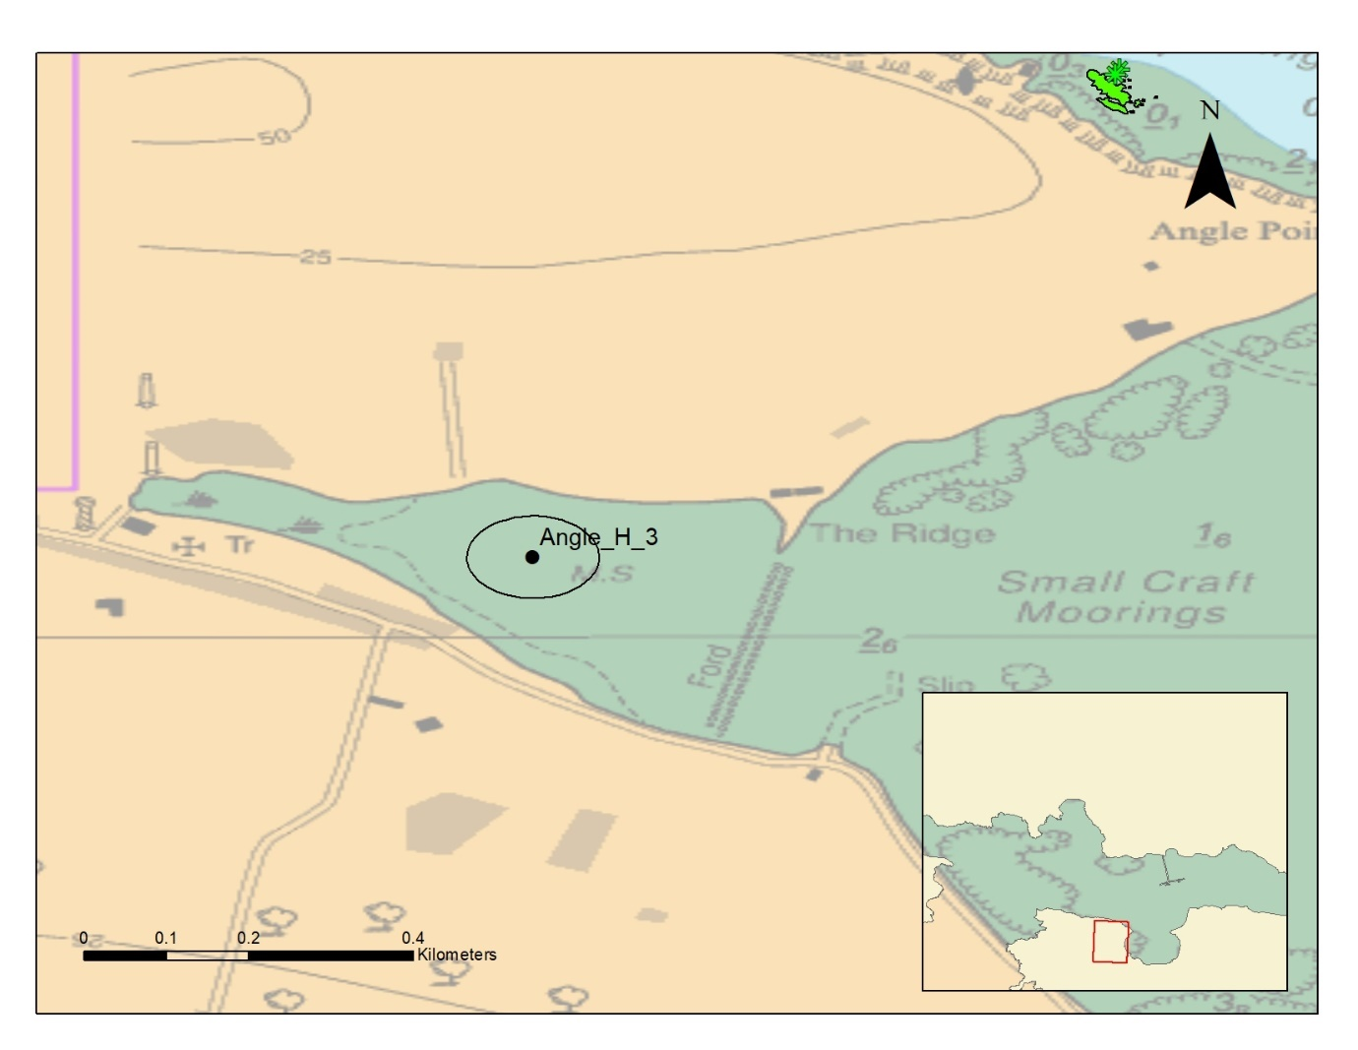
Figure 16 Seagrass extent and records at Angle Bay, Pembrokeshire. Dark green area = mapped seagrass, light green star = seagrass point observation. black spots represent currently planned sampling (with 50m buffer).
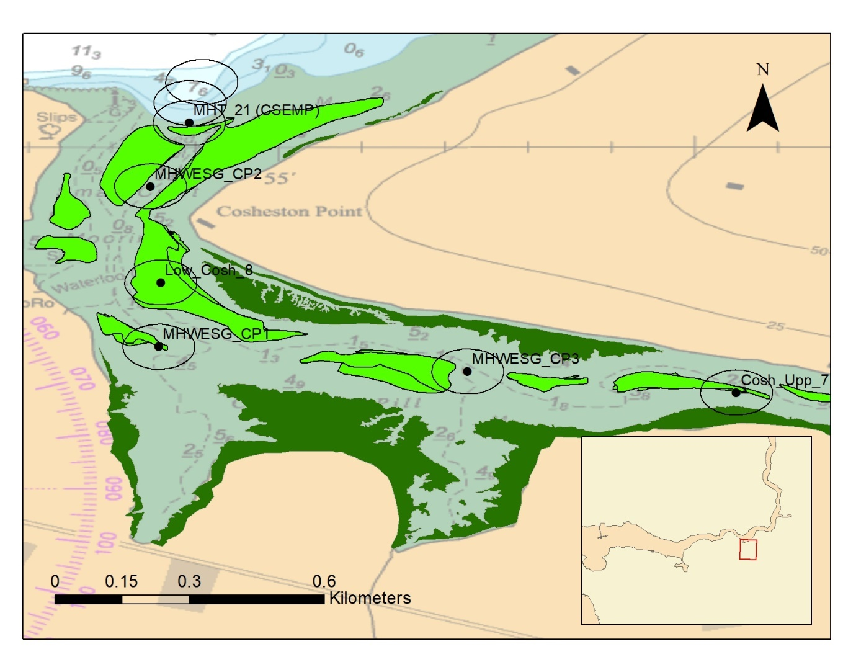Figure 17 Seagrass extent and records at Cosheston Pill, Pembrokeshire. Dark green area = mapped seagrass, light green star = seagrass point observation. Dark green area = mapped saltmarsh habitat. Black spots represent currently planned sampling which intersects with mapped seagrass area/points.
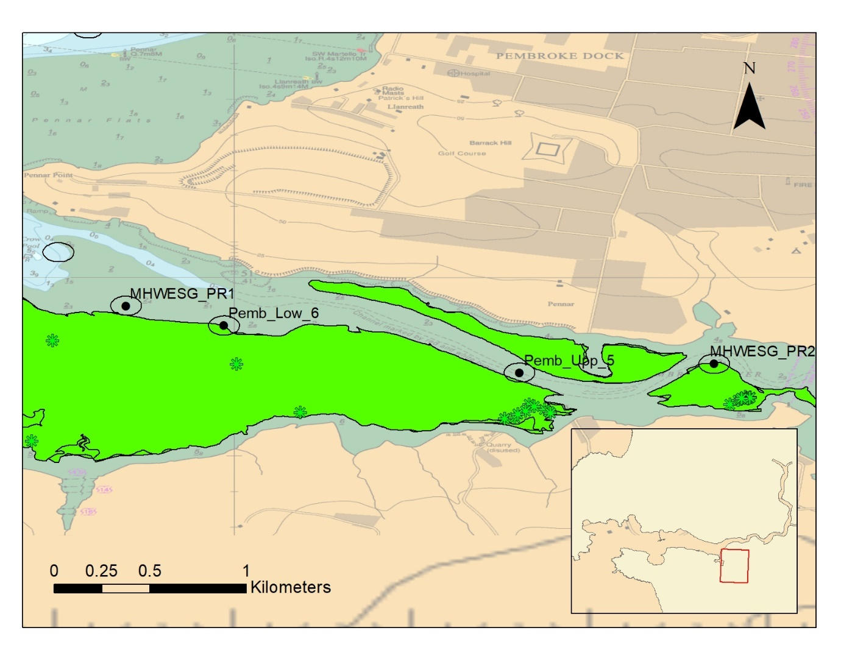Figure 18 Seagrass extent and records at Pembroke Pill, Pembrokeshire. Light green area = mapped seagrass, light green star = seagrass point observation. Labelled black dots represent currently planned sampling which intersect with recorded seagrass areas/points. Clear circles = 50m planned sampling buffer.
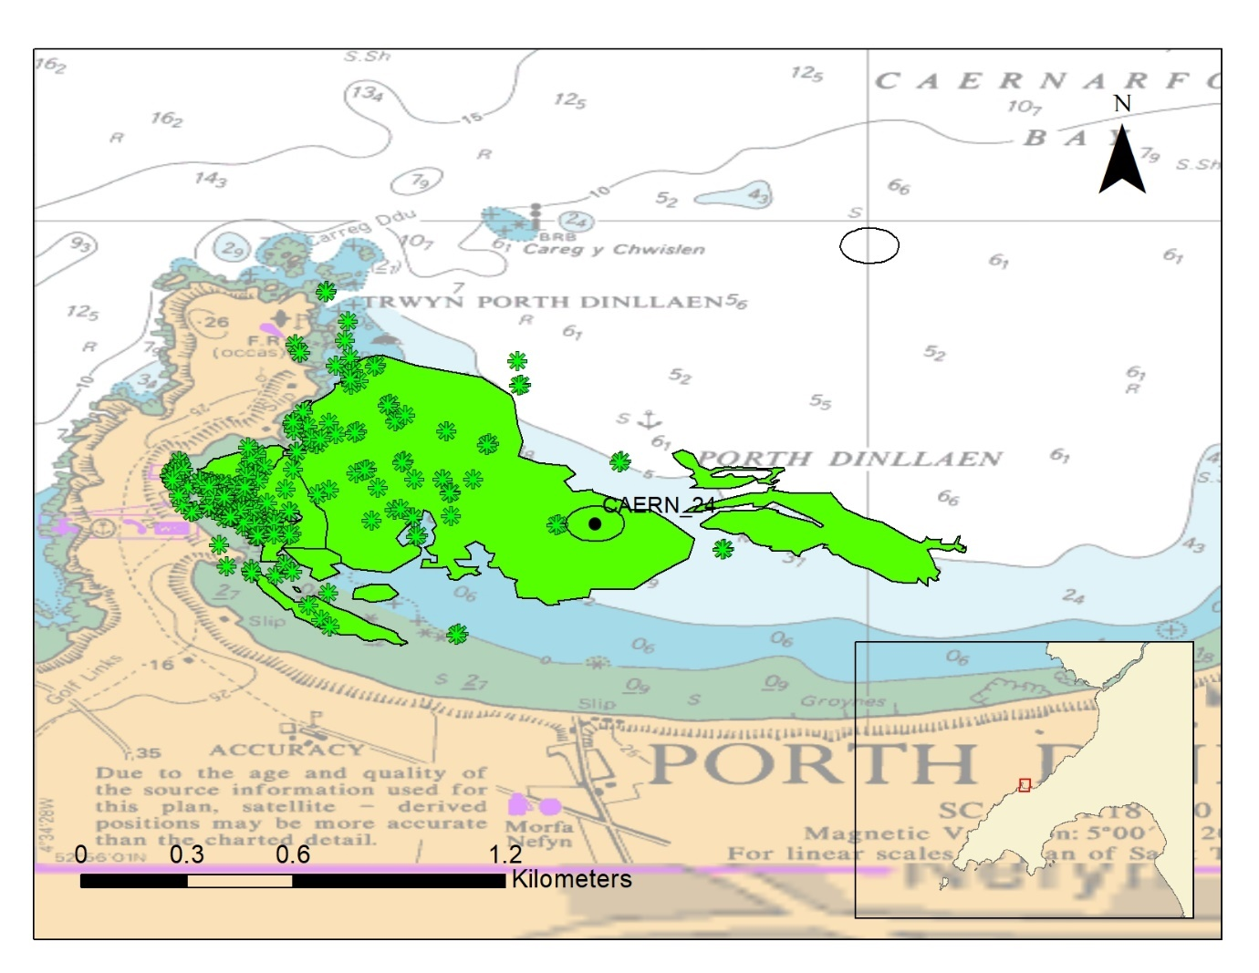Figure 19 Seagrass extent and records at Morfa Nefyn, Pwllheli. Light green area = mapped seagrass, light green star = seagrass point observation. Black dots represent currently planned sampling.
Atlantic Saltmeadow
Several sites are mapped close to Atlantic Salt meadow. Most sampling is targeted close to the edge of mapped saltmarsh. Saltmarsh is avoided as it is not possible to grab sample in saltmarsh (too shallow and not appropriate habitat).

a. | 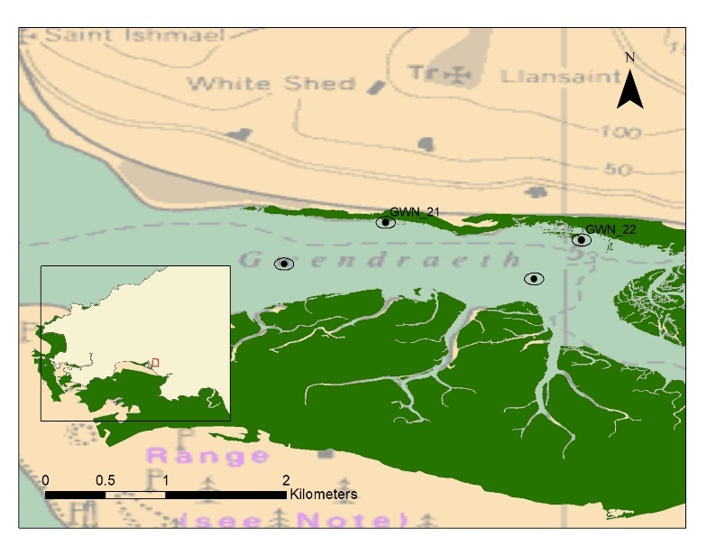
b. | 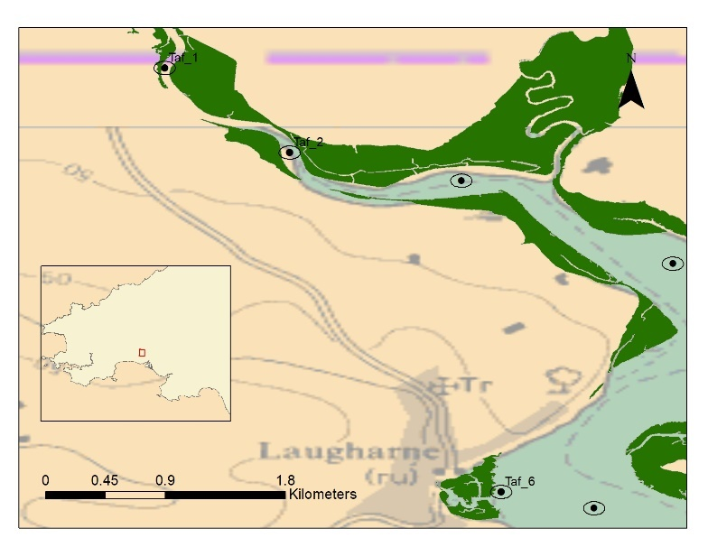
c. | 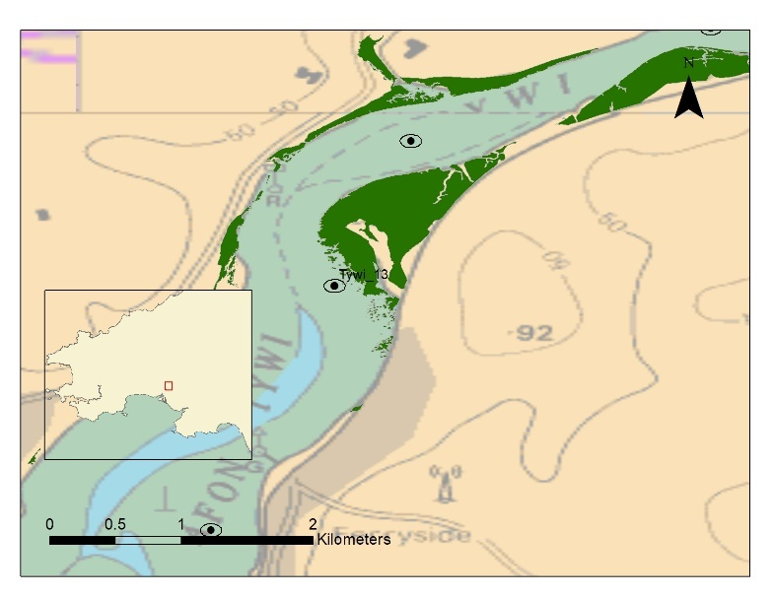

Figure 20 Mapped saltmarsh in the three rivers estuary. Dark green area = mapped saltmarsh. Black dots represent currently planned sampling with 50m buffer.
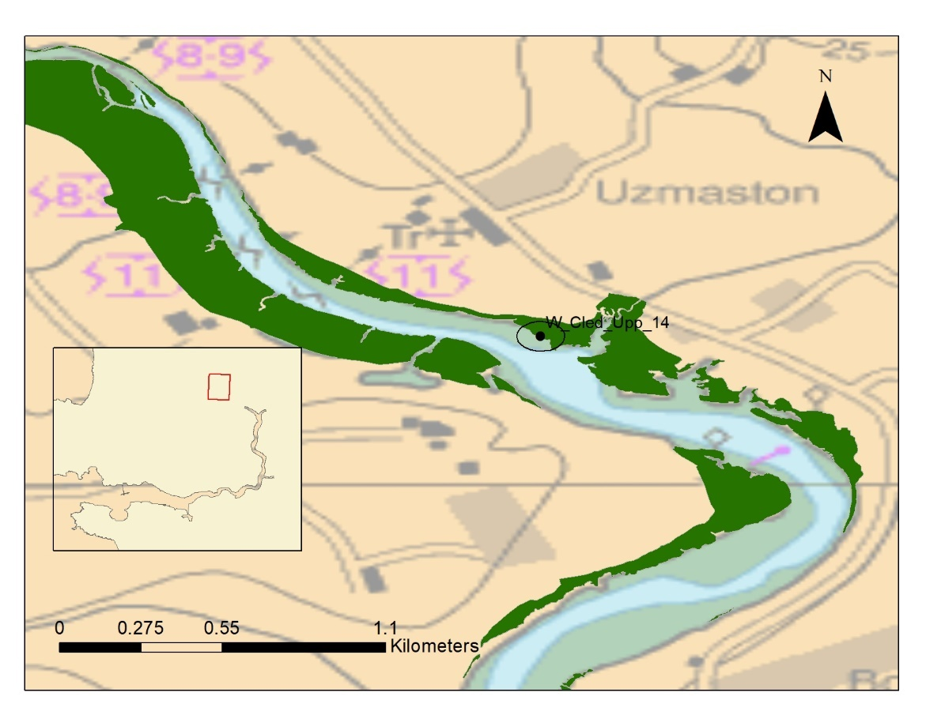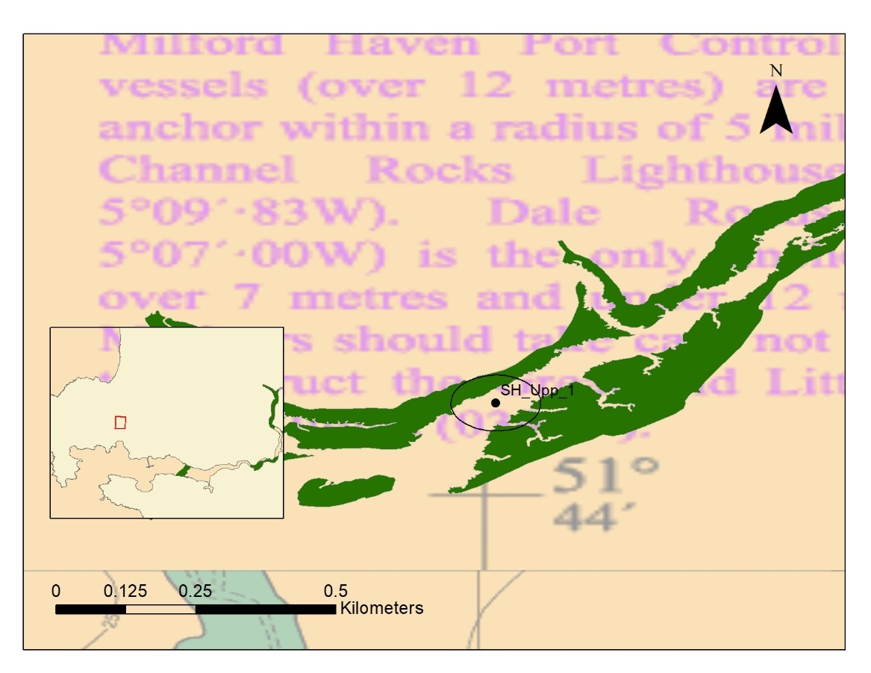
Figure 21 Mapped saltmarsh in the milford haven waterway. Dark green area = mapped saltmarsh. Black dots represent currently planned sampling with 50m buffer.

Seapens Burrowing Megafauna
Two planned grab sampling sites were thought to be close to the Sea-pen and other burrowing megafauna communities (point data). One site is in Tremadog Bay (TRM_021) and the other is in Cardigan Bay Central WER waterbody (CBC_001). The only reason we know about the area in Tremadog bay is because of information gathered from NRW grab sampling monitoring programmes. In Tremadog Bay, site TRM_021 is a surveillance station which is sampled 10 times annually whereas the site CBC_001 in Cardigan Bay Central is sampled twice every three years. A search for Virgularia mirabilis, Pennatula phosphorea, and Funiculina quadrangularis on the NBN database revealed that there were no records close to planned sampling apart from Holyhead where sampling is planned to avoid the area where Virgularia mirabilis are known to be present although this is not classified as Seapens Burrowing Megafauna as it’s presence is likely due to artificial structures.

A.
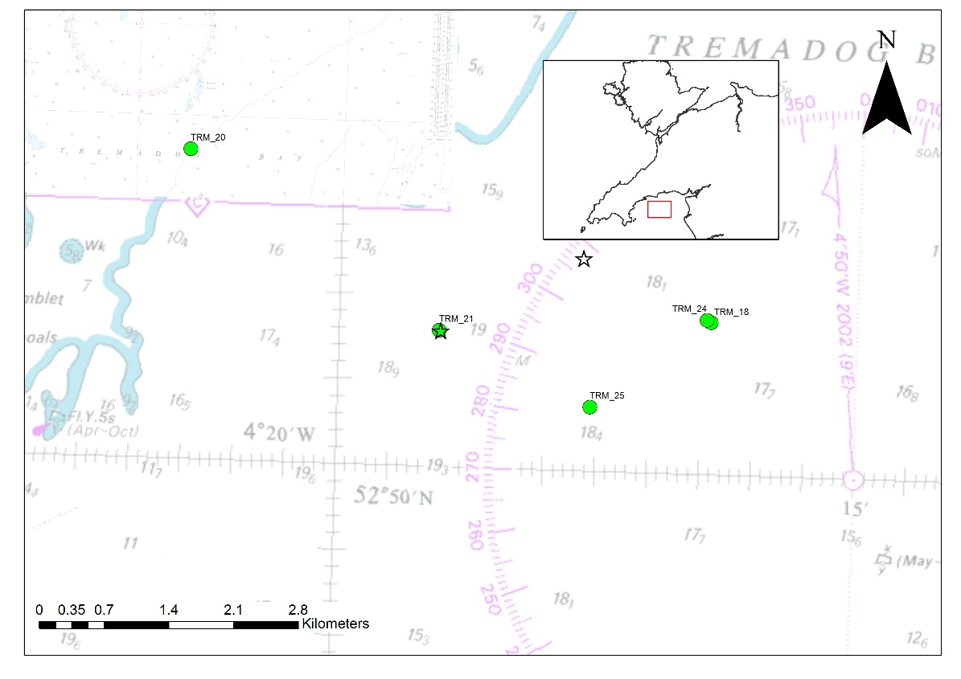
B.
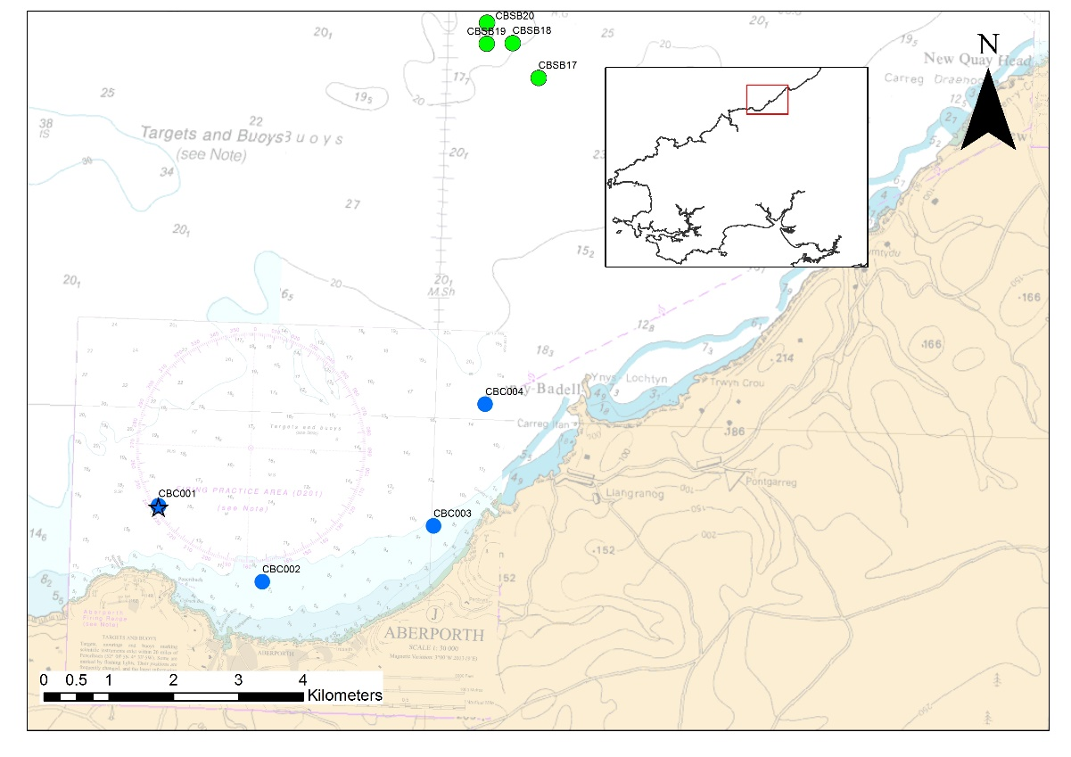
Figure 22 NRW planned sampling alongside records of Sea-pen and other burrowing megafauna communities (star symbol) in Tremadog Bay (a) and Cardigan Bay Central (b)

Maerl Bed
One planned sampling location (MHC_05) is within the only mapped maerl bed in Welsh waters. It is likely that some fragments of maerl are also picked up in sampling stations local to this maerl bed as the maerl fragments moves with sediment movement (for example live maerl has been noted at station MHC_06 in the past) (Figure 23).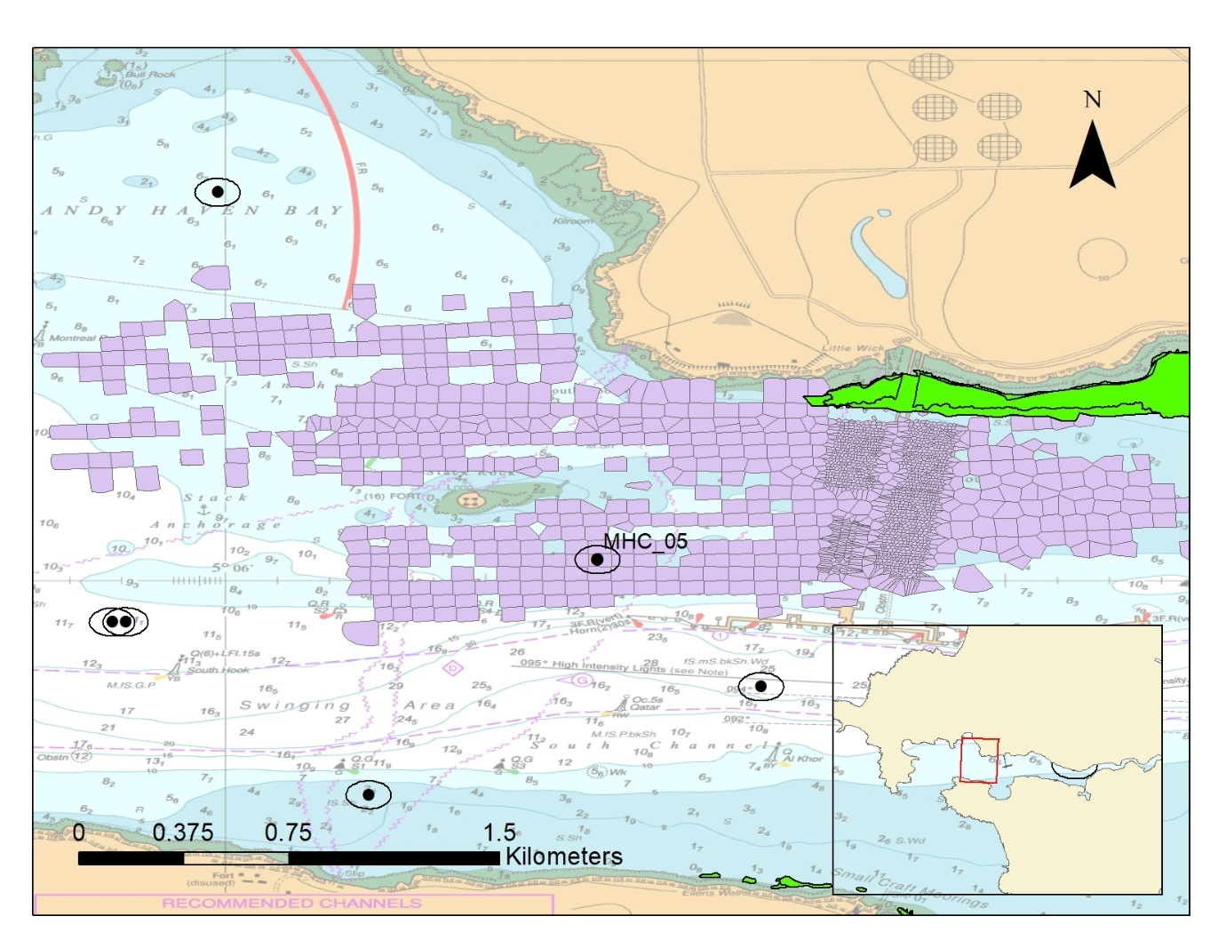

Figure 23 Mearl bed with (purple area) alongside current planned NRW grab sampling

Unplanned Sampling:
For sampling which is not yet planned (ad hoc, operational monitoring or incident response) where practically possible (sometimes samples will need to be relocated on the day of the survey, in this case it may not be possible to have these discussions), the sampling will be planned to avoid sensitive areas and/or will be discussed with NRW conservation officers prior to the survey being undertaken.

Annex I Designated habitats:
Much of the sampling is planned within Annex I habitats as often the primary purpose of the monitoring is to monitor these habitats. Unplanned sampling, Severn waterbody sampling and adhoc sampling are not included in figures below. The following Habitats are considered sensitive when they are a designated feature of a Special Area of Conservation:

- Reefs
- Large shallow inlets and bays
- Estuaries
- Mudflats and sandflats not covered by seawater at low tide
- Atlantic salt meadows (Glauco-Puccinellietalia maritimae)
- Salicornia and other annuals colonising mud and sand

Reefs
A GIS proximity check revealed that a small number of sampling stations were close to or within modelled Annex I reef (subtidal and intertidal) habitat. These locations have been successfully sampled in the past which suggest that at least some of the local habitat is suitable for grab sampling. A closer assessment of samples within 50m of reef show that samples were mostly close to but not overlying definite reef. Stoney mixed substrate can be classified as reef and in some cases is part of the habitats we are trying to sample. In general, the aim of grab sampling is to target sediment when planning surveys, as such we aim to avoid reef. Reef maps can be provided to survey personnel to ensure that best care is made to avoid reef features and where sampling fail sampling can be moved away from reef feature. For more detail please view planned sampling positions in relation to most up to date reef feature maps.

Subtidal Sandbanks
Monitoring subtidal sandbanks using grab sampling is required to assess condition and therefore manage this feature. See Table 11 for a summary of the number of currently planned samples.

Table 11 A summary of the number of samples currently planned within the Large Shallow Inlet and Bay Feature
Special Area of Conservation | 2025 | 2026 | 2027
Cardigan Bay / Bae Ceredigion | 0 | 30 | 0
Carmarthen Bay and Estuaries / Bae Caerfyrddin ac Aberoedd | 30 | 0 | 0
Pembrokeshire Marine / Sir Benfro Forol | 51 | 0 | 3
Pen Llyn a'r Sarnau / Lleyn Peninsula and the Sarnau | 0 | 0 | 46
Y Fenai a Bae Conwy / Menai Strait and Conwy Bay | 231 | 20 | 20
(blank) | 15 | 0 | 0

Large shallow inlets and bays
Monitoring Large Shallow Inlets and Bays using grab sampling is required to assess condition and therefore manage this feature. See Table 12 for a summary of the number of currently planned samples.

Table 12 A summary of the number of samples currently planned within the Large Shallow Inlet and Bay Feature
Special Area of Conservation | 2025 | 2026 | 2027
Carmarthen Bay and Estuaries / Bae Caerfyrddin ac Aberoedd | 47 | 92 | 40
Pembrokeshire Marine / Sir Benfro Forol | 130 | 110 | 283
Pen Llyn a'r Sarnau / Lleyn Peninsula and the Sarnau | 50 | 52 | 84
Y Fenai a Bae Conwy / Menai Strait and Conwy Bay | 265 | 40 | 40

Estuaries
Monitoring Estuaries using grab sampling is required to assess condition and therefore manage this feature. See Table 13 for a summary of the number of currently planned samples for estuary features.

Table 13 A summary of the number of samples planned within the Estuary Feature
Special Area of Conservation | 2025 | 2026 | 2027
Cardigan Bay / Bae Ceredigion | 0 | 8 | 0
Carmarthen Bay and Estuaries / Bae Caerfyrddin ac Aberoedd | 147 | 0 | 0
Dee Estuary / Aber Dyfrdwy (Wales) | 20 | 20 | 20
Pembrokeshire Marine / Sir Benfro Forol | 90 | 20 | 310
Severn Estuary | 15 | 15 | 15

Mudflats and sandflats not covered by seawater at low tide
Monitoring Estuaries using grab sampling is required to assess condition and therefore manage this feature. See Table 14 for a summary of the number of currently planned samples. The annual samples noted here are the Dee and Milford Haven CSEMP sites which are close to the intertidal but are generally taken sub tidally.

Table 14 A summary of the number of samples planned within the Intertidal Mud and Sandflat Feature
Special Area of Conservation | 2025 | 2026 | 2027
Carmarthen Bay and Estuaries / Bae Caerfyrddin ac Aberoedd | 140 | 0 | 0
Dee Estuary / Aber Dyfrdwy (Wales) | 20 | 20 | 20
Pembrokeshire Marine / Sir Benfro Forol | 28 | 20 | 176

Atlantic salt meadows (Glauco-Puccinellietalia maritimae) and Salicornia and other annuals colonising mud and sand
See above assessment on saltmarsh and sampling.

Sensitive and Annex I Habitats and NRW Grab Sample Monitoring Conclusion
Overall, relatively few sampling positions are close or within to sensitive habitats or annex I habitat feature which is not targeted as part of the monitoring programme. Where sampling picks up sensitive habitat it is important to make a note of this to improve our knowledge of such habitats (e.g. species/biodiversity associated with sensitive habitats).

Samples within current known extent of a sensitive habitat:
Sampling within these areas is needed to ascertain SAC habitat condition. All information gained from sampling is used to understand, maintain or enhance sensitive protected habitats. For example, several historic Milford Haven sampling locations are in areas of Zostera noltei (eel grass). The data gained from this sampling aids assessment of health and condition of beds and is used to inform site management and report on feature condition.

Samples taken in recently expanded extent of a sensitive habitat:
Much of NRW sampling forms part of long-term monitoring of fixed locations to assess trends in community change (some of which goes back as far as the 1960’s). Having to relocate due to a community change (e.g. through expansion of Zostera beds or colonisation by Sabellaria spp.) would confound the sampling design and our ability to draw reliable conclusions from the already established monitoring programme. Where we encounter the habitat outside known established areas the number of samples of the habitat present gives an indication of both extent and certainty of presence (i.e. confidence), this information will be used to assess condition and for future casework advice (this is then used to protect sensitive habitats). For example, we may want to continue sampling an area where we find sensitive habitats (such as Sabellaria spp.) in order to assess the habitat extent and then report the area covered so we can use this in casework advice.

Annex I habitats (not targeted)
Where sampling occurs on Annex I habitat which is not the target of sampling (i.e. reef and Atlantic salt meadows and Salicornia and other annuals colonising mud and sand) it still provides some information to support condition assessment of these features and the sampling is not at a scale which would impact the feature.

