Mona Landfall Survey Area Geotechnical Investigations
Water Framework Directive Compliance Assessment
Prepared for
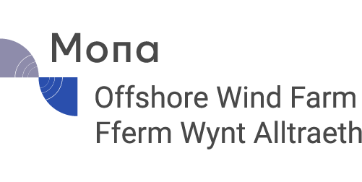
Mona Offshore Wind Limited
Date
06 February 2025
Reference
0756129
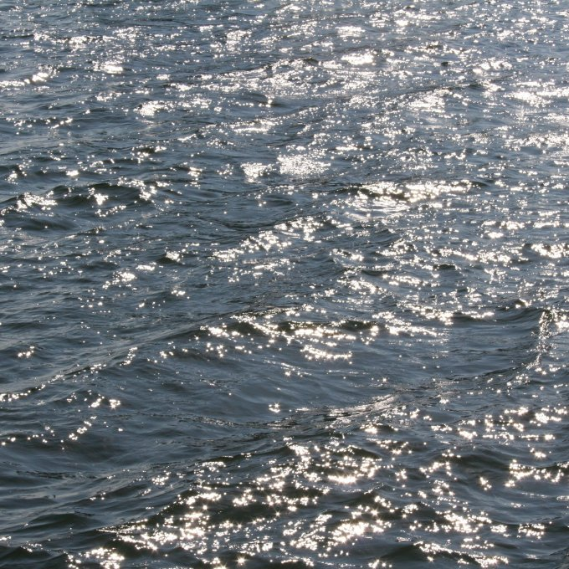
Document details
The details entered below are automatically shown on the cover and the main page footer. PLEASE NOTE: This table must NOT be removed from this document.
DOCUMENT TITLE | Mona Landfall Survey Area Geotechnical Investigations
DOCUMENT SUBTITLE | Water Framework Directive Compliance Assessment
PROJECT NUMBER | 0756129
DATE | 06 February 2025
VERSION (delete field if unneeded) | 2.0
AUTHOR | Max McGinn
CLIENT NAME | Mona Offshore Wind Limited

Document history
 |  |  |  | ERM Approval to issue
Version | Revision | Author | Reviewed by | Name | Date | comments
Draft | 0.1 | MM | RN
Draft | 1.0 | RN | DK | AH | 31.01.25 | First draft for client
Draft | 1.1 | GLS |  |  |  | Addressing client comments
Final | 2.0 | GLS | EM | JP | 17.02.25 | Final draft for client

Signature page

Mona Landfall Survey Area Geotechnical Investigations
Water Framework Directive Compliance Assessment
0756129

 |  | 
Max McGinn  Marine Consultant |  | Dr Raffaella Nobili  Managing Marine Consultant
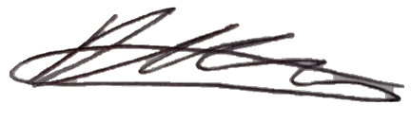
Damien Kirby
Principal Consultant
2nd Floor, Exchequer court,
33 St Mary Axe,
London
EC3A 8AA

© Copyright 2025 by The ERM International Group Limited and/or its affiliates (‘ERM’). All Rights Reserved.
No part of this work may be reproduced or transmitted in any form or by any means, without prior written permission of ERM.

Table of Contents
1. Introduction 1
2. Method statement for Proposed Works 3
3. Relevant Legislation 3
4. Screening and scoping 4
4.1 Screening 5
4.2 Scoping 5
4.2.1 Water Body Identification 5
4.2.2 North Wales HMWB Scoping 7
5. Artificial and Heavily Modified Water Bodies 20
6. Compliance assessment 22
7. Conclusion 22
8. REFERENCES 23

List of Tables
Table 4-1: WFD Water Bodies Consiidered within Screening. Rows highlighted in yellow are taken forward for further assessment, those in red are not considered further. 7
Table 4-2: Water Framework Directive assessment: scoping template for activities in estuarine and coastal waters 8
Table 4-3: WFD Water Bodies Screened in and Taken to Stage 2 Scoping 9
Table 5-1 North Wales Water Body Mitigation Measures and Status (WWW, 2022). 20

List of Figures
Figure 1.1 MONA Landfall Survey Area 2
Figure 4-1: MONA LANDFALL SURVEY AREA, Water Framework Directive designated water bodies, their status, and protected areas 6

Acronyms and Abbreviations
Acronym | Description
AMWB | Articifially Modified Water Body
cCPT | Cone Penetrometer
ERM | Environmental Resources Management
EQSD | EU Environmental Quality Standards Directive (2008/105/EC)
GEP | Good Environmental Potential
GES | Good Ecological Status
HDD | Horizontal Directional Drilling
HPD | High-Pressure Dilatometer
HMWB | Heavily Modified Water Body
IMO | International Maritime Organization
INNS | Invasive Non-native Species
MPA | Marine Protected Area
nm | Nautical miles
NRW | Natural Resources Wales
OFW | Offshore Wind Farm
OGN | Operational Guidance Note
RBMP | River Basin Management Plan
PPDT | Discretionary Pore Pressure Dissipation Tests
SAC | Special Area of Conservation
SPA | Special Protection Area
WFD | Water Framework Directive

Introduction
Mona Offshore Wind Limited has applied for a Development Consent Order (DCO) for the Mona Offshore Wind Project, located in the Irish Sea (application reference EN010137). The draft DCO (document reference C1 F09) includes a Deemed Marine Licence (dML) (Schedule 14) for licensable activities within Welsh offshore waters beyond 12 nm. The Mona Offshore Wind Project will also be subject to a standalone Marine Licence from Natural Resources Wales (NRW) for licensable activities within the 12 nm limit of Welsh waters (application reference ORML2429T).
To inform the development of the Project, Mona Offshore Wind Limited intends to carry out geotechnical investigations (surveys) commencing in 2025, at the proposed Mona Landfall Survey Area.
The surveys proposed consist of:
- Up to 12 geotechnical boreholes below Mean High Water Springs (MHWS) up to 40 m below seabed (licensable marine activity).
For information only, additional tests and survey work include:
- Cone or Piezocone Penetration Test (CPT/PCPT) downhole in situ testing;
- And the option for Discretionary Pore Pressure Dissipation Tests (PPDT) and High Pressure Dilatometer (HPD) downhole Pressuremeter;
- Pilot drill; and
- Geophysical surveys.
The CPT/PCPT, PPDT, HPD and pilot drill are non-licensable activities under Article 16 and Article 32, respectively, of the Marine Licensing (Exempted Activities) (Wales) Order 2011 and the Marine and Coastal Access Act. Geophysical survey activities are also non-licensable activities under the Marine and Coastal Access Act. Where necessary these activities will be the subject of the appropriate exemption notifications. They have been described in this document for information purposes only and are discussed in more detailed in the Mona Geotechnical Nearshore Supporting Information Document.
This Water Framework Directive (WFD) compliance assessment refers only to the geotechnical boreholes within the Mona Landfall Survey Area, i.e. in Welsh waters only. As such, it is Natural Resources Wales (NRW) that has a statutory duty to ensure compliance with the WFD. The Mona Landfall Survey Area is situated between Colwyn Bay and Abergele on the northern coast of Wales (Figure 1.1).
Under the WFD, all proposed schemes with the potential to impact upon WFD-designated water bodies must be assessed to ensure:
- No deterioration of the current status or potential of any WFD quality elements; and
- Future attainment of ‘good’ status or other objectives of any WFD quality elements is not prevented.
This report follows guidance provided in NRW Operational Guidance Note (OGN) 078 (NRW, 2024) and Environment Agency (2016) for the production of a WFD compliance assessment report.

Figure 1.1 Mona Landfall Survey Area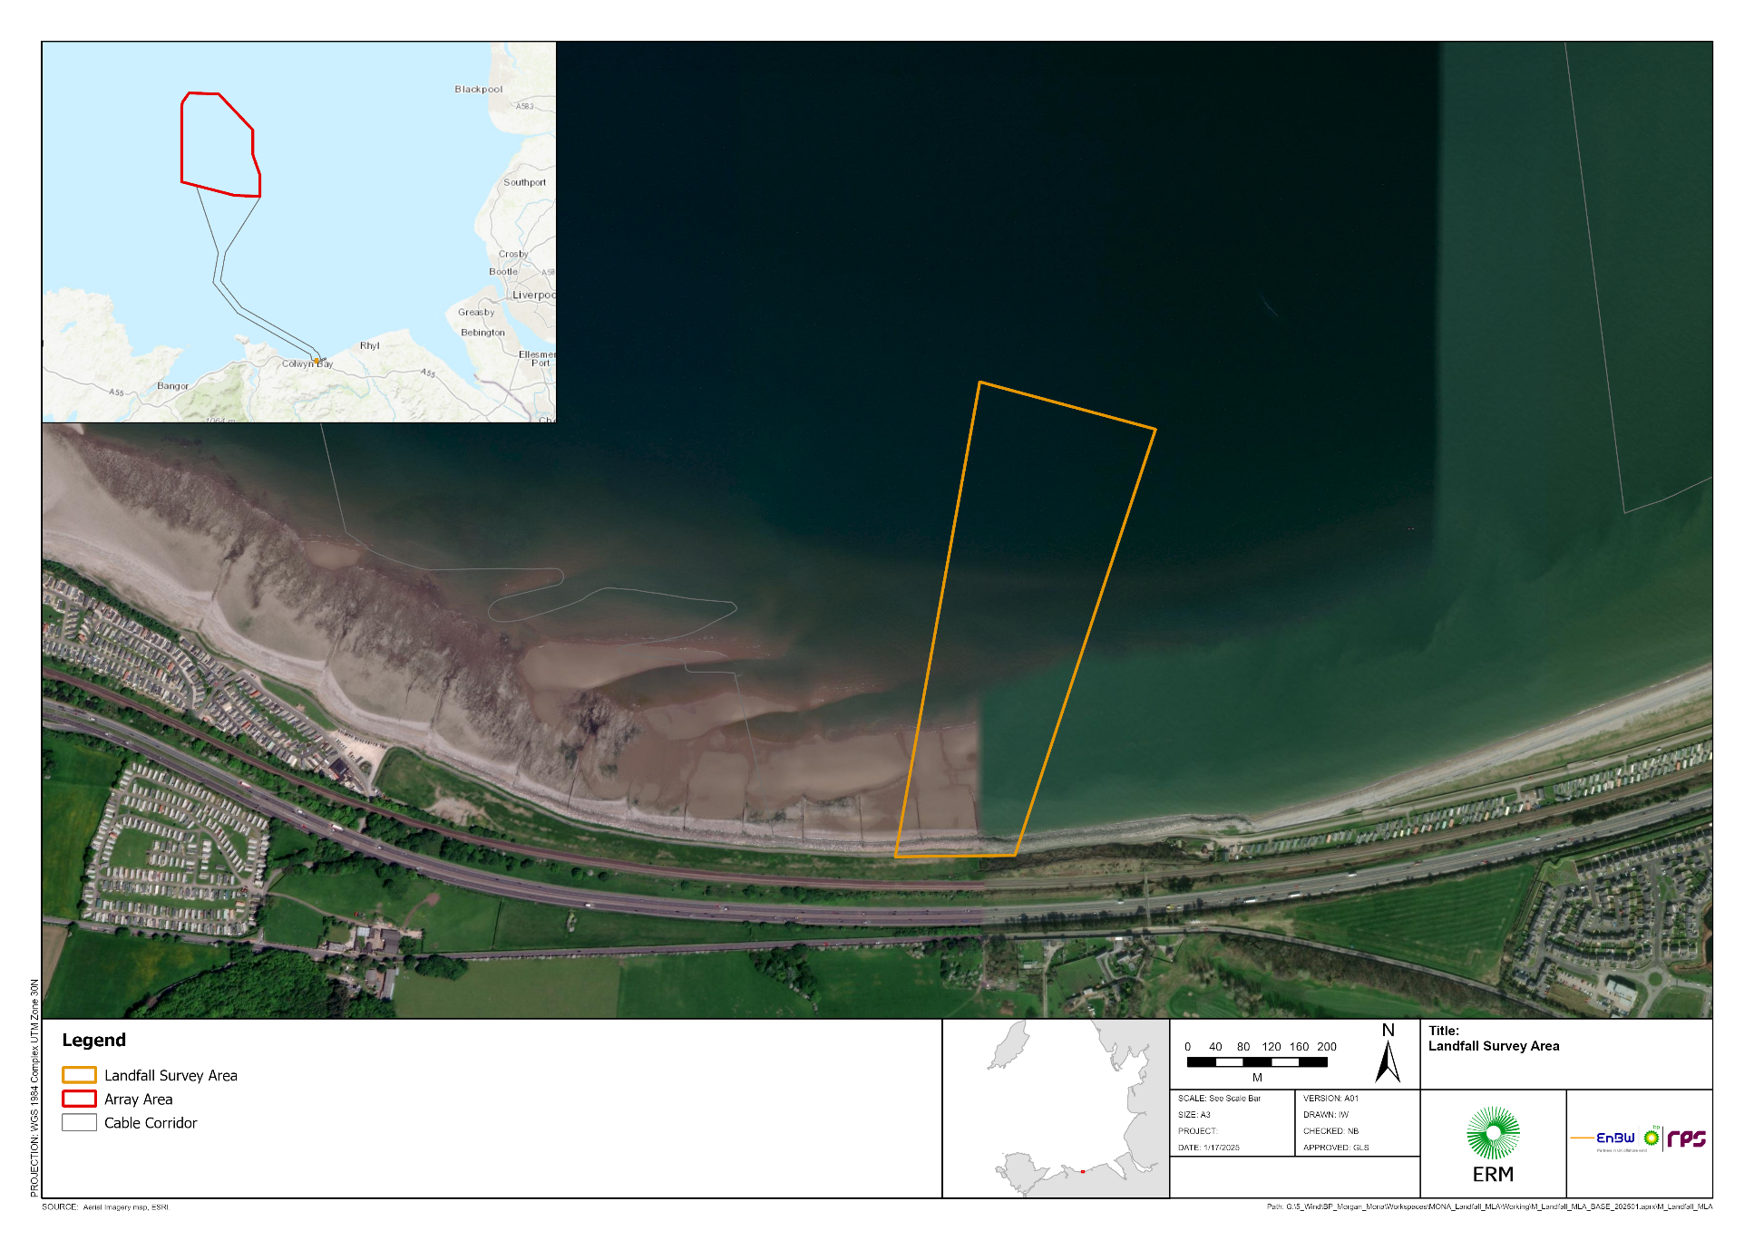

Method statement for Proposed Works
The proposed works are for a shallow geotechnical survey of the Mona Offshore Wind Farm transmission cable landfall area. The purpose of the geotechnical site investigation is to determine the characteristics and mechanical properties of the various types of soil and bedrock within the landfall area of the Mona Offshore Wind Farm. This will be achieved by acquiring, evaluating and presenting geotechnical information obtained from drilling, soil samples, cores and in situ tests. The data collected will be used to determine if the soil characteristics are suitable to conduct Horizontal Directional Drilling (HDD) at landfall.
Boreholes will be undertaken by a jack-up vessel with 4 spud legs with a total seabed footprint of 1.81 m² (0.453 m² per spud leg).

Boreholes
Up to 12 boreholes are proposed to be undertaken within the Mona Landfall Survey Area situated below mean high water. It is expected that only 8 boreholes will be required; however, this application includes provision for an additional 4 boreholes in case challenging drilling conditions or weather results in the temporary abandonment and the need for re-entry at some of the locations. Achieving this may necessitate 12 vessel movements and spudcan deployments.
The boreholes will penetrate to a depth of approximately 40 m, with the addition of Cone / Piezocone Penetrometer (CPT/PCPT) tests and Downhole Geophysics to occur throughout the full depth. Additionally, Discretionary Pore Pressure Dissipation Tests (PPDT) and High-Pressure Dilatometer (HPD) downhole pressure meter testing may also be conducted. In total, up to 3.78 m³ of recovered material will be obtained and subsequently tested in an onshore laboratory.

Timings and Sequence of Works
The geotechnical survey licence application is for works to be undertaken between May 2025 and October 2026 (including contingency). Once mobilised, the surveys are expected to have a total duration of only 16 weeks.

Relevant Legislation
The EU Water Framework Directive (WFD) (2000/60/EC), has been transposed by the Water Environment and Water Framework Directive (England and Wales) Regulations Act 2017 as amended by the Floods and Water (Amendment etc.) (EU Exit) Regulations 2019. The aim of these Regulations is to raise the quality of all water bodies (with a target of achieving GES by 2027), and prevent their deterioration and enhance the ecosystems therein. The WFD is a key tool to achieve sustainable management of coastal and transitional waters, and is delivered through use of River Basin Management Plans (RBMPs).
For surface waters there are 2 separate water body classifications: ecological and chemical. The WFD is based on attributing a classification status to all water bodies, with the aim for all water bodies to be at a ‘good’ status. For a water body to be in overall 'good' status, both ecological and chemical status must be at least 'good'. Coastal waters are limited to 1 nautical mile (nm) from the coast in Wales, except for chemical status which is assessed up to 12 nm. Where the hydromorphology of a surface water body has been significantly altered for anthropogenic purposes, it can be designated as an Artificial or Heavily Modified Water Body (A/HMWB). An alternative environmental objective, or “Good Environmental Potential” (GEP) is applicable in these cases.
This WFD Assessment has been conducted in accordance with the following legislation:
- EU Environmental Quality Standards Directive (EQSD) (2008/105/EC), covered by the Water Environment and Water Framework Directive (England and Wales) Regulations Act 2017 as amended by the Floods and Water (Amendment etc.) (EU Exit) Regulations 2019. The chemical status of a water body (up to 12 nm) provides details on the water quality and is defined through compliance with EQS. These standards ensure that surface waters meet minimum quality requirements for selected pollutants and progressively reduce or phase out emissions of hazardous substances;
- Nitrates Directive (91/676/EEC), transposed by Nitrate Pollution Prevention (Wales) Regulations 2008 as amended by the Floods and Water (Amendment etc.) (EU Exit) Regulations 2019 addresses the pollution by nitrates from agricultural sources, aiming at reducing water pollution by nitrates to prevent eutrophication;
- Bathing Waters Directive (2006/7/EC implemented through the Bathing Waters Regulations 2013, as amended by The Floods and Water (Amendment etc.) (EU Exit) Regulations 2019, which sets specific microbiological criteria to ensure the quality and safety of waters used for human recreation. NRW monitors and assesses bathing water quality at each designated bathing water site in Wales between May and September;
- Shellfish Waters Directive (2006/113/EC) was repealed in December 2013 and these requirements are now included within the WFD, which sets specific microbiological criteria to ensure the quality and safety of shellfish intended for human consumption;
- River Basin Management Plan (RBMP) (NRW, 2022a). RBMPs are a crucial management tools in integrated water resources management. These plans provide a comprehensive framework for understanding and addressing water-related challenges within a specific drainage basin. RBMPs set legally binding, locally specific environmental objectives that serve as the foundation for water regulation and planning activities. These objectives underpin activities such as permitting and provision of stability for economic development. The plans aim to enhance nature and the natural water assets that are the foundation of everyone’s wealth, health, and well-being, as well as the things people value, including culture and wildlife. These plans cover rivers, lakes, canals, estuaries, coasts, and groundwater, recognizing their essential services and worth; and
- The overarching aims of the Environment (Wales) Act 2016 (as amended) regarding sustainability and emissions management, have also been considered.

Screening and scoping
The WFD Compliance Assessment methodology is completed according to the following stages:
- Stage 1 Screening: identify activities associated with the survey (during each stage) that have the potential to have an impact and identify the water bodies hydrologically connected to the survey activities;
- Stage 2 Scoping: identify the potential risks to each water body and each receptor (quality elements of the water body); and
- Stage 3 Impact Assessment: assess the hydrological connectivity (pathway) of the site investigation activities (source) on the WFD water bodies and other statutory receptors and determines if any activity may cause deterioration of the status of the water body or jeopardise the achievement of Good Ecological Status (GES) for said water body.
Temporary impacts are not considered to result in deterioration in WFD status of the water body. This is deemed to apply if the water body:
- Is only impacted for a short time period;
- Recovers within a short time period (1 to 2 tidal cycles, or 14–28 days); and
- Recovers without the need for any restoration measure.

Screening
NRW OGN 078 (2024) specifies certain activities that are not considered to present a risk of deterioration of water body status, or of preventing a water body from achieving its objective. It is advised that these activities can be screened out from further assessment. Boreholes are listed under removal activities within estuarine/coastal environments. Nevertheless, a WFD compliance assessment has been conducted for avoidance of doubt, and to ensure thoroughness and the proposed activities have been taken forward to the Scoping stage.

Scoping
The scoping assessment is completed using the scoping template provided by UK Government (UK Gov, 2017), in conjunction with NRW guidance (NRW, 2024).

Water Body Identification
This assessment will consider designated WFD Coastal or Transitional water bodies within the Clwyd catchment area which may be affected by the survey activity, including:
- Water bodies directly impacted by the survey footprint;
- Water bodies indirectly impacted by the survey activity and located within the area of influence of survey activities, determined by the extent of sediment plume, the realistic worst-case scenario (affected in turn by the tidal excursion zone); and
- Water bodies hydrologically connected to, directly affected water bodies (downstream).
Figure 4-1 shows the designated coastal and transitional water bodies identified for the whole area, WFD protected areas (i.e. Marine Protected Areas (MPAs), bathing waters and shellfish waters), and disposal sites near the landfall area (NRW, 2025a and b).

Figure 4-1: Mona Landfall Survey area, Water Framework Directive designated water bodies, their status, and protected areas
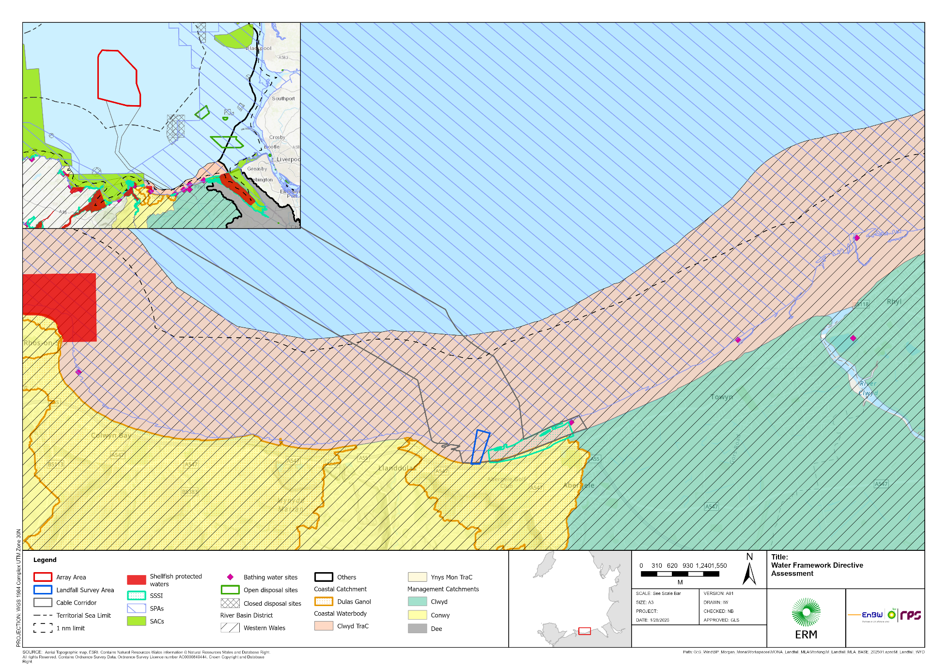

Table 4-1 lists the WFD designated water bodies considered relevant in relation to the survey activity and/or the main water body. Water bodies >4.3 km from the proposed activity have been screened out of the assessment (distance based on the worst case estimated tidal excursion) as it is determined at this distance there is no pathway to potential deterioration to the designated water body status. Therefore, the water bodies highlighted in red in Table 4-1, have not been considered further within this assessment and only the North Wales HMWB (highlighted in yellow in Table 4-1) is taken to Stage 2 Scoping (Section 4.2.2).
Table 4-1: WFD Water Bodies Considered within Screening. Rows highlighted in yellow are taken forward for further assessment, those in red are not considered further.
Water Body | ID | Type | Status 2021 | Relation to water body and activities
North Wales - HMWB | GB641011650000 | Coastal | Moderate | 0 km
Clwyd – HMWB | GB541006608000 | Transitional | Moderate | Activity: >6 km  Water body: hydrologically connected
Dee – HMWB | GB531106708200 | Transitional | Moderate | Activity: >20 km  Water body: upstream/hydrologically connected
Anglesey North | GB641010620000 | Coastal | Moderate | Activity: >20 km  Water body: downstream

North Wales HMWB Scoping
As set out above, the North Wales HMWB is taken to Stage 2 Scoping. Table 4-2 describes the survey activity and Table 4-3 details the characteristics of the water body assessed.

Table 4-2: Water Framework Directive assessment: scoping template for activities in estuarine and coastal waters

Your activity | Description, notes or more information
Applicant name | Mona Offshore Wind Limited
Application reference number (where applicable) | N/A
Name of activity | Mona Landfall Geotechnical Survey 2025
Brief description of activity | Geotechnical Landfall Site Investigations - Boreholes  Number of boreholes – Up to 12  Diameter (mm) – 102  Maximum depth (m) – 40  Approximate Total volume collected per sample (m³) – 0.29  Approximate Total volume collected (m³) – 3.78  The drilling of a maximum of 12 boreholes situated below mean high water is required. Additionally, Discretionary Pore Pressure Dissipation Tests (PPDT) and High Pressure Dilatometer (HPD) downhole Pressure meter testing may also be conducted. In total, up to 3.78 m³ of recovered material will be obtained.  The field work will be carried out with one jack-up vessel comprising 4 spud legs 0.76 m in diameter (0.453 m² area each) for a total of 21.81 m² seabed disturbance (worst case of 12 boreholes).
Location of activity (central point XY coordinates or national grid reference) | Mona Landfall Survey Area:
  ID | Latitude (WGS84) |  |  | Longitude (WGS84)
  1 | 53° | 17.757' | N | 003° | 36.794' | W
  2 | 53° | 17.721' | N | 003° | 36.566' | W
  3 | 53° | 17.39' | N | 003° | 36.743' | W
  4 | 53° | 17.388' | N | 003° | 36.898' | W
Footprint of activity (m²) | For the collection of 12 cores in total with a diameter of 102 mm (0.0082 m² area each), the total footprint would equate to 0.098 m².  The spud legs of a jack-up vessel are 0.76 m in diameter (0.453 m² area each) for a total of 21.74 m² seabed disturbance (worst case of 12 boreholes).  Worst case total disturbance = ~22 m².
Timings of activity (including start and finish dates) | The landfall geotechnical survey is scheduled to start in May 2025 for approximately 16 weeks. However, the marine licence is requested from 12 May 2025 extending until 31 October 2026 to allow contingency in the programme should delays occur such as vessel availability and weather interruption.
Extent of activity (for example size, scale frequency, expected volumes of output or discharge) | Up to 12 geotechnical survey investigation boreholes will be taken within the Mona cable route landfall area. Boreholes will be up to 40 m deep and will have a diameter of 102 mm. The total volume of sediment collected will be 3.78 m³.
Use or release of chemicals (state which ones) | No

Table 4-3: WFD Water Bodies Screened in and Taken to Stage 2 Scoping
Water body¹ | Description, notes or more information
WFD water body name | North Wales – Located within the Mona cable route landfall area.
Water body ID | GB641011650000
River basin district name | Western Wales
Water body type (estuarine or coastal) | Coastal
Water body total area (ha) | 40,991
Overall water body status (2021) | Moderate
Ecological status | Moderate
Chemical status | Moderate
Driving element for status | Mercury and Phytoplankton
Target water body status and deadline | Good Potential by 2033
Hydromorphology status of water body | Not Assessed
Heavily modified water body and for what use | Yes: “Wider environment – nature protection and other ecological uses”
Higher sensitivity habitats present | Saltmarsh; chalk reefs; subtidal kelp beds; mussel beds
Lower sensitivity habitats present | Gravel & Cobbles (intertidal and subtidal coarse sediments); intertidal soft sediments such as sand and mud; subtidal soft sediments such as sand and mud; rocky shore (intertidal rock); subtidal boulder field; subtidal rocky reef
Phytoplankton status | Moderate
History of harmful algae | Not reported
WFD protected areas within 2 km | Liverpool Bay/Bae Lerpwl Special Protection Area (SPA); Menai Strait and Conwy Bay Special Area of Conservation (SAC); The Dee Estuary SPA; Dee Estuary SAC.  Conwy, Llandudno Shellfish Waters; Dee (west) Shellfish Waters; Rhos-on-Sea Shellfish Water.  Bathing waters:  - Llandudno North Shore (Sufficient)  - Colwyn Bay (Good)  - Colwyn Bay Porth Eirias (Excellent)  - Abergele (Good)  - Kinmel Bay (Sandy Cove) (Good)  - Marine Lake, Rhyl (Sufficient)  - Rhyl (Sufficient)  - Rhyl East (Good)  - Prestatyn (Excellent)

Specific risk information
Consider the potential risks of your activity to each of these receptors: hydromorphology, biology (habitats and fish), water quality and protected areas. Also consider invasive non-native species (INNS).

Section 1: Hydromorphology
Consider if hydromorphology is at risk from your activity.
Use the water body summary table to find out the hydromorphology status of the water body, if it is classed as heavily modified and for what use.
Could the proposal lead to changes in: | Yes | No | Hydromorphology risk issue(s)
Morphological conditions, for example depth variation, the seabed and intertidal zone structure | Requires impact assessment | Impact assessment not required | Due to the small scale of the geotechnical survey, negligible changes in morphological conditions and water dynamics are anticipated. Therefore, there is no risk of changes to hydromorphology.
Tidal patterns, for example dominant currents, freshwater flow and wave exposure | Requires impact assessment | Impact assessment not required | Due to the small scale of the geotechnical survey, negligible changes in morphological conditions and water dynamics are anticipated. Therefore, there is no risk of changes to hydromorphology.
Is the proposal in a HMWB? | Requires impact assessment | Impact assessment not required | Yes, however, the geotechnical survey will not take place in a water body that is heavily modified for the same use as the proposed activities.

Section 2: Biology
Habitats
Higher sensitivity habitats ² | Lower sensitivity habitats ³
chalk reef | cobbles, gravel and shingle
clam, cockle and oyster beds | intertidal soft sediments like sand and mud
intertidal seagrass | rocky shore
maerl | subtidal boulder fields
mussel beds, including blue and horse mussel | subtidal rocky reef
polychaete reef | subtidal soft sediments like sand and mud
saltmarsh
subtidal kelp beds
subtidal seagrass
² Higher sensitivity habitats have a low resistance to, and recovery rate, from human pressures.
³ Lower sensitivity habitats have a medium to high resistance to, and recovery rate from, human pressures.
Could the proposal lead to: | Yes | No | Biology habitats risk issue(s)
Changes to the composition and abundance of aquatic flora | Yes to one or more – requires impact assessment | No to all – impact assessment not required | No, the impacts are very localised and will not cause changes in the composition and abundance of aquatic flora.
Changes to the composition and abundance of benthic invertebrate fauna | Yes to one or more – requires impact assessment | No to all – impact assessment not required | No, the impacts are very localised and will not cause changes in the composition and abundance benthic invertebrate fauna.
For TraC water bodies - scope in if the footprint (where footprint can be direct or a plume i.e. chemical or thermal; for dredging multiply the area by 1.5x) of your activity is:
0.5 km² or larger | Yes to one or more – requires impact assessment | No to all – impact assessment not required | Footprint < 0.5 km²
1% or more of the water body’s area | Yes to one or more – requires impact assessment | No to all – impact assessment not required | Footprint <1% of water body extent (including expected sediment plume resulting from boreholes and spudcan placement).
Within 500 m of any higher sensitivity habitat | Yes to one or more – requires impact assessment | No to all – impact assessment not required | Higher sensitivity habitats have been identified within the Mona nearshore area including Annex I habitats such as mudflats and sandflats not covered by seawater at low tide, Sabellaria alveolata reef and Mytilus edulis beds. Additionally clay with piddocks have also been identified. However, due to the highly localised and short-term nature of the geotechnical survey, no impact assessment is required. Impacts to benthic ecology are discussed further in Section 7.2.1 of the Mona Geotechnical Nearshore SID. The locations of the boreholes have been screened by geophysical survey data. Therefore, geotechnical locations will be sited to avoid sensitive habitats.
1% or more of any lower sensitivity habitat | Yes to one or more – requires impact assessment | No to all – impact assessment not required | Footprint <1 % of lower sensitivity habitat.
⁴ Note that a footprint may also be a temperature or sediment plume. For dredging activity, a footprint is 1.5 times the dredge area.

Fish
Consider if fish are at risk from your activity, but only if your activity is in an estuary or could affect fish in or entering an estuary.
Could the proposal lead to: | Yes | No | Biology fish risk issue(s)
Changes to the composition, abundance and age structure of fish fauna | Requires impact assessment | Impact assessment not required | No non-temporary effects are predicted as a result of the activities.
An impact on normal fish behaviour like movement, migration or spawning (for example creating a physical barrier, noise, chemical change or a change in depth or flow) | Requires impact assessment | Impact assessment not required | No non-temporary effects are predicted as a result of the activities.
Entrainment or impingement of fish | Requires impact assessment | Impact assessment not required | No non-temporary effects are predicted as a result of the activities.
Refuge/predation areas | Requires impact assessment | Impact assessment not required | No non-temporary effects are predicted as a result of the activities.
Or: Is in an estuary and could affect fish in the estuary, outside the estuary but could delay or prevent fish entering it or could affect fish migrating through the estuary | Continue with questions | Go to next section | The works are not located near an estuary. The nearest estuary is >6 km away.

Section 3: Water quality
Consider if water quality is at risk from your activity.
Include water quality in the detailed assessment if the activity could affect: | Yes | No | Water quality risk issue(s)
Water clarity (turbidity or suspended particulate matter concentration), thermal conditions (including shading), oxygen levels – dissolved oxygen conditions, nutrients - dissolved inorganic nitrogen, microbial patterns and salinity/conductivity. | Requires impact assessment | Impact assessment not required | Borehole removal will result in highly localised short-term increase in suspended sediment concentration/turbidity and release of water based biodegradable drilling fluids. Changes in oxygen and nutrient levels as well as microbial patterns and salinity/conductivity may occur. However, these will be temporary, highly localised and would be expected to return to normal within a spring/neap tidal cycle.
A water body with a phytoplankton status of moderate, poor or bad | Requires impact assessment | Impact assessment not required | The Mona transmission cable landfall route is situated within the North Wales water body which has a phytoplankton status of moderate. However, no non-temporary effects are predicted as a result of the activities and the geotechnical survey will be carried out with minimal environmental disturbance. As such, this is not anticipated to result in a significant increase in dissolved inorganic nutrients concentration (sediment disturbance led) which could lead to phytoplankton biomass increases and in turn, impact the phytoplankton status of the water body.
A water body with a history of harmful algae | Requires impact assessment | Impact assessment not required | Not reported.

Consider if water quality is at risk from your activity through the use, release or disturbance of chemicals.

If your activity uses or releases chemicals (for example through sediment disturbance or building works) consider if: | Yes | No | Water quality risk issue(s)
The chemicals are on the Environmental Quality Standards Directive (EQSD) list | Requires impact assessment | Impact assessment not required | No chemicals on the EQSD will be intentionally released into the marine environment. Bunding, storage facilities and spill kits will be employed to contain and prevent the accidental release of fuel, oils and chemicals associated with equipment and vessels operations into the marine environment.
Activity disturbs sediment with contaminants (for estuarine and coastal above Cefas Action Level 1). | Requires impact assessment | Impact assessment not required | Sediment sampling has been conducted throughout the Mona Offshore Cable Corridor and Access Areas and the Mona Array Area, and no contaminants were observed to exceed Cefas Action Level 1 within the North Wales water body (Volume 6, Annex 2.2: Water Framework Directive Coastal Waters Assessment [APP-F6.2.2] (RPS, 2024)). Therefore, no sediments above Cefas Action Level 1 may be disturbed during the removal of the boreholes.

If your activity has a mixing zone  (like a discharge pipeline or outfall) consider if: | Yes | No | Water quality risk issue(s)
The chemicals released are on the Environmental Quality Standards Directive (EQSD) list | Requires impact assessment | Impact assessment not required | No mixing zone associated with these works.

Section 4: WFD protected areas
Consider if WFD protected areas are at risk from your activity. These include:
- special areas of conservation (SAC) | - bathing waters
- special protection areas (SPA) | - nutrient sensitive areas
- shellfish waters

Consider if your activity is: | Yes | No | Protected areas risk issue(s)
Within 2km of any WFD protected area⁶ | Requires impact assessment | Impact assessment not required | The survey area overlaps with the Liverpool Bay/Bae Lerpwl SPA. However, a WFD impact assessment is not required because the proposed survey works are highly localised, small scale and temporary. As such, no impacts on this SPA are anticipated. A separate HRA Screening report discusses the effects of the survey activity on marine protected areas and concludes No Likely Significant Effects for all features and designated sites (Appendix A: Mona Landfall HRA).  The closest bathing water is Abergele (40450) classified as Good, located ~1.5 km from the survey activity. Other bathing waters are located >5 km away and outside the area of influence of the survey activity. Due to the localised and temporary nature of the survey activity, no significant risk on bathing waters has been predicted.  The closest shellfish water is Dee (West), located >20 km from the survey activity therefore, no significant risks to protected shellfish waters has been identified.
⁶ Note that a regulator can extend the 2km boundary if your activity has an especially high environmental risk.

Section 5: Invasive non-native species (INNS)
Consider if there is a risk your activity could introduce or spread INNS.
Risks of introducing or spreading INNS include:
- materials or equipment that have come from, had use in or travelled through other water bodies
- activities that help spread existing INNS, either within the immediate water body or other water bodies

Consider if your activity could: | Yes | No | INNS risk issue(s)
Introduce or spread INNS | Requires impact assessment | Impact assessment not required | No.  Vessel movements will be limited to the area. Vessels will comply with the International Maritime Organization (IMO) ballast water management guidelines to ensure that the risk of potential introduction and spread of INNS will be minimised. All equipment, materials, machinery and PPE used will be in a clean condition prior to their arrival on site, and upon removal from site, to minimise risk of introducing non-native species into the marine environment. The impact is not predicted to cause significant, non-temporary deterioration.

Summary
Receptor | Potential risk to receptor? | Note the risk issue(s) for impact assessment
Hydromorphology | No
Biology: habitats | No
Biology: fish | No
Water quality | No
Protected areas | No
Invasive non-native species | No

Artificial and Heavily Modified Water Bodies
The North Wales water body under assessment is categorised as a Heavily Modified Water Body (HMWB). As such, it has a set of designated mitigation measures designed to ensure the achievement of GEP. Table 5-1 shows these mitigation measures for the water body, in addition to their status in 2022 as outlined in the Heavily Modified Uses and Mitigation Measures Table (NRW, 2022b) and determines whether the proposed activity will affect their implementation.
Table 5-1 North Wales Water Body Mitigation Measures and Status (WWW, 2022).
Mitigation Measure | Status in 2022 | Can the mitigation measure continue to be implemented/implemented in the future?
Indirect mitigation | Not Applicable - Not Required in This Water Body | N/A
Avoid the need to dredge | Not Applicable - Not Required in This Water Body | N/A
Dredging disposal strategy | Not Applicable - Not Required in This Water Body | N/A
Reduce impact of dredging | Not Applicable - Not Required in This Water Body | N/A
Reduce sediment resuspension | Not Applicable - Not Required in This Water Body | N/A
Re-time dredging or disposal | Not Applicable - Not Required in This Water Body | N/A
Sediment management | Not Applicable - Not Required in This Water Body | N/A
Dredge disposal site selection | Not Applicable - Not Required in This Water Body | N/A
Manage disturbance | Not Applicable - Not Required in This Water Body | N/A
Retain habitats | Not Applicable - Not Required in This Water Body | N/A
Fish passes | Not Applicable - Not Required in This Water Body | N/A
Enhance ecology | Not Applicable - Not Required in This Water Body | N/A
Changes to locks etc | Not Applicable - Not Required in This Water Body | N/A
Access to feeder-streams | Not Applicable - Not Required in This Water Body | N/A
Realign flood defence | Not Applicable - Not Required in This Water Body | N/A
Remove obsolete structure | Not Applicable - Not Required in This Water Body | N/A
Remove or soften hard bank | Not Applicable - Not Required in This Water Body | N/A
Preserve or restore habitats | Not Applicable - Not Required in This Water Body | N/A
In-channel morph diversity | Not Applicable - Not Required in This Water Body | N/A
Bank rehabilitation | Not Applicable - Not Required in This Water Body | N/A

Compliance assessment
The outcome of the WFD Screening and Scoping (Section 4) concluded that there is no potentially significant impact from the proposed works that may prevent any WFD quality element within any water body achieving good status or which may cause deterioration. Therefore, no further compliance assessment has been undertaken.

Conclusion
This assessment has considered the potential risks to WFD receptors from the proposed geotechnical survey works. All receptors were scoped out of assessment, primarily due to the highly localised and temporary nature of the proposed activity.
Pathways to potential impacts were limited to sediment mobilisation from borehole removal, spudcan placement on the seabed, and associated changes in turbidity. However, given the temporary and small magnitude of predicted changes within the inshore area, the proposed survey is not expected to pose any risk of deterioration in water body status, or of adverse effects on WFD protected areas.
It is concluded that the proposed works do not pose any risk to the status or objectives of local WFD water bodies. The impacts assessed have all been determined to have a negligible impact at the scale of the overall water body and as such the proposed activities are considered to be compliant with the WFD.

REFERENCES
NRW (Natural Resources Wales), 2025a. Water Watch Wales. Atlas. Available online at: https://waterwatchwales-nrw.hub.arcgis.com/. [Accessed January 2025].
NRW (Natural Resources Wales), 2025b. DataMapWales. Available online at: https://datamap.gov.wales/maps/new?layer=geonode:nrw_wfd_groundwater_c3_baseline_classification#/. [Accessed January 2025].
NRW (Natural Resources Wales), 2024. OGN 078 Guidance for assessing activities and Projects for compliance with the Water Framework Directive.
NRW (Natural Resources Wales), 2022a. River basin management plans. Available online at: https://naturalresources.wales/about-us/what-we-do/strategies-plans-and-policies/river-basin-management-plans/?lang=en. [Accessed January 2025].
NRW (Natural Resources Wales), 2022b. Heavily Modified Uses and Mitigation Measures July 2022. Available online at: https://cyfoethnaturiolcymru.sharefile.eu/share/view/sdde43d782ae54702ad52b189cadcd827. [Accessed January 2025].
RPS, 2024. Mona Offshore Wind Project. Environmental Statement Volume 6, Annex 2.2: Water Framework Directive Coastal Waters Assessment. Available online at: https://infrastructure.planninginspectorate.gov.uk/wp-content/ipc/uploads/projects/EN010137/EN010137-000397-F6.2.2_Mona_ES_Water%20Framework%20Directive%20Coastal%20Waters%20Assessment.pdf [Accessed February 2025].
UK Gov (UK Government), 2017. Guidance: Water Framework Directive assessment: estuarine and coastal waters. Available at: https://www.gov.uk/guidance/water-framework-directive-assessment-estuarine-and-coastal-waters#scoping-identify-risks-to-receptors [Accessed January 2024].

