PAN-027863 My Map Report:
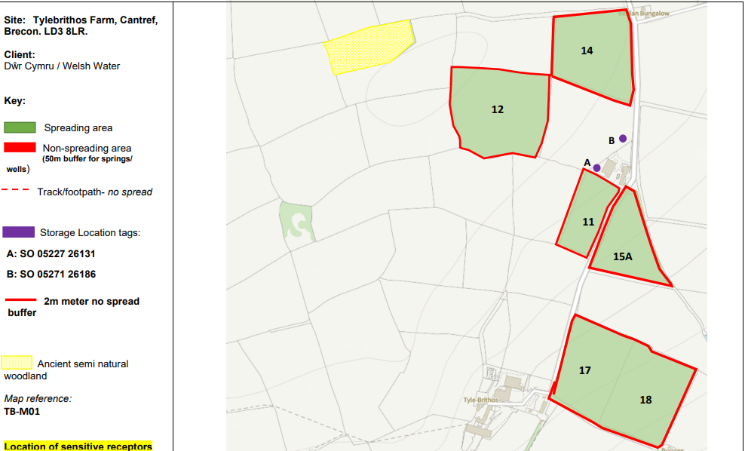
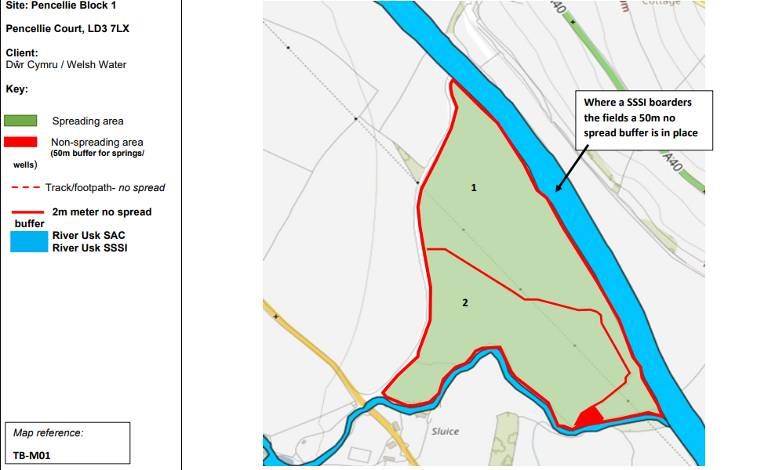
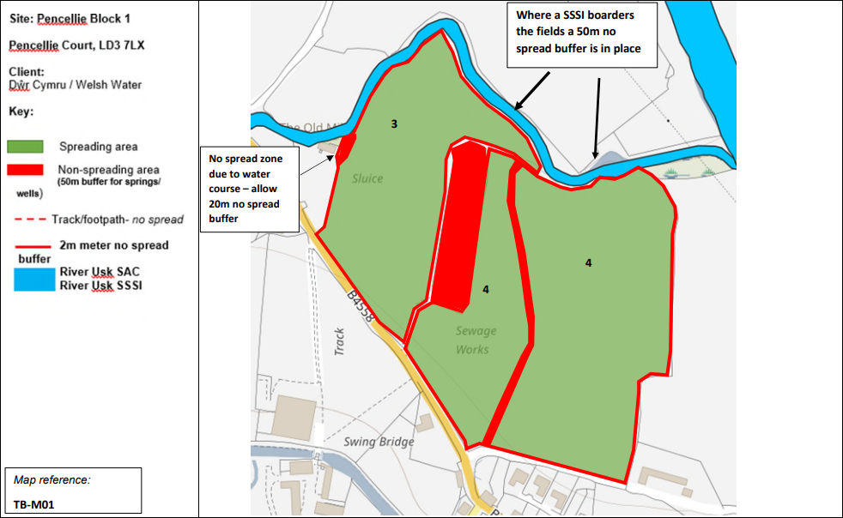
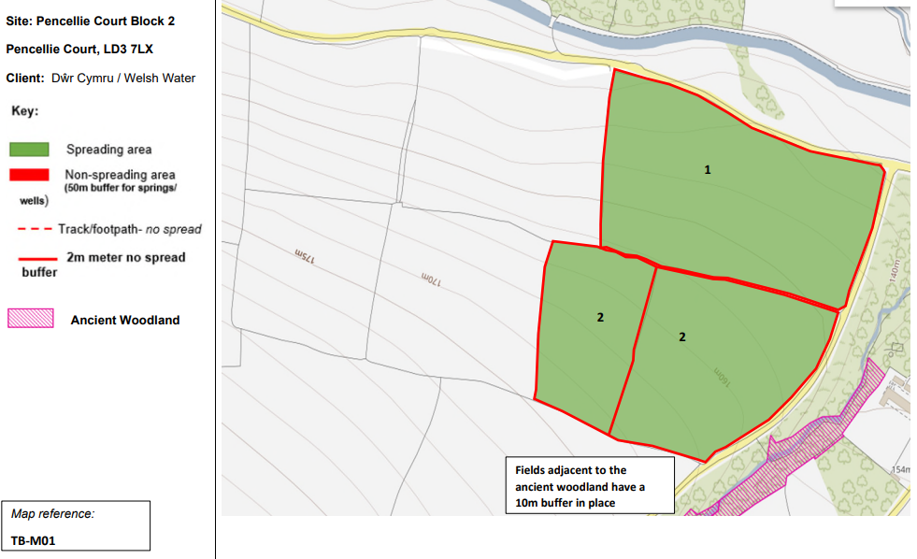
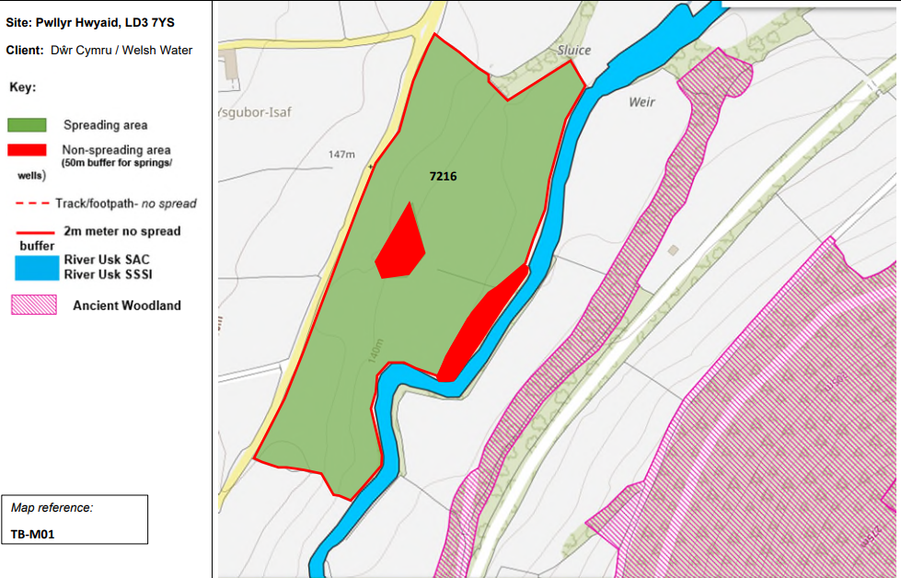
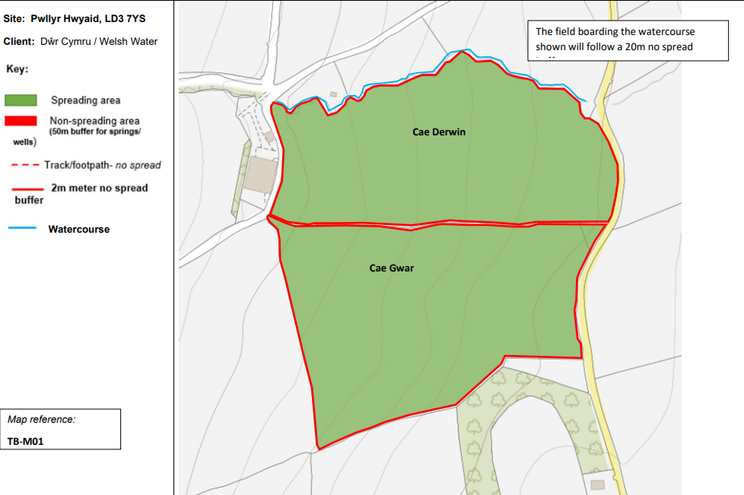
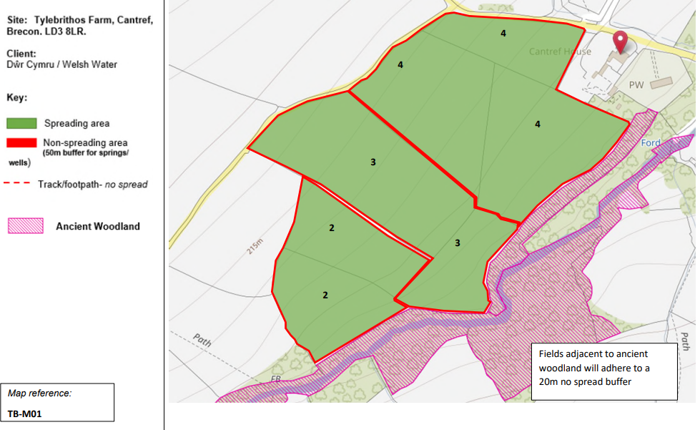

Detailed river network:
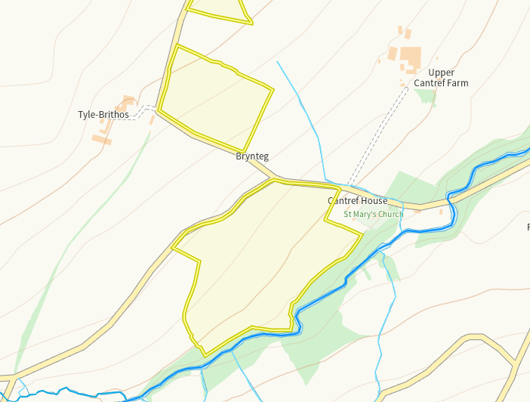
The Afon Cynrig runs opposite the spreading areas of Tylebrithos 2, 3 and 4. There is a 20m no spread buffer zone implemted along this border to prevent run off. No action required.
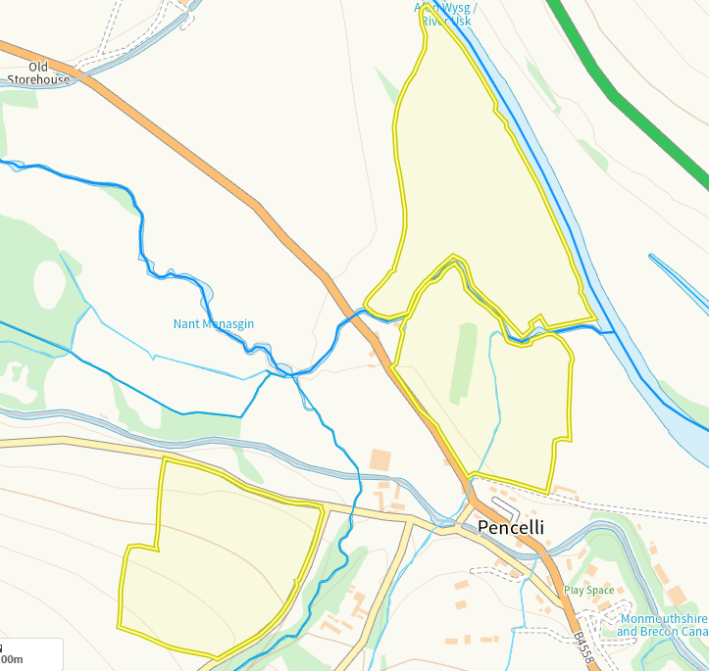
The Nant menasgin river runs through the gap between block 1 fields 3, 4,1 and 2 A 50m buffer zone is implemted on these borders due to it also being a river Usk tributarie so run off risk is low. A modified attribution runs through field 4, this has been buffered but not been specified the size, this will be clarified via RFI.
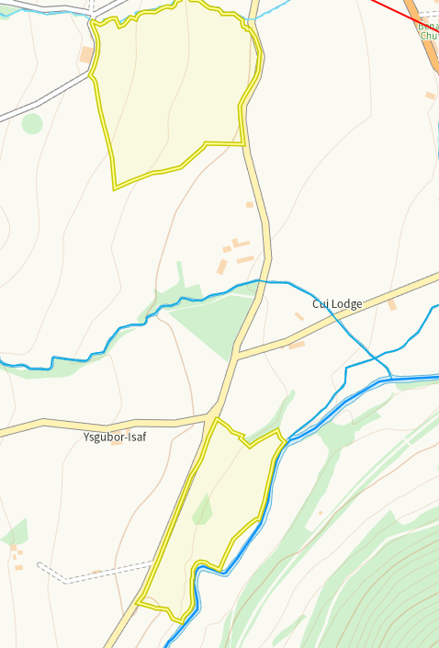
Caerfanell runs parallel to 7216 which is also a river Usk tributarie, there is a modified attribution above between 7216 and cae Gwar but the distance is too far between spreading areas to have a direct impact and the buffer for Caeranell will buffer run off to avoid an impact at the point they connect
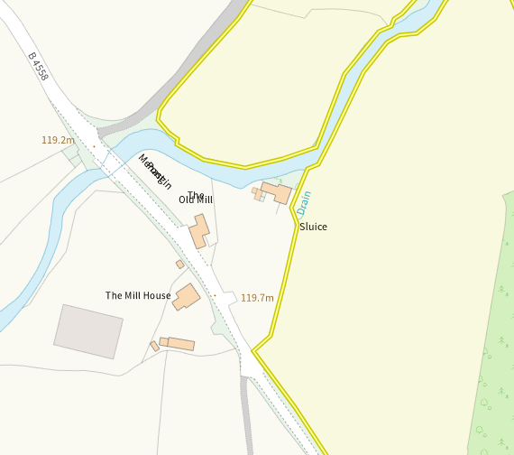
A field drain sits on the edge of field 3 (block 1) this has been identified and a 20m no spread buffer imposed.
Groundwater protection zones (source)
None in range
Wells, springs or boreholes used for the supply of water for human consumption including from a private water supply or supplies
None in range
any springs wells or boreholes not used to supply water for domestic or food production purposes within 50m

None in range

European designated sites- Natura 2000 (SPA, pSPA, SAC or cSAC) or Ramsar- or SSSI within 500m
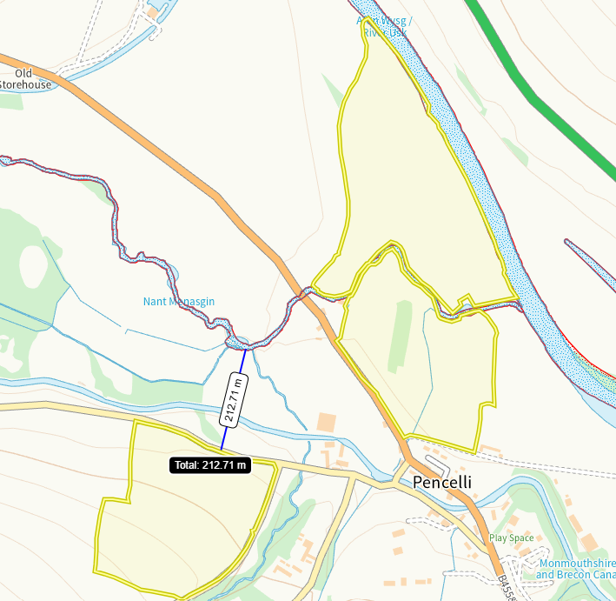
The River Usk (upper usk SSSI), River usk tributaries and River usk SAC sit on the borders of Block 1 fields 1, 2, 3 and 4. This has been identified in submitted maps. Field block 2 1 and 2 are 212m away form the SSSI/SAC boundaries and as such no impact pathway is perceived.
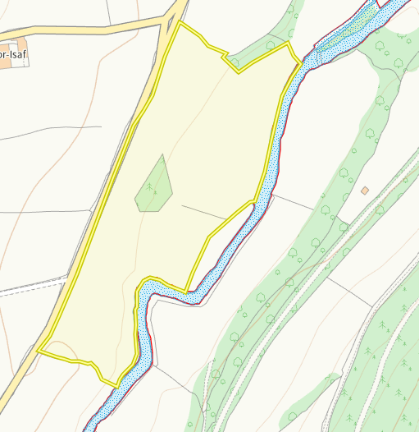
Field 7216 borders the River usk tributaries and river usk SAC. This has been identified on submitted maps.
Other protected sites:
- Protected Species and Protected Habitats-
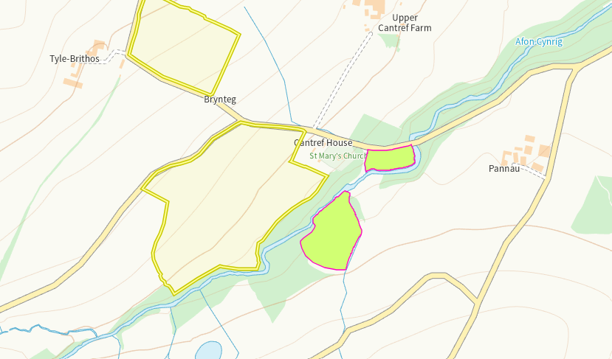
Lowland dry acid grassland and Lowland calcareous grassland is 39m and 93m from fields T4. There is a 20m no spread buffer zone imposed on this border which prevent run off. No action required.
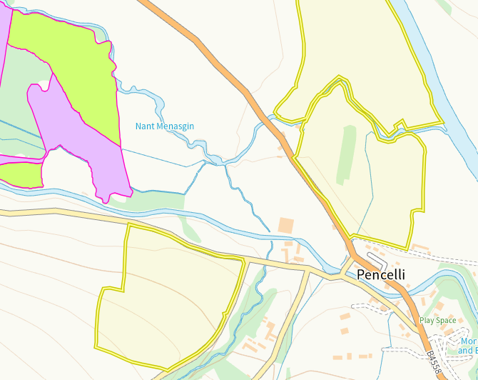
Lowland dry acid grassland and Lowland calcareous grassland, Purple moor grass and rush pastures are 70m from field Block 2 1 and 2. Due to the distance between the spreading area and sensitive receptor, run off risk is low.
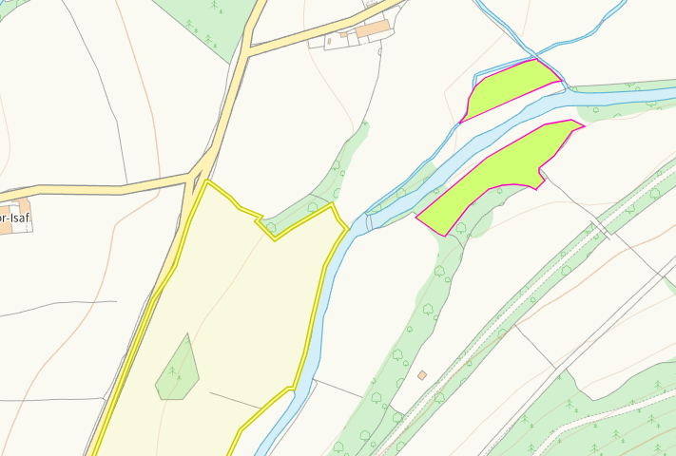
Lowland dry acid grassland and Lowland calcareous grassland, Purple moor grass and rush pastures are 63m from field 7216. Due to the distance between the spreading area and sensitive receptor, run off risk is low.
- Scheduled Ancient Monument- None in range
- Local Nature Reserve- None in range
- National Nature Reserve- None in range
- Ancient Woodlands
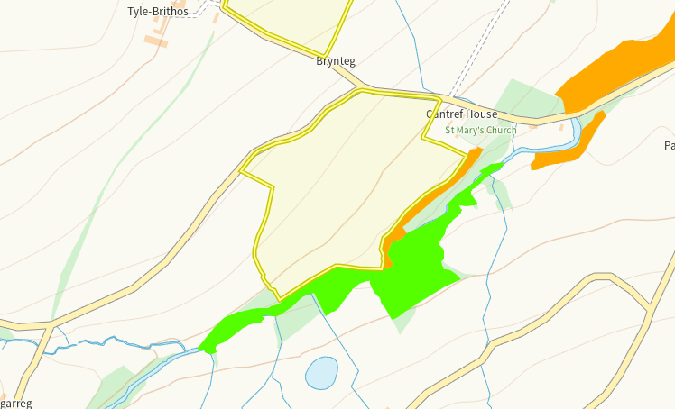
An area of ancient woodland is on the border of field 2, 3 and 4 (Tylebrithos). This has been identified I submitted maps and a 20m buffer zone imposed on the border.

- Local Wildlife Sites (SINC) - None in range
- National Park- None in range
- Groundwater Safeguard Zone- None in range
- Hedges, Ditches- Nothing of concern
- Local residents, Housing, schools, Workplaces, Recreational facilities

Slope Map
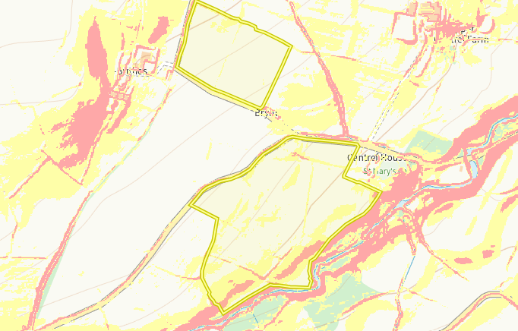
Areas of 7-12 degree slope (yellow) are on the edge of fields 2, 3 and 4, 17 and 18 (Tylebrithos) in addition to small sections of 12 + degree slope (red) in 2, 3 and 4. The border in which the slope crosses out of the spreading are has a 20m no spread buffer to prevent run off due to an ancient woodland. The rest of the slope are contained to the spreading area.
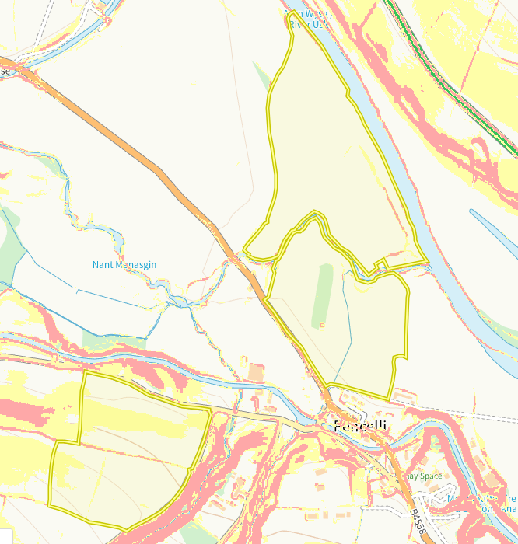
Fields 1, 2, 3 and 4 (block 1) have very minimal areas of 7-12 degree slope and 12 degree plus slope. There are 50m buffers on the borders next to the watercourse due to them being SAC/SSSI, in addition to the areas of sloping being very small. Run off risk low. Fields 1 and 2 (block 2) have larger areas of 7-12 degree slope and small 12 degree plus sloping areas. There is a lack of sensitive receptors in proximity of these fields.
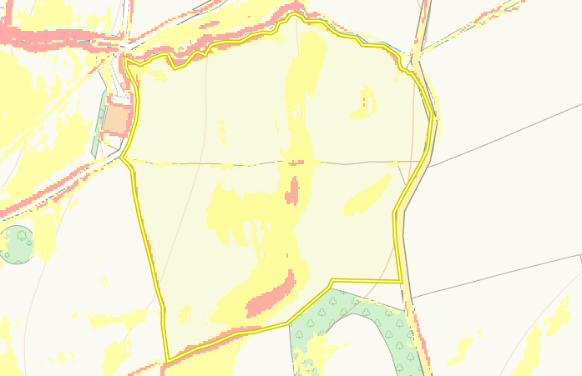
There areas of 7-12 degree slope and smaller areas of 12 degree plus slope in fields Cae Derwin and Cae Gwar. The sloping is mainly within the field boundary. There is a 20m no spread buffer on the border near the watercourse. Run off risk low.

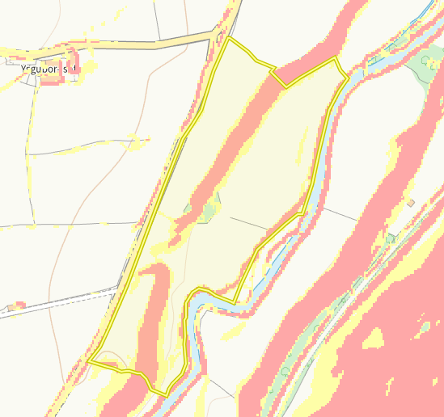
There are large areas of 7-12 and 12 plus degree slope in field 7216 and the sloping extends out of the spreading area. There is not sensitive receptors either end of this fields, the SSSI bordering is adequately buffered to minimise ris

Flood risk
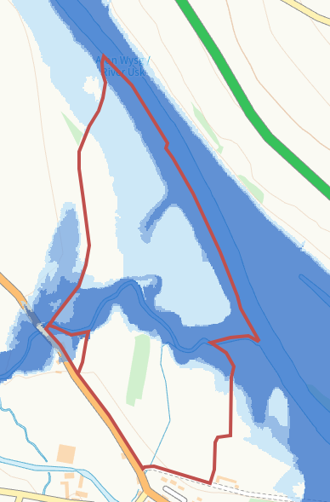
Field 1, 2, 3 and 4 (block 1) have areas of low – high flood risk from rivers over a large proportion of the spreading area. This has not been assessed or mitigated as part of the application. In addition the bordering rivers are SSSI/SAC’s.
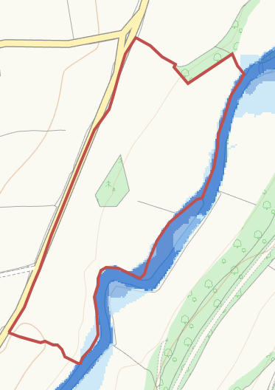
A small area of high flood risk borders field 7216. Again this has not been assessed or mitigated and there is a bordering SSSI/SAC.
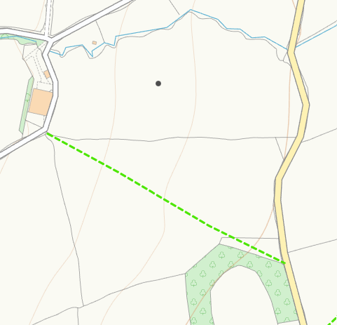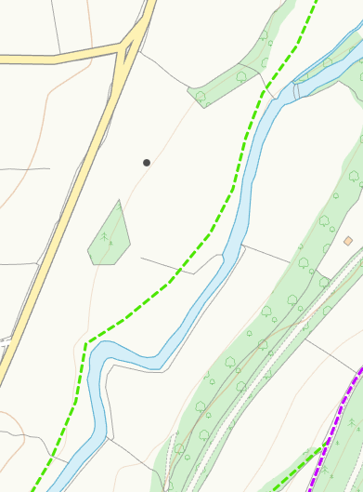
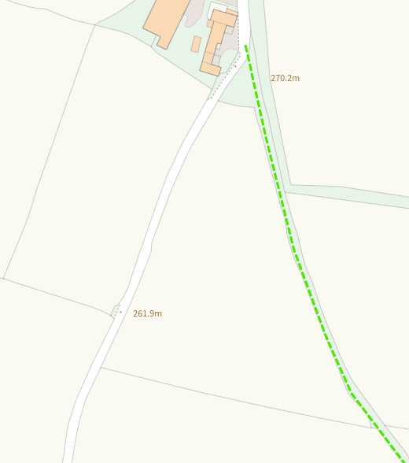
Public footpaths in fields 15A, Cae Gwar and 7216 have not been mapped.

