

Permit with introductory note
The Environmental Permitting (England & Wales) Regulations 2016

Dŵr Cymru Cyfyngedig

Emergency run to waste discharge at Pontsticill Water Treatment Works
Pontsticill
Merthyr Tydfil
CF48 2UP

Permit number

EPR/CB3194FL

Emergency run to waste discharge at Pontsticill Water Treatment Works

Permit Number EPR/CB3194FL

Introductory note

This introductory note does not form a part of the permit
The main features of the permit are as follows.
Run to Waste (RTW) discharge of dechlorinated drinking water from the Pontsticill WTW. This specification is as determined on the POF008 (Critical Parameter Board) and the discharge shall be made in accordance with the Pontsticill WTW Emergency Run to Waste Procedure. It is anticipated that this will occur for a maximum of 2hrs at a maximum flow rate of 460l/s (max volume 3300m³) via an 800mm pipe. Flow is the summated flow of the combined outlets of the second stage filters as the forward flow will be isolated removing the inline magflow meter from service and proving to the DWI that there is no forward flow of non-compliant water to public supply. The site also has a similar discharge activity regulated by permit AN0322601.
The status log of the permit sets out the permitting history, including any changes to the permit reference number.

Status log of the permit
Description | Date | Comments
Application PAN-006478 | Duly made 18/10/2019 | Application for discharge of Trade effluent consisting of off-specification dechlorinated drinking water
Additional information received | 18/10/2019 | Revised ERTW procedure.
Additional information received | 12/03/2021 | Turbidity and suspended solids monitoring
Additional information received | 08/04/2021 | Revised ERTW test procedure 26032021
Permit determined | 10/06/2021 | Permit issued to Dwr Cymru Cyfyngedig

End of introductory note

Permit
The Environmental Permitting (England and Wales) Regulations 2016
Permit number
EPR/CB3194FL

The Natural Resources Body for Wales (“Natural Resources Wales”) hereby authorises, under regulation 13 of the Environmental Permitting (England and Wales) Regulations 2016
Dŵr Cymru Cyfyngedig (“the operator”),
whose registered office is
Linea
Fortran Road
St Mellons
Cardiff
CF3 0LT

company registration number 02366777
to operate a water discharge activity at
Pontsticill Water Treatment Works
Merthyr Tydfil
CF48 2UP
to the extent authorised by and subject to the conditions of this permit.

Name Date
Melissa Broad | 10/06/2021

Authorised on behalf of Natural Resources Wales

Conditions
- Management
  - General management
    - The operator shall manage and operate the activity:
      - in accordance with a written management system that identifies and minimises risks of pollution so far as is reasonably practicable, including those risks arising from operations, maintenance, accidents, incidents, non-conformances and those drawn to the attention of the operator as a result of complaints; and
      - using sufficient competent persons and resources.
    - Records demonstrating compliance with condition 1.1.1 shall be maintained.
    - Any person having duties that are or may be affected by the matters set out in this permit shall have convenient access to a copy of the permit.
- Operations
  - Permitted activities
    - The only activity authorised by the permit is the activity specified in schedule 1 table S1.1.
  - The site
    - The discharge activity shall take place at the discharge point marked on the site plan at schedule 7 to this permit, and as listed in table S3.2; and, the operating techniques that are the subject of conditions prefixed by 2.3 shall be applied at the location(s) shown, or otherwise described, in schedule 7.
  - Operating techniques
    - For the activity referenced in schedule 1, table S1.1 the activity shall, subject to the conditions of this permit, be operated using the techniques and in the manner described in the documentation specified in schedule 1, table S1.2, unless otherwise agreed in writing by Natural Resources Wales.
    - If notified by Natural Resources Wales that the activities are giving rise to pollution, the operator shall submit to Natural Resources Wales for approval within the period specified, a revision of any plan or other documentation (“plan”) specified in schedule 1, table S1.2 which identifies and minimises the risks of pollution relevant to that plan , and shall implement the approved revised plan in place of the original from the date of approval, unless otherwise agreed in writing by Natural Resources Wales.
  - Pre-operational conditions
The activities shall not be brought into operation until 01/12/2021
- Emissions and monitoring
  - Emissions to water
    - The limits given in schedule 3 table S3.1 shall not be exceeded.
  - Emissions of substances not controlled by emission limits
    - The operator shall take appropriate measures to minimise so far as reasonably practicable the polluting effects of the emissions of substances in the discharge not controlled by emission limits (excluding odour).
  - Monitoring
    - The operator shall, unless otherwise agreed in writing by Natural Resources Wales, undertake the monitoring specified in the following tables in schedule 3 to this permit:
      - point source emissions specified in tables S3.1 and S3.3.
    - The operator shall maintain records of all monitoring required by this permit.
    - An Accessible monitoring point shall be provided and maintained to enable the emissions monitoring programme to be carried out at the monitoring point specified in table S3.3 of schedule 3 and shown marked on the site plan in schedule 7.
- Information
  - Records
    - All records required to be made by schedule 3, 4 and 5 to this permit shall:
      - be legible;
      - be made as soon as reasonably practicable;
      - if amended, be amended in such a way that the original and any subsequent amendments remain legible, or are capable of retrieval; and
      - be retained, unless otherwise agreed in writing by Natural Resources Wales, for at least 6 years from the date when the records were made.
    - The operator shall maintain convenient access, in either electronic or hard copy, to the records, plan and management system required to be maintained by this permit.
  - Reporting
    - The operator shall send all reports and notifications required by the permit to Natural Resources Wales using the contact details supplied in writing by Natural Resources Wales.
    - Within the time period after the end of the reporting period specified in schedule 4 table S4.1 the operator shall, unless otherwise agreed in writing by Natural Resources Wales, submit reports of the monitoring and assessment carried out in accordance with the conditions of this permit, as follows:
      - in respect of the parameters and monitoring points specified in schedule 4 table S4.1;
      - [for the reporting periods specified in schedule 4 table S4.1 and] using the forms specified in schedule 4 table S4.2; and
      - giving the information from such results and assessments as may be required by the forms specified in those tables.
  - Notifications
    - Natural Resources Wales shall be notified as soon as reasonably practicable following detection, within the site of the regulated facility of:
      - any malfunction, breakdown or failure of equipment or techniques, accident, or emission of a substance not controlled by an emission limit which has caused, is causing or may cause significant pollution; and
      - any breach of a limit specified in schedule 3 table S3.1.
      - any other significant adverse environmental effects, which may have been caused by the activity, shall also be notified to Natural Resources Wales as soon as reasonably practicable following detection.
    - The information provided under condition 4.3.1 shall be supported by sending the information listed in schedule 5 to this permit within the time period specified in that schedule.
    - Natural Resources Wales shall be notified within 14 days of the occurrence of the following matters, except where such disclosure is prohibited by Stock Exchange rules:
Where the operator is a registered company:
      - any change in the operator’s trading name, registered name or registered office address; and
      - any steps taken with a view to the operator going into administration, entering into a company voluntary arrangement or being wound up.
Where the operator is a corporate body other than a registered company:
      - any change in the operator’s name or address; and
      - any steps taken with a view to the dissolution of the operator.
    - Where the operator proposes to make a change in the nature of the activity by increasing the concentration of, or the addition of, or allowing the introduction of, a substance to the activity to an extent that the operator considers could have a significant adverse environmental effect on the receiving waters, and the change is not permitted by emission limits specified within schedule 3 table S3.1 or the subject of an application for approval under the EP Regulations or under the terms of this permit:
      - Natural Resources Wales shall be notified in writing at least 14 days before the increase or addition or allowing the introduction; and
      - the notification shall contain a description of the proposed change.
    - The operator shall notify the Natural Resources Wales, as soon as practicable after receipt of a telemetry warning, that operation of the discharge activity has taken place.
  - Interpretation
    - In this permit the expressions listed in schedule 6 shall have the meaning given in that schedule.
    - In this permit references to reports and notifications mean written reports and notifications, except where reference is made to notification being made “as soon as reasonably practicable”, in which case it may be provided by telephone.

Schedule 1 – Operations

Table S1.1 Activities
Activity reference | Description of activity | Limits of specified activity
A1 | Discharge of trade effluent consisting water treatment works run to waste discharge location | The rate of discharge shall be controlled to prevent any significant scouring of the bed or bankside of the receiving water

Table S1.2 Operating techniques
Activity reference | Description of documentation | Parts | Date Received
A1 | Pontsticill WTW Emergency Run to Waste test Procedure | All | 26/03/2021

Schedule 2 – Waste types, raw materials and fuels
Schedule 2 not in use.

Schedule 3 – Emissions and monitoring
Table S3.1 Point Source emissions to water (other than sewer) – emission limits and monitoring requirements
Effluent(s) and discharge point(s) | Parameter | Limit (including unit) | Reference Period | Limit of effective range | Monitoring frequency | Compliance Statistic
A1 Trade effluent consisting of off- water treatment works run to waste via discharge location | Maximum daily discharge volume | 4000 m³/day | Total daily volume | N/A | Whenever a discharge occurs | Maximum
 | Maximum rate of discharge | 500 litres per second | Instantaneous (spot sample) | N/A | Whenever a discharge occurs | Maximum
 | Discharge start and end times | N/A | N/A | N/A | Whenever a discharge occurs | N/A
 | Total available chlorine | 50 µg/l | Instantaneous (spot sample)  Within first 15 minutes and each hour thereafter | N/A | Whenever a discharge occurs | Maximum
 | pH | 6 to 9 | Instantaneous (spot sample) | N/A | Whenever a discharge occurs | Minimum and maximum
 | Suspended solids (measured after drying at 105ºC) | 25mg/l | Instantaneous (spot sample) | Suspended solids sampling is only required when turbidity is greater than 8NTU | Whenever a discharge occurs | Maximum
 | Total aluminium as Al | 1000µg/l | Instantaneous (spot sample) | N/A | Whenever a discharge occurs | Maximum

Table S3.2 Discharge points
Effluent Name | Discharge Point | Discharge point NGR | Receiving water/Environment
A1 Trade effluent consisting of water treatment works run to waste via discharge location | Discharge location | SO 05948 11482 | Taff Fechan

Table S3.3 Monitoring points
Effluent(s) and discharge point(s) | Monitoring type | Monitoring point NGR | Monitoring point reference
A1 Trade effluent consisting of water treatment works run to waste via discharge location | Effluent sampling | SO 05978 11467 | Monitoring point

Schedule 4 – Reporting
Parameters, for which reports shall be made, in accordance with conditions of this permit, are listed below.
Table S4.1 Reporting of monitoring data
Parameter | Monitoring point reference | Reporting period | Period begins
Duration of total spills, including daily volume, start and end times, instantaneous flow plus reasons for the discharge. Turbidity, Suspended solids (measured after drying at 105ºC), Total available chlorine, pH, Total aluminium as Al | Monitoring point | Reports to be provided to Natural Resources Wales at the start and end of each discharge and upon request. | At the start of each discharge event.
Summary report covering all run to waste activity permits, containing all parameters specified in table S3.1 including turbidity plus including results of investigation into the reasons for the discharge and proposed improvements. | Monitoring point | Annually  Report to be submitted within 2 months of the end of the calendar year | 1 January

Table S4.2 Reporting forms
Parameter | Reporting format
Duration of total spills, including daily volume, start and end times, instantaneous flow plus reasons for the discharge. Turbidity, Suspended solids (measured after drying at 105ºC), Total available chlorine, pH, Total aluminium as Al | Electronic or other format as specified by Natural Resources Wales
Summary report containing all parameters specified in table S3.1 plus including results of investigation into the reasons for the discharge and proposed improvements. | Annually - Summary report of compliance with the monitoring programme specified in Table 3.1 in a format specified by Natural Resources Wales

Schedule 5 – Notification
These pages outline the information that the operator must provide.
Units of measurement used in information supplied under Part A and B requirements shall be appropriate to the circumstances of the emission. Where appropriate, a comparison should be made of actual emissions and authorised emission limits.
If any information is considered commercially confidential, it should be separated from non-confidential information, supplied on a separate sheet and accompanied by an application for commercial confidentiality under the provisions of the EP Regulations.

Part A
Permit Number | EPR/CB3194FL
Name of operator | Dwr Cymru Cyfyngedig
Location of Facility | Pontsticill Water Treatment Works, Merthyr Tydfil, CF48 2UP
Time and date of the detection

(a) Notification requirements for any malfunction, breakdown or failure of equipment or techniques, accident, or emission of a substance not controlled by an emission limit which has caused, is causing or may cause significant pollution
To be notified within 2 hours of detection unless otherwise agreed in writing by Natural Resources Wales
Date and time of the event
Reference or description of the location of the event
Description of where any release into the environment took place
Substances(s) potentially released/type or nature of sewage released
Best estimate of the quantity or rate of release of substances and/or duration of discharge
Best estimate of the environmental impact of the discharge
Measures taken, or intended to be taken, to stop any emission
Description of the failure or accident.

(b) Notification requirements for the breach of a limit specified in schedule 3 table S3.1
The information specified below is to be notified to Natural Resources Wales as soon as reasonably practicable following detection.
Monitoring point reference/ source
Self monitoring regime (where relevant)
Type of failure | Eg maximum and minimum pH and maximum total available chlorine
Date of sample/event
Parameter
Result and units
Limit and units

Part B – to be submitted as soon as reasonably practicable unless otherwise agreed in writing by Natural Resources Wales
Any more accurate information on the matters for notification under Part A.
Measures taken, or intended to be taken, to prevent a recurrence of the incident/breach/exceedance
Measures taken, or intended to be taken, to rectify, limit or prevent any pollution of the environment which has been or may be caused by the emission

Name*
Post
Signature
Date
* authorised to sign on behalf of the operator

Schedule 6 – Interpretation
“accident” means an accident that may result in pollution.
"annually" means once every year.
“application” means the application for this permit, together with any additional information supplied by the operator as part of the application and any response to a notice served under Schedule 5 to the EP Regulations.
“appropriate measures” for the purposes of the emission of substances not controlled by emission limits condition (condition 3.2.1) do not require the operator to undertake treatment to a level beyond that specified in schedule 1 table S1.1, or to carry out routine monitoring for substances not controlled by emission limits.
“emissions of substances not controlled by emission limits” means emissions of substances to air, water or land from the permitted activities, which are not controlled by an emission limit.
“EP Regulations” means The Environmental Permitting (England and Wales) Regulations SI 2016 No.1154 and words and expressions used in this permit which are also used in the Regulations have the same meanings as in those Regulations.
“MCERTS” means Natural Resources Wales’ Monitoring Certification Scheme.
“Natural Resources Wales” means the Natural Resources Body for Wales established by article 3 of the Natural Resources Body for Wales (Establishment) Order 2012. The Natural Resources Body for Wales (Functions) Order 2013 transferred the relevant functions of the Countryside Council for Wales, and functions of the Environment Agency and the Forestry Commission in Wales to the Natural Resources Body for Wales.
"quarter" means a calendar year quarter commencing on 1 January, 1 April, 1 July or 1 October.
“significant pollution” means a high level impact incident as indicated by NRW incident classification system.
“year” means calendar year ending 31 December.

Schedule 7 – Site plan

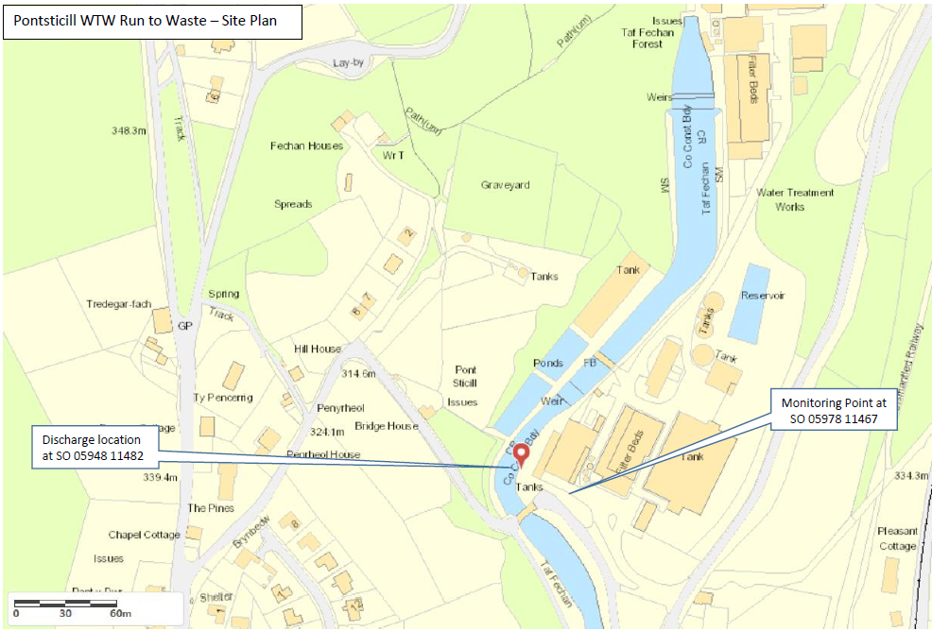

© Crown Copyright and database right 2021. Ordnance Survey licence number 100019741.

END OF PERMIT

