PAN-028160 My Map Report:
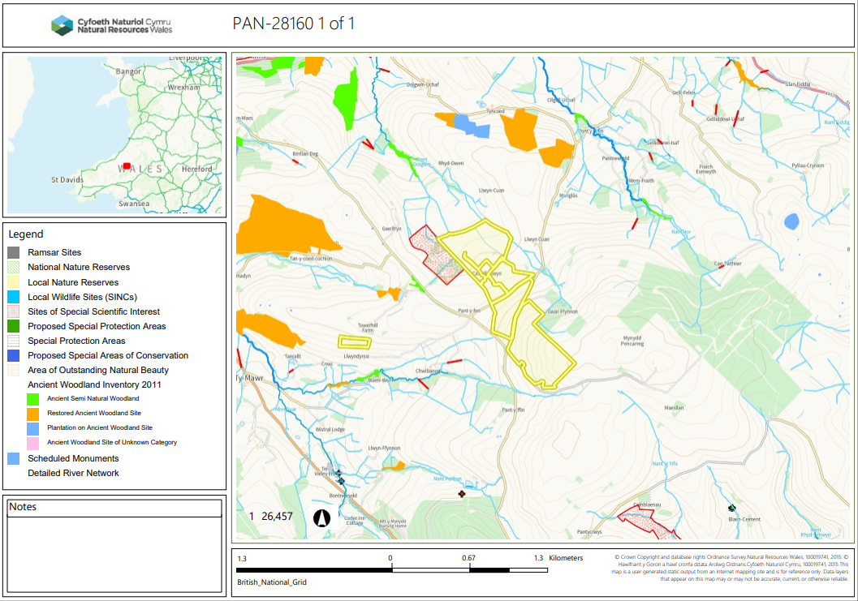
Detailed river network:
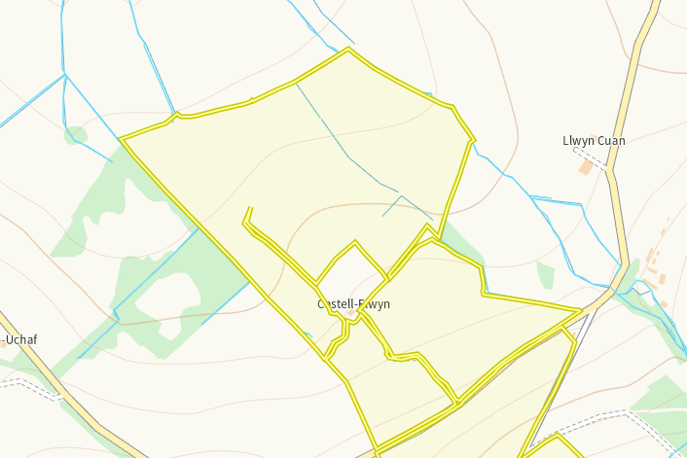
Modified attribution border fields 5 and 1. In addition a drain runs through the middle of fields 1 and 2. Another drain sits at the top of field 6 and a modified attribution runs on the edge of field 7. These have all been identified on submitted maps and appropriate 10m buffer zones implemented.
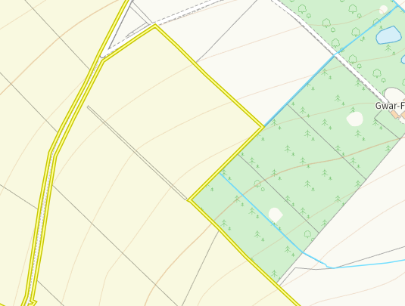
A modified attribution runs on the underside edge of field 10. This again is on submitted maps and has a 10m no spread buffer implemented.

Groundwater protection zones (source)
None in range
Wells, springs or boreholes used for the supply of water for human consumption including from a private water supply or supplies
None in range
any springs wells or boreholes not used to supply water for domestic or food production purposes within 50m

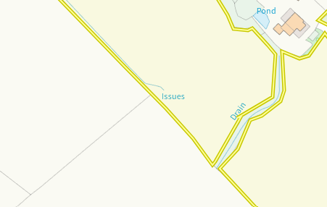
An issue is on the edge of field 5. This has been identified and an appropriate 50m budder applied.
European designated sites- Natura 2000 (SPA, pSPA, SAC or cSAC) or Ramsar- or SSSI within 500m

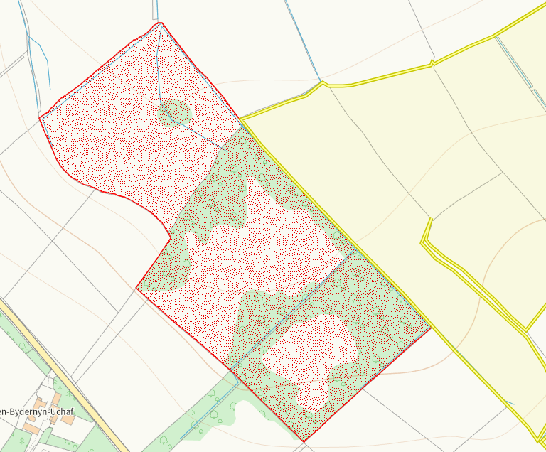
Caeau Blaen-bydernyn SSSI sits on the border of field 5. This has been identified on submitted maps and a 10m no spread buffer implemted to prevent run off.

Other protected sites:
- Protected Species and Protected Habitats-
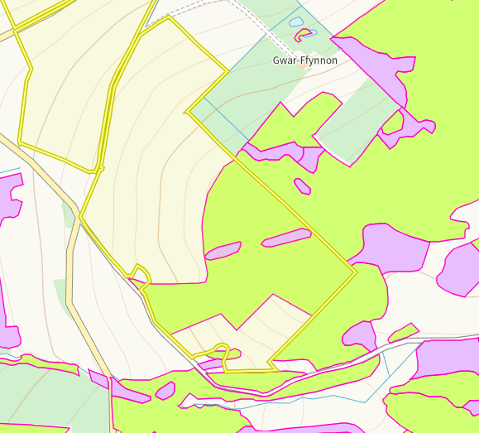
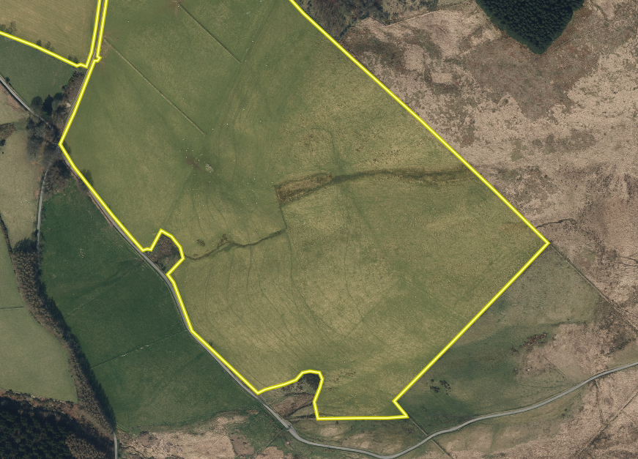
The areas of pink are Purple moor grass and rush pastures with the yellow depicting Lowland dry acid grassland crossing into the spreading area of BRW11. Ariel imagery shows there is consistent pasture which suggests the habitat is no longer present. No action required.

- Local Nature Reserve- None in range
- National Nature Reserve- None in range
- Ancient Woodlands- None in range
- Local Wildlife Sites (SINC)- None in range
- National Park-None in range
- Nitrate Vulnerable Zone (NVZ)- None in range
- Groundwater Safeguard Zone-None in range
- ANOBs- - None in range
- Hedges, Ditches- Nothing of concern
- Local residents, Housing, schools, Workplaces, Recreational facilities – Sensitive receptors marked but OMP requested.

Slope Map
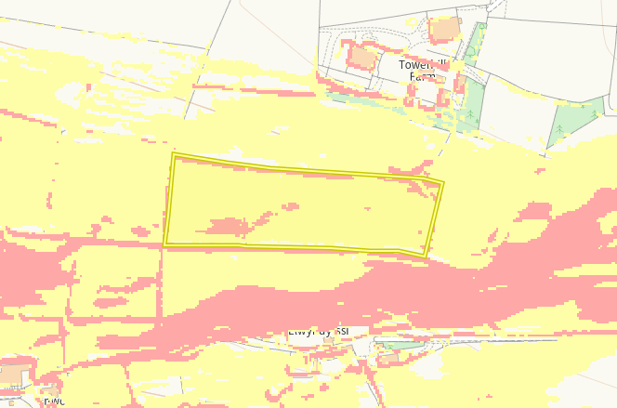
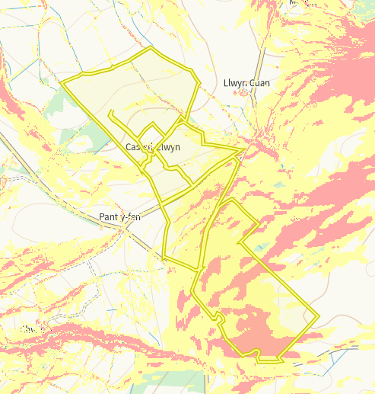
Fields 5, 2, 4, 1, 7, 6, 8, 9, 10, 12 and 11 all have areas of 7-12 degree slope (yellow) with field 10, 11, 8, 9, 4, 12 and 7 all having some areas of 12 degree plus slope (red). There is a 10m no spread buffer zone around the perimeter of all the fields prevent run off. In addition the only liquid waste is being soil injected meaning the precise application and is unlikely to cause run off. The other waste streams are again solid forms so will not have run off risk. No action required.

