Permit
The Environmental Permitting (England & Wales) Regulations 2016

By Product recovery LTD

New House lagoon
New House
Old Monmouth Road
Abergavenny
Monmouthshire
NP7 8BS

Permit number

EPR/DB3497ZC

Permit
The Environmental Permitting (England and Wales) Regulations 2016
Permit number

EPR/DB3497ZC

The Natural Resources Body for Wales (“Natural Resources Wales”) authorises, under regulation 13 of the Environmental Permitting (England and Wales) Regulations 2016

ByProduct recovery Limited (“the operator”),

whose registered office whose principal office is

Control House A1 Business Park

Knottingley Road

Knottingley

West Yorkshire

England

WF11 0BU

company registration number 06257744

to operate waste operations at

New House lagoon

New House

Old Monmouth Road

Abergavenny

Monmouthshire

NP7 8BS

to the extent authorised by and subject to the conditions of this permit.

Under regulation 27(2) of the Regulations, standard rules SR2010No17are conditions of this permit.

Name | Date
Huw Davies | 02/04/2025

Authorised on behalf of Natural Resources Wales

Schedule 1 - Site plan

This is the plan referred to in the standard rules SR2010No17.

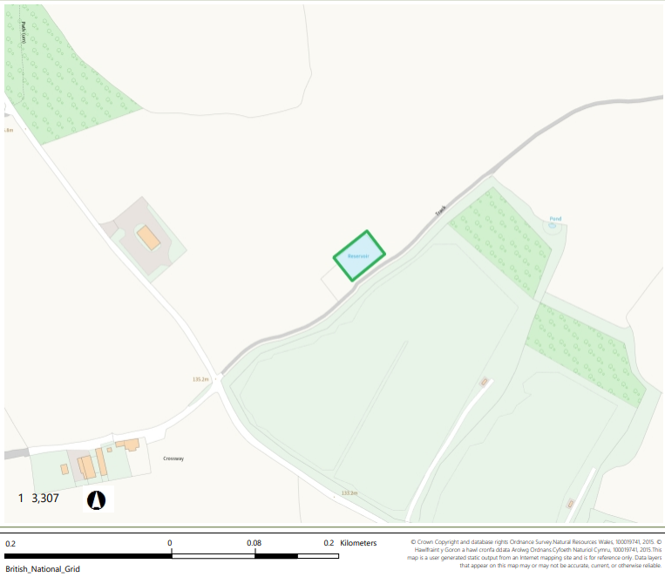

END OF PERMIT

