Schedule 5 - Notification

These pages outline the information that the operator must provide.

Units of measurement used in information supplied under Part A and B requirements shall be appropriate to the circumstances of the emission. Where appropriate, a comparison should be made of actual emissions and authorised emission limits.

If any information is considered commercially confidential, it should be separated from non-confidential information, supplied on a separate sheet and accompanied by an application for commercial confidentiality under the provisions of the PPC Regulations.

Part A
Permit Number | EPR/BL1096IB/V012
Name of operator | Castle Cement Limited
Location of Installation | Padeswood Works, Padeswood, Mold.
Time and date of the detection | 00:01 14/02/16 and 00:01 15/02/16

(a) Notification requirements for any malfunction, breakdown or failure of equipment or techniques, accident, or fugitive emission which has caused, is causing or may cause significant pollution

To be notified within 24 hours of detection

Date and time of the event

Reference or description of the location of the event

Description of where any release into the environment took place

Substances(s) potentially released

Best estimate of the quantity or rate of release of substances

Measures taken, or intended to be taken, to stop any emission

Description of the failure or accident.

 | (b) Notification requirements for the breach of a limit
 | To be notified within 24 hours of detection unless otherwise specified below
 | Emission point reference/ source | A8
 | Parameter(s) | Particulates
 | Limit | 10mg/Nm³
 | Measured value and uncertainty | 12.8mg/Nm³ / 11.8mg/Nm³
 | Date and time of monitoring | 00:00 – 24:00 13/02/16 / 00:00 – 24:00 14/02/16
 | Measures taken, or intended to be taken, to stop the emission | Investigation ongoing to identify potential courses on filter system

Time periods for notification following detection of a breach of a limit
Parameter |  |  | Notification period

(c) Notification requirements for the detection of any significant adverse environmental effect

To be notified within 24 hours of detection

Description of where the effect on the environment was detected

Substances(s) detected

Concentrations of substances detected

Date of monitoring/sampling

Part B - to be submitted as soon as practicable
Any more accurate information on the matters for notification under Part A. | Kiln was restarted late on the 12th and dust emissions were high but not over limit. This is usual operation as the filter system conditions following the major shutdown works where bags are changed and some cross contamination from dirty to clean side can occur during this process. Additional cleaning and movement of materials though the kiln system through shutdown and remedial works can also mean there is an increased dust loading at start up but this usually settles quickly.  However in this case the loading remained around the permit limit and a systematic investigation of the filter system was started when it became clear the levels were not dropping off as expected, with banks being shut and opened in sequence to identify the issues. Work of this type can only be done whilst the filter/kiln system is in operation as diagnosing faults of this type on a static system is not viable.  These investigations led to some suspect banks had been identified and were shut off. However a kiln stop was also taken as issue elsewhere meant feed stock was running low so the impact of the closures was uncertain until feed was restarted.  Although the emissions were lower on restart they were not sufficiently so to impact on the daily average for the 13th February.  Following on into the 14th initially the results of the previous day’s work bought the dust below the limit however it become more variable as the day went on and the filter system was again checked over for obvious issues. Additional process adjustments were also made to reduce emissions.  These impacted fully on emissions later in the day but not at sufficient levels to reduce the daily average below limit for the 14th Feb  (Graph of ½ hour averages appended on following page)
Measures taken, or intended to be taken, to prevent a recurrence of the incident | This is an occurrence linked to start-up and is managed through that process.
Measures taken, or intended to be taken, to rectify, limit or prevent any pollution of the environment which has been or may be caused by the emission | Excess emission estimated at 18kg for the 13th and 11kg for the 14th over limit allowance, would have dispersed quickly with no environmental impact (no complaints were received linked to this incident.
The dates of any unauthorised emissions from the installation in the preceding 24 months. | 13/04/14 01/04/15 10/09/15  02/09/14 06/07/15 15/10/15  06/09/14 15/07/15 07/12/15  21/01/15 17/07/15 02/01/16  06/02/15 23/08/15 13/02/16

Name* | V Smith
Post | Q&E Manager

Signature
Date | 14/03/16

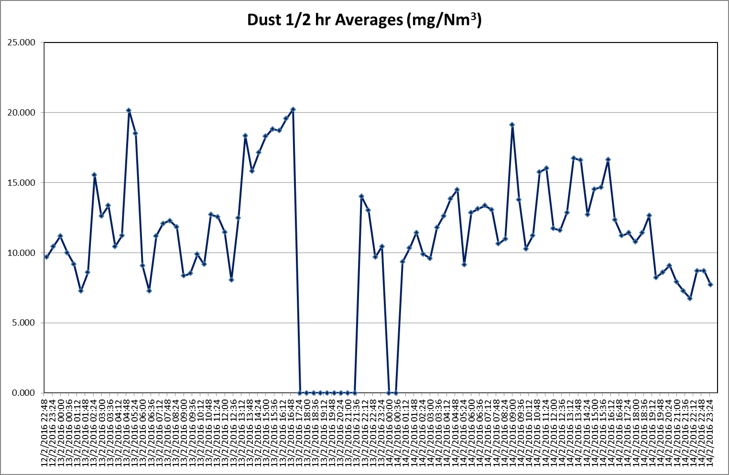
* authorised to sign on behalf of Castle Cement Limited

