PAN-029001 Mapping Report
NOTE- permit boundary extended to include supplementary quarantine area “Q” but this does not change the results of this report
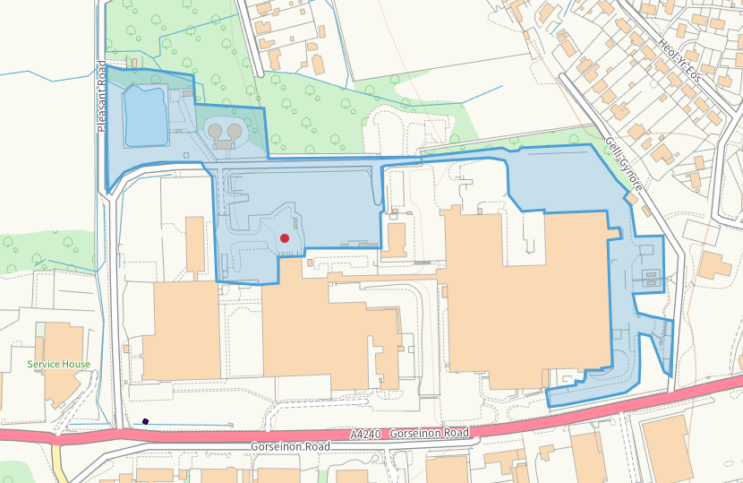
Q

None:
- Special protection areas (SPA)/Potential special protection areas (pSPA)
- Special areas of conservation (SAC)/Candidate special areas of conservation (cSAC)
- Ramsar sites
- Site of Special Scientific Interest (SSSI)
- Areas of Outstanding Natural Beauty (AONB)
- Heritage Coast
- Local nature reserves
- National nature reserves
- National parks

Ancient woodland
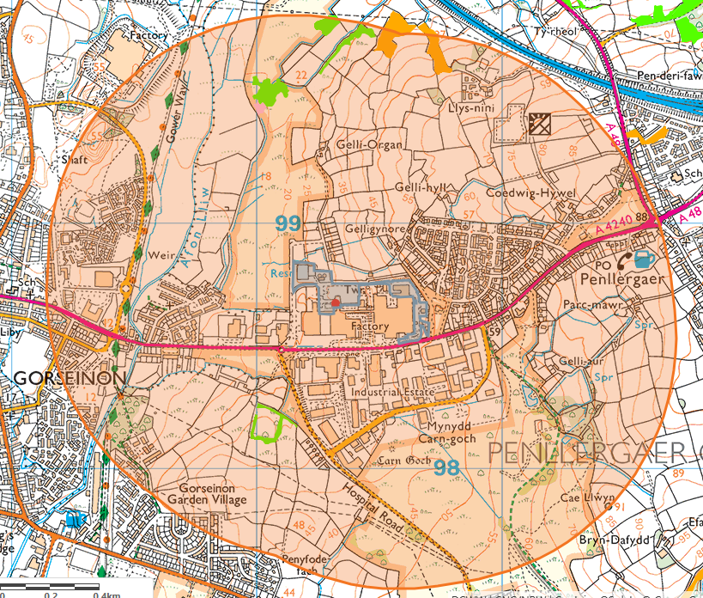
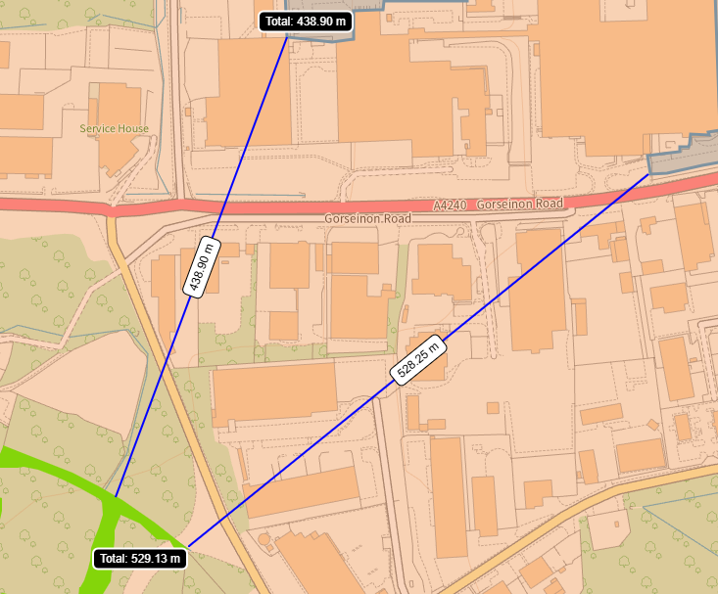
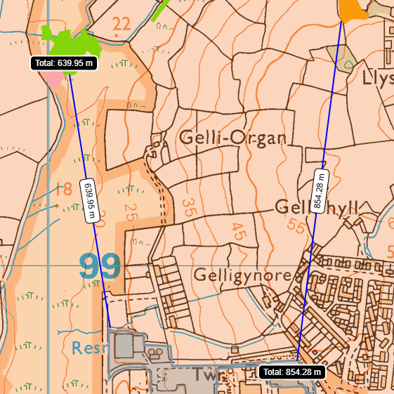

Local wildlife sites
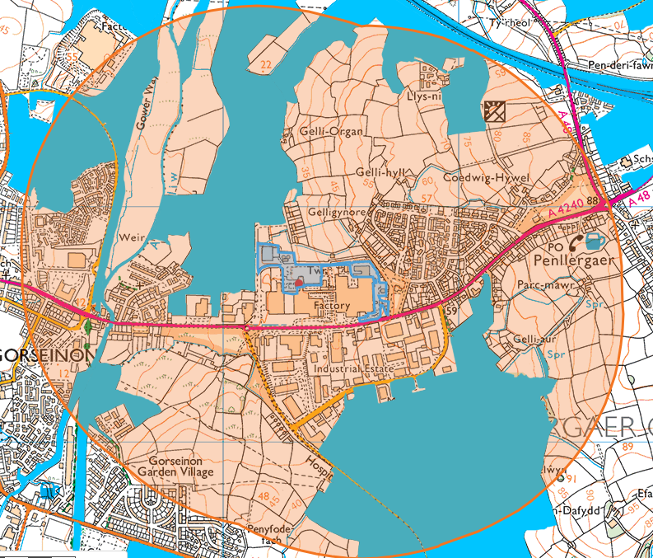

Llys Nini: Waungron to Gowerton Railway line:
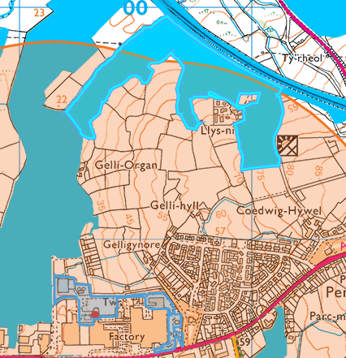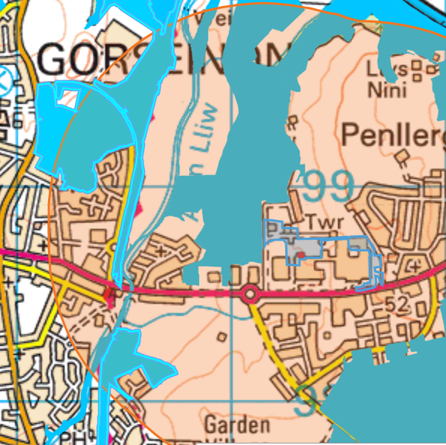
630 Meters 606 meters

Mynydd Garn goch Common: Upper Mynydd Garn goch Common
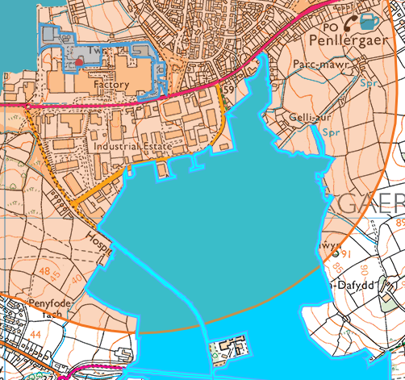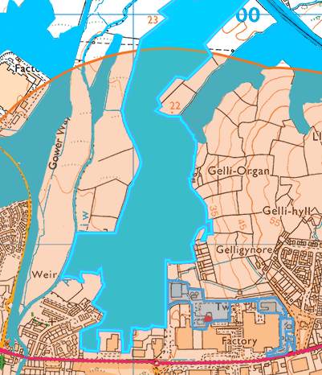
265 meters Shared border

Lower Lliw Corridor & Llan Confluence:
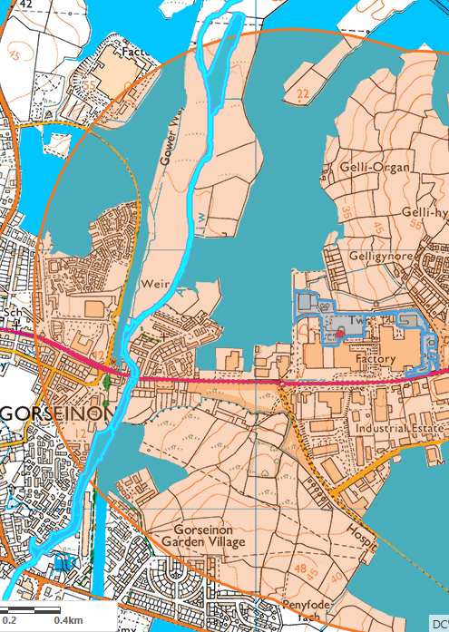
450 meters
Scheduled ancient monuments
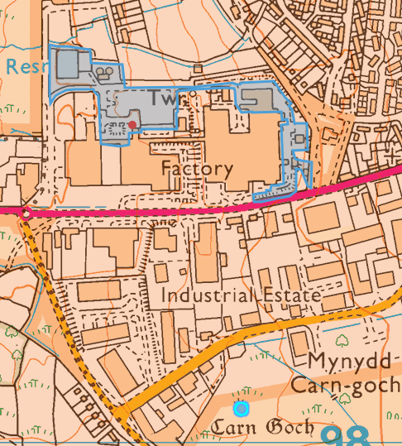
Garn Goch Round Barrow- 420 meters

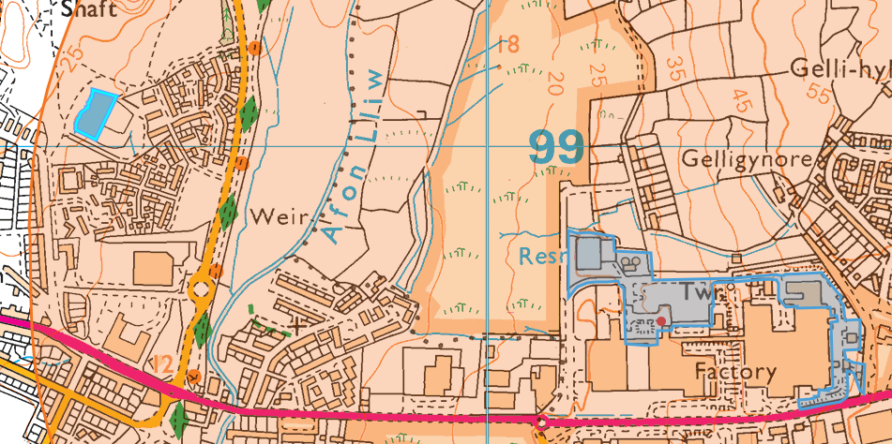
Melin Mynach, Gorseinon- 875 meters

World Heritage Sites
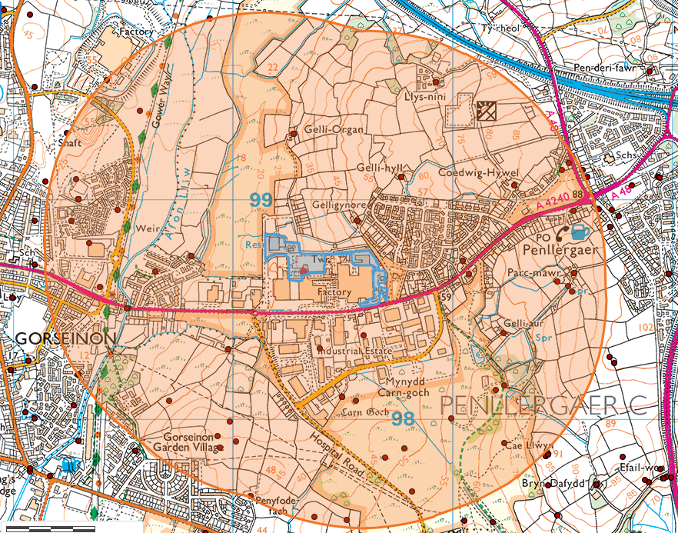
NAME | PERIOD | TYPE | CONDITION | NGR
Formal Gardens, Melin Mynach, Gorseinon | POST MEDIEVAL | formal garden | Destroyed | SS593990
Quarry, Penllergaer | POST MEDIEVAL | quarry | Destroyed | SS61059872
Stone, Penllergaer | POST MEDIEVAL | stone | Near intact | SS61249789
Bryngwyn-bach Farm | POST MEDIEVAL | farmstead | DAMAGED | SS5998398315
Garn-goch Colliery (No. 3) | Unknown | colliery | Not known | SS61249815
Parc Mawr Earthwork | UNKNOWN | earthwork | NOT KNOWN | SS6154998579
Bryngwyn Sheet Works Bryngwyn Steel Works) | Unknown | sheet metal works | Not known | SS593982
Gelli Hyll, Llangyfelach | POST MEDIEVAL | farmstead | RESTORED | SS6077099100
Gelli Organ, Llangyfelach | POST MEDIEVAL | house | Not known | SS6028299296
Llys Nini, Llangyfelach | POST MEDIEVAL | house | Converted | SS6093099530
Well, Garden Village | POST MEDIEVAL | well | NOT KNOWN | SS6037797553
Boundary ditches, Gorseinon | POST MEDIEVAL | boundary ditch | DAMAGED | SS6001997896
Gelli-gynore Farm | POST MEDIEVAL | farmstead | RESTORED | SS6057198900
Garn Goch Cairn | Bronze Age | cairn | Damaged | SS6056398083
Pen-y-fodau-fach Farm | POST MEDIEVAL | farmstead | INTACT | SS6008497649
Parc-mawr Farm | POST MEDIEVAL | farmstead | NEAR INTACT | SS6156098661
Early Grist Corn Mill, Melin Mynach, Gorseinon | Medieval | corn mill | Destroyed | SS593990
Llys Nini, Llangyfelach | POST MEDIEVAL | farmstead | Converted | SS6093099530
Mill House, Melin Mynach, Gorseinon | POST MEDIEVAL | mill house | Destroyed | SS593990
Anti-glider trench at Carn Goch | Modern | anti aircraft defence site | Not known | SS6078497866
Findspot, Penllergaer | Neolithic | findspot | Not known | SS60509810
Gelli Organ, Llangyfelach | POST MEDIEVAL | farmstead | Not known | SS6028299296
Battlefield (Carn Goch Common) Penllegaer | Unknown | battlefield | Not known | SS610980
Gorseinon Tin Plate Works | Unknown | plating works | Destroyed | SS59359880
Quarry, Penllergaer | POST MEDIEVAL | quarry | Destroyed | SS61089866
Well, Penllegaer | UNKNOWN | well | NOT KNOWN | SS6148398625
Boundary ditches, Gorseinon | POST MEDIEVAL | boundary ditch | DAMAGED | SS5993497922
Coedwig-Hywel Farm | POST MEDIEVAL | farmstead | INTACT | SS6128599062
Mine, Gorseinon | POST MEDIEVAL | mine | Not known | SS59439954
Llys Nini, Llangyfelach | POST MEDIEVAL | farmstead | INTACT | SS6093099530
Isolation hospital, Carn Goch Common | POST MEDIEVAL | infectious diseases hospital |  | SS6069997822
Gelli Hyll, Llangyfelach | POST MEDIEVAL | farmstead | Not known | SS6077099100
Island House, Penllergaer | POST MEDIEVAL | house | NEAR DESTROYED | SS6153499163
Gors-waddan Farm | POST MEDIEVAL | farmstead | INTACT | SS5981698740
The Camp, Boys' School | POST MEDIEVAL | school | NEAR DESTROYED | SS6155698945
Parc-mawr Farm | POST MEDIEVAL | farmstead | INTACT | SS6156098661
Rhydymaerdy Bridge, River Lliw | POST MEDIEVAL | bridge | Destroyed | SS59539850
Gelli Hyll, Llangyfelach | POST MEDIEVAL | house | Not known | SS6077099100
Gelli Organ, Llangyfelach | POST MEDIEVAL | house | INTACT | SS6028299296
Llys Nini, Llangyfelach | POST MEDIEVAL | house | INTACT | SS6093099530
Gorseinon Colliery | POST MEDIEVAL | colliery | Destroyed | SS60409832
Boundary ditches, Gorseinon | POST MEDIEVAL | boundary ditch | DAMAGED | SS5994697867
Curvilinear Enclosure Ditch, Gorseinon | ROMAN | curvilinear enclosure | DAMAGED | SS 59713 98080
Gelli Hyll, Llangyfelach | POST MEDIEVAL | house | INTACT | SS6077099100
Pen-y-fodau-fach Farm | POST MEDIEVAL | farmstead | NEAR DESTROYED | SS6008497649
Bridge, Melin Mynach, Gorseinon | POST MEDIEVAL | bridge | Not known | SS593990
Gelli Organ, Llangyfelach | POST MEDIEVAL | farmstead | INTACT | SS6028299296
Carn Goch Common | Unknown | enclosure | Near intact | SS60829767
Ebenezer, Gorseinon | MODERN | war memorial | NOT KNOWN | SS5965098670
Quarry, Penllergaer | POST MEDIEVAL | quarry | NEAR DESTROYED | SS61059872
Grovesend Steel and Tinplate Works | POST MEDIEVAL | steel works | Destroyed | SS59489895
Melin Mynach Paper Mill, Gorseinon | POST MEDIEVAL | paper mill | Damaged | SS59299909
Well, Penllegaer | UNKNOWN | well | NOT KNOWN | SS6152998604
Findspot, Penllergaer | Neolithic | findspot | Not known | SS60509810
Lliw River Bridge, Rhyd y Mardy | POST MEDIEVAL | ford | Converted | SS59529850
Bryngwyn Sheet Works Bryngwyn Steel Works) | Unknown | sheet metal works | NEAR DESTROYED | SS593982
Coal Pits, Penyrheol | POST MEDIEVAL | colliery | Not known | SS59589940
Gelli Hyll, Llangyfelach | POST MEDIEVAL | farmstead | INTACT | SS6077099100
Dye-house, Melin Mynach, Gorseinon | POST MEDIEVAL | dye house | Not known | SS593990
Well, Penllegaer | POST MEDIEVAL | well | NEAR DESTROYED | SS6150299133
Monarch Vitriol Works | POST MEDIEVAL | acid works | Destroyed | SS59279890
Gelli-gynore Farm | POST MEDIEVAL | farmstead | INTACT | SS6057198900
Gors-waddan Farm | POST MEDIEVAL | farmstead | RESTORED | SS5981698740
Parc-mawr Farm | POST MEDIEVAL | farmstead | RESTORED | SS6156098661
Gowerton Mineral Railway | POST MEDIEVAL | tramway | Destroyed | SS60609838
Gelli-aur Farmstead | POST MEDIEVAL | farm | DAMAGED | SS6123598389
Gelli Organ, Llangyfelach | POST MEDIEVAL | house | NEAR INTACT | SS6028299296
Llys Nini, Llangyfelach | POST MEDIEVAL | house | NEAR DESTROYED | SS6093099530
Pen-y-waun farmstead | POST MEDIEVAL | farmstead | NEAR DESTROYED | SS6052397540
Melin Mynach Woollen Mill, Gorseinon | POST MEDIEVAL | woollen mill |  | SS593990
Mineral Railway, Garn-goch Colliery | POST MEDIEVAL | railway | NEAR DESTROYED | SS6120098130
Gorseinon Station | POST MEDIEVAL | railway station | Not known | SS594986
Coedwig-Hywel Farm | POST MEDIEVAL | farmstead | RESTORED | SS6128599062
Boundary ditches, Gorseinon | POST MEDIEVAL | boundary ditch | DAMAGED | SS5998997988
Barrow, Penllergaer | Bronze Age | findspot | Not known | SS60509810
Gelli Hyll, Llangyfelach | POST MEDIEVAL | house | RESTORED | SS6077099100
Llys Nini, Llangyfelach | POST MEDIEVAL | farmstead | NEAR DESTROYED | SS6093099530
Bryngwyn-bach Farm | POST MEDIEVAL | farmstead | INTACT | SS5998398315
Engine House, Melin Mynach, Gorseinon | POST MEDIEVAL | engine house | Not known | SS593990
Gelli Organ, Llangyfelach | POST MEDIEVAL | farmstead | NEAR INTACT | SS6028299296

*None in permitted area

Controlled waters such as rivers and lakes
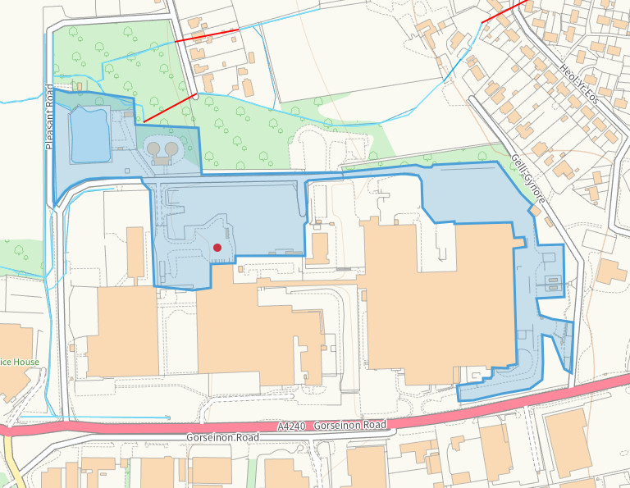

European Protected Species/Nationally Protected Species/Section 7 Priority species/Section 7 Priority habitats:
- Purple moor grass and rush pastures (east)
- Lowland dry acid grassland and Lowland calcareous grassland (south) (northx2)
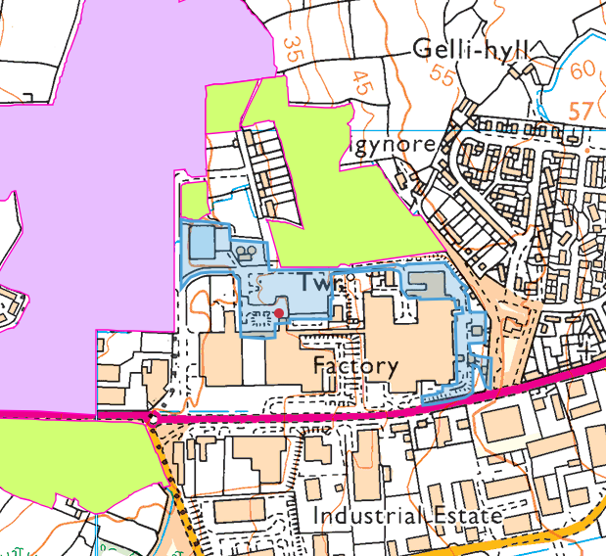

- European Eel migratory route/Atlantic Salmon migratory route
- Marsh Fritillary
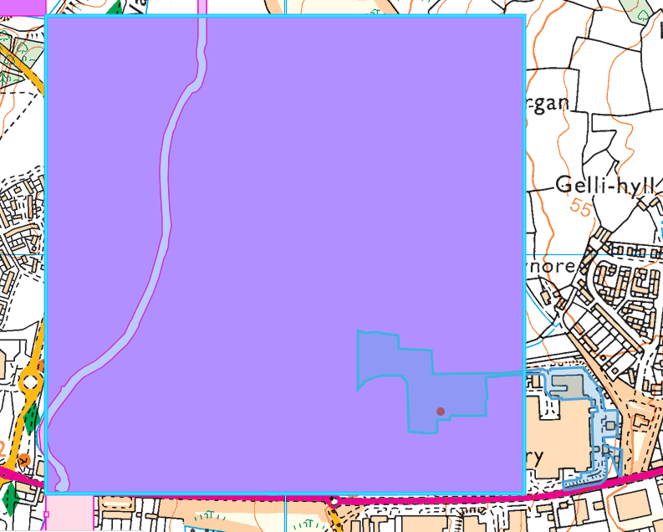

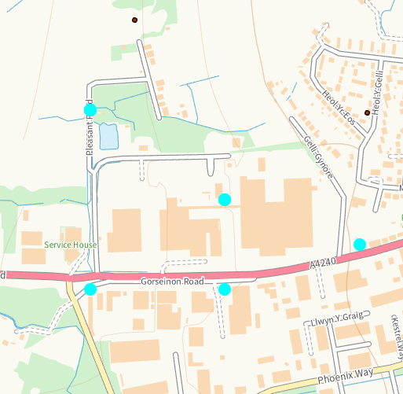
- Dunnock, Reed Bunting, Song Thrush, House Sparrow, Starling, Herring Gull
- Hedgehog, Grass Snake
- Cornflower
- Lichen

