Project: | Valero Jetty Repairs CML2517
Advice Note No.: | N/A
Reference: | MC000060
Date: | 05 June 2025
NRW Comment
Relevant Section: | Marine Environmental Appraisal (MEA) - Section 4.2.1 Increased SSCs and associated deposition
Comment: | NRW (A) note that Discretionary Advice provided in March 2024, advised that the zone of influence for the potential impact of an SSC plume caused by the proposed project on sensitive receptors downstream of the work site should be determined using the spring tide maximum tidal excursion. NRW (A) note this has not been provided, however in this instance, due to the small scale (~45 m³) of drilling arises and temporary nature of the works, we are satisfied that the assessment drawing on evidence from local dredging activities is sufficient.
RAG Status: | Yellow
RPS Response
Noted NRW’s satisfaction with the assessment and no further response provided.
NRW Comment
Relevant Section: | MEA – Section 4.3.4 Effects on benthic ecology associated with pumping grout
Comment: | 4.3.4 Effects on benthic ecology associated with pumping grout  Although NRW (A) agree with the overall assessment of negligible in relation to the effects of grout pumping and its ability to alter water pH, we advise that all appropriate means should be adopted to ensure that excess grout does not escape into the marine environment which may cause further loss / degradation of habitat. Relevant information should be included in the project CEMP for later review.  4.3.5 Changes in water quality, including the release of sediment bound contaminants  Despite the small, elevated levels of some contaminants within the drilling arisings we believe that these will be dispersed quickly and are of a magnitude unlikely to have a discernible long-term effect on the benthic communities in the vicinity of the proposed works.
RAG Status: | Amber
RPS Response
Please see the attached PDF which presents a detailed diagram of activities associated with pumping grout. The permanent casing containing the grout will be larger in diameter than the drilled rock socket. The casing will be vibrated/hammered until refusal by the rock and therefore will be sealed at this joint, eradicating any chance of grout leakage. The only means of grout release to the water is over the top of the permanent casing. The annulus between the rock and the pile will require 10.08 m³ of grout, and the annulus between the casting and the pile will require 21.9 m³ of grout. This totalling 32 m³ of grout. The amount and flow of grout will be monitored very carefully, the installer will only pump in 30.5 m³ of grout ensuring the grout ends 1 m from the top of the sleeve.
Therefore, no CEMP has been provided at this stage in relation to pumping grout.
NRW Comment
Relevant Section: | MEA – Sections 3.6.1. to 3.6.3
Comment: | The assessment appears to have based its baseline density information on SCANS III and IV data. While these densities were subsequently not used to form conclusions within the assessment, we would generally recommend the use of the Welsh Marine Mammal Atlas (Evans and Waggitt, 2023) for baseline density purposes. We further note that the SCANS densities are intended to capture larger scale abundance estimates and most likely are not representative of the lower presence of animals within Milford Haven waterway.  For the HRA (and ideally for future projects) we would instead recommend taking an approach similar to the one used in the ES for the Marine Energy Test Area (META) project in the same area: META ES (Chapter 9: Marine Mammals, Basking Shark and Otter), and Appendix 9.1 of the same ES, both of which made reference to incidental sightings data within Milford Haven waterway obtained from West Wales Biodiversity Information Centre (WWBIC). This evidence could then be used in conjunction with the injury and disturbance ranges submitted and the limited scale of the activity (e.g. number of piles, number of construction days) to argue that the number of animals disturbed, and likelihood of animals injured by the project would be small.
RAG Status: | Yellow
RPS Response
Valero Pembrokeshire Oil Terminal Ltd notes NRW’s advice with respect to the HRA (and future projects) to provide sightings data from WWBIC. These additional data were sought from WWBIC, however were not returned in time for re-submission to NRW, and further evidence is provided below based on broadscale data sets.
SCANS-III and SCANS-IV abundance and density estimates were detailed in the MEA for harbour porpoise and bottlenose dolphin. As part of the MEA baseline assessment, the Evans and Waggitt (2023) Welsh Marine Mammal Atlas was also consulted to identify the scale of the density of these two species within Welsh waters. Given the highly limited scale of the noise producing activities associated with the Project (vibro-piling, drilling, and jack-up vessel use) and the very low impact ranges modelled (see Table 1) marine mammal density estimates were not used to estimate the number of animals potentially disturbed. Therefore, densities from SCANS and Evans and Waggitt (2023) were not used further in the MEA, and these data sources were only used to identify marine mammal species potentially present in the vicinity of the Project.

Table 1: Noise modelling results for the marine mammal hearing groups presented in the MEA.
Species and Noise Source | Range of Effect (m)
Species and Noise Source | PTS | TTS |  | Disturbance
Harbour porpoise (VHF)
Vibro-piling | N/E | N/E |  | 606
Drilling | N/E | 7 (N/E) |  | 277
Jack up vessel | N/E | N/E |  | N/E
Bottlenose dolphin (HF)
Vibro-piling | N/E | N/E |  | 606
Drilling | N/E | N/E |  | 277
Jack up vessel | N/E | N/E |  | N/E
Grey seal (PCW)
Vibro-piling | N/E | 5 (N/E) |  | 606
Drilling | N/E | N/E |  | 277
Jack up vessel | N/E | N/E |  | N/E
Otter (OCW)
Vibro-piling | N/E | N/E |  | 606
Drilling | N/E | N/E |  | 277
Jack up vessel | N/E | N/E |  | N/E

Given that the activities associated with the Project will be conducted in the summer, the modelled density estimates per quarter for harbour porpoise and bottlenose dolphin are presented in Figure 1 and Figure 2, respectively (Evans and Waggitt, 2023). The location of the Milford Haven Waterway has been highlighted on these figures for the panels showing summer densities for each species. Given the resolution of the images, the Milford Haven Waterway is not particularly clear in Figure 1 and Figure 2, however it is clear that higher summer densities of both harbour porpoise and bottlenose dolphin are present elsewhere in Welsh waters.
Further, since the MEA was submitted to NRW, a report on the spatial models of cetacean densities based on the SCANS-IV results has since been published (Gilles et al., 2025). The results for harbour porpoise and bottlenose dolphin are shown in Figure 3 and Figure 4, respectively. Again, the spatial resolution of these figures is not particularly clear for the Milford Haven Waterway, but clear higher densities of both species are visible elsewhere, and the Milford Haven Waterway is not a density hotspot.
As per the approach taken on the Marine Energy Test Area (META) project, data on harbour porpoise, bottlenose dolphin, grey seal, and otter have now been requested from the WWBIC to cover a 6 km radius from the location of the Valero jetty berth wherein the works will be undertaken. A 6 km radius was chosen as it was the maximum radius available from the WWBIC and was deemed to be suitably sized given the scale and location of the Project within the Milford Haven Waterway. However, these data were not received by the time of the deadline to respond to NRW’s comments, and thus, the data presented in the META EIA were consulted, as they included the Milford Haven Waterway (see Figure 5) (Marine Energy Wales, 2019). These data (with records between 1979 and 2018) illustrated that cetacean sightings within the Milford Haven Waterway were low, compared to those further off the Pembrokeshire Coast. Similarly, grey seal sightings within the Milford Haven Waterway were low (see Figure 7) (Marine Energy Wales, 2019). While sightings of otter in the Milford Haven Waterway were higher than those for the other marine mammal species (Figure 6) (Marine Energy Wales, 2019), no significant effects are predicted to occur from noise associated with the Project. This is because the injury and disturbance ranges modelled (Table 1) were low, with no PTS thresholds exceeded and TTS thresholds not exceeded (or very low) for all marine mammal hearing groups. While behavioural disturbance ranges were modelled out to a maximum of 606 m for vibro-piling for all hearing groups, this range is very low in the context of the wider habitat in the Milford Haven Waterway, wherein there are low densities of the four marine mammal species assessed. In addition, vibro-piling is expected to occur intermittently over a period of up to three days, therefore does not represent a long-term impact and any disturbance will be temporary (over a very short duration) and reversible.

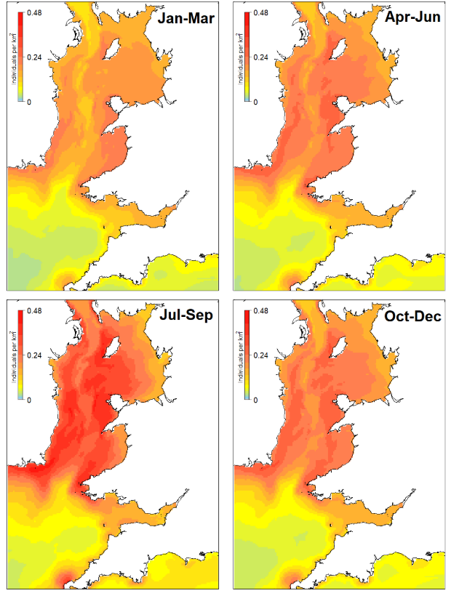
Figure 1: Harbour porpoise modelled densities by quarter (measured as the mean density per cell across months within a season) (from Evans and Waggitt (2023)). Circles indicate the location of the Milford Haven Waterway, wherein the Project is located.
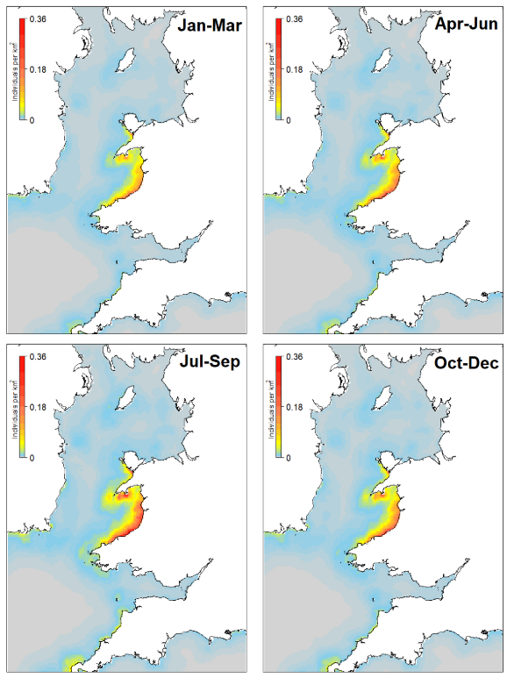
Figure 2: Bottlenose dolphin densities modelled per quarter (from Evans and Waggitt (2023)). Circles indicate the location of the Milford Haven Waterway, wherein the Project is located.
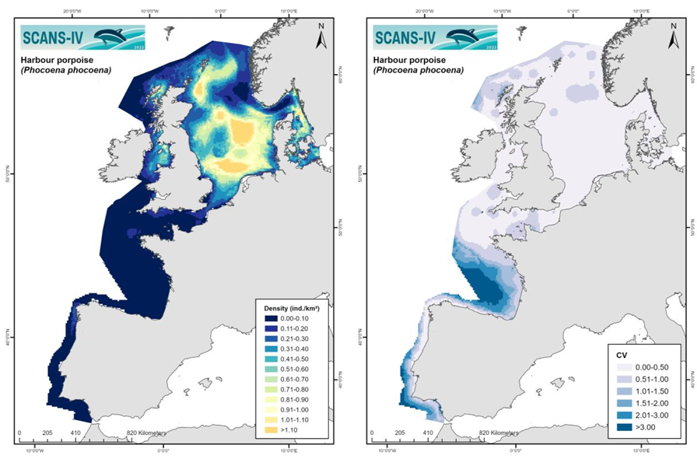
Figure 3: Predicted surfaces of estimated density (left) and associated Coefficient of Variation (CV) (right) for harbour porpoise based on the SCANS-IV survey (Gilles et al., 2025).
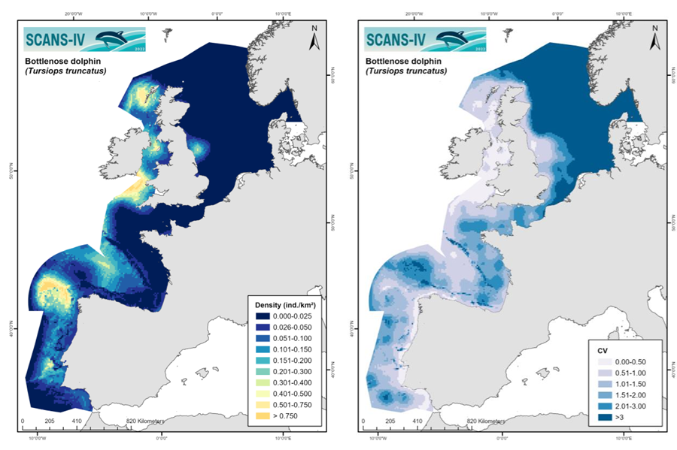
Figure 4: Predicted surfaces of estimated density (left) and associated CV for bottlenose dolphin based on the SCANS-IV survey (Gilles et al., 2025).
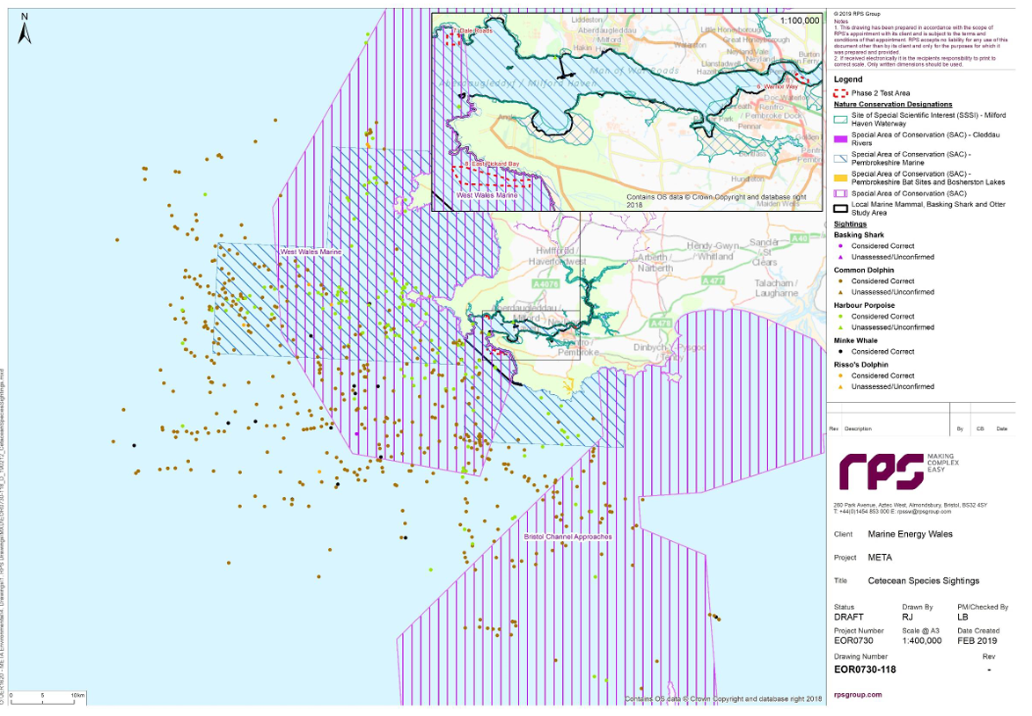
Figure 5: Cetacean (and basking shark) sightings from the WWBIC from the META Project (1979 – 2018) (Marine Energy Wales, 2019). Location of the Valero Pembrokeshire Oil Terminal circled in purple.
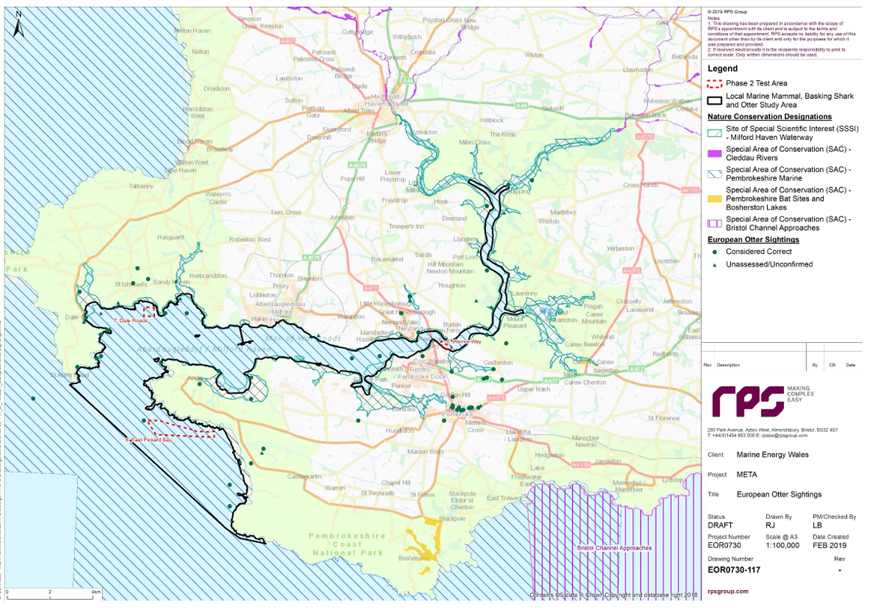
Figure 6: Otter sightings from the WWBIC from the META Project (1979 – 2018) (Marine Energy Wales, 2019). Location of the Valero Pembrokeshire Oil Terminal circled in purple.

NRW Comment
Relevant Section: | MEA – Cumulative Effects Assessment (CEA)
Comment: | We recommend that depending on project timelines and the decided upon cut-off for screening in projects for the cumulative / in-combination assessments, the Llyr project may also need to be screened in.
RAG Status: | Yellow
RPS Response
As detailed in the Project Description for the Llŷr Floating Wind Farm, offshore construction activities are planned to commence in Q1 2027 (Llŷr Floating Wind Ltd, 2024). The installation of offshore components is likely to be completed over two years, with full commissioning of the wind farm in Q4 2028. Therefore, there will be no temporal overlap with the offshore construction activities of the Llŷr Floating Wind Farm and those associated with the Project, which are planned for summer 2025. Therefore, the Llŷr Floating Wind Farm has been excluded from the CEA and in-combination assessment.
NRW Comment
Relevant Section: | MEA – Section 6 HRA Stage 1 LSE Screening - Further evidence or Further assessment required
Comment: | We disagree with the Applicant’s conclusion that there is no potential for LSE for the SACs screened into the assessment, particularly for Pembrokeshire Marine SAC within which the proposed works are being carried out. This SAC contains the largest and most important grey seal pupping colony in the Irish and Celtic Sea region. A conclusion of no LSE from underwater noise as a result of this project has been based on the assumption of low numbers within Milford Haven waterway, without providing appropriate evidence in the form of sightings data. Such evidence should be provided to support a conclusion of no LSE, or this impact pathway taken to appropriate assessment.
RAG Status: | Amber
RPS Response
The proposed works will be undertaken within the Pembrokeshire Marine SAC, which is designated for a range of features, including Annex II grey seal. Further evidence is given here to provide justification to screen this SAC out of Appropriate Assessment in the HRA, specifically for the grey seal feature, which has been raised as a concern by NRW in this comment.
Although the site-specific data from the WWBIC were not delivered in time for the submission of the responses to NRW, additional data sources than those presented in the MEA for grey seal have been assessed to provide further justification on the low numbers of grey seal within the Milford Haven Waterway (and thus screening this SAC out of further assessment in the HRA). The META project included WWBIC for grey seal in its EIA from 2019. These data showed low sightings of grey seal in the outer Milford Haven Waterway, with no records in the vicinity of the Project (Figure 7). Carter et al. (2022) modelled low medium at-sea densities of grey seal around the coast of Pembrokeshire, however these were low within the Milford Haven Waterway itself (see Figure 8). Further, the most recent annual seal monitoring report from the Special Committee on Seals (SCOS) reported low haul out densities of grey seal within the Milford Haven Waterway, with higher densities elsewhere in Pembrokeshire (within the SAC) (SCOS, 2024) (see Figure 9). Finally, grey seal pupping and haul out site data are also available on the NRW DataMap Wales portal (NRW, 2022). These data points are amalgamated from four datasets (Baines et al., 1995, Robinson et al., 2023, Strong et al., 2006, Westcott and Stringell, 2004), and illustrate that pupping and haul out sites are present along the Pembrokeshire coast, however there were none recorded directly within the Milford Haven Waterway (see Figure 10).
Overall, these additional datasets provide further justification for the low numbers of grey seal within the vicinity of and Zone of Impact (ZoI) of the Project and the wider Milford Haven Waterway.
In addition, the injury and disturbance ranges modelled were low, with no PTS thresholds exceeded and TTS thresholds not exceeded (or very low) for grey seal (and otter, which is also an Annex II feature of this SAC) (Table 1). While behavioural disturbance ranges were modelled out to a maximum of 606 m for vibro-piling for all hearing groups, this range is still low in the context of the wider habitat in the SAC, and is unlikely to reach key grey seal habitat within this SAC (such as the waters in the vicinity of haul out sites). In addition, vibro-piling and drilling are expected to occur intermittently over a period of up to three days, therefore does not represent a long term impact and any disturbance will be temporary over a very short duration.
Considering the noise modelling results and the additional sightings data provided here, it has been concluded that the Project will not result in an LSE upon the Annex II grey seal (or otter) feature of the Pembrokeshire Marine/Sir Benfro Forol SAC.

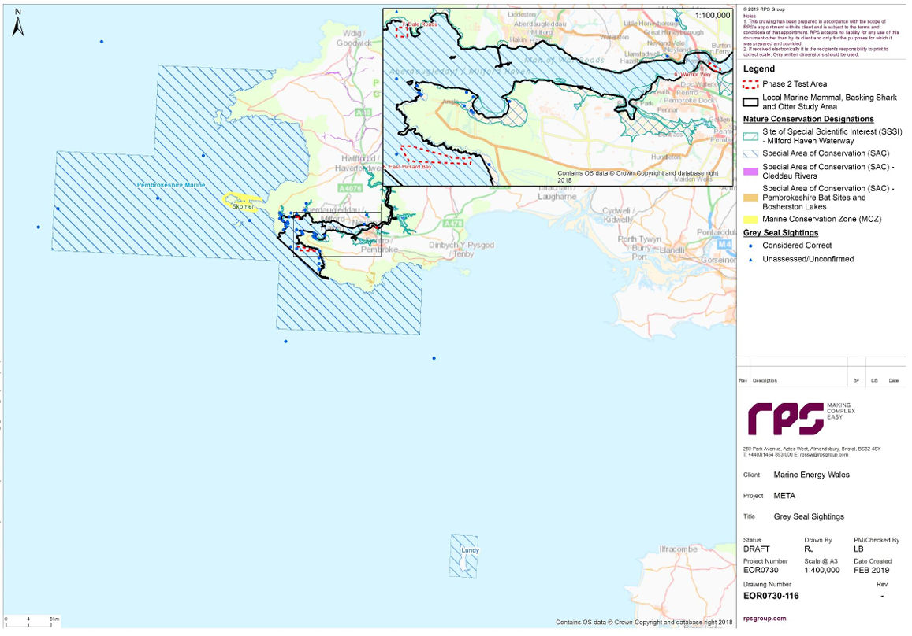
Figure 7: Grey seal sightings from the WWBIC from the META Project (1979 – 2018) (Marine Energy Wales, 2019). Location of the Valero Pembrokeshire Oil Terminal circled in purple.
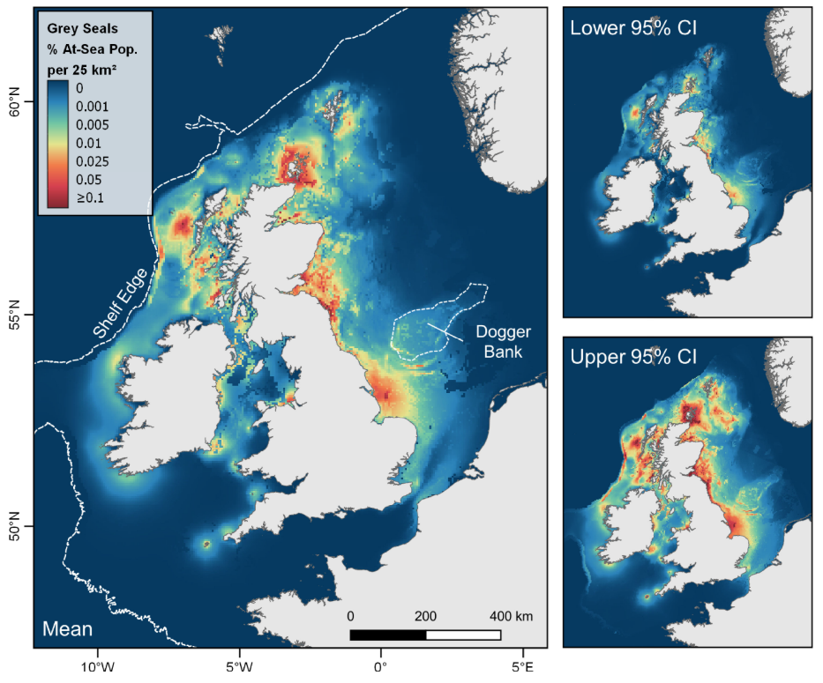
Figure 8: At-sea distribution (relative density) of grey seals from haul outs in the UK and Ireland. Maps show mean with associated cell-wise, lower and, upper 95% confidence intervals of the percentage of the at-sea population (i.e. excluding hauled-out animals) estimated to be present in each 5 km x 5 km grid cell at any one time (Carter et al., 2022).
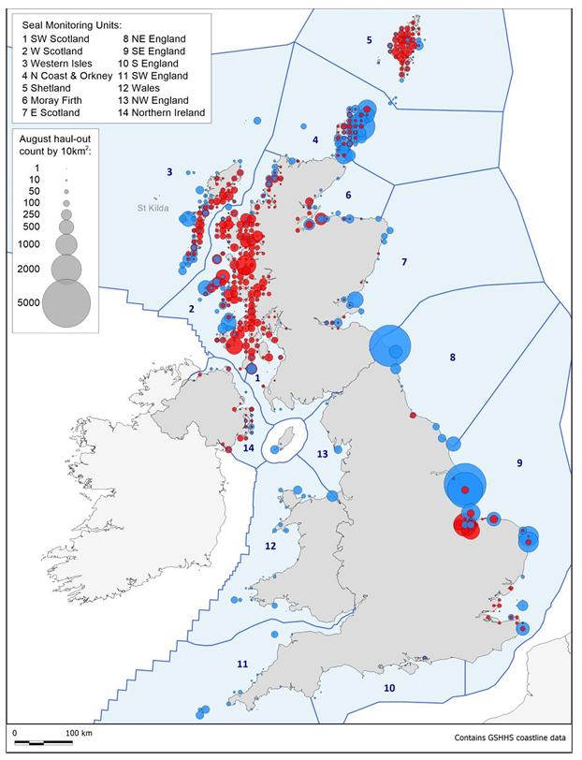
Figure 9: Seal Monitoring Units used for monitoring and reporting seal abundance and trends. Counts in August (2023 or latest prior year for which data were available) for harbour (red) and grey (blue) seals are shown on a 10 km² grid scale (SCOS, 2024). Milford Haven Waterway circled in purple.
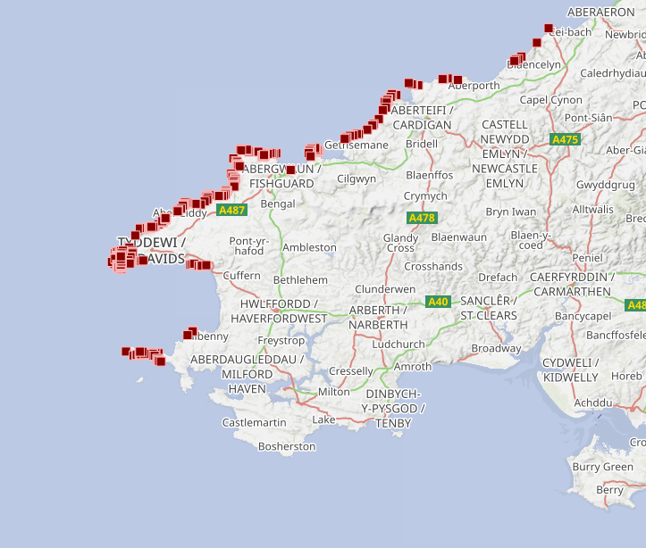
Figure 10: Grey seal pupping and haul out sites (red squares: amalgamated from four datasets between 1995 to 2017) on the NRW Data Map Portal (NRW, 2022). Milford Haven Waterway circled in purple.

NRW Comment
Relevant Section: | MEA – Underwater Noise Modelling Technical Report Section 3.3
Comment: | We disagree with the approach taken to base the behavioural disturbance assessment on comparisons with the Southall et al (2007) severity scores. The thinking behind these scores has since been superseded by the recommendations in Southall et al (2021).  In the final paragraph of section 3.3 the applicant states that: "therefore the thresholds discussed in section 3.3 have been adopted." However a number of received sound levels are mentioned and it is unclear which thresholds were used specifically. We note further that only studies for low frequency and mid frequency cetaceans were mentioned in the text, it is therefore unclear what disturbance threshold was used for harbour porpoise and grey seal which are the two marine mammal species that are qualifying features for the SACs screened into the MEA. Given that this project occurs within an SAC that contains the largest and most important breeding colony of grey seals in the Celtic & Irish sea, greater consideration should be given to assessing the impact on grey seals.  Bearing in mind the small scale of this project, we would generally recommend the use of the NMFS level B harassment noise threshold of 120 dB SPLrms when assessing disturbance from a continuous noise source due to its ease of use and general applicability to all species.
RAG Status: | Amber
RPS Response
The only sources of sound modelled in the underwater noise study were continuous, non-impulsive sound sources. We confirm that the NMFS level B Harassment threshold of 120 dB SPLrms was used as a behavioural threshold for all marine mammal species groups. With regard to Very High Frequency (VHF) cetaceans, this is also the metric recommended in NRW's Position on Assessing Behavioural Disturbance of harbour porpoise from underwater noise (NRW, 2023).
NRW Comment
Relevant Section: | MEA – Underwater Noise Modelling Technical Report
Comment: | The General Arrangement - Section & Elevation Sheet 2 of 2 contains information on both depth and sediment layers in the vicinity of the jetty. It is unclear why in section 5.3 Geo-Acoustic Input Parameters, the sediment was modelled as coarse sand and gravel which differs from the sediment information presented in the Section and Elevation Sheet.
RAG Status: | Yellow
RPS Response
The sediment listed in Section 5.3 of the noise modelling report is an input to the propagation model and therefore is chosen to be representative of the broader area over which the sound is propagating rather than the immediate area under the pile. Conservative values of the sediment properties (sound speed, density and attenuation coefficients etc) were chosen based on the 1993 OPRU Milford Haven sublittoral sediment survey which lists the various sediments found in the immediate and wider areas. Examples of sediments include gravelly muddy sand, gravelly sand, sandy gravel and muddy sandy gravel. The assumption used of course sand and gravel represents a precautionary and conservative assumption since in general more muddy sediments would result in higher attenuation of sound. It is therefore concluded that the sediment geo-acoustic properties chosen for the model were appropriate and conservative.
NRW Comment
Relevant Section: | MEA – Section 6.1, page 27
Comment: | "It should be noted that there is a considerable degree of uncertainty and variability in the onset of disturbance and therefore and disturbance ranges should be treated as potentially over precautionary. Another important consideration is that vessels and construction noise will be temporary and transitory, as opposed to permanent and fixed. In this respect, construction noise is unlikely to differ significantly from vessel traffic already in the area"  While we agree that the numbers impacted are likely to be small, as per general advice given for other applications, in arguing that an impact pathway is temporary as opposed to permanent there is a risk that an impact (however small or large) may be dismissed. Furthermore, while construction noise may be similar to existing noise in the area, consideration should always be given to the fact that the overall level of a stressor (in this case noise) has been increased as opposed to assuming tolerance.  We recommend that a robust and concise conclusion could be made by simply presenting the impact ranges and providing evidence of low numbers of sightings of marine mammals within Milford Haven Waterway, within the context of the very short timeline and limited scope of the project.
RAG Status: | Yellow
RPS Response
In the Underwater Noise Modelling Report (Appendix C of the MEA), the impact ranges were presented for a range of different vessels, as shown in Table 2. PTS thresholds were not exceeded for any vessel type or marine mammal hearing group, with TTS ranges not exceeded for all, except harbour porpoise (out to 9 m for tow vessels). Disturbance ranges were modelled out to a maximum of 890 m for all hearing groups (Table 2), however this is reversible and temporary. The rapid response of marine mammals following vessel disturbance is discussed in the published literature. Wisniewska et al. (2018) used animal-borne acoustic tags on seven harbour porpoise in coastal waters with high levels of vessel traffic and found that although the animals dove away from the surface (when 16 kHz third octave levels increased to 100 dB re 1 mPa) they quickly (after only 8 minutes) resumed normal feeding/surfacing behaviour when the noise had decreased. Similarly, Hao et al. (2024) used drone video footage to study harbour porpoise reactions to boats approaching at different speeds (10 or 20 knots). Though focused on small vessels, the study found that porpoises generally reacted within close proximity (<200 m) and quickly (<50 s) resumed their natural behaviour once the boat had passed. The direct impact of the boat was brief, and behaviour during exposure was similar to behaviour prior to exposure.
Given the limited spatial and temporal scale of the Project, vessel movements will be minor in comparison to existing baseline levels and there is evidence from published studies to suggest that marine mammals regularly occur in the presence of vessels. Jones et al. (2017) found a large degree of predicted co-occurrence of vessels and grey/harbour seals around the UK, especially within 50 km of the coast near seal haul outs. Similarly, Oakley et al. (2017) found that at Port Talbot docks, there were five cases of continuing presence of harbour porpoise near large cargo ships, often alongside the ship or within 800 m of it, indicating habituation to the stationary ships, vessel traffic at the site and associated sound.
In addition, low numbers of marine mammals are likely to be present within the Milford Haven Waterway (see additional data provided above for previous comments) and potentially within the ZoI associated with vessel noise. Therefore, the impact of vessel noise upon marine mammal is considered to be negligible.

Table 2: Potential impact ranges (m) for marine mammals from vessel noise during all phases, incorporating the Southall et al. (2019) weightings and thresholds and NMFS (2024) weightings and thresholds included in brackets were they differ. (N/E refers to a threshold not exceeded).
Species and Noise Source | Range of Effect (m)
Species and Noise Source | PTS | TTS |  | Disturbance
Harbour porpoise (VHF)
Crew Transfer Vessel | N/E | N/E |  | 503
Tow | N/E | 9 (N/E) |  | 722
Self-Propelled Flat Top Barge (when moving) | N/E | N/E |  | 890
Jack up vessel | N/E | N/E |  | N/E
Bottlenose dolphin (HF)
Crew Transfer Vessel | N/E | N/E |  | 503
Tow | N/E | N/E |  | 722
Self-Propelled Flat Top Barge (when moving) | N/E | N/E |  | 890
Jack up vessel | N/E | N/E |  | N/E
Grey seal (PCW)
Crew Transfer Vessel | N/E | N/E |  | 503
Tow | N/E | N/E |  | 722
Self-Propelled Flat Top Barge (when moving) | N/E | N/E |  | 890
Jack up vessel | N/E | N/E |  | N/E
Otter (OCW)
Crew Transfer Vessel | N/E | N/E |  | 503
Tow | N/E | N/E |  | 722
Self-Propelled Flat Top Barge (when moving) | N/E | N/E |  | 890
Jack up vessel | N/E | N/E |  | N/E

NRW Comment
Relevant Section: | MEA – Underwater Noise Modelling Technical Report Table 5.2
Comment: | Swim speeds are quoted for fish in table 5.2. NRW (A) advise that static receptors are used in underwater sound modelling, due to the varying nature of responses that fish both within and across different species make when reacting to noise in their environment as well as the varying levels of swimming abilities across species. These behavioural reactions can include shoaling, freezing, burst swimming and others, meaning a modelled directional swim away from the noise source is not representative behaviour for fish.  Section 5.4.1 does state that for fish, calculations have also been made for a static receiver, but it is not clear if static or fleeing receptors were used when calculating the impact radius as provided in table 6.2. We request that the Applicant clarifies which receptors were used.
RAG Status: | Amber
RPS Response
The only sources of sound modelled in the underwater noise study were continuous sources. The only thresholds for continuous sources provided in Popper et al. (2014) are in terms of the root mean square (rms) metric, which is an instantaneous exposure and therefore does not take account of whether the fish are fleeing or static. The ranges presented are therefore simply the range at which the rms threshold level set out in Popper et al. (2014) is exceeded.

References
Baines, M. E., Earl, S. J., Pierpoint, C. and Poole, J. (1995). The West Wales Grey Seals Census. CCW contract science report 131
Carter, M. I. D., Boehme, L., Cronin, M. A., Duck, C. D., Grecian, W. J., Hastie, G. D., Jessopp, M., Matthiopoulos, J., McConnell, B. J., Miller, D. L., Morris, C. D., Moss, S. E. W., Thompson, D., Thompson, P. M. and Russell, D. J. F. (2022). Sympatric Seals, Satellite Tracking and Protected Areas: Habitat-Based Distribution Estimates for Conservation and Management. Frontiers in Marine Science, 9, pp.18. DOI:10.3389/fmars.2022.875869.
Evans, P. G. H. and Waggitt, J. J. (2023). Modelled Distribution and Abundance of Cetaceans and Seabirds in Wales and Surrounding Waters. NRW Evidence Report, Report No: 646. Natural Resources Wales. Bangor. 646. pp.354.
Gilles, A., Authier, M., Pigeault, R., Ramirez-Martinez, N. C., Benoit, V., Carlström, J., Eira, C., Geelhoed, S. C. V., Laran, S., Sequeira, M., Sveegaard, S., Taylor, N. L., Saavedra, C., Vázquez-Bonales, J. A. and Hammond, P. S. (2025). Spatial models of cetacean density in European Atlantic waters based on SCANS-IV summer 2022 survey data. Final report published 14 May 2025. pp.31.
Hao, X., Hamel, H., Grandjean, C. H., Fedutin, I., Wahlberg, M., Frankish, C. K. and Nabe‐Nielsen, J. (2024). Harbour porpoises respond to recreational boats by speeding up and moving away from the boat path. Ecology and Evolution, 14 (5). DOI:10.1002/ece3.11433.
Jones, E. L., Hastie, G. D., Smout, S., Onoufriou, J., Merchant, N. D., Brookes, K. L., Thompson, D. and González-Suárez, M. (2017). Seals and shipping: quantifying population risk and individual exposure to vessel noise. Journal of Applied Ecology, 54 (6), pp.1930-1940. DOI:10.1111/1365-2664.12911.
Llŷr Floating Wind Ltd. (2024). Volume 1: Chapter 04 – Description of the Proposed Project. Llŷr 1 Floating Offshore Wind Farm Environmental Statement pp.69.
Marine Energy Wales. (2019). Chapter 9: Marine Mammals, Basking Shark and Otter. META Environmental Impact Assessment pp.86.
NMFS. (2024). Update to: Technical Guidance for Assessing the Effects of of Anthropogenic Sound on Marine Mammal Hearing (v3): Underwater and In-Air Criteria for Onset of Auditory Injury and Temporary Threshold Shifts. NOAA. US Department of Commer. NMFS-OPR-71. pp.182.
NRW. (2022). DataMap Wales: Seal Pupping and Haul-Out Sites [Online]. Available at: https://datamap.gov.wales/layers/geonode:seal_pupping_sites. Accessed on: May 2025.
NRW. (2023). NRW’s Position on assessing behavioural disturbance of harbour porpoise (Phocoena phocoena) from underwater noise. Position statement. NRW. Version 1.0.
Oakley, J. A., Williams, A. T. and Thomas, T. (2017). Reactions of harbour porpoise (Phocoena phocoena) to vessel traffic in the coastal waters of South West Wales, UK. Ocean & Coastal Management, 138, pp.158-169. DOI:10.1016/j.ocecoaman.2017.01.003.
Popper, A., Hawkins, A., Fay, R., Mann, D., Bartol, S., Carlson, T., Coombs, S., Ellison, W., Gentry, R., Halvorsen, M., Løkkeborg, S., Rogers, P., Southall, B., Zeddies, D. and Tavolga, W. (2014). Sound Exposure Guidelines for Fishes and Sea Turtles: A Technical Report prepared by ANSI-Accredited Standards Committee S3/SC1 and registered with ANSI. New York, Springer.
Robinson, G. J., Clarke, L. J., Banga, R., Griffin, R. A., Porter, J., Morris, C. W., Lindenbaum, C. P. and Stringell, T. B. (2023). Grey Seal (Halichoerus grypus) Pup Production and Distribution in North Wales during 2017. Natural Resources Wales. Bangor. NRW Evidence Report No. 293. pp.66.
SCOS. (2024). Scientific Advice on Matters Related to the Management of Seal Populations: 2024. Natural Environment Research Council Special Committee on Seals. pp.237.
Southall, B. L., Finneran, J. J., Reichmuth, C., Nachtigall, P. E., Ketten, D. R., Bowles, A. E., Ellison, W. T., Nowacek, D. P. and Tyack, P. L. (2019). Marine Mammal Noise Exposure Criteria: Updated Scientific Recommendations for Residual Hearing Effects. Aquatic Mammals, 45 (2), pp.125-232. DOI:10.1578/am.45.2.2019.125.
Strong, P., Lerwill, J., Morris, S. and Stringell, T. (2006). Pembrokeshire Marine SAC grey seal monitoring 2005. CCW Marine Monitoring Report No. 26. pp.51.
Westcott, S. and Stringell, T. B. (2004). Grey seal distribution and abundance in North Wales, 2002-2003. Bangor. CCW Marine Monitoring Report No. 13. pp.80.
Wisniewska, D. M., Johnson, M., Teilmann, J., Siebert, U., Galatius, A., Dietz, R. and Madsen, P. T. (2018). High rates of vessel noise disrupt foraging in wild harbour porpoises (Phocoena phocoena). Proceedings of the Royal Society B: Biological Sciences, 285 (1872). DOI:10.1098/rspb.2017.2314.

