Permit
The Environmental Permitting (England & Wales) Regulations 2016

Mason Bros Quarry Products Limited

Tangiers Quarry
Tangiers
Haverfordwest
SA62 4BU

Permit number

EPR/DB3497CZ

Permit
The Environmental Permitting (England and Wales) Regulations 2016
Permit number

EPR/DB3497CZ

The Natural Resources Body for Wales (“Natural Resources Wales”) authorises, under regulation 13 of the Environmental Permitting (England and Wales) Regulations 2016

Mason Bros Quarry Products Limited (“the operator”),

whose registered office is

The Office

Norton Yard

Lampeter Velfrey

Narberth

Dyfed

SA67 8UL

company registration number 02448753

to operate waste operations at

Tangiers Quarry

Tangiers

Haverfordwest

SA62 4BU

to the extent authorised by and subject to the conditions of this permit.

Under regulation 27(2) of the Regulations, standard rules SR2010 No12 are conditions of this permit.

Name | Date
Huw Davies | 28/03/2025

Authorised on behalf of Natural Resources Wales

Schedule 1 - Site plan

This is the plan referred to in the standard rules SR2010 No12

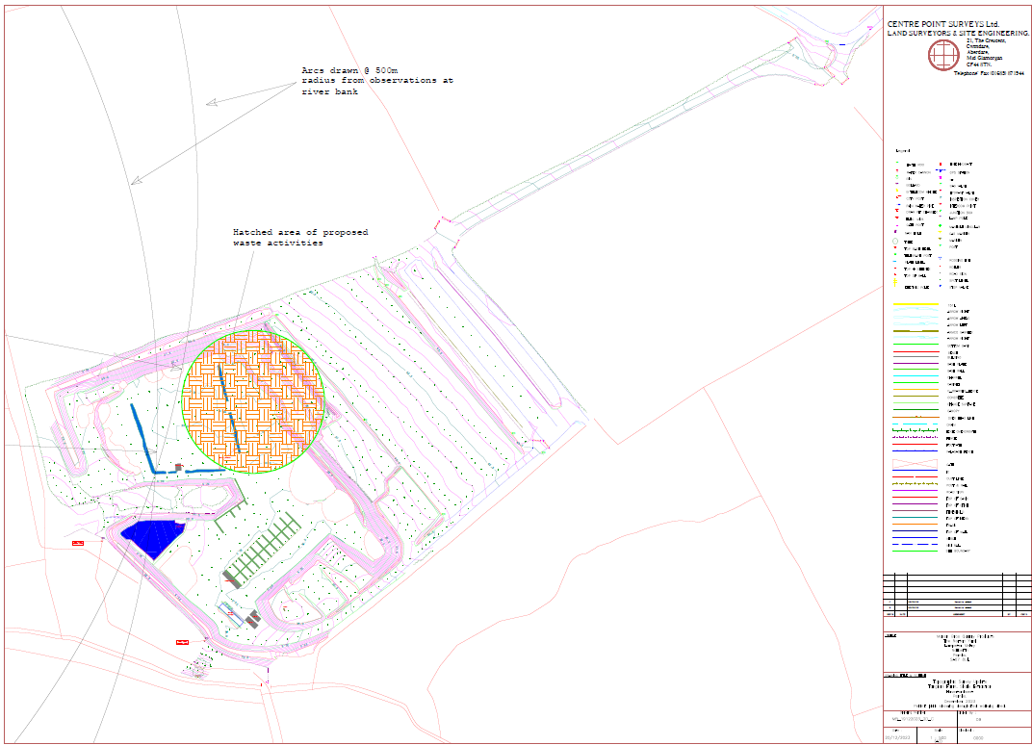

END OF PERMIT

