PAN-029269 My Map Report:
2.4.1 The activities shall not extend beyond the site, being the land shown edged in green on the site plan attached to the permit.
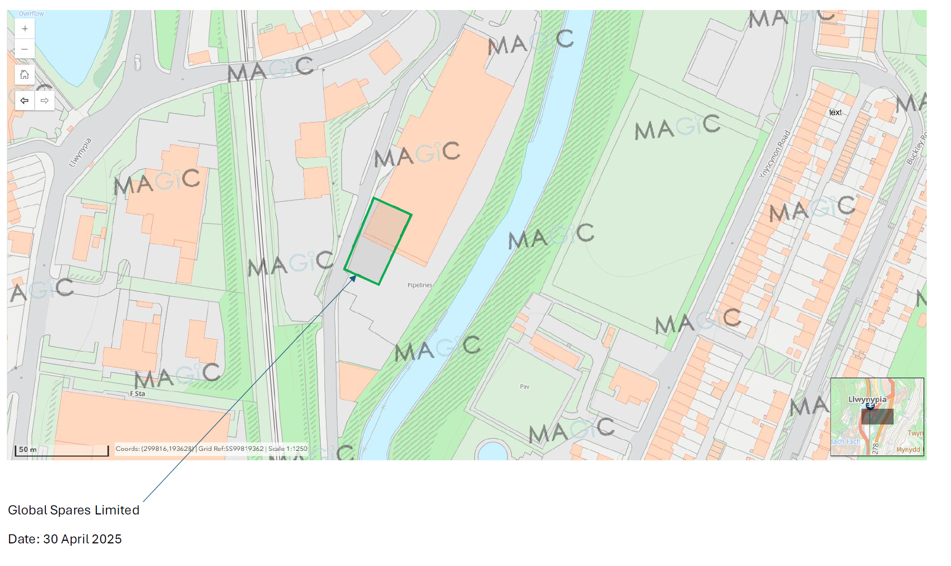
2.4.2 The activities shall not be carried out within 200 metres of a European Site and or a SSSI.
None in range.
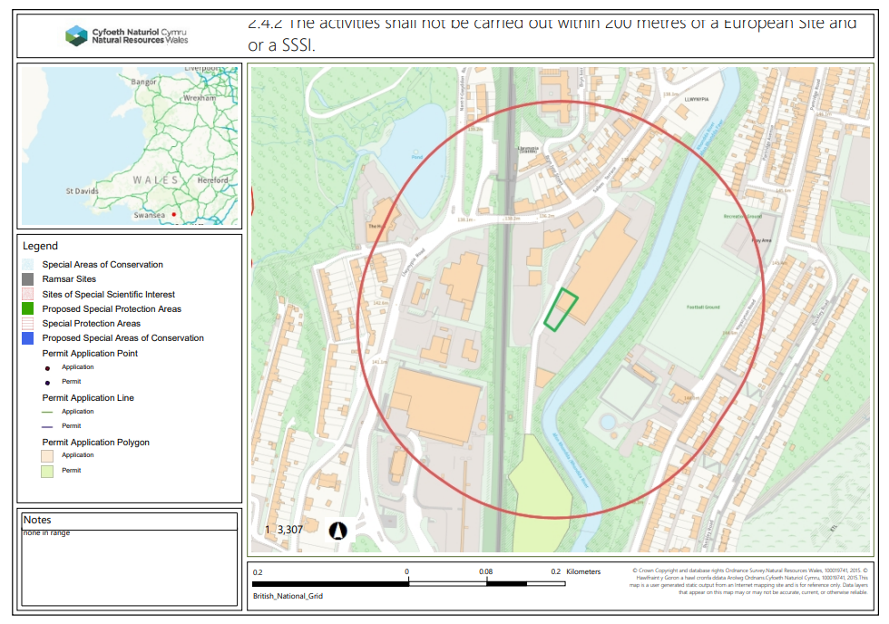
2.4.3 The activities shall not be carried out within Groundwater Source Protection Zone 1, or if a Source Protection Zone has not been defined then within 50m of any well spring or borehole used for the supply of water for human consumption. This must include private water supplies.Groundwater protection zones.
None in range
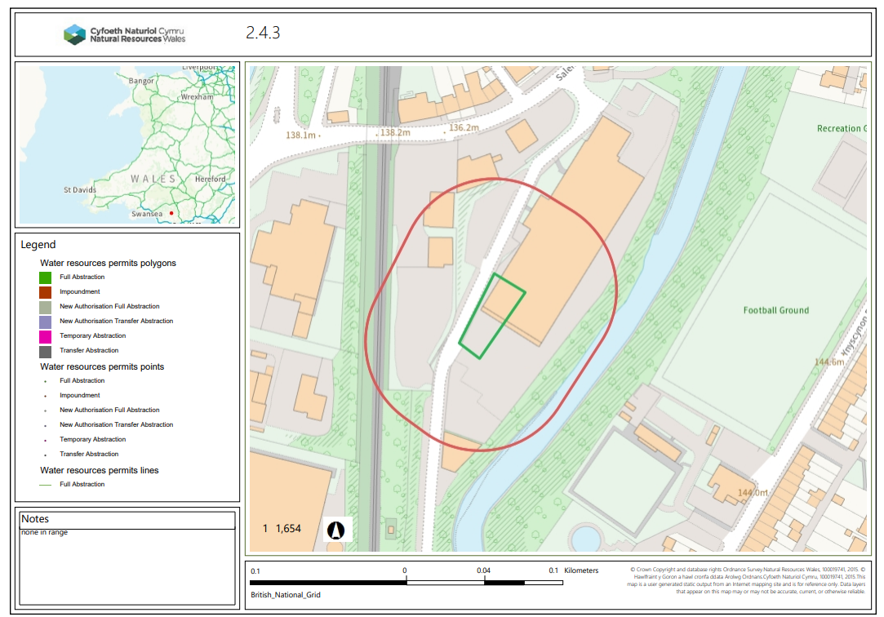
End

