CRoW Appendix 4 (140_10_SD02)  CRoW Act 2000: Natural Resources Wales application for permission - Formal Notice |  | 
Natural Resources Wales Formal Notice.
Requirements of Section 28I of the Wildlife & Countryside Act 1981 as amended by the Countryside and Rights of Way Act (CRoW) 2000.
Duty in relation to granting any consent, licence or permit for activities likely to damage Sites of Special Scientific Interest (SSSI).
Guide to filling in this form for Natural Resources Wales staff:
To be completed by Permitting Officers for any applications for a permission which the Natural Resources Wales has considered under S28G duties to protect and enhance SSSIs. This applies to all proposed permissions within a SSSI, and to operations outside the SSSI boundary which are likely to damage its special features.
Refer to OI 140_10 ‘Applying the Countryside and Rights of Way (CRoW) Act 2000 to applications for permits with potential for impact on Sites of Special Scientific Interest (SSSI)’, including the flowchart in Appendix 2.
Pink italic text – drafting notes, to be deleted before completion/consultation.
Blue text – examples, to be replaced with permission-specific information.
Ensure you have completed all sections.
- Natural Resources Wales area/region/NPS hub: | NPS – Installations Permitting  Environment Team – Wrexham and Flintshire
- Name of SSSI: | - Buckley Claypits and Commons 1.7km  - Maes Y Grug 4.9km  - Connah’s Quay ponds and woodland 5.1 km  - River Dee 8.9km  - Dee Estuary 7.5km  - Shotton Lagoons and Reedbeds 8.7km  - Mynydd Y Fflint / Flint Mountain 9.8km  - Coed Talon Marsh 4km  - Chwarel Cambrian / Cambrian Quarry,  Gwernymynydd 7.4km  - Alyn Valley Woods and Alyn Gorge Caves 8.3km  - Bryn Alyn 9.1km  - Glaswelltiroedd Eryrys (Eryrys Grasslands) 9.3km  - Llay bog 7.2km  - Chwarel Singret 7.9km  - Marford Quarry 8.8km  - Halkyn Mountain/ Mynydd Helygain 9.7km  - Berwyn a Mynyddoedd De Clwyd / 9.3km  Berwyn and South Clwyd Mountains  Note – the distances quoted are by the applicant, and are to the protected site from the new proposed carbon dioxide capture plant. Distance to the existing installation boundary are somewhat lower, with the closest (Deeside and Buckley Newt Site) being ~1km from the existing installation boundary).
- Type of permission: | Environmental Permit
- Date for Natural Resources Wales permit determination: | Draft decision by end July 2025
- Predicted 28 day date for response from NRW conservation/ecology (under S28 I(4)): | End July 2025 (if required)
- Natural Resources Wales reference no: | PAN-026621 (EPR-BL1096IB) EPR-BL1096IB DMS link (internal NRW), PAN-026621 Public Register.
- National grid reference: | X: 328915 Y: 362079 (Padeswood Cement Works, CH7 4HB)  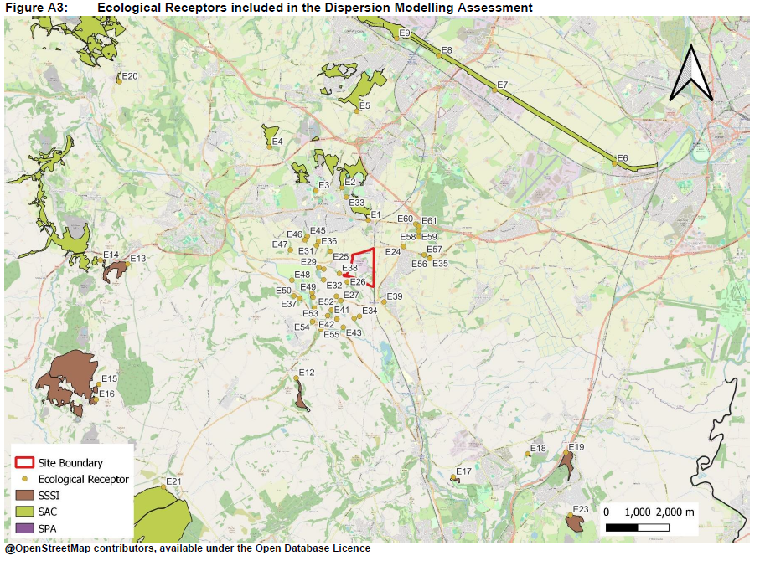
- Description of proposal: | Substantial Variation to cement plant installation permit to add Carbon Dioxide Capture Plant (CCP) and associated natural gas fired Combined Heat and Power (CHP) plant (132 MW_{th} max) to the existing cement kiln site. The CHP is for internal energy use only, to provide the power required for the carbon dioxide separation process equipment.  However, in order for the CCP to function correctly, it is necessary to substantially further reduce the level of many trace pollutants in the kiln waste gases (NOX, SOX, particulate, VOC…) compared to the existing stringent emission limits, before the carbon capture takes place – otherwise they interfere with the capture process. So additional abatement is planned (enhanced bag filter, catalytic NOx reduction, additional wet scrubbing…) for the kiln train. This is for engineering purposes, but has the co-benefit of reducing environment impact of emissions (it is not “conditions” per SSSI consent). In respect of ecological impacts any trace pollutants (ammonia, nutrient N from amines, VOC) from the carbon capture step or additional natural gas CHP combustion are more than offset by these reductions in kiln emissions, reflected in proposed lower emission limit values by the applicant for a number of substances, taking them well beyond BAT for a standalone cement kiln. Further technical explanation of the industrial process and effect on emissions can be found in the application and NRW decision document.
- Is the proposed activity within (wholly or partially) the SSSI boundary? | No – nominal distances to SSSIs from the new development listed in box (2) above – distances to the existing installation boundary are up to 1km shorter depending on direction
- Has there been any pre-application discussion or correspondence with NRW conservation/ecology | NO  There has been dialogue between NRW ANCB and Industry regulation during determination, principally regarding HRA and informal agreement that No likely significant effect is concluded (DMS Email 12/05/25). The same logic / approach applies to SSSI impact assessment and is therefore relevant.
- What aspect(s) of the proposed permission may damage the features which are of special interest for the SSSI?
The following ‘Operations Requiring Consent’ (or other activities associated with the permission) that may cause damage) are relevant to the proposed permission.
7 Dumping, spreading or discharging of any materials (for Buckley Claypits and Commons, but anticipated equivalent for all SSSI’s within screening distance) – i..e discharge of waste gases / pollutants via chimney stack from industrial source and potentially impacting on SSSI(s)

No “direct” impact mechanisms (e.g. construction, vehicles, storage, disturbance…) are relevant as industrial site is considerably remote from the protected SSSIs

The following SSSI features and mechanisms of impact have been considered to assess the likelihood of damage:

All protected features – plants etc by direct impact of specified air pollutants, and animals by indirect impact on their habitat/grazing/foodstuff. Air pollutants may adversely affect plant life if in excess of critical levels/loads specified per pollutant

- Decision
i) The proposed permission is not likely to damage any of the flora, fauna or geological or physiological features which are of special interest.

While there is a pathway for possible harm (industrial source, transport and dispersion via the air, impact on flora (receptor) of pollutants, impact on fauna indirectly by effect on supporting flora) the emissions impacts of relevant pollutants (NOX, SOX, NH3, etc, as listed in the table of supporting data below – other than HF) are all decreasing owing to the proposed changes to the facility – principally because additional abatement is incorporated that reduces emission rate. There are changes to dispersion, but these are relatively minor. Therefore there is no negative impact of the proposed changes on SSSIs. So process contribution is insignificant (even if >1% after changes) because it is lower than it is currently consented. In many cases per pollutant it can also be concluded that impact is unlikely to damage for other reasons (e.g. NOX daily average is below significance threshold, NOX annual average is below critical load) – as summarised in the table below, but the reduction in impact in all cases justifies that no damage will occur. Even where background pollutant concentrations exceed critical levels/loads owing to other pollutant sources.

The one exception to this rationale is HF (hydrogen fluoride) which shows an apparent increase in impact, owing to assumptions made in the modelling, and the very rapid reaction / deposition of this reactive gas. As explained in detail in the NRW decision document and HRA, this apparent increase is largely anomalous owing to precautionary modelling assumptions; impacts are broadly unchanged. As the Process contribution is insignificant (<10% of a short term limit – daily and weekly) and the predicted environmental concentration is well below the environmental standard (~10% of weekly, 2% of daily), we can still confidently conclude for this pollutant that damage is unlikely with slightly different reasoning.

It is noted that the carbon capture process releases trace amounts of capture agents – amines. These have no critical level/load for habitats, but are in any case tightly controlled for the protection of human health. Their impact on habitats is considered via their breakdown to release ammonia, but any additional ammonia from this source is more than offset by reduction in ammonia emissions from the kiln as a result of CO2 capture implementation.

Natural Resources Wales is minded to:
Issue the permission
- Name and job title of Natural Resources Wales officer: | Dr David Poole  Senior Specialist Advisor, Industrial Decarbonisation, working on behalf of permitting service
- Date form sent to NRW conservation/ecology | NA – assessment made and placed on file as “not likely to damage”
For Natural Resources Wales use only, once NRW conservation/ecology response received
- NRW conservation/ecology comment on assessment: | Please delete as appropriate:  i) NRW conservation/ecology advise the operation can go ahead  ii) NRW conservation/ecology advise the operation can go ahead with conditions  iii) NRW conservation/ecology advise against permitting the operation  Please ensure that the NRW conservation/ecology response is attached to this Formal Notice.
- Name and job title of NRW conservation/ecology officer:
- Date of receipt of NRW conservation/ecology response:

Additional information: Summary of maximum impact of air pollutants on protected sites (SSSI and SAC/SPA/RAMSAR). All impacts are going down compared to the current consented cement works (i.e. improvement) other than HF, which is nominally shown as a slight increase, but which is insignificant (<10% of short-term [daily and weekly] limits). Green highlight per line (and supporting text) indicates a principle reason why likelihood of damage can be excluded.



