Fee
- The application fee paid (based on the 2024/25 charging scheme) was a total of £12,660 made up of base fee of £10,011, SSSI Assessment fee of £306 and Fire prevention and mitigation plan assessment fee of £2343.
Having reviewed the application, more assessment fees are incurred than the two given above; these are as follows:
- Noise impact assessment and noise management plan
- Dust and emissions management plan
- Odour management plan
- Fire prevention and mitigation plan
- Discharge to water
- Assessment/ documentation of other protected sites
- Site of Special Scientific Interest Assessment
- Habitats Regulations Assessment
Current fees (which are reviewed and updated annually) can be found on our website:
- Natural Resources Wales / Our charging schemes
- Natural Resources Wales / Charges for waste permits
The fee for the submitted application based on the current charging scheme totals to £21,301.

Application form
Tell us about the activities you want to do
- Domestic, Commercial and Industrial waste transfer station with treatment- The non-hazardous waste treatment capacity has been given as “not more than 5,000t/annum” this value should be in tonnes per day.
- Treatment of Waste to produce soil, soil substitutes and aggregate- Non-hazardous waste treatment capacity given as “not more than 75,000t/annum” this value should be in tonnes per day.
Tell us about the total storage capacity
- The total storage capacity of non-hazardous waste has been given as 41,000 tonnes. This value should be in tonnes at any one time. We are querying this as this value is just over half the proposed annual throughput of the site.

Industrial Emissions Directive (IED) activities and limits
- Treatment of slags and ashes is a treatment under the Industrial Emissions Directive (IED). The IED limit to remain a waste facility is 75 tonnes per day treatment capacity. Currently you have told us that your treatment capacity is 5000t/annum, but not what the daily treatment capacity is. You must provide information to demonstrate how you will comply with the relevant limits and therefore remain as a waste facility.

Waste types
- The waste types given in document SGM02 Non-technical Summary (and the SGM03- Environmental Management System ISSUE) are copied directly from two rule sets in their entirety. As such the waste descriptions are heavily caveated compared to the descriptions given in WM3. As this is a bespoke permit application, you do not have to follow the rule set descriptions of the waste or include all the waste types as listed in the SRPs, although you may wish to. We are highlighting this as we have assessed the application on the currently proposed wastes codes.
- The document SGM05- Drainage Strategy states that the site is permitted to accept “Oils, coolants and other COSHH substances, used in the servicing and maintenance of plant and vehicles;” but these are not included in the waste code list(s). Its needs to be explicit if these are wastes or not. If they are wastes, then the appropriate codes need to be included in the application.

Proof of technical competence
- No proof of technical competence has been provided. In response to this question on the application form the reference of SGM01- Document Reference List has been given but this does not contain any information on technical competence.

SGM05- Drainage Strategy
- The application states there are two discharges off site SWDP01 and SWDP02. The document SGM05- Drainage Strategy doesn’t refer to any discharges using the given references “SWDP01” or “SWDP02”. These references should be used throughout this document, on the two site plans, and in the rest of the application for consistency.
- The document SGM05- Drainage Strategy has 3 listed appendices:
- APPENDIX 1 – DRAINAGE PLAN
- APPENDIX 3 – SITE DRAINAGE DRAWING
- APPENDIX 3 – SMOKE / CO DETECTOR LOCATION CHECK FORM
And section 3 refers to a plan “Drawing Number EV170606/SGM03 – Site Drainage”.
The plans provided within the application are 2154-SGM-001-SGM Waste Site Plan and 2154-SGM-002- SGM Waste Drainage Plan.
It is not clear if there are plans missing, or the references and appendices list are incorrect.

Dust and emissions management plan
- The guidance requires a dust and emissions management plan to be submitted with a bespoke application as the following conditions has been met:
- Keeping or treating waste material that gives rise to fine or dusty materials (i.e. the processing of inert construction and demolition wastes to produce recycled soils and aggregates)
- Within 500m of a sensitive receptor (please note the guidance for what is considered a sensitive receptor)
While section 10.1.1 of document SGM03- Environmental Management System ISSUE does include information on Dust and Particulates it does not include all the required information required in Control and monitor emissions for your environmental permit - GOV.UK

Odour Management plan
- Our guidance How to comply with your environmental permit guidance states that an odour management plan must be provided if you are carrying out an activity for which odour is a key issue- “household, commercial and industrial waste transfer station“. The information provided within the application form and risk assessment does not unfortunately negate that requirement.
Please see H4 odour management guidance for what to include in the Odour Management Plan: Environmental permitting: H4 odour management - GOV.UK

Noise Impact Assessment (and Noise Management Plan)
- The submitted Noise Impact Assessment (NIA) has been completed using BS5228:2009 (Code of practice for noise and vibration control on construction and open sites – Noise). For applications for an EPR permit we expect you to follow the criteria and reporting requirements of BS 4142:2014+A1:2019 Method for rating and assessing industrial and commercial sound (BS 4142). Therefore we cannot accept the submitted NIA.
Please see the follow guidance for information on what is required:
- Noise and vibration management: environmental permits - GOV.UK
- Method implementation document (MID) for BS 4142 - GOV.UK
- Risk assessments for your environmental permit - GOV.UK
- Noise impact assessments involving calculations or modelling - GOV.UK
Depending on the outcome you may also need to provide a Noise Management Plan.

Risk Assessment
- The risk assessment references a Dust Control Plan but this was not provided nor was it included in SGM01- Document Reference List.
- The risk assessment references Dinham Meadow SSSI which is not within 2km of the site, and is therefore not relevant to this application.
- The proposed boundary of the site appears to overlap with the edges of the surrounding Gwent Levels - Rumney and Peterstone SSSI:
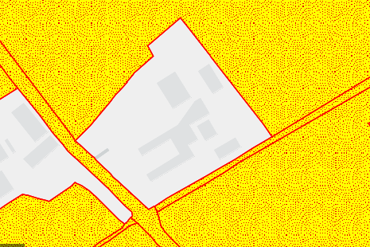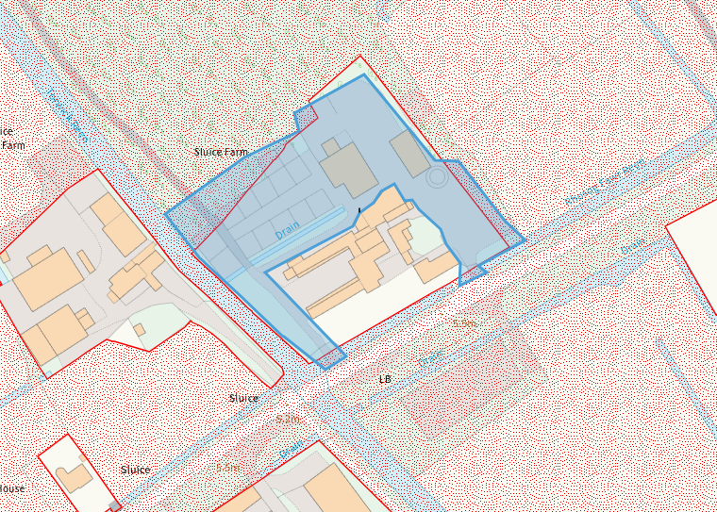

- The Severn Estuary SSSI, SAC, SPA and Ramsar are all within approximately 270 meters of the site boundary but have not been included in the risk assessment. Any SSSIs within 2km and any SACs, SPAs or Ramsar’s within 1km of the site must be included in your risk assessment.
This is especially important as this application is proposing a discharge into the reens which are designated themselves, or drain to other designated sites, and to also use the reens as a source of fire water.
- The only protected species included in the risk assessment are bats. There are other protected species in the vicinity including aquatic species in the reens and estuary, and birds and bees in the supporting fields and mudflats that need to be included as well as the mudflats themselves, saltmarsh and grasslands. This is especially important as this application is proposing a discharge into the reens which contain protected species, and to also use the reens as a source of fire water. Some of these (and the local wildlife site below) were identified within document SGM07- SGM Waste Preliminary Ecological Appraisal ISSUE.
- There is a local wildlife site (Rumney Great Wharf) approximately 590 metres from the proposed site that needs to be included within your risk assessment. It is a saltmarsh and grassland behind sea wall which provides roosting and feeding opportunities for wintering Short-eared owls. It also provides high tide roosting areas for wintering wildfowl such as Shelduck and Curlew. For further information on please contact Cardiff Council - MBHarris@cardiff.gov.uk
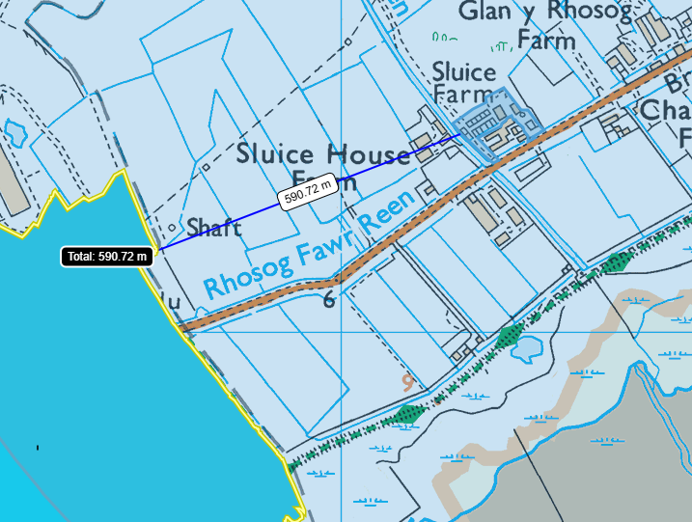

Information on designated sites and receptors can be found at:
- Natural Resources Wales / Find protected areas of land and sea
- Home | DataMapWales
And guidance on risk assessments can be found at:
- Risk assessments for your environmental permit - GOV.UK

Fire Prevention and Mitigation Plan (FPMP)
The SGM06- Fire Prevention Strategy ISSUE has been reviewed against our current guidance- Fire prevention and mitigation plan: waste management guidance. The following information is missing:
- The plan has not been produced in line with our current guidance which is version 2 (August 2017). Version 1 (May 2016) is quoted on page 7.
- The only waste types that are listed within the plan are "Paper, cardboard and rags, plastic, rubber and other materials". This is not a comprehensive enough list given the waste types that are proposed to be accepted. Some of the wastes of concern not included (but are not limited to) are woods, metals, tyres, WEEE, batteries, refuse derived fuel, mixed municipal wastes. These all need to be individually listed within the plan and must also include any other combustible wastes that are being proposed.
- Information is needed on the following:
- Section 5. Fire Prevention and Mitigation Plan contents- Following on from the above point regarding waste; Information is missing on amounts of waste will be accepted daily, its form, how much will be stored at any one time, storage duration, where on site its stored (plan just has a general “skip storage area).
- Section 5. Fire Prevention and Mitigation Plan contents- information is needed on Fire prevention techniques used (including management of hotspots, self combustion, monitoring, reporting), Techniques used to minimise fire spreading, how combustion products and emissions (to air, land and water) will be managed, the contact details of sensitive receptors within 1km of the site.
- Section 5. Fire Prevention and Mitigation Plan contents- Regarding site plan the following is missing; where each type of waste is stored, location of hydrants, areas of natural and unmade ground, location of drain covers and pollution control measures - e.g. firewater containment system, location of sensitive receptors within 1km of the site including human receptors and environmental receptors, designated quarantine area.
- Sections 8. Managing waste material stacks and 10. Baled waste storage- Information is needed on storage and management of baled waste- the non-technical summary states plastics are to be baled.
- Section 11. Enclosing stacks using bales and walls- Information is needed to the bays/walls used to enclose waste
- Section 15. Seasonality and waste stack management
- Section 16. Monitoring and turning of stacks
- Section 17. Fire detection
- Section 19. Firefighting strategy- use of heavy plant
- Section 20. Water supplies- calculation of amount needed are missing, also need information on the approval to use waster from reens and if (the attenuation pond) are reliable sources. Thought has to be given to the fact that the reens are part of the SSSI, and reducing the water levels may cause a negative impact.
- Section 21. Managing water run-off- calculation of amount to be contained is missing, as well as approval to discharge to sewer
- Section 22. Designated quarantine area
- Section 23. During and after an incident
- Section 24. Reviewing and monitoring your FPMP
- We note that information given in section 9.2.7 (Water from Firefighting) SGM03- Environmental Management System ISSUE is not included in your fire plan.

Site condition report
- We have noted that the SGM04- Site Condition Report ISSUE only includes the permitted activities of “Storage and processing of inert construction and demolition wastes into recycled aggregates and soils.”

Environmental Management System
The SGM03- Environmental Management System ISSUE has been reviewed against our current guidance- How to comply with your environmental permit guidance.
- The following information is missing:
- Operations (page 22)- Information on:
- waste acceptance, quantities, treatment and storage procedures
- on storage of materials on site (storage times and procedures, maximum storage capacities and procedures for specified storage areas and the facility as a whole, maximum storage heights
- procedures to identify the specific waste types stored at your facility
- procedures to segregate incompatible wastes for example use of appropriate separation distances and or suitable engineering measures.
- Site security (page 24)
- Non-compliance (page 24)- only given in terms of hazardous waste
- Closure (page 25)
- Complaints (page 25)
- Sufficient competent persons, resources and training (page 25)- no information on achieving or maintaining technical competence
- Emissions and monitoring (page 26)- litter, odour and pests not included
- Access to your permit (page 26)

