Permit
The Environmental Permitting (England & Wales) Regulations 2016

A & C Aggregates Limited

A&C Aggregates Ltd
Rowlands View
Templeton
Narbeth
SA67 8RG

Permit number

EPR/DB3593FH

Permit
The Environmental Permitting (England and Wales) Regulations 2016
Permit number

EPR/DB3593FH

The Natural Resources Body for Wales (“Natural Resources Wales”) authorises, under regulation 13 of the Environmental Permitting (England and Wales) Regulations 2016

A & C Aggregates Limited (“the operator”),

whose registered office is

Rowlands View

Templeton

Narbeth,

Pembrokeshire

SA67 8RG

company registration number 04620255

to operate waste operations at

A&C Aggregates

Rowlands View

Templeton

Narbeth

SA67 8RG

to the extent authorised by and subject to the conditions of this permit.

Under regulation 27(2) of the Regulations, standard rules SR2010No12 are conditions of this permit.

Name | Date
Anna Gale | 03/07/2025

Authorised on behalf of Natural Resources Wales

Schedule 1 - Site plan

This is the plan referred to in the standard rules SR2010No12.

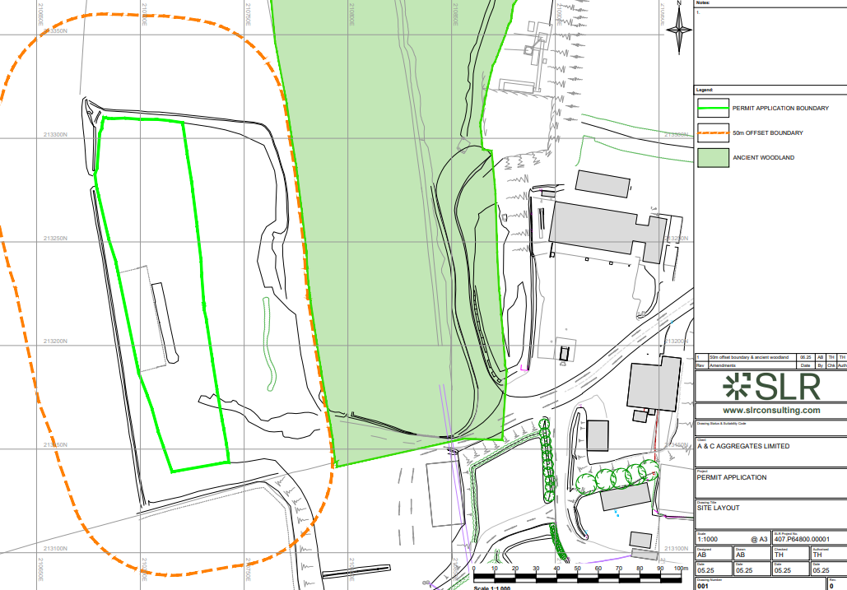

END OF PERMIT

