Annex (iv) – SSSI Assessment Form
SSSI Assessment for permit/licence and deployment applications | 
To be completed by Permitting Officers for any applications for a permission which Natural Resources Wales has considered under S28I duty to notify SNCB and take their advice into account. This applies to all proposed permissions within a SSSI, and to operations outside the SSSI boundary which are likely to damage its special features.
NRW as a Section 28G authority has, when exercising its functions, a general duty to take reasonable steps, consistent with the proper exercise of its functions, to further the conservation and enhancement of the flora, fauna or geological or physiological features by reason of which the site is of special interest’

Part 1 – SSSI Assessment
Part 2 – Formal notification to SNCB (to be completed if part 1 assessment concludes likely damage, not likely to damage because of conditions or you cannot conclude no likely damage)
Part 3 – Decision
Pink text – drafting notes, to be deleted before completion/consultation.
Blue text – examples, to be replaced with permission-specific information and text turned to black.

Part 1 – SSSI Assessment

- Permitting officer/team | Bryan Burn / Waste Permitting
- Permit application reference and site name | PAN-029596  EPR/GP3792SK  Noyadd Farm, Rhayader. LD6 5HH
- a. SSSI name(s)  b. location  c. NRW Operational Area/Environment Team | a. Rhagnentydd Gwy Uchaf / Upper Wye Tributaries  b. Powys  c. Mid  a. New House Meadow  b.Powys  c.Mid  a. Coed y Cefn  b.Powys  c.Mid
- Brief description of proposal | Landspreading deployment under SR2010No4 Mobile plant permit. Spreading potable water treatment sludge and sludge cake produced by DCWW Elan Valley, Tal-y-bont and Court Farm.  Application to spread a maximum of 9135 tonnes. The waste will be spread over 36.54 hectares of land within the listed fields.  DCWW liquid sludge will be surface applied using trailing  shoe as this is readily available to the farmer.  The cake will be spread using conventional rear discharge  spreaders as this is the most appropriate for the material  and rates it is to be applied at.  There is no requirement for further incorporation of the  waste on grass fields due to low ammonia content and  minimal odour.  All fields have a soil pH of above 5 and therefore can receive  application of the ferric based sludges, DCWW Elan Valley  and DCWW Talybont.  DCWW Court Farm is limited to fields above pH 6 due to  being alum based.  Spreading will only take place subject to ground conditions and following the Code of Good Agricultural Practice (Defra, 2011), NVZ regulations and the permit holder’s  Environmental Management System (EMS). Spreading activities will also comply with The Water Resources (Control of Agricultural Pollution) (Wales) Regulations 2021.  Targeted periods of spreading on grass fields include early spring (late February), after each cut of silage, dependent on crop growth and weather conditions, and prior to grazing through summer and autumn (September) prior to deployment expiry.  No more than 50t/ha will be spread on a field in any 3-week period in accordance with CoGAP, and no more than 250t/ha will be spread within any 12-month period.  Notification will be given prior to the commencement of spreading.  Fields 29 and 36 between Oct and Apr will not receive wastes as there is the possibility of flooding from the River Wye Tributary during this time. Both fields have no spread buffers to minimise potential run off. Nil risk to the adjacent SSSI.  Farm location  Noyadd Farm, Rhayader. LD6 5HH  SN 95770 66920  Fields  29 SN 95640 66486  31 SN 95778 67155  33 SN 96011 67381  34 SN 96218 67319  35 SN 96031 67136  36 SN 95642 66927  37 SN 95974 67029  38 SN 95920 66877  39 SN 96053 66741  40 SN 96119 66884  41 SN 95802 67295  Location plan  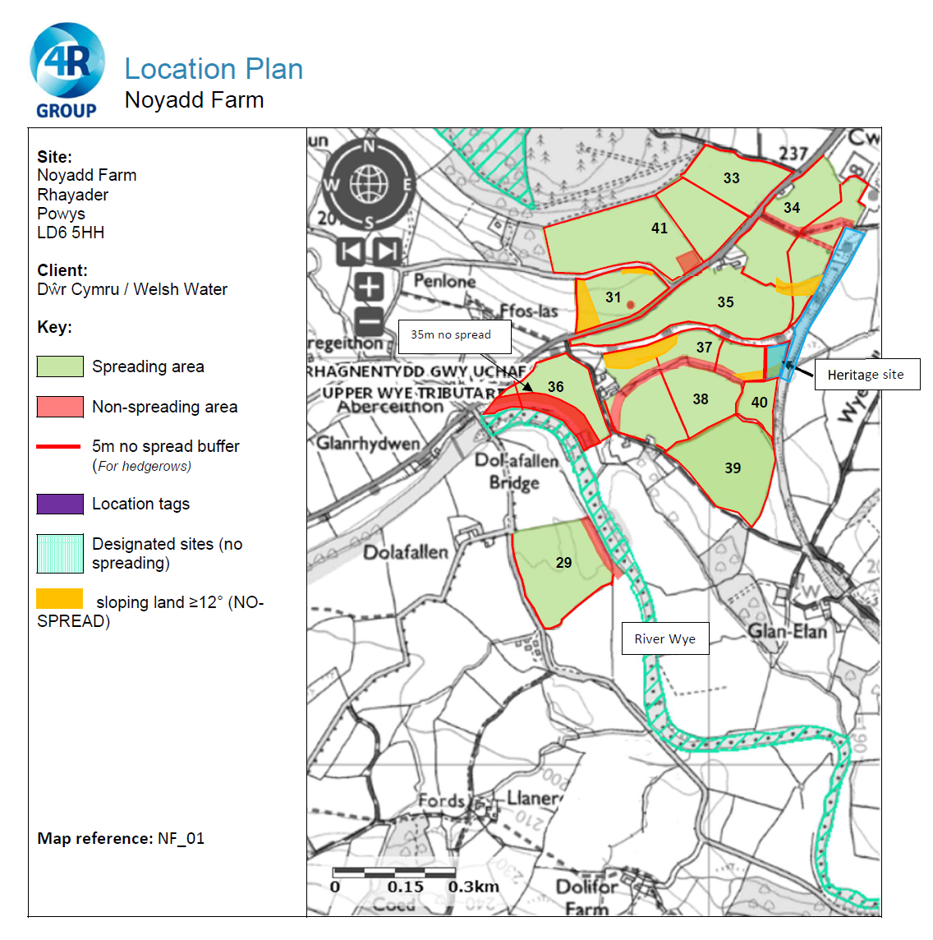  500 metre distances from deployment fields shown in red.  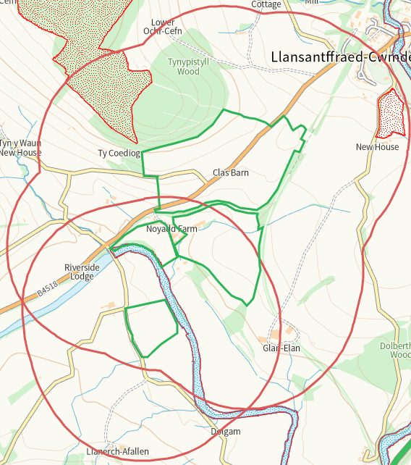
- What aspects of the proposed permission are likely to damage the SSSI features of special interest?

The following activities are likely to cause damage:

Rhagnentydd Gwy Uchaf / Upper Wye Tributaries
5. Application of manure, slurry, silage liquor, fertilisers and lime to agriculturally
unimproved permanent grass, forestry and all other unimproved riparian habitats
(including woodland and any other natural or semi-natural vegetation).
7. Dumping, spreading, discharging or storage of any materials.

New House Meadow
5. Application of manure, fertilisers and lime.
7. Dumping, spreading or discharging of any materials.

Coed y Cefn
5. Application of fertilisers and lime.
7. Dumping, spreading or discharging of any waste materials.

The following SSSI(s) features and potential impacts have been considered to assess the likelihood of damage:

Rhagnentydd Gwy Uchaf / Upper Wye Tributaries
https://cdn.cyfoethnaturiol.cymru/667365/SSSI_2556_Citation_EN0018188.pdf
https://cdn.cyfoethnaturiol.cymru/667439/SSSI_2556_SMS_EN0011b8a.pdf

New House Meadow
https://cdn.cyfoethnaturiol.cymru/676951/sssi_0964_citation_en001.pdf
https://cdn.cyfoethnaturiol.cymru/676956/sssi_0964_sms_en001.pdf

Coed y Cefn
https://cdn.cyfoethnaturiol.cymru/649009/SSSI_0674_Citation_EN001af1c.pdf
https://cdn.cyfoethnaturiol.cymru/649034/SSSI_0674_SMS_EN001a877.pdf

- Summary of any informal advice received from internal experts (if required and including pre-app advice) | n/a
- Recommendation | The proposed permission is not likely to damage any of the flora, fauna or geological or physiological features which are of special interest.
- Signature and date assessment made | Bryan Burn, 14/07/25
- Officers name and job title | Bryan Burn / Permitting Officer

