Record of a Habitats Regulations Assessment of a project or spatially-specific plan
OGN 200 Form 1A (with free-text boxes for likely significant effect screening and appropriate assessment)

Document owner: Head of Business for Natural Resource Management
Version History:
Document Version | Date Published | Summary of Changes
2.0 | 21/10/2024 | Following 2023/24 review of HRA OGNs
Next review date: October 2025

Record of a Habitats Regulations Assessment 4
1. Plan or Project Details 4
2. Determining the need for a Habitats Regulations Assessment 5
3. Considering the likelihood of a significant effect (LSE) 6
4. Appropriate assessment of the plan or project when considered alone 12
5. In combination assessment 16
6. Conclusion 19
7. Consultation with the ANCB and how sections 2, 3, 4 and 5 of this HRA report (as applicable) take into account that advice 21
8. Countersignature 22
9. Appendix 1 - Supporting information 23

OGN 200 Form 1A

Record of a Habitats Regulations Assessment
Plan or project name, brief description or application reference number | PAN-029596

HRA iteration/version | N/A

1. Plan or Project Details
Information about the plan or project

1 | Date application received | 09/06/2025
2 | Applicant details | Byproduct recovery Ltd
3 | NRW team responsible for carrying out, or requiring to be carried out, the plan or project, and name of lead officer | N/A
4 | Activity/ies proposed | Landspreading deployment under SR2010No4 Mobile plant permit. Spreading potable water treatment sludge and sludge cake produced by DCWW Elan Valley, Tal-y-bont and Court Farm.  Application to spread a maximum of 9135 tonnes. The waste will be spread over 36.54 hectares of land within the listed fields.  DCWW liquid sludge will be surface applied using trailing shoe as this is readily available to the farmer. The cake will be spread using conventional rear discharge spreaders as this is the most appropriate for the material and rates it is to be applied at.  There is no requirement for further incorporation of the waste on grass fields due to low ammonia content and minimal odour.  All fields have a soil pH of above 5 and therefore can receive application of the ferric based sludges, DCWW Elan Valley and DCWW Talybont. DCWW Court Farm is limited to fields above pH 6 due to being alum based.  Spreading will only take place subject to ground conditions and following the Code of Good Agricultural Practice (Defra, 2011), NVZ regulations and the permit holder’s Environmental Management System (EMS). Spreading activities will also comply with The Water esources (Control of Agricultural Pollution) (Wales) Regulations 2021.  Targeted periods of spreading on grass fields include early spring (late February), after each cut of silage, dependent on crop growth and weather conditions, and prior to grazing through summer and autumn (September) prior to deployment expiry.  No more than 50t/ha will be spread on a field in any 3-week period in accordance with CoGAP, and no more than 250t/ha will be spread within any 12-month period.  Notification will be given prior to the commencement of spreading.  Fields 29 and 36 between Oct and Apr will not receive wastes as there is the possibility of flooding from the River Wye Tributary during this time. Both fields have no spread buffers to minimise potential run off.
5 | Relevant legislation or statutory basis | The Environmental Permitting (England and Wales) Regulations 2016
6 | Location | Farm location  Noyadd Farm, Rhayader. LD6 5HH  SN 95770 66920  Fields  29 SN 95640 66486  31 SN 95778 67155  33 SN 96011 67381  34 SN 96218 67319  35 SN 96031 67136  36 SN 95642 66927  37 SN 95974 67029  38 SN 95920 66877  39 SN 96053 66741  40 SN 96119 66884  41 SN 95802 67295  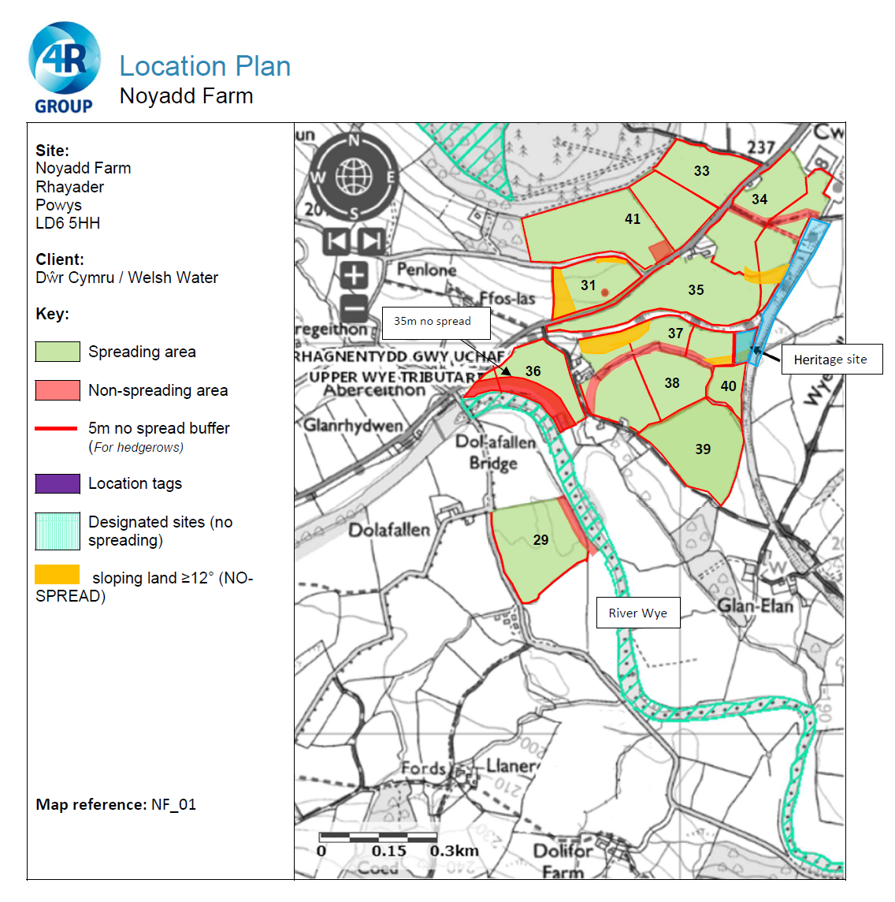
7 | Plan or project documents, including any application documents | Documents related to the deployment can be found on the DMS
8 | Environmental Statement (ES) | N/A
9 | Pre-application correspondence | N/A
10 | NRW team responsible for preparing this HRA report, and lead officer | Bryan Burn, Permitting Officer, Waste Permitting Team
11 | Team or person responsible for approving the plan or project (competent authority role) | Waste Permitting team

2. Determining the need for a Habitats Regulations Assessment
2.1 Is there any possibility that the plan or project could negatively affect any European sites? | Yes
2.2 Is the whole of the plan or project directly and only connected with or necessary to the management of one or more European sites, for the purposes of conserving the habitats or species for which the European site(s) is/are designated? | No
2.3 Is there a possibility that the plan or project could affect any other feature of the European site(s) concerned, or of another European site, in a way that would undermine that feature’s conservation objectives? | No

3. Considering the likelihood of a significant effect (LSE)

3.1 Renewal of a project authorisation on the same or more restrictive terms as an extant authorisation
Is this a renewal of an extant authorisation which complies with NRW approved criteria for ruling out significant effects of renewals (see Part 2 of OGN200) without conducting a project-specific LSE test? | No

3.2 Likelihood of significant effects (LSE) test

3.2.1 Which European sites might be affected by the plan or project?
(a) | Based on the plan or project specification, or information provided in the application, it is considered that these European sites have features which could be negatively affected by the plan or project | RIVER WYE / AFON GWY
(b) | The potential for the plan or project to negatively affect these European sites was also initially considered, but can be ruled out without further consideration | N/A

3.2.2 Screening for likelihood of significant effect

TABLE 3.2.2 Screening assessment
European site name: RIVER WYE / AFON GWY
There is no conceivable impact pathway to the RIVER WYE / AFON GWY SAC by virtue of the nature of the plan. The deployment will be conducted in accordance with the Permit, SSRA, Agricultural Benefit Statement and CoGAP.

The application has identified the SAC in the SSRA and provided control measures.
The application map identifies no spread buffers in fields 29 and 36 which are the closest fields.
Field 29 has a 20 metre no spread buffer to the North East boundary adjacent to the SAC and feild 36 has a 35 metre no spread boundary to the South West adjacent to the SAC, removing the potential for run off.
The waste will be spread by trailing shoe which applies the 190902 sludges close to the ground and the no spread buffers are substantial enough to to avoid the 190902 sludge cake from being spread to the boundaries.

Fields 29 and 36, between Oct and Apr, will not receive wastes as there is the possibility of flooding from the River Wye Tributary during this time removing potential run off potential.

Field 29 is slopes 0-7 degrees. Field 36 is mainly sloping 0-7 degrees, all areas that slope to a greater incline are substantially buffered.

Other fields are not a risk due to distance.

Screen out

TABLE 3.2.3 Screening decision of the plan or project ‘alone’
(a) If the screening conclusion for all features for all sites in Table 3.2.2 is ‘SCREEN OUT’ | The plan or project is not likely to have a significant effect on any European site, and no further consideration under the Habitats Regulations is required in order to determine the approval/application.  Screen out
(b) If the conclusion for any features in Table 3.2.2 is ‘SCREEN IN’ | The plan or project is likely to have a significant effect on one or more European sites and therefore an appropriate assessment is required.  N/A
(c) If there are no features in Table 3.2.2 that are ‘SCREEN IN’ and any features that are ‘IN COMB’ | The plan or project is not likely to have a significant effect on any European sites when considered alone, but the possibility of significant effects in combination with other plans and projects needs to be considered.  N/A

6. Conclusion
HRA is not required because there is no conceivable impact on any European sites.
(As documented in section 2.1)
HRA is not required because the whole of the plan or project is directly connected with or necessary to the management of one or more European sites, for the purposes of conserving the habitats or species for which the site(s) is/are designated, and the plan or project is not likely to have a significant effect on any other European sites.
(As documented in section 2.2 and 2.3)
This project is a renewal of a current permission which complies with NRW agreed criteria for ruling out likely significant effects of a renewal without conducting a project-specific LSE test. Therefore, it is considered not likely to have a significant effect on any European sites, either alone or in-combination with other plans or projects.
(As documented in section 3.1 of this form)
The plan or project has been screened for likelihood of significant effects and is considered not likely to have a significant effect on any European sites. (As documented in section 3.2 of this form, and section 5 if applicable) | X
In light of the conclusions of an appropriate assessment it has been established that the plan or project will not adversely affect the integrity of any European sites, taking into account any conditions or restrictions as applicable, either alone or in-combination with other plans or projects.
(As documented in section 4 of this form, and section 5 if applicable)
In light of the conclusions of the appropriate assessment, it has not been ascertained that the plan or project will not adversely affect the integrity of any European sites, as documented in section 4 of this form, and section 5 if applicable.
Approval for the plan or project cannot be given unless either:
- the plan or project specification, and/or the terms under which it might be approved, are modified so as to remove the risk of adverse effects, and a revised HRA is prepared, or
- the plan or project (not being an SSSI consent*) satisfies the requirements for a derogation and a Derogation Notice is prepared and submitted for consideration by the appropriate authority, normally Welsh Ministers
(*SSSI consents cannot be given as derogations)
Signed: Bryan Burn

Name: Bryan Burn Position: Permitting Officer

Date: 15/07/2025

Was this HRA conclusion an escalated decision? NO

