

Notice of variation and consolidation with introductory note
The Environmental Permitting (England & Wales) Regulations 2016

Dŵr Cymru Cyfyngedig

Storm Overflow at Bangor Beach Road SPS
Y Bae (opposite car park)
Bangor
Gwynedd
LL57 1AD

Variation number
PAN-028549

Permit number
CG0351702

Storm Overflow at Bangor Beach Road SPS

Permit Number CG0351702

Introductory note

This introductory note does not form a part of the permit

The following notice gives notice of the variation and consolidation of an environmental permit.

This permit variation and consolidation is to reflect asset improvements that have been agreed between Natural Resources Wales and Dŵr Cymru Cyfyngedig as part of the National Environment Programme (NEP).

As per table S3.1 in the permit below, 14 or more significant spills in any one year will trigger an investigation by the water company.

The schedules specify the changes made to the permit.

The status log of the permit sets out the permitting history, including any changes to the permit reference number. It is not backdated before 6th April 2010.

Status Log of the permit
Description | Date | Comments
Regulator initiated variation  Application CG0351702/V002 | Duly Made  25/10/2016 | AMP programme EDM variation
Variation Issued  CG0351702 | 26/10/2017 | Varied permit issued to Dŵr Cymru  Cyfyngedig.
Regulator-initiated variation  PAN-028549 | 12/05/2025 | AMP7 NEP variation of the permit to apply a 14 spill trigger investigation limit.
Variation Issued  CG0351702 | 28/07/2025 | Varied permit issued to Dŵr Cymru Cyfyngedig.

End of Introductory Note.
Notice of variation and consolidation
The Environmental Permitting (England and Wales) Regulations 2016

The Natural Resources Body for Wales (“Natural Resources Wales”) in exercise of its powers under regulation 20 of the Environmental Permitting (England and Wales) Regulations 2016 varies and consolidates

Permit number

CG0351702

Issued to

Dŵr Cymru Cyfyngedig (“the operator”)

whose registered office is

Linea

Fortran Road

St Mellons

Cardiff

CF3 0LT

company registration number 02366777

to operate a water discharge activity at

Storm Overflow at Bangor Beach Road SPS

Y Bae (opposite car park)

Bangor

Gwynedd

LL57 1AD

to the extent set out in the schedules.

The notice shall take effect from 28/07/2025

Name | Date
Joanne Fitton | 28/07/2025

Authorised on behalf of Natural Resources Wales.

Schedule 1
The following conditions were varied as a result of a Natural Resources Wales initiated variation:
- 2.2.1
- 2.3.1
- 2.3.1 (b), (c)
- 3.1.1
- 3.1.2

Schedule 2 – consolidated permit

Consolidated permit issued as a separate document.
Permit
The Environmental Permitting (England and Wales) Regulations 2016

Permit number

CG0351702

This is the consolidated permit referred to in the variation and consolidation notice for variation PAN-028549 authorising

Dŵr Cymru Cyfyngedig (“the operator”)

whose registered office is

Linea

Fortran Road

St Mellons

Cardiff

CF3 0LT

company registration number 02366777

to operate a water discharge activity at

Storm Overflow at Bangor Beach Road SPS

Y Bae (opposite car park)

Bangor

Gwynedd

LL57 1AD

to the extent authorised by and subject to the conditions of this permit.

The permit variation and consolidation shall take effect from 28/07/2025

Name | Date
Joanne Fitton | 28/07/2025

Authorised on behalf of Natural Resources Wales.

Conditions
- Management
  - General management
    - The operator shall manage and operate the activity:
      - in accordance with a written management system that identifies and minimises risks of pollution so far as is reasonably practicable, including those risks arising from operations, maintenance, accidents, incidents, non-conformances and those drawn to the attention of the operator as a result of complaints; and
      - using sufficient competent persons and resources.
    - Records demonstrating compliance with condition 1.1.1 shall be maintained.
    - Any person having duties that are or may be affected by the matters set out in this permit shall have convenient access to a copy of the permit.
- Operations
  - Permitted activities
    - The only activity authorised by the permit is the activity specified in schedule 1 table S1.1.
  - The site
    - The discharge activity shall take place at the discharge point marked on the site plan at schedule 7 to this permit, and as listed in table S3.2; and, the operating techniques that are the subject of conditions prefixed by 2.3 shall be applied at the locations shown, or otherwise described, in schedule 7.
  - Operating techniques
    - For the activity referenced in schedule 1, table S1.1, the activity shall, subject to the conditions of this permit, be operated using the techniques and in the manner described in the documentation specified in schedule 1, table S1.2, unless otherwise agreed in writing by Natural Resources Wales.
    - For the discharge specified in table S3.3:
      - The discharge shall only occur when and only for as long as either:
(i) the flow passed forward is equal to or greater than the overflow setting indicated due to rainfall and/or snow melt or
(ii) the hydraulic capacity of the sewer network downstream of the combined sewer overflow is reached due to rainfall and/or snow melt and the level of storm sewage in the sewer at the combined sewer overflow is greater than the weir level of the overflow structure which is specified as an overflow setting in table S3.3.
The capacity of the sewer network downstream of the combined sewer overflow shall not be altered in any way which would lead to a significant increase in the frequency or volume of the discharge.
      - Off-line storm storage must be fully utilised before a discharge occurs. It shall only fill when the flow passed forward is equal to or greater than the overflow setting indicated due to rainfall and/or snow melt and shall be emptied and its contents returned to the continuation flow as soon as reasonably practicable. The minimum off-line storm storage required is specified in table S3.3.
      - On-line storm storage must be fully utilised before a discharge occurs. It shall only fill with the excess flows due to rainfall and/or snow melt. The storage shall be emptied and its contents returned to the continuation flow as soon as reasonably practicable. The minimum on-line storm storage required is specified in table S3.3.
      - The discharge shall not be comminuted or macerated and shall have passed through screens as specified and shall not contain a significant quantity of solid matter with a particle size greater than any indicated. All screenings shall be removed from the discharge.
      - Where a mechanically cleaned screen is installed, a telemetry alarm system shall be installed and maintained, as far as reasonably practicable, so as to give the operator immediate notification of a failure of the screen cleaning mechanism, unless otherwise agreed in writing by Natural Resources Wales. The operator shall take all appropriate measures to return the screen cleaning mechanism to normal operation as soon as reasonably practicable after receipt of notification of the failure.
- Emissions and monitoring
  - Emissions to water
    - The limits given in schedule 3 table S3.1 shall not be exceeded.
    - Effective from the date of installation of EDM monitoring equipment at the site:
If the measured number of significant block counted spills exceeds the limit specified in Table S3.1 this constitutes a Trigger Exceedance and the operator shall:
- notify Natural Resources Wales of the Trigger Exceedance as soon as reasonably practicable (and no later than 4 weeks from the date of the Trigger Exceedance) in a format agreed by Natural Resources Wales;
- provide a reason for the Trigger Exceedance and a description of any remedial action undertaken or proposed. Where the reason/s for the Trigger Exceedance cannot be identified within the 3 months of the Trigger Exceedance the operator must provide a proposal with timeframes for a full investigation to be carried out to identify the reason/s for the Trigger Exceedance for approval by Natural Resources Wales;
- if a full investigation is required by condition 3.1.2(b), implement the proposal as approved by Natural Resources Wales and provide to Natural Resources Wales a report which identifies the reason/s for the Trigger Exceedance;
- submit a plan with timeframes to resolve the reason/s for the Trigger Exceedance identified in 3.1.2(c) for approval by Natural Resources Wales;
- the operator shall implement the plan as approved in condition 3.1.2(d).
  - Monitoring
    - The operator shall, unless otherwise agreed in writing by Natural Resources Wales, undertake the monitoring specified in the following tables in schedule 3 to this permit:
      - point source emissions specified in tables S3.1 and S3.4.
    - The operator shall maintain records of all monitoring required by this permit.
    - Accessible monitoring points shall be provided and maintained to enable the emissions monitoring programme to be carried out at the monitoring points specified in table S3.4 of schedule 3 and shown marked on the site plans in schedule 7.
    - The operator shall take appropriate measures to ensure that the event recorder remains fully operational at all times within the reference period specified in table S3.1. Any failures shall be remedied as soon as reasonably practicable.
- Information
  - Records
    - All records required to be made by schedule 3, 4 and 5 to this permit shall:
      - be legible;
      - be made as soon as reasonably practicable;
      - if amended, be amended in such a way that the original and any subsequent amendments remain legible, or are capable of retrieval; and
      - be retained, unless otherwise agreed in writing by Natural Resources Wales, for at least 10 years from the date when the records were made.
    - The operator shall maintain convenient access, in either electronic or hard copy, to the records, plan and management system required to be maintained by this permit.
  - Reporting
    - The operator shall send all reports and notifications required by the permit to Natural Resources Wales using the contact details supplied in writing by Natural Resources Wales.
    - Within the time period after the end of the reporting period specified in schedule 4 table S4.1 the operator shall, unless otherwise agreed in writing by Natural Resources Wales, submit reports of the monitoring and assessment carried out in accordance with the conditions of this permit, as follows:
      - in respect of the parameters and monitoring points specified in schedule 4 table S4.1;
      - for the reporting periods specified in schedule 4 table S4.1 and using the forms specified in schedule 4 table S4.2; and
      - giving the information from such results and assessments as may be required by the forms specified in those tables.
  - Notifications
    - Natural Resources Wales shall be notified as soon as reasonably practicable following detection, within the site of the regulated facility of any malfunction, breakdown or failure of equipment or techniques, accident, or emission of a substance not controlled by an emission limit which has caused, is causing or may cause significant pollution. Any other significant adverse environmental effects, which may have been caused by the activity, shall also be notified to Natural Resources Wales as soon as reasonably practicable following detection.
    - The information provided under condition 4.3.1 shall be supported by sending the information listed in schedule 5 to this permit within the time period specified in that schedule.
    - Natural Resources Wales shall be notified within 14 days of the occurrence of the following matters, except where such disclosure is prohibited by Stock Exchange rules:
Where the operator is a registered company:
      - any change in the operator’s trading name, registered name or registered office address; and
      - any steps taken with a view to the operator going into administration, entering into a company voluntary arrangement or being wound up.
Where the operator is a corporate body other than a registered company:
      - any change in the operator’s name or address; and
      - any steps taken with a view to the dissolution of the operator.
  - Interpretation
    - In this permit the expressions listed in schedule 6 shall have the meaning given in that schedule.
    - In this permit references to reports and notifications mean written reports and notifications, except where reference is made to notification being made “as soon as reasonably practicable”, in which case it may be provided by telephone.

Schedule 1 – Operations
Table S1.1 Activities
Description of activity | Limits of specified activity
A1 Discharge of storm sewage via Long Storm Discharge Point | N/A
A2 Discharge of storm sewage via Short Storm Discharge Point | N/A

Table S1.2 Operating techniques
Description of documentation | Parts | Date Received
Operating Technique | All | 12/05/2025

Schedule 2 – Waste types, raw materials and fuels
Schedule 2 not in use.

Schedule 3 – Emissions and monitoring
Table S3.1 Point Source emissions to water (other than sewer) – emission limits and monitoring requirements
Effluent and discharge point | Parameter | Limit (including unit) | Reference Period | Limit of effective range | Monitoring frequency | Compliance Statistic
A1 Storm sewage via Long Storm Discharge Point  and  A2 Storm sewage via Short Storm Discharge Point | Discharge start and end times | N/A | N/A | N/A | Whenever a discharge occurs | N/A
 | Block counted spills | N/A | 1st January to 31st December inclusive | N/A | 15 minutes | N/A
 | Block-counted significant spills | 14 spills | 1st January to 31st December inclusive | N/A | 15 minutes | Condition 3.1.2 applies - the spills threshold is a trigger for investigation only and not a statistic for use in compliance of asset
 | Event recorder status operational | N/A | N/A | N/A | 15 minutes | N/A

Table S3.2 Discharge points
Effluent Name | Discharge Point | Discharge point NGR | Receiving water/Environment
A1 Storm sewage | Long Storm Discharge Point | SH 58690 73410 | Afon Menai
A2 Storm sewage | Short Storm Discharge Point | SH 58660 72930 | Afon Menai

Table S3.3 Storm sewage discharge settings
Effluent and discharge point | Description of discharge | Overflow setting l/s | Maximum size of solid matter | Screen aperture size | Minimum storage capacity m³
A1 Storm sewage via Long Storm Discharge Point | Storm sewage | 382 up to 4382 | No greater than 6 mm in more than 1 dimension for flows <1000 l/s  No greater than 10 mm in more than 2 dimensions for flows ≥1000 l/s | 6 mm x 6 mm for flows <1000 l/s  10 mm for flows  ≥1000 l/s | 4300  Only flows from 382 l/s up to 1000 l/s enter storage.
A2 Storm sewage via Short Storm Discharge Point | Storm sewage | 4382 | No greater than 10 mm in more than 2 dimensions for flows ≥1000 l/s | 10 mm for flows  ≥1000 l/s | No storage for flows over 1000 l/s

Table S3.4 Monitoring points
Effluent and discharge point | Monitoring type | Monitoring point NGR | Monitoring point reference
A1 Storm sewage via Long Storm Discharge Point  and  A2 Storm sewage via Short Storm Discharge Point | Effluent sampling | SH 58651 72901 | Storm Sample Point
 | Event duration monitoring | SH 58655 72904 | Storm to Environment EDM Monitoring Point

Schedule 4 – Reporting
Parameters, for which reports shall be made, in accordance with conditions of this permit, are listed below.
Table S4.1 Reporting of monitoring data
Parameter | Monitoring point reference | Reporting period | Period begins
Combined sewer overflow performance, including adjusted number of significant spills | Storm to Environment EDM Monitoring Point | Annually  Report to be submitted within 2 months | 1st January
Duration of significant spills | Storm to Environment EDM Monitoring Point | Annually  Report to be submitted within 2 months | 1st January
Event recorder status operational | Storm to Environment EDM Monitoring Point | Annually  Report to be submitted within 2 months | 1st January
CSO performance, including total number of block counted spills | Storm to Environment EDM Monitoring Point | Annually  Report to be submitted within 2 months | 1st January
Duration of total spills | Storm to Environment EDM Monitoring Point | Annually  Report to be submitted within 2 months | 1st January
Storm sewage discharge start and end times | Storm to Environment EDM Monitoring Point | Reports to be provided to Natural Resources Wales upon request | As specified by Natural Resources Wales
Reason/s for the Trigger Exceedance and a description of any remedial action undertaken or proposed | Storm to Environment EDM Monitoring Point | Report to be submitted within 3 months of the date of a trigger exceedance | 1st January
Proposals with timeframes for any full investigation | Storm to Environment EDM Monitoring Point | Report to be submitted within 3 months of the date of a trigger exceedance | 1st January
Full investigation which identifies the reason/s for the Trigger Exceedance | Storm to Environment EDM Monitoring Point | Report to be submitted within the time period as agreed by NRW | 1st January
Plan with timeframes to resolve the reason/s for the Trigger Exceedance | Storm to Environment EDM Monitoring Point | Plan to be submitted within 24 months of the report identifying the reason/s for the Trigger Exceedance | 1st January

Table S4.2 Reporting forms
Parameter | Reporting format
Combined sewer overflow performance including number and duration of block counted spills | Annual summary report or other form as agreed in writing by Natural Resources Wales
Combined sewer overflow performance including number and duration of block-counted significant spills | Annual summary report or other form as agreed in writing by Natural Resources Wales
Storm sewage discharge start and end times | Form as agreed in writing by Natural Resources Wales
Event recorder status | Annual summary report or other form as agreed in writing by Natural Resources Wales  Percentage of time in the recording period that event duration monitoring equipment is operational
Investigation into the operation of the overflow | Electronic format as agreed in writing by Natural Resources Wales.
Reason/s for the Trigger Exceedance and a description of any remedial action undertaken or proposed | Electronic format as agreed in writing by Natural Resources Wales.
Proposals with timeframes for any full investigation | Electronic format as agreed in writing by Natural Resources Wales.
Full investigation which identifies the reason/s for the Trigger Exceedance | Electronic format as agreed in writing by Natural Resources Wales.
Plan with timeframes to resolve the reason/s for the Trigger Exceedance | Electronic format as agreed in writing by Natural Resources Wales.

Schedule 5 – Notification
These pages outline the information that the operator must provide.
Units of measurement used in information supplied under Part A and B requirements shall be appropriate to the circumstances of the emission. Where appropriate, a comparison should be made of actual emissions and authorised emission limits.
If any information is considered commercially confidential, it should be separated from non-confidential information, supplied on a separate sheet and accompanied by an application for commercial confidentiality under the provisions of the EP Regulations.

Part A
Permit Number | CG0351702
Name of operator | Dŵr Cymru Cyfyngedig
Location of Facility | Storm Overflow at Bangor Beach Road SPS, Y Bae (opposite car park), Bangor, Gwynedd, LL57 1AD
Time and date of the detection

(a) Notification requirements for any malfunction, breakdown or failure of equipment or techniques, accident, or emission of a substance not controlled by an emission limit which has caused, is causing or may cause significant pollution.
To be notified within 7 days of detection unless otherwise agreed in writing by Natural Resources Wales.
Date and time of the event
Reference or description of the location of the event
Description of where any release into the environment took place
Substances(s) potentially released/type or nature of sewage released
Best estimate of the quantity or rate of release of substances and/or duration of discharge
Best estimate of the environmental impact of the discharge
Measures taken, or intended to be taken, to stop any emission
Description of the failure or accident.

Part B – to be submitted as soon as reasonably practicable unless otherwise agreed in writing by Natural Resources Wales
Any more accurate information on the matters for notification under Part A.
Measures taken, or intended to be taken, to prevent a recurrence of the incident/breach/exceedance
Measures taken, or intended to be taken, to rectify, limit or prevent any pollution of the environment which has been or may be caused by the emission

Name*
Post
Signature
Date
* authorised to sign on behalf of the operator

Schedule 6 – Interpretation
“accident” means an accident that may result in pollution.
“annually” means once every year.
“application” means the application for this permit, together with any additional information supplied by the operator as part of the application and any response to a notice served under Schedule 5 to the EP Regulations.
“block counted spill” one or more overflow events within a period of 12 hours or less will be considered to be one spill, one or more overflow events extending over a period of greater than 12 hours up to 36 hours will be considered to be 2 spills. Each subsequent 24-hour duration counts as 1 additional spill and the whole of the 24-hour block is included.
“event recorder" a recorder which records the start time and end time of individual overflow events
“emissions of substances not controlled by emission limits” means emissions of substances to air, water or land from the permitted activities, which are not controlled by an emission limit.
“EP Regulations” means The Environmental Permitting (England and Wales) Regulations SI 2016 No.1154 and words and expressions used in this permit which are also used in the Regulations have the same meanings as in those Regulations.
“minimum screen capacity flow” means the minimum flow passed through the screens to the outfall when the screen bypass operates.
“monitoring frequency” as used in Table S3.1 in the context of event duration monitoring is the temporal interval at which a change in state between no discharge and discharge is to be detected.
“Natural Resources Wales” means the Natural Resources Body for Wales established by article 3 of the Natural Resources Body for Wales (Establishment) Order 2012. The Natural Resources Body for Wales (Functions) Order 2013 transferred the relevant functions of the Countryside Council for Wales, and functions of the Environment Agency and the Forestry Commission in Wales to the Natural Resources Body for Wales.
“overflow” for the purposes of schedule 7, overflow means the weir or orifice or other control which directs excess flow away from the continuation sewer when the flow exceeds the overflow setting due to rainfall and/or snowmelt.

“overflow event” any individual operation, of any duration, of the event recorder or any recorded discharge of sewage from the outfall.
“overflow setting” means the minimum flow passed forward to the continuation sewer when the overflow operates.
“quarter” means a calendar year quarter commencing on 1 January, 1 April, 1 July or 1 October.
“significant pollution” means a high-level impact incident as indicated by NRW incident classification system.
“significant spill” any spill that has not been demonstrated to have been, or measured as being, less than 50 m³ in volume.
“SOAF” means Storm Overflow Assessment Framework.
“year” means calendar year ending 31 December.
“Formula A” is defined as (PG+I+E) + 1360P + 2E litres/day. Where P = population served, G = water consumption per head per day (litres/head/day) I = infiltration (litres/day) E = trade effluent flow to sewer (litres/day)

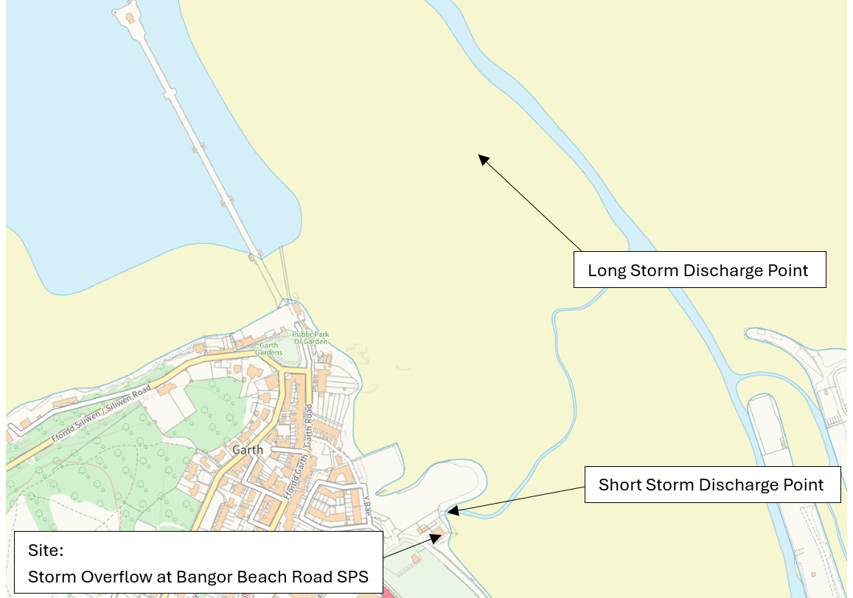
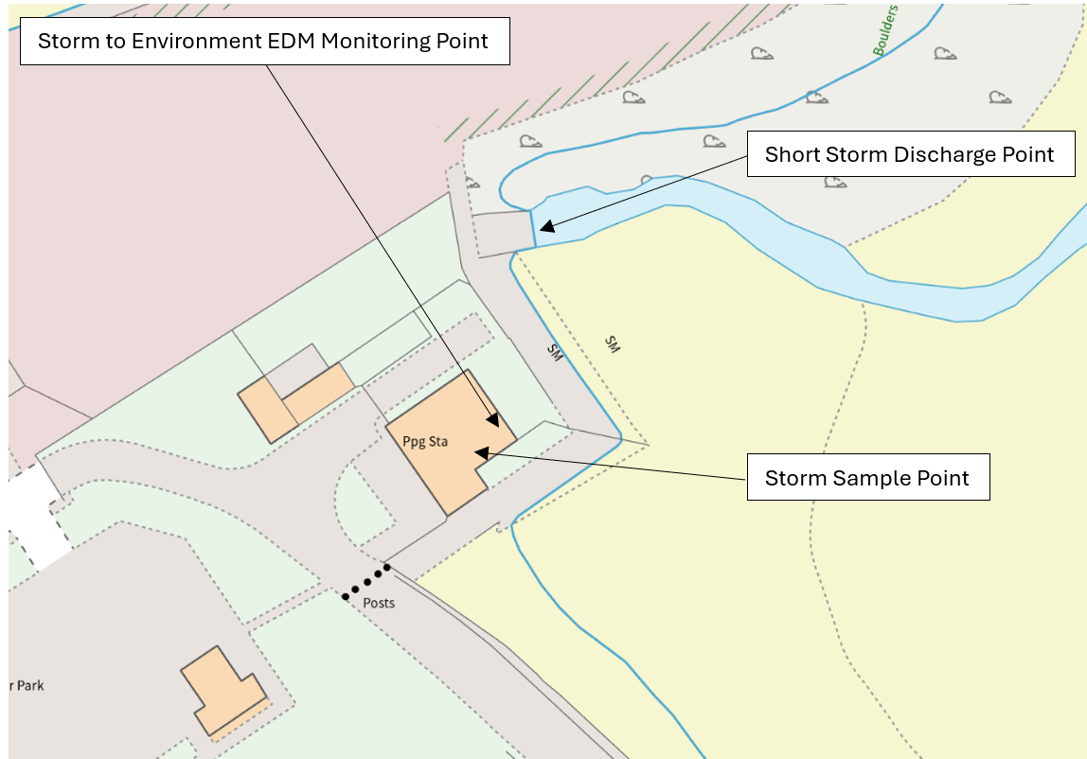
Schedule 7 – Site plans
© Crown Copyright and database right 2025. Ordnance Survey licence number 100019741.
END OF PERMIT

