Bangor Beach Road Sewage Pumping Station
Operating Explanation Document

OTA1: Bangor Beach Road SPS requirements
Permit Number | Site Name | Operator
CG0351702 | Beach Road Pumping Station | DCWW

Revision log
Revision Number | Details | Date
V1 | Initial Submission | 12/05/25

Start date
This Operating Agreement document will take effect from date of issue of the NEP (March 2025).
Sign off
Name | Role | Organisation | Signature | Date
Claire Grainger | Environmental Permitting Team Leader | Dwr Cymru Cyfyngedig |  | 12/05/2025
TBC | TBC | Natural Resource Wales

Contents
1. Introduction and purpose of document 4
2. Background 4
3. Asset Operation 5
3.1. Summary of 2025 upgrades 5
3.2. Operation in dry weather 5
3.3. Operation during storm 6
3.3.1. Summary of overflow regime 6
3.3.2. Permit Conditions for discharges 8
3.3.3. Expected performance 9
4. Conclusion 10

Introduction and purpose of document
Bangor Beach Road Sewage Pumping Station (SPS) is located in the northeast of Bangor between Beach Road football pitch and the Menai Strait. The SPS receives combined wastewater from the Bangor catchment and, pumps foul and storm flows to Treborth WwTW (approximately 12 miles southwest) for treatment. During storm conditions, the SPS has historically pumped excess screened storm flows to the Menai Strait via a long sea (LSO) and a short sea outfall (SSO). In response to the AMP7 National Environment Programme (NEP) requirements to reduce impact of the SPS on the Menai Strait shellfish water quality, significant asset upgrades have been undertaken to Beach Road SPS between 2023 and 2025.
Following advice from NRW’s Permitting Officer (April 2025) it was decided that, with the upgrades, the operation of Beach Road SPS was sufficiently complex to require an Operating Explanation document that can be referenced in the assets permit. This document outlines the operation of the asset and supplementary documents in a non-technical manner.

Background
The AMP7 NEP has a shellfish driver for Beach Road SPS (W_SW_IMP2 driver relating to Shellfish Water improvement actions).
The upgrades undertaken at Beach Road SPS 2023- 2025 were based on solutions identified from catchment and water quality assessments undertaken by DCWW between 2019 and 2022. The hydraulic model of the catchment and coastal water quality model were updated to assess the impact of the Beach Road SPS on the Menai Strait shellfish waters and then used to consider a number of interventions in the catchment, such as tidal infiltration removal and asset optimisation. The modelling analysis showed that storm discharges from Beach Road SPS had a relatively significant impact on local shellfish beds within the Menai Straits. Hence DCWW focused on reducing storm discharges to reduce impact and meet their NEP obligations.
The modelling assessments concluded that if Beach Road SPS could retain storm water and reduce storm discharges to an average of 10 per year it would meet the desired spill driver target and significantly reduce impact on the local shellfish beds in the Menai Straits. The modelling demonstrated that a circa 4,300 m³ storm storage would reduce the SPS to 10 storm discharges per year from the LSO and/or SSO. The storm tank would retain flows during storms and returned it to the network before being pumped for downstream treatment at the WwTW, operation as described below.
Further details on the impact of the solution and supporting modelling is available in the NRW Solution Report 4392_S_216-ARP-07-XX-RP-XX-10040 (February 2023).

Asset Operation

Summary of 2025 upgrades
The asset has been updated with the addition of an offline storm storage tank. The tank is situated below ground level under the football pitch adjacent to the SPS. The existing SPS asset was retrofitted, keeping the civil structure as existing but altering pumps and pipework to bring the new storm tank into the system. The existing storm sump 2 was repurposed so that, rather than pumping to the LSO, storm water flows are pumped to and stored in the new 4,300m³ storage tank until storms have ceased and flows are returned to the network. The sections below outline the operation in dry and storm conditions and provides the key set points to show how the asset operate in line with the permit. Detailed operation can be found in the works operating manual.

Operation in dry weather
During normal operating conditions the asset does not discharge stormwater. Flows from the Bangor catchment enter the (two) inlet channels and combine and pass flow (via various isolation valves) to sump 1. There are three foul pumps (pumps 1, 2 and 3) which transfer Flow Pass Forward (FPF) to Treborth WwTW for treatment (consented FPF is 382 l/s). A schematic of the SPS during normal operating (non-storm) conditions is given in Figure 1 below. Pumps 1, 2 and 3 operate Duty Assist Standby.
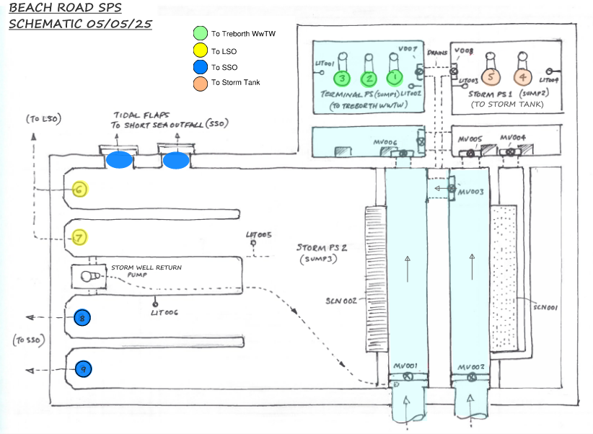
Figure 1: Beach Road SPS Schematic - Dry weather operation

Operation during storm

Summary of overflow regime
There are several storm overflow routes within the SPS as described below.
If the incoming flows increase over 382 l/s and the foul pumps are beaten, then the flow backs up into both inlet channels and spills over the 0.32m high weir (storm weir 1) through the 6mm 2D perforated screen (storm screen 1) and into the “Storm PS1” aka / shown in Figure 2 as “sump 2”. The new storm pumps (two pumps in duty/assist) in sump 2 can deliver 1000 l/s to the new (4,300m³) storm tank.
If the incoming flows are even higher, then the inlet channel spills over the 0.61m high weir (storm weir 2) through the 10mm 1D bar screen (storm screen 2) and into the "Storm Wet Well" aka / shown in Figure 2 as “sump 3”. Once the storm wet well reaches a certain level the Pumps 6 and 7 operate (duty/assist, discharging via the LSO) and then if it continues, Pumps 8 and 9 also operate (duty/assist discharge via the SSO). 800 m³ storage is available (below top water level) across the sumps 2 and 3 (in line with the old permit).
There is a further hydraulic link between after storm screen 1 to sump 3 i.e. flows pass over storm weir 1 and screen 1, if flows are backing up (from sump 2) then they can pass over weir 3 which connects (below the inlet channels) to the storm wet well/sump 3.
When flows subside, a penstock opens and allows flows to drain from the Outfall Wet Well into the Storm Wet Well and then via the sump pump back into the foul (FPF) wet well. The new storm tank is returned via a penstock to the network upstream of the SPS, it will open incrementally, draining down the storm tank, when level and FPF in the SPS allow.
A schematic of the SPS during storm conditions and a cross section showing weir level are given in Figure 2 and Figure 3 below.
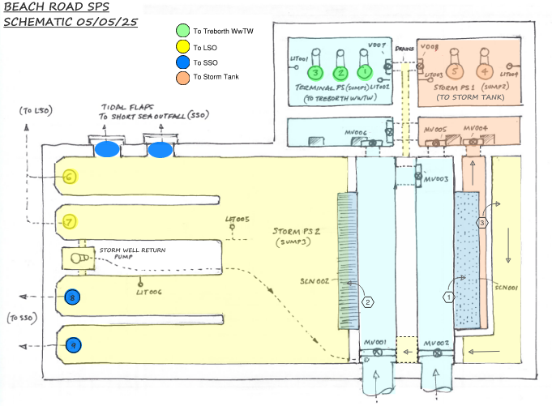
Figure 2: Beach Road SPS Schematic - Dry weather operation
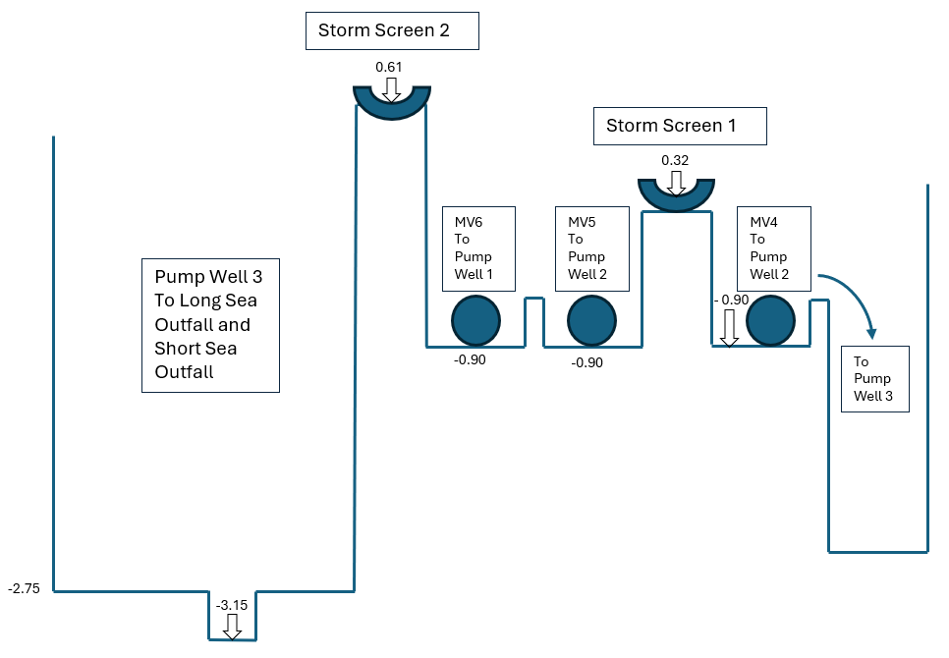
Figure 3: Beach Road SPS storm weir levels

Permit Conditions for discharges
In line with the permit, a stormwater discharge can occur when the following conditions are met, additional commentary is provided to show how the upgrades to the SPS align with this:
Permit condition | Commentary
FPF to Treborth WwTW of 382 l/s achieved | This remains unchanged. The FPF pumps have been optimised in 2022 to ensure FPF is achieved.
Storm storage of 800 m³ is utilised | This is now 5,100m³ in total (800m³ in existing wells and 4,300m³ in the new tank), which was determined based on WQ requirements of the shellfish water.
flows <1275l/s go via the 6mm 2D screen and 1275+l/s via the 10mm 1D screen | The pumps in sump 2 have been replaced and now serve the new storm tanks and not the LSO. The flow rates have been updated.  flows <1000l/s go via the 6mm 2D screen and 1000+l/s via the 10mm 1D screen.  Noting that with the addition of the new storm storage volume the annual quality of spill flow over the 10mm screen is less than previously.
Table 1: Summary of permit and commentary
Table of overflow settings and storm storage requirements from permit
 | Permit No. | Site ID | Site Name | FPF (l/s) | Storage (m³) | Screen aperture size (mm)
EXISTING / OLD | CG0351702 |  | Beach Road Pumping Station | 382 to Treborth WwTW  382-4382  to long  outfall,  >4382 to  short  outfall | 800 | flows <1275l/s  6mm 2D,  1275+l/s  10mm 1D
NEW | CG0351702 |  | Beach Road Pumping Station | 382 to Treborth WwTW  383 – 1000 to storm tank  1001 – 4382 to LSO  >4383 to  short  outfall | 5100 | flows <1000l/s  6mm 2D,  1000+l/s  10mm 1D
Table 2: Beach Road SPS overflow settings and storm storage requirements

Expected performance
The hydraulic model has been used to determine the expected performance of the SPS. With the new storm pumps in sump 2, and new storm storage tank (4,300m³) included, the flow splits between the storm weirs and sumps as follows.
- For a typical year modelled, the vast majority of the flows goes through Storm Screen 1 (as expected because of the levels) and less flows go through Storm Screen 2. The proportion is:
  - Storm Screen 1 (6mm): 190,427m3 (97%)
  - Storm Screen 2 (10mm): 5,491m3 (3%).
- There is a risk that, due to the head in the inlet channel flows could pass over the storm screen 1 unscreened, then over storm weir 3 to sump 3. The amount of flows that go unscreened through Storm screen 1 cannot be calculated with the model setup, as all the flows that go through that link are considered "screened" in the model.
- This was investigated further during the modelling stage and, a good indication of how much flow could overtop the screen, is the water levels in the inlet channels: If the water levels are higher than the Storm Screen 1 top level, that means there is a risk of flows passing over the screen. The graph below shows the water levels in the inlet chamber (for a typical modelled year). All the flows over the red line (0.320mAOD) are suspected to go over the top of storm screen.

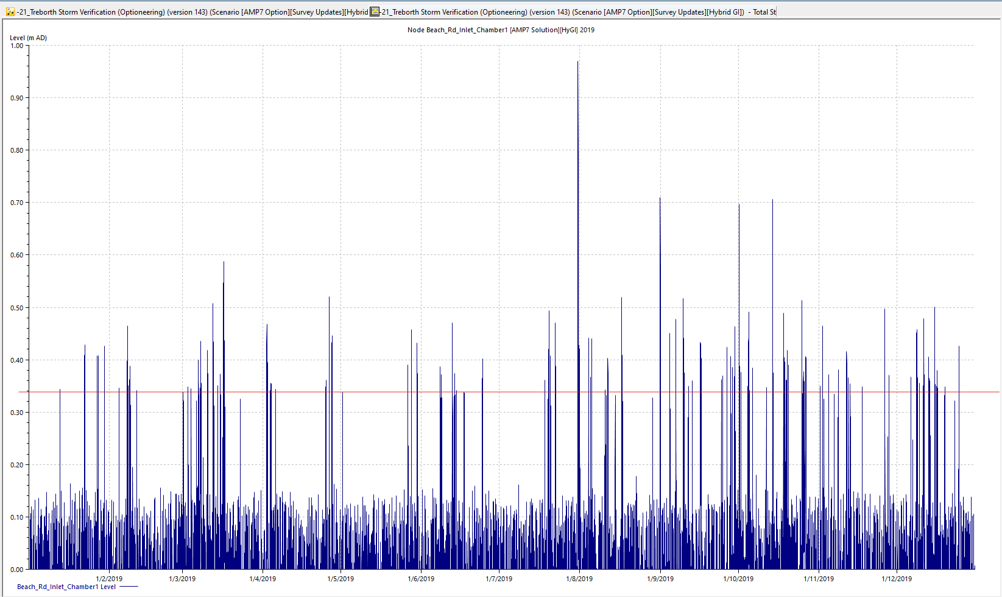
Figure 4: Inlet channel levels modelled for a typical year

Conclusion
The above summarises, in a non-technical manner, the operation of the upgraded Beach Road SPS. This is inline with the modelled solutions in the NRW Solution Report (February 2023) and implemented upgrade and control philosophy for the site.

