Permit
The Environmental Permitting (England & Wales) Regulations 2016

Global Spares Limited
Unit 9 Griffin Windows Ridgewell Way
Llwynypia
Tonypandy
Wales
CF40 2JP

Permit number

EPR/DB3592CU

Permit
The Environmental Permitting (England and Wales) Regulations 2016
Permit number

EPR/DB3592CU

The Natural Resources Body for Wales (“Natural Resources Wales”) authorises, under regulation 13 of the Environmental Permitting (England and Wales) Regulations 2016

Global Spares Limited (“the operator”),

whose registered office is

Unit 9 Griffin Windows Ridgewell Way

Llwynypia

Tonypandy

Wales

CF40 2JP

company registration number 15785398

to operate waste operations at

Global Spares Limited

Unit 9 Griffin Windows Ridgewell Way

Llwynypia

Tonypandy

Wales

CF40 2JP

to the extent authorised by and subject to the conditions of this permit.

Under regulation 27(2) of the Regulations, standard rules SR2011No3 are conditions of this permit.

Name | Date
Huw Davies | 23/06/2025

Authorised on behalf of Natural Resources Wales

Schedule 1 - Site plan

This is the plan referred to in the standard rules SR2011 No3

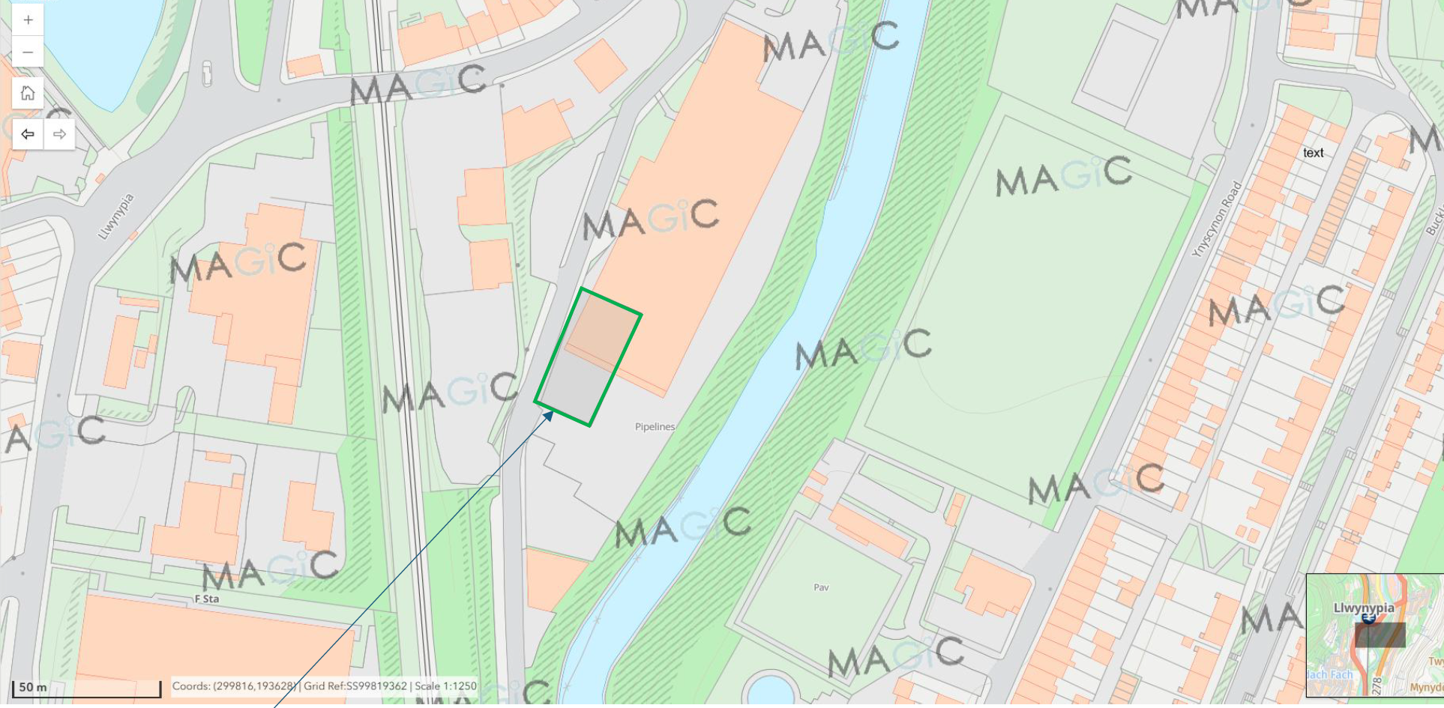

END OF PERMIT

