Annex (iv) – SSSI Assessment Form
SSSI Assessment for permit/licence and deployment applications | 
To be completed by Permitting Officers for any applications for a permission which Natural Resources Wales has considered under S28I duty to notify SNCB and take their advice into account. This applies to all proposed permissions within a SSSI, and to operations outside the SSSI boundary which are likely to damage its special features.
NRW as a Section 28G authority has, when exercising its functions, a general duty to take reasonable steps, consistent with the proper exercise of its functions, to further the conservation and enhancement of the flora, fauna or geological or physiological features by reason of which the site is of special interest’

Part 1 – SSSI Assessment
Part 2 – Formal notification to SNCB (to be completed if part 1 assessment concludes likely damage, not likely to damage because of conditions or you cannot conclude no likely damage)
Part 3 – Decision
Pink text – drafting notes, to be deleted before completion/consultation.
Blue text – examples, to be replaced with permission-specific information and text turned to black.

Part 1 – SSSI Assessment

- Permitting officer/team | Bryan Burn, Waste Permitting
- Permit application reference and site name | PAN-029883  Blaen Y Coed Ysbyty Ifan, BetwsyCoed, Gwynedd.  LL24 0NY  SH 81620 45970
- a. SSSI name(s)  b. location  c. NRW Operational Area/Environment Team | a. Migneint-Arenig-Dduallt  b. Conwy  c. NW industry and Waste Regulation Team
- Brief description of proposal  . | Landspreading deployment under SR2010No4 Mobile plant permit. Spreading potable water treatment sludge from 10x DCWW sites with one storage location.  Application is to spread 4505 tonnes. The waste will be spread over 18 hectares at the listed feilds.  The wastes will be surface spread by tractor and tanker using dribble bar. This equipment is readily available to the farmer/contractor and the most appropriate for the material and application rates used.  The activity is not wholly or partly within the SSSI boundary.  The wastes may be applied separately or in combination. If the wastes are applied in combination the total combined amount applied will not exceed 250t/ha, the total nitrogen loading will be less than 250kg/ha, and the amount of available nitrogen and total or available phosphate and potash (whichever is appropriate) will not exceed the fertiliser recommendation or the amount removed in crop offtake, whichever is the greater.  Only fields which have soil pH 6 or above can receive alum-based sludge. Therefore, there will be no application of alum-based sludge on fields 2, 7 and 8 in this deployment.  Spreading will only take place subject to ground conditions and following the Code of Good Agricultural Practice (Defra, 2018), NVZ regulations and the permit holder’s Environmental Management System (EMS).  Spreading activities will also comply with the Spreading  activities will also comply with The Water Resources  (Control of Agricultural Pollution) (Wales) Regulations 2021.  Targeted periods of spreading on grass fields are from  February, through May and after cutting of silage (June-  October) as per the RB209 (2023).  No more than 50t/ha of waste will be spread on a field in any 3-week period in accordance with CoGAP, and no more than 250t/ha will be spread within any 12-month period. The number of times a waste will be spread will be dependent on the total tonnage divided by the max application rate (50t/ha in 3 weeks).  Notification will be given prior to the commencement of spreading.  Farm Location:  Blaen Y Coed Ysbyty Ifan, BetwsyCoed,  Gwynedd. LL24 0NY  SH 81620 45970  Lagoon:  A: SH 81649 46016  Fields:  1 SH 82096 46327  2 SH 81870 46143  3 SH 82069 46550  7 SH 81123 45900  8 SH 80865 45607  20 SH 82392 46972  21 SH 82484 46849  22 SH 82659 47067  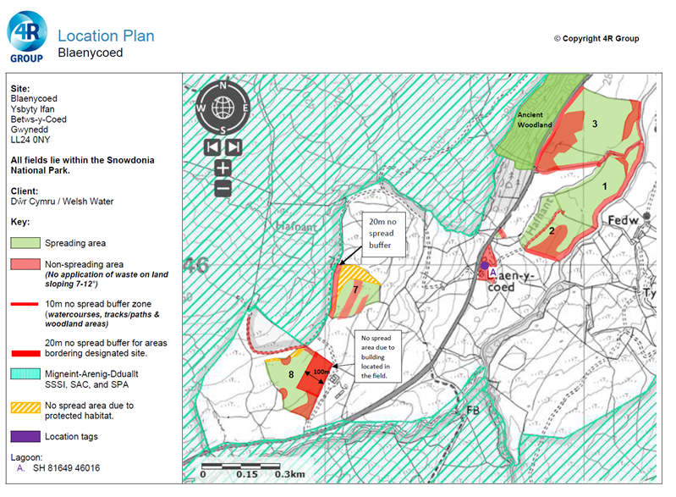  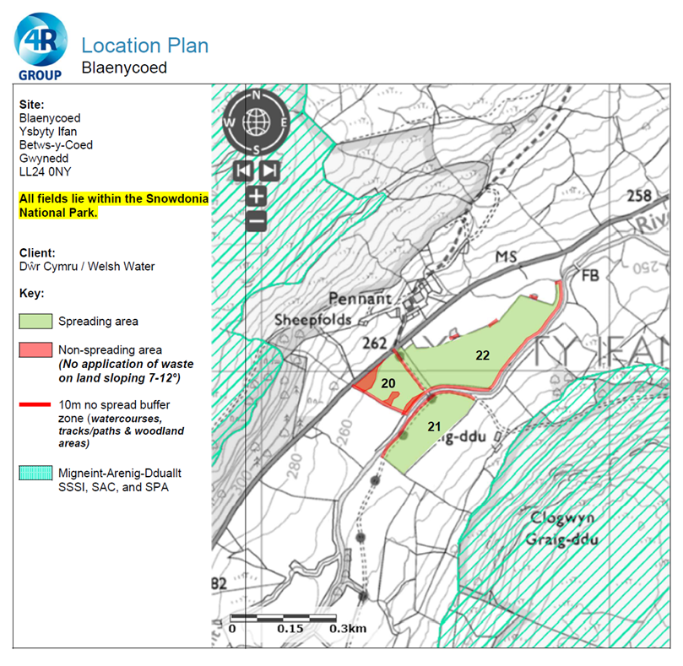  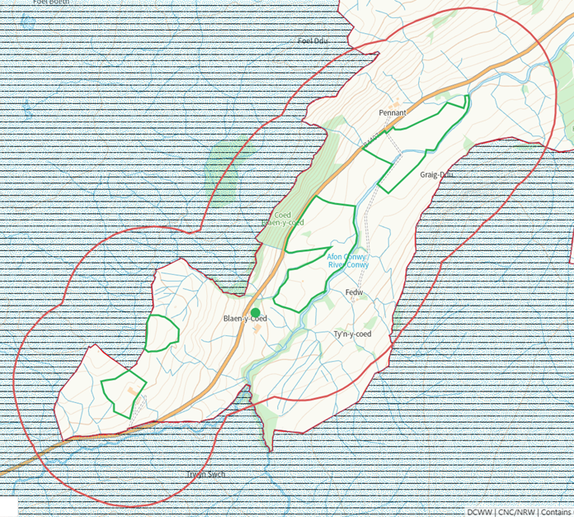  Where fields 7 and 8 border the SSSI no spread buffers are in place (10 and 20 metres respectfully).  All watercourses within 10 metres of the fields have no spread buffers.
- What aspects of the proposed permission are likely to damage the SSSI features of special interest?

The following activities are likely to cause damage:

5. Application of manure, slurry, silage liquor, fertilisers and lime
7. Dumping, spreading or discharging of any materials.
22. Storage of materials.

The following SSSI(s) features and potential impacts have been considered to assess the likelihood of damage:

Geological features
2.1 Manganese mineralization in mine spoil and rock outcrops at Mwyngloddfa Mynydd
Nodol
2.2 Ordovician (Arenig) sedimentary and volcanic rocks exposed in disused quarries, natural
outcrops and stream sections at Amnodd-wen & Ffilltergerig

Habitats
2.3 Blanket bog
2.4 Dry heath
2.5 Wet heath
2.6 Upland broad-leaved woodland and scrub
2.7 Lakes (nutrient-poor and brown, peaty lakes)
2.8 Flush and spring
2.9 A mixture of associated habitats including: grassland and rush pasture, swamp, cliffledge communities, vegetated scree, rock crevice communities, boulders, scree, rivers,
streams and bracken.

Plants
2.10 Nationally scarce plants (marsh clubmoss, tall bog-sedge, rock stonecrop and eyebright)
and regionally rare or threatened flowering plants (mountain everlasting, northern
bedstraw, dwarf willow, few-flowered sedge, water sedge and stiff sedge)
2.11 An assemblage of mosses and liverworts which are nationally rare, nationally scarce
and/or Atlantic species
2.12 The nationally rare liverwort, Welsh notchwort

Birds
2.13 The upland breeding bird assemblage
2.14 Hen harrier
2.15 Merlin
2.16 Peregrine

Insects and other invertebrates
2.17 The upland invertebrate assemblage
2.18 The locally uncommon large heath butterfly
2.19 The nationally rare ground beetle Trechus rivularis
2.20 The nationally scarce weevil Anthonomus conspersus
2.21 The nationally rare fungus gnat Brevicornu kingi

https://cdn.cyfoethnaturiol.cymru/646354/SSSI_0566_SMS_EN0010107.pdf
https://cdn.cyfoethnaturiol.cymru/646192/SSSI_0566_Citation_EN001c619.pdf

- Summary of any informal advice received from internal experts (if required and including pre-app advice) | n/a
- Recommendation | The proposed permission is not likely to damage any of the flora, fauna or geological or physiological features which are of special interest
- Signature and date assessment made | Bryan Burn, 01/08/25
- Officers name and job title | Bryan Burn  Permitting Officer

