Google earth view
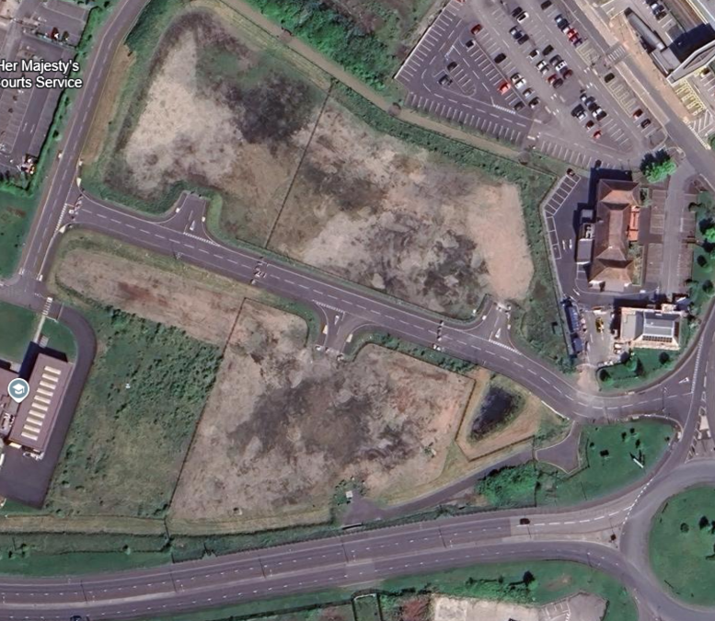

NRW plotted boundaries
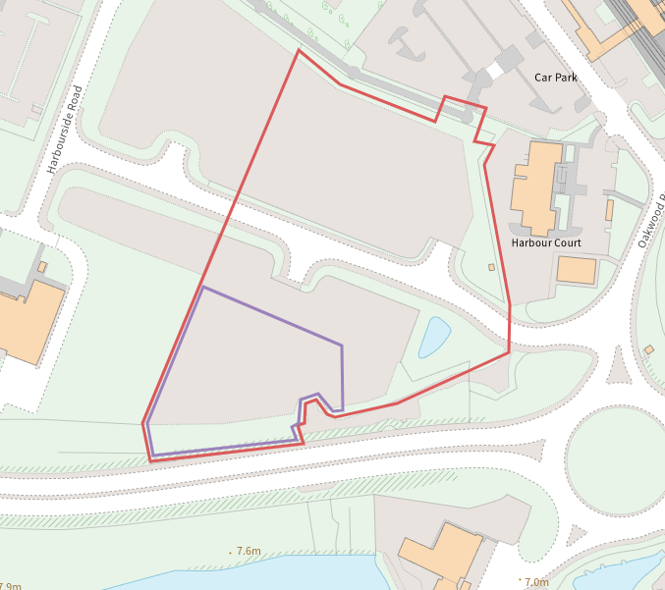
Unclear which is the deployment area:
- Red- Morgan Sindall Site Hoarding area
- Purple- Biogenie Working Area

Local Wildlife site
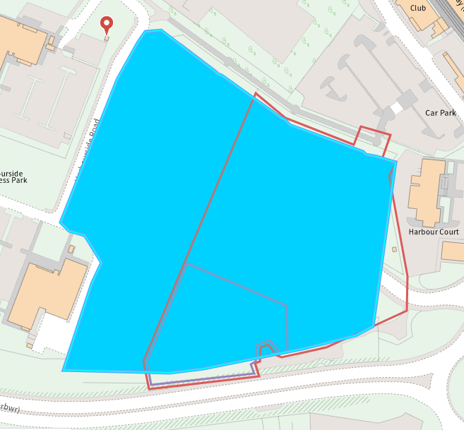
- Harbourside Law Courts (within deployment boundary)

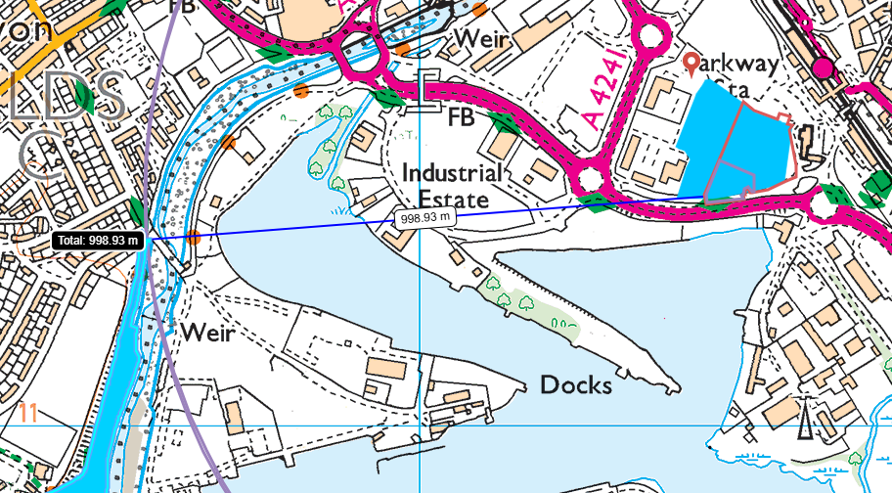
- Afan Estuary- 998 metres from site
Watercourses
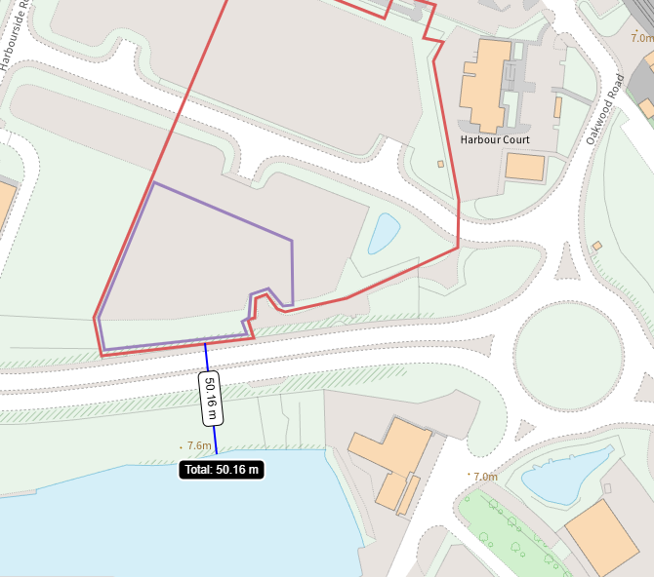

Habitats and Species
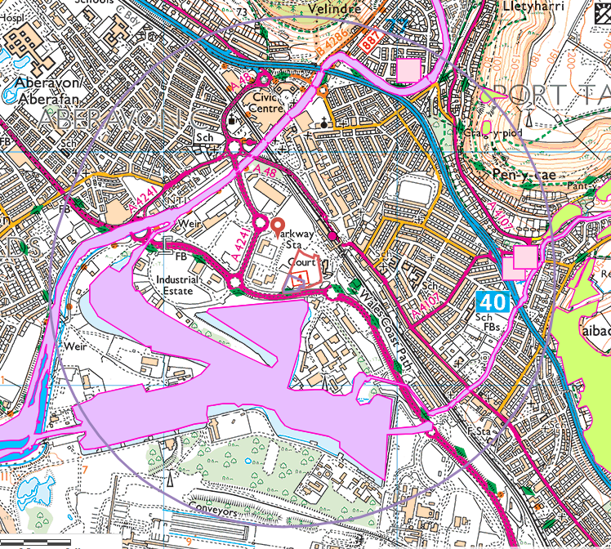
Habitats- Lowland heathland and Lowland dry acid grassland all approx 1km to the NE
Species- Atlantic Salmon, Atlantic Salmon migratory route, Brown/Sea Trout, Bullhead, European Eel, European Eel migratory route, Unidentified Lamprey- all within harbour, Afon Afan and Ffrwd Wyllt

Section 7
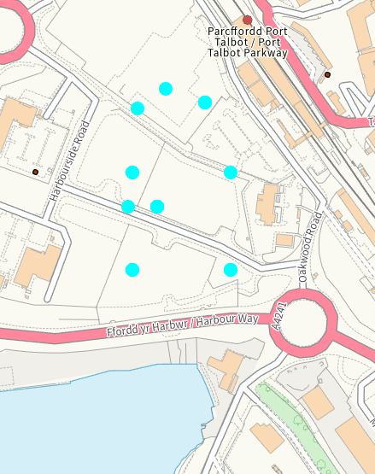
- Brown-banded Carder Bee
- Butterlies
- Birds- Starling, Linnet, Herring gull, Dunnock, House sparrow, Lapwing
- Slowworm
- Plant- Large-flowered Sticky Eyebright

