

Environmental Management Plan
Mynydd Isa Campus
640037

Status: Published - Approved
Version: V11.0
Date: 29/01/2025

Contents
Contents 2
1.0 Document Control 3
1.1 Document Approval 3
1.2. Document Revision 3
1.3 Purpose of Document 3
2.0 Project Management Plan Introduction 4
2.1 Project Specific Information 4
2.2 Project Location Details 5
2.3 Pre-Construction, Tender and Supporting Documentation Reviewed 6
3.0 Site Specifics 7
3.1 Specific Environmental Aspects Identified 7
3.2 Environmental Constraints Plan 12
3.3 Regulatory Approvals and Consents 13
3.4 Robertson Gateway Reviews 14
4.0 Environmental Emergency Response 15
4.1 Preparedness and Response 15
4.1.1 Reporting an Incident 15
4.1.2 Emergency Response Testing 16
4.1.3 Roles of Staff During an Incident 16
4.2 Spills of Fuels and Chemicals 16
4.2.1 Spill Equipment 17
5.0 Subcontractor and Supplier Reporting Requirements 17
6.0 Environmental Targets 18
6.1 Environmental Enhancements Considered 18
7.0 Environmental Communications 19
8.0 Roles and Responsibilities 20
9.0 Appendices 21
Appendix 1 – Impacts and Aspects Register 21
Appendix 2 – Pollution Prevention Plan 21
Appendix 3 – Toolbox Talk Calendar 21
Appendix 4 – Interested Parties 22

1.0 Document Control

1.1 Document Approval
Table 1: EMP issues & approval
Date Created | Initial Plan Created 16/12/2022 | Created By: | Alan Wilcox
Approved By: | James Moore

1.2. Document Revision
Table 2: EMP revision status
Revision | Date | Issue Type Summary | Reviewed By  Project Lead | Approved By  Operations
Doc Setup | - | Doc Setup completed by Nicole Smith (Project Office Lead) |  | Mark Walker  Snr PM
V02 | 16/12/2022 | Bulk of detail completed and plan issued | Alan Wilcox  PM | James Moore  Snr PM
V03 | 29/03/23 | Periodic Review of Plan | Steve Rooney  PM | James Moore  Snr PM
V04 | 03/05/2023 | Periodic Review of Plan | Steve Rooney  PM | James Moore  Snr PM
V05 | 16/06/2023 | Periodic Review of Plan | Steve Rooney  PM | James Moore  Snr PM
V06 | 19/07/2023 | Periodic Review of Plan | Steve Rooney  PM | James Moore  Snr PM
V07 | 22/08/2023 | Update to new template | Steve Rooney  PM | James Moore  Snr PM
V08 | 15/12/23 | Periodic Review of Plan | Steve Rooney  PM | James Moore  Snr PM
V09 | 26/3/24 | Periodic Review of Plan | Steve Rooney  PM | Steve Ramsden  Snr PM
V10 | 23/10/24 | Periodic Review of Plan and minor amendments highlighted. | Dimitrios Pantazis  SSM | Steve Rooney  PM
V11 | 29/01/25 | 3 monthly review | Kevin Smith(PM) | Steve Ramsden(SPM)

1.3 Purpose of Document
The purpose of the Environmental Management Plan (EMP) is to define the system for managing environmental issues on the Project and is part of the Robertson Environmental Management System (EMS). The EMS sets out the process and procedures used to effectively identify and mitigate the environmental risks. All staff assigned to the Project shall follow the requirements of this Plan and the Procedures and Instructions referenced therein. The EMP is one of the Technical Plans that sit within the Project Management Plan (PMP) with all relevant environmental information to be communicated as required.
The bid team and/or preconstruction team must begin collating and completing this form. During mobilisation and construction, the ownership of EMP Plan transfers to the project operations lead.
The EMP is a project lifecycle document and must be developed at the earliest possible opportunity, then maintained until the works are completed. The EMP requires to be reviewed and updated whenever there is a significant change in the site’s Environmental Aspects, Impacts/Risks, or every 3 months.
The relevant SHE and Environmental Manager/Advisor should be consulted on all amendments to this EMP.

2.0 Project Management Plan Introduction

2.1 Project Specific Information
Project Details
Project Name | Mynydd Isa Campus | Project Number | 640037
Project / Site Address | Argoed High School, Bryn Road, Mynydd Isa, Flintshire, CH7 6RY | Business Unit | North West
Start Date | 03/11/2022 | End Date | ZZ
Site Area (m2) | 60,000m2 | GIFA (m2)
Project Environmental Appointed Person |  | Kevin Smith (27/01/25)
Agreed Working Hours
Monday – Friday: 0700 - 1800
Saturday: 0700 – 1330 (as required)
Sunday: No Sunday working unless previously agreed with the Client and local authority.
Restricted vehicle access for construction vehicles/deliveries during school drop off and pick up times:
- 08:30am – 09:30am
- 15:00pm – 16:00pm

Project Description:
Project Type: New Build
Project Classification: Educational

Project is a new build school. 2 storey building, with separate wings for primary and secondary schools and shared main entrance area and kitchen. The scheme includes the development of the new building and all external works, including primary and secondary play space, car parking, landscaping, multi-use games courts and a new floodlit all weather grass pitch with acoustic fencing.

2.2 Project Location Details
Map of Site Location:
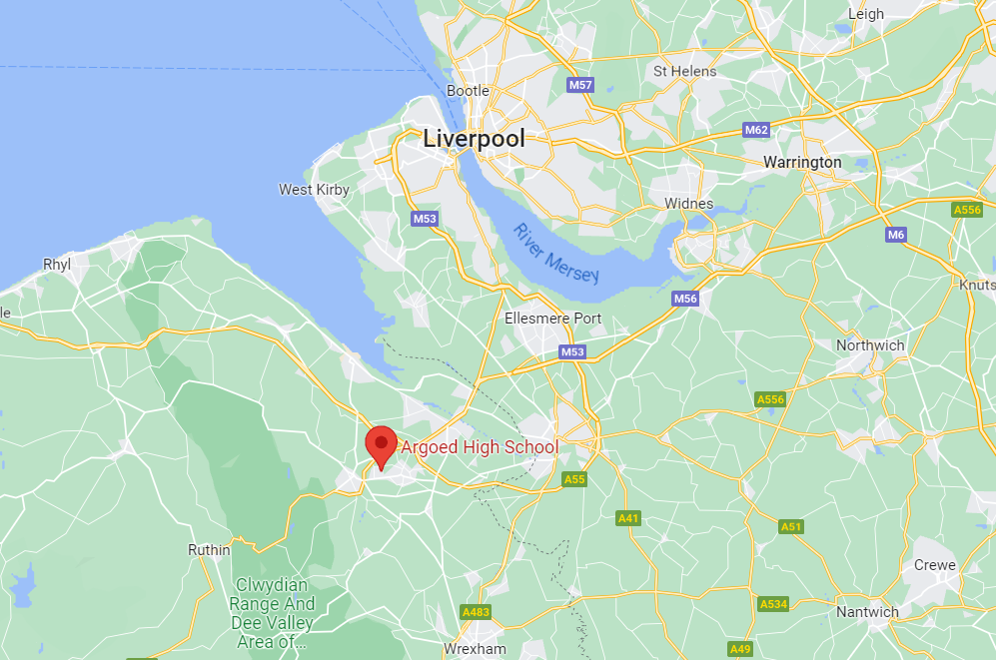
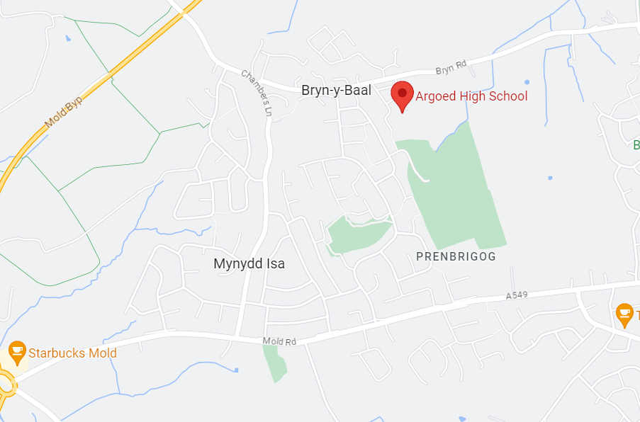

2.3 Pre-Construction, Tender and Supporting Documentation Reviewed
All documentation reviewed as part of project:
List all tender/ preconstruction documents and recent surveys i.e. geotechnical reports, ecology reports, arboriculture, asbestos surveys, EIAS, Biodiversity Net Gain, Planning Conditions etc

Document Name | Owner | Date | Location of file
Tree survey.  TCP A1 drawing with locations and refs. | Indigo Surveys (Client appointed for planning) | 11/06/2020 | Flintshire Planning Portal
Ecological Implications Assessment | Indigo Surveys | 2021 | Sharepoint B02 Invitation to Tender.
Asbestos Report (School Building) | Sentinel Environmental | 11/06/2020 | Sharepoint B02 Invitation to Tender.
Flood Consequence Assessment | HSP Consulting | 01/05/2020 | Sharepoint B02 Invitation to Tender.
Geo-Environmental Assessments Phase 1 and 2 | HSP Consulting | September 2020 | Sharepoint B02 Invitation to Tender.
Planning Decision Notice | Flintshire Council | June 2022 | Flintshire Planning Portal

Pre-Construction and Planning Information:
Please ensure to include any relevant content from the Preconstruction Environmental Checklist which is not captured elsewhere. RG-EMS-02-FOR-008.
Site is to be regarded as Brownfield overall as some areas have been previously developed. There are areas which are potentially greenfield. Geo-Environmental Report notes the following:
The site is shown as open fields from the earliest mapping, with no significant changes until the 1980s when Argoed High School is recorded on site. The surrounding land within 250m is predominantly recorded as open fields with residential housing recorded to the west of the site from the 1970’s. No significant changes are recorded on subsequent mapping.
Planning Consent 063496 from Flintshire County Council notes the following conditions which are relevant to the construction phase of the project:
5. All planting, seeding or turfing comprised in the approved details of landscaping shall be carried out in the first planting and seeding seasons following the occupation of the buildings or the substantial completion of the development, whichever is the sooner.
11. Positive means to prevent the run-off of surface water from any part of the site onto the highway shall be provided in accordance with details to be submitted to and approved by the local planning authority prior to the commencement of any site works. This is for the permanent works however infers this is also important during the construction phase.
15. No development with the potential to impact on invasive species, shall commence until a Biosecurity Risk Assessment has been submitted to and approved in writing by the local planning authority. The risk assessment shall include measures to control, remove or for the long- term management of invasive species both during construction and operation. The Biosecurity Risk Assessment shall be carried out in accordance with the approved details.
16. No development that has the potential to impact upon the strategic water main crossing the site shall take place until details of a scheme to either protect the structural condition or divert the strategic water mains crossing the north-east of the site have been submitted to and approved in writing by the local planning authority. Completed by Water / Utility provider in advance of works commencing.
17. Only foul water from the development site shall be allowed discharge to the public sewerage system and this discharge shall be made to the 225mm diameter foul sewer at or downstream of manhole reference number SJ26642406 as indicated on the extract of the Sewerage Network Plan attached to this decision notice. Emphasises importance for construction phase.
18. No development within the 20m radius potential zone of influence of the three mine shafts shall commence (excluding the demolition of existing structures) until;
a) a scheme of intrusive investigations has been carried out on site to establish the risks posed to the development by past coal mining activity, including recorded mine shafts 326364-315, 326364-317 and 326364-288; and
b) any remediation works and/or mitigation measures to address land instability arising from coal mining legacy, as may be necessary, have been submitted and approved in writing by the Local Planning Authority, in consultation with the Coal Authority in order to ensure that the site is made safe and stable for the development proposed.
The intrusive site investigations and remedial works/and or mitigation to be undertaken as required during construction shall be carried out in accordance with authoritative UK guidance.

3.0 Site Specifics

3.1 Specific Environmental Aspects Identified
Following review of all relevant Pre-Construction and general site information, the below items have been identified as Significant Environmental Aspects on this project. A summary of the main considerations is provided alongside details of the control measures which are to be implemented to minimise the recognised Environmental risks.
Include details of Significant Environmental Aspects as Identified in the Impacts and Aspects register, along with proposed control measures. The below headings are common aspects across Robertson sites – these should be supplemented as necessary and deleted if irrelevant. The considerations noted are guidelines and are not exhaustive – the details noted should be representative of the site in question.
Text in red should be deleted or edited to be site specific. Red text should be used as an aide.
3.1.1 Surface Waters, Wells and Groundwaters
England - click here to identify main rivers, here for flood zones and here for Source Protection Zones and Drinking Water Protection Areas / Safeguard Zones
Wales – click here for Source Protection Zones
Scotland - Map of flood zones Scotland here, Scotland Environment Map - Map | Scotland's environment web
NRW Flood and Coastal Erosion map notes the following:
Risk of flooding from Rivers: Very Low Risk
Risk of flooding from the Sea: Very Low Risk
Risk of flooding from Surface Water and Small Watercourses: Some areas of high, medium and low risk.

Map of flooding areas as below screenshot.

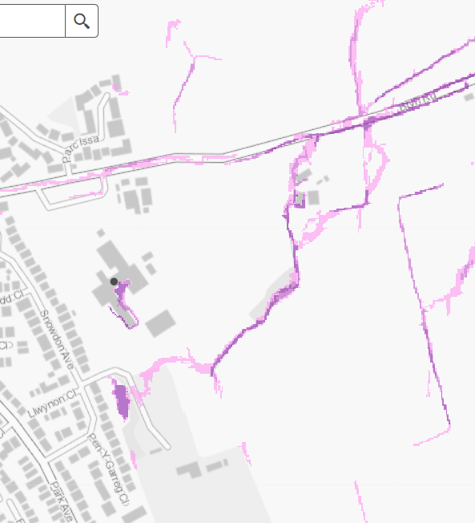
Surface water / small watercourse flooding typically follows the course of the small watercourse surrounding the site. The drainage strategy for the project splits the site into three catchments and drains two of these into the stream shown here. The drainage strategy and flood consequence assessment consider these in detail and consider this to be an acceptable solution. With a totally revised and planned out drainage strategy being implemented on site it is considered unlikely that there is any real flood risk on site. At the time of this plan update this assessment echoes the Robertson experience of the site. A flood response plan will be completed in order to comply with Robertson’s EMS.

Dewatering will likely be required on site. This will be minimised as far as possible and completed in line with the detail in the next section.

3.1.2 Temporary & Site Drainage ( incl. Surface Water)
A site drainage plan should be developed showing locations of drainage (surface water drains, soakaways, land drains, foul water and combined sewers) and watercourses and potential sources of pollution e.g. fuel / oil storage, soil stockpiles, contamination, COSHH storage etc.
Drain covers or protection should be used on drains in sensitive areas. Surface water run-off contaminated by silt, heavy metals, chemicals, sewage or oil must not be allowed to enter surface water drains or watercourses.
It should also be established if any of the surface water drains discharge directly into any nearby watercourse. Where this is the case, measures to be taken in the event of a spill to prevent pollutants entering these watercourses e.g. providing drain covers or placing a boom across the point of discharge.
Contaminated surface water must not be allowed to enter surface water drains or watercourses.
Attention must also be given to preventing pollution of land from Robertson activities, as remediation following contamination from polluting substances can be both difficult and expensive.
Discharge of clean surface water run-off (for example from a roof, road, pathway or clean standing area) to surface water drains, watercourses and soak-away does not require an Environmental Permit (or discharge consent). Clean surface water must not be contaminated with silt, heavy metals, chemicals, sewage or oil. Any contaminants must be removed prior to discharge.
Drainage Strategy for the completed development is to be largely echoed throughout the construction phase of the project. Engagement with NRW at early stages outlined that compliance with the requirements of the Regulatory Position Statement on dewatering would prevent the need for a permit, and dewatering is to proceed in line with the planning-approved drainage strategy for the operational phase of the building.

A water treatment unit has been brought to site which monitors and controls the pH and turbidity (silts) of water being disposed of. This is collected via filter drains and transferred to either of the basins before ultimate disposal to the watercourse that flanks the site.

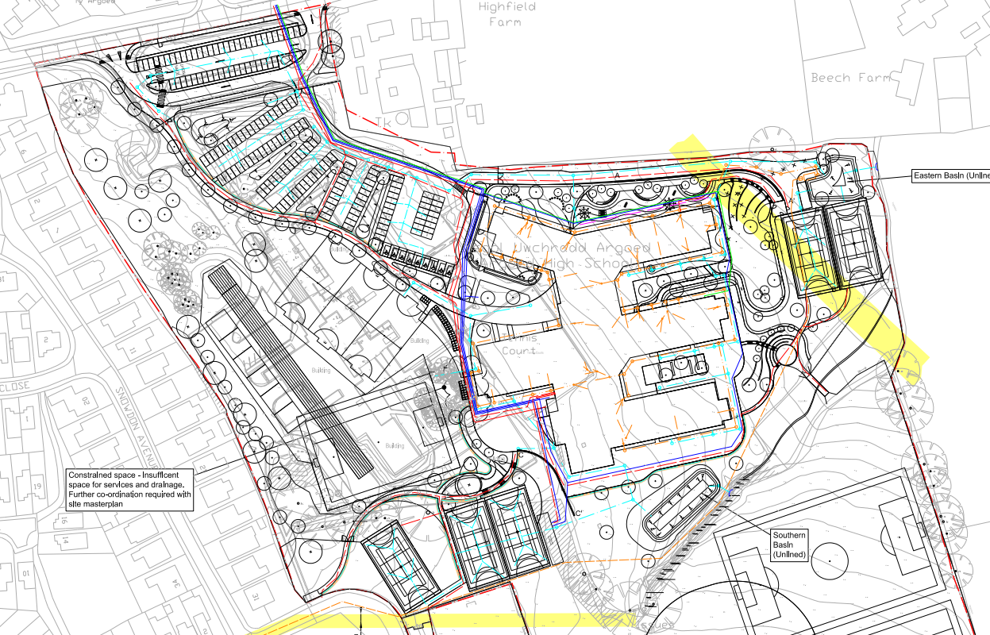

3.1.3 Storage of Fuel, Chemicals & building Chemicals
Containers must be stored within a Plant Nappy®, EnviroPad® (or similar), bund or any other suitable secondary containment system (SCS) if they are not double skinned / bunded. All containers must be in a safe place to minimise the risk of damage and locked-off when not in use.
For oil tanks, intermediate bulk containers and mobile bowsers the SCS or integral bund must be able to hold:
- Where one container is being stored - a minimum of 110% of the total volume.
- Where more than one container is being stored - a minimum of 110% of the largest container’s storage volume, or at least 25% of their total volume (whichever is greater).
- For drum storage, the interceptor tray must be able to hold at least 25% of the total storage capacity of the drums.

Bunded areas must be made impermeable to water and oil and protected from the ingress of rainwater. The base and walls must not be penetrated by any valve, pipe or opening that is used for draining the system.
It is anticipated that between 2000 and 4000L of diesel will require to be stored on site at any given time.

Petrol will be brought to site as needed and there should be 25-100L of this fuel on site at any given time.

A COSHH Store will be operated by either Robertson or individual contractors who bring notable volumes of COSHH onto site for use during their works.

COSHH and fuel stores will be located 10m from drainage features and 30m from all surface waters. A spill bin will be provided at all fuel storage locations.

3.1.4 Contaminated Land
Prior to any works commencing, the potential impacts from earthworks and contaminated land must be assessed. The assessment must include identifying any control measures required to reduce the impact of our activities.
Potential environmental impacts and control measures must be communicated to all relevant staff and subcontractors. Subcontractors must include relevant control measures in method statements and risk assessments. Control measures must be monitored to ensure they are in place when required, effective and maintained throughout the works. Control measures must be included in site inductions.
Prior to carrying out any remediation, reuse or disposal of contaminated soils or groundwater, the project team must consult with the Environmental Team to ensure that all applicable legislative requirements are met.
Site investigations conducted so far have not identified any significant contamination within the site boundary. Some made ground has been encountered (likely related to the construction of the existing school), which may contain some contaminants, and infrastructure related to the drainage of the access road and car park may also have become contaminated as a result of decades of use. Phase 2 (demolition of the existing school and forming of sports areas) is of particular concern regarding contamination.
The results of the chemical testing have been assessed using web-based software for classifying hazardous waste, using HazWasteOnlineTM. The materials tested are likely to be classified as non-hazardous
No visual or olfactory signs of contamination have been noted during the works conducted to date with a large amount of ground and earthworks already completed.
3.1.5 Soil Movement, Export and Site Won Material (Treating, screening)
Earthworks are to be managed in order to minimise erosion and run-off. Any soil stockpiles in place during the project will be suitably managed, both in terms of reducing associated dust and in terms of mitigating the risk of giving rise to polluted surface water.
Site investigation notes that all samples tested returned classifications of non-hazardous soil and stone and there have been no visual or olfactory signs of contamination of any sort noted since Robertson commenced works on site. At the present time the majority of earthworks and material export is complete.
Excess soil and stone material will be exported from site to suitably licensed destinations by suitably licensed carriers. Compliant transfer notes will be collected for all movements and records kept for 2 years.
All endeavours will be made to export soils as they are generated in order to avoid having to make mitigation efforts related to preventing silted runoff. If required stockpiles will be enclosed by bunds and silt fencing in order to prevent runoff reaching any of the drainage features or watercourses surrounding the site.

3.1.6 Statutory Nuisance
Nuisance Management is mandatory on all sites to prevent adverse nuisance impacts such as dust, odour, emissions, noise, vibration and lighting on local sensitive receptors such as local biodiversity and people. Where possible, causes of nuisance shall be controlled at source
With an absence of protected species on site it is considered that all receptors are human or plants.

Sensitive receptors include residents to the West, South and North, with retained trees and vegetation within the site and to the peripheries. It is considered that vegetation will only be sensitive to Dust.

Noise:
- Noise monitoring to be carried out only if considered required. The requirement would be triggered by unplanned noisy works outwith working hours, resident complaints or client request. This would include baseline readings taken during working hours but when no construction activity is ongoing, and while works are progressing to allow assessment of noise impacts at the site boundary. A cut off value would be determined in advance of monitoring commencing. It is not foreseeable that monitoring will be needed and to date this has not been needed.
- Working hours will be adhered to as the primary means of avoiding generating nuisance.
- Activities generating noise will generally be external with use of general construction plant for landscaping works and during external superstructure works. At the point of review the soil and stone export, major earthworks, founds, slab and a lot of drainage are all installed already. The remaining landscaping works may entail cutting and material import for hard landscaping with an amount of associated machine work.
- Works internally will be mitigated through using cutting cabinets, acoustic blankets and external envelope build up to reduce the transfer of noise to the external environment, effectively controlling it at source.
- Resident liaison will be upheld throughout the project as considered necessary in order to pre-warn of unavoidable noise generation out of hours and other similar potential issues.

Dust will be controlled by water suppression or on tool extraction systems. Where possible water will be retained on site in the attenuation ponds in order to facilitate damping down. A speed limit of 5mph will be in place to avoid dust being thrown up by delivery wagons or similar. Mist cannon will be deployed as required over excavation work or material deliveries to ensure that dust does not develop into a nuisance.

Lighting will be inward and downward facing wherever possible. Non-essential lighting will be turned off when not required for use.

Other forms of nuisance such as vibration and odour are not foreseeably going to be generated.

No Section 61 Agreements are considered necessary.

3.1.7 Ecology and Biodiversity
All ecological and biodiversity constraints will be managed onsite in line with Robertson Ecology and Biodiversity Procedure RG-EMS-05-PRD-001
Ecology report notes the following:
The site was considered to be of low value to wildlife, as it was dominated by close mown amenity grassland/playing fields with relatively low floristic diversity. The scattered trees and hedgerows have potential to support nesting and foraging birds. None of the trees contained features such as woodpecker holes, fissures and exfoliating bark, that provided potential for bat roosting and/or hibernation. There was no still water or other wetland features on the site and as such the site had negligible potential for amphibians. The site offered poor habitat for reptiles due to the frequent mowing regime and lack of suitable cover.

There were no signs of Badger activity and no suitable habitat for Otters or Water Voles, whilst there was negligible potential for significant invertebrate assemblages, in particular those species listed as a priority in the UK Biodiversity Action Plan and/or Local Biodiversity Action Plan. An external inspection of the buildings revealed one of the buildings had medium suitability for roosting and/or hibernating bats. These were conducted in 2021 and showed no bat constraints on site.
There are no Invasive Non-Native Species known to be present on site although vigilance will be exercised along the water course for common invasive plants such as Himalayan Balsam and Giant Hogweed. Some non-native non-invasive plants exist in the retained vegetation here and these are to be removed during landscaping works to ensure a healthy mix of native species is promoted.
Tree protection is required on site to the retained trees. This has been reviewed by the arboriculturist and is to their approval. A number of stumps were unearthed during the excavation phase which have been retained on site in the hope that they can be left in vegetated areas to the site periphery on completion for the benefit of insects.
Within 1.0 km of the site there were two statutory sites; Buckley Claypits and Commons Site of Special Scientific Interest (SSSI), and Deeside and Buckley Newt Sites Special Area of Conservation (SAC).
Due to the distances between the land and these sites, the presence of significant barriers including main roads and buildings, and the lack of direct connectivity, any proposed development is unlikely to impact adversely on these sites or the ecological communities therein.
Mitigation is to include:
Any scrub removal or works which may affect a nest should be undertaken outside the period 1st March to 31st August inclusive or overseen by an ecologist. Work will not be carried out within a minimum of 5.0 metres of any in-use nest, although this distance could be more depending on the sensitivity of the species. Any in-use nest will be allowed to fledge before it is disturbed.
Care will be taken at all times when carrying out earthworks, as small mammals could be present. Any small mammals disturbed or uncovered will be left to vacate the site in their own time.
If excavations are to be undertaken, it should be noted that open trenches could potentially trap wildlife. Escape routes will therefore be provided if trenches cannot be infilled immediately.

Project Located Within | Applicable (Y / N) | Notes
Site of Special Scientific Interest (SSSI) | N | Where one or more of the items listed opposite are applicable, please contact your environmental adviser / manager immediately.
Special Area of Conservation (SAC) | N
Special Protection Area (SPA) | N
RAMSAR | N
National Nature Reserve (NNR) | N
Local Nature Reserve (LNR) | N
Local Wildlife Site (LWS) | N

3.1.8 Waste and Recycled Aggregate
The generation of waste on site will be managed in accordance with the Waste Hierarchy and the Site Waste Management Plan. Classification of waste will be carried out in line with WM3, and disposal of waste will be in line with the Statutory Duty of Care imposed on all Waste Producers. Waste processes on site are described Waste Management Procedure RG-EMS-04-PRD-001
The Site Team, in conjunction with the Business Unit’s SmartWaste Co-Ordinator will use SmartWaste to identify and record waste disposal activity, forecast waste volumes and identify suitable methods to eliminate, or where this is not practicable, reduce waste generated by the project.
Waste Management on site will be carried out in a manner which:
- protects the environment, wildlife and biodiversity. Waste incidents will be avoided so as to prevent negative public perception of the business, avoid issues with winning work and avoiding prosecution / financial penalties.
- Is in line with the Waste Hierarchy – eliminate, reduce, reuse, recycle, dispose.
- Is in compliance with Robertson Construction Group’s Statutory Duty of Care over all waste produced on our sites. This applies to directly produced waste and subcontractor waste.
- Satisfies client requirements.

Waste Records will be retained on Smartwaste and Sharepoint and must include the following as a minimum:
- Legible and compliant waste transfer notes.
- Full copies of all relevant Waste Management Licences, Permits and Exemptions.
- Valid Copies of Waste Carriers Licenses

Recycling / Diversion from landfill reports for all subcontractor waste
There should be no import of waste or recycled aggregate to site.

3.1.9 Project Specific and Client Requirements
Project is to be BREEAM certified. No other known client requirements.

3.1.10 Concrete
Concrete wash water contains suspended solids and is highly alkaline (has a high pH). Solutions that are highly alkaline are as harmful to the environment as strong acids. Unlike wet concrete that is poured into the ground, concrete wash water is very mobile and can easily enter drains and controlled waters, e.g. groundwater, rivers and reservoirs, causing significant harm to aquatic life and the environment.
The import and use of concrete and cementitious materials, and the washing of associated plant will be carried out in line with Concrete Washout Procedure RG-EMS-03-PRD-003 so as to avoid any environmental damage associated with the high alkalinity of these materials.
Concrete washout methods selected are:
Adana – Lined skip. Waters to be allowed to cure off or dosed with excess concrete in order to solidify this in advance of export. If this is not possible offsite export as a trade effluent will be required.
Robertson – Lined skip. Waters to be allowed to cure off or dosed with excess concrete in order to solidify this in advance of export. If this is not possible offsite export as a trade effluent will be required.

3.1.11 Archaeology
All Archaeology constraints will be managed onsite in line with all legal and ethical requirements. Sites will be managed in a way that avoids any negative impact on heritage, and maintains the value of artefacts and structures in terms of culture, education, research, leisure, tourism and the economy.

No known Archaeological constraints. From letter precluding the building from listing: I can confirm we consider that Argoed High School does not possess special historic or architectural interest. Heritage Appraisal issued by Graeme Ives Heritage Planning also notes existing building has no historical or architectural interest.

Historic Wales Map does not show any constraints which will foreseeably be impacted by Robertson works.

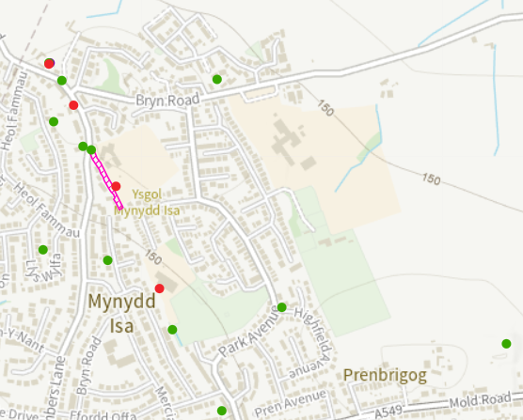

3.2 Environmental Constraints Plan
An Environmental Constraints Plan should be created using template RG-EMS-02-FOR-010. This should be displayed at key locations on site, which may include the Induction Room, Environmental Noticeboard, at Fire and Information Points, on fences and hoarding at relevant locations.
The constraints plan can be created from a basic site layout, drainage drawing or similar and should identify all features of Environmental significance on site, including but not limited to the below:

- Watercourses / surface water that required protection i.e. silt fencing, cut off trenches/ sumps.
- Drainage runs and features e.g. gullies, manholes, swales and soakaways.
- COSHH Storage / Oil & Fuel storage / Refuelling Areas
- Spill kits
- Retained vegetation, trees and TPOs,
- Protected Species i.e. bat roosts, bird nests, badger setts etc
- Invasive plants
- Soil Stockpiles
- Concrete washout
- Wheel wash
- Areas or hotspots of known contamination
- Waste management areas
- Standing heritage and listed buildings
- Archaeological areas / excavations

3.3 Regulatory Approvals and Consents
Complete the table below with details of all regulatory approvals and consents which are required to complete planned works on site. It is essential to engage with the Environment Team when applying for external consents to ensure that these are included on the Group Consents Register.

Licence / Consent Name | Licence / Consent Number | Licence Holder Name | Issuing Body | Expiry Date

3.4 Robertson Gateway Reviews
Include details of any environmental monitoring being undertaken to satisfy statutory, regulatory or client requirement:
* Complete plan with checks required; ensure to include and project specified requirements*
Other required checks – e.g. daily checking of interfaces with watercourses. Include information on frequency of monitoring, locations and summary of why this is required.
Environmental Elements for Check & Inspection: | Frequency of Inspections: | By Whom: | Report To: | Remarks:
Site Environmental Checklist RG-EMS-02-FOR-007 | Monthly | John Bettridge | Steve Rooney
SHE Weekly Checklist | Weekly | John Bettridge | Steve Rooney
Spill Response Drill Record  RG-EMS-02-FOR-003 | 6 Monthly | Steve Rooney | Steve Ramsden
Environmental Management Plan Review  RG-EMS-02-FOR-001 | 3 Monthly | Kevin Smith | Steve Ramsden
Site Waste Management Plan Review SMARTWASTE System | 3 Monthly | Kevin Smith | Steve Ramsden

4.0 Environmental Emergency Response
An environmental emergency incident is an event that either causes harm or has the potential to cause harm to an environmental receptor e.g. air, water, land, wildlife or local habitat. The primary aim is to protect human health and the environment, prevent further incidents and identify actions to improve future incident management.
This section deals with environmental incidents arising from Spills of Fuels/Chemicals, Fire, Flooding, Asbestos, Sewage and Waste fly tipping which may occur at Robertson Group’s operational and administration sites. The Health & Safety Management System also advises on managing emergency incidents. Refer to the Construction Phase Health and Safety Plan RG-HS-04-FOR-001 which sets out proposals that deal with the response and management of health, safety & environment risks associated with our work. Other relevant plans are:
- Fire – RG-HS-06-FOR-002 Site Fire Management Plan
- Flooding – RG-EMS-03-FOR-001 Flood Response Plan
- Asbestos – RH-HS-20-GUI-001 Asbestos Guidance

4.1 Preparedness and Response
- All persons working for or on behalf of Robertson Group have responsibilities to be aware of the procedures and equipment in place to deal with emergency incidents.
- The Project Manager is to identify risk of environmental incidents as a result of the site operations. Where the potential exists, they must ensure mitigation measures are implemented prior to works.
- Where an environmental incident occurs, competent personnel should firstly assess and where appropriate, deal with the incident.
- Where the nature or scale of the environmental incident is outside the capability of the competent person/s, they shall notify without delay, the Project Manager who will contact an appropriate environmental incident containment organisation to deal with the incident and mitigate any impact to the environment.
- Emergency Spill Procedure to be communicated RG-EMS-03-PRD-002
- Adler and Allan are the Emergency Spill Contractor for Robertson who can be called on for assistance when required 0800 592 827. This is usually for spills which are too large or difficult to control and clean up internally.

4.1.1 Reporting an Incident
All persons working for or on behalf of Robertson Group have a responsibility to report the occurrence of any environmental incident as soon as possible as per the Incident Reporting section in the Project Environmental Procedure RG-EMS-02-PRD-001. The Project Manager must:
- Report using Environmental Incident Report Form RG-EMS-02-FOR-002 / SHE Assure which defines the severity of the incident i.e. Major / Minor / Near miss
- Review the incident and ensure that the appropriate corrective actions have been undertaken and relevant preventative actions have been identified.
In all cases the Robertson Regional SHE Manager / Advisor and Group Environmental Manager must also be notified of any incidents and the details of the incident recorded through the Group’s online reporting system; SHE Assure. Further instructions for managing incidents are contained in the Group HSMS Topic 14 Managing Accidents and Incidents.

Please familiarise yourself and project team with the SHE Spotlight, When an Inspector Calls.

4.1.2 Emergency Response Testing
Where practicable, the project will conduct periodic testing of emergency preparedness and response procedures. Where testing is conducted, the results of the test and any improvement actions will be recorded on the Spill Drill Record Form RG-EMS-02-FOR-003. Testing arrangements in relation to fire are specified in Site Fire Management Plan RG-HS-06-FOR-002. Records of testing and resultant actions are maintained at project level.

4.1.3 Roles of Staff During an Incident
All persons working for or on behalf of Robertson have responsibilities to ensure they are aware or have been made aware of the procedures and equipment in place to deal with emergency incidents.

Name | Position | Role During Incident (amend as necessary)
Steve Rooney | Project Manager | Coordinate overall response
John Bettridge | Site Manager | Assess safety of personnel, communicate risks and evacuate area if necessary
Steve Rooney | Project Manager | Assess whether incident can be dealt with by local site team or whether specialists or emergency services are required
John Bettridge | Site Manager | Contain incident / clean-up spill/supervise clean-up operation
Steve Rooney | Project Manager | Report incident to SHE Manager and Environmental Manager
John Bettridge | Site Manager | Arrange for any hazardous waste to be removed by licensed contractor

4.2 Spills of Fuels and Chemicals
Spills are one of the most frequent environmental incidents and can lead to pollution residual risks to health. Leaving spills unchecked will lead to both short- and long-term environmental damage and can impact the health and safety of employees, contractors and the public. The information within Spill Response Procedure RG-EMS-03-PRD-002 is provided to help deal with such a spill.
All COSHH materials should be recorded on the Project COSHH Register RG-HS-19-FOR-001 which should be readily available within the site office.

4.2.1 Spill Equipment
In the event of an incident, emergency equipment is available to help prevent pollution. Record the equipment and materials you have available at this location e.g. oil spill kit, chemical spill kit, absorbent pads and socks, drain mats/covers, pump equipment, plastic sheeting, bin/container for storing waste from used spill kits etc.
Type of Equipment | Quantity | Location
Spill Bin | 1 | Refuelling area
Spill Bin | 1 | At top retention pond
Spill Bin | 1 | At bottom retention pond

Any spill kit used is to be recorded on the Spill Kit Usage Log RG-EMS-03-FOR-003 which should be stored in a within the inside of the spill kit. If spill kit is required to be deployed, please ensure the spill is recorded as required within Section 3.1.1. Reporting an incident.

5.0 Subcontractor and Supplier Reporting Requirements
Subcontractors and Suppliers will be required to report on the below items on a monthly basis, or as reasonably requested by RCG. Sites will collate this information and pass it to the relevant SmartWaste Co-Ordinator for upload to the SmartWaste system.
- Liquid fuel use on site (typically including White diesel, HVO, petrol)
- Any electricity use (in kWh) that is not supplied by RCG temporary or permanent connections
- Waste removed from site – to be reported in line with Requirements
- Water consumption where not supplied via metered RCG temporary or permanent connection.
- Timber import (including volumes, CoC documentation and delivery lines evidencing CoC applicability and compliance)
- Recycled Aggregate import (including volumes and evidence of WRAP Quality Protocol Compliance)

6.0 Environmental Targets
The Environment Targets are calculated for each project based on metrics such as Project Value, Internal Floor Area and BREEAM requirements. Please speak to the Sustainability team for your Project Specific Targets.
GIFA is 10,300m2, Project Value is £64,658,986
Target Area | Company Target | Calculation Method | Target
Carbon Emissions from Energy Use | 686 kgCO2e/£100k Project Spend | (Project Spend ÷ £100,000) x 686 | 443,560.64 kgCO2e
Water Consumption | 10m3 /£100k Project Spend | (Project Spend ÷ £100,000) x 10 | 6,465.90 M3
Construction Phase Waste Generated | 6.9t / 100m2 of Site Area (GIFA) | (Site Area ÷ 100) x 6.9 | 710.70 T
Overall Diversion from Landfill | 97% | (Waste Diverted from Landfill ÷ Total Waste Generated) x 100 | 97%

6.1 Environmental Enhancements Considered
Record details of Environmental Enhancements planned / considered which would assist RCG in evidencing that site biodiversity and ecological value have not decreased between RCG inheriting the site and completing the works. This is vital to the Sustainability and Environment efforts currently being made by the business.

7.0 Environmental Communications
Environmental considerations, risks and control requirements will be communicated to Site Staff, Subcontractor Operatives and relevant working and non-working Visitors via the below methods:
Site Induction - All contractors attending site shall receive a site-specific induction that
details the site environmental risks, contact details, and any site-specific processes or procedures.

Co-Ordination / Project Meetings - The site team will use meetings as deemed necessary to ensure that Environmental matters and risks are suitably communicated to all relevant parties. Meeting minutes will be recorded and distributed to all the parties in attendance.

Intervention cards – (Green, Yellow, Red) Reports shall include observations related to both good and bad environmental practice witnessed on site. These will be discussed at Project Review meetings and Contractor Progress Meetings.

TBTs- A minimum of 1 Environmental toolbox talk per calendar month will be delivered to every key subcontractor working on site. These will be relevant to the works ongoing on site, identified Environmental Aspects and other wider considerations such as season and weather conditions. Please see appendix 3.

Daily Briefings - Relevant sensitivities for planned works will be communicated to Subcontractors and directly employed Operatives as part of the site’s daily briefing process.

Environmental Notice Board – the Environmental Notice Board will be displayed at a prominent position on site or in the welfare areas. This will include relevant environmental information for the site including RCG Environmental policies and ISO certifications, Constraints plan, refuelling procedures, spill response procedures, utility consumption records and other relevant documentation that Operatives require to be aware of.

Documentation to be Accessible by Site Staff at All Times
Each RCG Site will ensure that the following information is accessible by all relevant site staff in line with the RCG Information Management System. This will include (as a minimum):
- Copy of Environmental Management Plan including Appendices
- Copy of the Site Waste Management Plan (completed on SmartWaste and reviewed quarterly)
- Copy of the Pollution Prevention Plan, where applicable
- Copies of all relevant Site Consents / Licenses
- Copy of relevant Planning Consents and Client ER documents.
- Copy of Site Investigation and Contaminated Land information where relevant
- Copies of compliance documentation relating to recycled material and timber import.
- Complaints and Feedback registers.
- Relevant monitoring records – noise, dust and vibration.
SMARTWASTE
- Full copies of all relevant Waste Management Licenses, Permits and Exemptions for direct and subcontractor waste disposal must be stored on SMARTWaste.
Copies of valid Waste Carriers Licenses for all waste carriers attending site direct or through subcontractors to be stored on SMARTWaste, these licences only 3 years so must be checked and updated when required.

8.0 Roles and Responsibilities
Project Directors / Managers shall be ultimately responsible for the development and implementation of the EMP and the environmental issues associated with their sites. They may delegate the role to another member of their team, with the approval of the relevant Operational Head. The Group SHE Director co-ordinates Environmental Management with Robertson to take account of continuing developments in customer requirements, legislation, and management principles. The table below summarises the general roles and responsibilities of all parties involved in the project.
Project Role | Responsibility
Project Director/ Manager | Ensure a full EMP is developed, approved, updated and distributed to relevant parties. Delegate responsibilities to individuals and ensure sufficient resources are available to implement the Environmental Management System including appointment of competent persons, training and other programmes. Establish communication and consultation will all relevant parties including client, contractors, design team, third parties and the public.
Construction/ Site Managers | Ensure the environmental aspects, impacts and controls identified are managed in accordance with the EMP and that all personnel for whom they are responsible are aware.
SHE Manager | Supporting project team in delivery on the environmental requirements including conducting site inspections.
Community Liaison Manager | Arranges and manages interface within the communities of which we operate within
All Site Operatives &  Subcontractors | Undergo environmental induction and awareness training as required in training matrix. Demonstrate commitment to the implementation of the Environmental Policy. Co-operate with the Company in fulfilling its compliance obligations. Conform to requirements of the EMP and Site Waste Management Plan. Be aware of any Project specific objectives and targets. Co-operate with the Company to achieve continual improvement. Co-operate with the Company to prevent pollution. Monitor their workplace for potential threats to the environment and alert their supervisor or manager of any that are observed.
Design Team | Ensure that the design development accounts for regulatory and legislative environmental requirements. Contribute to the preparation of the EMP where required. Support the development and submission of consents, licences and authorisations. Support the development and implementation of BREEAM requirements.
SmartWaste Champion | Lead on the setting up and reporting of waste and other environmental data
BREEAM Lead | (If applicable) Coordinate the project’s BREEAM assessment
Environmental Appointed Person | The Project Environment Appointed Person will ensure relevant parties are aware of Significant Aspects and Impacts; Environmental hazards, near misses, incidents and complaints; Changes to the Environmental Management System; Audit Results and Trends; Results of Management Reviews; Objectives and Target Results; Receiving, distributing and responding to communications from interested parties.
Others

9.0 Appendices

Appendix 1 – Impacts and Aspects Register
*Please refer to RG-EMS-02 -FOR-009

Appendix 2 – Pollution Prevention Plan
*Pollution Prevention mitigation to be included within the Environmental Management plan within section 3 for specific environmental constraints and mitigation measures for the project.
If separate Pollution Prevention Plan is required by SEPA / EA / Client etc please refer to Document RG-EMS-03-FOR-002 and speak with the Environmental Advisor / Manager for assistance

Appendix 3 – Toolbox Talk Calendar
Items in red are considered seasonally relevant.

Items in black are generic inclusions which can be moved or omitted depending on site requirements.

Month | TBT | Month | TBT
January | Water Pollution, Winter Working | July | Spill Provisions / Response
February | Great Crested Newts (end of hibernation period), COSHH Storage | August | Asbestos / Haz Waste, Working on Brownfield Sites
March | Nesting Birds, De-Vegetation | September | Concrete Washout, Waste Hierarchy and Segregation
April | Invasive Species – Plants, Badgers | October | Great Crested Newts (start of hibernation period), Noise and Vibration
May | Bats (end of hibernation period), Waste Compliance | November | Bats (start of hibernation period)
June | Dust Suppression, Archaeology | December | Water Pollution, Winter Working

Appendix 4 – Interested Parties
Stakeholder | Area of Concern | Contact Number/Web
Environment Agency  Scottish Environmental Protection Agency | Significant environmental incident with harm to wildlife or habitat.  Any legally binding Environmental Obligation | Incident Hotline  0800 80 70 60
Ambulance/Fire/Police | Emergency Situation on Site | 999
National Gas Emergency Service | Gas Leak | 0800 111 999
Adler & Allan | Emergency Spill Contractor | 0800 592 827 Emergency (24/7)
Local water supplier e.g. Scottish Water | Sewage leaks/Burst mains
Electrical System Operator- Scottish Power, SSE, Northern Energy Grid | Electrical Emergency  e.g. hazards involving electricity lines, pylons etc. | 0800 40 40 90
Historic Environment Scotland  Historic England | Listed Buildings, National Monuments, Battlefields, Archaeological features. | 0131 668 8716  0370 333 0607
Local Residents and Neighbours | Nuisance on site – noise, dust, vibration, odour
Local Authority Environmental Health Dept | Nuisance – noise, dust, vibration, pest control.
Natural England  Nature Scot | Natural Environment including Protected Species and Designated Sites | 0300 060 3900  0300 060 3900

