Site plan
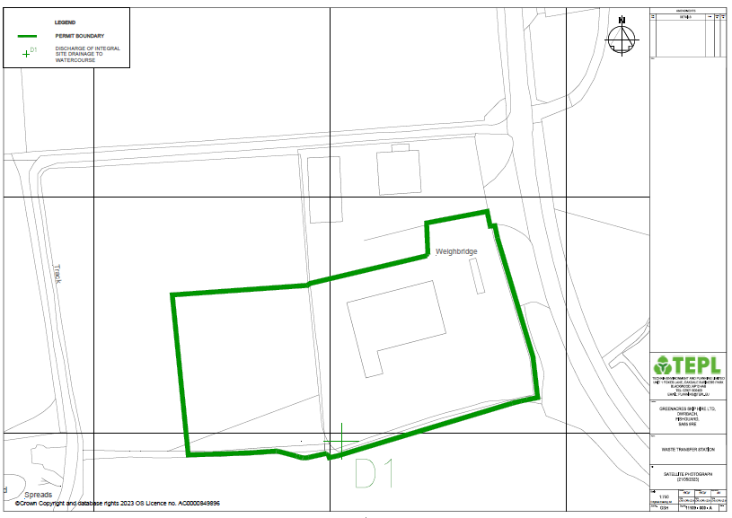

Nearest residential receptors
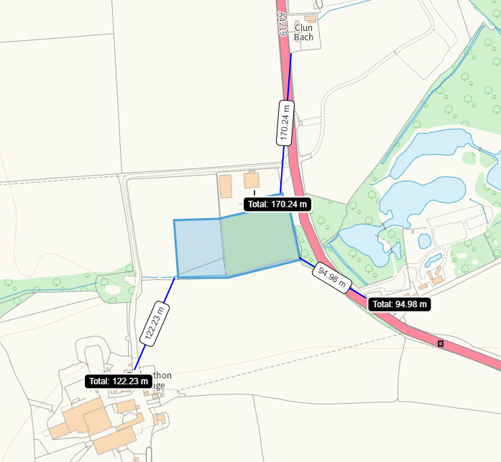
95 meters- Yet-Y-Gors, Dwrbach, Fishguard, SA65 9RE. Also campsite and fishery at this address
122 meters- Trebrython Farm, Dwrbach, Fishguard, SA65 9RP
170 meters- Clyn Bach, Dwrbach, Fishguard, SA65 9RE

13 addressed within 500 meters- mixture of business, residential and recreational.
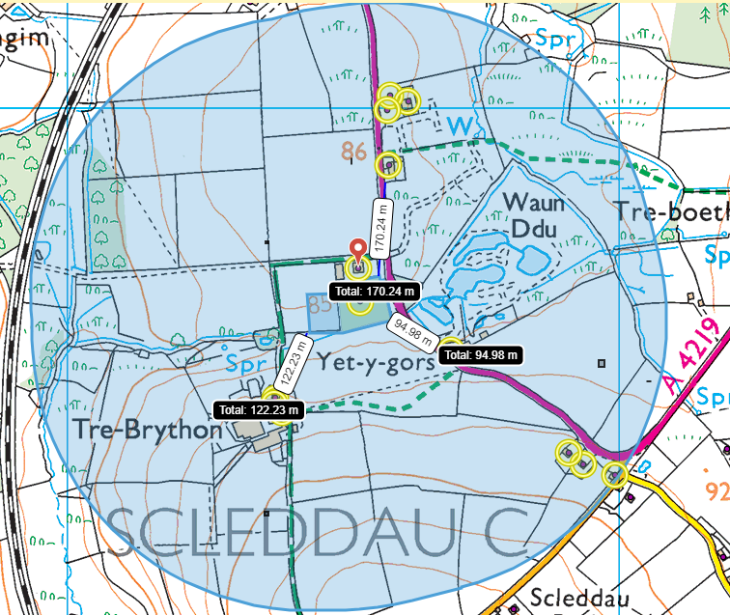
ORGANISATION NAME | BUILDING NAME | THOROUGHFARE | DEPENDENT LOCALITY | POST TOWN | POSTCODE
 | THE OLD SMITHY |  | DWRBACH | FISHGUARD | SA65 9RD
 | YET-Y-GORS |  | DWRBACH | FISHGUARD | SA65 9RE
 | AVALON |  | DWRBACH | FISHGUARD | SA65 9RE
 | BLAENWAUN |  | DWRBACH | FISHGUARD | SA65 9RE
 | CLYN BACH |  | DWRBACH | FISHGUARD | SA65 9RE
 | 1 TREBRYTHON |  | DWRBACH | FISHGUARD | SA65 9RP
 | TREBRYTHON |  | DWRBACH | FISHGUARD | SA65 9RP
 | 2 TREBRYTHON |  | DWRBACH | FISHGUARD | SA65 9RP
 | 1 | CELTIC LINK INDUSTRIAL PARK | DWRBACH | FISHGUARD | SA65 9RY
 | 2 | CELTIC LINK INDUSTRIAL PARK | DWRBACH | FISHGUARD | SA65 9RY
GREENACRES SKIP HIRE LTD |  |  | DWRBACH | FISHGUARD | SA65 9RE
TONY MORRIS & SONS DEVELOPMENTS LTD |  | CELTIC LINK INDUSTRIAL PARK | DWRBACH | FISHGUARD | SA65 9RY
TRAVIS PERKINS TRADING CO LTD |  |  | DWRBACH | FISHGUARD | SA65 9RE

historic items (ancient monuments, historic sites etc.) within 500m
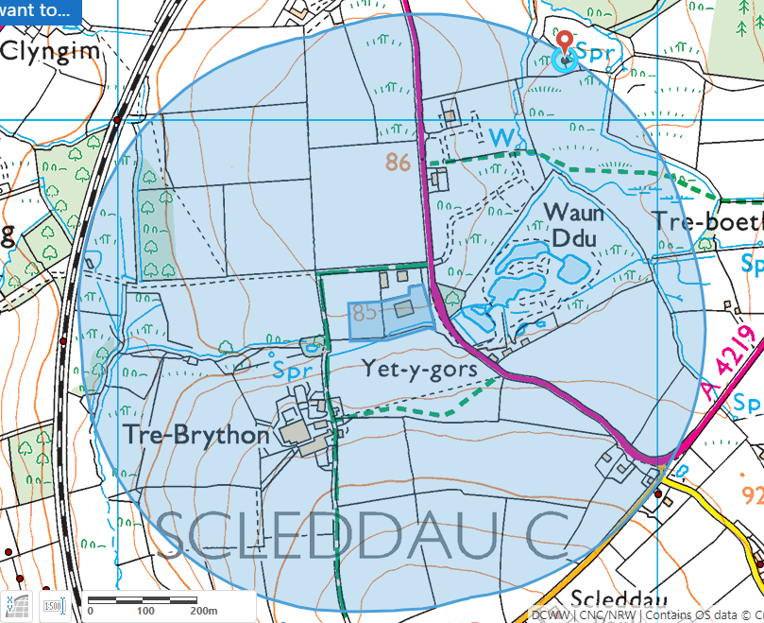
- World heritage site DAT47072 (archwilio.org.uk)
ancient woodlands within 1km
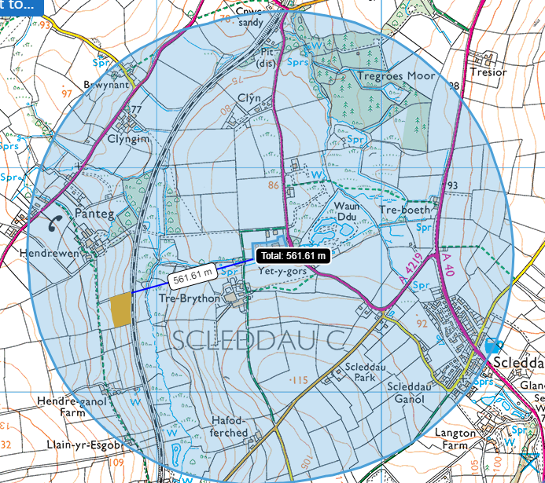
- Restored Ancient Woodland Site 562 meters from site
sites of special scientific interest (SSSIs) within 2km
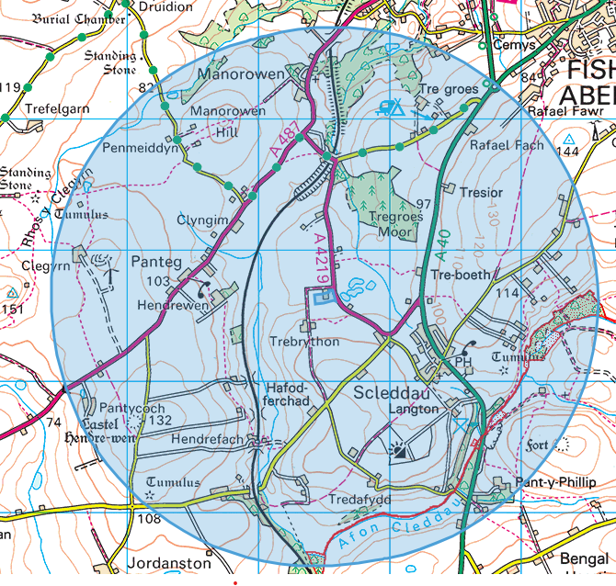
- Afon Cleddau Gorllewinol / Western Cleddau River SSSI approx 1.4 km away (as the crow flies). Connected to site via stream and discharge
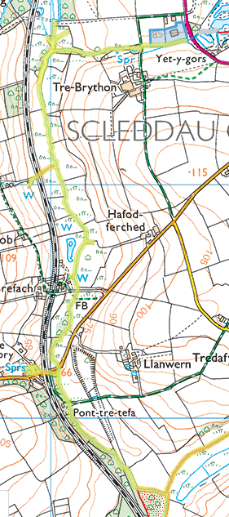

Flood risk
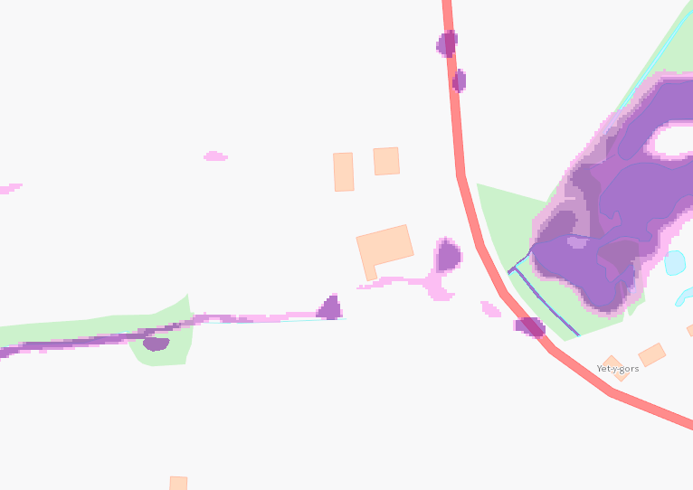
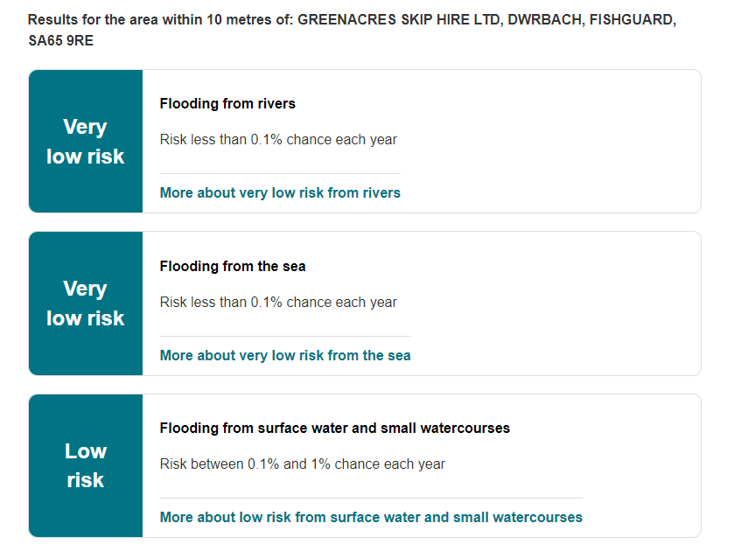
protected habitats
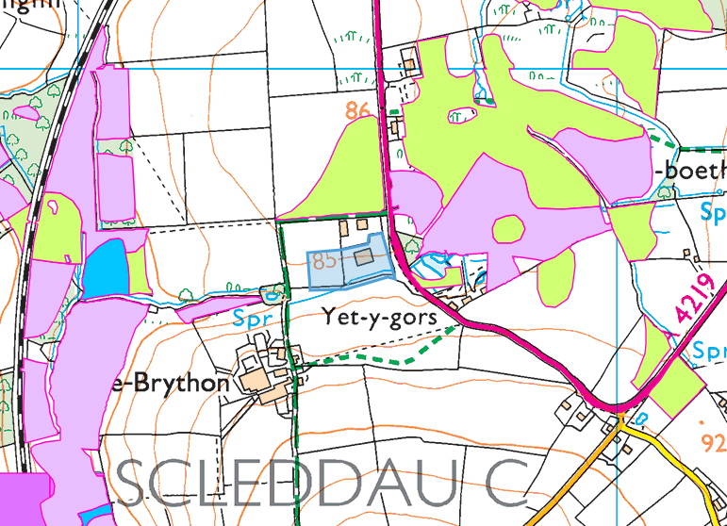
- Lowland dry acid grassland and Lowland calcareous grassland, Lowland heathland, Purple moor grass and rush pastures, Reedbeds

Section 7 species
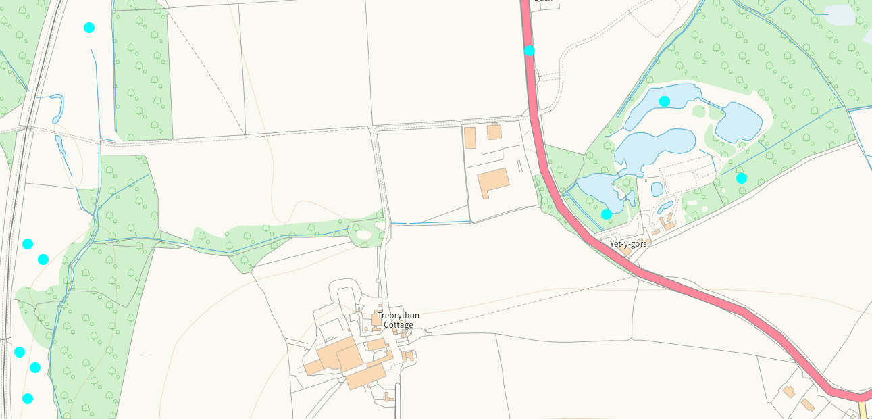
Eurasian Otter and European Water Vole and Adder and Common Toad and Common Lizard (east of the site in wetlands)
West European Hedgehog (north of the site)
Common Toad and Marsh Fritillary butterfly (west of the site)

source protection zones/aquifers
- No SPZ
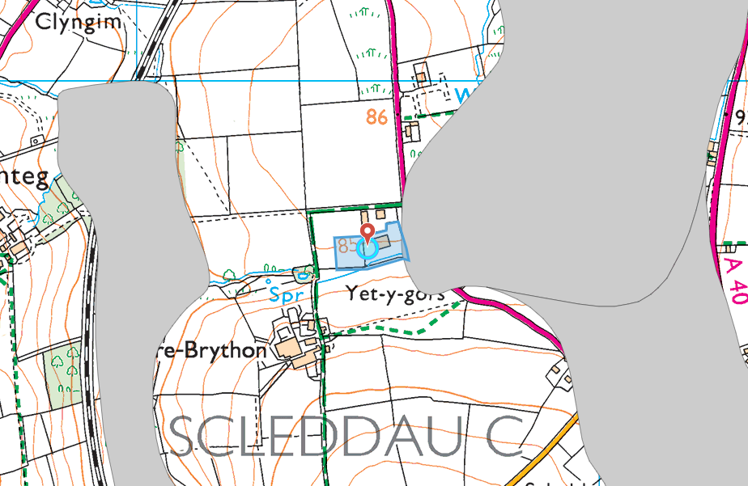
- Superficial aquifer- east of site- Unproductive- GLACIOLACUSTRINE DEPOSITS, DEVENSIAN
- Superficial aquifer West of site- Unproductive- PEAT
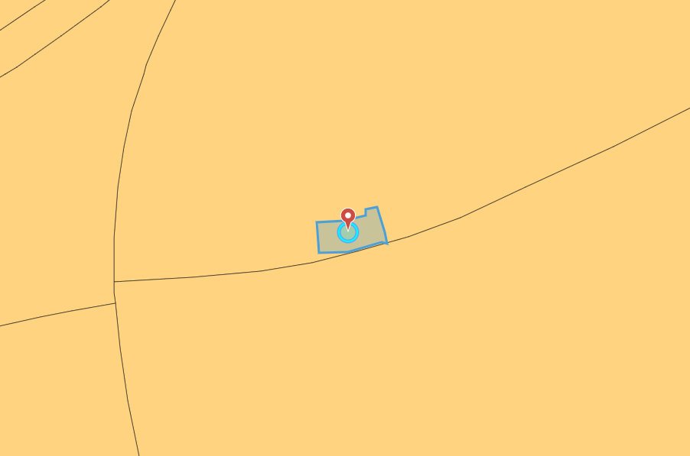
- Bedrock aquifer- Secondary B- ABER MAWR SHALE FORMATION (on site) and LINGULA FLAGS FORMATION (south of site)

surface water courses (sinks/issues/springs/wells etc.)
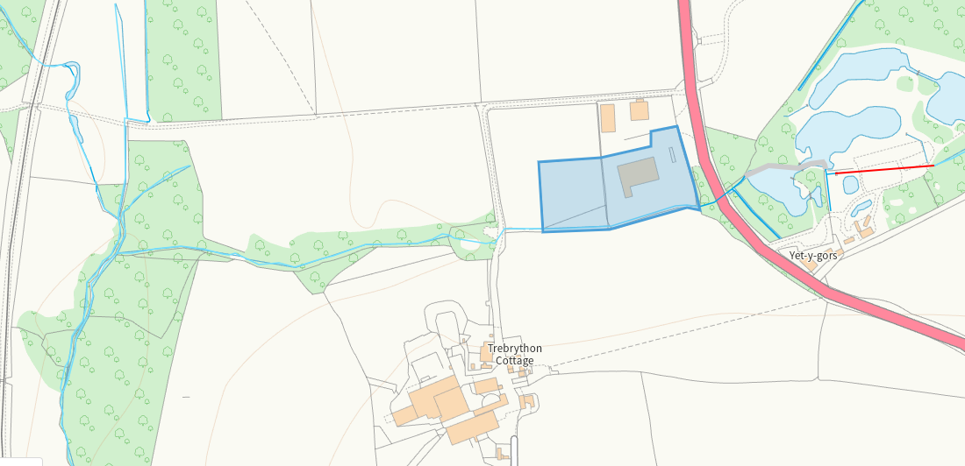
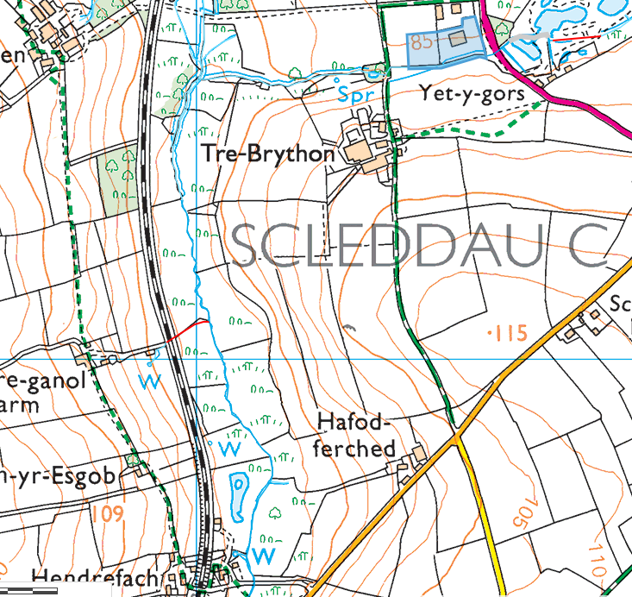
Number of wells downstream
None:
- national parks within 1km
- areas of outstanding natural beauty (AONBs) within 1km
- special areas of conservation (SACs) within 1km
- special protection areas (SPAs) within 1km
- Ramsar sites (wetlands) within 1km
- marine conservation zones within 1km
- local wildlife sites within 1km

