Permit
The Environmental Permitting (England & Wales) Regulations 2016

We Recycle Tyres Limited

Bachymbyd Workshops
Llanrhaeadr
Denbigshire
LL16 4PF

Permit number
EPR/DB3596HA
Permit
The Environmental Permitting (England and Wales) Regulations 2016
Permit number

EPR/DB3596HA

The Natural Resources Body for Wales (“Natural Resources Wales”) authorises, under regulation 13 of the Environmental Permitting (England and Wales) Regulations 2016

We Recycle Tyres Limited (“the operator”),

whose registered office is

Bachymbyd Workshops

Llanrhaeadr

Denbigshire

LL16 4PF

company registration number 13322705

to operate waste operations at

G O N Granite

Bachymbyd Worskshop

Llanrhaeadr

Denbigh

LL16 4PF

to the extent authorised by and subject to the conditions of this permit.

Under regulation 27(2) of the Regulations, standard rules SR2024No2 are conditions of this permit.

Name | Date
Huw Davies | 16/09/2025

Authorised on behalf of Natural Resources Wales

Schedule 1 - Site plan

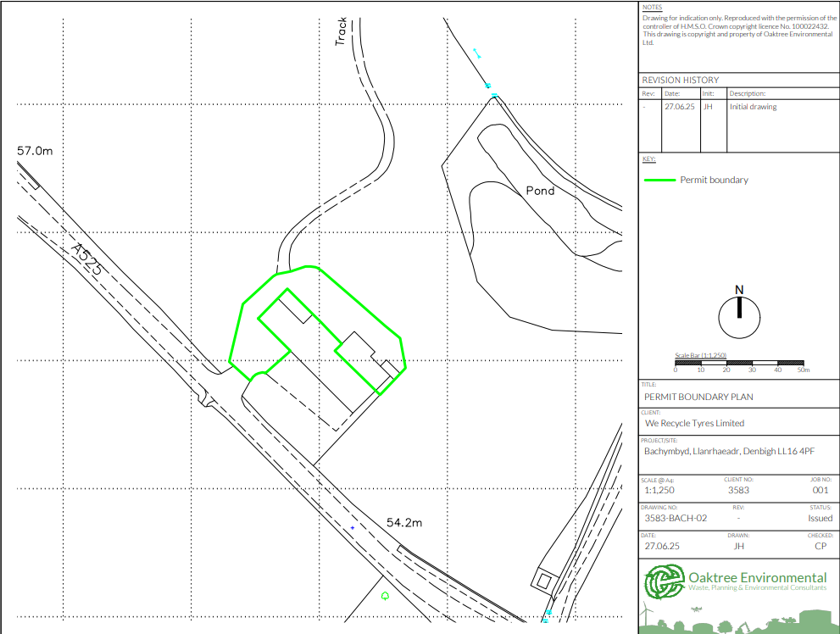
This is the plan referred to in the standard rules SR2024No2

END OF PERMIT

