Contract Name | Menai Shellfish | Contract Number: | WWF006

Client Reference: | Menai Shellfish
Scope of Works: | Scour protection / revetment works on the fore shore by the pumping station Construction of a pre cast concrete below ground surface water storage tank, rising main and gravity pipelines, construction of new manhole, manhole modifications, sewer remedial works and ducting works and scour protection works on the foreshore
Design/Construction/Maintenance: | Construction
AGC Document Reference: | CEMPWWFOO6
Version: | 2

 | Name | Job Title: | Signature: | Date:
Prepared By: | Reuben Smith | Site Agent | 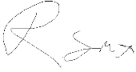 | 06/05/25
Reviewed By: | Richard Golder | Environment Advisor |  | 07/05/25
Authorised By: | Joe Pritchard | Project Manager | 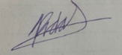 | 07/05/25

Issue | Date | By | Approval | Changes
01 | 16.04.2024 | Reuben Smith |  | First Issue
02 | 07.05.2025 | Reuben Smith |  | Emphasis upon scour protection revetment works within the ongoing project scope
03 | 17.09.2025 | Reuben Smith |  | Amendment to working hours
Welsh Water Review and Acceptance
Reviewed and accepted by:
Name:
Signature:
date: ______/______/______

GLOSSARY
TERM | DEFINITION
AIR | Aspects & Impacts Register
BMS | (Griffiths) Business Management System
BPM | Best Practicable Means
BREEAM | Building Research Establishment Environmental Assessment Method
CEMP | Construction Environmental Management Plan
CEEQUAL | Civil Engineering Environmental Quality Assessment & Awards Scheme
EA | Environment Agency
ECoW | Environmental/Ecological Clerk of Works
EPP | Environmental Permit to Proceed
EIA | Environmental Impact Assessment
ES | Environmental Statement
EHO | Environmental Health Officer
HRA | Habitat Regulations Assessment
HWCN | Hazardous Waste Consignment Note
FRAP | Flood Risk Activities Permit
GEMS | Griffiths Events Management System
IDB | Internal Drainage Board
INNS | Invasive Non-Native Species
IRP | Incident Response Plan
KPI | Key Performance Indicator
OWC | Ordinary Watercourse Consent
LPA | Local Planning Authority
MMP | Materials Management Plan
NE | Natural England
NRW | Natural Resources Wales
PEA | Preliminary Ecological Appraisal
PROW | Public Right of Way
RAMS | Risk Assessment Mathos Statement
SAC | Special Area of Conservation
SEPA | Scottish Environment Agency
SNCB | Statutory Nature Conservation Body (NE, NRW & SNH)
SNH | Sottish Natural Heritage
SPA | Special Protection Area
SSSI | Site of Special Scientific Interest
SUDs | Sustainable Drainage Systems
SWMP | Site Waste Management Plan
TBT | Toolbox Talk
TPO | Tree Preservation Order
WTN | Waste Transfer Note

Contents
Introduction 6
Limitations 7
1.0 Project Description 8
1.1 The Site 8
1.2 The Proposed Design 9
1.3 Site set up and compound 11
1.4 Equipment and plant 11
1.5 Environmental Risk Assessment Summary 12
2.0 Project Management Plan Administration 13
2.1 Distribution 13
2.2 Revisions 13
3.0 General 14
3.1 The Project Works 14
3.2 Hours of Work 14
3.3 Existing Records, Drawings & Information 15
3.4 Project Programme 15
3.5 Project Objectives 16
3.6 Environmental Consents, Licences and Permits/Exemptions 1
4.0 Management 2
4.1 Organisation and Responsibilities/Appointments 2
4.2 Internal Communication 3
4.3 Client and Other Stakeholder Communication 3
4.4 Change Control 4
4.5 Project Management Documentation 4
4.6 Project Review 5
4.7 Project Records 6
4.8 Project Document Management 6
4.9 Project Audit 7
4.10 Incident Response Plan (IRP) and Emergency Arrangements 7
4.11 The Local Community 8
4.12 Training and Competencies 8
4.13 Complaints, Control of Records and Management Review 9
5.0 Environment 10
5.1 Summary and Action Plan of Key Environmental Aspects and Impacts 10
5.2 Verification of Environmental Control Measures 12
5.3 Cultural Heritage - Archaeology and Listed Structures 13
5.4 Temporary Land Use 14
5.5 Biosecurity and Invasive Non Native Species 14
5.6 Ecology 15
Table 5.4 Designated Sites 15
5.6.1 Protected Species 16
5.6.2 Arboriculture 2
5.7 Contaminated Land 2
5.7.1 General 3
5.8 Emissions to Air and Nuisance 3
5.8.1 Measures to Reduce Potential Impacts on Air Quality 3
5.8.2 Noise 4
5.8.3 Section 61 Control of Pollution Act 1974 (COPA) 6
5.8.4 Construction Vibration 6
5.8.5 Light Management 7
5.8.6 Dust and Fume Management 7
5.9 Materials and Waste Management 8
5.9.1 Waste Management 8
5.9.2 Materials Management 11
5.9.3 Unexpected Contamination 11
5.10 Flood Risk 12
5.11 Water Management and Pollution (work activities) 12
5.11.1 Pollution of Land and Water 12
5.11.2 Silt and Surface Water Runoff Mitigation Measures 13
5.11.3 Site Personnel and Documentation 16
5.11.4 Monitoring Procedures 17
5.11.5 Concrete Washout 17
5.11.6 Construction Aggregates 17
5.11.7 Energy Management 18
5.11.8 Environmental Non-Conformity NCR 18
6.0 Incident Management, Emergency Response and Notification 19
Appendix 1– Environmental and Social Policy 20
Appendix 2 – Organogram 21
Appendix 3 – Site Waste Management Plan 22

Construction Environmental Management Plan
Revision 1.0* (see section 2.2 for revision history)
Review date required: 04/07/25

Introduction
This Construction Environmental Management Plan (CEMP) provides a framework for the management of environmental and social issues on the project to ensure legal, contractual, and procedural requirements are met. The Plan will cover the policies, objectives, targets, people, responsibilities, and documentation relevant to the project.
Alun Griffiths Contracting (AGC) is certified to ISO 14001:2015 and understand their legal obligations to the protection of the environment for works carried out on behalf of their clients. In addition, there is a culture of managing the impacts associated with design deliverables, prevention of pollution and continual improvement with all aspects of environmental and social management. A copy of our Environmental & Social Policy is available in Appendix 1.
The AGC Environmental Management System consists of mapped processes, operational procedures, risk assessments and method statements, and forms part of the AGC integrated Business Management System (BMS).
Any statutory rules and regulations that are referenced should be read in conjunction with this Environmental Management Plan, and the procedures and standards referenced within this document.
This Construction Environmental Management Plan (CEMP) is the first stage in project risk assessment and planning to identify the significant hazards for which appropriate controls are necessary to reduce risk.
This site-specific CEMP has been developed to avoid, minimize and/or mitigate any construction effects on the environment and the surrounding community with the purpose to minimize waste sent to landfill, minimize disruption to nearby residents and the local community, to aid in achieving zero pollution incidents and to protect, and where possible, enhance biodiversity.
This CEMP contains, or makes reference to, sufficient information to identify how the project will be managed from an environmental perspective.
It defines the project specific environmental risks, monitoring, water management and site waste management to be used to mitigate or remove environmental risks/impacts, control the works, meet contract requirements and record compliance. Not all of these procedures can be established immediately, the plan allows some details to evolve at an appropriate time.
The CEMP is to be reviewed and revised every year, or more frequently if substantial changes to the project construction make this desirable.
This CEMP should be considered as a living document. It will evolve via regular reviews, as the project progresses, including changes to best practice, environmental regulation and the site conditions. As a minimum the CEMP will be updated every 6 months.
This plan sets out the management arrangements of this project and provides essential information on environmental issues. It is valid for all works in the design, construction, reinstatement and maintenance phases of the Project.
This document is to be used in conjunction with company and project procedures.

Limitations
The comments given in this plan and the opinions expressed within are based upon the survey conditions encountered by third parties.
It should be noted that there may be conditions pertaining to the site that have not yet been discovered by the current investigations and therefore could/have not been taken into account.

Project Description
The Welsh Water Menai Shellfish project, which is aimed at improving the Storm Overflow performance from the Bangor Beach Road Sewage Pumping Station (Treborth Catchment, Bangor). This PS is one of four assets that fall under the Asset Management Plan (AMP) 7 National Environmental Programme (NEP) to meet the Shellfish Water Directive of 10No. spills per annum for the Menai Strait.
A Root Cause Assessment (RCA) was undertaken for the whole catchment [4191_S_501-ARP-XX-XX-RP-XX-10000] which led to a focus on Bangor Beach Road. The assessment report summaries the findings from the catchment wide investigations, hydraulic modelling and outlines the proposed interventions to reduce spills to the Menai Strait Shellfish waters.
The Treborth catchment has one WwTW, which serves a resident population of 20,668. The wastewater network consists of a foul gravity collection system with pockets of combined storm sewerage in discrete areas across Bangor. The gravity system is served by seven key sewage pumping stations (each with a consented storm overflow) which discharge to Treborth WwTW. A catchment plan is given below.
The construction project will be over a year period with completion due September 2025
In order to construct the storm tank section of the project, sheet piles will be installed to create a cofferdam. Before excavation works can start a well point dewatering system will be set up to help keep the excavation dry, water will be discharged into the DCWW system. Trench boxes will be required when diverting the existing sewer pipe away from the proposed tank footprint. Scour protection /revetment works will be undertaken on the foreshore

Further details are provided in section 5 of this report. An organogram of the site team is presented in Appendix 2.

The Site
The scheme is located to the north east of Bangor at post code LL57 1AD and is centred at National Grid Reference 258704 372826.
Site Location Plan:
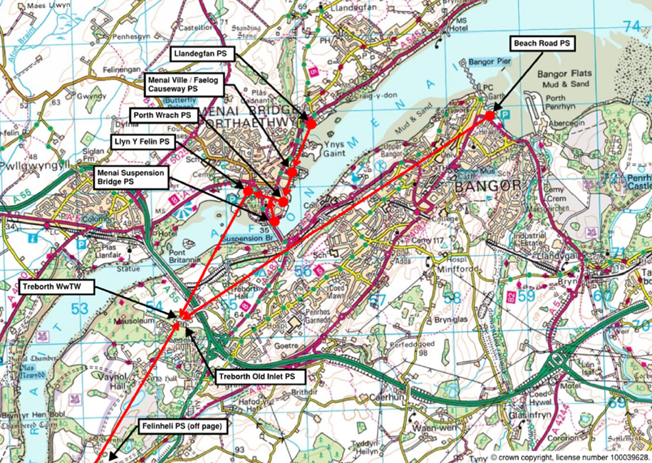

The Proposed Design
- New 4300m³ storage tank below adjacent football pitch, with cleaning systems optimised for minimal maintenance requirements.
- Tank to be designed to operate with buried covers.
- Gravity storm tank return (with a discharge flow control) to Manhole SH58726806 upstream of PS and Emergency Overflow from the tank back to pump well 3a [EO requirement to be confirmed during outline design]. The return flow control is to be linked to the pump inlet levels and is optimised to empty the tank as quickly as possible without causing recirculation or premature spills.
- The gravity return flow control shall be designed to prevent flow recirculation [i.e., not raise the water level to a point where the storm pumps start up].
By Others:
Replace the two storm pumps in Pump Well 2 (first spill storm well – refer to Figure 2) with pumps [1,000l/s total flow] and redirect them to pump to new storage tank. New storm pumps modelled to stop when storm tank water level is at 5mAoD [Tank has a modelled Invert level of 1.0mAoD]. Pump 1 was modelled with a flow of 500l/s and starts pumping when the PS water level is 0.2m AoD and stops at -0.6mAoD, whilst Pump 2 was modelled with a flow of 500l/s and starts pumping when the PS water level is at -0.36mAoD and stop at -1.070 [values to be confirmed during detailed design].
A simplified plan of the scheme is shown below.
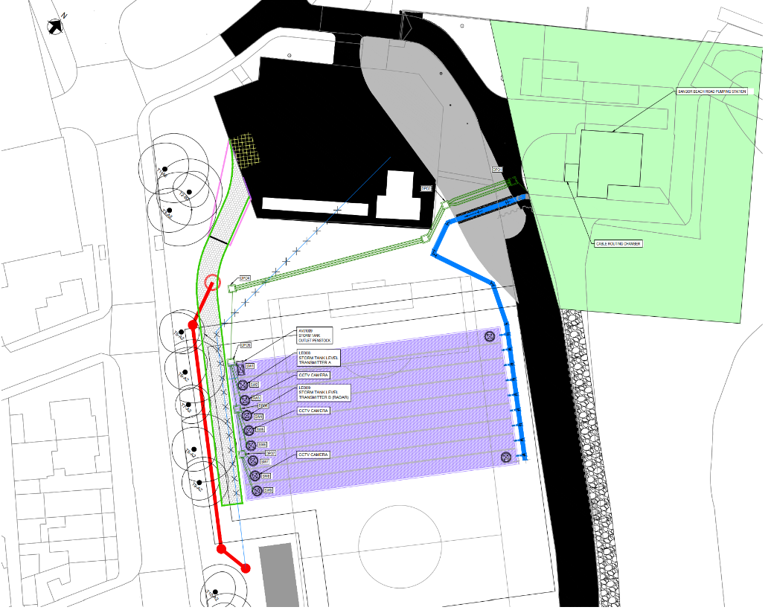

Scour Protection Works: Schematic representation of work scope
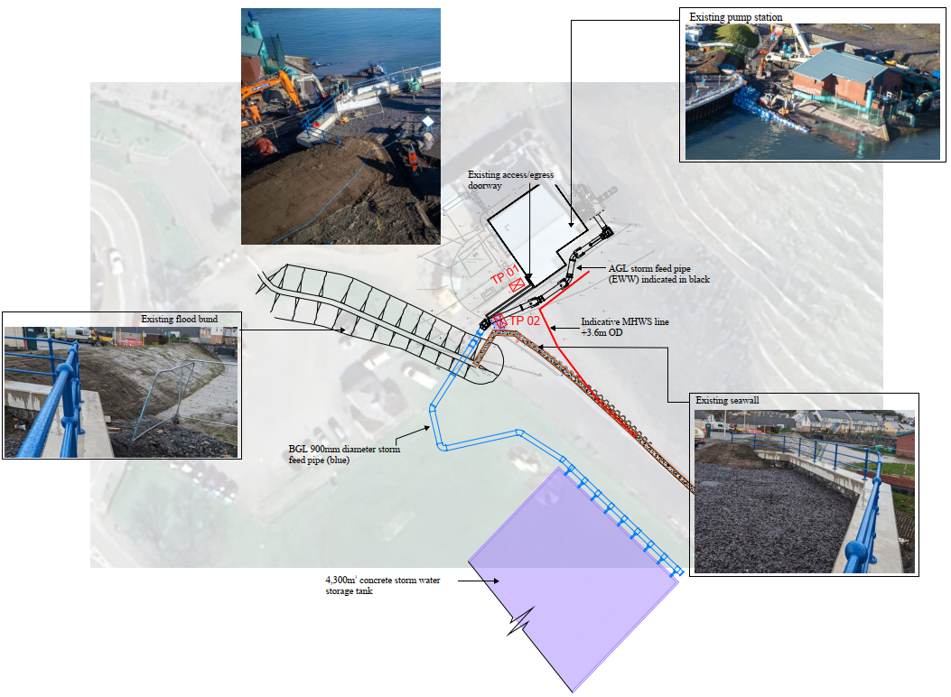

Site set up and compound
The site and compounds shall be managed in accordance with HSE Manual section 3.1. Full details can be obtained by reference to the HSE Manual which will include the display of:
- Site Specific Environmental Action Plan Summary
- Site Information/Services Plan
- Traffic Management Plan
- Silt Run-off Prevention and Protection Poster.
The main compound will be located within Beach Road East car park.

Equipment and plant
AGC and its sub-contractors will identify the equipment and plant to be used, including type, size and expected number. Plant used for the development is likely to comprise conventional construction and highways construction plant including mechanical excavators, dumpers and other heavy plant including sheet piling rigs.

Environmental Risk Assessment Summary
An Aspects and Impacts register has been compiled to identify the potential environmental impacts of the project construction and mitigation measures to be adopted to reduce/eliminate the risks. The Aspects and Impacts Register summarised below in Table 1.1.
Table 1.1 Summary of Aspects and Impacts
Risk | Impact
Noise, dust, vibration | Disturbance to local residents/business  Disturbance to roosting and wading birds  Statutory nuisance
Night time lighting | No night time working
Litter | Disturbance to local residents/business  Ecology damage
Highway and PROW closures | Disturbance to local residents/business and statutory nuisance
Sediment/chemical/fuel run off | Pollution of surface water/groundwater/ marine environment
Ground disturbance | Archaeology and Heritage  Mobilisation of contamination/pollution  Spread of non-native invasive species (INNS)
Chemical/fuel spills | Ground and water contamination
Poor soil management | Unable to return land to owner in suitable condition
Disturbance of protected plant and animal species | Ecological damage
Spread of plant and animal disease | Biosecurity
Mixing wastes | Increased waste generation/costs
Poor management of construction materials | Increased waste generation/costs
Failure to comply with legislation and Codes of Practice | Regulatory non compliance

Comprehensive details of the environmental risk assessment are presented in section 5.

Project Management Plan Administration

Distribution
Once approved and verified this CEMP is distributed by the Project Manager (PM). Copies of this plan are distributed to the contacts in Table 2.1 below:
Table 2.1 List of Distribution Contacts
Copy | To | Controlled/ Uncontrolled | Date of issue | Signature of recipient
01 | Site file | Controlled
02 | Angela Meadows, Client’s representative | Controlled
03 | ARUP, Principal Designer | Controlled
 | Richard Golder, AGC Area Environment Advisor | Uncontrolled | 07 05 2025
Recipients of controlled copies sign and return a copy of this sheet in confirmation that they have received the plan and have removed/clearly marked previous issues as superseded.
A fully verified and authorised copy of this front sheet is sent by the PM to the Systems Manager at head office.

Revisions
Revisions to this plan are made and approved in the same way as the originals including the obtaining of client approval and authorisation where required by the conditions of contract.

General

The Project Works
Where the CEMP is only sufficient for the initial stages of the project, (e.g., site establishment and clearance), this is defined in Table 3.1 and an appropriate review date is entered on the front sheet.
The plan is developed and revised for the following stages of the project prior to this date.
Table 3.1 – The Project
Description of the project | - Scour protection / revetment works on the fore shore by the pumping station  - Construction of a pre cast concrete below ground surface water storage tank  - Rising main and gravity pipelines, construction of new manhole, manhole modifications  - Sewer remedial works  - Ducting works  - Penstock, electrical cables, pumping station works and connections to existing system will all be complete by another DCWW contractor under a separate CDM area.
Client | Welsh Water
Client Representative | Angela Meadows
Principal contractor | Alun Griffiths Contractors Ltd
Principal Designer | DCWW
Other consultant | Caulmert and ARUP
Project works covered by this plan | Scour protection / revetment works on the foreshore by pumping station Construction of a pre cast concrete below ground surface water storage tank, rising main and gravity pipelines, construction of new manhole, manhole modifications, sewer remedial works and ducting works.
Significant works to be subcontracted – All part of Main Project, not part of scour protection works | Sheet Piling for cofferdam  Installation of supplying precast concrete units to construct tank  Sewer Remedial works

Hours of Work
Site construction hours will be:
Monday to Friday 08:00 – 18:00
Saturday 08:00 - 13:00
Any work to be undertaken outside of the above hours must be agreed in advance and in writing by Gwynedd Council.
The project manager must consult the Environment Advisor on any working hour constraints.

Existing Records, Drawings & Information
Table 3.2 Information Records
Records | Date Received | Provided by
Pre-tender Information | Feb 2024 | WW
Asbestos Register/Information | Feb 2024 | WW
Drawings | Feb 2024 | WW
Environmental Information | Feb 2024 | ARUP
Drainage Information | Feb 2024 | WW

Project Programme
Whilst the anticipated completion date stated is updated as necessary in revisions to the CEMP, it is indicative only and has no contractual significance.
Table 3.3 The Project Programme
Contract award date | February 2024
Issue of Pre-Construction Information Pack (PCIP) to Principal Contractor | February 2024
Time allocated by Client/CDM Coordinator for the planning and preparation of the construction work | 2 weeks
Ecological / Environment Surveys | Shadow HRA (Habitats risk assessment) awaited from APEM for scour protection works on fore shore . PEA report 15 06 2023 conducted by APEM and HRA SEPT 2023 (APEM) Bureau Veritas, Noise and Vibration Impact Assessment, June 22.
Site Possession date | 19/02/24
Construction Phase Start Date | 26/02/24
Planned construction completion date | Sept 2025.
Last date for contractors, including Principal Contractor, to submit Environmental information for Health & Safety File (inc.) | Sept 2025

Project Objectives
AGC seeks to meet its overall objective of satisfying all stakeholders on the project.
The specific objectives concerning production and service provision are as set out in the specification and other contract documents.
The Project Manager monitors performance and records data for input into the project KPI database from which the performance of the project can be benchmarked and the overall performance of the company can be measured against its targets.

Environmental Consents, Licences and Permits/Exemptions
Guidance on when a consent, licence or permission is needed and how it is obtained is provided in environment form EN.F.03 Project Permits & Consents Register.
The consents detailed below in Table 3.7 are required for this contract. These marine licenses are for design works of the overall project- Marine licence awaited for the scour protection / revetment works on the foreshore from NRW
Table 3.7 Environmental Consents, Licences and Permits
Consent/Permit Reference | Requirement | Start Date | End date
CML2421 Marine License | Glandwr Rd beach manhole and piping works | 01/05/24 | 01/10/24
CML2479 Marine License | Glandwr Rd beach manhole and piping works re- application of expired license CML 2421 | 01/12/24 | 30/11/25
Application in progress Marine licence | Scour protection foreshore revetment works | tbc | tbc
Abstraction | Water abstraction to carry out works on the cofferdam | 01/05/24 | 28/02/25

The marine licence must be adhered to at all times. Any incidents must be reported to the Licensing Authority as soon as possible using the hotline number 0300 065 3000. The Welsh Government Marine & Fisheries Division (Control & Enforcement Branch) must be notified at least 10 days prior to the licensed activities taking place and 10 days after completion. In addition, local mariners and fishermen's organisations must be made fully aware of the activities at least 10 days prior to commencement. HM Coastguard must be informed at least 24 hrs before the activities commence.

This CEMP must be submitted to the Welsh Government Marine & Fisheries Division (Control & Enforcement Branch) for written approval 6 weeks prior commencement of the licensed activities

Management

Organisation and Responsibilities/Appointments
The Project Manager is responsible for the implementation of this plan to ensure that:
- the requirements of this plan are communicated to the project team and subcontractors required to work in accordance with it
- all activities are planned, implemented and controlled
- the activities of those working to this plan are coordinated and interface problems resolved
- progress of implementation is monitored
- corrective and preventive actions are controlled
- audit findings are reviewed and actioned as appropriate
- this plan is reviewed with project changes and revised as required.

The organisation chart of Appendix 2 describes the project team and their relationships. This team is constantly reviewed against changes in the scope of the work.
The site Project Manager gives written notice to individual personnel of responsibility for the designated roles listed in Appendix 2.
The organisation chart and signatory powers are amended as the project team members or their specific responsibilities change. Records of changes are retained in the project records so that responsibility at each stage of the work can be identified.
Personnel at every level are required to actively help to eliminate potential adverse effects on the environment, health and safety, quality and the business by personal example, the application of their knowledge, experience and management skills or by bringing matters to the attention of their supervisors. Personnel are empowered to stop their work where this is essential to prevent adverse effects on environment, health, safety, or quality and are required to notify their supervisor immediately. Personnel appointed to this project are detailed in Table 4.1 below.

Table 4.1 – Project Appointments
Position | Person Appointed
Project Manager | Joe Pritchard
Site Agent | Reuben Smith
Senior Engineer | Rowan Connolly
Quality Manager | Suzanne Proctor
Health & Safety Advisor | Peter Roberts
Environment Advisor | Richard Golder
Ecologist | Ambar Villanueva-brackley. APEM Ltd
Public Liaison Officer | Richard Foxhall

Internal Communication
Environmental risks, opportunities, documentation and processes will be communicated across the project team and to the AGC Leadership team. As a minimum the Environmental Policy Statement and the Sustainability policy will be visible on all project notice boards, communicated at site induction. Incidents and opportunities will be communicated at weekly SHEQ meetings, AGC newsletters and team stand-downs.
The requirements of this CEMP and task specific environmental risks will be communicated to the Construction teams in the RAMS and the EPP applicable to each activity.

Client and Other Stakeholder Communication
The Project Manager determines and implements effective arrangements for formal communication with the client or his representative in relation to information, enquiries, amendments, approvals and feedback including complaints utilising the Stakeholder Engagement Plan which is presented in Appendix 5.
On this project, such communication is achieved at review meetings and as indicated in Table 4.2.
Table 4.2 Client communication
Organisation | Position | Contact Details
Angela Meadows | Client Project Manager | Angela.Meadows@dwrcymru.com
DCWW | NEC Supervisor | John Swallow

In addition, the Project Manager establishes communication links with other stakeholders such as the designer, principal designer, local authority, regulators and community representatives. Details of these are provided in Table 4.3.
Table 4.3 Stakeholder Communication
Name and Company | Contact Details
Gwynedd Borough Council | 01766 771000
Marine Licence Enforcement Authority | Marine Licensing Team ;Welsh Government Offices Cathays Park King Edward V11 Avenue Cardiff CF 10 3NQ Tel 0300 065 3000 e mail marinelicensing@natural resourceswales.gov.uk
HM coast guard | National Maritime Operations centre Zone 31@hmcg.gov.uk
Highways Authority | 01286 677 067
NRW | marinelicensing@natural resourceswales.gov.uk

Change Control
All changes to contract requirements, together with changes to arrangements, resources and subcontracts are recorded in accordance with any relevant contract requirements.
Superseded documents are promptly withdrawn from use and are clearly marked as superseded.
All changes to construction requirements are reviewed for possible effects on existing risk assessments and subsequent control arrangements.
Changes to AGC’s procedures and guidance documents within the BMS are notified to Project Managers via controlled email and to all personnel via bulletins. Changes to legislation are monitored by via bulletins and/or the issue of revised documents.
Changes to this plan are referred to in section 3.2.

Project Management Documentation
The following documents are to be used in the management of the project:
- Mandatory AGC procedures and standards
- AGC guidance documents (including standard checklists and forms)
- Project health, safety and environmental risk assessments
- Project procedures, method statements and risk assessments/aspects & impacts
- Project resourced programmes
- Drawings register
- Change management register (CMR) including register of early warnings and compensation events (or equivalent dependent on contract)
- Requests for information
- Register of nonconformities and complaints
- Inspection and Test Plans (ITP)
- Register of submissions and approvals
- Records
The Project Manager is responsible for ensuring that the relevant documents are available to personnel required to use them, and personnel carrying out the work are responsible for ensuring that the current documentation is used.

Project Review
Reviews of contract requirements are undertaken by the Project Manager to ensure that requirements are adequately defined and documented and that queries are resolved.
Reviews are held at the start of each project by establishing the requirements specified by the client, (including programme), requirements not specified but necessary (information required), statutory and regulatory requirements and any additional requirements.
Further reviews are undertaken throughout the duration of the project at internal meetings of the project team and at meetings with the client’s representative to verify that planned arrangements remain suitable and are effective in controlling the work. These meetings also review the results of audits, nonconformities and problems and establish actions to prevent recurrence and improve the system.
The anticipated frequency, attendance for meetings are set out in Table 4.4.
PM to amend the tables to show what meetings to plan: who attends, frequency and the agenda.
Table 4.4 – Review meetings
Meeting | Frequency | Attendance
Progress | Weekly | Project Manager, Environment Advisor, Site Manager etc.
Environmental Review | Monthly | Project Manager Environment Advisor/ Site Manager etc
Change Control & Change Management Meetings | Monthly | Project Managers, QA etc.
Design management/ review meeting | Monthly | Project Manager, Design coordinator, Designer’s representatives etc
The project management team, assisted by their contractors, will review the plan at regular intervals, not to exceed monthly.

Project Records
Project records are maintained throughout the duration of a project as evidence of the compliance, conduct, progress and certification of the project works, and to provide assurance that relevant requirements have been met.
These records include all correspondence, instructions, minutes of meetings, as-built programmes, resource schedules, registers, test certificates, inspection checklists, training records etc. Project records are maintained and archived in accordance with the project document control system defined within this project management plan and designed in accordance with BMS.P.04 Document Control.
All relevant Risk assessments, method statements and subcontractor documents are filed within the project filing system.
Arrangements for the collection and storage of this information are agreed with the Principal Designer and notified to all relevant contractors during the start-up meeting.
Environmental records are retained in files within the project filing system in accordance with EN.F.01 Environmental Checklist and EN.F.06 Environmental Permit to Proceed.
Waste Transfer Notes (WTNs) are retained for a minimum of two years and Hazardous Waste Consignment Notes (HWCNs) for a minimum of three years.

Project Document Management
The PM establishes a formal project document management system in accordance with the following requirements as detailed in BMS.P.04 Document Control.
All documents received or issued by the project are controlled and maintained in accordance with BMS.P.04.
The relevant parts are communicated to all project personnel required to work with documents. BMS.P.04 Document Control defines how this is achieved.

Project Audit
Audits are programmed to match current demands and problems, and system coverage is monitored by the SHEQ Department who advise the directors as to the continuing sufficiency of the programme. The purpose of audits is to:
- verify compliance with AGC’s arrangements for quality, health and safety and environmental management at the location and in particular to check compliance with this project management plan (operational requirements)
- assess management against lS0 9001, ISO 45001 and ISO 14001 to highlight potential improvements in the system and to verify against an objective standard that good management practice is in operation (system requirements)
- confirm that the system gives satisfactory effect to statutory requirements and AGCs policy (regulatory requirements)
- Audits are undertaken in accordance with the Procedure BMS.P.10 Audit & Inspection by trained internal auditors who are selected by the SHEQ Department, The Project Manager/Site Agent are to ensure prompt close out of actions arising from audits.
The Project Manager makes arrangements to accommodate internal audits, together with any external audits requested by the client or his representative, or arranged by the SHEQ for the registration bodies.

Incident Response Plan (IRP) and Emergency Arrangements
All incidents will be managed in accordance with the Environmental Incident Management Standard (EN.S.09) in conjunction with the Incident Reporting Standard (EN.S.40) and the Emergency Preparedness Plan (EN.F.16).
Site-specific emergency procedures are prepared to ensure limitation of injury and damage should an incident occur. All incidents and recovery operations must be recorded on GEMS and be reported to the Environment Advisor. These procedures are communicated to the workforce at induction and toolbox talks and are displayed on notice boards.
Emergency procedures are drilled at an appropriate frequency to ensure continued suitability. These are detailed in Table 4.5 below.
Table 4.5 – Incident and Emergency Arrangements
Site Emergency arrangements | Are arrangements to be drilled? | Frequency of drill
Fire points /muster arrangements | Yes | 6 Monthly
Oil and chemical spill | Yes | 6 Monthly
Watercourse pollution | Yes | 6 monthly
Following an incident, communication with the media and public is managed and controlled. The incident coordinator nominated in Appendix 2 is responsible for such communications.

The Local Community
The Project Public Liaison Officer (PLO) investigates the local area around the site and identifies residents, businesses, facilities such as hospitals and schools, associations and other community organisations that may be adversely affected by the project works. In consultation with the client’s representative, and subject to any contract restrictions, the PLO communicates with those potentially affected and explains the nature of the works. Notice boards describing project progress may be installed.
Particular attention is given to site neighbours, who are continually informed of matters affecting their property and activity.
Opportunities are also sought for positive action in the local community such as support to local businesses, charities, community groups, school visits and assistance with community improvement projects.

Training and Competencies
All staff commencing employment on the site, including sub-contractors, will attend a site induction prior to starting works.
- The site induction will include information on areas of environmental sensitivity, how the site activities may affect them, methods necessary to protect them. These are to include activities to be avoided, recognition of ecological constraints, including invasive and protected species and procedures, Incident response procedures, risk assessment and method statement briefings and relevant environmental legislation for the project.
- Site staff shall provide proof of competency to perform any tasks that have the potential to cause a significant environmental impact. Should it be required, project/site specific training will be provided.
- Records of all personnel competencies and all attendees on induction courses shall be kept on site.
- Supplementary toolbox talks will be provided if deemed necessary,
- All managers and supervisors will be briefed on the CEMP.
- Site -specific Method Statements will be prepared prior to the works commencing and will include environmental protection, mitigation measures and emergency preparedness appropriate to all activities undertaken. The Project Manager or Environment Advisor will review key Method Statements prior to their issue.

Complaints, Control of Records and Management Review
All complaints or information requests will be made notified to the Project Manager and will be logged promptly within the site records by the project delivery team.
Careful monitoring of complaints received, including recording details of the location of the affected party, time of the disturbance and nature of the complaint received can assist with managing the works to reduce the likelihood of further complaint.
Environmental monitoring will be undertaken in order to provide information to be taken into account during construction and to feed back into the CEMP and method statements, and to evaluate the environmental effects of the construction process.
Noise and vibration monitoring will be conducted during piling activities and where construction works are undertaken close to residential properties. These will be assessed in relation to the report by Bureau Veritas and can be used should complaints from the public arise. – These are to be conducted a spart of the main projects works and are not a requirement of the scour protection works
The project Environment Advisor is responsible for establishing a programme of environmental monitoring. This will include monitoring against any consent and contractual requirements, objectives and targets.
Environmental records, including waste management records, will be maintained in accordance with the respective company procedure and legal requirements. The records are to be maintained, in either hard copy or electronic format as required by the individual procedure that the records relate to, in such a way that they are readily identifiable, retrievable and protected against damage, deterioration or loss. The procedure that the records relate to also specifies the retention time for the records and who has the authority to dispose of them.
Review of the CEMP will be carried out at each project phase. Where changes are made that impact upon the scope of the works the CEMP will be updated to ensure its continuing relevance and accuracy.

Environment

Summary and Action Plan of Key Environmental Aspects and Impacts
Details of the Environmental Aspects and Impacts of the project will be sought from the Client’s Representative through the Design Environmental Risk assessment (DERA), enquiry documentation, other data sources and surveys.
The following tables show the highest scoring environmental and social impacts taken from the site-specific Aspects & Impacts Register for the Project.
Table 5.1-Highest Scoring Environmental Risk
Activity | Risk | Description | Control Measures | Responsibility
Compaction, disc cutting/piling/demolition/ | Statutory noise nuisance Ecological disturbance | Noise impacts to local residents/schools/business/  Disturbance to two identified wintering bird roosts  Disturbance to wintering birds  Disturbance to marine mammals | Plant engines to be directed away from sensitive receptors.  Install noise barriers  Use quiet plant/equipment  Section 61 agreement may be required  No piling Sept – March  No piling in high tide  Piling in summer months to reduce duration of work when more daylight hours | Site Agent
Construction activities/ piling | Vibration damage to structures  Ecological disturbance | Cracks to façade, structural instability  Disturbance to marine mammals | Vibration monitoring  No piling Sept – March  No piling in high tide  Piling in summer months to reduce duration of work when more daylight hours | Site Agent
Construction activities/ excavation | Damage to archaeology | Masonry retaining wall  Tank traps  Beach Rd East car park parapet wall | Written scheme of investigation and archaeological watching brief | Site Agent
Site traffic, construction activities, waste storage and stockpiles | Dust impacts to local properties, roads and ecology | Dust created by construction activities, particularly when windy. | Seal all soil and aggregate stockpiles  Cover skips  Use road sweeper  Damp down site haul roads and demolition/screening activities  Adhere to site speed limits | Site Agent
Dewatering excavations and site sediment/ plumage / run off into marine environment | Pollution | Water run off to drains/ditches/watercourses. Run off from haul roads and stockpiles. Dewatering and scour protection works and excavations | Seal stockpiles  Use road sweeper  Use filter sock / sediment tank/ silt buster to remove fines from water prior to discharge. Use of silt curtains / bubble curtains in marine / water side of rock Armor stone to prevent water pollution of marine environment | Site Agent/ Environment Advisor
Fuel/chemical/  concrete storage and use | Pollution | Run off into drains/ ditches and water courses and onto land | Store all fuel/chemicals securely in double bunded containers. Store away from drains.  Use biodiesel and biodegradable oils/lubricants  Maintain adequate supply of spill kits.  Concrete wash out 10m away from marine environment and carefully controlled | Site Agent
Excavation | Contaminated land – soils and water pollution | Exposure to site workers and off-site receptors.  Waste generation  Disturbance could cause contamination to spread | Cease work and test for contamination. Consider remedial measures and re-use options | Site Agent/ Environment Advisor
Waste Storage | Contravention of Environmental Protection Act | Mixing non-hazardous and hazardous waste. Re-using site won soils without MMP | Segregate different waste types and label accordingly. Seek advice from Environment Advisor. | Site Agent/ Environment Advisor
Litter/man made debris | Contravention of Marine License | Disturbance to ecology | No litter to be left on the foreshore. Marine license to be briefed to operatives | Site Agent/Environment Advisor
Invasive non-native plant species | Contravention of the Wildlife and Countryside Act | Spreading off site | Keep plant and machinery clean. Regular wash of machine and dumper  Install boot wash. | Site Agent/ Environment Advisor
De-vegetation/ tree removal | Ecology | Disturbance to ecological receptors | Checked by an ecologist no more than 48hrs before removal.  Check for TPO | Site Agent/ Environment Advisor/
Rock Armor Revetment /Scour protection | Sediment plumage | Potential dust and sediment from stone entering marine environment | Ensure clean stone rock armor jet washed prior to use. Vehicle Wash-Down: Implement wash-down facilities for vehicles leaving the site to prevent the spread of INNS | Site agent

Table 5.2 – Highest Scoring Social Risks
Activity | Risk | Description | Control Measures | Responsibility
Construction | Noise/ vibration/dust | Disturbance to community | Prior warning of noisy works and duration  Mitigation – acoustic barriers, mains or hybrid generators  Road sweeper | Site Agent
Traffic | Congestion | Disturbance to community | Avoid ‘rush hour/school run’ hours for deliveries/major traffic movements | Site Agent

In order for all site operatives and sub-contractors to be aware of project specific environmental risks the following toolbox talks (TBT) are proposed.
- Archaeology/Cultural Heritage
- Marine Licence controls
- Pollution Prevention
- Flood risk
- Invasive non- native species
- Noise
- Dust
- Waste Management

Verification of Environmental Control Measures
Site operations are monitored to ensure:
- Legislative requirements are met
- Client and contractual requirements are met
- AGC’s policy requirements and the requirements of ISO 14001 are met

AGC place prime responsibility for minimising the potential detrimental environmental impact of its activities upon line management. This is accomplished by the monitoring of site operations and activities by all managers and supervisors. The Project Manager undertakes formal site environmental inspections weekly and periodic environment tours are also undertaken by directors and senior managers.
The SHEQ Department ensures that for every AGC site an Environment Advisor or ECoW is appointed, whose duties include regular environmental inspections and reports.
The frequency of inspection is based on risk with an increased frequency for sites of a particularly hazardous or complex nature. Environmental reports are made and logged on the GEMS system and appropriate actions issued as required.
The inspection and audit schedule, as a minimum, is detailed in Table 5.3 below.
Table 5.3 Audit/Inspection Schedule
Audit/Inspection Ref. | Audit/Inspection Scope | Frequency
EN.F.01 | Environmental Checklist | Monthly
EN.F.07 | Water Monitoring Form | Dependent upon works

Where a potential non-conformance or opportunity for improvement is identified, a Close Call shall be raised on the GEMS system and the record used to document actions taken. Where a confirmed non-conformance is identified it will be managed in accordance with the BMS.P.13 Non Conformance and Corrective Action Procedure.

Cultural Heritage - Archaeology and Listed Structures

The desk based assessment, reference B2004.DBA.01, March 2020 (edited May 2021) by Archaeoleg Brython Archaeolgy Cyf concludes that there would be no significant negative impact upon any heritage assets as a result of the proposed development and would have a positive impact on Listed Buildings in the area where the risk of flooding is reduced.
The potential areas of concern requiring mitigation were identified, as follows:
- Association of current coastal wall with historic smithy and timber yard
- Buried remains beneath Beach Road East car park
- World War II anti invasion devices (tank traps)
- Fig tree likely planted by Italian prisoners of war
A Written Scheme of Investigation of these features and an archaeological watching brief are recommended and incorporated into planning conditions 8 and 9. A detailed report of the archaeological fieldwork is to be submitted to Gwynedd Council within 6 months of completion.
In the event of an unexpected discovery of archaeological remains on site, AGC will inform the Client’s Representative immediately and protect the remains until agreement is reached with the Client’s Representative, and appropriate Statutory Bodies, on the methods for continuance of the works. Procedures detailed within EN.S.06 Management of built heritage and archaeology shall be followed.

Temporary Land Use
Consultation with all land owners, local residents and businesses will continue throughout the duration of the construction works to ensure disruption is minimised as far as possible. The working areas will be managed so that access to residential properties, community facilities and commercial enterprises are maintained. Any temporary access restrictions will be agreed in advance with the affected party(s) and any agreed timings will be strictly adhered to. Care will be taken to minimise construction disturbance where works take place adjacent to residential properties and community facilities such as places of worship, schools and cemeteries.
The Project Area will be fenced off to prevent access. This will prevent accidentally extending the temporary land take, damage of adjacent land or disturbance to livestock. The requirements of the landowner shall be considered when the fencing is specified and installed. Arrangements will be put in place to ensure that, wherever possible, access to land and serviced is maintained during construction.
Following all construction works, the Project will reinstate temporary land take to the previous condition in agreement with the requirements of the land owner.

Biosecurity and Invasive Non Native Species
There are no Invasive species identified on the scour protection work site on the fore shore. Appropriate construction, handling, treatment and disposal procedures will be implemented in relation to species listed in Schedule 9, Part I or Part II of Section 62 of the Wildlife and Countryside Act 1981 (as amended) or the Weeds Act 1959.
Measures will be implemented to promote bio-security and minimise the risk that invasive non-native species and diseases are spread Removal of any invasive species will take account of ecological best practice guidance and appropriate measures will be taken to identify and protect other features of environmental importance (e.g., heritage assets).

Ecology
The project is located within an area of high environmentally sensitivity. The European designated sites that could be impacted by the construction works, without mitigation, are detailed below.

Table 5.4 Designated Sites
Designated site | Potential Impact
Menai Strait and Conwy Bay SAC | Pollution from construction site on marine wildlife
Traeth Lafan SPA, SSSI and LNR | Disturbance of wintering birds
North Anglesey Marine SAC | Disturbance of harbour porpoise
Pen Llyn a’r Sarnau SAC | Disturbance of grey seals and bottlenose dolphins
West of Wales Marine SAC | Disturbance of harbour porpoise

Further details are provided in the YGC HRA and EICA reports. Any updated outcomes from a commissioned HRA may effect further mitigation /controls to be implemented for the scour protection works on the foreshore
Mitigation and/compensation is required to minimise impacts to the environment. Restrictions on noise, working hours and lighting will be implemented. Ecological constraints will be managed in accordance with the Environmental Risk Management Process which requires the relevant ecologist to undertake a site-specific risk assessment, review of planned works, identification of adequate controls measures and briefing the construction team.
All relevant controls and permits will be detailed in the RAMS for specific elements of the works. An Environmental Permit to Proceed (EPP) may be produced by the project Environment Advisor for works in sensitive areas. This would include on- going site supervision and a watching brief by an ecologist during the construction works should it be required
The works programme has been developed to take account of seasonal ecological requirements. The following constraints have been considered:
- Vegetation removal during bird nesting season (March to August inclusive)
- Disturbance of wading and migratory bird roost sites during winter
- Reptile and amphibian suitable habitat removal during the hibernation season (November to March)
To maximise the potential of re-establishment of natural habitats post construction any topsoil that is stripped will be stored and reused in its original location to ensure local soil and seed bank provenance is maintained.
    - Protected Species
Bats
There are records of bats within 1 km of the site and three Special Areas of Conservation (SAC) designated sites within 30km with bats as the qualifying species. Construction works will only be conducted during daylight hours to prevent disturbance, unless appropriate mitigation is agreed with the project ecologist in advance of the works.
No trees with bat roost potential are to be removed under the current scheme and no bat roosts have been identified. An ecologist must be consulted if this scope of work changes or bat roosts are suspected.
If required, bat roost exclusions and mitigation will be implemented under a European Protected Species Licence (EPSL) issued by NRW. No work will commence until authorised to do so by the licence named ecologist or an accredited agent.
Disturbance of roosts adjacent to the Project Area will be controlled by implementing Best Practical Means to control noise and vibration and lighting.
Bat boxes will be installed on trees adjacent to those that are to be removed.
Badger
There are two records of badger within 1km of the project but no recorded setts. No evidence of badger were recorded during surveys, however, suitable foraging habitat is located in the scrub and grassland to the east and badger prey species are likely to be present within the construction area.
Construction works will only be conducted during daylight hours to prevent disturbance, unless appropriate mitigation is agreed with the project ecologist in advance of the works. All excavations will include a means of escape for mammals should they become trapped inside
Should any previously unrecorded badger tunnels / setts be identified works in the area will cease and an exclusion zone will be placed around the area. An ecologist will be consulted and the incident recorded as a Close Call on GEMS.
Nesting, Migratory and Wading Birds
Works undertaken between March-September have the potential to damage or destroy nests. The intertidal habitat, trees and scrub provide suitable foraging and nesting habitat for birds. The harbour wall has been identified as containing many suitable nests sites for the Rock Pipet.. Should an active nest be located, construction works within a prescribed exclusion zone will cease until permitted to resume by the project ecologist.
The project will comply with EN.S.02 Management of Ecology and Biodiversity to avoid any contravention of the Wildlife & Countryside Act 1981 in connection to disturbing all nesting birds.
The local marine environment contains wintering wading birds of national and European importance including, Curlew, Dunlin, Knot, Redshank, Red breasted Merganser and Oystercatcher. In conditions of severe winter weather, Traeth Lafan acts as a refuge area for Oystercatchers displaced from the Dee Estuary. The site is also an important moulting roost for Great Crested Grebe in late summer/early autumn.
Hazel Dormice
There are no known dormice presence located within the Project Area.
Great Crested Newts (GCN)
There are no know GCN meta-populations located within the Project Area.

Otter
No evidence of otters was identified during surveys. However, the intertidal area and scrub around the scheme provide suitable foraging and resting habitat for otters. In particular, the existing retaining wall may provide suitable otter resting habitat..
Construction mitigation will maintain the conservation status of otter through protection of confirmed otter shelters or holts from disturbance and by ensuring the maintenance of otter passage along watercourses during the construction phase.
Works will only be carried out during day time to prevent disturbance. Excavations will be covered or include a means of escape for mammals should an otter enter the excavation during construction.
A pre-construction check of the habitats for evidence of otters will be undertaken to confirm the presence/likely absence of these species in advance to the commencement of works on watercourses. If the results show increased activity in the area since the baseline surveys, necessary mitigation (which may require a licence from Natural NRW) will be implemented if required.
Where holt/shelter disturbance cannot be avoided, a European Protected Species Licence is obtained and the creation of replacement sheltering/holt habitat of equal quality and functionality to that which will be lost will be undertaken.
Reptiles and amphibians
Reptiles and amphibians have been found within 1km of the scheme, although, none were identified during surveys. The scrub and ruderal vegetation around the project area may support reptiles, such as, slow worm and common lizard. There are no ponds in the vicinity that could provide breeding habitat.
The conservation status of reptile populations will be maintained through a combination of the exclusion and/or the translocation/displacement of reptiles and amphibians from parts of the Project Area where construction will occur.
Vegetation clearance or removal of log piles and other habitat features suitable for use by reptiles will be undertaken outside of the hibernation season and under supervision.
Terrestrial Invertebrates
There are records of invertebrate species within 1km and scrub and standard trees provide suitable habitat for this species.

Water Vole
No water voles have been identified and the habitat is not considered suitable.
Protected Species Licences
Ecology surveys to inform protected species licence applications have been completed. No protected species licences are required. However, should the ecological status of the site change they will be recorded in the Consents Register.
An ecologist will be engaged for providing technical advice and site assurance of adherence where Licence and Precautionary Method of Working (PMW) requirements exist
    - Arboriculture
A Tree Impact Assessment by L.O’Connor; ARBOR has been prepared in accordance with BS:5837/20212. Trees T1-5 and T7 and a hedge, G1, are to be removed to facilitate the construction works. Their removal will be mitigated by additional tree planting.
Trees T6 and T8-10 are to be retained. Protective fencing in accordance with BS:5837/20212 encompassing the full extent of the Root Protection Zone (RPZ) will be installed around these trees and the condition of the fencing checked on a regular basis. The fencing can only be removed after agreement with Gwynedd Council.
Tree T11 (the Fig tree) will be translocated under the supervision of an arboriculturist.
The arboriculturist will provide a tool box talk to be self-delivered
General guidance for excavations that encounter tree roots is given below:
- Using a combination of hand tools and a mini-digger with a trenching bucket if agreed with the project ecologist or arboriculturist, to gradually excavate soils.
- If roots are encountered that are below 25mm diameter these can be pruned with sharp secateurs
- If roots are encountered that are larger than 25mm, then the excavation with the min-digger is to stop and the root revealed using hand tools. Once revealed this is to be photographed and sent to the arboriculturist for review.
- The excavation can continue beyond any revealed roots using a mini-digger.
- The exposed roots that are greater than 25mm diameter are to be covered with a wet hessian or similar material to prevent desiccation whilst exposed and confirmation is received on their treatment.

Contaminated Land
An assessment of potential contamination risks to on and off-site human receptors, controlled waters (groundwater and surface water) and the environment has not been undertaken. The following controls will be implemented with respect to contaminated land.
    - General
The following measures will be incorporated into the pre-construction detailed design process:
- Efforts will be made to re-use site won soils on site and source local materials, where possible.
- Efforts will be made to reduce the transportation of materials on and off site, and the storage of materials on site for significant time.
- Consideration will be given in the design to maximise off-site construction which will reduce both materials used, and waste generated on site.
- Where possible, recycled and secondary aggregates will be specified in the design and used where practicable.
- The design will seek to reduce actively the use of materials of a hazardous nature where viable.

Emissions to Air and Nuisance
Construction activity has the potential to cause nuisance within the site, to site personnel, to local residents, site neighbours and the general public in the form of noise, dust, mud, vibration smoke light and odour.
Activities likely to cause nuisance are identified in accordance with AGC’s standard EN.S.05 Control of Site Nuisance.
The project will, as far as reasonably practicable, control and limit emissions to the atmosphere in terms of gaseous and particulate pollutants from vehicles and plant used on site, and dust from demolition, earthworks and construction activities (including the use of public highways). If following activity risk assessment, the extent of that nuisance is significant, the Project Manager selects appropriate control measures to avoid the nuisance or mitigate the effects if avoidance is impracticable.
    - Measures to Reduce Potential Impacts on Air Quality
As a general principle, Best Practicable Means (BPM) will be employed to minimise risk of soiling of property and effects on human health and ecology from dust emissions. The key construction dust risks relate to earthworks; the removal of existing buildings; construction of new or replaced structures and bridges; and the track out of dust by vehicles leaving site. Ensuring that activities that may give rise to dust are minimised and/or suitably mitigated is crucial where there are sensitive receptors close by (such as residential dwellings and designated ecological sites).
Specifically controlled activities include mobile plant, which will be designed, operated and permitted in accordance with the most recent version of DEFRA’s Process Guidance Note 3/16 for Mobile Crushing and Screening. It will be regulated under the Environmental Permitting (England and Wales) Regulations 2016 (as amended) via an environmental permit.
If on-site concrete batching is employed, such operations will be undertaken using enclosed plant and in accordance with DEFRA’s Process Guidance Note 3/1 and permitted under the Environmental Permitting (England and Wales) Regulations 2016 (as amended). These will be placed as far from sensitive receptors as possible.
Good practice management measures are proposed to limit the impact of emissions from mobile plant and road going vehicles. As significant impacts are not expected, there are no enhanced requirements for the selection of plant based on their emissions performance or adoption of second stage exhaust clean up as might be required within major urban areas with significant existing air pollution issues. Change if significant impacts expected.
    - Noise
A Noise and Vibration Impact Assessment Report, Bureau Veritas, June 2022 was commissioned by YGC for the piling works only. The nearest sensitive residential receptors and the construction noise thresholds are shown below in Table 5.6.
Table 5.6 Construction Noise Thresholds
Receptor | Location | Distance to piling location (m) | BS5228 ABC Category | Construction noise threshold LAeq (dB) | Predicted noise levels LAeq (dB)
NSR1 | Junction of Beach Road and Strand Street | 200 | C | 75 | 61
NSR2 | Flats above Hackers Tyres on Beach Road | 170 | C | 75 | 64
NSR3 | Residential properties between Water Street and Orme Road | 40 | C | 75 | 79
NSR4 | Residential properties on Y Bae | 115 | A | 65 | 70

As the predicted noise levels are significantly higher than ambient noise levels noise mitigation will be required.
The project will control and limit noise levels, so far as is reasonably practicable using Best Practicable Means (BPM), so that residential properties and all other sensitive receptors are protected from excessive noise levels arising from the construction activities.
BPM are defined in Section 72 of the Control of Pollution Act 1974 and Section 79 of the Environment Protection Act 1990. as those measures which are ‘reasonably practicable having regard among other things to local conditions and circumstances, to the current state of technical knowledge and to financial implications’.
The potential noise and vibration effects of the construction works will be minimised by the use of control measures, as suggested by BS5228-1:2009+A1:2014. General principles for the control of noise and vibration during the construction works will include:
- Plant which complies with the relevant EU/UK noise limits and is less than the noise levels quoted in BS 5228: 2009+A1:2014 should be used. This would include all construction vehicles and mechanical plant to be fitted with effective exhaust silencers and maintained in good and efficient working order
- specific risk assessments for activities likely to create exceedances of the Significant Observed Adverse Effect Level (SOAEL) noise and/or vibration levels. Any controls identified as part of this assessment will be included in the RAMS
- where practicable, plant will be positioned away from and oriented to minimise noise at adjacent properties
- localised noise barriers around stationary work sites or plant should be considered where reasonably practicable
- ensuring that all staff and operatives are briefed on the requirement to minimise nuisance from site activities, via tool box talks etc
- good local community consultation regime, ensuring that the local community have been kept fully informed over the scale and nature of the works, when they are to take place, and who to contact if disturbed by the construction activities
- Where practicable deliveries may be limited to times outside rush hour/school run
Noise monitoring will be carried out to establish actual noise levels at nearest sensitive receptors during construction works.
In addition to the BPM outlined above, site-specific mitigation measures detailed in the HRA should be considered to minimise noise impacts at specific receptors.

    - Section 61 Control of Pollution Act 1974 (COPA)
A Section 61 Prior Consent may be required for any works undertaken outside the agreed working hours. Any work to be undertaken outside of the agreed working hours must be agreed in advance and in writing by Gwynedd Council. Very noisy works may require a Section 61 Prior Consent for daytime works.
If required the Section 61 application will contain the following information:
- Background noise assessments
- Location and nature of short-term activities which will involve construction noise likely to exceed the thresholds and the measures which will be taken to reduce the related noise and its duration
- Any potential noise generating activities which may be required outside of the stated normal working hours for construction and the measures and procedures to be adopted to limit potential nuisance
- Monitoring as appropriate where construction works with higher noise-generating potential proceed in proximity to identified sensitive locations
The Section 61 Prior Consent will set out the monitoring regime to be adopted during the works as the mechanism to validate the predictions made in assessing the noise and vibration generated by the construction activity.
In the case of work required in response to an emergency or which, if not completed, would be unsafe or harmful to the permanent works or the general public or the environment, Gwynedd Council will be informed, as soon as reasonably practicable, of the reasons for, and likely duration of the works. Examples of the type of work envisaged would include where pouring concrete takes longer than planned due to equipment failure, or weather, or where unexpected poor ground conditions, encountered whilst excavating, require immediate stabilisation.
Where works have been rescheduled due to unforeseen circumstances and may extend beyond normal working hours or otherwise change the assessment previously conducted for the Section 61 agreement, the project will apply for a variation to that Section 61 Prior Consent. The timescales for consideration of such changes will be agreed with Gwynedd Council as part of the Section 61 conditions.
There may be occasions where the project will request road closures to deliver an abnormal load and such requirements will be discussed as appropriate with the Gwynedd Council.
    - Construction Vibration
The project will control and limit noise levels, so far as is reasonably practicable using Best Practicable Means (BPM), so that residential properties and all other sensitive receptors are protected from excessive vibration levels arising from the construction activities.
Predicted vibration caused by piling is presented below
Receptor | Location | Distance to piling location (m) | Predicted vibratory vibration (mm/s)
NSR1 | Junction of Beach Road and Strand Street | 200 | 0.30
NSR2 | Flats above Hackers Tyres on Beach Road | 170 | 0.35
NSR3 | Residential properties between Water Street and Orme Road | 40 | 1.90
NSR4 | Residential properties on Y Bae | 115 | 0.65

The impact assessment report described the construction vibration activities at the nearest receptor as minor and is acceptable. However, good communication with local residents giving an estimated schedule of works is essential to reducing the number of complaints and regulatory liaison.
Vibration monitoring may be required as a precautionary measure.
    - Light Management
Artificial lighting has the potential to adversely impact neighbours and wildlife during construction activities. Works have been planned to avoid night time working where possible.
Compound lighting schemes have been developed and designed to minimise light spill and keep lux levels to a minimum. Timers may be used to limit night time lighting to levels that are required for the safe operation of the site during periods of night time working or to ensure the safety of security personnel patrolling the sites at night.
    - Dust and Fume Management
Dust generation will be monitored and in accordance with BPM the following mitigation measures will be considered:
- Employ dust suppression equipment (road sweeper, wheel wash, sprays)
- All soil and waste vehicles to be covered when leaving site
- Minimise drop heights when moving stone and soils
- Maintain site speed limits
- No burning on site
- Consider alternative demolition measures to reduce dust emission
- Seal or cover soil stockpiles
- Stone deliveries as and when needed
- Encourage no vehicle idling

Materials and Waste Management
    - Waste Management
The disposal of waste presents a significant hazard to the business in view of the regulatory requirements and the necessity of exercising appropriate Duty of Care. Disposing of waste, particularly hazardous waste, is also very expensive. By reducing waste generated and managing waste materials effectively, impact on the environment is minimised and the cost of waste disposal reduced.
Compliance with AGC Waste Management Standard EN.S.03 ensures:
- compliance with relevant waste management legislation
- application of industry best practice
- identification of opportunities in waste minimisation - apply the Waste Hierarchy
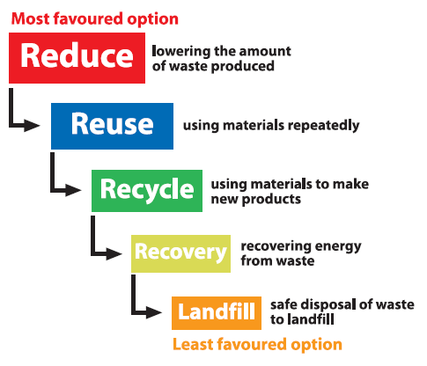

Waste streams should be segregated as required and always have a lid.
All hazardous waste containers should be lockable and remain locked when not in use
The fundamental principles of the waste hierarchy, eliminate, reduce, re-use, recycle, recovery, disposal will be applied to enable best practice on site and to improve the overall sustainability of the project.
This procedure applies to the storage, disposal and minimisation of all waste generated during the construction phase. It is also concerned with the establishment of procedures for complying with statutory and good practice requirements for waste management. The site manager is responsible for ensuring that the relevant documentation is completed and held on site.
All staff are responsible for adhering to the requirements of the standard EN.S.03. AGC shall, in order to reduce the need for waste disposal, minimise the generation of wastes and their potential environmental impacts, which may arise during the works and will maximise any opportunities for the re-use, recycling and recovery of wastes.
AGC will include proposals for the identification, segregation, handling and storage, with necessary protection to prevent cross contamination of surrounding stockpiles and the underlying ground, of the different types of wastes identified as arising from the works, where applicable.
All materials should be recycled, where applicable. Where possible, materials to be recycled will be sorted on-site and stockpiled accordingly, prior to collection.
Hazardous waste will be removed by a licensed waste contractor and appropriate measures made for their disposal in accordance with all applicable legislation. Where suspected contaminated ground or hazardous material is encountered that had not previously been identified by the prior site investigations, AGC is responsible for commissioning testing on samples to classify the extent and nature of these substances. This shall be undertaken by an UKAS accredited testing facility. Advice on testing to be undertaken can be obtained from the appointed Environment Advisor.
Stockpiling of potentially contaminated material should be avoided at times. If stockpiling is unavoidable, then material must be located, as a minimum, on hardstanding and covered with impermeable sheeting/membrane to prevent run off. Samples of excavated material will also be tested by AGC/the client, or an appointed consultant, to enable classification of the waste for disposal purposes.
All waste should be stored in appropriate containers to prevent escape of material. Necessary applications to the Local Authority and/or NRW/EA, under the terms of the Environmental Permitting Regulations 2016, and the Town and Country Planning Act (1990) for the storage, treatment or disposal of wastes will be undertaken.
The storage, handling, use, and disposal of any potentially hazardous materials shall be in accordance with the relevant statutory provisions and Health and Safety Executive (HSE) Codes of Practice and Guidance notes
In accordance with the waste standard EN.S.03, the Site Waste Management Plan (SWMP) EN.F.09 SWMP identifies the waste streams generated with forecast quantities, defines the selected waste management measures of reduction, reuse, recycling and recovery and, at the end of the project, allows a comparison to be made between forecast and actual waste quantities.
Quantities of waste, categorised as inert waste, non-hazardous waste and hazardous waste are input to the SWMP. Appendix 3 provides a template of the SWMP.

    - Materials Management
The environmental credentials of all raw materials imported will be taken into account. Locally sourced materials will be used wherever practical and economically possible along with the use of recycled materials and sustainably sourced timber according to the specification and performance requirements and whenever practicable and economically viable.
All raw and salvage materials will be appropriately stored on-site to minimise damage by vehicles, weather, contamination by other substances, or theft/vandalism. Secure storage will be provided for items of high value, materials which are hazardous, or which are easily damaged. Packaging will be retained on goods until the materials are required. Once removed, packaging materials will be stored and disposed of appropriately. Goods will be delivered on an “as needed/just in time” basis, this is in order to reduce stockpiling on-site, potential damage from vehicles and weather.
Stockpiles of all materials will be segregated and labelled accordingly to ensure to prevent the misuse of materials.
The location of soil stockpiles will be dependent upon the space available, the build programme and direction and therefore their precise location cannot be determined at the current stage. However, soils will be stockpiled at a distance from sensitive receptors such as existing residential areas or surface waters. Stockpiling will be undertaken in accordance with DEFRA guidance “Construction code of practice for the sustainable use of soils on construction sites, 2009”.
    - Unexpected Contamination
Should previously unidentified visual and/or olfactory evidence of potential contamination be encountered during the development, the Site Manager and/or Environment Advisor should be contacted immediately. Work should be stopped in the immediate area of the discovery and the area cordoned off until further notice.
The discovery should be inspected, investigated and sampled with analysis (soil or groundwater) undertaken by a suitably qualified engineer/scientist to assess the potential risk. Human health and/or controlled water risk assessment may be required to define the risk to end users and the environment. Depending upon the findings, additional investigation, risk assessment or remediation may be required. A specialist contractor may be required.
Any unforeseen contamination will be investigated and reported to the Local Planning Authority (LPA), as set by relevant planning conditions, to agree remedial requirements. Verification that works have been completed would be undertaken and a validation report submitted to the LA for approval.

Flood Risk
According to the NRW Development Advice Map, the development site is within Flood Zone 3, which is defined as areas at risk of flooding in the 0.5% probability flood event, from the sea, plus an allowance for climate change.
NRW Development Advice Map
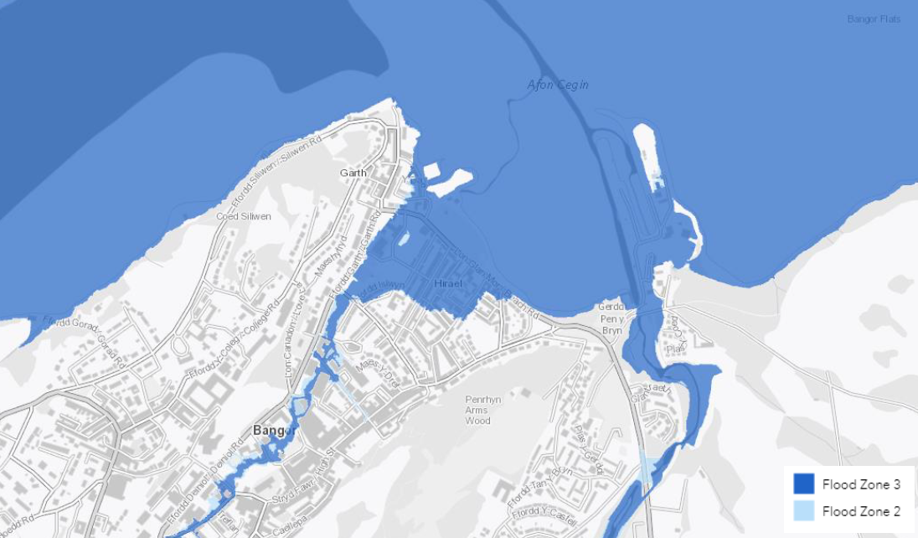
NRW Flood Risk Assessment Wales Map
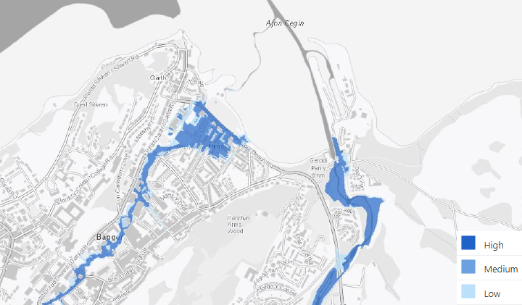
The NRW current Flood Risk Assessment Wales map also identifies the fluvial flood risk from the Afon Adda, a culverted watercourse which enters Hirael Bay near the Sewage Pumping Station, which pumps sewage to the Treborth Treatment Works

Water Management and Pollution (work activities)
    - Pollution of Land and Water
As a minimum the following control measures detailed in Table 5.8 will be implemented to prevent pollution.
Table 5.8 Pollution Control Measures
Activity | Control Measures
Operation of plant and equipment | Above ground oil storage tanks: GPP 2  Working at construction and demolition sites: PPG 6.  Generators/tower lights/ pumps should be stood on plant nappies
Storage of fuel and chemicals | Oil and fuel to be stored in accordance with the Oil Storage Regulations  Storage containers to be in good condition with proper fitted lids and secured against vandalism  Spill kits to be readily accessible in the event of a spillage  Storage areas to be at least 10m away from controlled waters
Highway works | Drains to be protected, where required and practicable
Working in/near water | Use biofuels in all plant. Follow works & maintenance in or near water: GPP5

A comprehensive assessment of the potential risks of water pollution as a result of work activities is made by the Project Manager. This is part of the activity risk assessment undertaken in accordance with AGC’s Procedure BMS.P.02 Risk Management. .
Control measures are selected in accordance with AGCs Procedures EN.S.04 Water Management and EN.S.08 Oil, Fuel and Chemical Management and associated guidance.
Particular attention is given to the following matters:
- work within water courses
- work over water courses
- run-off from earthworks
- work to existing drainage
- sub-surface grouting
- concreting
- dewatering
- excavation of contaminated ground
- activity related refuelling
- run-off from de-vegetated ground
- discharge from new drainage
    - Silt and Surface Water Runoff Mitigation Measures
The construction process has the potential to temporarily change site drainage conditions which will affect the storage capacity and surface water flows across site. This may result in the accidental discharge of silty water to surface water features. The programming and arrangement of works will therefore be carefully considered, with input from the Environment Advisor, to minimise the risk and will be subject to the following controls.
The Environmental Permitting (England and Wales) Regulations, 2016 (as amended) require all water discharges (groundwater, excavation water and rainfall) to surface waters be discharged under an Environmental Permit. However, there is a Regulatory Position Statement that allows the discharge of clean water from excavations for 3 months. All discharges will be controlled by an Environmental Permit to Proceed.
Watercourses and land will be protected from harm during construction by the use of appropriate mitigation measures such as silt fencing.
Discharge of construction water to a public sewer requires a Trade Effluent Consent from the local water company. The information required is similar to that required for an Environmental Permit.
Regular monitoring and reporting of all water discharges will be undertaken by the Environment Advisor.
The minimum pollution prevention requirements for construction surface water management practices/mitigation that will be applied during the development are detailed below. These practices/mitigations typically apply to the majority of construction sites and form general good practice.
- A Traffic Management Plan (TMP) may be implemented that will provide designated routes that will be used by heavy plant and for vehicle movements, particularly during topsoil stripping and excavation of soils. Where possible, designated routes will be gravelled and suitably compacted to form a clean running surface. Depending upon the build programme, the internal access roads will be finished to hardstanding subbase as soon as practicably possible to provide clean running surfaces. This will prevent construction plant from disturbing soft ground and mobilising sediment or create significant adverse impact to the construction surface water run-off quality onto roadways and into the drainage network and subsequently into the stream network.
- Soil stripping should be undertaken in dry weather and using a phased approach to minimise the amount of exposed soil across site.
- Areas subject to soil stripping and not forming part of the active construction zone will be demarcated as off limits to vehicle tracking. This will prevent unnecessary disturbance of soils.
- Wheeled plant such as telehandlers and dumper trucks should have their wheels cleaned and excess sediment removed from around the wheel housing prior to moving onto the wider public highway realm.
- It is advisable that a wheel washing facility is set up at the construction zone entrance/exit point should sediment adhere to vehicles. All vehicles leaving the construction zone should have their tracks/wheels washed via the use of a pressure-washer bowser, the resulting runoff will have to be controlled so as to not run onto roadways, into gullies or cause localised flooding of the entrance/exit.
- The Environment Agency (England only) has issued a low-risk waste position (LRWP) which applies if a project screens and dewaters, from the internal site roads only, no more than 30 tonnes of road sweeping waste over any 7-day period and stores no more than 12 tonnes of road sweeping waste at any one time
- Any pollution incidents (fuel or oil spills) will be cleaned up immediately following the incident. Any wastes will be removed from site for off-site disposal to prevent contamination from becoming entrained within the surface water infiltration system under the necessary permits and procedures.
- Contact where spill/incident/clean-up is beyond normal project capability: OHES Environmental 0333 600 2424
- No fuel storage will be allowed close to surface water attenuation ponds, stilling basins, trenches and weirs or directly close to surface waters and surface drainage
- Adhere to the and the Water Resources (Control of Pollution) (Oil Storage) (Wales) Regulations 2016
- Storage areas will not be located within 30m of surface water drains or highway gullies.
- Drums will be stored in bunded areas with a minimum capacity of 25% of the total volume contained within the bund, or 110% of the largest container, whichever is greater. Drums will be maintained in good condition, fitted with lids and labelled to indicate the contents.
- Trained operatives only will carry out refuelling of plant and equipment.
- Static combustion engine plant (e.g., compressors, lighting sets) will be integrally bunded or placed on drip trays.
- Vehicles are to be parked in a dedicated site car park. On street parking is to be prevented to allow a road brush access to clean the full width of the road and prevent surface waters from flowing past operational gullies.
- General good housekeeping shall be maintained across site, including the appropriate stockpiling of soils at a suitable distance from construction zone boundaries, surface water features, gullies and manhole covers to prevent debris from blocking up drainage infrastructure.
- The placement of gully guards in gullies maybe be installed during development for the duration of the construction project. These are to be inspected regularly and importantly replaced or cleaned as necessary, with a record kept. If found to be damaged, gully bags should be replaced immediately.
- The placement of a terram layer within all other non-operational manholes during construction, such as storm drain covers. These are to be inspected and replaced, when necessary, with a record kept.
- Pumps will be regularly checked for leaks and will be maintained in accordance with the manufacturer’s specification.
- Spill kits will be provided within close proximity to fuel and oil storage areas and operatives will be trained in their use.
- Fire extinguishers will be placed at re-fuelling points and will be ready to hand.
- Should a significant fuel spill occur, such as during a fuel bowser delivery, the appointed Environment Advisor will be contacted to obtain further advice. Spill kits would be deployed in the interim and a readily available stock will be kept on site in case of emergency
- Re-fuelling areas should be bunded, with spill kits located in close proximity to contain releases. Plant nappies will be utilised when refuelling is being undertaken.
- All delivery vehicles including HGVs should have their wheels washed prior to leaving the construction zone in order to prevent silt from being mobilised onto the public highway.
- Any excess sediment or silt slurries on roadways, particularly close to the construction zone entrance/exit points should be regularly scraped. This may be required multiple times each day, depending upon the prevailing weather conditions and traffic volume. Furthermore, it may need to be carried out more frequently during the day as opposed to just the start and end of the working day. Sediment and silt slurries should not be passed into surface water drainage systems and gullies.
- Sediment and silt slurries should be stored within the site boundary or an agreed storage area, away from gullies, drains and surface water receptors. It may be necessary to construct a temporary bunded area to contain this material, allowing it to dry out. Regular maintenance and cleaning of this bunded area should be undertaken to ensure continued capacity during wetter conditions.
- To clean excessive silt slurries at construction zones the use of road sweepers should be avoided. Road sweepers are not designed for this activity and further spread sediment on roadways if overwhelmed; or move sediment into the surface water drainage system. Agricultural brushes/road brushes are a good alternative system to move heavy sediment from roads.
- It is particularly important to note that road sweepers should not be used to clean up any hydrocarbon spillages in conjunction with undertaking general silt sweeping. This would result in the contamination of the silt that would subsequently require special treatment and/or costly off-site disposal as hazardous waste.
- Excavation water will not be discharged direct to surface water drains without prior treatment to remove silt.
- As a minimum, daily inspection of the roadways and surface water features should be undertaken.
    - Site Personnel and Documentation
The following measures are to be implemented by AGC and any subcontractors on the development to increase awareness of ground workers and site operatives:
- Undertake additional detailed site-specific awareness training (Toolbox Talk) on surface water, silt management and surface water/drainage protection for all ground workers.
- Include a detailed section relating to surface water drainage system protection within site induction folder.
- Undertake regular site inspections and obtain support from Environmental Consultant (if required).
    - Monitoring Procedures
The following monitoring procedures will be carried out regularly by the site management team to enable continuous review of the measures listed above. A comprehensive record of the effectiveness of the system will then be maintained to enable further review by any parties, such as the Local Planning Authority or NRW attending site:
- Inspection of all surface water mitigation measures, silt fencing, gullies, drains, gully bags and manholes to monitor surface water/sediment migration onto roadways. Maintenance, cleaning and replacement of silt mitigation measures, terram, gully bags and hay, as required.
- Monitoring of the surface water protection measures on a daily basis and more regularly during periods of heavy rainfall. To include photographs and any measurements recorded.
- This document will be reviewed and updated when required to reflect changes to site conditions and operations.
The water management and pollution risk assessment for site setup is contained within the RAMS for each relevant activity
    - Concrete Washout
A designated concrete washout area will be provided for washing out concrete delivery lorries, concrete pumps and grout lines. The final location will be determined based on the build programme and direction. Washout water is typically uplifted by vacuum tanker for off-site disposal or may be treated to remove alkalinity and re-used for dust suppression.
The direct ingress of mortar to the drainage system is not considered to be a significant risk as long as the recommendations above are adhered to.
    - Construction Aggregates
Typical aggregates used on construction sites include pea gravel and sand, which in themselves are considered to be unlikely to cause issues to surface waters owing to the large particulate size. Fine aggregates are typically not used on construction sites.
All construction aggregates will be stored in designated areas. These areas will be located away from the stream along the site boundaries, and drainage infrastructure, particularly road gullies. If appropriate, the aggregates will be bunded to prevent surface waters washing/remobilising the materials.

    - Energy Management
AGC seeks to reduce the emissions of greenhouse gases from the construction process on its projects and consequently looks for ways in which to reduce energy use. Sources of greenhouse gases contributing to the AGC ‘carbon footprint’ include:
- Electricity and gas supply for heating, lighting and services to site accommodation
- Gas oil used in site plant and site generators
- Petrol and diesel used for commuting and business travel
- Diesel used for transport of plant and materials
- Water supply and wastewater treatment
- Waste generation
Every effort is made to obtain grid supplied electricity to reduce dependence on diesel generators. Where this is not possible, an optimum size of generator is used with consideration given to a dual-generator system.
    - Environmental Non-Conformity NCR
Nonconformity in respect of environmental matters is recorded as an environmental incident, near miss or inspection finding. Reported via GEM System.
The responsibility for recording and reporting and investigating environmental incidents rests with line management, assisted as necessary by environment advisors trained in accident investigation techniques.
Incidents are reported in accordance with AGC’s Procedure HS.S.40 Incident Reporting Standard, and inspection findings are recorded on the environment department database in accordance with departmental procedures.
Investigation concentrates on identification of root causes in order that appropriate action can be taken to avoid recurrence. Periodic reviews of incidents are made and analysed to ensure that all necessary action has been taken. Recurrent problems or those relevant to other projects are referred to business unit system review meetings for the initiation of suitable longer-term actions.

Incident Management, Emergency Response and Notification
At all times the approach to a pollution incident to be be adopted is: STOP IT – CONTAIN IT – REPORT IT
In the case of spillages, for example, this process involves:
STOP
Stop all works pertaining to the incident, for example, to prevent further spillage turning of the valves/taps, righting the drum, stopping/restrict the flow at the source etc
CONTAIN
all sites are provided with spill kits, however further measures such as using sand or earth, absorbent pads, booms or skimmers or digging trenches etc. Use a spill kit to mop up the spillage. Contaminated material must be disposed of as hazardous waste.
REPORT
all pollution incidents to the Site Manager who will take the appropriate administrative action, in line with the AGC Accident/Incident/Near Miss Reporting Procedure.

In the event of a discharge of suspended solids or hydrocarbons into a surface water drain, the immediate stopping of all activities causing any form of pollution will be implemented to prevent further contamination.
In the event of a discharge of hydrocarbons, clean-up specialists may be used to facilitate a rapid response, where additional pollution control equipment may be required.
Environmental incidents will be reported to the project manager and/or appointed Environment Advisor, providing details of where and when the incident is taking place, what is happening, and who is responsible for the incident. Contact details for key site and emergency response personnel with responsibilities relating to the protection of the environment will be kept and publicised in key locations on site. Key contacts will include, Project Manager, Environment Advisor and the Client Project Manager.

Appendix 1– Environmental and Social Policy
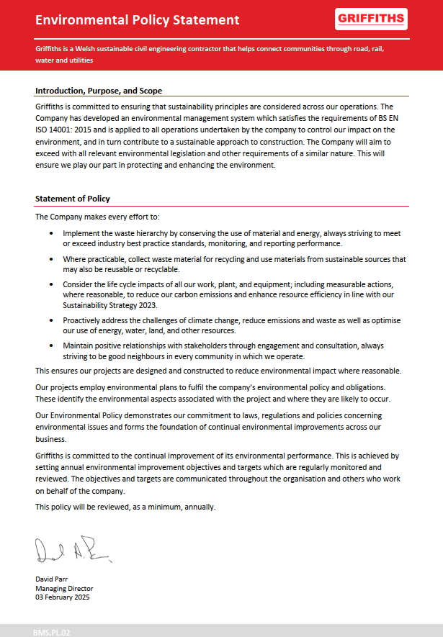

Appendix 2 – Organogram
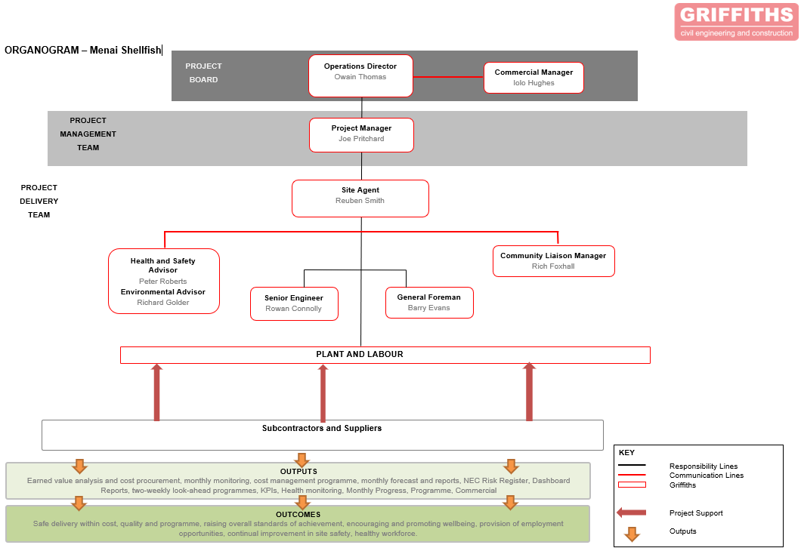

Appendix 3 – Site Waste Management Plan
Attached as separate document, below is the front cover sheet


