MARINE MAMMAL ENTANGLEMENT PROTOCOL

FOR THE PROPOSED EXTENSIONS OF CÂR-Y-MÔR CARN AR WIG AND PORTHLYSGI IMTA FARMS

1 Introduction
Câr-y-Môr has initiated a pioneering regenerative ocean farming system off the St Davids Peninsula in Pembrokeshire. There are two trial sites which this application is looking to expand, located at Carn ar Wig (Figure 1) and Porthlysgi (Figure 2). Currently, we are cultivating scallops (Pecten maximus), oysters (Ostrea edulis), and mussels (Mytilus edulis). This document outlines the marine mammal entanglement protocol that is being followed and will continue to be adhered to.
Section one provides an overview of the sea farm's development and lists the marine species most likely to be observed around the farm. Section two details the protocol for monitoring marine mammal and fish entanglement, as well as the knowledge required for employees to carry out these tasks. Section three presents an adaptive management plan. This includes the protocol to be followed if a marine mammal is found entangled in the farm, the reporting procedure for such incidents, and a process for implementing new practices based on these events. The farm manager of Câr-Y-Môr, currently Fergus Evans, is responsible for overseeing the protocol. All costs incurred by Câr-Y-Môr in relation to this protocol will be covered by the Society.

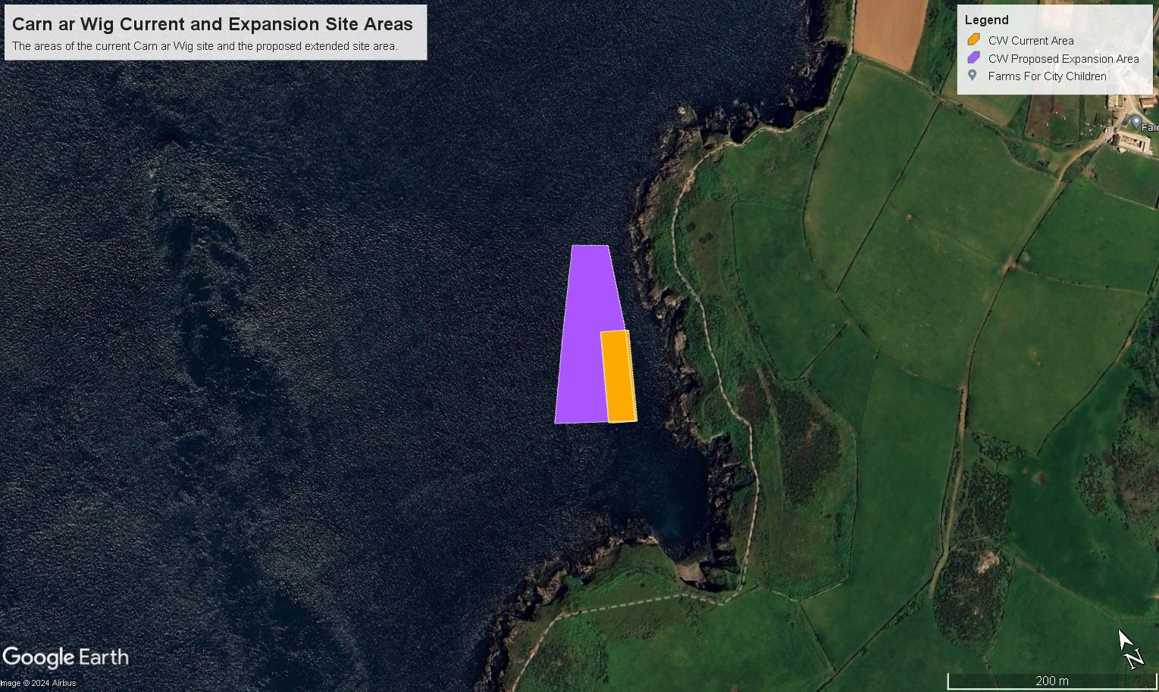
Figure 1: Carn ar Wig Current and Proposed Extension Sites. Orange shows the current Carn ar Wig site area, while purple shows the proposed area of the extended site.
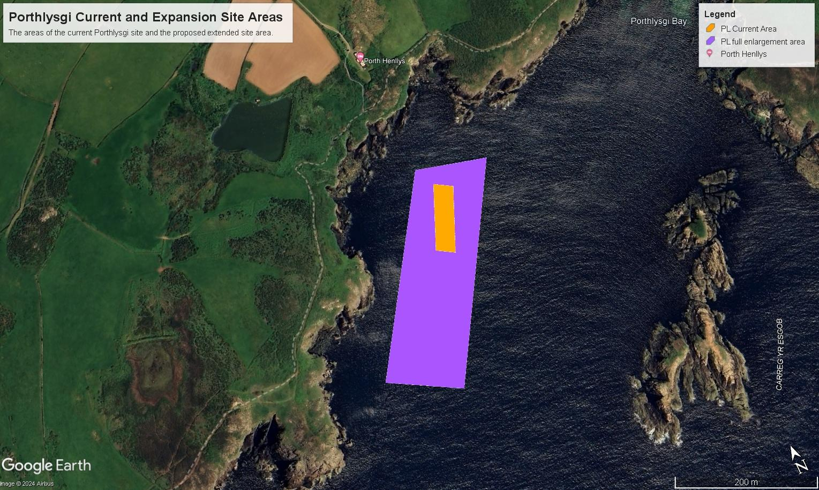
Figure 2: Porthlysgi Current and Proposed Extension Sites. Orange shows the current Porthlysgi site area, while purple shows the proposed area of the extended site.

Table 1 Trial Site Coordinates:
Site Name | Current Coordinates | Trial Site Extension Coordinates
Porthlysgi trial site | Longitude: -5.304682, Latitude: 51.863036  Longitude: -5.304309, Latitude: 51.862895  Longitude: -5.304918, Latitude: 51.862058  Longitude: -5.305277, Latitude: 51.862199 | Longitude: -5.3028, Latitude: 51.8628  Longitude: -5.3055, Latitude: 51.8602  Longitude: -5.3041, Latitude: 51.8634  Longitude: -5.3069, Latitude: 51.8607
Carn ar Wig trial site | Longitude: -5.315736, Latitude: 51.868074  Longitude: -5.315337, Latitude: 51.867964  Longitude: -5.315830, Latitude: 51.867141  Longitude: -5.316227, Latitude: 51.867242 | Longitude: -5.3151, Latitude: 51.8690  Longitude: -5.3160, Latitude: 51.8674  Longitude: -5.3156, Latitude: 51.8691  Longitude: -5.3171, Latitude: 51.8677  Longitude: -5.3163, Latitude: 51.8684  Longitude: -5.3155, Latitude: 51.8682

1.1 The Farms

The farms will implement a standard mussel rig system. Header lines will be positioned at the water's surface and equipped with standard mussel buoys. Initially, these buoys will be spaced 15 metres apart. As the stock develops, additional buoys will be added to increase buoyancy. Once the stock is fully mature, the buoys will be spaced approximately 7 metres apart. Dropper ropes will be attached to the header lines, hanging vertically in the water column to either collect spat or allow mussels to grow. Lantern nets, containing oysters, mussels, and scallops, will also be attached to the header lines. Please refer to the images below for an overview of the Car-y-Mor system.

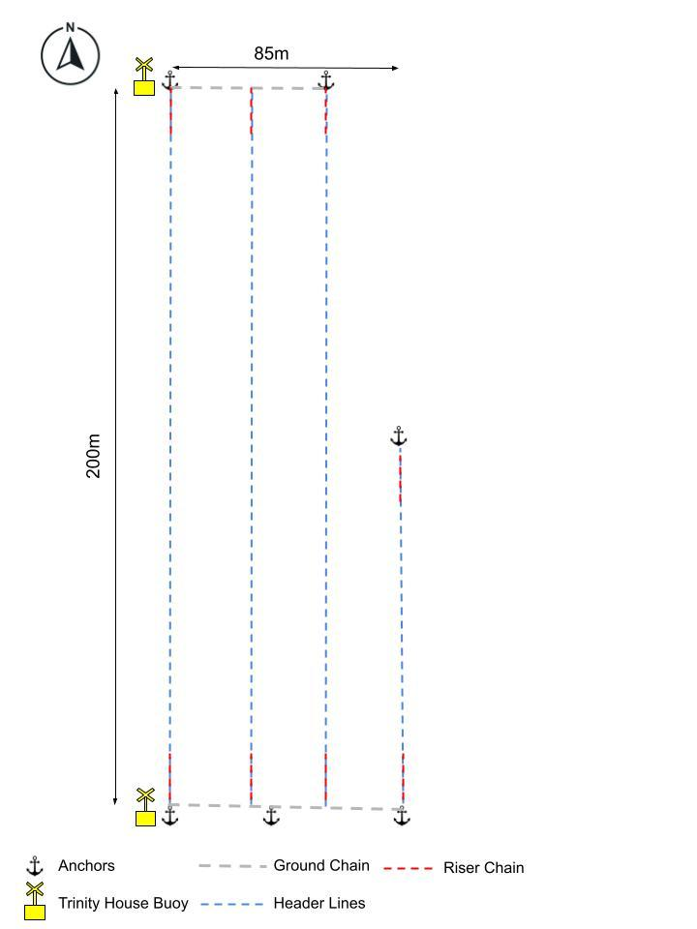

Figure 3: Carn ar Wig site rendering. 3 x 200 m and 1 x 90m header lines at the surface of the water.

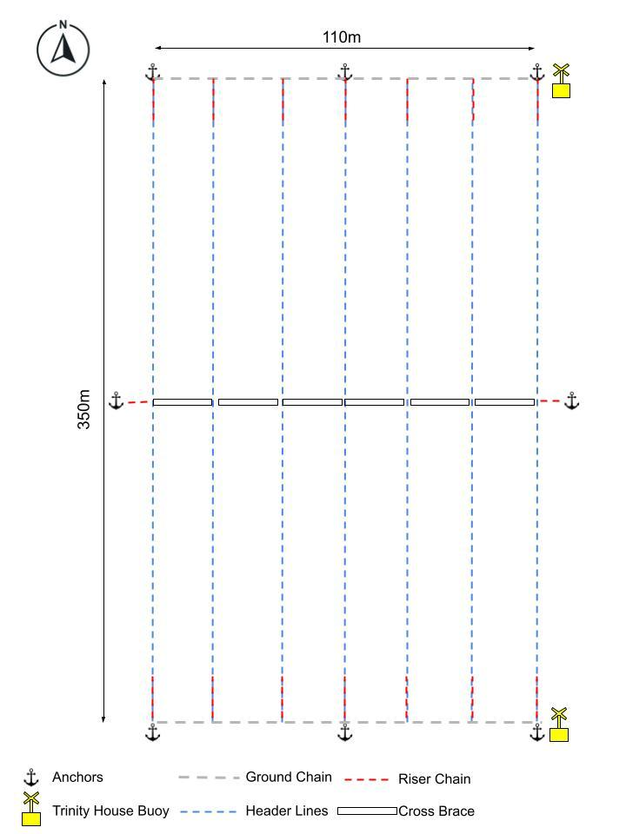

Figure 4: Porthlysgi site rendering. 14 x 320m headlines at the surface of the water.

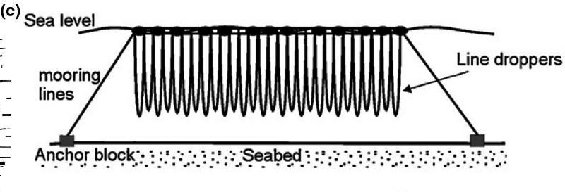
Figure 5: Mussel rigging system used by Câr-Y-Môr.

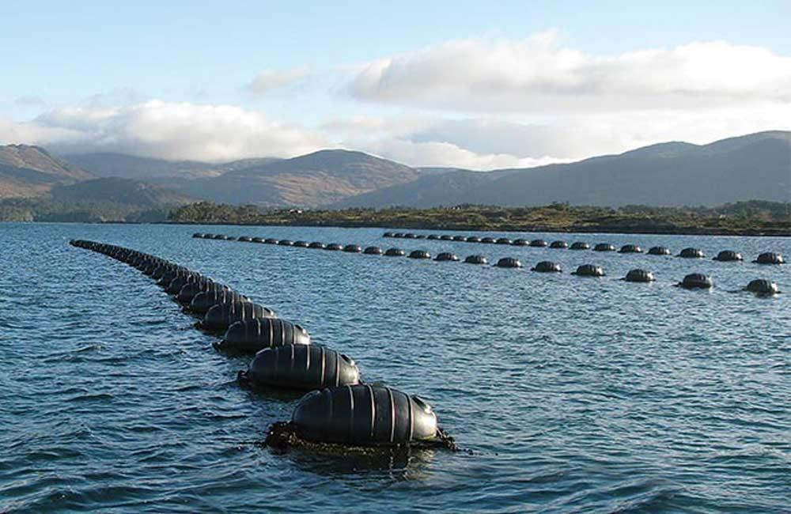

Figure 6: Example mussel farm.

1.2 Relevant Marine Megafauna in the Area
The Carn ar Wig and Porthlysgi sites are within sites designated for the conservation of marine mammals. These are the Pembrokeshire Marine SAC (Grey Seal / Otter), and the West Wales Marine SAC (Harbour Porpoise). However, a wider range of marine mammals may be observed in the region.

Notable marine megafauna present in the area include the grey seal (Halichoerus grypus), common dolphin (Delphinus delphis), bottlenose dolphin (Tursiops truncatus), harbour porpoises (Phocoena phocoena), Risso’s dolphin (Grampus griseus), Short-beaked common dolphin (Delphinus delphinus) and even some visiting whales such as the Northern minke whale (Balaenoptera acutorostrata). Grey seal haul-out sites are present in the Ramsey Sound. Grey seals are an Annex II species of Pembrokeshire Marine SAC with a breeding population of around 5,000 individuals This makes up 4% of the UK grey seal population. Pupping season is in the autumn, from August at the earliest, to December at the latest. The Ramsey Sound population is mostly on the southeast coast of the island.

There is a porpoise sensitive area within the Sound, identified under the Pembrokeshire Marine Code, with ‘cautionary’ areas to the north of the Sound, and ‘extreme caution’ areas to the south. Harbour Porpoise is a designated feature of West Wales Marine SAC. We would also note that even though we have only described the well known species in the area; this protocol applies to any and all marine megafauna species, due to the possibility of species uncommon in the region transiting in proximity to the farm area.

1.3 Risk to the species
Evidence of marine megafaunal interactions with shellfish farms globally is low (Kemper et al., 2003; Price et al., 2017). Our general hypothesis is that this means the risk of entanglement posed by the proposed farm is low as well. Over three years of monitoring we have come to the conclusion that marine megafauna do not interact with the site (report attached). However, the sites will continue to be monitored throughout the life of the farms.

2 Monitoring Plan
The monitoring plan provided in this section will remain in place throughout the full lifetime of the shellfish farms, including the current permission and any future extensions. The purpose of this monitoring plan is as follows:
- To ensure the staff understand how to observe, mitigate, and resolve cases of marine mammal entanglement.
- To inform how to conduct surface inspections to monitor entanglement risks.
- To inform how to conduct subsurface inspections to monitor entanglement risks.
Data collected during site monitoring (including, but not limited to, the spotting of marine megafauna during farm visits, entanglement incidents, and marine debris found around the site) will be shared with Natural Resources Wales and relevant stakeholders. Should a marine animal (marine mammal and/or fish) entanglement occur, the adaptive entanglement plan outlined in Section 3 will be implemented.
Reports on the data mentioned above will include:
- Any entanglement incidents that have occurred.
- Any identified entanglement hazards (including, but not limited to, damaged or loose gear and ghost fishing gear) and the actions taken to remedy them.
- Details of any marine mammals or other large megafauna recorded in proximity to the farm area.
These reports will be shared with Natural Resources Wales and relevant stakeholders on an annual basis.
2.1 Marine Entanglement Monitoring Training
Marine mammal entanglement monitoring training is designed to gain a better understanding of:
- How marine mammals interact with the sea-farm
- The proper procedures to follow should an animal be found entangled
The following training courses should be completed by at least one member of the crew operating the farm at any time (crew visiting the farm site for monitoring or maintenance purposes):
- Marine Mammal Medic Training Course: Offered by the British Divers Marine Life Rescue, this course is a comprehensive introduction to the procedures to follow when an entangled mammal is found.
- Marine Mammal Observer Training Course: This course is designed to give farm operators a better understanding of how to implement JNCC's mitigation guidelines for reducing impacts from impulsive noise.
2.2 Surface Inspections
Surface inspections will occur whenever the work barge can access the farms, typically several times per week, with a minimum frequency of once weekly. The farms are usually visited 2-4 times a week for maintenance, harvesting of species and monitoring of stock during which times surface inspections can be made. If access by boat is not possible, inspections will be conducted from the coast path using binoculars. No remote monitoring will be implemented due to the lack of phone signal in the area. To minimise risks to marine megafauna during site visits, the Pembrokeshire Marine Code and the SeaWise Code will be adhered to. Several team members have extensive experience in nature tours, sea kayaking, fishing, and marine farming, and are proficient in recognising and complying with these codes. New staff will be trained on these protocols.
During site inspections, the presence of marine megafauna within and around the farm site will be monitored. Local fishermen, who frequently operate near the farms, will also report any entanglement issues. Any ghost nets, fishing gear, or other debris that might increase entanglement risks will be removed during these visits.
A network of local individuals also monitors the farms, such as tour boats and kayakers who regularly visit and inspect the structures, many of whom are members or supporters of the Community Benefit Society and are encouraged to report any concerns. Additionally, local walkers on the coast path, especially during and after storms, often send in photos of the farms to help ensure everything is in good condition. This community involvement reflects the strong local support for the farms' success, which is seen as beneficial for employment and ecosystem services. However, Car-Y-Mor recognises that the onus for frequent and sufficient monitoring lies solely on us and as such the below protocols for surface and sub-surface inspections are carried out by farm staff 2-4 times a week.

Description of work barge employed by the farm and used for inspections, along with a 19 foot Aluminium tender :
- Aluminium hull construction.
- 10m x 4m Flat Bottom barge / pontoon with a 1m hull depth and cargo hold 2,5 x 1 x 0,9m.
- One Hydraulic Deck crane lifting 500 kg at 2,7m outreach in lightship condition (worst case) results in 1,8-degree heel, 1/2t Hydraulic Pot / Line Hauler Mounted on the Port Bow corner.
- The draft @ full load (8200 kg) Should be no more than 0,25 m and be capable of being coded to MCA COP 4 and 20 nm.
- To include a fully compliant Electronics and safety Equipment
- Railings to 1m along both sides, stern, removable working section on port side, heavy duty Dive ladder on transom.
- Vessel moves slowly <3knots north to south along lines. Onboard crane used to lift out lines.

These bespoke work vessels allow the best possible surface and subsurface inspections to be efficiently and effectively carried out each time the sea farms are visited - which is the ultimate safeguard to prevent entanglement. On each farm site visit the following inspection protocol will be carried out at the surface level:

Manual Sea-Farm Surface Inspection Protocol
Manual inspections carried out | Immediate actions taken | Future sea-farm design/operational changes
Checking rope tension of long-lines.  Entanglement of shellfish gear  buoyancy and alignment of buoys.  Wear on ropes.  Damage of trinity house buoys.  Flotsam, jetsam and ‘ghost’ fishing gear entangled in a sea-farm. | Slack mooring lines are adjusted to correct tension, worn components fixed or replaced. Replace buoy if damaged. Litter, ghost nets etc. removed. Inspect for damage to installation. | Any faults logged. Continual assessment of design. Modifications made as necessary.
Table 2: Manual sea-farm surface inspection protocol

2.3 Acoustic Monitoring

For the Love of the Sea has conducted acoustic monitoring with PEBL and Meece on several occasions over the past three years at the two sites. These surveys have confirmed the presence of porpoises, dolphins, and seals in the area at various times of the year and tide. The results also indicate that tour boats generate the most noise, except for the lifeboat during training and operations—an observation that aligns with common knowledge. The monitoring has not revealed any new significant information, and no entanglement issues have occurred throughout the years of operation.
However, the acoustic monitoring equipment poses a risk of entanglement with fishermen's potting strings, fishing lines, or the farm's structure. Given that this equipment is expensive and relatively fragile, we believe that the risk of entanglement can be further reduced by focusing the crew's time on servicing the basic farm structure and stock, and continuously inspecting for potential entanglement risks or issues, rather than on the multiple deployments and maintenance required for acoustic monitoring equipment. However, the collaboration between Car-Y-Mor and PEBL is ongoing so as funding/projects allow, future monitoring could be arranged to include further F-POD deployments.
2.4 Sub Surface Inspections
Visual sub-surface inspections will be conducted during each site visit using the work barge and tender. The water clarity in the area is generally very good, ranging from 5 to 7 metres, allowing observers to clearly see into the water column. The headlines, framing lines, seaweed lines, and lanterns are situated above this depth, with all other underwater growing equipment attached to the headlines. In the rare event of an entanglement, the headlines would appear distorted, which would be noticeable from our boats even when water visibility is occasionally poor. Any misalignment of the buoys and headlines would prompt an immediate investigation, with the headlines being lifted using the barge crane.
We have tested underwater cameras for monitoring purposes, but the site's tide and swell conditions make it challenging to obtain high-quality footage. From experience, we know that the quickest and most effective method to check for entanglement is to lift the gear with the crane. Additionally, in the unlikely event of an animal entanglement, it is crucial to release the animal as quickly as possible, especially air-breathing mammals, to ensure their survival. Therefore, we have concluded that lifting the gear is a more efficient and reliable approach than attempting to use underwater cameras.
.Manual Inspections
Manual inspections carried out | Immediate actions taken | Future sea-farm design/operational changes
Observers on the vessel deck monitor for:  - Entanglement in shellfish gear  - Debris or ghost fishing nets entangled in the sea farm  Misalignment of buoys indicates potential subsurface issues that need inspection  Annual checks by divers include:  - Chain inspections  - Anchor inspections | If repairs are required:  - The anchor and chain are winched onto the deck  - Repairs or replacements are made as necessary  - The anchor and chain are then re-deployed in the same position and orientation | Different designs of equipment are used to prevent future wear.
Table 3. Manual sea farm sub surface inspection protocol.

3 Adaptive Entanglement Management Plan
Should an entanglement incident occur the relevant authorities will be notified (see section 3.1.1). A report on the incident will be given to NRW and any other bodies that may request a copy. Sections 3.1 and 3.2 give more detail on the procedures for an immediate response to an incident and the steps that will take place following the immediate response.

3.1 Immediate Response

In the event of an entanglement, if the animal can’t immediately be successfully released, the personnel onboard the vessel will immediately report any live entanglements to the British Divers Marine Life Rescue (BDMLR) to get help for the animal, followed by Natural Resources Wales. Any deceased entanglements should be reported to the Cetacean Stranding Investigation Programme (CSIP), followed by Natural Resources Wales. Contact details for these organisations can be found in Section 3.1.1. Please follow the advice provided by the organisations once you have reported the incident.

3.1.1 Identification of relevant protection organisations
Several relevant conservation and rescue bodies with an interest in marine animal entanglement have been identified. They are as follows:
- Natural Resources Wales (NRW) Tel: 0300 065 3000, email: icc@naturalresourceswales.gov.uk
- Cetacean Stranding Investigation Programme (CSIP), tel: 0800 6520333
- British Divers Marine Life Rescue (BDMLR), tel: 01825 765546
- Welsh Marine Life Rescue (WMLR), tel: 01646 692943
- Royal Society for the Prevention of Cruelty to Animals (RSPCA), tel: 0300 1234 999

3.1.2 Reporting Trapped or Deceased Species
Immediately following an entanglement incident an initial report will be prepared and sent to NRW within five working days of the initial entanglement discovery. The entanglement event report will include the following:
- Location (GPS coordinates)
- Time and date the entanglement was identified
- Status; alive or dead on discovery
- Species or a description to facilitate ID (length, colouration, physical characteristics or identifying features)
- Estimated size
- Condition (any obvious wounds or status of decomposition if dead)
- Description of entanglement (location relative to the surface, number and locations of ropes or other gear on the body, etc.
A full event report will then be submitted following further investigations into the incident. This will include information from the original report as well as:
- Photographs
- Post-discovery actions and results (e.g. rescue attempted or recovered for necropsy, etc).

3.2 Steps Taken Post Entanglement Event
After the initial entanglement report is submitted, we would then begin consultation with Natural Resources Wales about the most practical means to prevent future entanglements and ensure safe operation of the farm. Below are some suggestions of technologies that may prevent entanglement. However, none of the potential adaptive management measures detailed in Table 6 would be implemented until consultation has taken place.

Species at risk | Primary mitigation strategy | Immediate Action
Cetaceans | Use of acoustic deterrent on sea-farm such as dolphin pingers⁵ | All farm infrastructure will be removed from the water. We would then begin consultation with Natural Resources Wales about how to move forward to prevent future entanglements and ensure safe operation of the farm.
Sea Turtles | Currently no technological deterrents are available. Ensure the sea-farm is fully operational and conduct inspections as outlined in section 2. | Submit an incident report and consult with NRW on how best to proceed.
Seals | Use of acoustic deterrent on sea-farm | Submit an incident report and consult with NRW on how best to proceed.
Table 6: Adaptive entanglement mitigation strategies

4 Conclusion
Should an incident occur, we will submit an initial report and a follow-up report a year later detailing the effectiveness of the various monitoring and response strategies to NRW. These reports will include:
- Summaries of any entanglement incidents that have occurred (in addition to the immediate incident report)
- Details of all entanglement inspections, including, at a minimum:
  - Date and time
  - Duration
  - Conditions
  - Survey type (surface or subsurface)
  - Inspectors details
  - Any identified entanglement hazards (including but not limited to damaged or loose gear and ghost fishing gear)
  - Actions taken to remedy identified hazards
  - Marine mammals or other large megafauna identified in proximity to the farm area (position/distance of animal, species ID, number of animals)
These details will be recorded to ensure comprehensive monitoring and effective response to any incidents, enhancing the overall safety and sustainability of our operations. ​
5 References
Kemper, C. M., Pemberton, D., Cawthorn, M., Heinrich, S., Mann, J., Würsig, B., Shaughnessy, P., & Gales, R. (2003). Aquaculture and Marine Mammals: Co-Existence or Conflict? In Marine mammals: fisheries, tourism and management issues (Issue January, pp. 208–226). CSIRO. https://www.researchgate.net/publication/260392957_AQUACULTURE_AND_MARINE_MAMMAL_CO-EXISTENCE_OR_CONFLICT

Price, C. S., Keane, E., Morin, D., Vaccaro, C., Bean, D., & Morris, J. A. (2017). Protected species and marine aquaculture interactions. In NOAA Technical Memorandum NOA NCCOS (Vol. 211, Issue January).

