Template A5 Seaweed harvesting

Project Definition:
The activity will be undertaken at both Carn Ar Wig and Porthlysgi, 2 existing sites which Câr-y-Môr is looking to expand. The sites are located in the Ramsey Sound and Porthlysgi Bay, both in Pembrokeshire. The current and proposed expansion coordinates are as below:

Site Name | Current Coordinates | Expansion Coordinates
Porthlysgi | Longitude: -5.304682, Latitude: 51.863036  Longitude: -5.304309, Latitude: 51.862895  Longitude: -5.304918, Latitude: 51.862058  Longitude: -5.305277, Latitude: 51.862199 | Longitude: -5.303021, Latitude: 51.862639  Longitude: -5.305677, Latitude: 51.859996  Longitude: -5.304358, Latitude: 51.863163  Longitude: -5.307102, Latitude: 51.860495
Carn ar Wig | Longitude: -5.315736, Latitude: 51.868074  Longitude: -5.315337, Latitude: 51.867964  Longitude: -5.315830, Latitude: 51.867141  Longitude: -5.316227, Latitude: 51.867242 | Longitude: -5.315138, Latitude: 51.868999  Longitude: -5.315974, Latitude: 51.867356  Longitude: -5.315646, Latitude: 51.869147  Longitude: -5.317075, Latitude: 51.867665

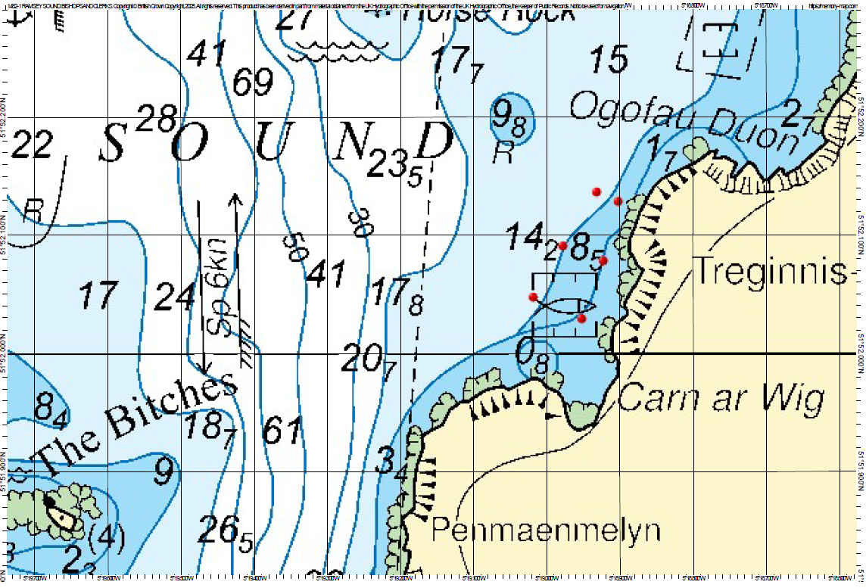

Figure 1 - Chart showing the expanded site boundaries (red dots) for Carn Ar Wig

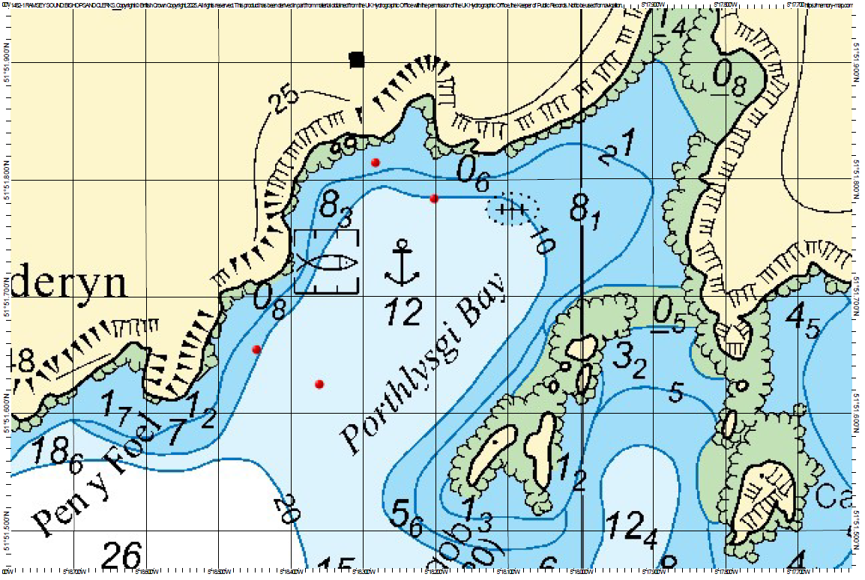

Figure 2 - Chart showing the expanded site boundaries (red dots) for Porthlysgi

Both sites will be IMTA (Integrated Multi Trophic Aquaculture) sites, and therefore there will be both shellfish and seaweed grown on the sites. The seaweed will be grown on cultivation lines suspended ~2m underneath the surface of the water and attached to header lines on each end of the farm. To remove the seaweed the Câr-y-Môr work barge will be used to lift the cultivation lines by use of a crane on board the boat, and then crew will use hand tools such as scissors/knives/shears etc to cut the seaweed from the lines. The barge will then move along the line allowing access to more seaweed for harvesting. Once the season is over, the cultivation lines are removed from the water and stripped clean ready to be reused for the next year’s seeding.

Description of existing environment:
What is the nature of the seabed/coast in the vicinity of the seaweed harvesting area and to what extent might it be sensitive to an increase in wave energy? (Reference: 1,2,3,4,5,6,7)

Both sites are situated within Policy Development Zone 3 - St David’s to Strumble Head of Shoreline Management Plan 21: St Ann’s Head to Great Ormes Head. This Shoreline Management Plan describes the coastline as cliffs around both sites. The seabed at Carn Ar Wig is a mixture of patches of rocky substrates consisting of boulder, pebbles and cobbles and then coarse sediment areas with some sand/gravel. Porthlysgi is a sandy bay with some kelp-covered rocky areas to the north-west of the site area closer to the cliffs. Both areas are subject to large ranges in wave energy over the course of the year and are described as ‘Exposed to moderately wave-exposed’ areas of rock according to Broadscale Habitat Maps provided by JNCC’s EUSeaMap 2023 meaning these are already high energy environments and therefore would not be sensitive to an increase in wave energy.
Is the setting exposed to wind/ wave activity (e.g. open coast) or sheltered (e.g. up-estuary)?

Carn Ar Wig is located on the eastern edge of the Ramsey Sound and so depending on the direction of the wind it can be exposed to wind/wave activity. If the wind is coming from the west then Ramsey Island tends to provide shelter and block the wind/wave action from reaching the sound. Porthlysgi is located inside Porthlysgi Bay and so again depending on the direction of the wind it can be sheltered unless the wind direction is pushing waves directly into the bay.

For the location of interest, to what extent does the presence of seaweed attenuate wave energy?

It is possible that large areas of dense seaweed can attenuate wave energy. However the proposed farm areas will be used to cultivate both shellfish and seaweed, thus reducing the density of the seaweed lines which will be interspersed through shellfish lantern nets and spat ropes. Carn Ar Wig and Porthlysgi will also be 2 and 3Ha sites respectively which limits the effect the farms will have on wave energy in the area, particularly as the Ramsey Sound is known for being a high energy environment with powerful waves often passing through and strong currents. However, the farms are located close to the cliff faces and in Porthlysgi’s case tucked into the bay, so there is a possibility that they will provide some protection to these cliffs from potential erosion.

What is the approximate tidal range (spring and neap)? (Reference: 8)

The ABPmer Renewables atlas does not have any data for within the Ramsey Sound. However, a paper published in 2023 by researchers at Plymouth University found an average tidal range of 5.05m (Miles, J., Coles, D., Simmonds, D., Paine, A., & Barr, S. (2023). Measurements of tidal flow variability in Ramsey Sound, Pembrokeshire. Proceedings of the European Wave and Tidal Energy Conference, 15. https://doi.org/10.36688/ewtec-2023-228).

What is the elevation of the seabed/ inter-tidal in the area of the activity, relative to Mean High Water of Spring Tides? (Reference: 2,3,4,5,9,10)

The DataMapWales website provides data on Bathymetry around the UK including the Ramsey Sound. This data shows depth as metres below chart datum, where chart datum approximates to Lowest Astronomical Tide. This data shows Porthlysgi Bay to be at 10m depth consistently with where the Porthlysgi site will be and Carn Ar Wig to be at 10m depth on the northern edge, reaching as shallow as 5m on the south-eastern edge.

What are the average and peak current speeds? (Reference: 8)

The ABPmer Renewables atlas does not have any data for within the Ramsey Sound. However, a paper published in 2023 by researchers at Plymouth University found ‘Peak mean flows on the spring flood appear to reach 3.19 m/s, consistent with [Evans, P., Mason-Jones, A., Wilson, C., Wooldridge, C., O'Doherty, T., O'Doherty, D., 2015. Constraints on extractable power from energetic tidal straits. Renewable Energy, 81 (2015) 707-722. DOI: 10.1016/j.renene.2015.03.085], however analysis of the data against rank suggests the highest three measurements are slightly greater than the general data distribution, and a maximum of 2.75 m/s is possibly more realistic. The ebb (southerly) maximum was 2.01 m/s. The residual tide (average over the two weeks) was 0.14 m/s in a northerly direction. The spring–neap variability was clearly visible, with neap tide northerly flows peaking at 1.68 m/s and southerly flows reaching 1.29 m/s’ (Miles, J., Coles, D., Simmonds, D., Paine, A., & Barr, S. (2023). Measurements of tidal flow variability in Ramsey Sound, Pembrokeshire. Proceedings of the European Wave and Tidal Energy Conference, 15. https://doi.org/10.36688/ewtec-2023-228).

What are the characteristics of the seabed/ inter-tidal sediments at the site which may be disturbed (including shallow geology)? (Reference: 2,3,4,5,6,7)

Carn Ar Wig has a mixture of boulders, pebbles, cobbles and some coarse sediment including gravel and sand, Porthlysgi is mainly a sandy/coarse sediment habitat with some kelp covered rocks on the north-west edge of the farm. As the seaweed is grown in the top 2m of the water column the only anticipated effects of growing seaweed here would be from the anchors placed on the seabed which has been assessed in great detail in the Baseline Benthic Habitat Survey Report also submitted as part of this application.

Is the nearby coast eroding? (Reference: 1)

The cliffs around the coastline of both sites are classed as eroding slowly within the Shoreline Management Plan and the overall intent of managing this area of the coast is to allow the natural development of the shore with ‘No Active Intervention’ listed as the Policy Plan for 2025, 2055 and 2105.

What is the direction (and ideally rate) of longshore/ seabed sediment transport? (Reference: 1)

The Shoreline Management Plan does not mention seabed sediment transport and only references longshore drift once, where it determines there is no significant longshore drift occurring at Whitesands Bay. There are no beaches on the coastline adjacent to the sites and so longshore drift would not be considered a concern here.

Impact assessment
How might currents be modified through removal of seaweed and could this change the sediment characteristics of the seabed in nearby areas, through modification of sedimentation rates?

The currents in the Ramsey Sound can be very strong; through first hand observations of the existing farms already located at the 2 sites being proposed, we have seen currents that are too powerful for us to be able to access the farm infrastructure even using mechanical assistance such as the crane and deck winch on the boat. The effects of these currents have been observed even in the centre of St Justinian’s, our third site which is 3Ha and grows only seaweed which would present a greater density than the sites proposed here. Therefore it is unlikely that removing the farmed seaweed in this area would have any effect on the current speeds in the Ramsey Sound. As this area is described as a high energy area and is well known to have strong currents it is very unlikely that farming seaweed here would have any effect on the sediment of the seabed in this area, and this is backed up through diver footage taken over several years on the existing farms which have been in this location for 5 years.

