Checking whether a bespoke application is duly made – WDA/GWA

Complete all dates DD/MM/YY. When all the checks are done update the dates, our IT systems and make sure everything is saved correctly to the DMS. Save the completed document to DMS using the title Duly Making Checklist (public register document). Delete boxes that do not apply to the application.

! Important
We have 21 calendar days from receipt of an application to decide if it is duly made. If we request additional information, the applicant should return it within 10 working days.
The duly made date is either…
(i). the date the application was originally received at Natural Resources Wales in the event of no additional information being requested during the duly make process or
(ii). the date at which the final piece of additional information requested during the duly make process is received.

Summary

Application details
Application Reference | PAN-004149
Applicant name | Mohammed Hillal Bin Tarraf Al Mansoori
Facility name | Ynys Y Bont, Aberan, Brecon, LD3 9NN
NRM Area | NRM Usk
Local Authority | Powys County Council
Dates
Date arrived in Permit Receipt Centre |  | 11/12/2018
Date arrived with Permitting Officer |  | 19/12/2018
Date RFI sent |  | 20/12/2018
Date duly made |  | DD/MM/YYYYY
Anticipated Issue Due Date based on complexity of application (i.e. 1 or 2 months for simples / 3 or 4 months for complex: this needs to match the PALS Due Date). |  | DD/MM/YYYYY
Date payment made |  | DD/MM/YYYYY
Date returned to applicant or deemed withdrawn |  | DD/MM/YYYYY
Date applicant sent duly made letter |  | DD/MM/YYYYY
If asked to acknowledge a cheque payment date this acknowledgement sent: |  | DD/MM/YYYYY

! Important: If a customer gives feedback on the form the Permitting Officer should make sure this is passed on to the Permitting Development and Support team.

Permitting Officer carrying out Duly Made Assessment: | Date
Tara Al-Far | 19/12/2018

Initial checks, including payment, confidentiality, national security and declaration - Part F1 or F2 (and relevant parts of B6.5)
Is the form complete and does it contain all the right information…. | Yes | No
Has the correct application form (and version of the form) been used? | x
Is the fee correct based on the activity described?  Fee paid (delete as appropriate): £125  Payment type (delete as appropriate): BACS | x
Does the application contain notification of national security issues/ or asked for any information to be kept confidential? If yes all officers involved must follow Environmental permitting: dealing with claims for national security |  | x
Has the correct person completed the declaration and do we have declarations for each applicant? Check against relevant people. | x

Application form Part A (and relevant parts of B6.5)
Is the form complete and does it contain the right information… | Yes | No
Applicant details complete? | x
Is the applicant a legal person as per definition of ‘operator’? Note: for registered companies and Limited Liability Partnerships check it is registered on Companies House. | x
Address details complete? | x
Contact details complete? | x

Application Types | Forms
Bespoke domestic sewage (<15m3/d to GW / <20m3/d to SW) | B6.5
Bespoke domestic sewage (>15m3/d to GW / >20m3/d to SW) and or all trade discharges | B2 and B6
- Bespoke Land Spreading discharges (i.e. sheep dip) | B2 and B7
NB: Make sure there is a section in the B6 for each type of facility listed in Part B2.

Location and habitats checks – to complete for all applications
National Park (SW discharges only) | SPZ | Drinking water protected area | SAC | SPA | Ramsar | SSSI | Protected species | Shellfish or bathing water
Y/N | 1/2/3/N | Y/N | Y / N | Y/N | Y / N | Y / N | Y/ N | Y / N

Application form Part B6.5 – new bespoke for domestic sewage < 15m3/day to ground / <20m3 to SW
Is the form complete and does it contain the right information… | Yes | No | N/A
1 & 2a. Complete Part A section above | x
2b - d. Site name, address and NGR provided?  Type of activity confirmed? | x
3. Confirmed that read guidance and management system will meet requirements? | x
4. Has applicant provided a site plan and it is clear enough? | x
5a. Type of premises stated? | x
5b. Distance to foul sewer provided? If any part of the premises is within 30m of sewer, the applicant must provide evidence that they have approached the sewerage undertaker and submitted their formal response regarding connection. They must also show the difference in cost between connection to foul sewer and cost of purchase and installation of the proposed treatment facility. | x
5c -d. Is the foul sewer within 30m?  Have they provided adequate justification for a non-mains drainage system? (If yes ensure follow non-proliferation policy OI 538_06) |  | x
5e. Volume and calculations provided and correct? If table 1 not used(if applicant hasn’t used the table to work out volume) |  | x
5f. Type of system given?  If ‘other’ have design details been provided? | x
5g. Sample point NGR provided? (if not at the outlet) (note that existing discharges to ground less than 5m3/day don’t need to provide a sample point) | x
5h. Discharge Point NGR provided? | x
5i. Receiving environment in Table 2 provided? | x
6 -10. Relevant section completed (depending on receiving environment) | x
11a –b. Start date provided?  Will the discharge take place all year? |  | x
11c-d- 15. As per Part F2 above | x

Application form Part B2 – new bespoke
Note: questions 1a-c, 2, 3d 6a, 6c and 7 only are relevant to WQ. | Yes | No | N/A
1a-c.
2. Site name, address and NGR provided?
3d. Summary of management system provided?
6a. Has applicant provided a site plan?
(Site plan must include the treatment facility, pipework and discharge point outlined in green. Sample point should also be marked on site plan).
6c. Non-technical summary provided?
7. H1 risk assessment provided?

Application form Part B6 – new bespoke WDA/GWA
Is all information in Part B6 complete and each associated document acceptable? | Yes | No | N/A
Table 1. Check the applicant has completed all the questions that they need to.
1. Brief description of effluent description provided?
2a. Start date provided? If chargeable, remember to explain to applicant that this is when annual charges will start.
2b. End date provided?
2c. Discharge all year? If no, discharge periods provided?
3. Is the discharge in a sewered area? If yes, applicant must provide evidence that they have approached the sewerage undertaker and submitted their formal response regarding connection. They must also show the difference in cost between connection to foul sewer and cost of purchase and installation of the proposed treatment facility.
4. Volume / rate provided?
4f. Separate sheet provided to show how figures calculated?
5. Intermittent discharges - relevant questions completed?
(refer to B6 table 1 to check)
5m. Separate sheet provided to show how figures calculated?
6a. Will effluent be treated? If no, justification provided on separate sheet? Question to be added from 04/12.
6b. Stages of treatment / overall design provided?
6c. Has the applicant provided detail of final effluent discharge quality? Question to be added from 04/12.
7a – e Will the discharge will contain dangerous / priority / hazardous substances?
Has the applicant ticked the boxes in a – d or is this type of discharge likely to contain dangerous / priority / hazardous substances e.g. trade effluents?
If yes, applicant must provide sample data.
7f-g Temperature of discharge provided? (trade effluent only)
8. Relevant monitoring NGRs provided?
8d - e. Flow measurement details provided? (check against EPR 7.01 sec. 2.4.3.2)
8g. Monitoring points marked on site plan?
9. Emissions management plan provided? Note this question doesn’t apply to domestic sewage discharges less than 15 m3/day to ground / less than 20m3/day to surface water. (Examples - polymer / chemical dosing or fish farm management plans)
10. Design Criteria. Has the applicant submitted modelling / H1 risk assessment to support the application? Note this question doesn’t apply to domestic sewage discharges less than 15 m3/day to ground / less than 20m3/day to surface water.
10a. Final effluent from a water company WwTW or intermittent sewage discharges – sewer modelling report or water company / Environment Agency approval form must be submitted.
10b. Discharges to lakes, estuaries, coastal or bathing waters – modelling must be submitted.
10c. Discharge to non-tidal rivers – applicant can choose to do the assessment or ask us to do it on their behalf.
10d. Discharge to groundwater – H1 annex J risk assessment must be submitted. Question to be added from 04/12. but is an existing H1 requirement. Groundwater remediation schemes – remediation strategy agreed with area GW&CL team must be submitted.
10e. Environmental impact assessment
11. Relevant annex and questions in that annex completed?
Is the application accompanied by the supporting documents relevant to the type of application? (e.g. Site specific risk assessment; UPM modelling work; area sign off sheet)

Application form Part B7 – new bespoke Land Spreading activity (i.e. sheep dip)
Is all information in Part B7 complete and each associated document acceptable? | Yes | No | N/A
1. Site plan and NGR, size and description of the discharge area provided? The site plan should show the boundaries of the discharge area, ownership or tenancy boundaries and water and land features. Example plan in B7 guidance.
2a - c. Details of water features provided and identified on site plan?
2d. Any permits or agreements within 500m? Details provided?
2 e -g. Soil characteristics provided?
2h – l. Drainage details provided?
2 m – n. Vegetation details provided?
Relevant appendix and questions in that appendix completed?

Decision summary
1 | Is the application sufficiently complete for us to begin determination and have we received the right fee?  Yes >>> Application is duly made (complete below and go to Q4):  No >>> Send a Request for information letter asking for the information required to complete the application. Give applicant 10 working days to supply missing information The email should include the paragraphs to be included in the letter to request further information. (complete below and go to Q3):
  Date of decision (i.e. DM assessed date) | DD/MM/YYYYY
  Duly made date (i.e. date application deemed complete) | DD/MM/YYYYY
  Date letter sent: | 20/12/2018
2 | Has the requested information been received within the 10 days given?  No >>> not duly made. Go to 3.  Yes >>> go to 1.Further information should be returned to P&SC so that the dates can be recorded on log and track, and the information can be added to EDRM and the public register. If NPT carried out additional technical checks, P&SC should contact the NPT officer to confirm that the additional information is sufficient to duly make the application.
3 | Send a Not duly made letter and state that fees are to be returned with the application.  Add details of RFI in notes box below and complete not duly made box). Save this report to the DMS with any other correspondence.
4 | Is the duly made application for a site of high public interest?  Yes >>> For high public interest contact area to discuss stakeholder engagement plan and whether or not we need to advertise in a newspaper.  No >>> Send duly made letter

Only complete the following if application is not duly made
Are we returning the application fee to the applicant? | Yes |  | No
Yes: date fee is returned: | DD/MM/YYYYY
No: state reason why we have not returned the charge:

Only complete the following if application is withdrawn before it is duly made
Date application withdrawn | DD/MM/YYYYY
Date we return fee | DD/MM/YYYYY

Decision and actions required
BAC’s payment not found
Applicant to confirm location of discharge point as NGR given does not correspond to site plan see below:
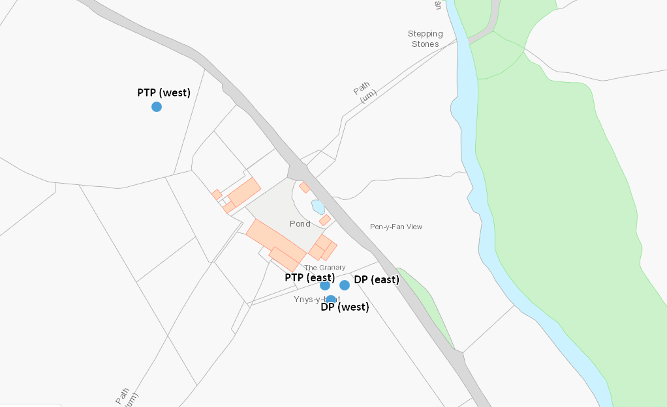
Volume calculations have been combined for both permits and then divided by two. Unable to work out separate flows and loads for each treatment facility. Ask applicant to verify which buildings and activities relate to each permit and submit 2 individual calculation sheets. Additionally, calculation for hand wash units is incorrect: based on estimated usage total volume should be 140 L rather than 14 L.
Permit start date not included

