PAN-028759 My Map Report:

surface water courses

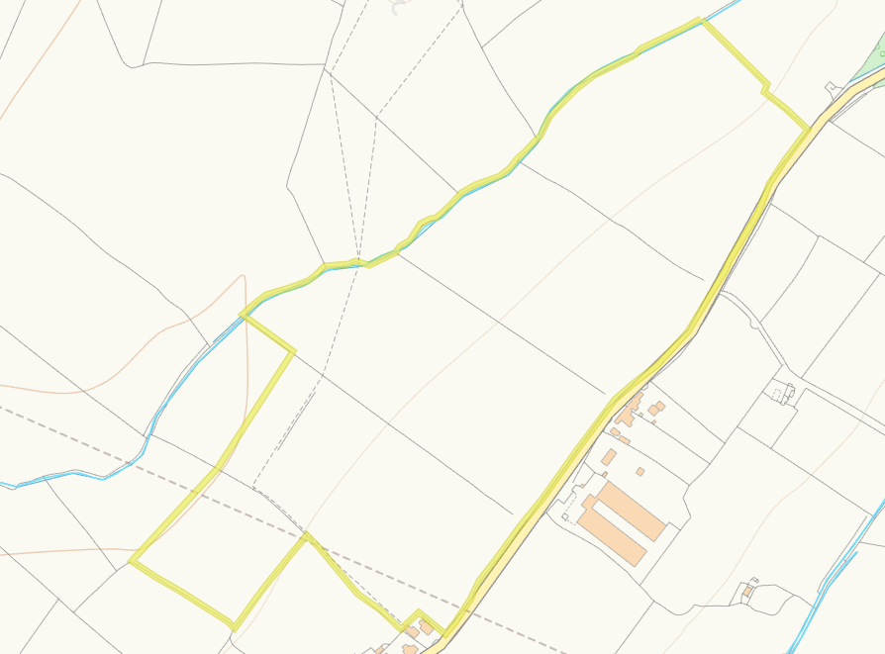
A drain runs along the border of fields 11, 12 ad 13. A 10m no spread buffer zone. A 10m no spread buffer has been applied on this border which is compliant with permit conditions.
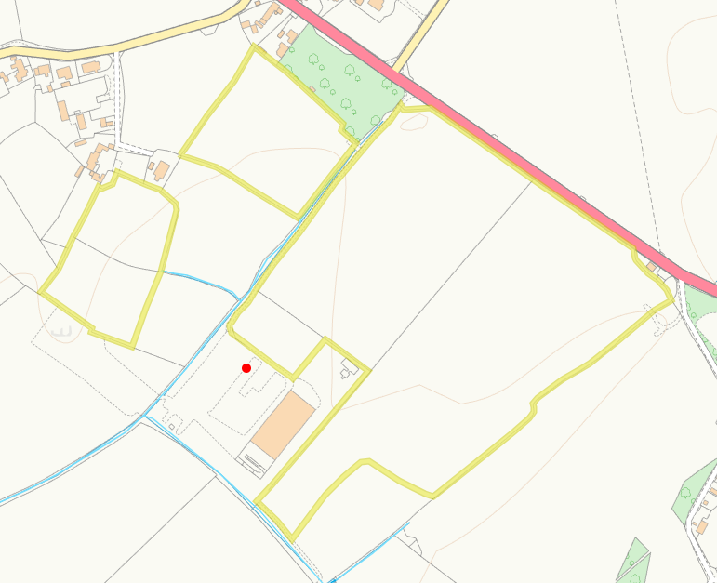
A drain runs along the edge of field 5 and field 1 as well as one running along the bottom of field 2, 10m no spread buffers have been applied on both adjacent borders to comply with permit conditions. A modified attribution runs into the side of field 7, a large no spread zone is implemented on this area.
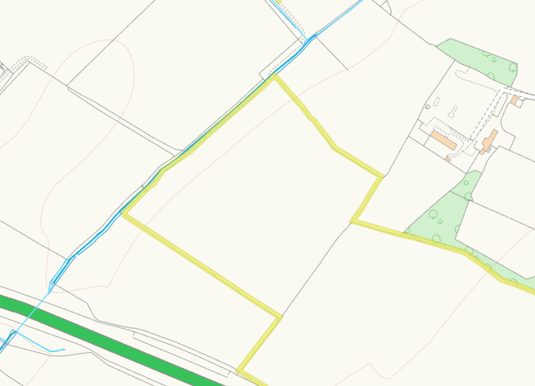
A drain runs parallel to the edge of field 3. A 10m no spread buffer has been applied on this border which is compliant with permit conditions.
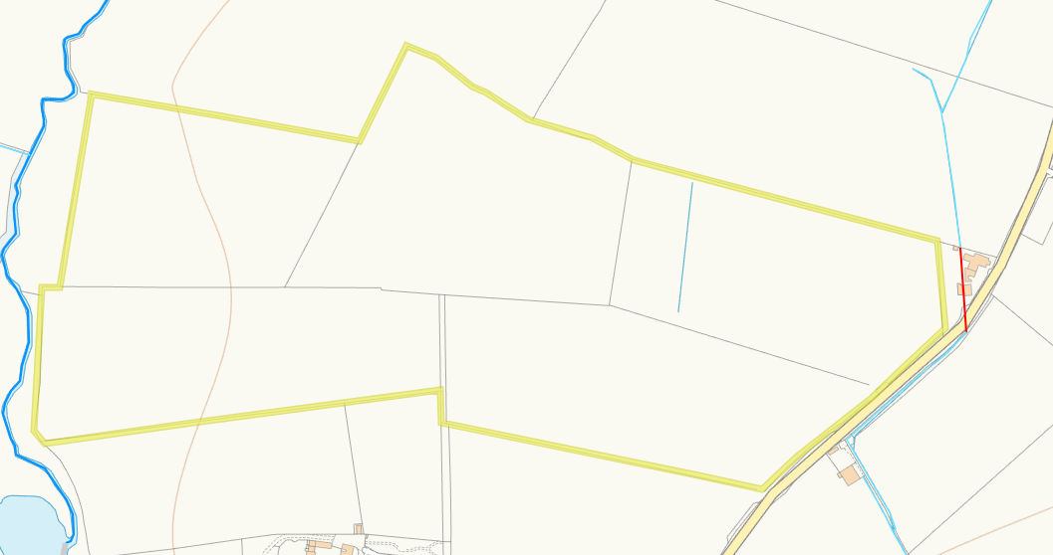
Afon Cefni runs on the edge of field 16 and 17. A 10m no spread buffer has been applied on this border which is compliant with permit conditions. In addition a watercourse is seen in the spreading area of field 14. A 10m no spread buffer is also imposed over this watercourse.

groundwater source protection zones

None in range

any well, spring (or issue) or borehole used for the supply of water for human consumption including from a private water supply or supplies.

None in range

any spring (or issue), well or borehole not used to supply water for domestic or food production purposes within 50m

None in range

any spring (or issue), well or borehole used to supply water for domestic or food production purposes within 250m

None in range

any European designated sites- Natura 2000 (SPA, pSPA, SAC or cSAC) or Ramsar- or SSSI within 500m

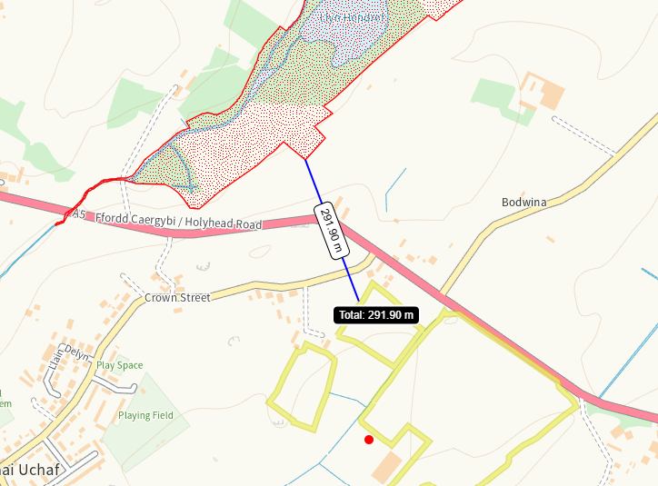

Field 5 is located 291 meters from Cors Bodwrog SSSI. There is no direct impact pathway to the site due to distance the closest field is from the SSSI. This has been identified in submitted maps and a SSRA supplied.

Within Groundwater Safeguard Zone
None in range
Protected Habitats and species
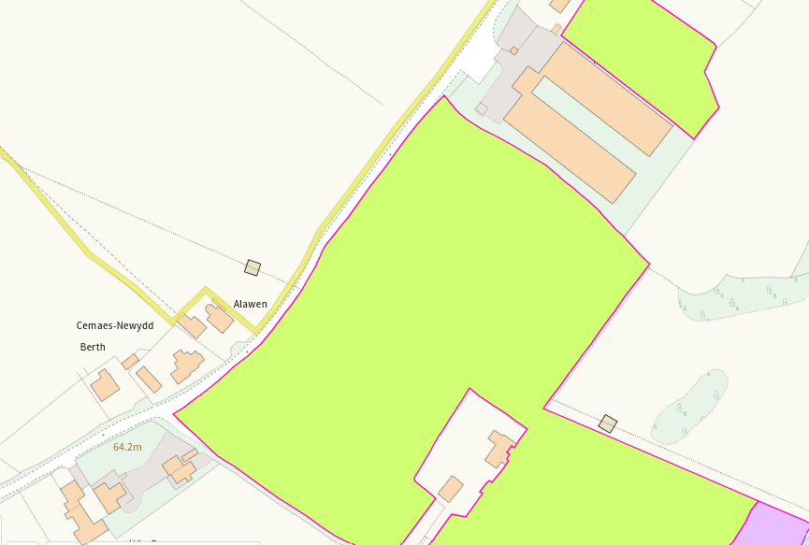
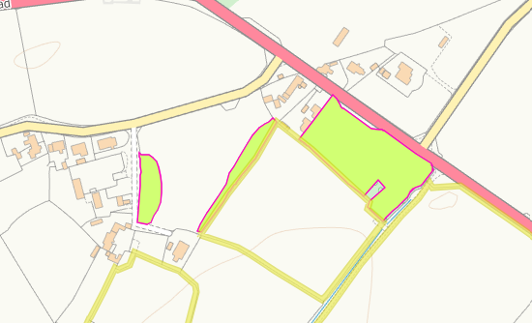
Lowland dry acid grassland and Lowland calcareous grassland borders fields 9/10. There is a physical road barrier between the habitat and fields so run off risk is low. In addition it borders field 5. This is labelled on maps and a 10m no spread buffer zone imposed on bordering edges.

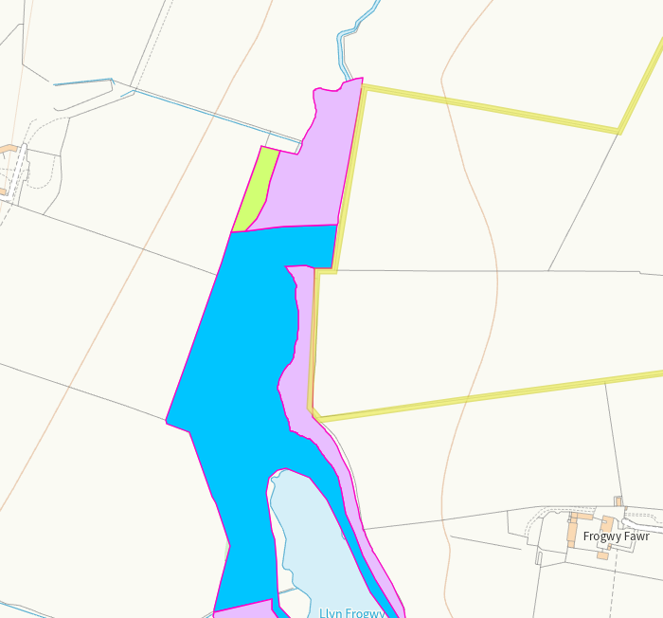
Purple moor grass and rush pastures. Reedbeds, Lowland dry acid grassland, Purple moor grass and rush pastures. 10m no spread buffer is implemented on this border to prevent run off.

Scheduled Monument
None in range
Local Nature Reserve
None in range
National Nature Reserve
None in range
Ancient Woodlands
None in range
Local Wildlife Sites (SINC)
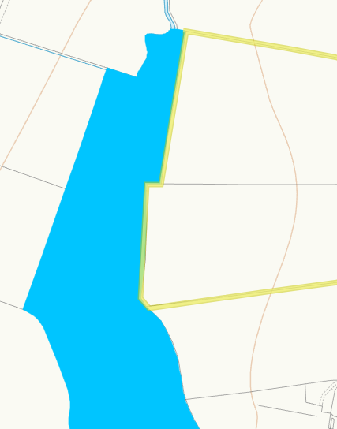
Llyn Frogwy SINC borders field 16 and 17. This is identified on submitted maps and a 10m no spread buffer imposed to prevent run off.
Hedges and Ditches – Nothing of concern

Sloping map


