PAN-028327 My Map Report:

Detailed river network:
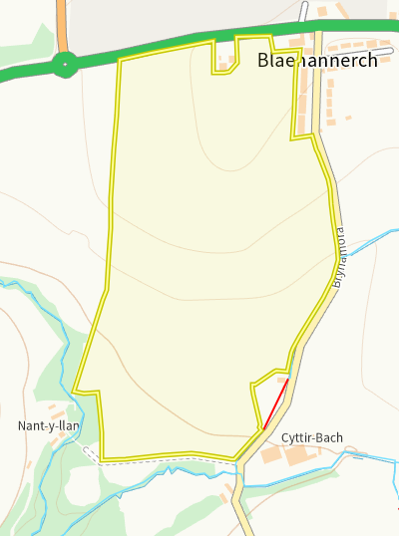
Field T17 and T18 both have modified attributions running along their bouhndary, In addition the river Nant Arbeth is 11m away from the corner of field T18. All areas where the watercourse cross or are in close proximity to field boundarys have a 10m no spread zone to mitigate the risk of run off into the watercourses. No action required.

Groundwater protection zones (source)
None in range

Wells, springs (or issue) or boreholes used for the supply of water for human consumption including from a private water supply or supplies
None in range
any springs (or issue) wells or boreholes not used to supply water for domestic or food production purposes within 50m

None in range
European designated sites- Natura 2000 (SPA, pSPA, SAC or cSAC) or Ramsar- or SSSI within 500m

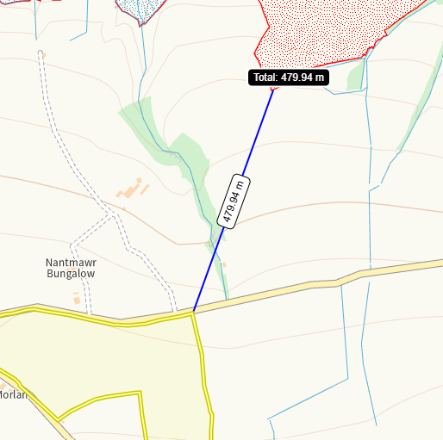 habitat
Caeau Crug Bychan, Ty Gwyn a Llwyn Ysgaw SSSI is 479m from the egde of Bigni 8. There is a 30m no spread buffer imposed on this corner making the SSSI over 500m and therefore no action required.
Other protected sites:
- Protected Species, Protected Habitats-
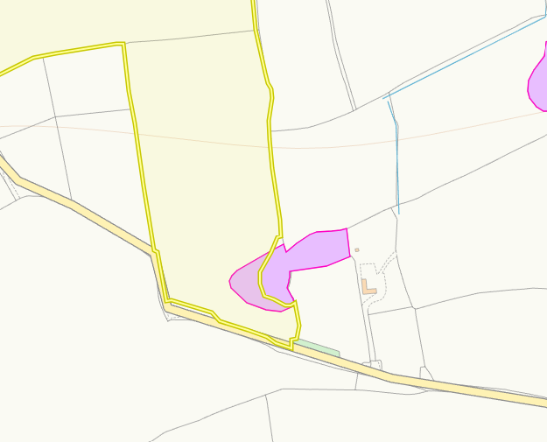
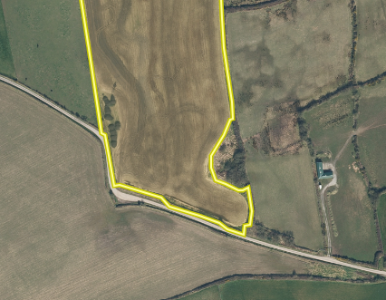

Field B9 has section of protected purple moor grass and Rush pastures within it’s boundary. When looking at aerial images it is evident there is a difference in the two habitats present. However, a no spread buffer zone is implemted over the area of differing habitat. The part extending out into the spread zone is evident not to contain purple moor grass and rush pasture and as such no action is required.

- Scheduled Ancient Monument- None in range
- Local Nature Reserve- None in range
- National Nature Reserve- None in range
- Ancient Woodlands- None in range
- Local Wildlife Sites (SINC)- None in range
- National Park- None in range
- Hedges, Ditches- Nothing of concern
- Local residents, Housing, schools, Workplaces, Recreational facilities – Nothing of concern

Slope Map
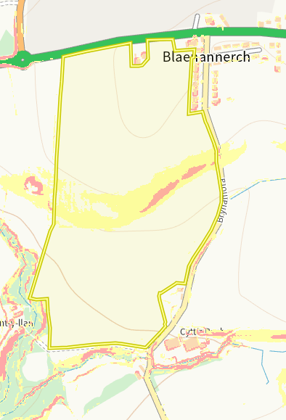
Area of 7-12 degree (yellow) and 12 degree plus (red) is found in fields T17.There is a lack of sensitive receptors bordering this field and the steepest sloping land is contained within the field. The spreading will be done via dribble bar so a relatively precise method of application. Each individual application will not exceed 50t/ha per field further reducing the risk of run off. No action required.

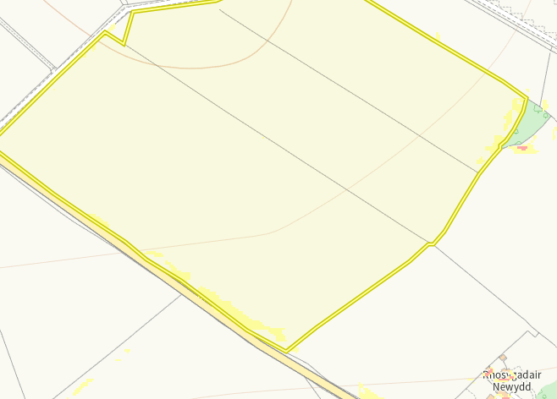
Area of 7-12 degree (yellow) us found in fields R4 and R6. The slopes are very minimal in the fields with a lack of sensitive receptors bordering the fields. The spreading will be done via dribble bar so a relatively precise method of application. Each individual application will not exceed 50t/ha per field further reducing the risk of run off. No action required.

