PAN-029164 My Map Report:
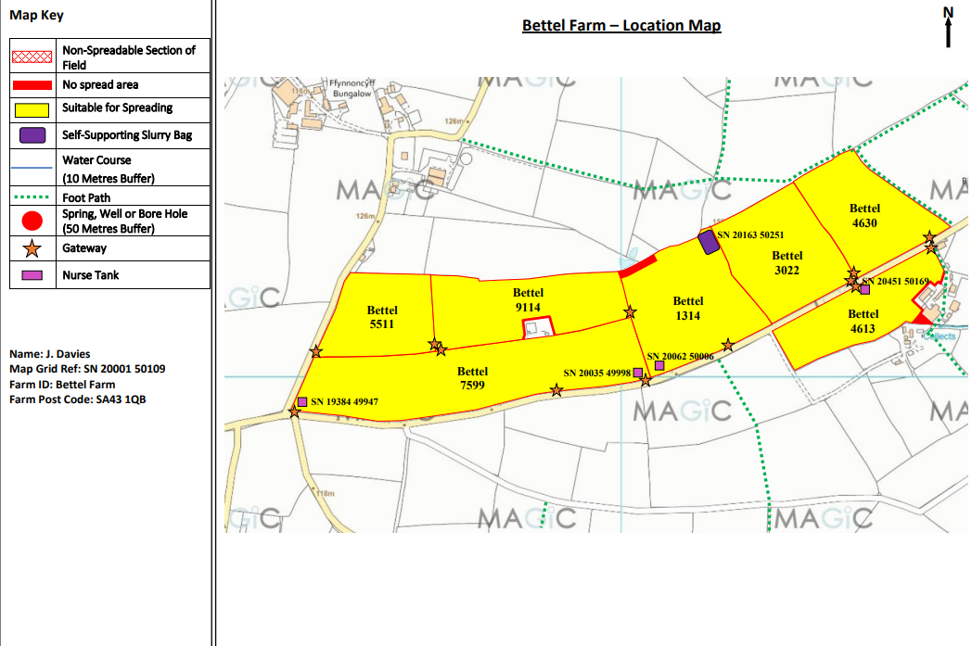
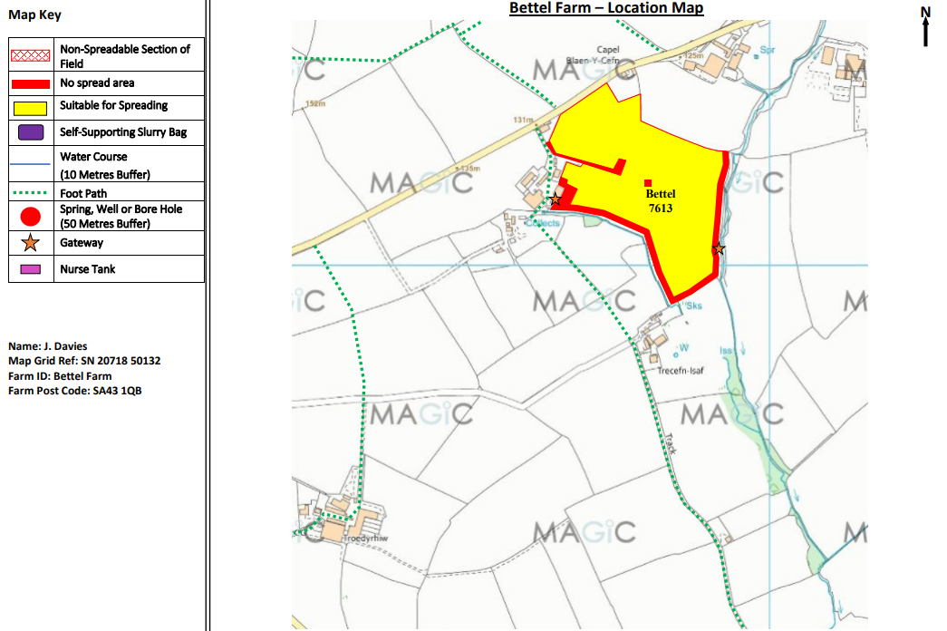
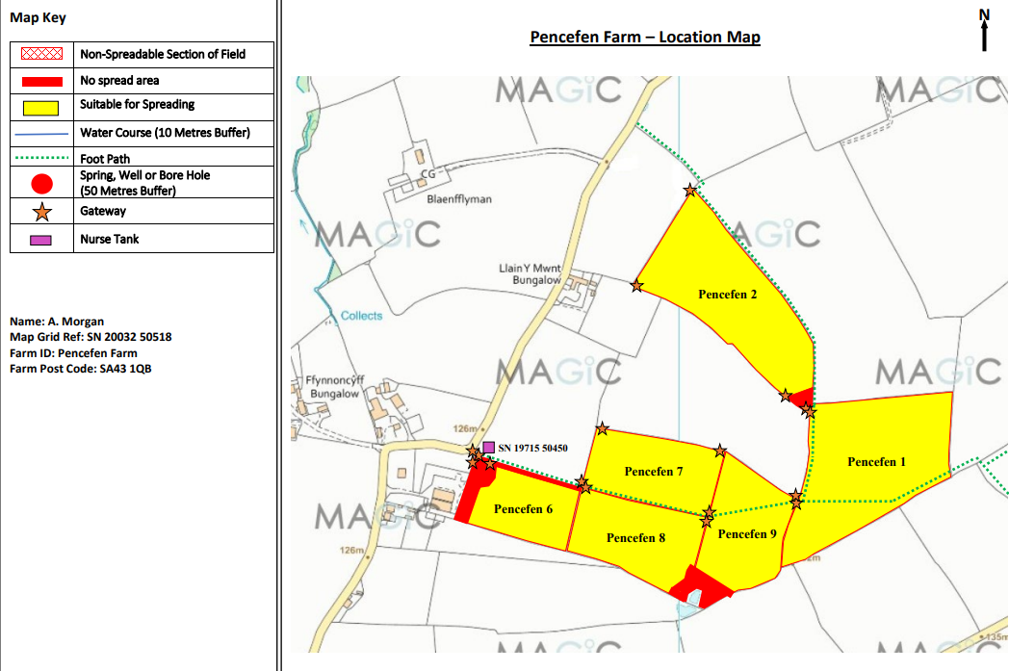

Detailed river network:

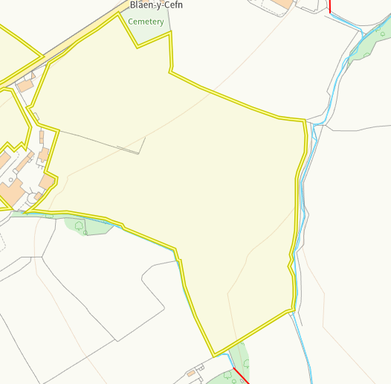
Modified attributions run either side of Bettel 7613. There is no spread buffer zones on both of these borders to prevent run off. No action required.
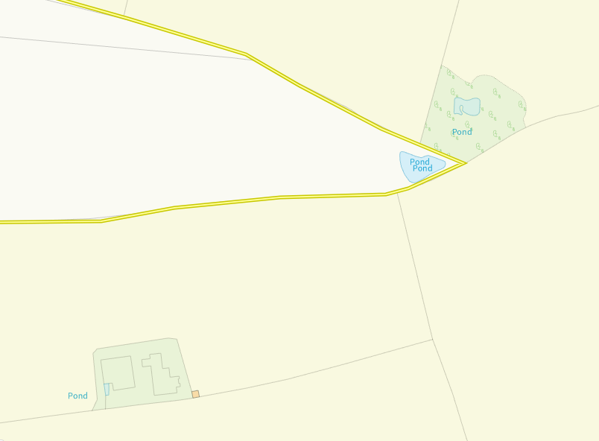
Ponds are seen in the area under Pencefn 9. There has been a large no spread buffer zone imposed over all surface water and the areas surrounding to prevent run off. No action required.

Groundwater protection zones (source)
None in range
Wells, springs or boreholes used for the supply of water for human consumption including from a private water supply or supplies
None in range
any springs wells or boreholes not used to supply water for domestic or food production purposes within 50m

None in range
any spring (or issue), well or borehole used to supply water for domestic or food production purposes within 250m

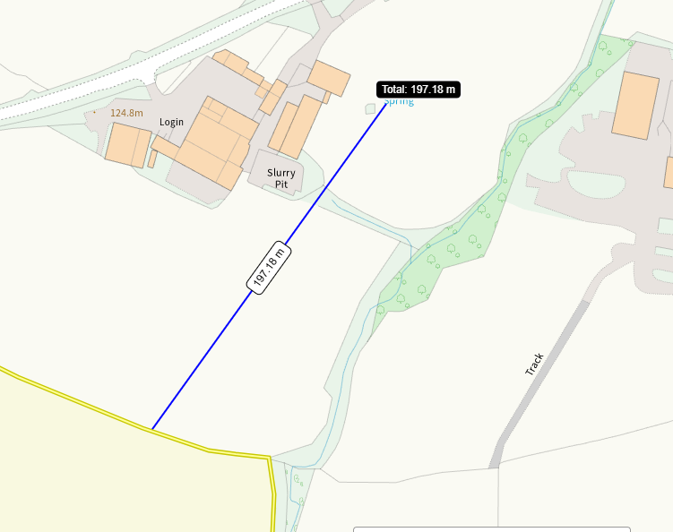
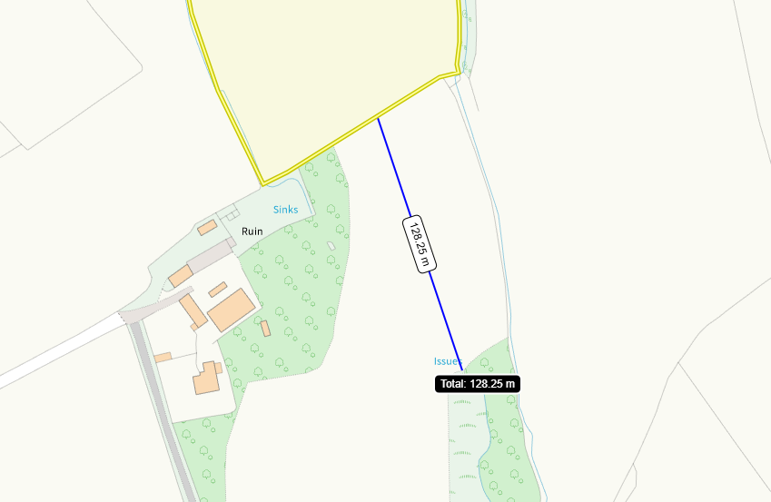

A spring and issue are within 250m of Bettel 7613. Both have ben identified on submitted maps but not impact pathway. No action required.

European designated sites- Natura 2000 (SPA, pSPA, SAC or cSAC) or Ramsar- or SSSI within 500m

None in range
Other protected sites:
- Protected Species- None in range
- Protected Habitats- None in range
- Scheduled Ancient Monument- None in range
- Local Nature Reserve- None in range
- National Nature Reserve- None in range
- Ancient Woodlands- None in range
- Local Wildlife Sites (SINC)- None in range
- National Park- None in range
- Nitrate Vulnerable Zone (NVZ)- None in range
- Groundwater Safeguard Zone- None in range
- ANOBs- None in range
- Hedges, Ditches- Nothing of concern
- Local residents, Housing, schools, Workplaces, Recreational facilities – Identified in OMP

Slope Map

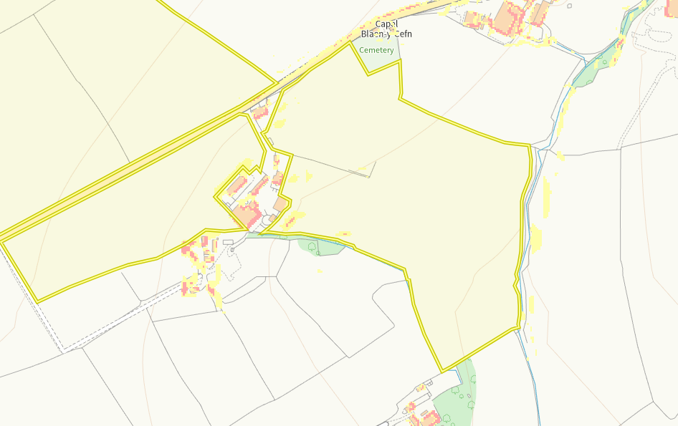
Areas of 7-12 degree slope (yellow) in fields Bettel 4613 and Bettel 7613 in addition to small areas of 12 degree plus (red). The sloping areas are very minimal and there is a alack of sensitive receptors outside the spreading area. No spread buffers are implemented on those borders where the sloping is present, Run off risk is low.
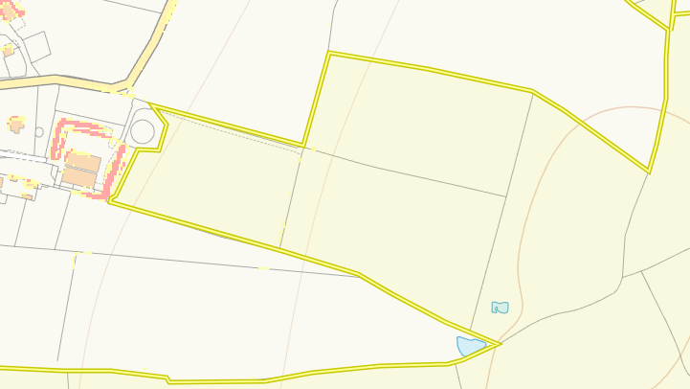
Very minimal 7-12 degree slope in fields Pencefen 6, 7 and 8. Very minimal sloping so run off risk is very low.

