PAN-030162 My Map Report:
Application maps
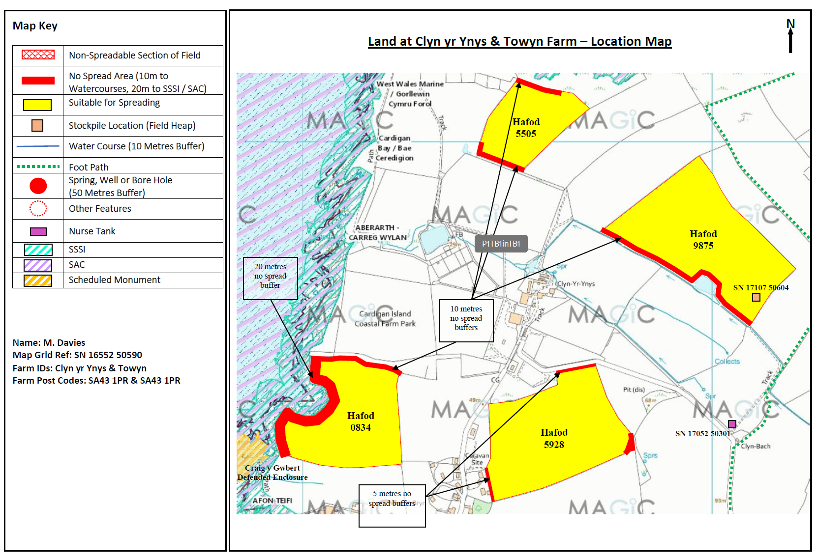
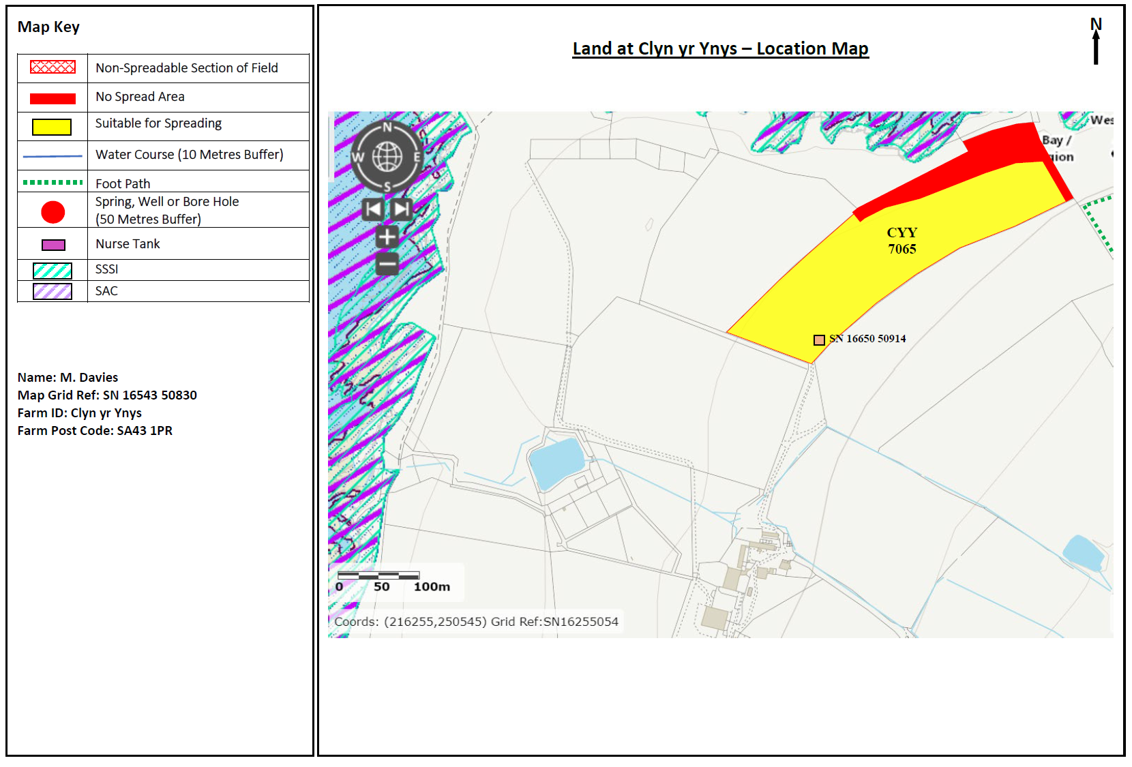
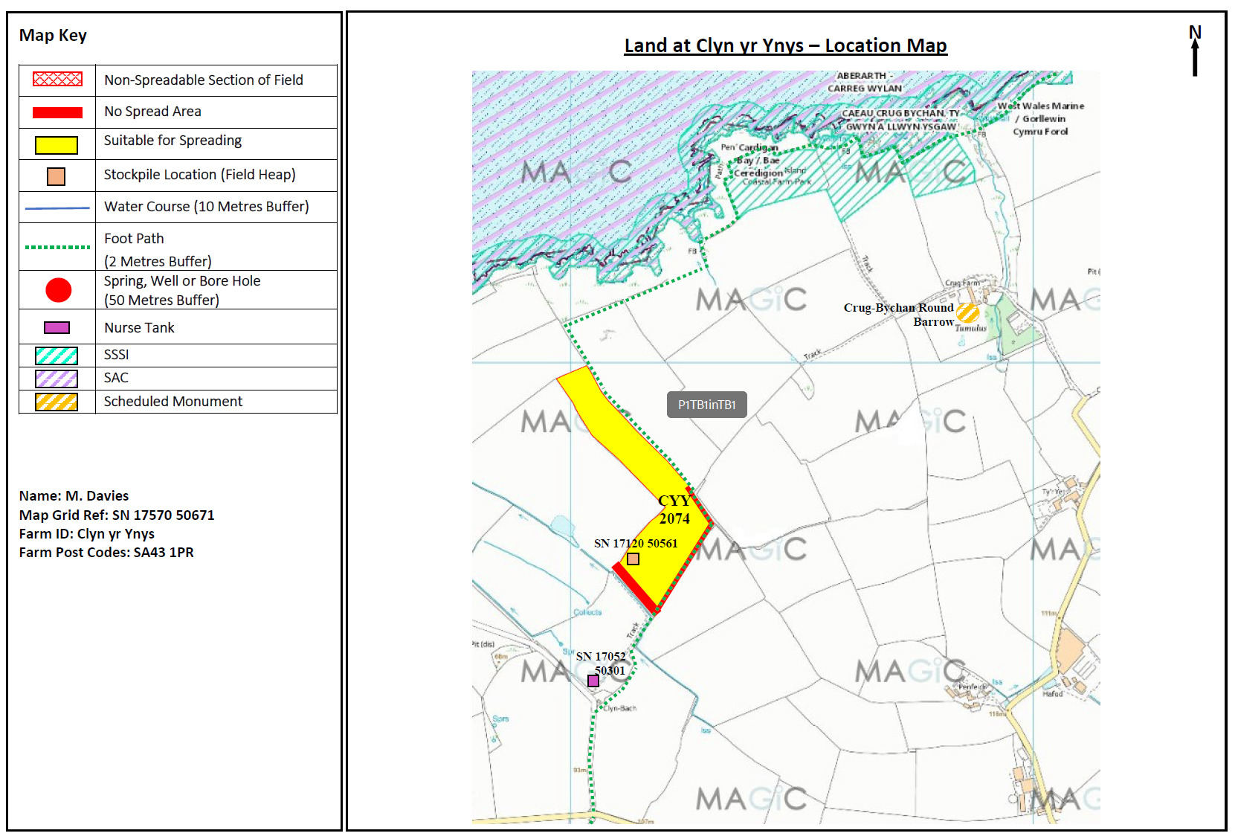
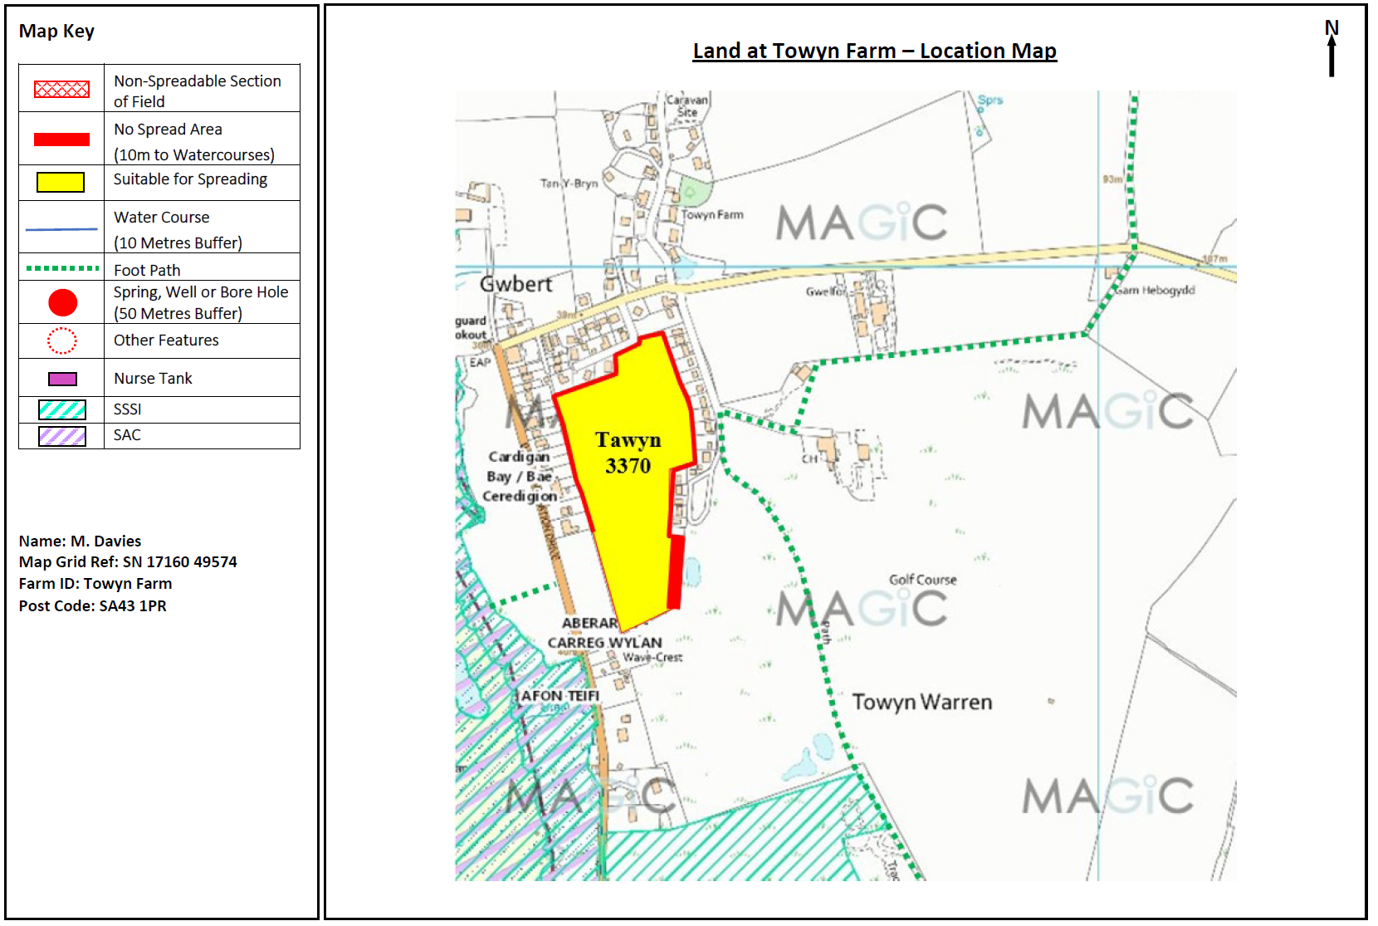
Nant y Croi 10 removed from deployment following RFI
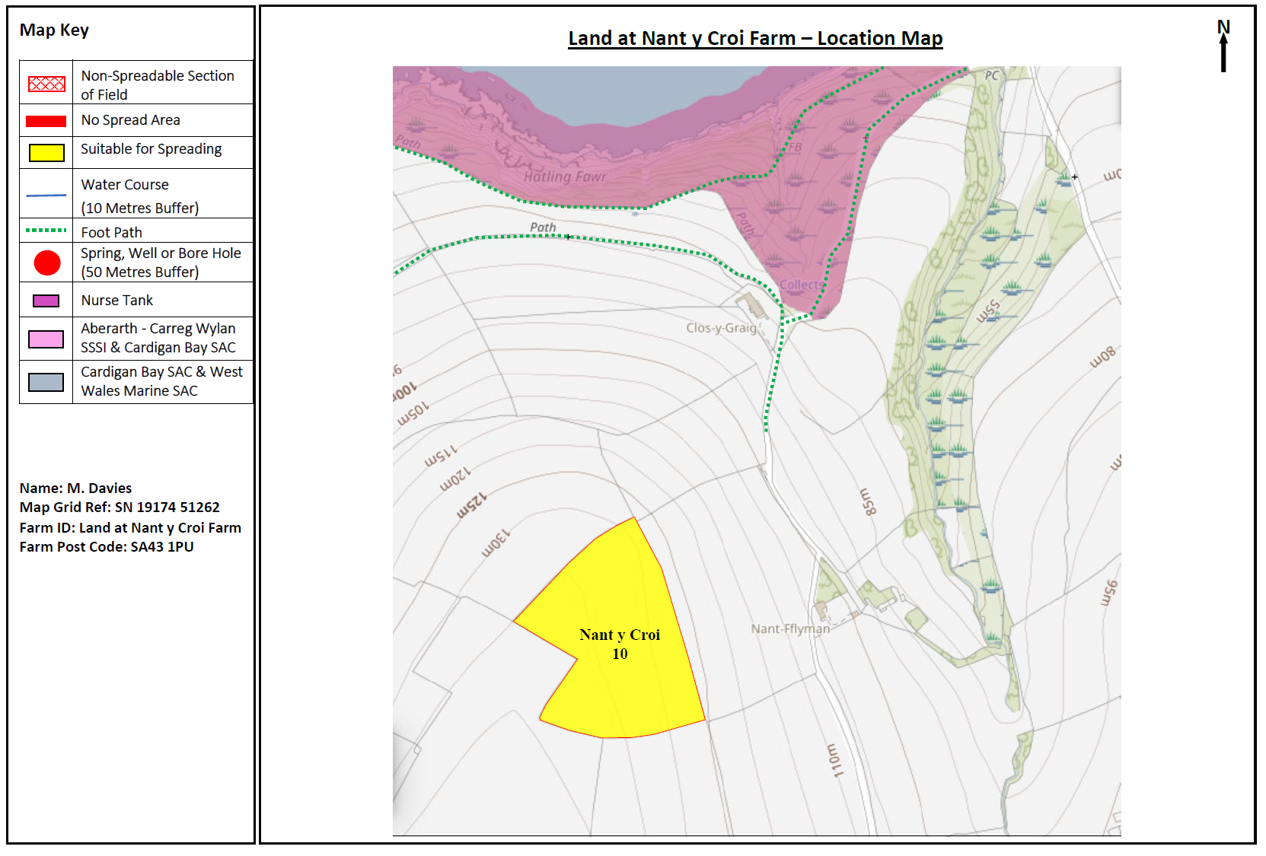
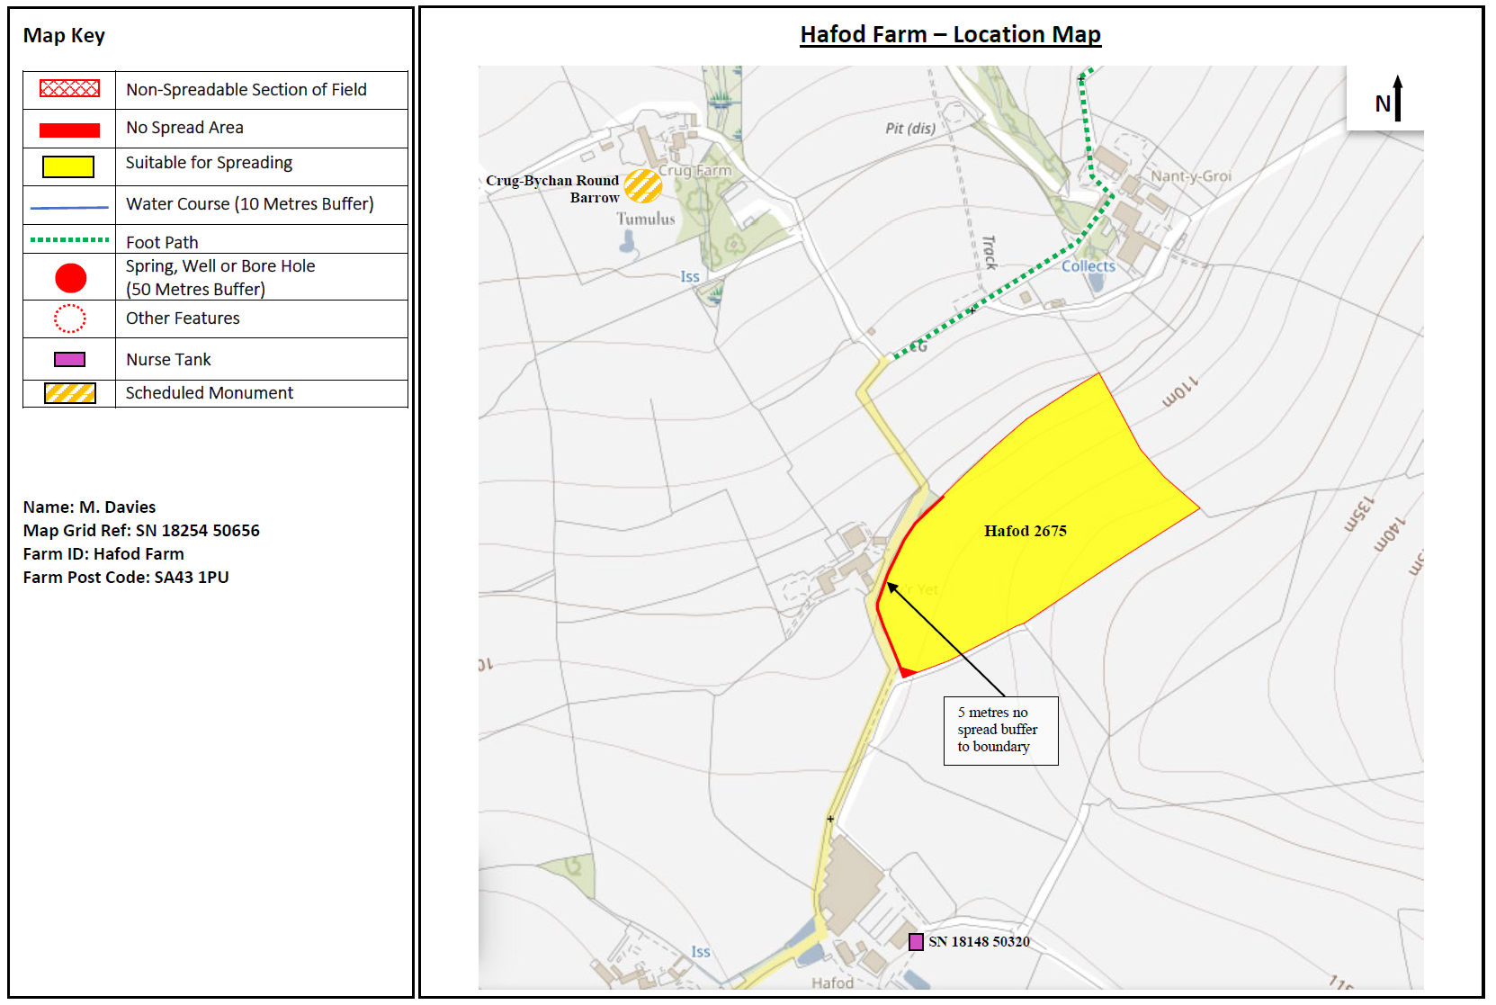

Deployment Boundaries and storage
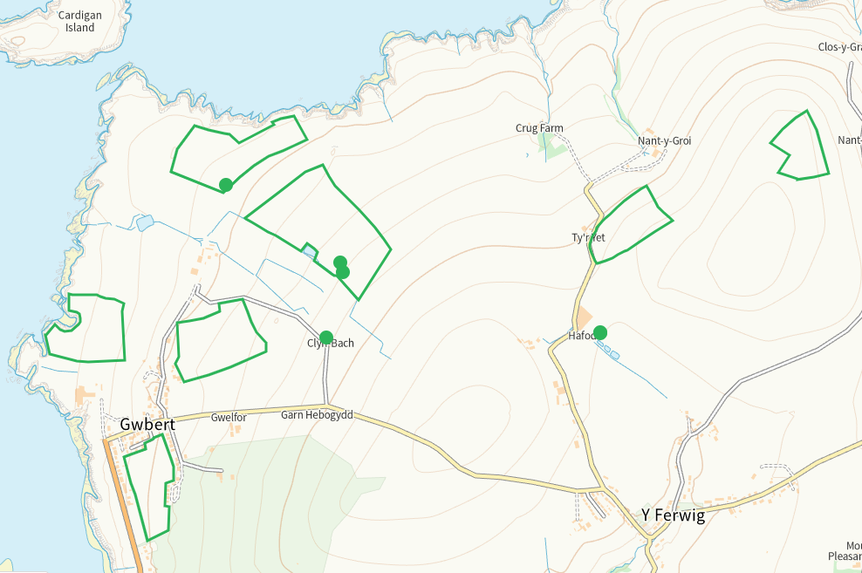
Detailed river network 10m
Watercourse and pond adjacent to Havod 9875. Buffered on application map
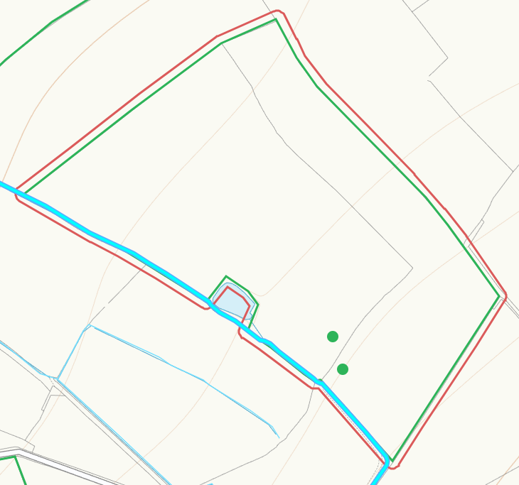
Pond adjacent to 3370. Buffered on application map
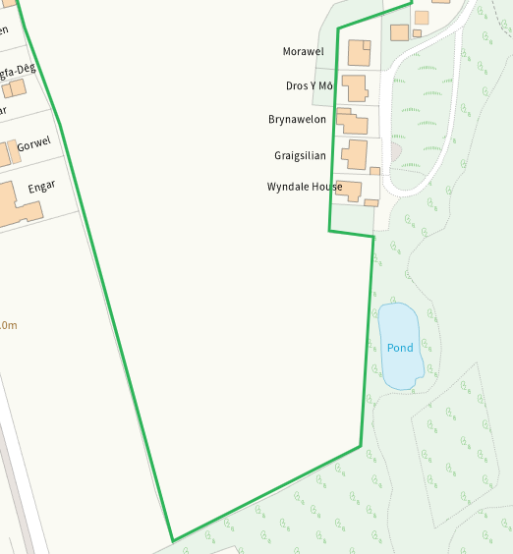
None at other feilds
Groundwater source protection zones
none
Any well, spring (or issue) or borehole used for the supply of water for human consumption including from a private water supply or supplies within 50m.
none
Any well, spring (or issue) or borehole used for the supply of water for human consumption including from a private water supply or supplies within 250m.
none
Within Groundwater Safeguard Zone
none
European designated sites- Natura 2000 (SPA, pSPA, SAC or cSAC) or Ramsar- or SSSI within 500m
SSSI Aberarth - Carreg Wylan and Caeau Crug Bychan
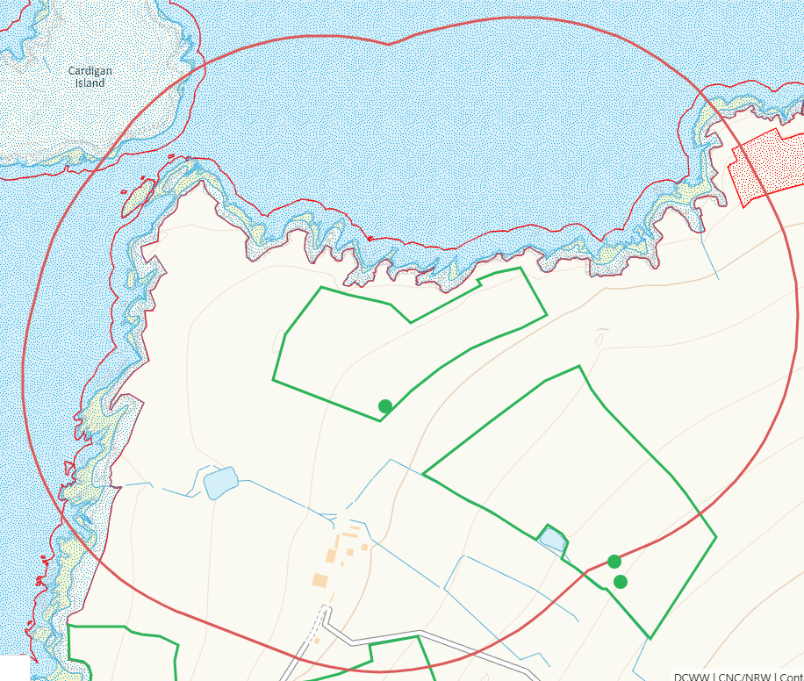
SAC Caeau Crug Bychan, Ty Gwyn a Llwyn Ysgaw and West Wales Marine / Gorllewin Cymru Forol
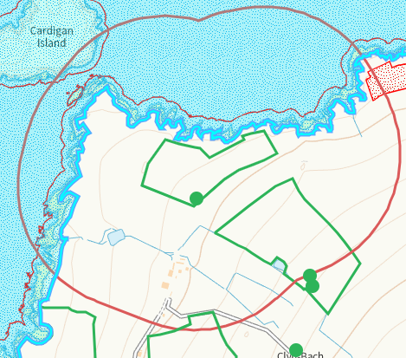
SAC Afon Teifi
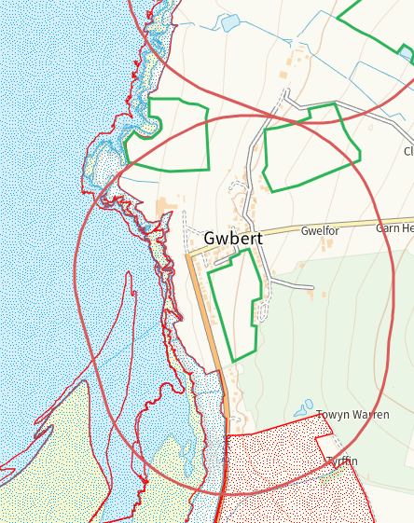
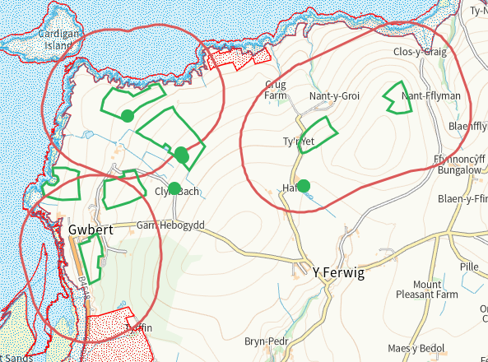
Other protected sites within 500m:
- Protected Species-

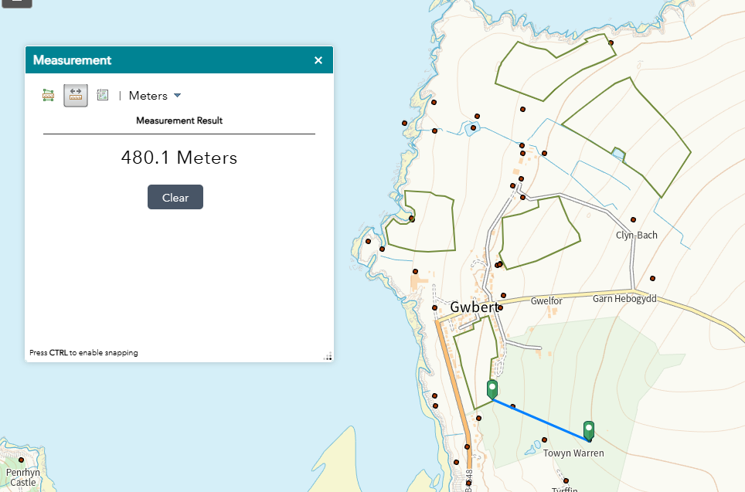

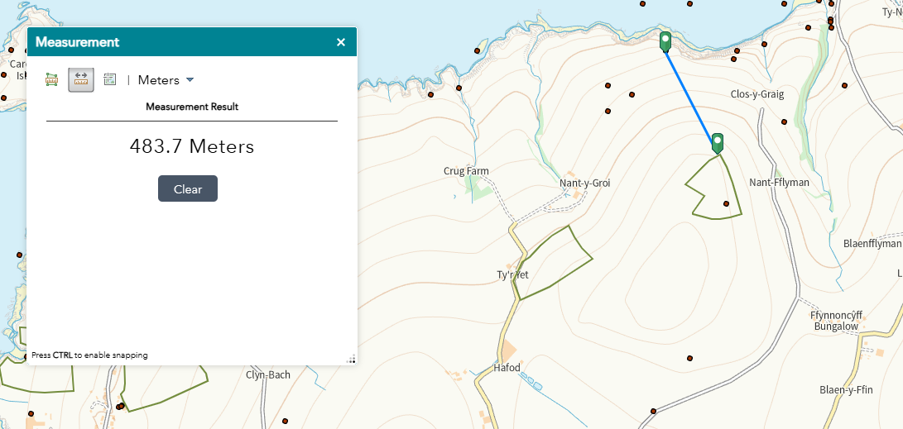
European Eel migratory route.
Atlantic Salmon migratory route.
Threatened Lichen.
Suitable buffers in application maps.
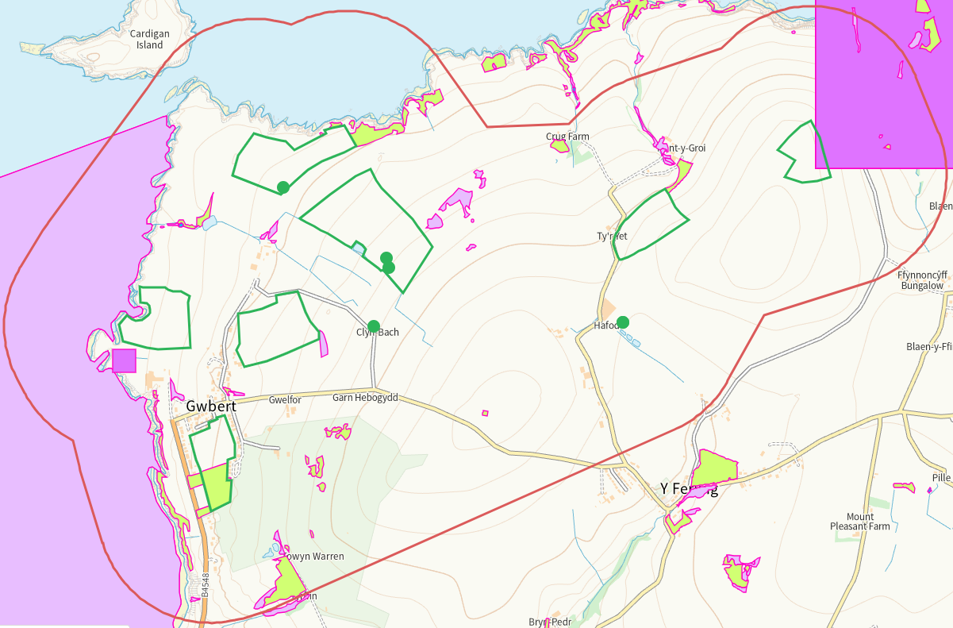
- Protected Habitats-
Purple moor grass and rush pastures.
Lowland dry acid grassland and Lowland calcareous grassland.
Reedbeds.
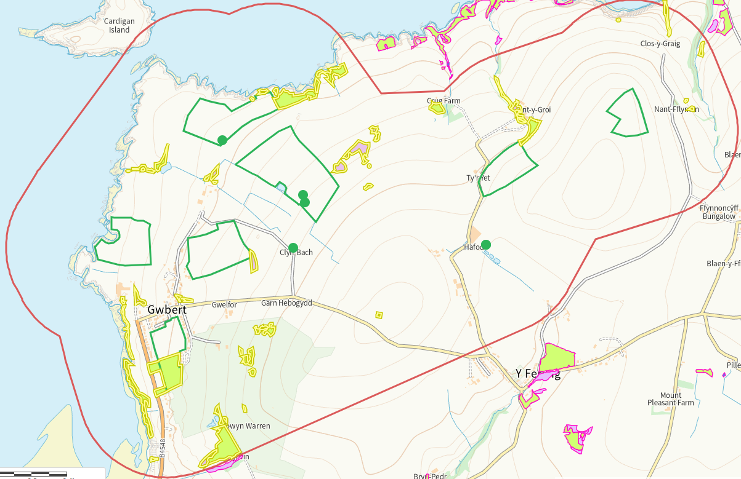
- Scheduled Ancient Monument-
Crug-Bychan Round Barrow, nil risk
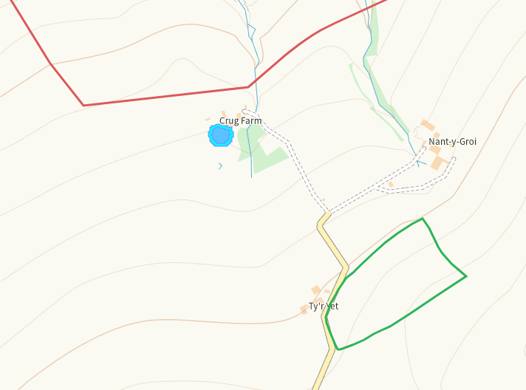
Cardigan Island Defended Enclosure, nil risk
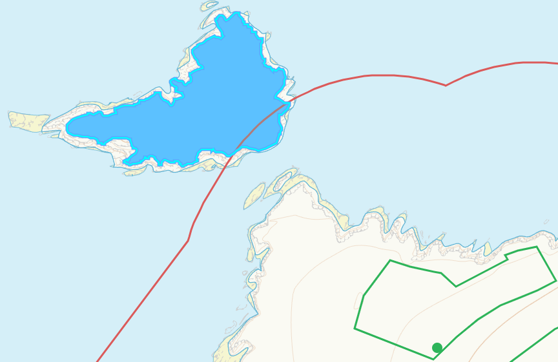
Craig y Gwbert Defended Enclosure, nil risk
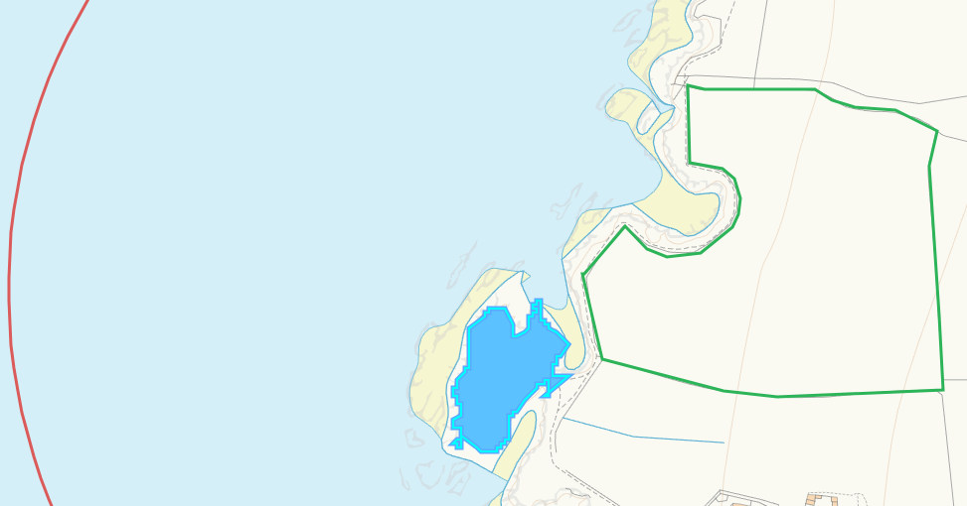
- Local Nature Reserve- none
- National Nature Reserve-none
- Ancient Woodlands-none
- Local Wildlife Sites (SINC)- none
- National Park-
Arfordir Penfro / Pembrokeshire Coast, nil risk
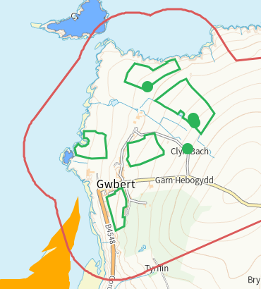
- Nitrate Vulnerable Zone (NVZ)- ALL Wales
- Groundwater Safeguard Zone- none
Flood risk
Risk at pond adjacent to Hafod 9875. Buffered on application map.
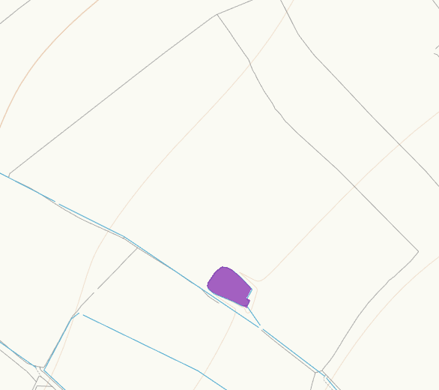
None at other fields.
Public rights of way
Footpath W of Hafod 0834. Buffered on application map
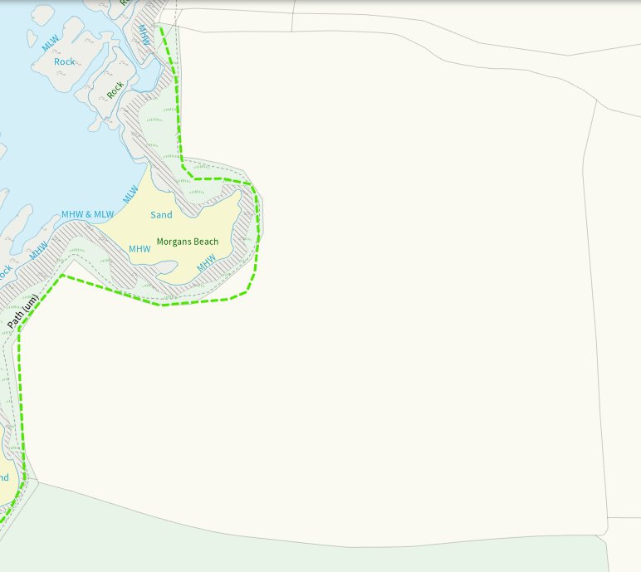
None at other feilds
Distance from Main Farm Address
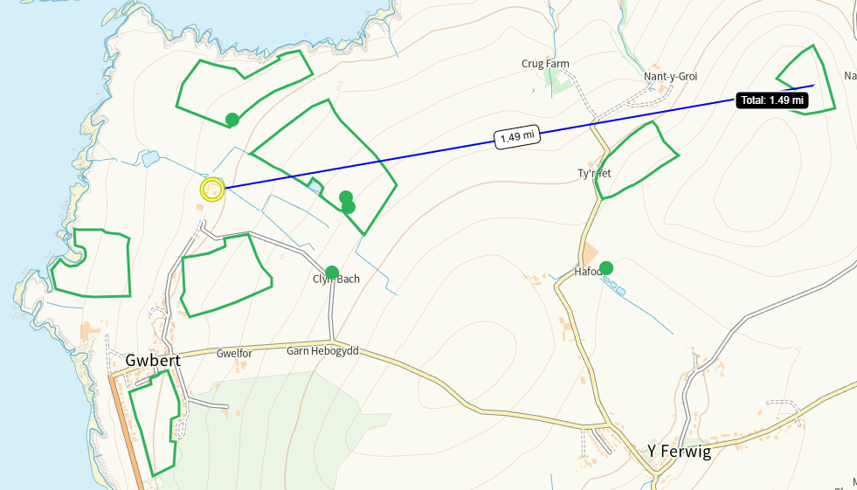
Slope Map
Hafod 5505, 9875, 5928, 0834, Nant y Croi 10, Tawyn 3370, Cyy 2074, Cyy 7065 – 0-7
Hafod 2675, 0-7 with portions of 7-12. Nil risk
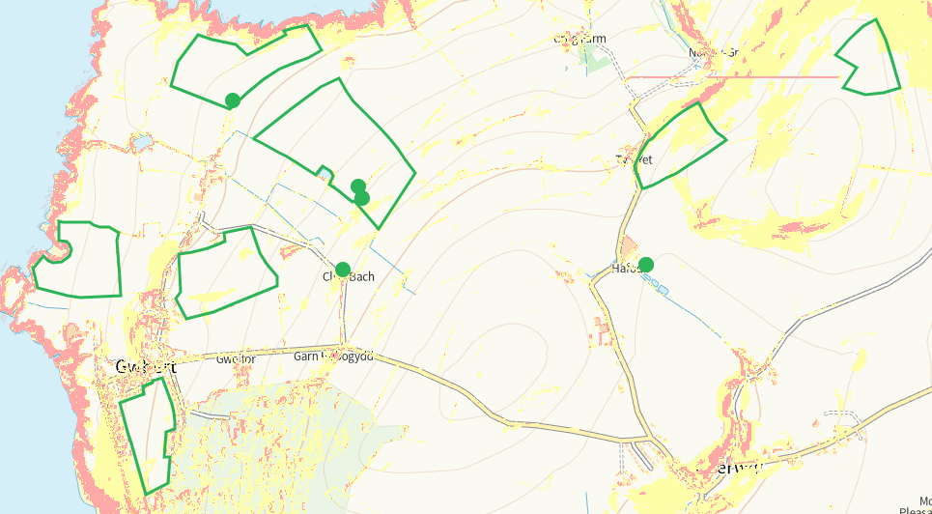
END

