Annex (iv) – SSSI Assessment Form
SSSI Assessment for permit/licence and deployment applications | 
To be completed by Permitting Officers for any applications for a permission which Natural Resources Wales has considered under S28I duty to notify SNCB and take their advice into account. This applies to all proposed permissions within a SSSI, and to operations outside the SSSI boundary which are likely to damage its special features.
NRW as a Section 28G authority has, when exercising its functions, a general duty to take reasonable steps, consistent with the proper exercise of its functions, to further the conservation and enhancement of the flora, fauna or geological or physiological features by reason of which the site is of special interest’

Part 1 – SSSI Assessment
Part 2 – Formal notification to SNCB (to be completed if part 1 assessment concludes likely damage, not likely to damage because of conditions or you cannot conclude no likely damage)
Part 3 – Decision
Pink text – drafting notes, to be deleted before completion/consultation.
Blue text – examples, to be replaced with permission-specific information and text turned to black.

Part 1 – SSSI Assessment

- Permitting officer/team | Bryan Burn / Waste Permitting
- Permit application reference and site name | PAN-029407. New House Farm, Canaston Bridge, Narberth, Pembrokeshire. SA67 8DE
- a. SSSI name(s)  b. location  c. NRW Operational Area/Environment Team | a. SSSI Minwear Wood  b. Southwest  c. Environment Team 8- Pembrokeshire  a. SSSI Milford Haven Waterway  b. Southwest  c. Environment Team 8- Pembrokeshire  a. SSSI Afon Cleddau Dwyreiniol / Eastern Cleddau River  b. Southwest  c. Environment Team 8- Pembrokeshire
- Brief description of proposal | None of the fields are wholly or partly within the SSSI(s) boundaries.  SSSI Minwear Wood is on the 500 metre distance line to the South of fields 26/27.  Risk management  No spreading areas to watercourses. Waste applied at specified rates and timings. Low in available nitrogen and phosphate applied is equal to or less than crop offtake. The waste is low in readily available nutrients.  Spread when conditions are suitable. Material to be soil incorporated within 24 hours following spreading where spread before planting of next crops, or spread into growing grass crops. 10m no spread areas enforced to watercourses. 50m no spread buffers to springs / boreholes / wells. No spreading within 48 hours of forecasted heavy rainfall. Liquid sludge spread with low trajectory dribble bar applicator.  SSSI Milford Haven Waterway is approximately 170 metres South of fields 26/27.  Risk management  No spreading areas to watercourses. Waste applied at specified rates and timings. Low in available nitrogen and phosphate applied is equal to or less than crop offtake. The waste is low in readily available nutrients.  Spread when conditions are suitable. Material to be soil incorporated within 24 hours following spreading where spread before planting of next crops, or spread into growing grass crops. 10m no spread areas enforced to watercourses. 50m no spread buffers to springs / boreholes / wells. No spreading within 48 hours of forecasted heavy rainfall. Liquid sludge spread with low trajectory dribble bar applicator.  SSSI Afon Cleddau Dwyreiniol / Eastern Cleddau River is is approximately 270 metres North of fields 18/19 and approximately 150 metres Northwest of field 15.  Risk management  No spreading areas to watercourses. Waste applied at specified rates and timings. Low in available nitrogen and phosphate applied is equal to or less than crop offtake. The waste is low in readily available nutrients.  Spread when conditions are suitable. Material to be soil incorporated within 24 hours following spreading where spread before planting of next crops, or spread into growing grass crops. 10m no spread areas enforced to watercourses. 50m no spread buffers to springs / boreholes / wells. No spreading within 48 hours of forecasted heavy rainfall. Liquid sludge spread with low trajectory dribble bar applicator.  Landspreading deployment under SR2010No4 Mobile plant permit. Spreading 19 09 01 Natural sludge (produced prior to a water treatment works through additional filtration/ settlement of raw water following primary filtration and screening). This description has been agreed by NRW. Email from Julie Tate, Senior Specialist Advisor, to the applicant dated 09/04/2025.  Application to spread a maximum of 2161 tonnes. The waste will be spread over 46.95 hectares of land within the listed fields at the location fields. The waste will be stored in nurse tanks then spread onto the fields.  Spreading of the waste will be carried out in accordance with the Code of Good Agricultural Practice, The Water Resources (Control of Agricultural Pollution) (Wales) Regulations 2021 and in accordance with the requirements of the deployment and Environmental Permitting Regulations.  Fields 6 & 10 will be spread in July – August 2025 prior to cultivations and the stubble turnips being planted. The waste will be soil incorporated as soon as possible and within 24 hours.  Fields 24, 26 & 27 will be spread in June – September 2025 prior to cultivations and grass establishment. The waste will be soil incorporated as soon as possible and within 24 hours. The total application rate may be split into two applications if not spread at full rate with a second application of liquid sludge spread into the growing crops in March –  June 2026.  Fields 15, 18, 19, 20 & 21 will be spread in June – July 2025 in advance of third & fourth cuts of silage. The application rate may be split with a second application of liquid sludge spread into the growing crops in March – April 2026 in advance of first cut silage 2026.  The maximum application rate for each field may be split into multiple applications and will not exceed 50t/ha (or the stated maximum application in table rate if lower) in any one application to a field.  Farm location  New House Farm, Canaston Bridge, Narberth, Pembrokeshire. SA67 8DE  Only the fields and storage in bold below are within 500 metres of the SSSI(s).  Fields  6 - SN 07384 12967  10 - SN 04092 14730  15 - SN 06824 14470  18 - SN 07115 14530  19 - SN 07234 14402  20 - SN 07163 14253  21 - SN 07023 14414  24 - SN 03970 14976  26 - SN 03957 14467  27 - SN 04317 14506  Storage – nurse tanks  SN 07305 13053  SN 07446 13086  SN 06777 14675  SN 03849 15067  SN 06914 14804  Maps are at the end of this document.
- What aspects of the proposed permission are likely to damage the SSSI features of special interest?

The following activities are likely to cause damage:

SSSI Minwear Wood
5. Application of manure, fertilisers and lime.
7. Dumping, spreading or discharging of any materials.

SSSI Milford Haven Waterway
5. Application of manure, slurry, silage liquor, fertilisers and lime.
7. Dumping, spreading or discharging of any materials on, in or against bat roosting
areas or access points including storage of materials likely to produce noxious fumes in or near the bat roosts.
22. Storage of materials in quarries, caves or against rock faces, or in or against bat
roosting areas or access points, including storage of materials likely to produce noxious fumes.
26. Use of vehicles or craft or the use of vehicles, machinery or other devices likely to produce noise, fumes, light or heat near to the bat roosting areas.

SSSI Afon Cleddau Dwyreiniol/Eastern Cleddau River
5. Application of manure, slurry, silage liquor, fertilisers and lime.
7. Dumping, spreading or discharging of any materials.
26. Use of vehicles or craft that are likely to damage the special features of the site.

The following SSSI(s) features and potential impacts have been considered to assess the likelihood of damage:

SSSI Minwear Wood
https://cdn.cyfoethnaturiol.cymru/649179/SSSI_0682_Citation_EN0012fd0.pdf
https://cdn.cyfoethnaturiol.cymru/649204/SSSI_0682_SMS_EN00163d9.pdf
Semi-natural broadleaved woodland.

Source
Deterioration of site through contamination, nutrient enrichment, habitat loss, siltation, smothering, soil erosion, soil runoff.

Harm
Harm to protected site, habitat & species through contamination, nutrient enrichment, disturbance.

Pathway
Spreading activity, flooding, nutrient run off or leaching to watercourses, soil erosion and soil run off.

SSSI Milford Haven Waterway
https://cdn.cyfoethnaturiol.cymru/639589/SSSI_0282_Citation_EN0010ded.pdf
https://cdn.cyfoethnaturiol.cymru/639793/SSSI_0282_SMS_EN0018585.pdf
2.1 Estuaries (contains all shore types and communities)
2.2 Specialised marine habitats (including eelgrass beds, rockpools, overhangs and
underboulder communities)
2.3 Sand gapers and bristle worms in muddy gravel shores.
2.4 Bristle worms in poorly sorted mixed sediment shores.
2.5 Bristle worms in variable salinity muddy gravel shores.
2.6 Serrated wrack, sponges and sea-squirts on tide-swept lower mid-shore rock
2.7 Serrated wrack with sponges, sea-squirts and red seaweeds on tide-swept lower mid-shore mixed substrata
2.8 Kelp, sea-squirts and sea mats on tide-swept subtidal fringe rock
2.9 Oyster beds on shallow subtidal muddy sediment
2.10 Saltmarsh (including Atlantic salt meadows)
2.11 Reedbeds
2.12 Semi-natural ancient woodland
2.13 Saline lagoons
2.14 Marsh pea
2.15 Spurge-laurel
2.16 Wayfaring tree
2.17 Dwarf eelgrass
2.18 Assemblage of coastal flowering plants
2.19 Assemblage of saltmarsh and intertidal flowering plants
2.20 Assemblage of mosses and liverworts
2.21 Assemblage of nationally rare and scarce lichens
2.22 Shelduck
2.23 Wigeon
2.24 Teal
2.25 Curlew
2.26 Dunlin
2.27 Little grebe
2.28 Otter
2.29 Tentacled lagoon worm
2.30 Brown hair-streak butterfly
2.31 Assemblage of saltmarsh invertebrates
2.32 Greater horseshoe bats
2.33 Lesser horseshoe bats
2.34 Geology: Non-marine Devonian - Little Castle Head
As well as the features listed above, Milford Haven Waterway SSSI has other habitats that
contribute to the special interest. These include scrub, marshy grassland, semi-improved
neutral grassland, calcareous grassland, coastal grassland, continuous bracken, mixed and
broadleaved woodland, dry dwarf shrub heath and standing water, together with other
elements such as hedgerows, streams, ponds, small rock outcrops or individual trees. This
diversity of habitats is important for a wide range of species.

Source
Deterioration of site through contamination, nutrient enrichment, habitat loss, siltation, smothering, soil erosion, soil runoff.

Harm
Harm to protected site, habitat & species through contamination, nutrient enrichment, disturbance.

Pathway
Spreading activity, flooding, nutrient run off or leaching to watercourses, soil erosion and soil run off.

SSSI Afon Cleddau Dwyreiniol/Eastern Cleddau River
https://cdn.cyfoethnaturiol.cymru/668449/SSSI_2644_Citation_EN001d2b6.pdf
https://cdn.cyfoethnaturiol.cymru/668564/SSSI_2644_SMS_EN0019495.pdf
• River habitats including water crowfoot habitat
• Potamogeton berchtoldii x P. polygonifolius (cf.)
• Associated riverside habitats (including semi-natural broadleaved woodland, scrub, mire
and marshy grassland).
• Otter
• Fish (bullhead, brook lamprey, river lamprey, sea lamprey)
As well as the features listed above, the Eastern Cleddau River SSSI has other habitats that are essential to the maintenance of the special wildlife interest. These include neutral grassland,
acid grassland, heathland, continuous bracken, tall herbs or fern, river gravels, ponds, streams,
ditches, hedgerows and individual trees. This diversity of habitats similarly supports a wide
range of species and these too are a key component of the special interest of the site

Source
Deterioration of site through contamination, nutrient enrichment, habitat loss, siltation, smothering, soil erosion, soil runoff.

Harm
Harm to protected site, habitat & species through contamination, nutrient enrichment, disturbance.

Pathway
Spreading activity, flooding, nutrient run off or leaching to watercourses, soil erosion and soil run off.

- Summary of any informal advice received from internal experts (if required and including pre-app advice) | n/a
- Recommendation | SSSI Minwear Wood  The proposed permission is not likely to damage any of the flora, fauna or geological or physiological features which are of special interest due to management/operational processes, distance from the spreading location, waste type being spread and method of spreading.  SSSI Milford Haven Waterway  The proposed permission is not likely to damage any of the flora, fauna or geological or physiological features which are of special interest due to management/operational processes spreading method, waste type, no spread buffer zones.  SSSI Afon Cleddau Dwyreiniol/Eastern Cleddau River  The proposed permission is not likely to damage any of the flora, fauna or geological or physiological features which are of special interest due to management/operational processes physical obstructions, distance from spreading location, waste type, spreading method and no spread buffer zones.
- Signature and date assessment made | Bryan Burn. 05/06/25
- Officers name and job title | Bryan Burn. Permitting Officer

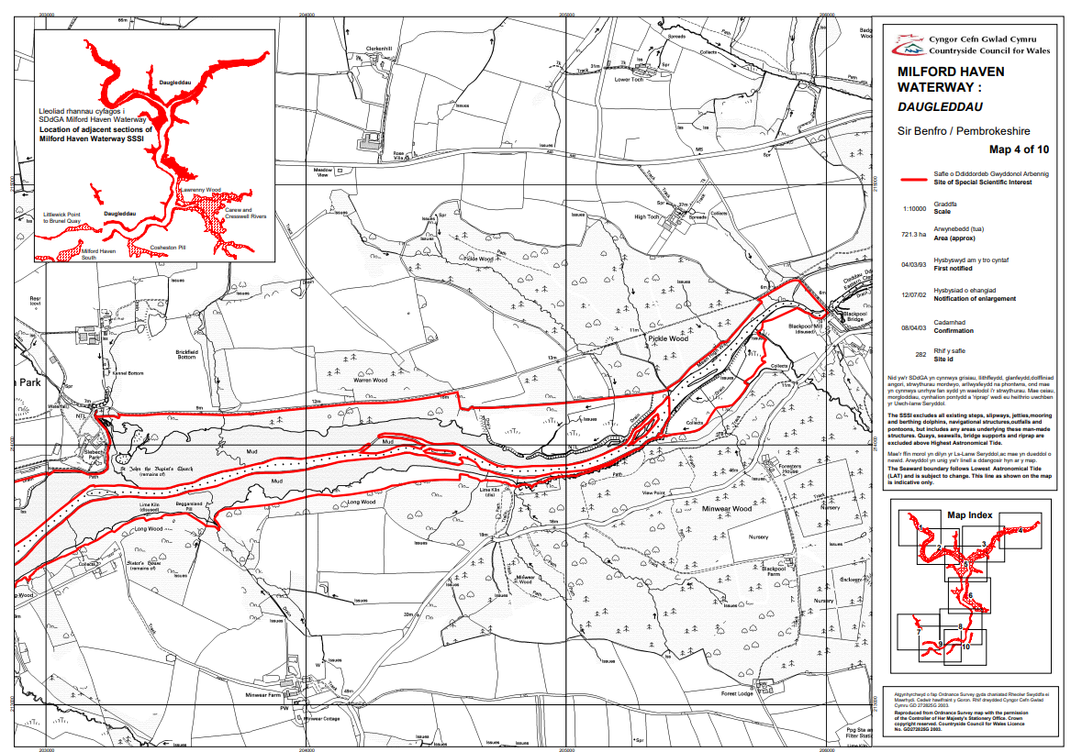
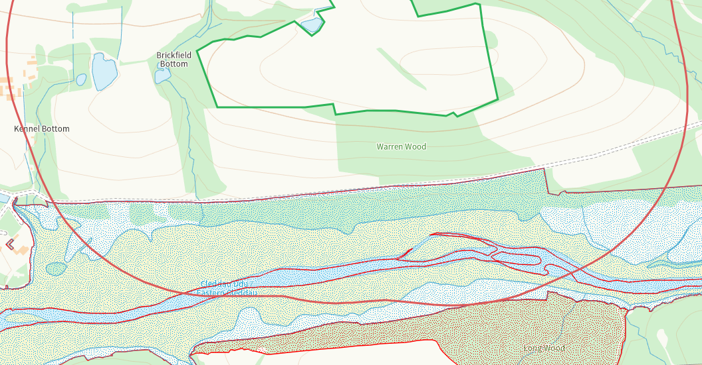

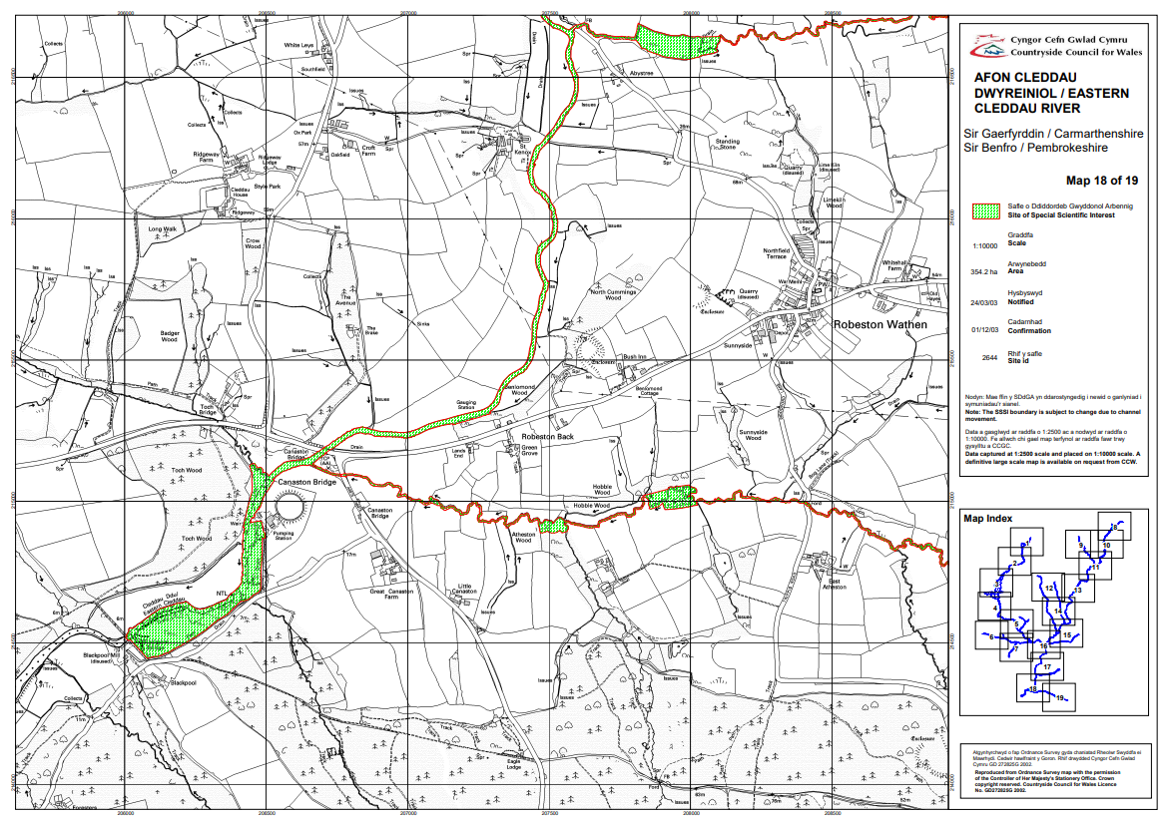
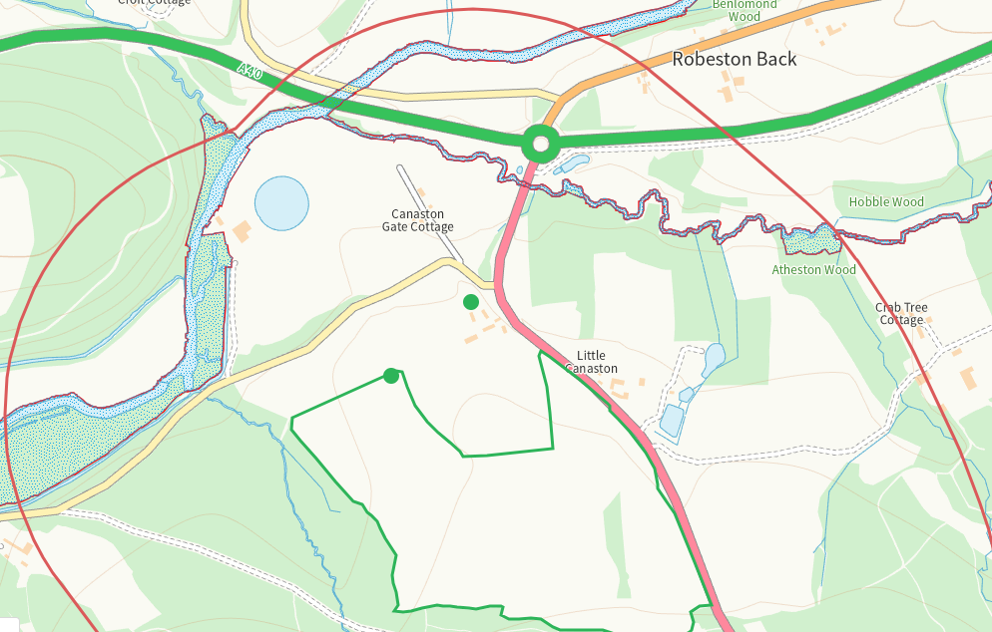

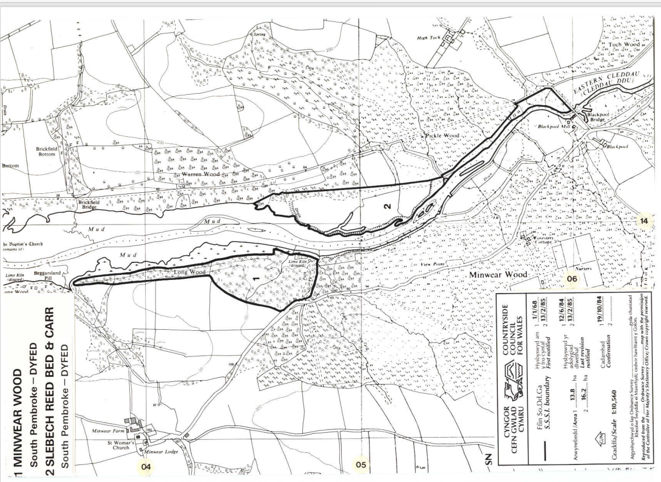

END

