PAN-030123 My Map Report:
Application maps
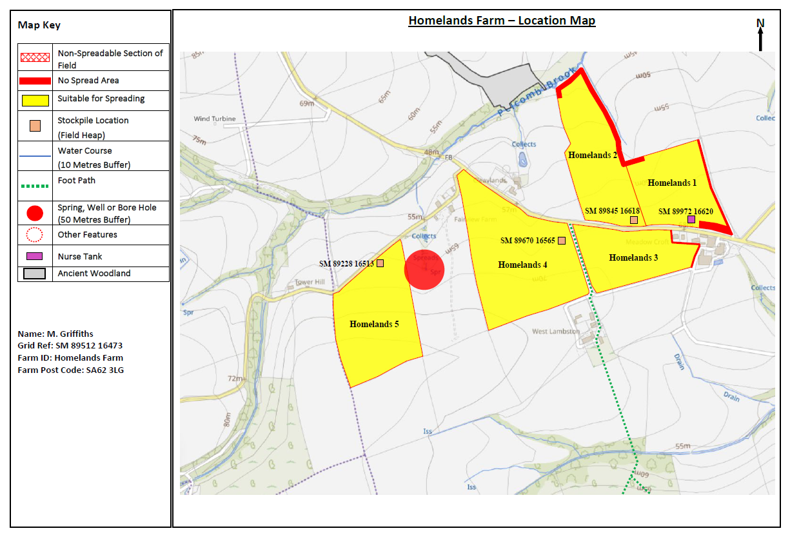
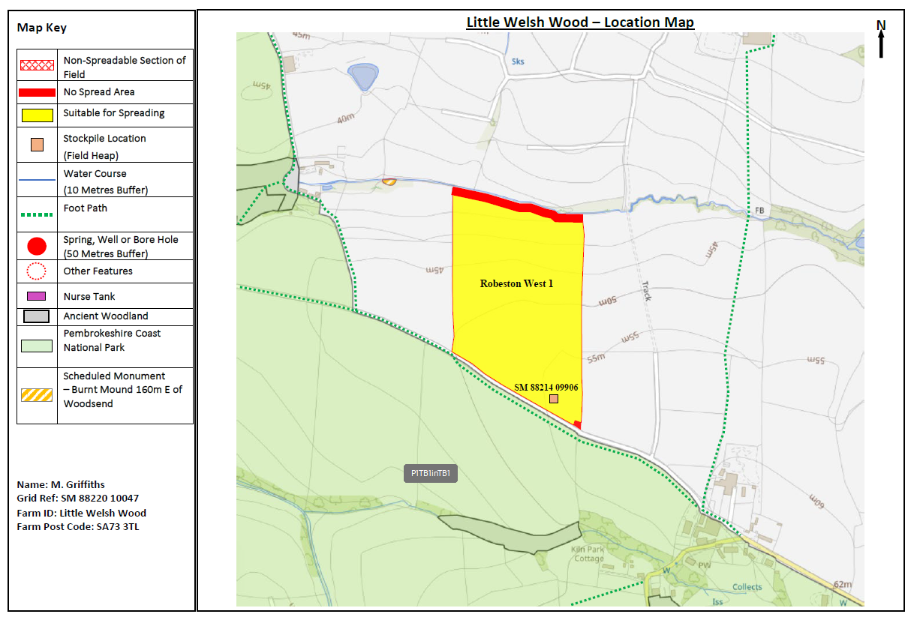
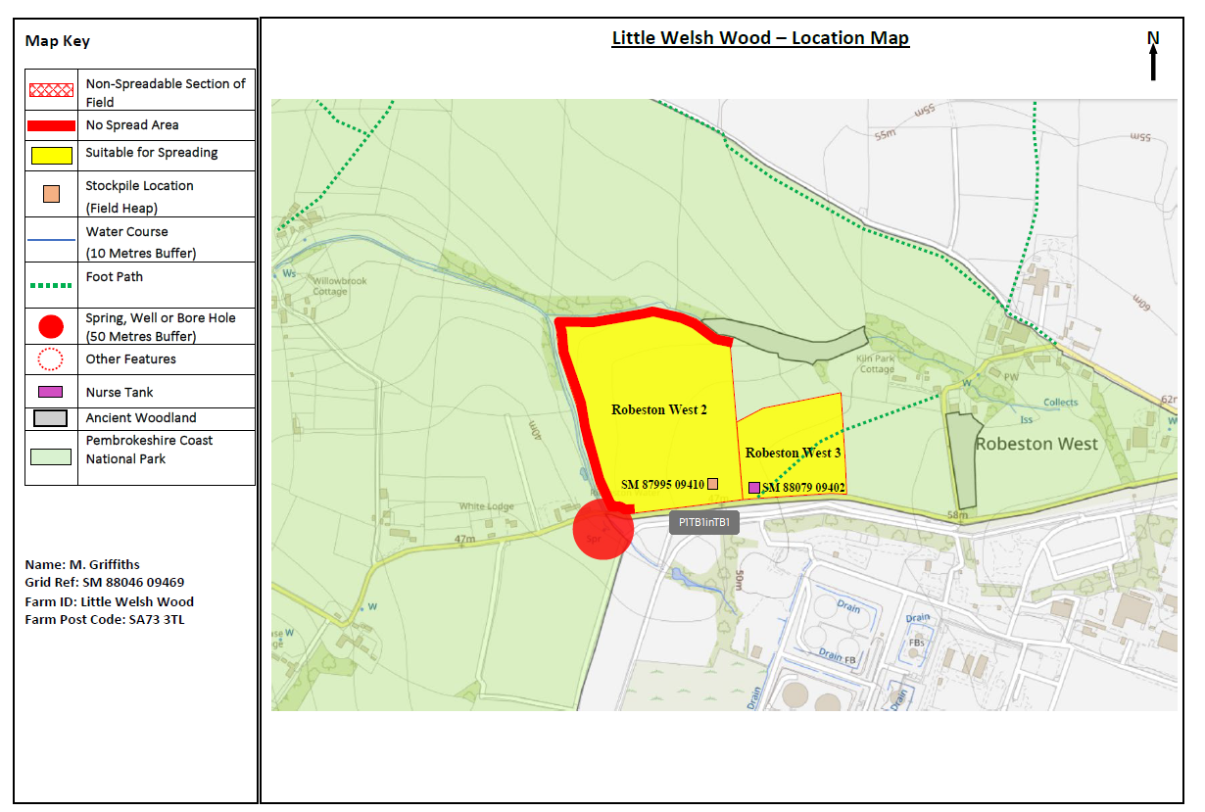

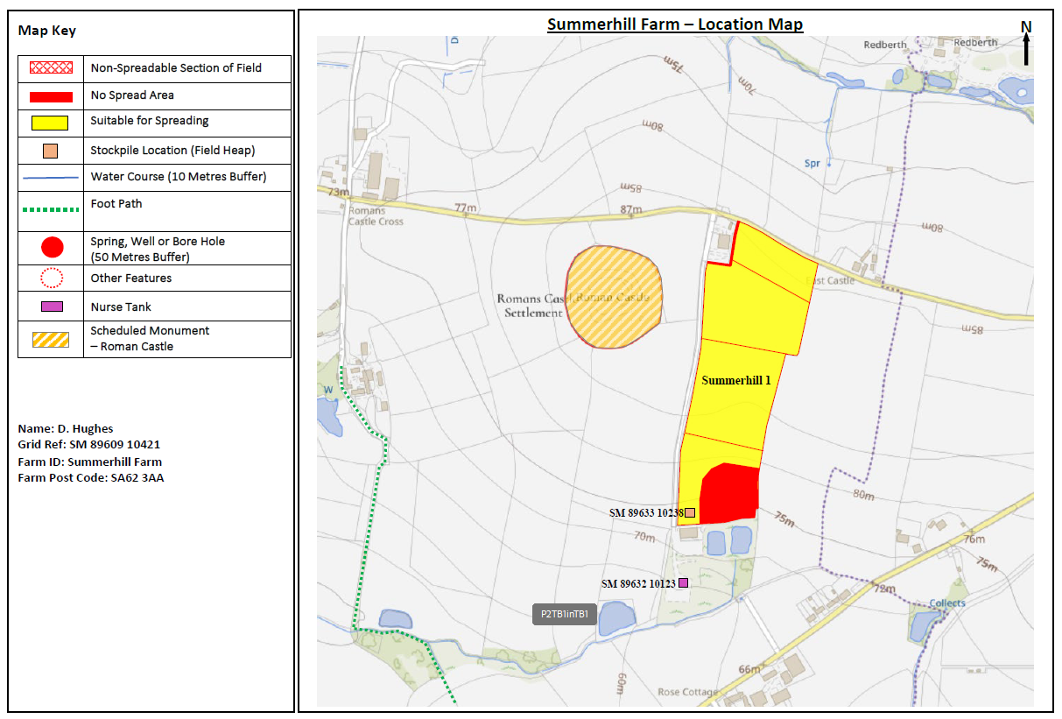
Deployment Boundaries and storage
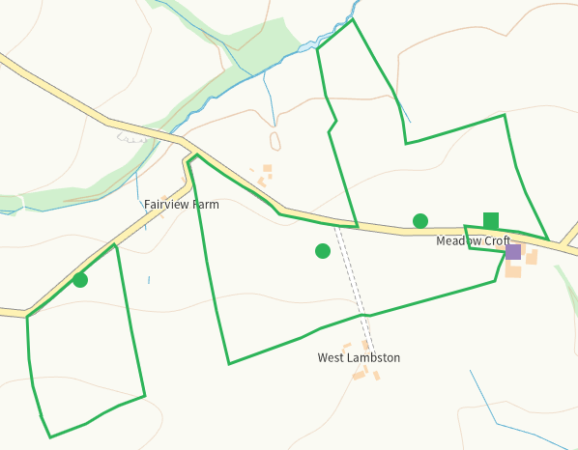
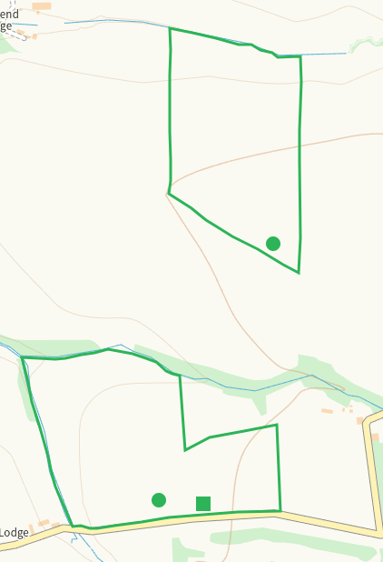
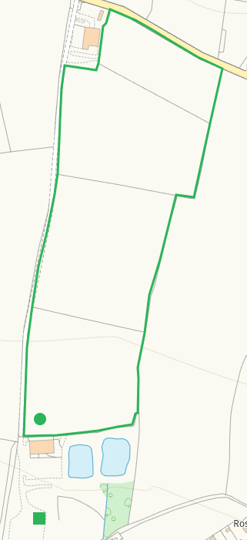
Detailed river network 10m
Watercourse runs adjacent to H2 where it is buffered to the boundary on the application map. MyMap shows that the watercourse extends into H1 and H2, these areas are not buffered RFI
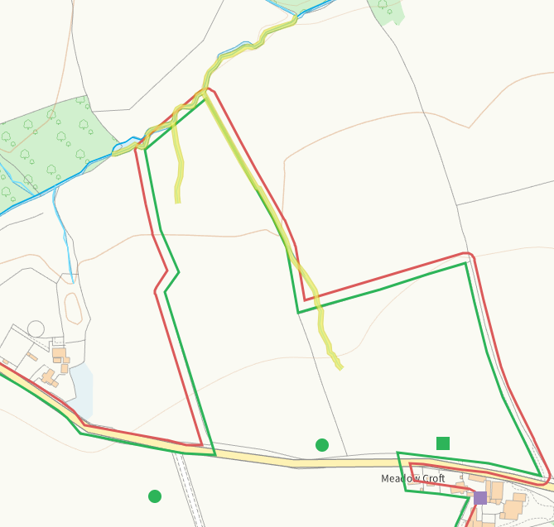
Watercourse N of RW1, shown on application map with buffer
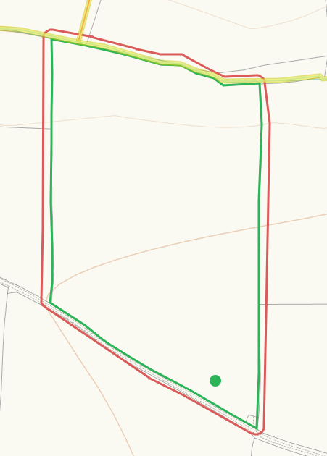

Watercourse N and W of RW2, shown on application map with buffer
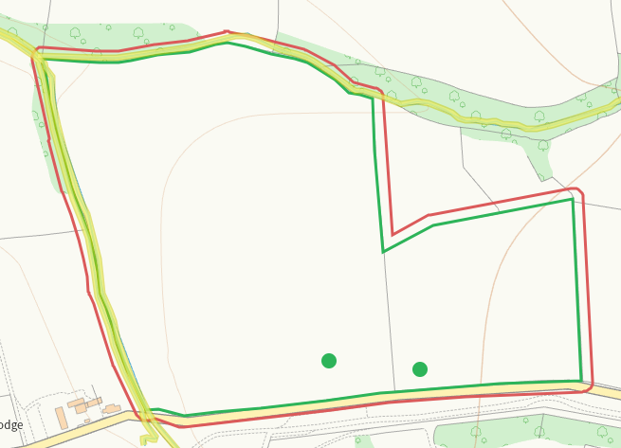
Watercourse S of S1, area buffered on application map
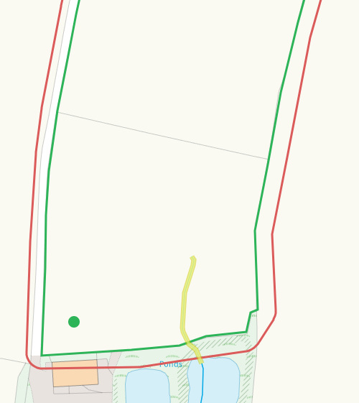
None at other feilds
Groundwater source protection zones
None in range
Any well, spring (or issue) or borehole used for the supply of water for human consumption including from a private water supply or supplies within 50m.
Spring SW of RW2, buffered on application map
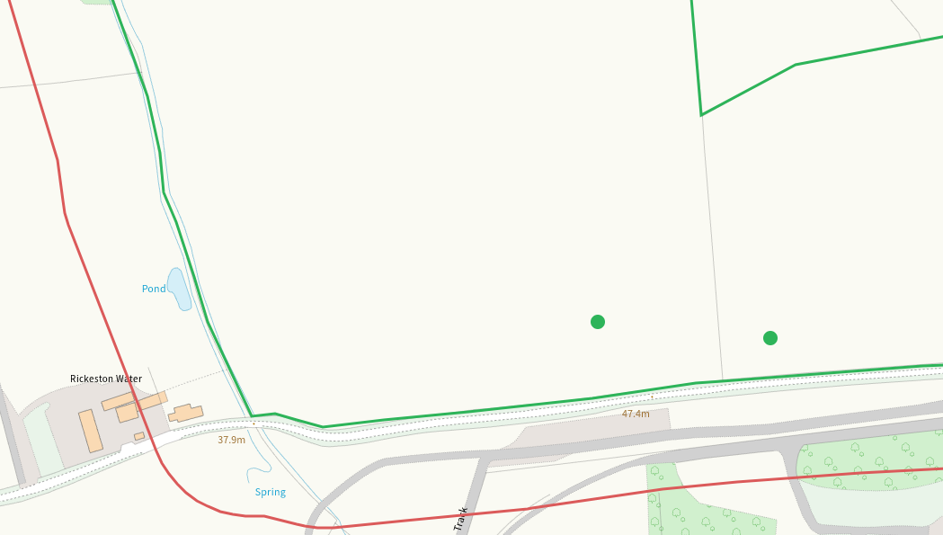
Spring E of H5 buffered on application map
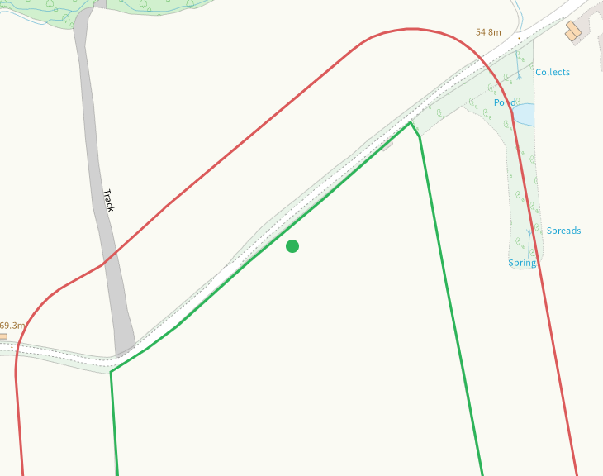
None at other fields
Any well, spring (or issue) or borehole used for the supply of water for human consumption including from a private water supply or supplies within 250m.
Issue S of H5 shown on application map
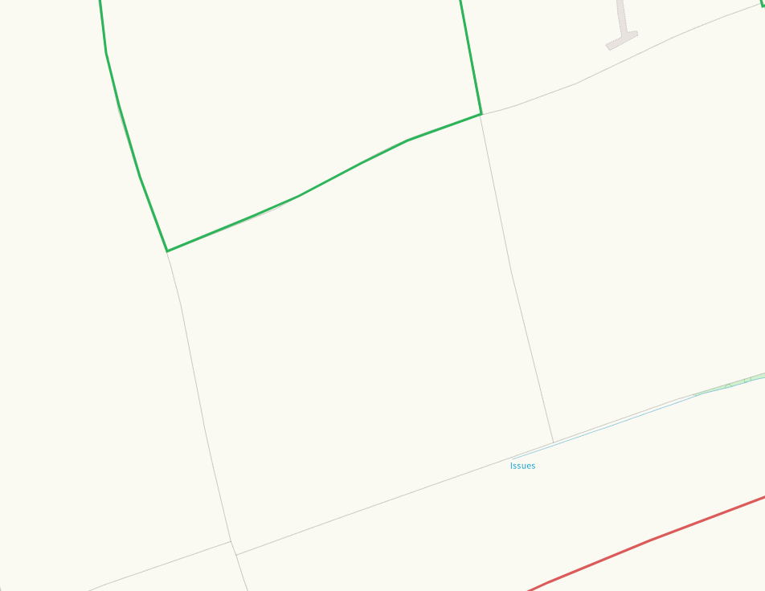
Spring N of S1, shown on application map
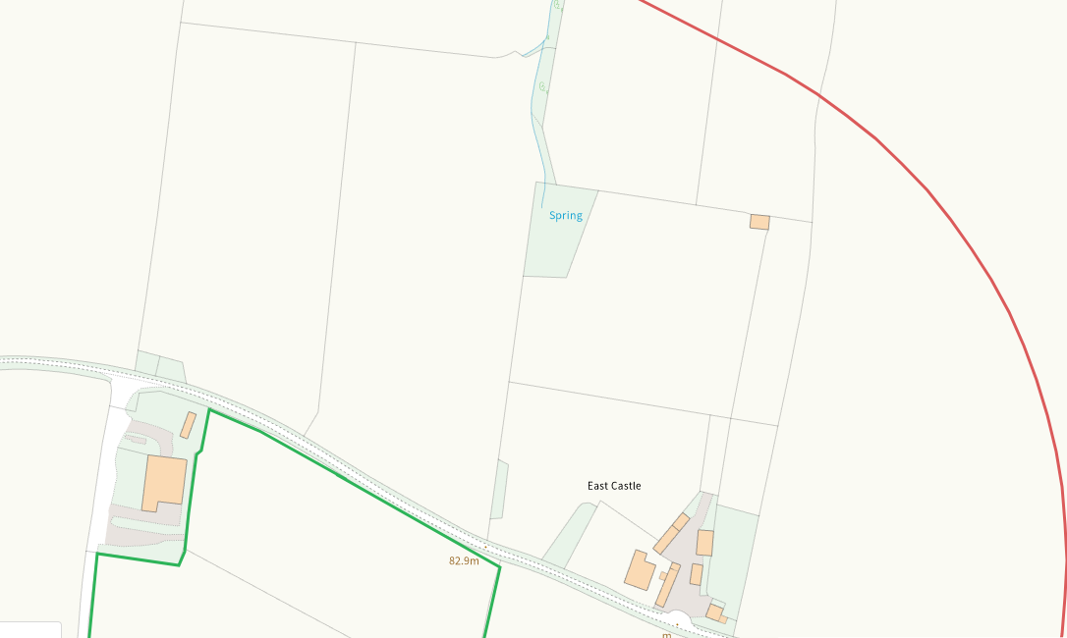
None at other feilds
Within Groundwater Safeguard Zone
None in range

European designated sites- Natura 2000 (SPA, pSPA, SAC or cSAC) or Ramsar- or SSSI within 500m
None in range
Other protected sites within 500m:
- Protected Species-
None recorded in range of H1-5, RW1,
Several within range of RW2 and 3 predominantly bat species
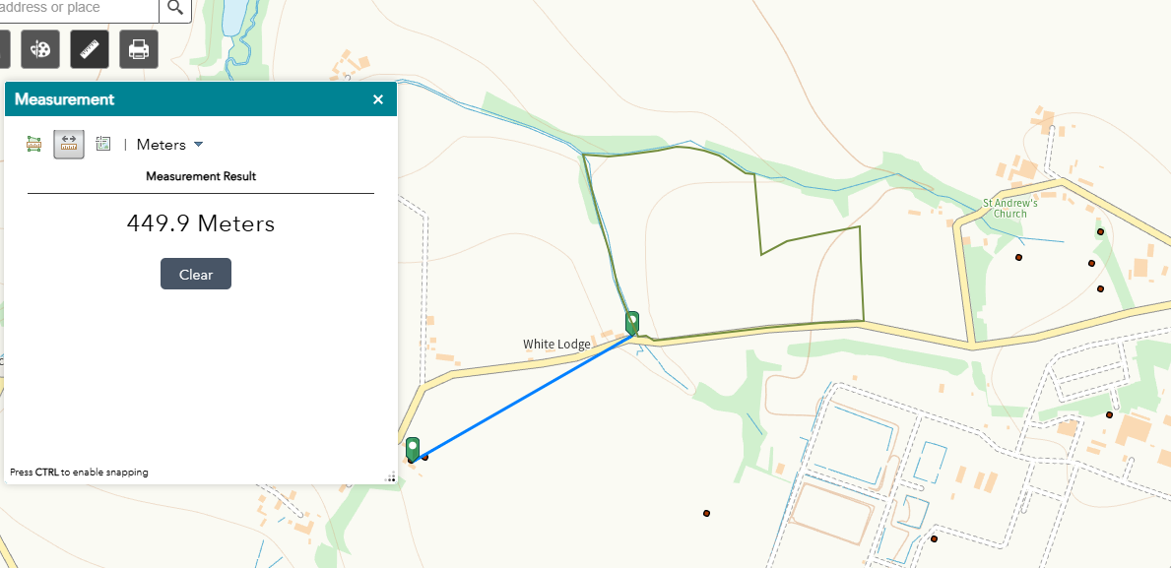

Some within range of S1. predominantly bat and otter
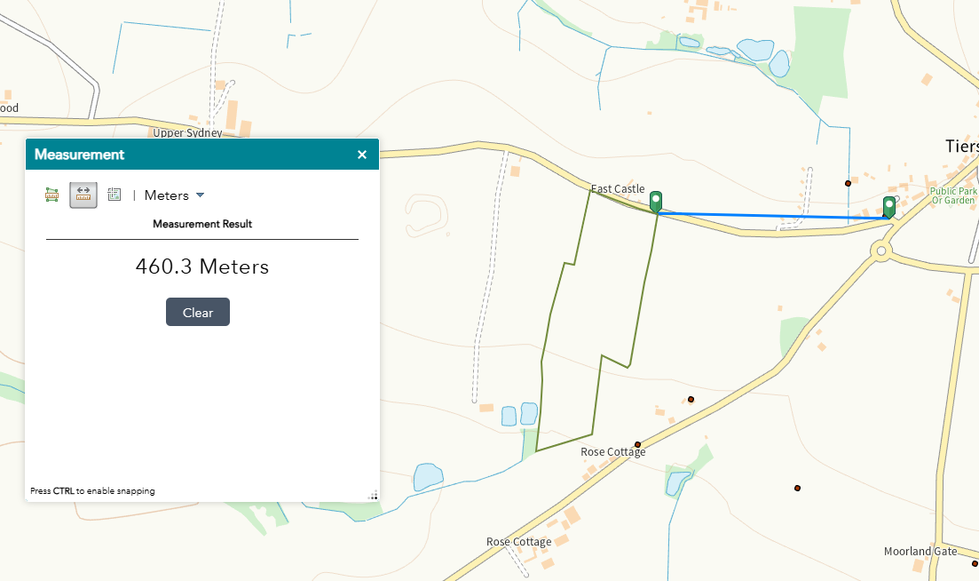

- Protected Habitats-
Lowland dry acid grassland and Lowland calcareous grassland, Lowland heathland, Purple moor grass and rush pastures in range of H1-5

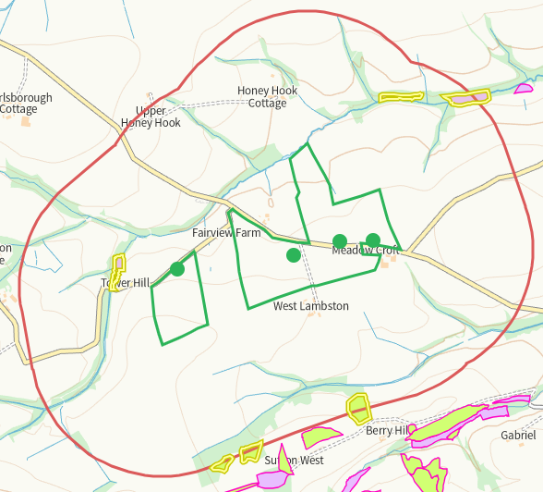

Purple moor grass and rush pastures in range of RW2&3

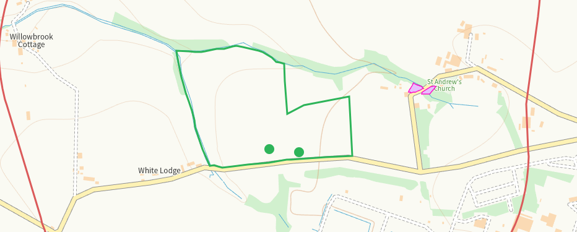

Lowland dry acid grassland and Lowland calcareous grassland, Purple moor grass and rush pastures in range of S1.

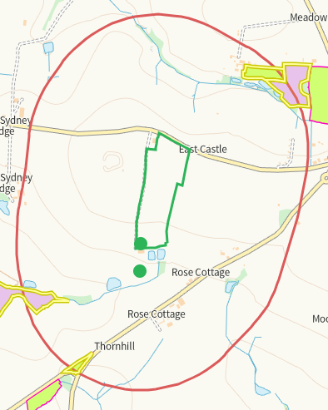

- Scheduled Ancient Monument-
Walwyn's Castle W of RW2, shown on application map and mitigated in SSRA
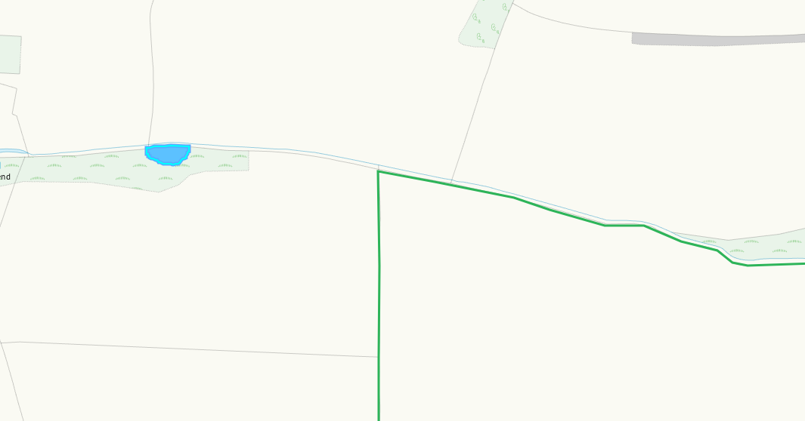

Walwyn's Castle W of S1, shown on application map and mitigated in SSRA
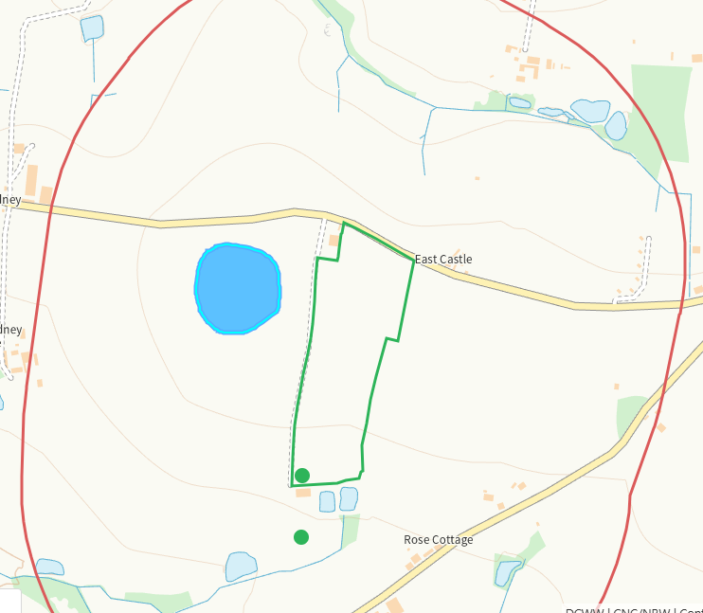

None at other feilds
- Local Nature Reserve- none
- National Nature Reserve- none
- Ancient Woodlands-
Ancient woodland NW of H2, shown on application map and mitigated in SSRA

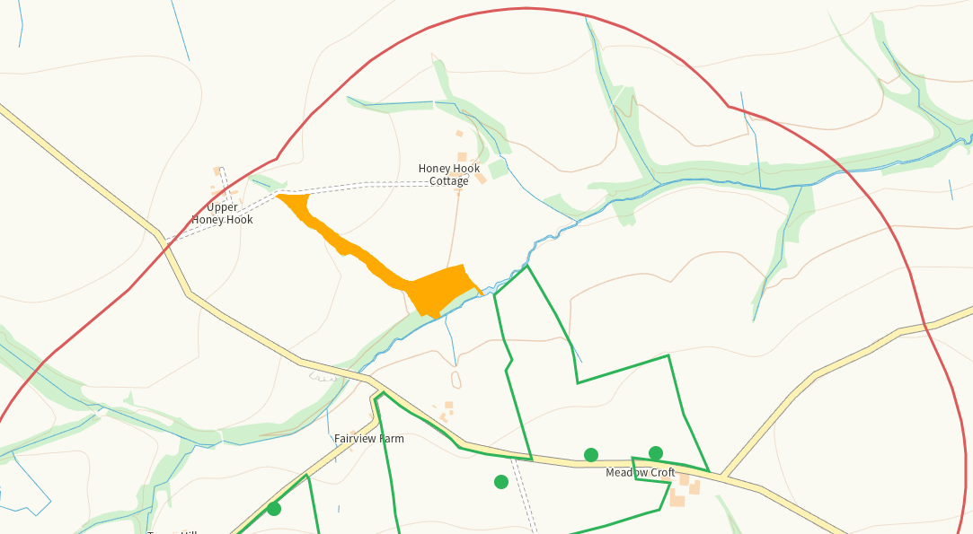
Ancient woodland W of RW2, shown on application map and mitigated in SSRA
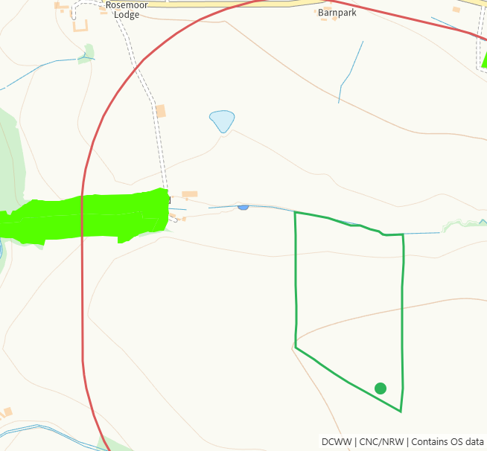
Ancient woodland E of RW2&3, shown on application map and mitigated in SSRA

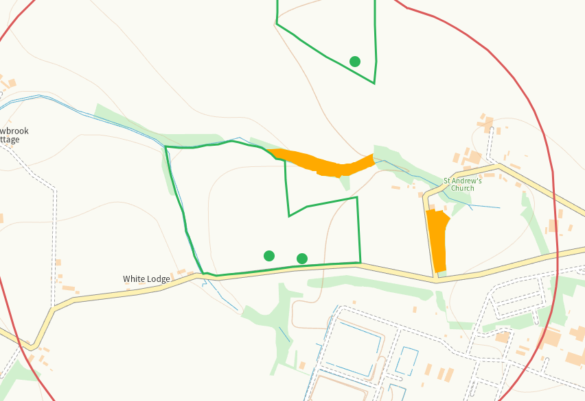
None at other feilds
- Local Wildlife Sites (SINC)- none
- National Park-
RW1 adjacent to and RW2&3 are within Arfordir Penfro / Pembrokeshire Coast National Park. Shown on application map and mitigated in SSRA
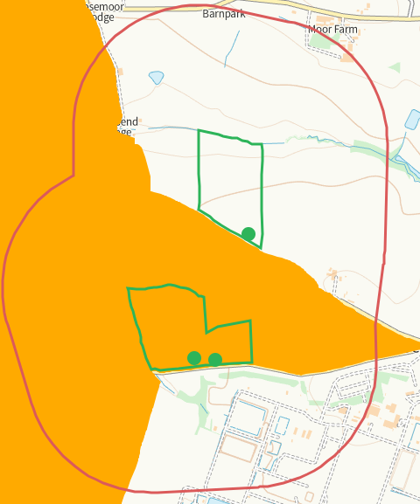
None at other feilds
- Nitrate Vulnerable Zone (NVZ)- ALL Wales
- Groundwater Safeguard Zone- none

Flood risk
Nil risk to any feild
Public rights of way
Footpath between H3 and H4. Shown on application map.
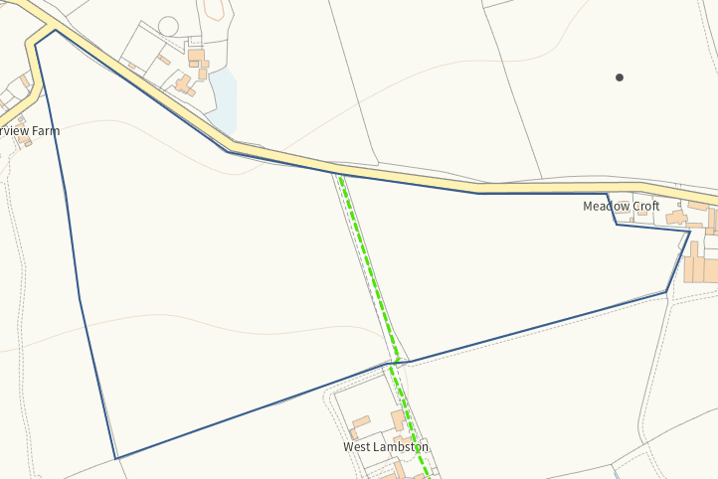
Footpath S of RW1. Shown on application map
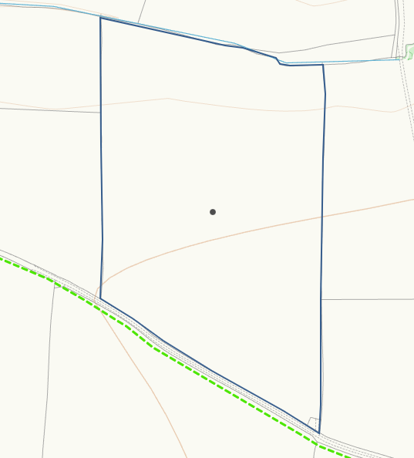
Footpath transits through RW3. Shown on application maps
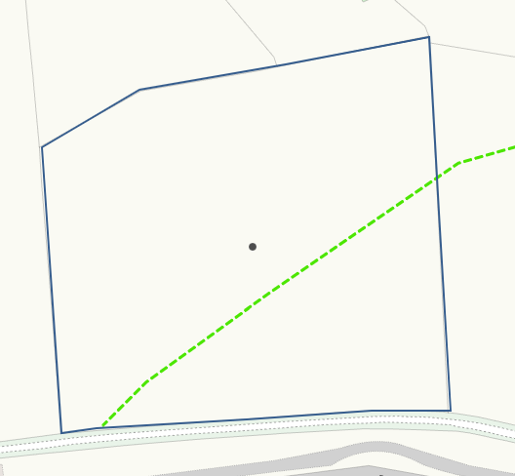
None at other feilds
Distance from Main Farm Address
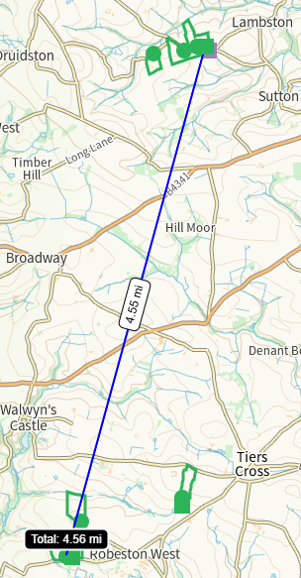
Slope Map
H1-5, RW1&3, S1 all 0-7
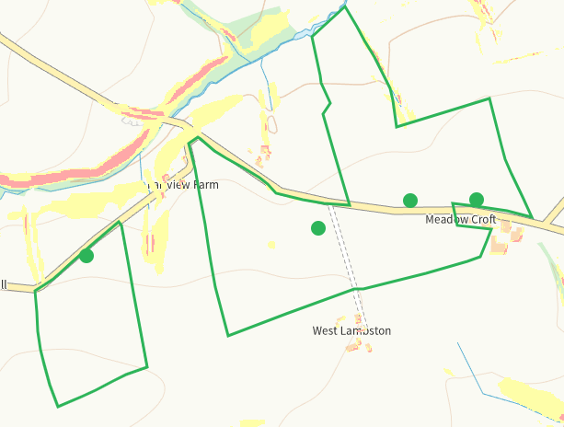
RW1 0-7, minor 7-12
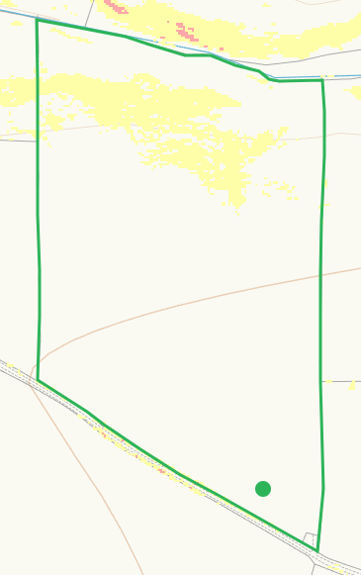
RW2 0-7 minor 7-12 where buffers are in place
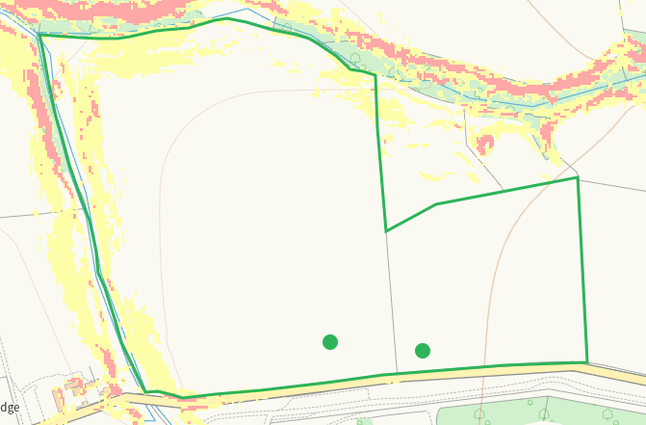
END

