Annex (iv) – SSSI Assessment Form
SSSI Assessment for permit/licence and deployment applications | 
To be completed by Permitting Officers for any applications for a permission which Natural Resources Wales has considered under S28I duty to notify SNCB and take their advice into account. This applies to all proposed permissions within a SSSI, and to operations outside the SSSI boundary which are likely to damage its special features.
NRW as a Section 28G authority has, when exercising its functions, a general duty to take reasonable steps, consistent with the proper exercise of its functions, to further the conservation and enhancement of the flora, fauna or geological or physiological features by reason of which the site is of special interest’

Part 1 – SSSI Assessment
Part 2 – Formal notification to SNCB (to be completed if part 1 assessment concludes likely damage, not likely to damage because of conditions or you cannot conclude no likely damage)
Part 3 – Decision
Pink text – drafting notes, to be deleted before completion/consultation.
Blue text – examples, to be replaced with permission-specific information and text turned to black.

Part 1 – SSSI Assessment

- Permitting officer/team | Bryan Burn/Waste Permitting
- Permit application reference and site name | PAN-030162  Clyn yr Ynys, Gwbert, Cardigan, Ceredigion. SA43 1PR. SN 16571 50635
- a. SSSI name(s)  b. location  c. NRW Operational Area/Environment Team | a. Aberarth - Carreg Wylan  b. Cardigan  c. Mid / Env Team 5 - Ceredigion  a. Caeau Crug Bychan  b. Cardigan  c. Mid / Env Team 5 - Ceredigion
- Brief description of proposal | Landspreading deployment under SR2010No4 Mobile plant permit. Spreading potable water treatment sludge 19 09 02 from 10x DCWW sites with three field heaps and two nurse tanks.  Application is to spread 6410 tonnes. The waste will be spread over 46.50 hectares at the listed feilds.  The activity is not wholly or partly within the SSSI boundaries.  Fields Hafod 5928, Nant y Croi 10 & Hafod 2675 will be spread in March – April 2026 prior to first cut silage. Field 5928 will be spread with sludge cake, or with an application of liquid sludge up to 50t/ha. Fields Nant y Croi 10 & Hafod 2675 will only be spread with liquid sludge. Field Hafod 5928 will then be spread again with sludge cake, or liquid sludge & fields Nant y Croi 10 & Hafod 2675 only with liquid sludge in May - June 2026 and following further silage cuts July – September 2026. Spreading of these grass fields may be split into up to 5 separate applications for liquid sludge & the total of all applications will not exceed the max application rate for each field.  For liquid sludge each individual application will not exceed 50t/ha in any one application to a field and individual applications will be at least 3 weeks apart. For sludge cake spread on field Hafod 5928, spreading may be split into 2 separate applications.  Fields Hafod 5505, Hafod 9875, CYY 7065, CYY 2074 & Hafod 0834 will be spread with sludge cake, or with an application of liquid sludge up to 50t/ha prior to cultivations and planting of the spring wheat crops in March – May 2026. The fields will then be spread again with liquid sludge with up to 2 applications at least 3 weeks apart and up to 50t/ha per application into the growing crops in April – June 2026. The waste will be soil incorporated as soon as possible and within 24 hours where spread prior to cultivations and planting of the spring wheat crops.  Field Hafod 3370 will be spread with sludge cake, or with an application of liquid sludge up to 50t/ha prior to cultivations and planting of the forage maize crop in April – June 2026. The field will then be spread again with liquid sludge with up to 2 applications at least 3 weeks apart and up to 50t/ha per application into the growing crop in May – June 2026. The waste will be soil incorporated as soon as possible and within 24 hours where spread prior to cultivations and planting of the forage maize crop.  Spreading of the waste will be carried out in accordance with the Code of Good Agricultural Practice, The Water Resources (Control of Agricultural Pollution) (Wales) Regulations 2021 and in accordance with the requirements of the deployment and Environmental Permitting Regulations.  NRW will be informed at least 48 hours prior to any spreading commencing and no spreading will occur within 48 hours of forecasted heavy rainfall.  Should the ground or weather conditions mean it’s unsuitable for spreading then temporary storage of liquid sludge in a nurse tank may be required. These potential locations are detailed on the attached field maps & within the LPD1 form.  The stackable water clarification sludge cakes are delivered to the spreading fields and stockpiled in temporary field heaps prior to spreading. Spreading of the sludge cakes is undertaken with rear discharge muck spreaders.  When multiple liquid water clarification sludges or sludge cakes are applied to the same field in separate applications the maximum application rates will be set so that for the total combined amount applied the total nitrogen loading will be less than 250 kg/ha, and the amount of available nitrogen and total or available phosphate and potash (whichever is appropriate) will not exceed the fertiliser recommendation or the amount removed in crop offtake.  Potentially Toxic Elements: The supplied concentrations at the proposed application rates are all lower than the maximum permissible levels detailed in the Sludge (Use in Agriculture) Regulations for biosolids applied to agricultural  land, which is believed to be a suitable comparison for wastes applied to agricultural land.  Dwr Cymru Welsh Water Llechryd & Bontgoch water treatment works use iron-based coagulants to condition the water.The sludges will only be spread on fields with a soil pH of 5.5 or above.  Dwr Cymru Welsh Water Bolton Hill, Preseli & Strata Florida water treatment works use aluminium-based coagulants to condition the water. The sludges will only be spread on fields with a soil pH of 6.0 or above.  Fields Nant y Croi 10 and Hafod 2675 have soil pHs of 5.8 and 5.7 and as such no Bolton Hill, Preseli & Strata Florida water treatment works liquid sludges or sludge cakes will be spread on these fields.  Potential run-off after application: The wastes will be applied following the Code of Good Agricultural Practice. The maximum application rate for each field over 50t/ha where spread with liquid sludges will be split into multiple applications and will not exceed 50t/ha in any one application to a field.  The fields will be spread using precision spreading dribble bar equipment for liquid sludges and with rear discharge muck spreaders for sludge cake, with no spreading areas enforced as per maps.  No waste will be spread within 10m of any ditch, pond or surface water, within 50m of any spring, well, borehole, or reservoir that supplies water for human consumption or farm dairies.  No spread buffers are in place where required.  Main Farm Location:  Clyn yr Ynys, Gwbert, Cardigan, Ceredigion, SA43 1PR. NGR SN 16571 50635  Feilds:  SN 16551 51051  SN 16983 50759  SN 16726 51038  SN 17208 50624  SN 16088 50345  SN 16598 50289  SN 16338 49708  SN 18964 51053  SN 18257 50747  Storage:  SN 16650 50914 – feild heap  SN 17107 50604 – field heap  SN 17120 50561 – field heap  SN 17052 50301 – nurse tank  SN 18148 50320 – nurse tank  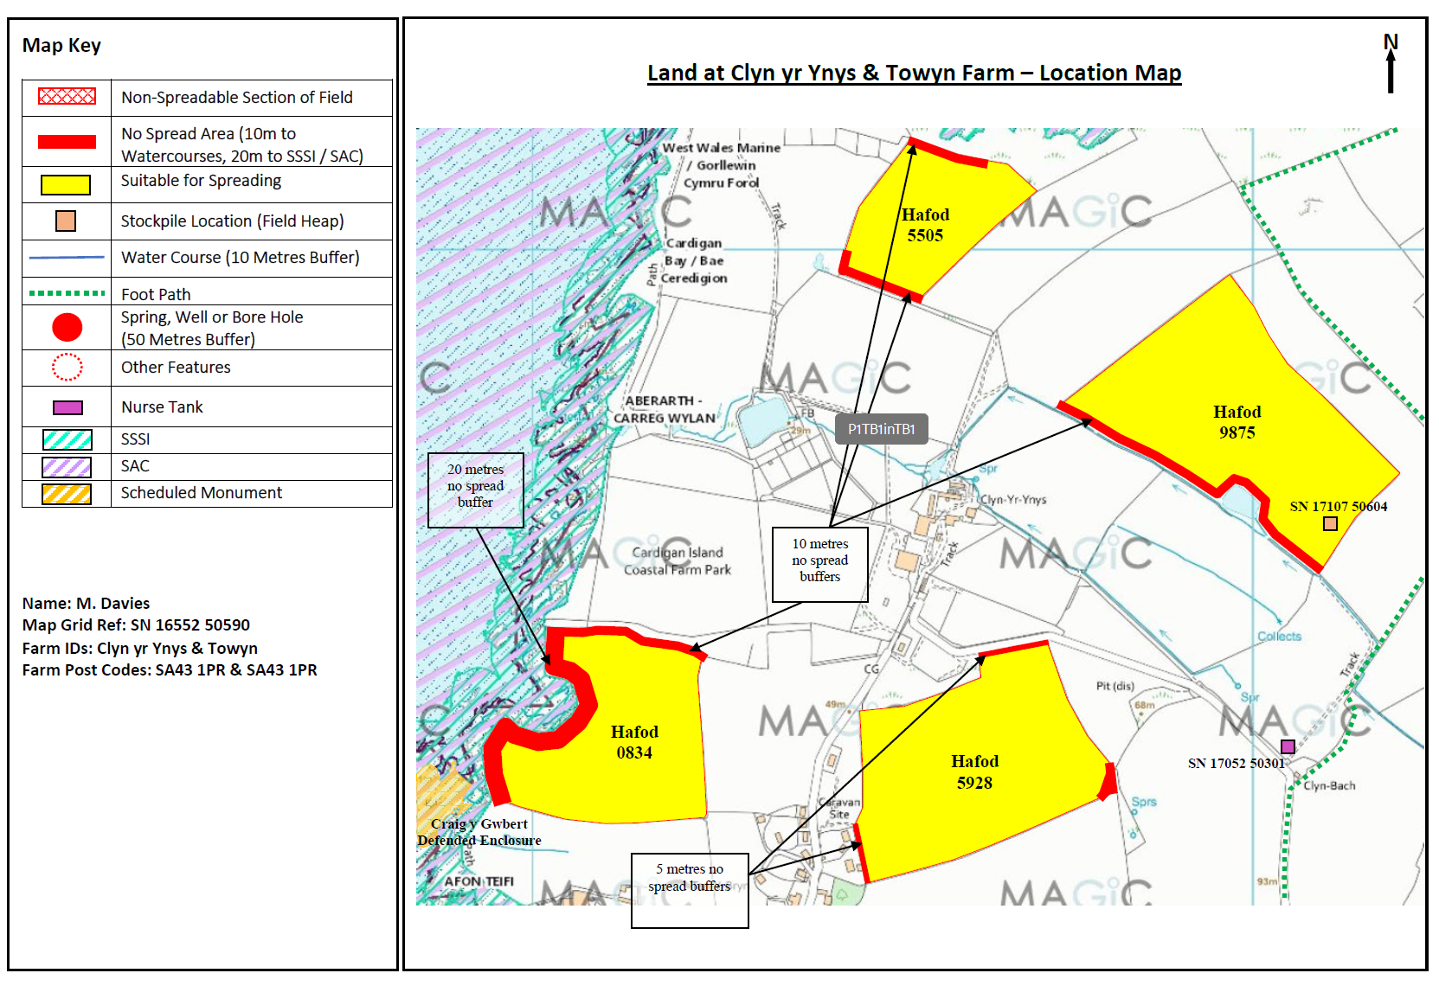  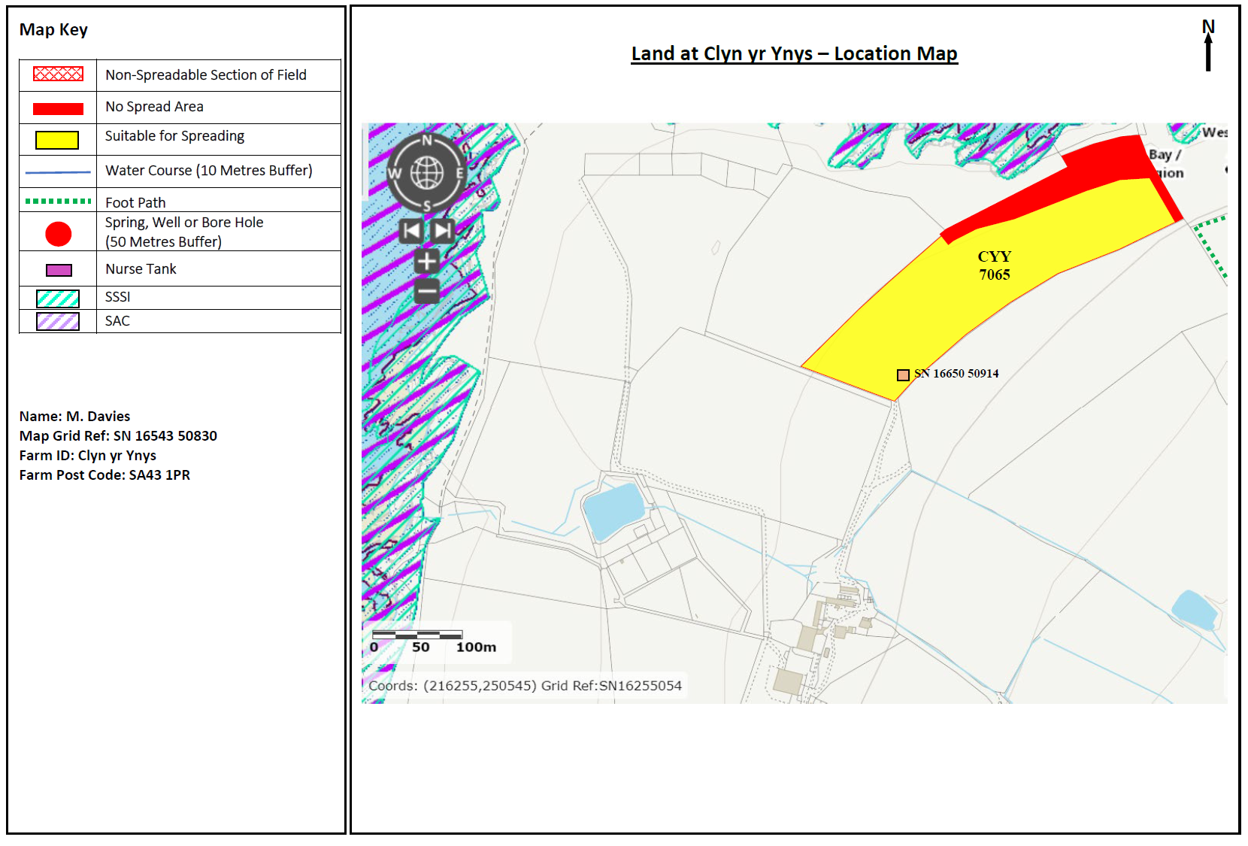  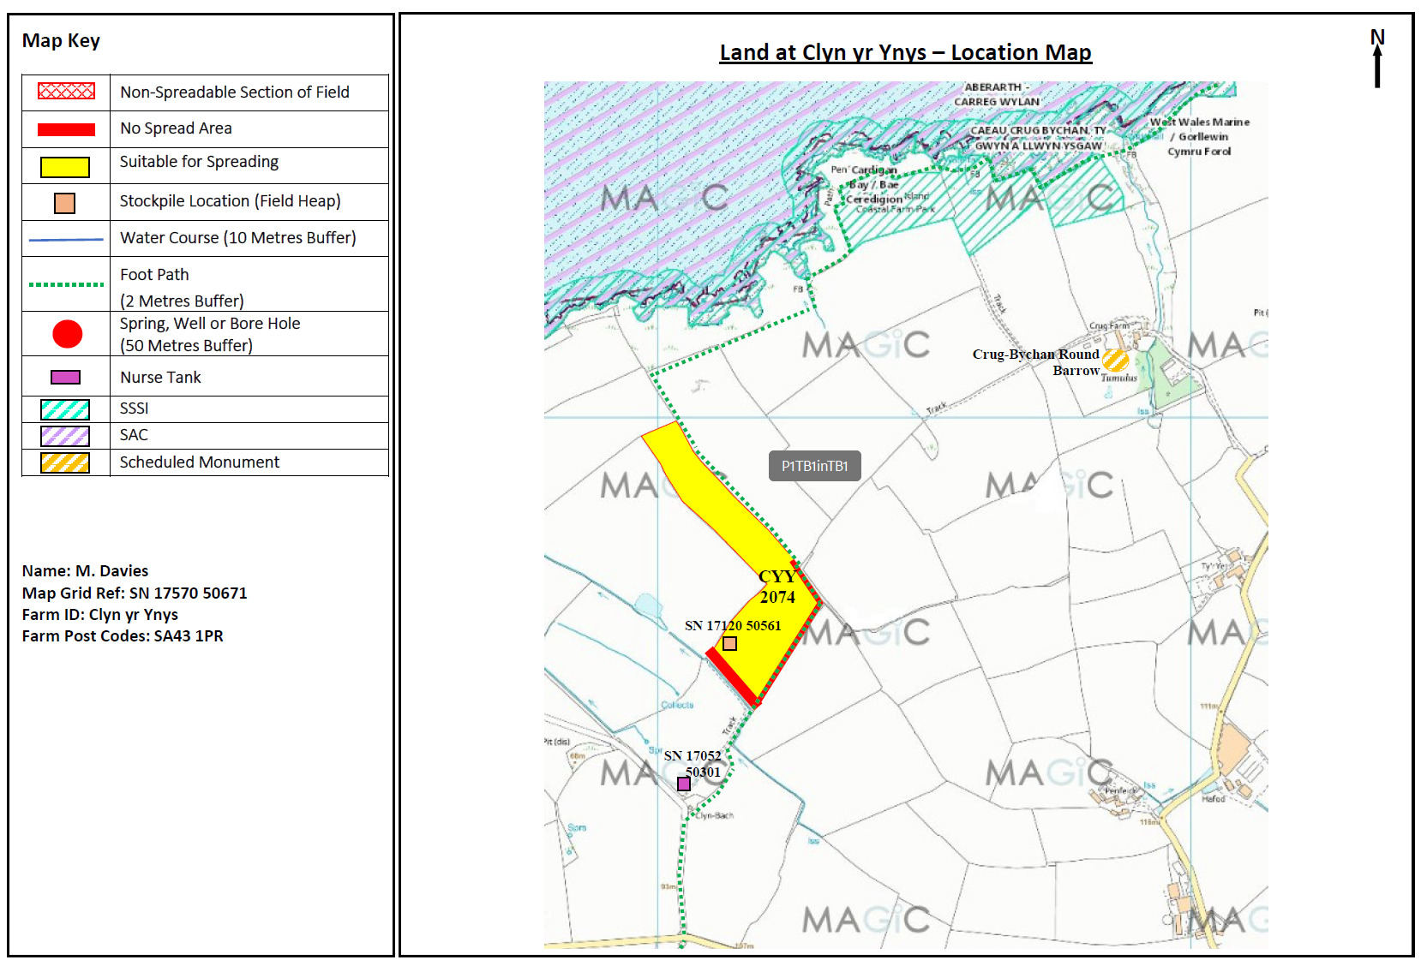  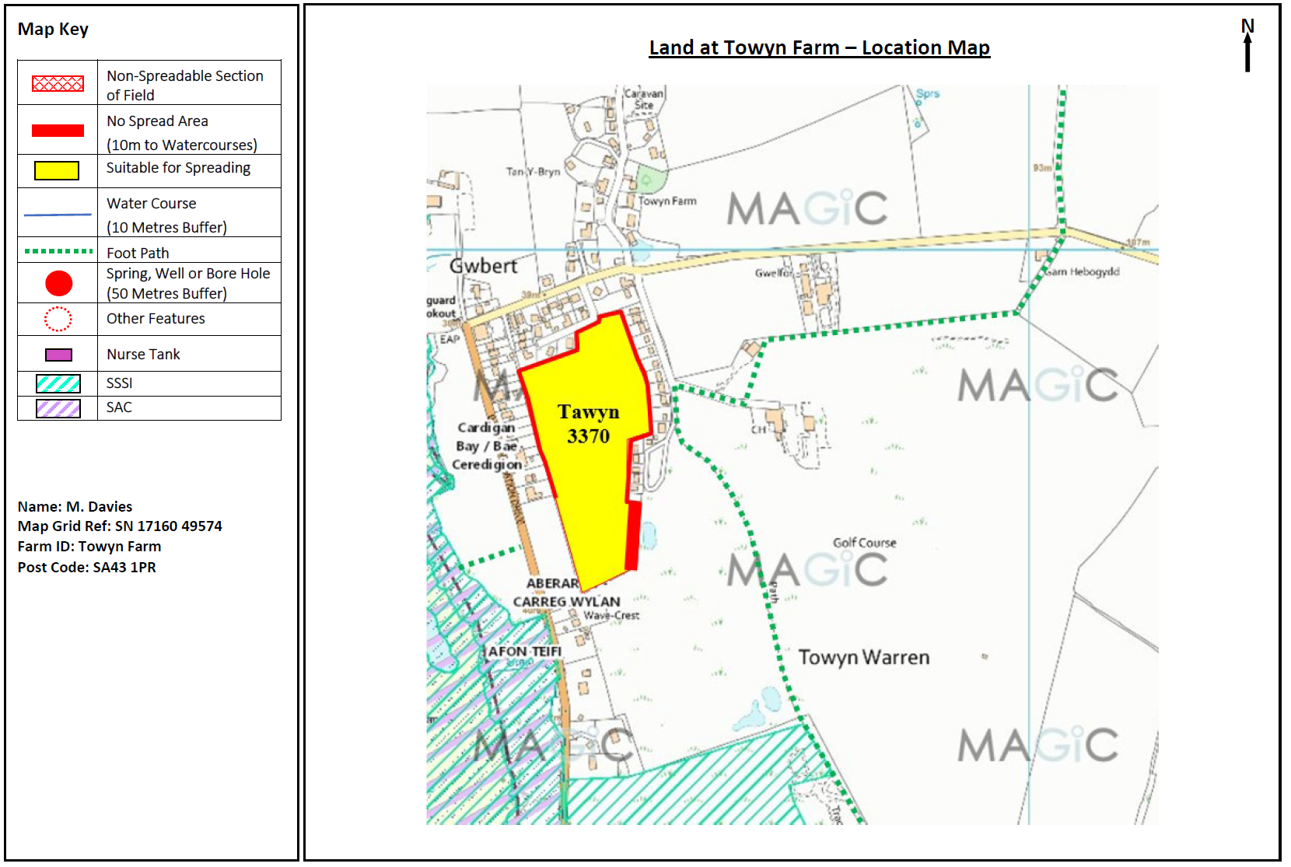  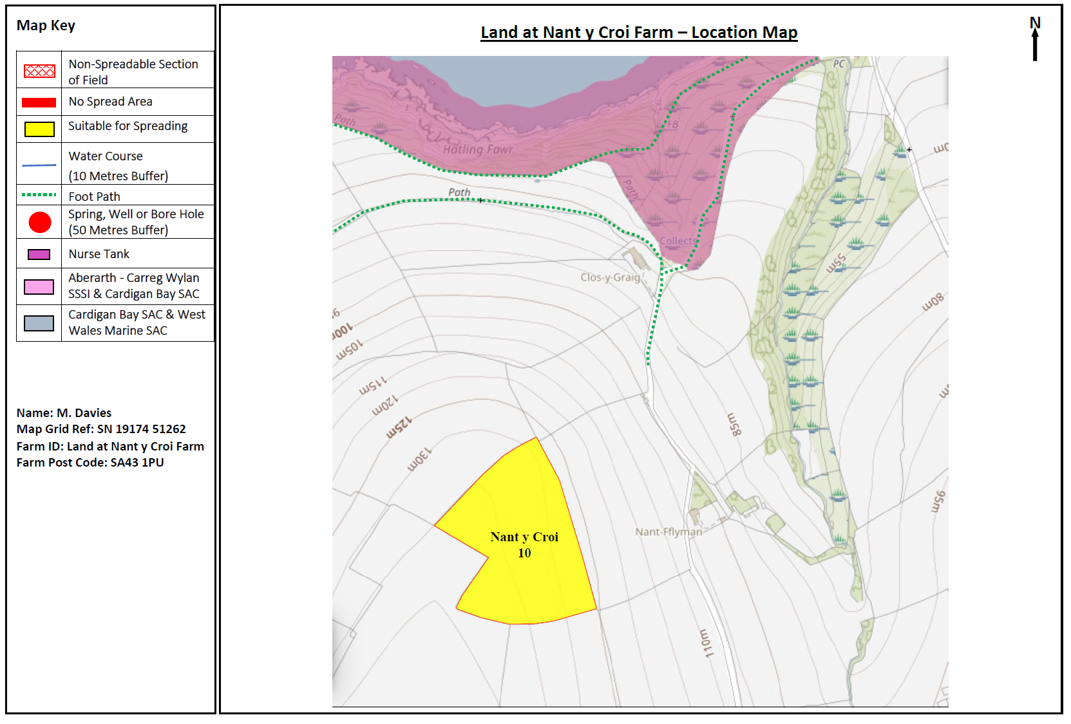  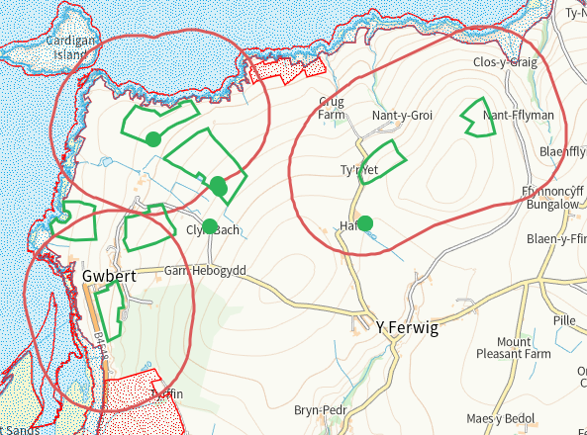
- What aspects of the proposed permission are likely to damage the SSSI features of special interest?

The following activities are likely to cause damage:
Aberarth - Carreg Wylan.
5. Application of manure, slurry, silage liquor, fertilisers and lime
7. Dumping, spreading or discharging of any materials.
22. Storage of materials on or against cliffs, rock outcrops and foreshore

Caeau Crug Bychan.
5. Application of manure, slurry, silage liquor, fertilisers and lime
7. Dumping, spreading or discharging of any materials.
22. Storage of materials.

The following SSSI(s) features and potential impacts have been considered to assess the likelihood of damage:

Aberarth - Carreg Wylan
https://cdn.cyfoethnaturiol.cymru/641362/SSSI_0355_SMS_EN0017c63.pdf
https://cdn.cyfoethnaturiol.cymru/641262/SSSI_0355_Citation_EN0018c6a.pdf

Caeau Crug Bychan.
https://cdn.cyfoethnaturiol.cymru/662219/SSSI_1244_SMS_EN001fb35.pdf
https://cdn.cyfoethnaturiol.cymru/662194/SSSI_1244_Citation_EN001efe2.pdf

- Summary of any informal advice received from internal experts (if required and including pre-app advice) | n/a
- Recommendation | The proposed permission is not likely to damage any of the flora, fauna or geological or physiological features which are of special interest
- Signature and date assessment made | Bryan Burn 17/09/25
- Officers name and job title | Bryan Burn, Permitting Officer

