When a permit is varied from an SRP to a bespoke activity we must assess the changes as if it were a new bespoke permit, as the controls that were applied to the rule set (in this case 75,000tpa throughput and 50,000 tonnes storage) are no longer in place. We therefor require the relevant supporting documents to be provided in full.

This document includes the reasons the application was returned, the primary reasons are given in points 4 (Environment Management System), 5 (Fire prevention mitigation plan), 6 (Noise impact assessment and management plan) and 15-30 (Dust Management Plan).

Application form
- The answer to question Tell us about the waste activity you are applying to add or change states that the sites Non-hazardous waste treatment capacity is 250,000tpa. The form asks for this to be given in the form of tonnes per day, not tonnes per annum. 250,000tpa equates to just under 685 tonnes per day.
If you are to reapply the correct form should be used, and the daily number confirmed.

- The answer to question Tell us about the total storage capacity and annual throughput states that the total storage capacity of non-hazardous waste will be 125,000 tonnes (at any one time) and the total annual throughput in tonnes per year will be 250,000 tonnes. The answer to the earlier question Give a summary of your application only states that the annual throughput is increasing.
If you are to reapply, both changes should be listed.

- Declaration- the declaration has not been completed correctly to say this is a valid application. The declaration has been signed by David Holman on behalf of Hanson Quarry Products Europe Limited, however Mr. Holman is not listed on companies house, nor has authorisation been given by a relevant person for Mr. Holman to sign on the companies behalf.
If you are to reapply, either a relevant person needs to sign the declaration, or authorisation from a relevant person needs to be supplied.

Required documents not supplied
- Environment Management System- the application form requires an EMS summary to be provided “which sets out any changes or additional measures you will put in place to the address risks from the proposed changes.”
Additionally our bespoke application guidance confirms that “You must send a summary with your application. It must include enough information to allow us to assess whether your full system does meet the standards set out in our guidance.” Our guidance is How to comply with your environmental permit.
The EMS supplied in support of the application is bs-en-iso-14001-hanson-quarry-products-31-12-25, which is an Environmental Management System Certification for ISO 14001:2015, but provides no site-specific information on the site or how it is run.
If you are to reapply, then a site specific EMS needs to be provided that is in line with our guidance How to comply with your environmental permit.

- Fire prevention mitigation plan- An FPMP is required if any of the proposed wastes are listed within our current guidance- Fire prevention and mitigation plan: waste management guidance
On the application form in response to the fire risk question it is stated "The wastes accepted at the site are not combustible. There is no fire prevention plan required for the activity at present and there are no proposed combustible wastes proposed as a result of the variation." However there are 3 combustible codes listed in the permit- 03 01 01 waste bark and cork, 03 03 01 waste bark and wood and 19 05 03 compost from source segregated biodegradable waste only. If you wish to accept and treat these wastes, then an FPMP is needed.
If you are to reapply, then an FPMP is required that is in line with our current guidance- Fire prevention and mitigation plan: waste management guidance

- Noise impact assessment and management plan- On the application form in response to the noise or vibration risk question it is stated "The site is currently operational and has not received noise complaints through the operation to date. The increase in throughput of the facility will not change the operational hours of the facility and as such does not represent a significant risk of noise and/or vibrations."
We do not agree with this justification. A Noise impact assessment (NIA) and Noise management plan (NMP) are needed due to the following cumulative reasons:
- The permitted activities are sorting, separation, screening, crushing and blending of waste for recovery as a soil, soil substitute or aggregate.
- The annual throughput is tripling from the current amount which indicates that the treatment activities will be occurring for longer duration.
- Activities are occurring overnight. BS4142 categorises daytime as typically between 07:00 h and 23:00 h and night‑time is between 23:00 h and 07:00 h. Your risk assessment confirms that importation operations will be undertaken 24 hours a day and waste processing operations will occur 06:00 – 20:00 Monday – Friday and 08:00 – 16:00 Saturday.
- All activities are to occur outside.
- The nearest residential receptor is 185 meters from the site.
If you are to reapply, the NIA and NMP should be written in line with the following:
- Noise and vibration management: environmental permits - GOV.UK
- Method implementation document (MID) for BS 4142 - GOV.UK
- ‘BS 4142:2014+A1:2019 Method for rating and assessing industrial and commercial sound’ (BS 4142).

Legal limits- Industrial Emissions Directive
- The activity in this application is subject to the Industrial Emissions Directive namely treatment of slags and ashes. There are 3 wastes listed in the permit that are subject to this limit- 10 01 01 Bottom ash and slag only, 10 01 02 Pulverised fuel ash only, and 10 01 15 Bottom ash and slag only from co-incineration other than those mentioned in 10 01 14.
The treatment capacity limit to remain a waste facility is 75 tonnes per day.
If you were to re-apply, you would have to provided information to demonstrate how this limit would be complied with and therefore be able to remain as a waste facility. If you cannot comply with this limit i.e. the treatment capacity is greater than 75 tonnes per day, then an installation permit will have to be applied for. This information should be included within your EMS.

Assessment of supplied documents
Site specific risk assessment- Machen Environmental Risk Assessment
We have reviewed your risk assessment and have the following comments:
- While section 2.1.2 does confirm that there are no proposed emissions to ground or surface water from this activity, it should be acknowledged that the quarry area/activity does have abstraction and discharge permits. Information on how the activity covered by the variation will not impact on the abstraction/discharge should be included within the risk assessment.

- Section 2.2 quantifies the sources of risk. The Noise and Vibration list only includes the Loading/unloading of waste. It does not include any of the permitted treatments of sorting, separation, screening, crushing and blending. Treatment (and storage) of waste should also be included in the Fugitive Emissions Particulate matter, Contaminated surface water run-off; and Mud sections at a minimum.

- Section 2.4- The referenced drawing HUN/B066441/REC/01 – Environmental Receptor Plan has not been included in the risk assessment. Drawing HUN/B066441/PER/01 – Permit Boundary Plan is also missing.

- Section 2.4 is missing the following:
- 3 sites of special scientific interest (SSSIs) within 2km of the site:
  - Ruperra Castle and Woodlands SSSI
  - Plas Machen Wood SSSI,
  - Dan y Graig Quarry, Risca SSSI
- 7 local wildlife sites (also known as Sites of Importance for Nature Conservation, or SINCs) within 1km of the site (these are shown on a map below). Information on LWS/SINCs can be found here- LERC Wales Citations:
  - Coed Pen-Llyn, Machen to the NW of the site
  - Castell Meredydd Woodland to the East of the site
  - Mynydd Machen, West of Risca to the North
  - River Rhymney to the SW
  - Coed Cefn-Pwll-Du, South of Machen to the SW (on the other side of River Rhymney)
  - Coed y Mochyn, Risca to the North (on the other side of Mynydd Machen, West of Risca
  - Machen Woodlands, Machen to the NW of the site (on the other side of Coed Pen-Llyn, Machen)

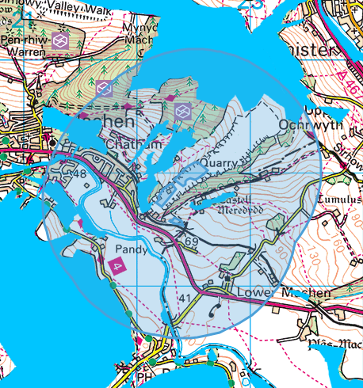

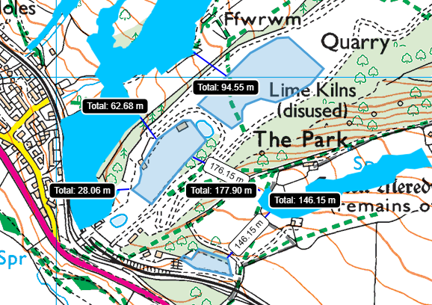
- Flood risk- the site is at High, medium, and low Flood Risk from Surface Water & Small Watercourses. This can be checked on Natural Resources Wales / Check your flood risk on a map (Flood Risk Assessment Wales Map). We do note that “flooding” is included in the risk assessment, but the flood risk has not been quantified.
- Castell Meredydd Scheduled Monument- Scheduled Monument - Full Report - HeritageBill Cadw Assets - Reports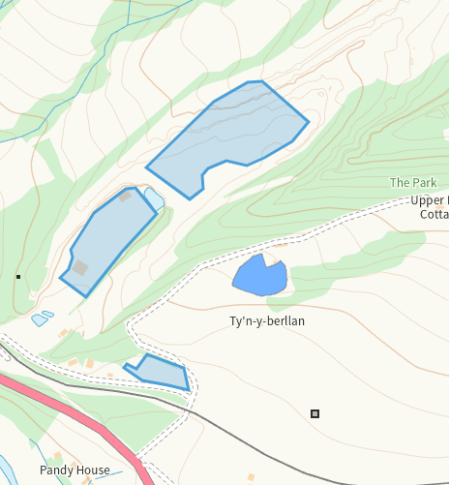
- Additionally, there are two Domestic Dwelling receptors with ID “2”.

- Table A2- states importation operations will be undertaken 24 hours a day, but does not detail what will occur under “importation operations”. It is not clear if this is the referenced loading/unloading of wastes or what this will entail. This should be detailed in the EMS, risk assessment, and NIA/NMP.

- Table A2- includes “Noise from the mechanical treatment of waste.” But does not include what these treatments are, what wastes are being treated, or the machinery used to carry out the treatments. This should be detailed in the EMS, risk assessment, and NIA/NMP.

- Table A3- includes Dust from vehicle movements, loading/unloading of waste, and from storage of waste, but does not include dust generated from the treatment of waste. This should be detailed in the EMS, risk assessment, and Dust Management Plan (see below).

Dust Management Plan- Machen Dust Management Plan No Drawings
We have reviewed your Dust Management Plan and have the following comments:
- The following drawings have been listed but not included:
- HUN/B066441/PER/01 – Permit Boundary Plan
- HUN/B066441/REC/01 – Environmental Receptor Plan
- MAC/B066441/LAY/03 - Site Layout Plan

- Section 1.1.5 refers to two activities that are not covered by this permit- keeping or treatment (or both) of household, commercial or industrial waste in a materials waste transfer station/ material recycling facility” and “keeping or treating (or both) scrap metal”. This section should be revised to ensure it is correct for this application. Additionally the Emissions management plan for dust section of Control and monitor emissions for your environmental permit - GOV.UK has been updated.

- Section 2.6.4 gives a maximum storage capacity for treated material. Is this separate from the amount given in section 2.6.3 because it is no longer considered a waste? This information should be included in the sites EMS.

- Section 2.8.1 includes an “Over band magnet”. Given the type of activity and the wastes to be treated it is not clear why this is included. Section 2.8.1 is the only instance in the application which lists the type of plant and equipment to be used so we have been unable to compare and verify this list.

- Section 2.9 Dust Sensitive Receptors- see point 11 above for missing receptors. Additionally, there are two Domestic Dwelling receptors with ID “2”.

- Section 2.10.2 states “The prevailing wind in the local area is from the west southwest (WSW)”, however Table 4 (Page 12) under “Enclosure” states “As the wind direction is of a southeast direction, it is anticipated that the suspension of dust... will be minimal.”

- Section 2.11 Local Contributors to Dust- the quarry itself and its activities should be included here as a source of dust.

- Table 3 includes “Tipping, storage and treatment of waste inside building” however section 2.5.2 confirms “All treatment and storage activities will occur externally”. This needs to be reviewed, and each type of treatment individually assessed.

- Table 4 states “Enclosure of waste treatment processes” and “Treatment of waste will comprise of dry recycling activities.” Both statements appear to be incorrect and should be reviewed.

- Table 4 states the site has both permeable and impermeable surface, however the risk assessment states there is only hardstanding which we consider to be permeable.

- Table 4 states “All preventative measures will be implemented during the operating hours detailed in Section 2.7.” Section 3.4.5 also refers to this. Section 2.7 further gives importation hours and waste processing hours. It should be made clear which of these are considered operating hours. Please note that we consider BOTH to be operating hours.

- Section 4 has multiple references to the regulator being the Environment Agency. This should be updated to Natural Resources Wales.

- The Dust Management Plan should outline how staff will be trained on the Dust Management Plan

- The Dust Management Plan should outline how appropriate records will be kept (for example of monitoring, complaints)

- The Dust Management Plan should outline how the records of the monitoring and complaints will be reviewed with the aim of improving operations on site

- The Dust Management Plan should outline how regularly and when the entire DEMP will be reviewed

See guidance Control and monitor emissions for your environmental permit - GOV.UK on what to include in the Dust Management Plan

Application fee
- The application fee paid for this application comprised of the Bespoke Normal Variation fee, and component fee for Dust and emissions management plan (DEMP).
Should you re-apply with the same parameters the following assessment fees are also required:
- Assessment / documentation of other protected sites
- Site of Special Scientific Interest (SSSI) assessment
- Noise impact assessment and noise management plan
- Fire prevention and mitigation plan (FPMP)
Please see our current charging scheme Tables G3a and G3c for the current fee amounts.

